# SmartThings OpenADR Pseudo-VEN Cloud API Documentation (Part 2)

## API 4. Respond to DR Event

Method: POST  
Endpoint: /EiEvent

Purpose: Send event acknowledgment back to VTN

Request Body Fields:

|  |  |  |  |
| --- | --- | --- | --- |
| Field | Type | Mandatory | Description |
| eventID | String | M | DR Event ID |
| optType | String | M | Participation status (optIn or optOut) |

Request Sample:

{'eventID': 'evt_001', 'optType': 'optIn'}

Sample Response:

{'status': 'acknowledged'}

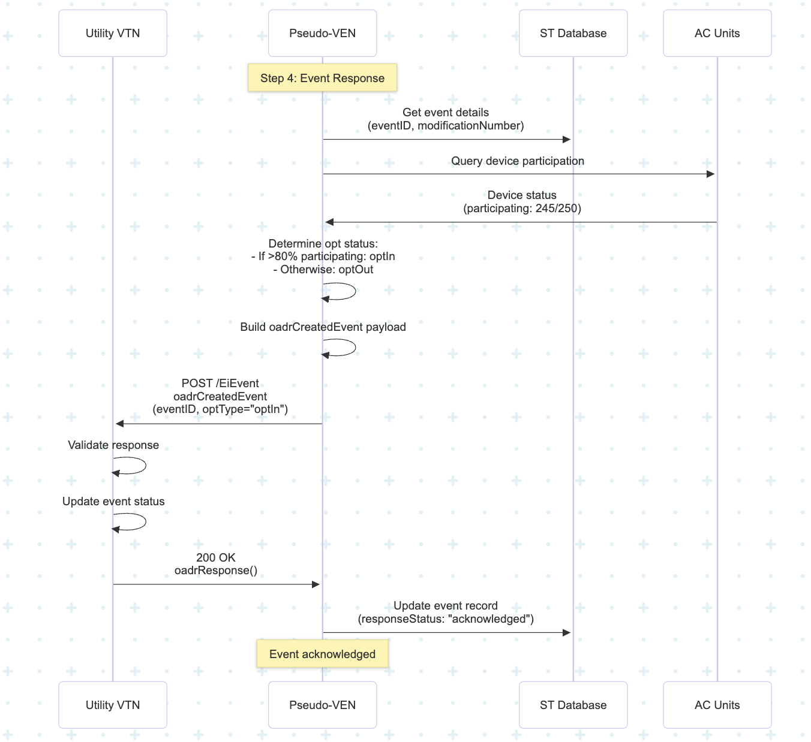

## API 5. Setup Reporting

Method: POST  
Endpoint: /EiReport

Purpose: Exchange metadata and establish telemetry reporting

Request Body Fields:

|  |  |  |  |
| --- | --- | --- | --- |
| Field | Type | Mandatory | Description |
| reportSpecifierID | String | M | Report specifier ID |
| granularity | String | M | Reporting interval (e.g., PT15M) |

Request Sample:

{'reportSpecifierID': 'rpt_telemetry_usage', 'granularity': 'PT15M'}

Sample Response:

{'reportSpecifierID': 'rpt_telemetry_usage', 'status': 'configured'}

## API 6. Send Periodic Reports

Method: POST  
Endpoint: /EiReport

Purpose: Collect and send telemetry data every reporting interval

Request Body Fields:

|  |  |  |  |
| --- | --- | --- | --- |
| Field | Type | Mandatory | Description |
| reportRequestID | String | M | Unique report request ID |
| intervalData | Array | M | Aggregated telemetry values |

Request Sample:

{'reportRequestID': 'rpt_req_001', 'intervalData': [{'power': '625', 'energy': '31.25', 'setpoint': '75'}]}

Sample Response:

{'reportRequestID': 'rpt_req_001', 'status': 'updated'}

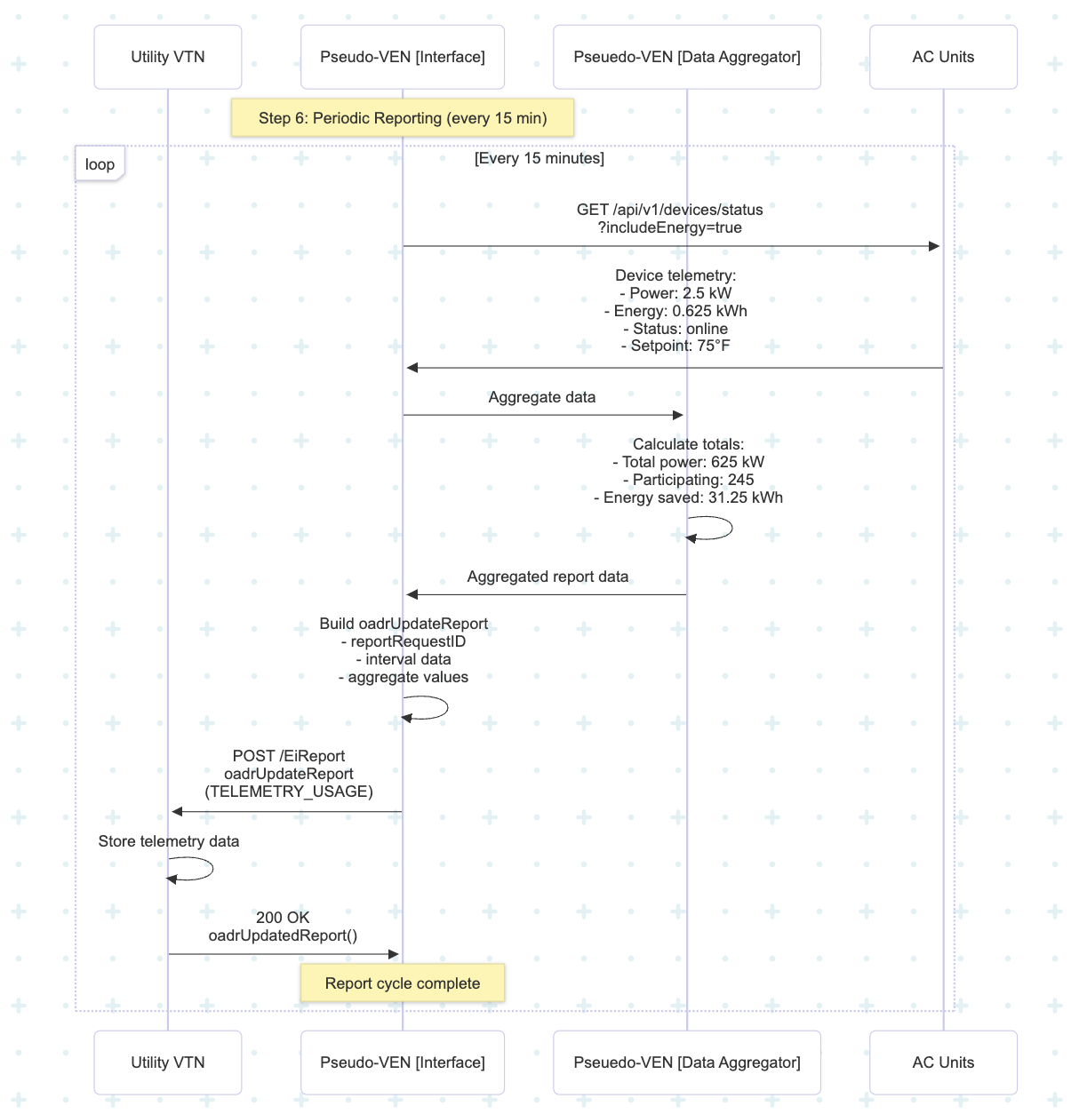

## API 7. Cancel Report

Method: POST  
Endpoint: /EiReport

Purpose: Stop sending periodic reports when requested by VTN

Request Body Fields:

|  |  |  |  |
| --- | --- | --- | --- |
| Field | Type | Mandatory | Description |
| reportRequestID | String | M | Report to cancel |
| reportToFollow | Boolean | M | If true, send final report |

Request Sample:

{'reportRequestID': 'rpt_req_001', 'reportToFollow': True}

Sample Response:

{'reportRequestID': 'rpt_req_001', 'status': 'canceled'}

## API 8. Opt-Out During Event

Method: POST  
Endpoint: /EiOpt

Purpose: Allow manual override or temporary opt-out during active event

Request Body Fields:

|  |  |  |  |
| --- | --- | --- | --- |
| Field | Type | Mandatory | Description |
| eventID | String | M | DR Event ID |
| optOut | Boolean | M | Opt-out true or false |
| reason | String | O | Reason for override (e.g., manual_override) |

Request Sample:

{'eventID': 'evt_001', 'optOut': True, 'reason': 'manual_override'}

Sample Response:

{'optID': 'opt_003', 'status': 'created'}

