**3.2 ARCHITECTURAL DESIGN**

The architectural design develops a modular program structure and represents the control relationships between modules. It also defines interfaces that enable data to flow throughout the program.

**3.2.1. DATA FLOW DIAGRAM**

A data flow diagram is a graphical technique that depicts data flow and transforms that are applied as data move from input to output. The DFD is used to represent increasing information flow and functional details. A Level 0 DFD also called a fundamental system model or context model represents the entire software elements as a single bubble with input and output indicated by incoming and outgoing arrows respectively. Additional process and information flow parts are represented in next level i.e., Level 1 DFD. Each of the processes represented at level 1 are sub functions of overall system depicted in the context model.

**Data flow diagram symbol:**

Source/Destination of Data

Data flow

Storage

**Level 0: Context Level**

Response

Request

Request

Request

CUSTOMER

RESOURCE_TB

**Level 1:**

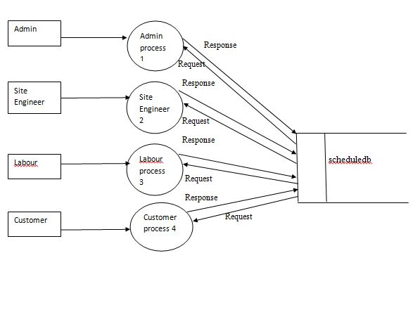

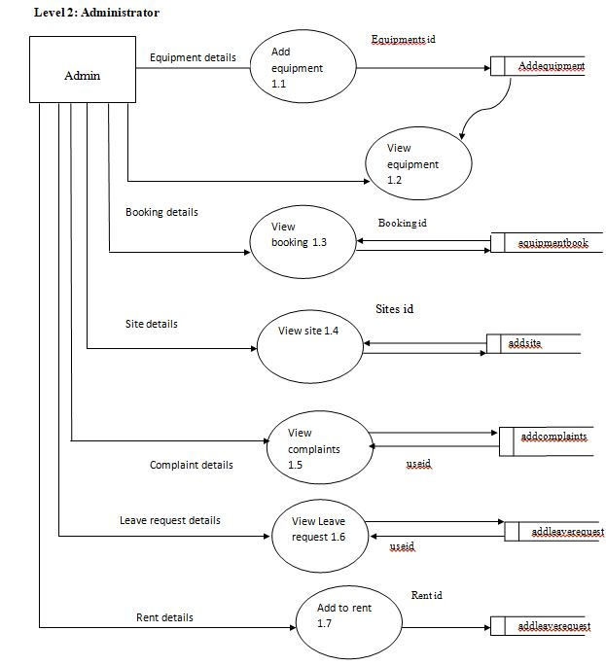

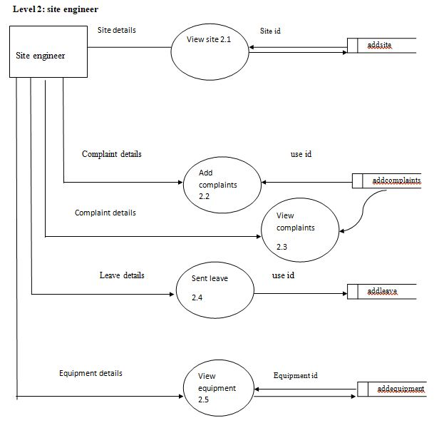

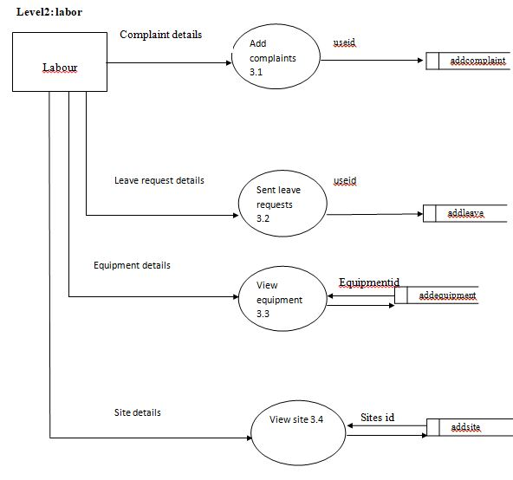

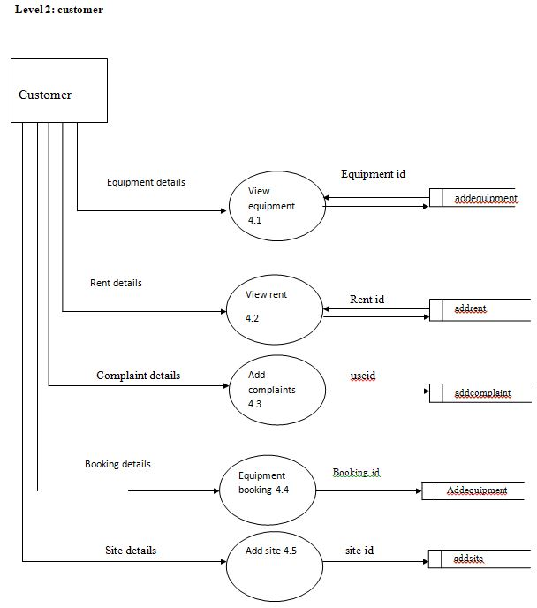

Changes are there