**Lab 4 : Connecting two different networks using Router in Cisco Packet Tracer**

**Date of the Session: / / Session Time: to**

# Learning outcome:

* Demonstrate the ability to configure a router in Packet Tracer.
* Understand the importance of successful connections in a Local Area Network (LAN) for effective communication.
* Validate network functionality through ping tests between connected devices.
* Gain hands-on experience in implementing accurate network setups for optimal performance.

**Pre-Lab Task**

1. Installation of Cisco Packet Tracer
2. Review basic networking concepts, including LAN, IP addressing, and subnetting.
3. Read provided documentation on configuring a network switch in Packet Tracer.
4. Identify and understand the roles and functions of network components, specifically switches in a LAN setup.
5. Practice basic switch configuration settings such as VLANs and IP address assignments.

# In-Lab Task: Configuring a Network Switch in Packet Tracer

Connecting Two Different Networks Using Router In Cisco Packet Tracer

The following steps outline the process of configuring a Network Switch

Materials and Tools:

* 1. Cisco Packet Tracer
  2. Network Switch
  3. End devices (e.g., PCs)

**Steps:**

**Step 1:**Add the required devices as shown below. We will add PCs for now and connect them with wire and switch to form a separate network.

|  |  |  |
| --- | --- | --- |
| **Course Title** | **NETWORK PROTOCOLS & SECURITY** | **ACADEMIC YEAR: 2023-24** |
| **Course Code(s)** | **22EC2210R** |  |

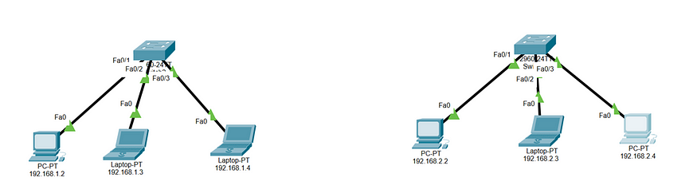

Setup the devices

**Step 2:**Go to the IP configuration tab of each Pcs and assign IP addresses.

**Step 3:**To link these two networks we introduced a Router and connected the network to the router using wire.

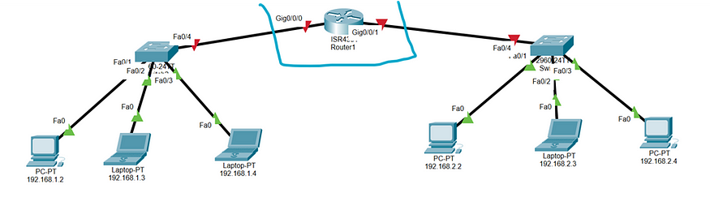

|  |  |  |
| --- | --- | --- |
| **Course Title** | **NETWORK PROTOCOLS & SECURITY** | **ACADEMIC YEAR: 2023-24** |
| **Course Code(s)** | **22EC2210R** |  |

**Step 4:**The next step is to configure the**Router.**Click on the router and go to CLI and enter en command.

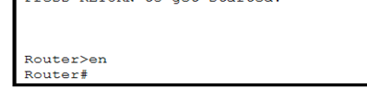

**Step 5:**Now run these commands in sequence.

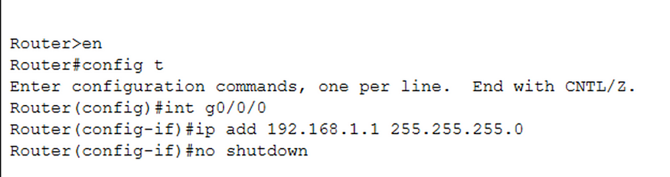

**Router(config)#int g0/0/1**

**Router(config-if)#ip add 192.168.2.1 255.255.255.0**

**Router(config-if)#no shutdown**

**Step 5:**Now to check the network connection we will ping a device from one network to the other.

>> ping 192.168.2.2

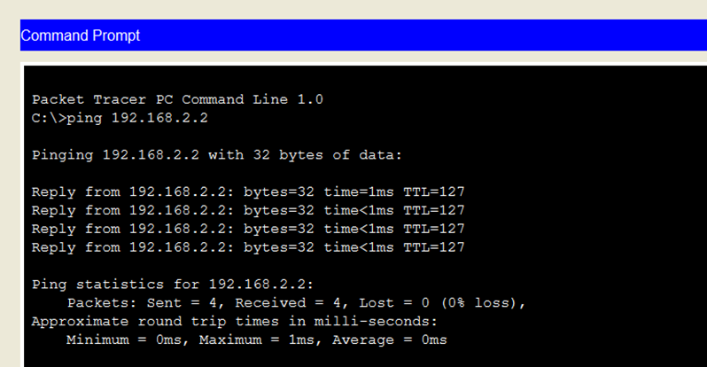

|  |  |  |
| --- | --- | --- |
| **Course Title** | **NETWORK PROTOCOLS & SECURITY** | **ACADEMIC YEAR: 2023-24** |
| **Course Code(s)** | **22EC2210R** |  |

# VIVA-VOCE Questions (In-Lab):

1. What is the purpose of a network switch, and how does it differ from other networking devices?
2. Why is it essential to set up a simulated environment with network devices before configuring a switch?
3. Can you explain the significance of assigning VLANs to switch ports?
4. How do you perform a basic connectivity test between two computers in Packet Tracer?
5. Explain the process of assigning an IP address to a switch.

# Post Lab Task:

* 1. Describe the devices used in the simulation.
  2. Explain the connections between devices using Network Switch.
  3. Explain the steps taken to perform connectivity tests between computers within the network.
  4. Consider scenarios where the network might need to scale up. How can the configuration be adapted to accommodate a larger number of devices?
  5. Can you think of alternative configurations that achieve the same objectives?

|  |  |
| --- | --- |
| **Evaluator Remark (if Any):** | **Marks Secured: out of 50** |
| **Signature of the Evaluator with Date** |

|  |  |  |
| --- | --- | --- |
| **Course Title** | **NETWORK PROTOCOLS & SECURITY** | **ACADEMIC YEAR: 2023-24** |
| **Course Code(s)** | **22EC2210R** |  |