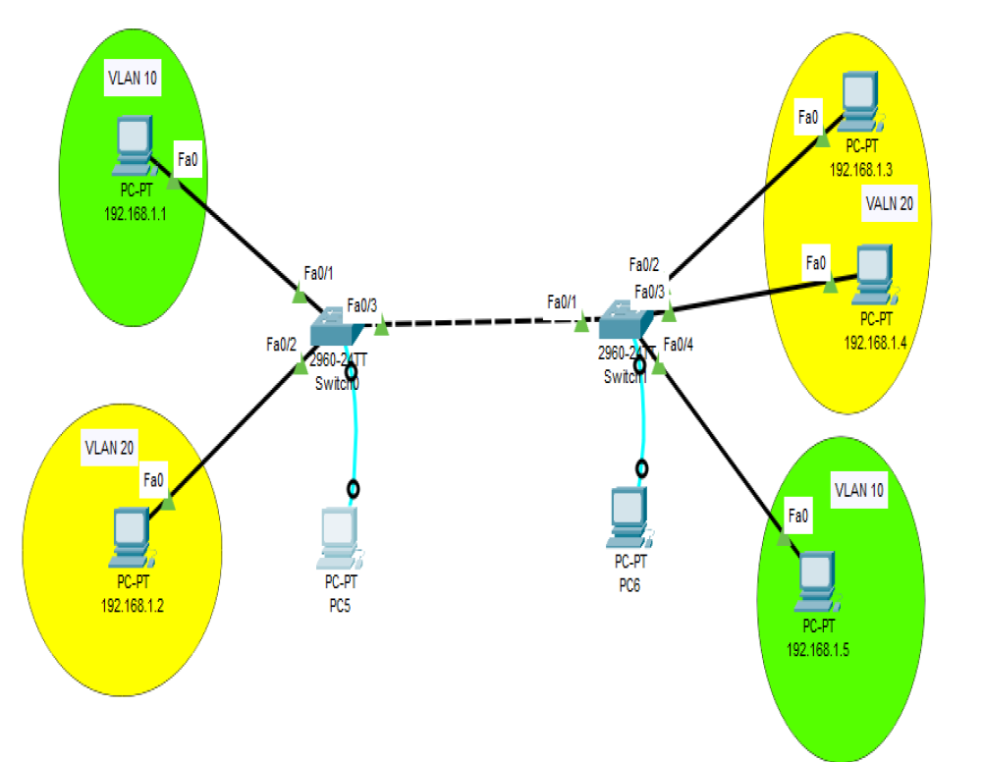

Switch-A (left)

**Set Hostname and Passwords**

Switch>en

Switch#config t

Switch(config)#hostname ECE_A

ECE_A(config)#line console 0

ECE_A(config-line)#password ompg

ECE_A(config-line)#login

ECE_A(config-line)#exit

ECE_A(config)#enable secret ompg_ece

**Configure VLANs**

**Create VLANs**:

ECE_A(config)#vlan 10

ECE_A(config-vlan)#name green

ECE_A(config-vlan)#exit

ECE_A(config)#vlan 20

ECE_A(config-vlan)#name yellow

ECE_A(config-vlan)#exit

**Assign Ports to VLANs**:

ECE_A(config)#int fa0/1

ECE_A(config-if)#switchport mode access

ECE_A(config-if)#switchport access vlan 10

ECE_A(config-if)#exit

ECE_A(config)#int fa0/2

ECE_A(config-if)#switchport mode access

ECE_A(config-if)#switchport access vlan 20

ECE_A(config-if)#exit

**Configure Trunking on the Interface**

ECE_A(config)#int fa0/3

ECE_A(config-if)#switchport mode trunk

**Set Allowed VLANs**

ECE_A(config-if)#switchport trunk allowed vlan 10,20

ECE_A(config-if)#exit

ECE_A(config)#exit

**Verify Trunk Configuration**

ECE_A#sh int trunk

ECE_A#show vlan brief

ECE_A#sh int status

**Switch-B**

**Set Hostname and Passwords**

Switch>en

Switch#config t

Switch(config)#hostname ECE_B

ECE_B(config)#line console 0

ECE_B(config-line)#password ompg

ECE_B(config-line)#login

ECE_B(config-line)#exit

ECE_B(config)#enable secret ompg_ece

%%%%%%%%%%%%%%%%%%%%%%%%%%%%%%%%%%%%

**Configure VLANs**

**Create VLANs**:

ECE_B(config)#vlan 20

ECE_B(config-vlan)#name yellow

ECE_B(config-vlan)#exit

ECE_B(config)#vlan 10

ECE_B(config-vlan)#name green

ECE_B(config-vlan)#exit

**Assign Ports to VLANs**:

ECE_B(config)#int fa0/4

ECE_B(config-if)#switchport mode access

ECE_B(config-if)#switchport access vlan 10

ECE_B(config-if)#exit

ECE_B(config)#int range fa0/2-3

ECE_B(config-if-range)#switchport mode access

ECE_B(config-if-range)#switchport access vlan 20

ECE_B(config-if-range)#exit

**Configure Trunking on the Interface**

ECE_B(config)#int fa0/1

ECE_B(config-if)#switchport mode trunk

**Set Allowed VLANs**

ECE_B(config-if)#switchport trunk allowed vlan 10,20

ECE_B(config-if)#exit

**Verify Trunk Configuration**

ECE_B#show interface trunk