**Lab5:**

**Configuration of Encapsulation dot 1Q using cisco packet tracer**

Communicate among different LANs

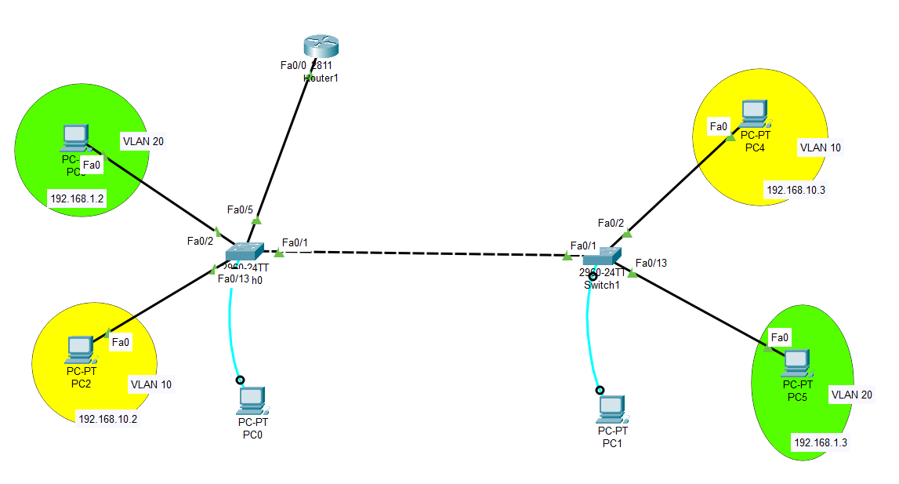

**Part 1: Construction of different VLANS and TRUNKING**

**Repeat previous experiment with the above IP address.**

**Gateway for VLAN 20: 192.168.1.1**

**Gateway for VLAN 10: 192.168.10.1**

**Part 2: Configure inter-VLAN routing on the router**

 Enable communication between the two vlans via a single physical interface

Divide the single physical interface on the router into logical interfaces (sub interfaces). Each sub-interface will then serve as a default gateway for each of the VLANs. This scenario is called **router on a stick** (R.O.A.S) and will allow the VLANs to communicate through the single physical interface.

**Note**: We**can’t**assign an IP address to the router’s physical interface that we have subdivided into logical sub-interfaces. We’ll instead assign IP addresses to the sub interfaces.

**Step 1: make FA0/5 trunk connection on the left switch**

**Step 2: Perform Inter-VLAN routing**

Router>en

Router#config t

Router(config)#int fa0/0

Router(config-if)#no shutdown

Router(config-if)#int fa0/0.10

Router(config-subif)#encapsulation dot1q 10

Router(config-subif)#ip add 192.168.10.1 255.255.255.0

Router(config-subif)#int fa0/0.20

Router(config-subif)#encapsulation dot1q 20

Router(config-subif)#ip add 192.168.1.1 255.255.255.0

Router(config-subif)#exit

Ping the PCs to check connections

To Try: Repeat the same experiment with Layer 3 switch

2900 series switches are L2 only switches. Meaning that you can setup VLANs but you won't be able to route between then.  
3X00 series switches are L3 switches. Hence you will be able to route between VLANs.

**Drag and drop the power supply from the bottom onto the empty rack in the switch**

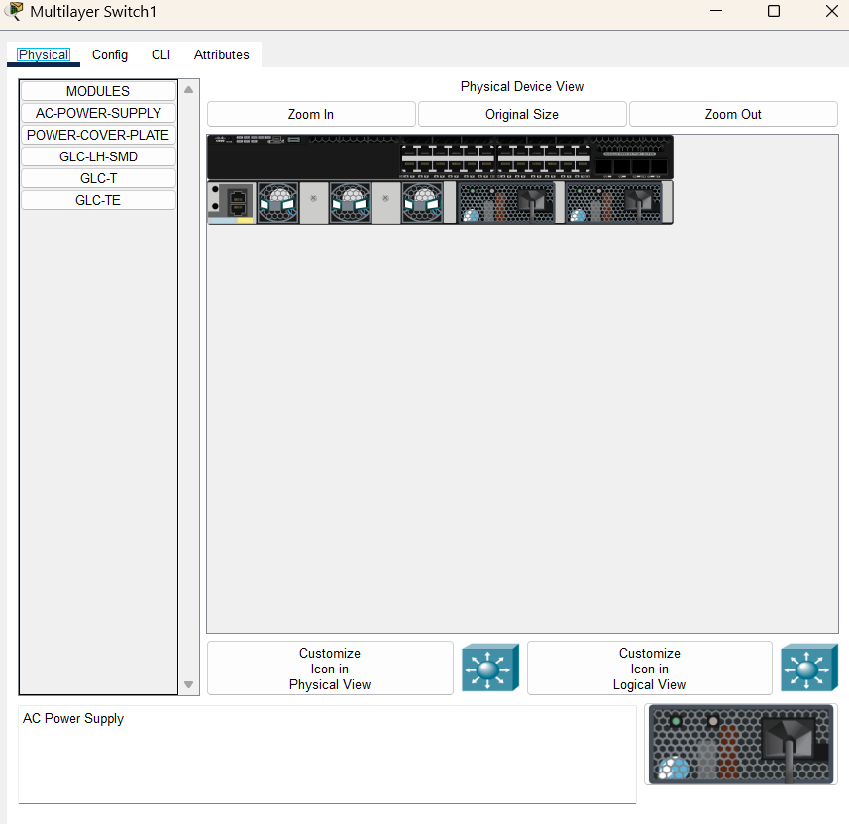

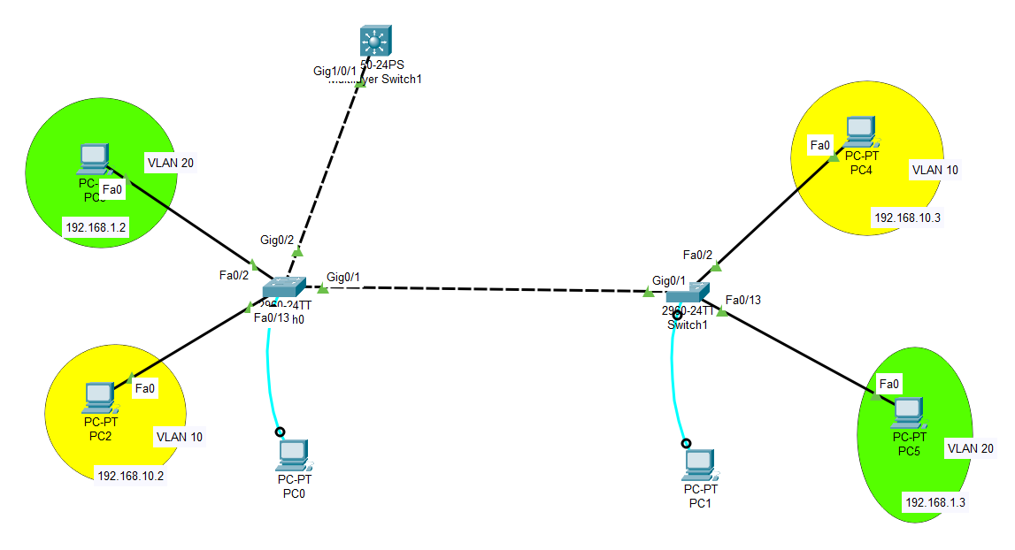

Switch>en

Switch#config t

Enter configuration commands, one per line. End with CNTL/Z.

Switch(config)#vlan 10

Switch(config-vlan)#name yellow

Switch(config-vlan)#exit

Switch(config)#vlan 20

Switch(config-vlan)#name green

Switch(config-vlan)#exit

Switch(config)#int vlan 10

Switch(config-if)#ip add 192.168.10.1 255.255.255.0

Switch(config-if)#exit

Switch(config)#int vlan 20

Switch(config-if)#ip add 192.168.1.1 255.255.255.0

Switch(config-if)#exit

Switch(config)#int g1/0/1

Switch(config-if)#switchport mode trunk

Switch(config)#ip routing

Switch(config)#exit

Check trunk status

Switch#sh int trunk

Ping the PCs to check connections