10. ADC Noise Reduction by Multi-Sampling & Moving Average Digital Filtering with ESP 32. (Practical)

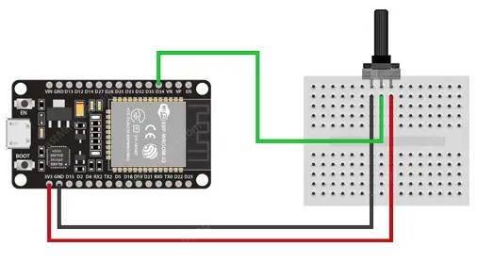

Source Code:

#define AN_Pot1     35

#define FILTER_LEN  15

uint32_t AN_Pot1_Buffer[FILTER_LEN] = {0};

int AN_Pot1_i = 0;

int AN_Pot1_Raw = 0;

int AN_Pot1_Filtered = 0;

void setup()

{

  Serial.begin(115200);

}

void loop()

{

  AN_Pot1_Raw = analogRead(AN_Pot1);

  AN_Pot1_Filtered = readADC_Avg(AN_Pot1_Raw);

  Serial.print(AN_Pot1_Raw);        // Print Raw Reading

  Serial.print(',');                // Comma Separator

  Serial.println(AN_Pot1_Filtered); // Print Filtered Output

  delay(1000);

}

uint32_t readADC_Avg(int ADC_Raw)

{

  int i = 0;

  uint32_t Sum = 0;

  AN_Pot1_Buffer[AN_Pot1_i++] = ADC_Raw;

  if(AN_Pot1_i == FILTER_LEN)

  {

    AN_Pot1_i = 0;

  }

  for(i=0; i<FILTER_LEN; i++)

  {

    Sum += AN_Pot1_Buffer[i];

  }

  return (Sum/FILTER_LEN);

}

10.Observation of Analog output from ESP 32(Skill).

Mydaq –AI -0+ connect to Gpio16,0- to ground

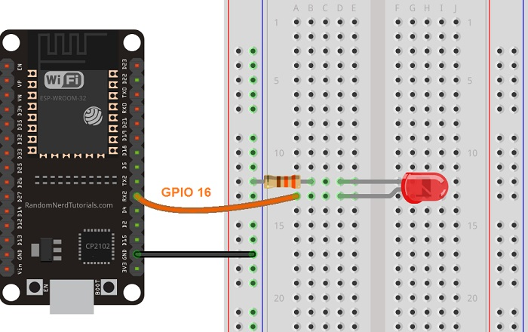

Code:

// the number of the LED pin

const int ledPin = 16;  // 16 corresponds to GPIO16

// setting PWM properties

const int freq = 5000;

const int resolution = 8;

void setup(){

  // configure LED PWM

  ledcAttach(ledPin, freq, resolution);

  // if you want to attach a specific channel, use the following instead

  //ledcAttachChannel(ledPin, freq, resolution, 0);

}

void loop(){

  // increase the LED brightness

  for(int dutyCycle = 0; dutyCycle <= 255; dutyCycle++){

    // changing the LED brightness with PWM

    ledcWrite(ledPin, dutyCycle);

    delay(15);

  }

  // decrease the LED brightness

  for(int dutyCycle = 255; dutyCycle >= 0; dutyCycle--){

    // changing the LED brightness with PWM

    ledcWrite(ledPin, dutyCycle);

    delay(15);

  }

}