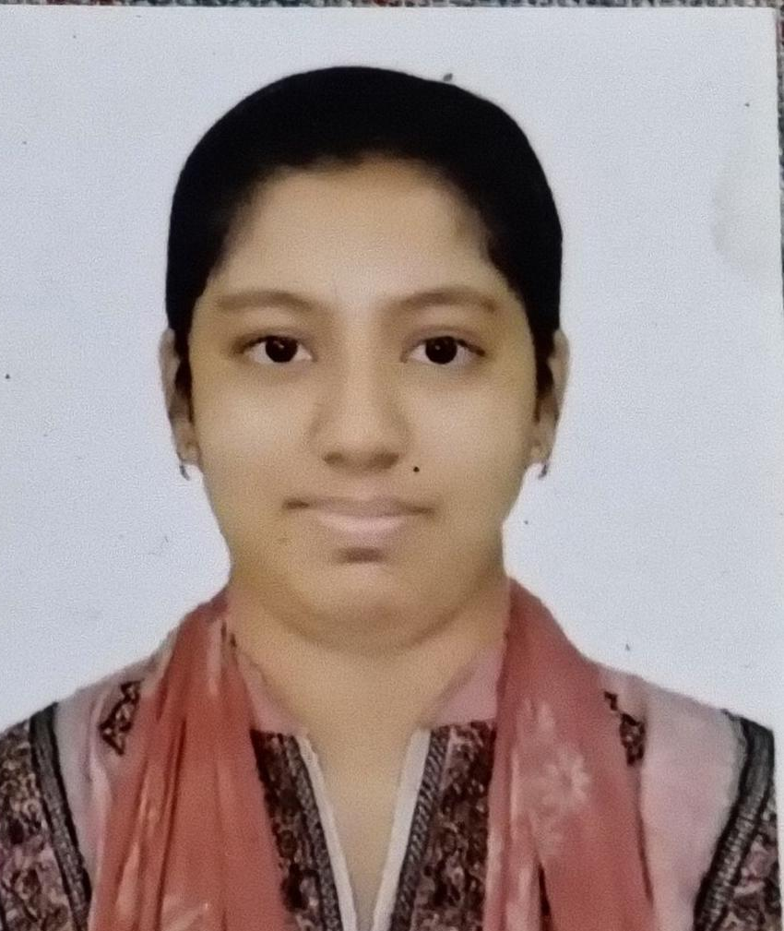

DOCTYPE html>
<html lang=”en”>
<head>
<meta charset=”UTF-8”>
<meta name=”viewport” content=”width=device-width, initial-scale=1.0”>
<title>Sayra Chowdhury | Academic Portfolio</title>
<!—Google Fonts & Font Awesome Icons
<link href=https://fonts.googleapis.com/css2?family=Poppins:wght@300;400;600;700&display=swap rel=”stylesheet”>
<link rel=”stylesheet” href=https://cdnjs.cloudflare.com/ajax/libs/font-awesome/6.4.0/css/all.min.css>

<style>
:root {
--primary-color: #1a365d;
--secondary-color: #2b6cb0;
--accent-color: #d69e2e;
--bg-light: #f7fafc;
--text-dark: #2d3748;
--text-muted: #718096;
--white: #ffffff;
}

- {
Margin: 0;
Padding: 0;
Box-sizing: border-box;
Font-family: ‘Poppins’, sans-serif;
}

Body {
Background-color: var(--bg-light);
Color: var(--text-dark);
Line-height: 1.6;
}

/* Header Section */
Header {
Background: linear-gradient(135deg, var(--primary-color), var(--secondary-color));
Color: var(--white);
Padding: 60px 20px;
Text-align: center;
}

.header-content {
Max-width: 900px;
Margin: 0 auto;
}

.profile-img {
Width: 150px;
Height: 150px;
Border-radius: 50%;
Border: 4px solid var(--white);
Object-fit: cover;
Margin-bottom: 20px;
Box-shadow: 0 4px 10px rgba(0, 0, 0, 0.15);
}

Header h1 {
Font-size: 2.2rem;
Margin-bottom: 5px;
}

Header p.subtitle {
Font-size: 1.1rem;
Color: #e2e8f0;
Margin-bottom: 15px;
}

.contact-info {
Display: flex;
Justify-content: center;
Flex-wrap: wrap;
Gap: 15px;
Font-size: 0.9rem;
}

.contact-info a, .contact-info span {
Color: var(--white);
Text-decoration: none;
}

.contact-info i {
Margin-right: 5px;
Color: var(--accent-color);
}

/* Container Layout */
.container {
Max-width: 1000px;
Margin: 40px auto;
Padding: 0 20px;
}

.section {
Background: var(--white);
Padding: 30px;
Border-radius: 8px;
Margin-bottom: 30px;
Box-shadow: 0 2px 5px rgba(0, 0, 0, 0.05);
}

.section-title {
Font-size: 1.4rem;
Color: var(--primary-color);
Border-bottom: 2px solid #e2e8f0;
Padding-bottom: 8px;
Margin-bottom: 20px;
Display: flex;
Align-items: center;
Gap: 10px;
}

.section-title i {
Color: var(--secondary-color);
}

/* Timeline / Cards Layout */
.item {
Margin-bottom: 20px;
}

.item:last-child {
Margin-bottom: 0;
}

.item-header {
Display: flex;
Justify-content: space-between;
Align-items: flex-start;
Flex-wrap: wrap;
}

.item-title {
Font-size: 1.1rem;
Font-weight: 600;
Color: var(--text-dark);
}

.item-subtitle {
Font-size: 0.95rem;
Color: var(--secondary-color);
Font-weight: 500;
}

.item-date {
Font-size: 0.85rem;
Color: var(--text-muted);
Background: #edf2f7;
Padding: 2px 8px;
Border-radius: 4px;
}

.item-details {
Margin-top: 8px;
Font-size: 0.95rem;
Color: #4a5568;
}

.item-details ul {
Margin-left: 20px;
}

/* Grid System for Skills & Projects */
.grid-2 {
Display: grid;
Grid-template-columns: repeat(auto-fit, minmax(280px, 1fr));
Gap: 20px;
}

.card {
Background: #f8fafc;
Border-left: 4px solid var(--secondary-color);
Padding: 15px 20px;
Border-radius: 4px;
}

.card h4 {
Color: var(--primary-color);
Margin-bottom: 8px;
}

/* Skills Tags */
.skills-list {
Display: flex;
Flex-wrap: wrap;
Gap: 10px;
List-style: none;
}

.skills-list li {
Background: #e2e8f0;
Color: var(--text-dark);
Padding: 6px 14px;
Border-radius: 20px;
Font-size: 0.85rem;
Font-weight: 500;
}

/* Footer */
Footer {
Text-align: center;
Padding: 20px;
Color: var(--text-muted);
Font-size: 0.85rem;
}

/* Responsive */
@media (max-width: 600px) {
.contact-info {
Flex-direction: column;
Align-items: center;
Gap: 8px;
}
.item-header {
Flex-direction: column;
}
}
</style>
</head>
<body>

<!—Header Section
<header>
<div class=”header-content”>
<!—আপনার ছবির ফাইলটি ‘profile.jpg’ নামে একই ফোল্ডারে রেখে এখানে লিংক দিন
<img src=”profile.jpg” alt=”Sayra Chowdhury” class=”profile-img” onerror=”this.src=’https://via.placeholder.com/150’”>
<h1>Sayra Chowdhury</h1>
<p class=”subtitle”>Language Educator | English Language Pedagogy Specialist</p>

<div class=”contact-info”>
<span><i class=”fa-solid fa-location-dot”></i> Shamsun Nahar Hall, DU, Dhaka</span>
<a href=tel:+8801778298001><i class=”fa-solid fa-phone”></i> +8801778298001</a>
<a href=mailto:sayrachowdhurypoula@gmail.com><i class=”fa-solid fa-envelope”></i> sayrachowdhurypoula@gmail.com</a>
</div>
</div>
</header>

<div class=”container”>

<!—About Me
<section class=”section”>
<h2 class=”section-title”><i class=”fa-solid fa-user”></i> About Me</h2>
<p>I am a passionate Language Educator and Master’s student in TESOL at the Institute of Education and Research (IER), University of Dhaka. With over a decade of hands-on experience in English language teaching and a solid academic foundation in Language Education, I specialize in language pedagogy, curriculum planning, and interactive learning methodologies. My goal is to bridge academic theories with effective classroom practices.</p>
</section>

<!—Academic Background
<section class=”section”>
<h2 class=”section-title”><i class=”fa-solid fa-graduation-cap”></i> Academic Background</h2>

<div class=”item”>
<div class=”item-header”>
<div>
<div class=”item-title”>Master of Education (M.Ed.) in TESOL</div>
<div class=”item-subtitle”>Institute of Education and Research (IER), University of Dhaka</div>
</div>
<span class=”item-date”>Ongoing</span>
</div>
</div>

<div class=”item” style=”margin-top: 15px;”>
<div class=”item-header”>
<div>
<div class=”item-title”>Bachelor of Education (B.Ed.) in Language Education</div>
<div class=”item-subtitle”>Institute of Education and Research (IER), University of Dhaka</div>
</div>
<span class=”item-date”>CGPA: 3.15</span>
</div>
</div>

<div class=”item” style=”margin-top: 15px;”>
<div class=”item-header”>
<div>
<div class=”item-title”>Higher Secondary Certificate (H.S.C)</div>
<div class=”item-subtitle”>Moulvibazar Board</div>
</div>
<span class=”item-date”>GPA: 5.00 | 2020</span>
</div>
</div>

<div class=”item” style=”margin-top: 15px;”>
<div class=”item-header”>
<div>
<div class=”item-title”>Secondary School Certificate (S.S.C)</div>
<div class=”item-subtitle”>Moulvibazar Board</div>
</div>
<span class=”item-date”>GPA: 5.00 | 2018</span>
</div>
</div>
</section>

<!—Work Experience
<section class=”section”>
<h2 class=”section-title”><i class=”fa-solid fa-briefcase”></i> Teaching & Professional Experience</h2>

<div class=”item”>
<div class=”item-header”>
<div>
<div class=”item-title”>English Language Instructor / Tutor</div>
<div class=”item-subtitle”>Self-Employed</div>
</div>
<span class=”item-date”>2014 – Present (10+ Years)</span>
</div>
<div class=”item-details”>
<ul>
<li>Delivered customized English language lessons focusing on grammar, vocabulary, reading, and communicative skills.</li>
<li>Designed engaging lesson plans and supplementary materials adapted to various student learning styles.</li>
<li>Mentored students to improve academic performance and confidence in spoken and written English.</li>
</ul>
</div>
</div>
</section>

<!—Featured Projects
<section class=”section”>
<h2 class=”section-title”><i class=”fa-solid fa-folder-open”></i> Featured Projects & Artifacts</h2>

<div class=”grid-2”>
<div class=”card”>
<h4>Language Teaching & Lesson Plans</h4>
<p class=”item-details”>Designed interactive grammar/vocabulary modules and communicative task-based activities (TBLT) for secondary learners.</p>
</div>
<div class=”card”>
<h4>Educational Scriptwriting</h4>
<p class=”item-details”>Authored structured, engaging video lesson scripts for e-learning platforms targeting core ELT concepts.</p>
</div>
<div class=”card”>
<h4>EdTech Impact Research</h4>
<p class=”item-details”>Exploratory study analyzing digital tool integration and its impact on student performance in language classrooms.</p>
</div>
<div class=”card”>
<h4>Inclusive Pedagogy Frameworks</h4>
<p class=”item-details”>Researched inclusive classroom strategies focusing on neurodivergent learners and learner-centered approaches.</p>
</div>
</div>
</section>

<!—Skills
<section class=”section”>
<h2 class=”section-title”><i class=”fa-solid fa-gears”></i> Skills & Tools</h2>
<ul class=”skills-list”>
<li>ELT Pedagogy</li>
<li>Communicative Language Teaching (CLT)</li>
<li>Curriculum Design</li>
<li>Lesson Planning</li>
<li>Educational Scriptwriting</li>
<li>Academic Writing</li>
<li>Google Classroom</li>
<li>Canva</li>
<li>MS Office Suite</li>
<li>English (Fluent)</li>
<li>Bengali (Native)</li>
</ul>
</section>

</div>

<footer>
<p>&copy; 2026 Sayra Chowdhury. All Rights Reserved.</p>
</footer>

</body>
</html>

