Detailed Information

**PDB IDs**

1. **3bqc:** High pH-value crystal structure of emodin in complex with the catalytic subunit of protein kinase CK2 (1.5A)

2. **3h30:** Crystal structure of the catalytic subunit of human protein kinase CK2 with 5,6-dichloro-1-beta-D-ribofuranosylbenzimidazole (1.56Å)

3. **3mb7:** Human CK2 catalytic domain in complex with a difurane derivative inhibitor (AMR) (1.65 Å)

4. **3nsz:** Human CK2 catalytic domain in complex with AMPPN (1.30 Å)

5. **3pe1:** Crystal structure of human protein kinase CK2 alpha subunit in complex with the inhibitor CX-4945 (1.6 Å)

6. **3war:** Crystal structure of human CK2a (1.04 Å)

7. **4kwp:** Crystal Structure of Human CK2-alpha in complex with a benzimidazole inhibitor (K164) at 1.25 A resolution (1.25 Å)

8. **5csv:** Crystal Structure of CK2alpha with Compound 6 bound (1.375 Å)

9. **5cu4:** Crystal Structure of CK2alpha with Compound 10 bound (1.56 Å)

10. **5cu6:** Crystal Structure of CK2alpha (1.36 Å)

11. **2pvr:** Crystal structure of the catalytic subunit of protein kinase CK2 (C-terminal deletion mutant 1-335) in complex with two sulfate ions

12. **5clp:** Crystal Structure of CK2alpha with 3,4-dichlorophenethylamine bound

13. **5csp:** Crystal Structure of CK2alpha with Compound 5 bound

14. **5cvg:** Crystal Structure of CK2alpha with a novel closed conformation of the aD loop

15. **3r0t:** Crystal structure of human protein kinase CK2 alpha subunit in complex with the inhibitor CX-5279

16. **3q9w:** Crystal structure of human CK2 alpha in complex with emodin at pH 8.5

17. **3q04:** Crystal structure of the apo-form of human CK2 alpha at pH 8.5

18. **5cs6:** Crystal Structure of CK2alpha with Compound 3 bound

19. **3owk:** Human CK2 catalytic domain in complex with a benzopyridoindole derivative inhibitor

20. **4rll:** Crystal structure of human CK2alpha in complex with the ATP-competitive inhibitor 4-[(E)-(fluoren-9-ylidenehydrazinylidene)-methyl] benzoate

**MSA**

Files:

sequences_pdb20.pir

sequences_pdb20.fasta

Input file for alignment using Bio. Align; MSA generated

Set Reference: 3war **-** Crystal structure of human CK2a (1.04 Å)

Set Sample: x – any of the other 19 structures

**Define Ranges, Extract CA co-ordinates from Reference and Sample**

* 30-300 bps
* Biopython script

**RMSD Calculation**

where , are the coordinates of Reference Structure CAs

, are the coordinates of Sample Structure CAs

**Superimposition of structures (backbone)**

Optimal movement of one structure over another to minimize RMSD

Method: Rigid Body Rotation and translation of B (sample) on A (reference)

*Reference:* 3war

*Sample:* 3bqc

Structures: 3war, 3bqc

Chain traces

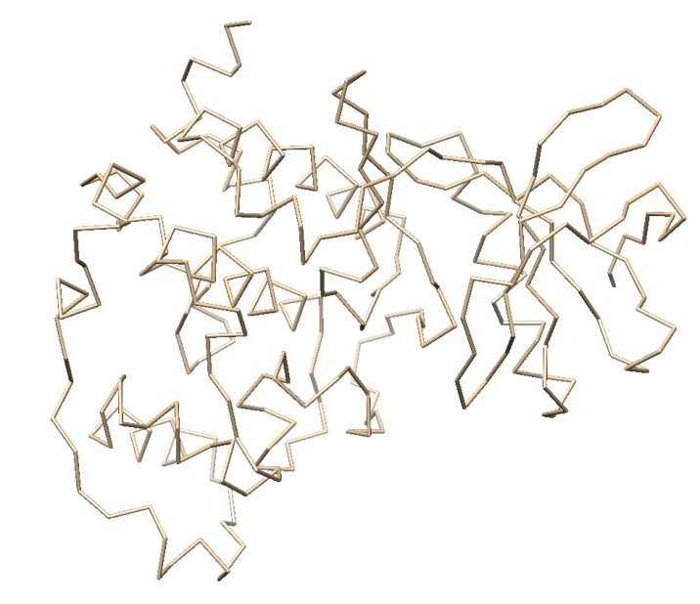 +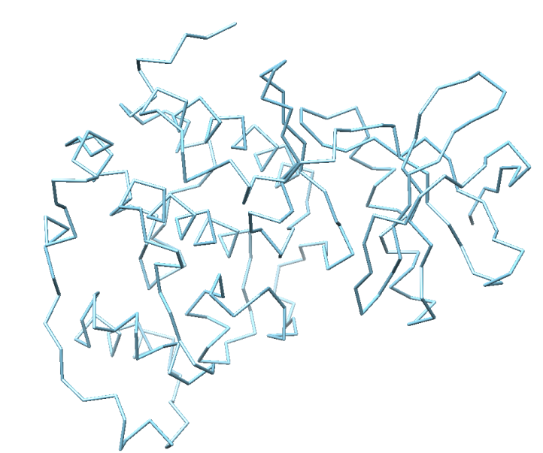

*3war*

*3bqc*

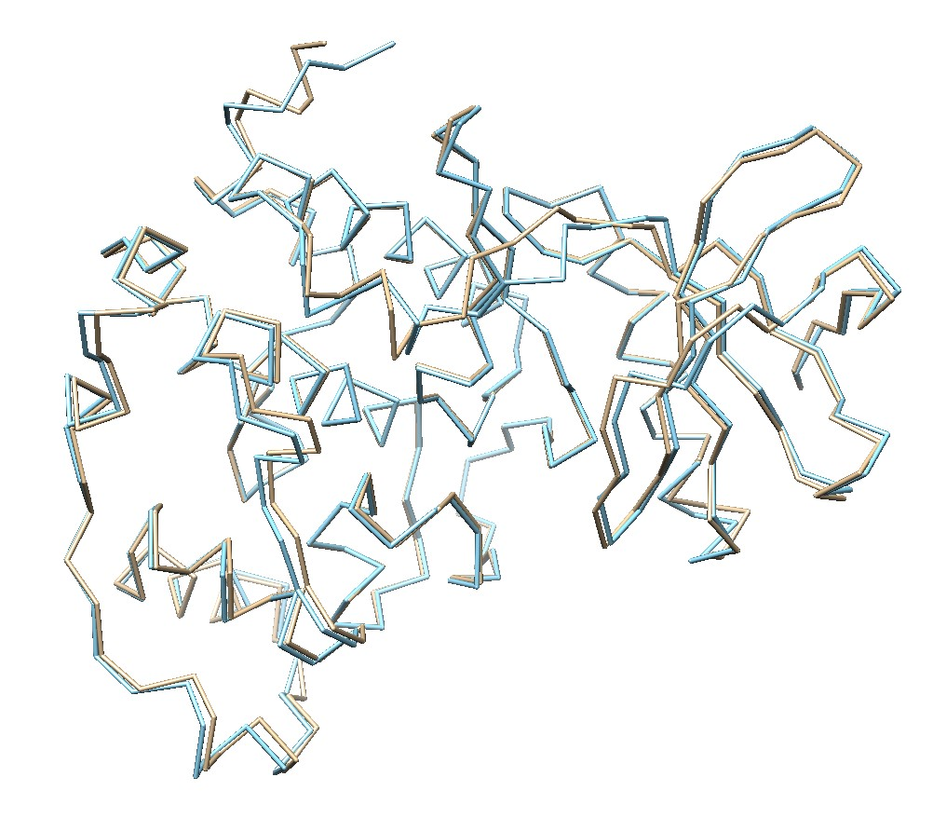

**Python implementation:**

*Reference:* 3war (30-330 bps)

*Sample:* 3bqc (30-330 bps)

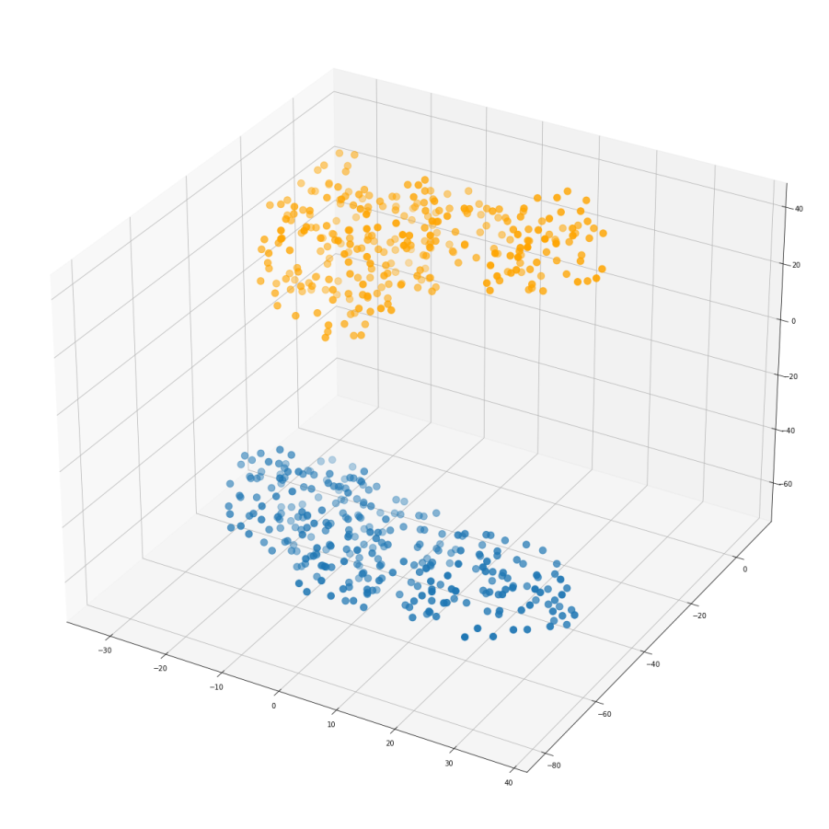 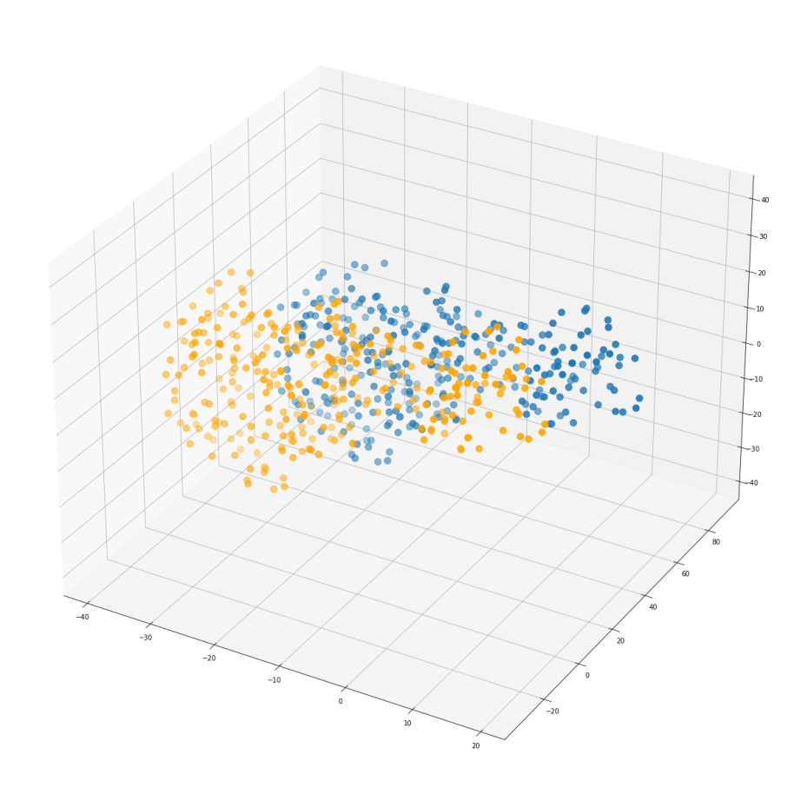

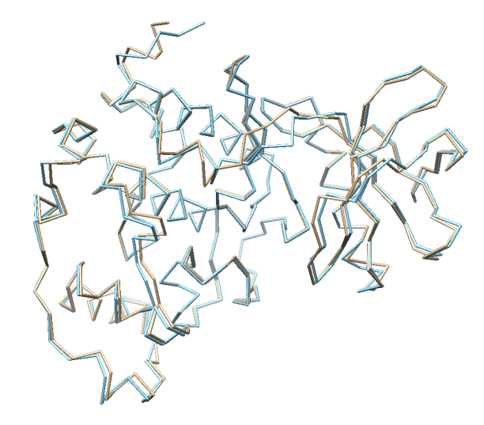 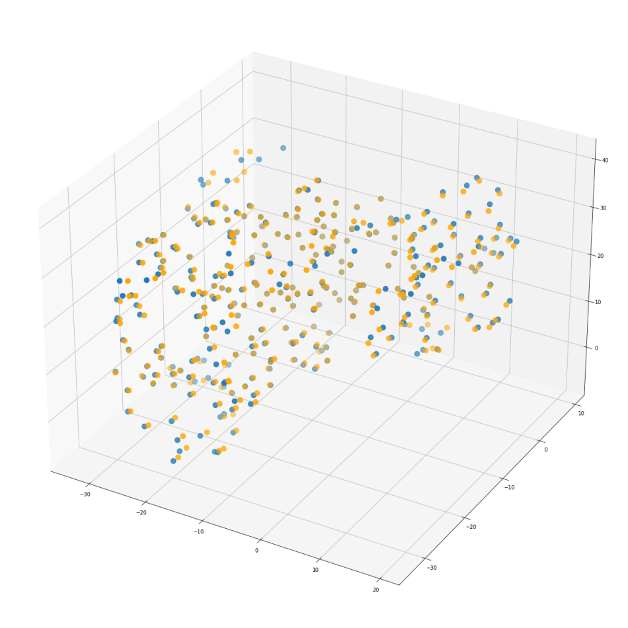

Initial average RMSD (3war/3bqc): **1.4168445841471353**

Minimized average RMSD (3war/3bqc): **0.5565493265787761**

**Per residue RMSD (3war/3bqc)**

*Raw RMSD*

**Per residue RMSD (Reference: 3war, Sample: x)**

**Regions of variability of samples with respect to reference structure (3war)**

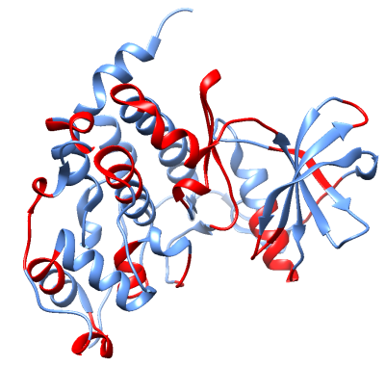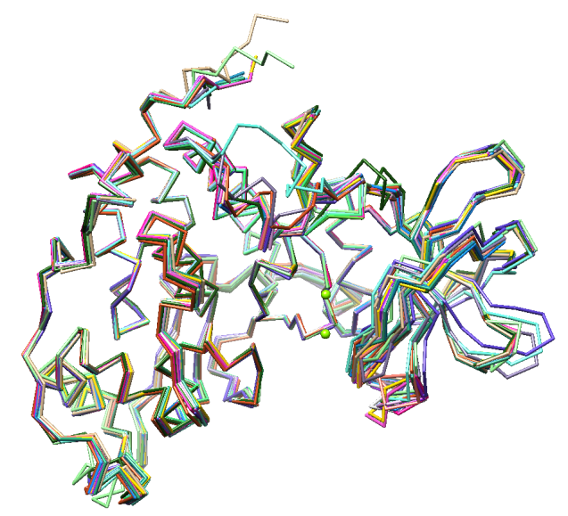 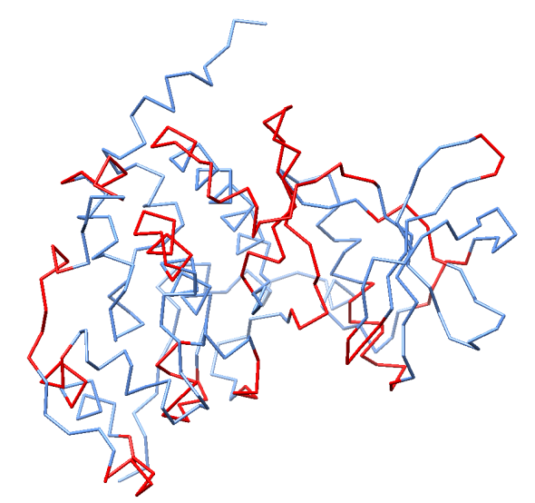

*Superimposed structures*

*(Reference: 3war)*

*3war; residue regions that differ in the other 19 structures marked in red; while the rest (blue) remain conserved*