



Recent Photo
4 x 6 cm
EMPLOYMENT APPLICATION

THIS APPLICATION IS GIVEN FREE OF CHARGE at ACLEDA Institute of Business, OR CAN BE DOWNLOADED FROM WEBSITE: www.acleda-aib.edu.kh THE ACCEPTANCE OF APPLICATION FORM DOES NOT IMPLY THAT THE APPLICANT WILL BE SHORT-LISTED OR EMPLOYED. ONLY QUALIFICATION OF JOB-RELATED KNOWLEDGE AND SKILLS MAY BE PRIORITIZED.
Note: This application is used for Clerk and Professional staff.

Position Applied for...Staff of Application Development… | Location ACLEDA INSTITUTE OF BUSINESS | Salary Desired $.300.../M
Could you go anywhere beside the above location? No Choice Everywhere Somewhere, .....................................................

BASIC INFORMATION | Have you ever applied to ACLEDA Institute of Business ACLEDA Bank or Subsidaries of ACLEDA Bank before? Yes No. If yes, please specify the position and date that applied for  .................................................................................Clerk of Application Development Unit...................................................................................................  Have you ever worked for ACLEDA Institute of Business ACLEDA Bank or Subsidaries of ACLEDA Bank? Yes No. If yes, please specify the position, Location and date of resignation  ................................................................................. Clerk of Application Development Unit.................................................................................................  Have you got any relatives (son, daughter, adoptee, sibling, father, mother) working for ACLEDA Institute of Business ACLEDA Bank or Subsidaries of ACLEDA Bank? Yes No. If yes, please list name below:
BASIC INFORMATION | Name | Position | ID | Location | Relationship
BASIC INFORMATION | ..........................................................  .......................................................... | .....................................................................  ..................................................................... | ...........  ........... | ...................................................  ................................................... | .................................  ..................................
BASIC INFORMATION | Have you got any relatives (son, daughter, adoptee, sibling, father, mother) applying to ACLEDA Institute of Business ACLEDA Bank or Subsidaries of ACLEDA Bank? Yes No. If yes, please list name below:
BASIC INFORMATION | Name | Position Applied for | Location |  | Relationship
BASIC INFORMATION | ....................Sok Chanta................  .......................................................... | Assistant Branch Maketing Manager  .......................................................... | Sangkat Chaom Chau3 Khan Pur SenChey  ........................................................................ |  | ...........Aunt..............  ..................................

PERSONAL INFORMATION | FULL NAME..............SAY SIVLANG..................... FULL NAME (IN KHMER) ...............សាយ ស៊ីវឡាំង..................... NICKNAME ..... ស៊ីវឡាំង......  Date of Birth... 15/09/2002......, Place of Birth...Samroung Village Samroung Krom Por Sen Chey Phnom Penh....., Race....KHMER........., Nationality........KHMER...............  Height......1.55...... cm, Weight.......70..........kg, Personal Phone Number : ...........017 77 31 45/ 096 639 4005.........................
PERSONAL INFORMATION | Education ...........................Bachelor Degree...................................Major................................FINTECH...........................................................................  Institution Name...............................ACLEDA INSTITUTE OF BUSINESS...................................................................................................................
PERSONAL INFORMATION | Marital Status: Single Married Divorced Widow(er), # of Children...........................................................................................  Spouse's Name................................................................ Occupation.............................................................. Company Name.............................................  Phone Number :........................................................  Father's Name..........Say Bunthoeun........ Alive Dead, Year of Birth....20/05/1983.... Occupation.....................Seller….........................  Mother's Name.......Sreng Marady................. Alive Dead, Year of Birth....29/11/1983....... Occupation................ Seller...........................  Parents' Phone Number : (Father)..........012 247407/ 012 247407................... : (Mother).................017 714 272.........................................
PERSONAL INFORMATION | Permanent Address (base on Family or Residence Book): Nº....133.....Street.......120K........ Group....5....... Village...........Samroung............  Commune.........Samroung Krom............ District-City.......Pur SenChey............. Province/Capital...................Phnom Penh...............................  The above address is my : Own House, Parents' House, Parents-in-Law's House, Guardian's House, Rental House  ........................................................................................................................................................................................................................................................

EDUCATIONAL BACKGROUND
Start with the higher to lower education (from the most current university to secondary school)

Institution Name | Location  ( Province-City & Country ) | Year Attended |  | Field of Study | Degree/  Diploma | Certificate
Institution Name | Location  ( Province-City & Country ) | From | To | Field of Study | Degree/  Diploma
Acleda Institute of Business | Phnom Penh | 2021 | 2024 | Fintech | Bachelor | Yes | No
Hun Sen Chompu Vorn | Phnom Penh | 2018 | 2020 | General Knowledge | Bac II | Yes | No
Hun Sen Chompu Vorn | Phnom Penh | 2015 | 2017 | General Knowledge | Bac I | Yes | No
 |  |  |  |  |  | Yes | No
 |  |  |  |  |  | Yes | No
If yes, please attached with certificate which certified by relevant competent authority.

TRAINING / SHORT COURSES
Institution Name | Location  ( Province-City & Country ) | Duration | Course Title | Certificate
 |  |  |  | Yes | No
 |  |  |  | Yes | No
 |  |  |  | Yes | No
 |  |  |  | Yes | No
If yes, please attached with one copy of each certificate.

OTHER SKILLS
- Time Management
- Good communicate

- Work in team

FOREIGN LANGUAGES
Languages |  | Reading |  |  |  |  | Writing |  |  |  | Speaking |  |  |  | Listening
 |  | Poor | Fair | Good |  | Very Good | Poor | Fair | Good | Very Good | Poor | Fair | Good | Very Good | Poor | Fair |  | Good | Very Good

English
Chiness
INTERNSHIPS
Company Name |  |  |  |  | Topic |  |  |  |  |  |  |  | Duration |  |  |  | Certificate
ACLEDA INSTITUTE OF BUSINESS |  |  |  |  | IT Support |  |  |  |  |  |  |  | 3 month |  |  |  | Yes |  | No
 |  |  |  |  |  |  |  |  |  |  |  |  |  |  |  |  | Yes |  | No
 |  |  |  |  |  |  |  |  |  |  |  |  |  |  |  |  | Yes |  | No
If yes, please attached with one copy of certificate.
EMPLOYMENT EXPERIENCE

Please give an accurate Full-time, Part-time employment record and include any Volunteer activities.
Start with your Current or Last Job ( ) to previous job () ( ).
If you do not have any experiences, please tick in this box: None , and give all periods of unemployed:..........................................

Company Name:.........ACLEDA INSTITUTE OF BUSINESS............ Type of Business: ..........School......... Phone ().023 999 944 /022 881 790.
Address: ..... Phum Anlong Kngan, Sangkat Khmuonh, Khan Saensokh, Phnom Penh....... E-mail: ............... info@acleda-aib.edu.kh.................
Current or Last Job Title: ................IT Support.......................... Supervisor Name: ..............Reach Makara................... Phone ()......015 400 242.........
Date of Employment: From.......01/08/2022......... To.............. 03/02/2023............... Wage/Salary: Starting.....210 $.......... Ending.........220 $........
Description of Job Responsibilities: ..........Support on computer problem in class ,Teach internship students about what IT support needs to know and Support to connect network printer or join domain of staff in office.....................................................................................................
....................................................................................................................................................................................................................................................................................................
Reason for Leaving: ........................................................................................................................................................................................................................................................
May We contact your supervisor for a reference? Yes No
Company Name:... ACLEDA INSTITUTE OF BUSINESS... Type of Business: ............. School..................... Phone ()023 999 944 /022 881 790
Address: ........... Phum Anlong Kngan, Sangkat Khmuonh, Khan Saensokh, Phnom Penh.............. E-mail: ..... info@acleda-aib.edu.kh.................
Current or Last Job Title: .Staff of Application development Unit.. Supervisor Name: .........Koy Bunthart........ Phone ()...096 5583 629....
Date of Employment: From.......03/03/2023............ To............Present........... Wage/Salary: Starting........... 220 $......... Ending........... 220 $.................
Description of Job Responsibilities: .........Implement on website............................................................................................................................................................
....................................................................................................................................................................................................................................................................................................
Reason for Leaving: ........................................................................................................................................................................................................................................................
May We contact your supervisor for a reference? Yes No
Company Name:........................................................................ Type of Business: .............................................................................. Phone ()....................................
Address: .............................................................................................................................................................. E-mail: .................................................................................................
Current or Last Job Title: ..................................................................... Supervisor Name: ................................................................... Phone ()...................................
Date of Employment: From.................................................. To....................................................... Wage/Salary: Starting............................. Ending............................
Description of Job Responsibilities: .......................................................................................................................................................................................................................
....................................................................................................................................................................................................................................................................................................
Reason for Leaving: ........................................................................................................................................................................................................................................................
May We contact your supervisor for a reference? Yes No

REFERENCES

List two personal references who are parents, guardians or other relatives that know you well.

1- | Name: Mr/Ms........................ Say Bunthoeun.......................... Relationship: .......... Father.................................... Occupation.....................Seller.....................  Address: .............Samroung Village Samroung Krom Khan Pur SenChey Phnom Penh Phone............. ().......017 77 31 45/ 096 639 4005...
2- | Name: Mr/Ms........................ Sreng Marady........................ Relationship: ............... Mother................. Occupation................... Seller...................................  Address:........Samroung Village Samroung Krom Khan Pur SenChey Phnom Penh Phone............. Phone ()............017 714 272.....................
Permanent Address/Residence Map

Please draw a road map to reach to your permanent residence (base on address in your Family or Residence book)

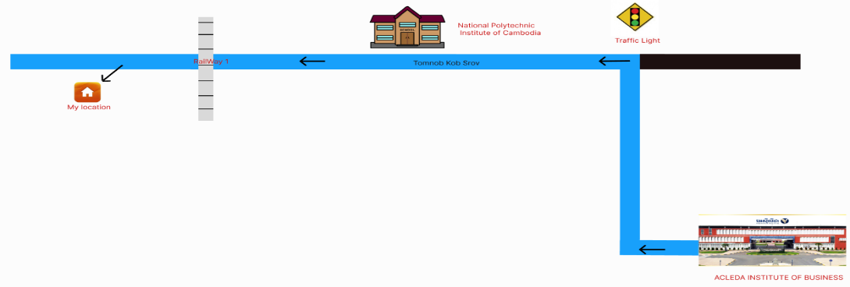


APPLICANT'S CERTIFICATION


I hereby certify that all the information provided in this application and attached documents is true, complete and correct to the best of my knowledge. I understand that any false information and misrepresentations are discovered, my application may be rejected and, if I am employed, my employment contract may be terminated with no conditions.

Signature of Applicant Thumbprint of Applicant Date

Note: - This application and attached documents are not returned.
- Sample application is available at www.acleda-aib.edu.kh.

FOR OFFICE USE ONLY

Received by Mr. / Ms. ..............................................Branch ....................Signature.............................Date..........................

Short-listed by Mr. / Ms. ............................................................................Signature..............................Date.........................

