PATTERN RECOGNITION ASSIGNMENT-1
REPORT

GROUP -3
NEHA MUTHIYAN (B14113)
SIDDHANT KUMAR (B14133)

in the guidance of
Dr. A.D Dileep
(Asst. Professor)
School of Computing and Electrical Engineering
September 2016

TABLE OF CONTENTS

AIM

EXPERIMENTAL OBSERVATIONS
Bayes Classifier

Dataset 1(a) : Linearly Separable data: (LS_Group3)

Classifier 1:
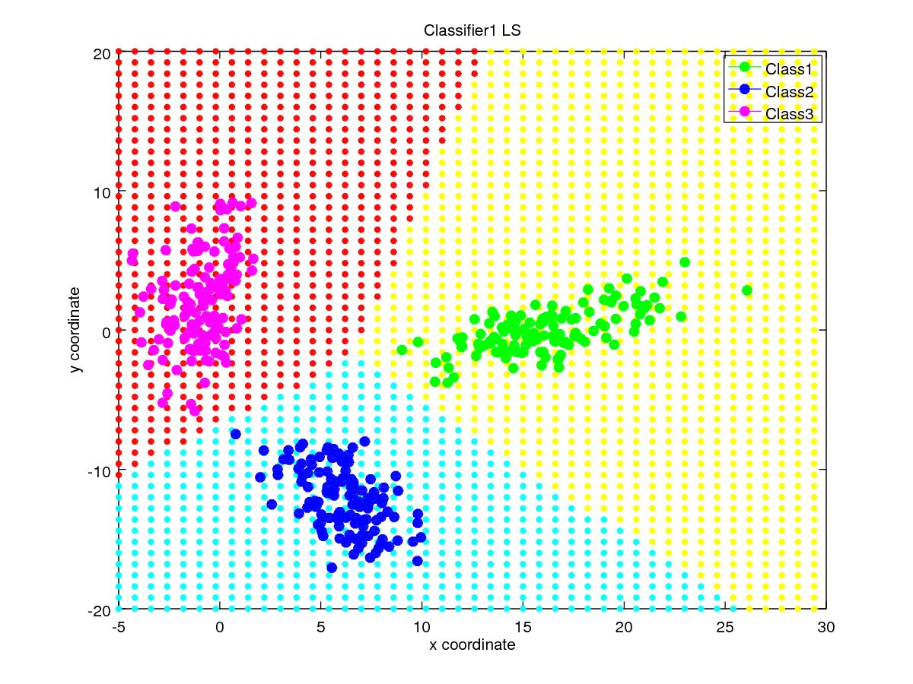
Classifiaction Accuracy (%) | 100%
Precision for Class1  Precision for Class2  Precision for Class3 | 1  1  1
Mean Precision | 1
Recall for Class1  Recall for Class2  Recall for Class3 | 1  1  1
Mean Recall | 1
F-measure for Class1  F-measure for Class2  F-measure for Class3 | 1  1  1
Mean F-measure | 1

Confusion Matrix :

Classifier 2:
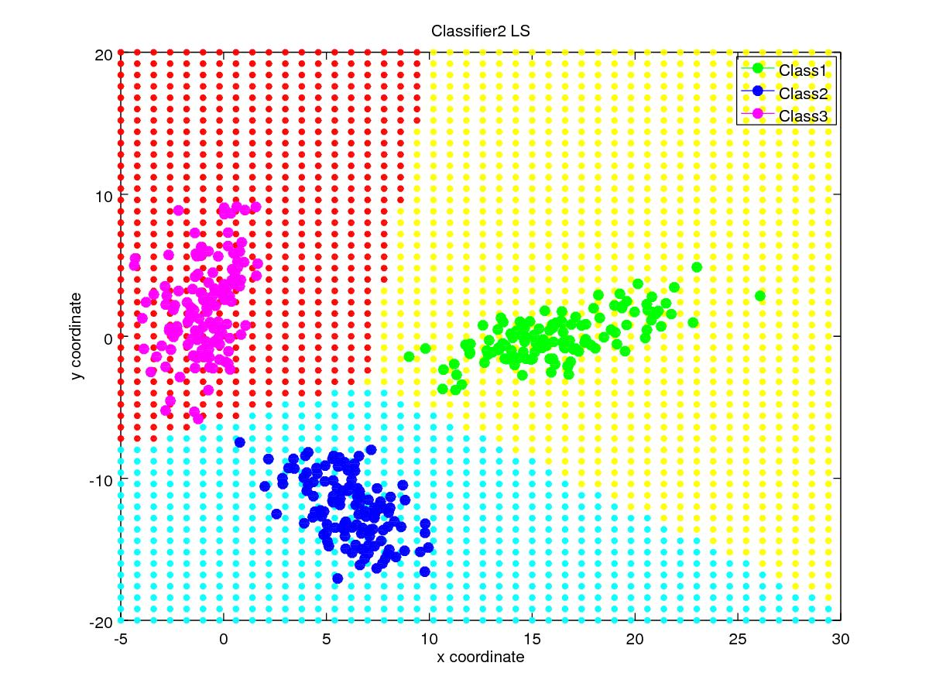
Classifiaction Accuracy | 100%
Precision for Class1  Precision for Class2  Precision for Class3 | 1  1  1
Mean Precision | 1
Recall for Class1  Recall for Class2  Recall for Class3 | 1  1  1
Mean Recall | 1
F-measure for Class1  F-measure for Class2  F-measure for Class3 | 1  1  1
Mean F-measure | 1

Confusion Matrix:

Classifier 3:
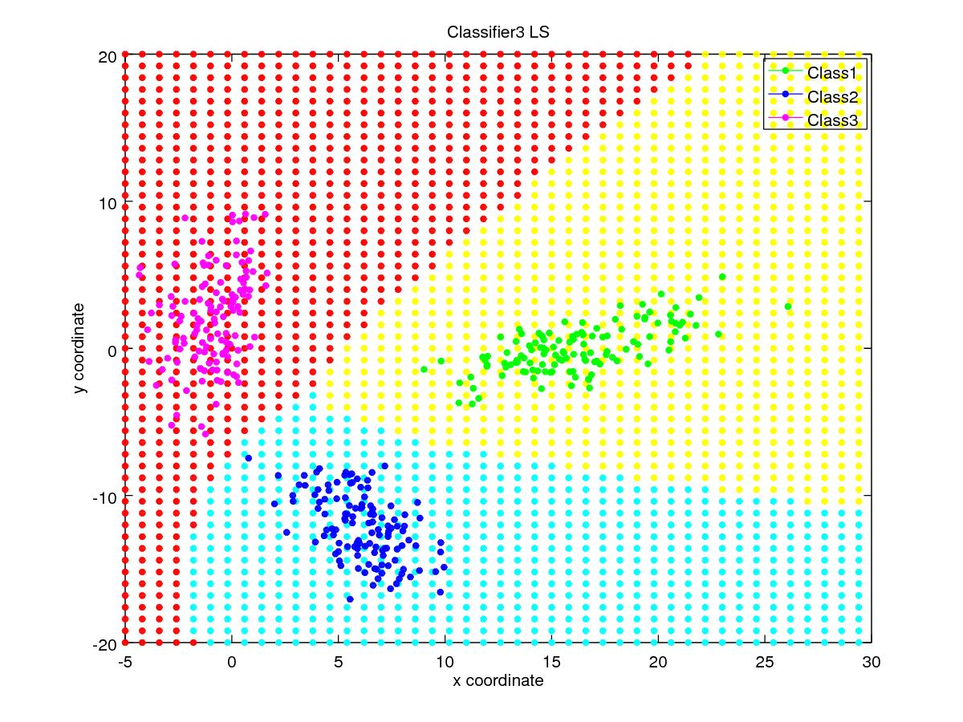
Classifiaction Accuracy (%) | 100%
Precision for Class1  Precision for Class2  Precision for Class3 | 1  1  1
Mean Precision | 1
Recall for Class1  Recall for Class2  Recall for Class3 | 1  1  1
Mean Recall | 1
F-measure for Class1  F-measure for Class2  F-measure for Class3 | 1  1  1
Mean F-measure | 1

Confusion Matrix :

Dataset 1(b) : Interlock

Classifier 1:
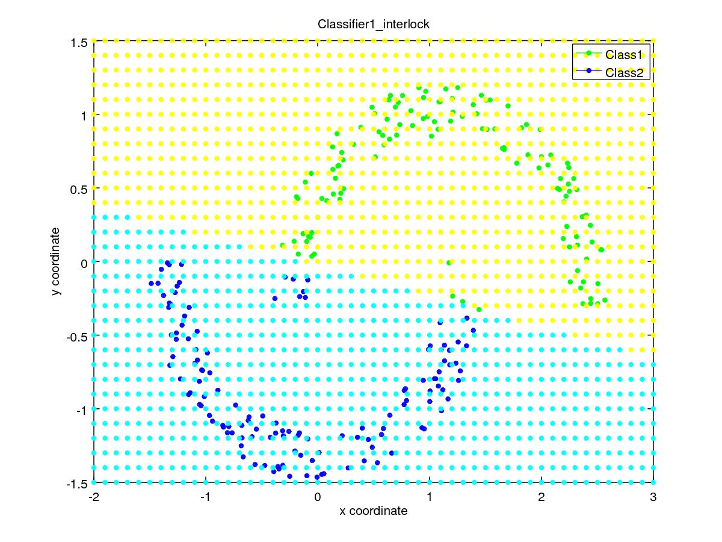
Classifiaction Accuracy (%) | 95.6 %
Precision for Class1  Precision for Class2 | 0.9672  0.9453
Mean Precision | 0.9562
Recall for Class1  Recall for Class2 | 0.944  0.968
Mean Recall | 0.956
F-measure for Class1  F-measure for Class2 | 0.9554  0.9565
Mean F-measure | 0.95595

Confusion Matrix :

Classifier 2:
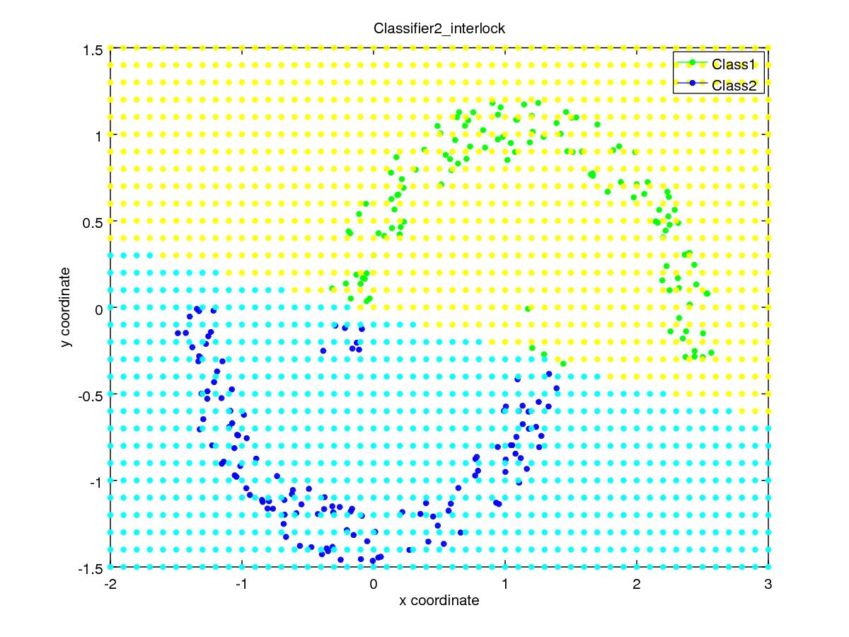
Classifiaction Accuracy | 95.6 %
Precision for Class1  Precision for Class2 | 0.9672  0.9453
Mean Precision | 0.9562
Recall for Class1  Recall for Class2 | 0.944  0.968
Mean Recall | 0.956
F-measure for Class1  F-measure for Class2 | 0.9554  0.9565
Mean F-measure | 0.95595

Confusion Matrix :

Classifier 3:
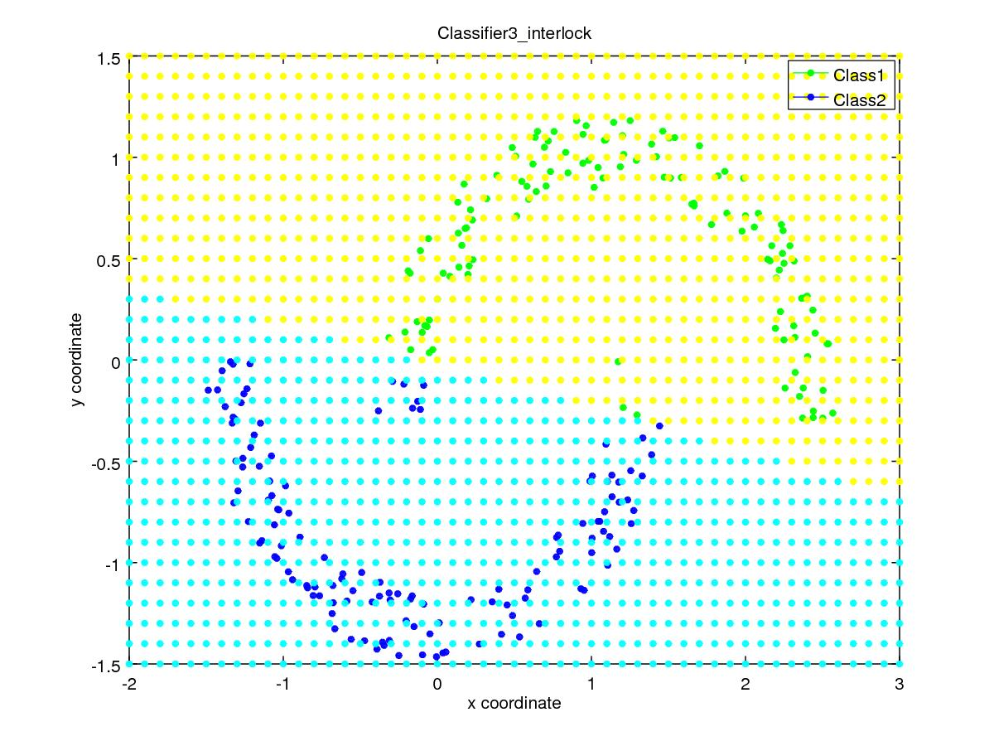
Classifiaction Accuracy (%) | 96 %
Precision for Class1  Precision for Class2 | 0.975  0.946
Mean Precision | 0.960
Recall for Class1  Recall for Class2 | 0.944  0.976
Mean Recall | 0.96
F-measure for Class1  F-measure for Class2 | 0.959  0.9606
Mean F-measure | 0.9598

Confusion Matrix :

Dataset 1(b) : Ring

Classifier 1:
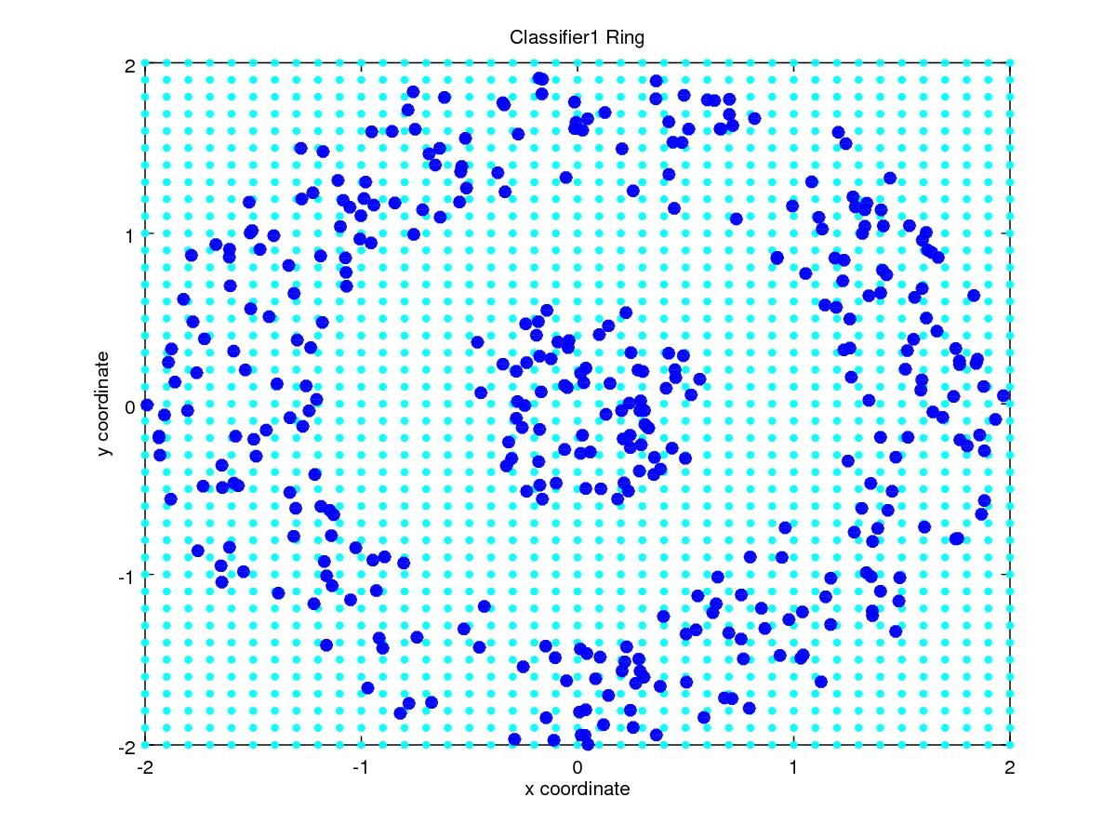
Classifiaction Accuracy
Precision for Class1
Precision for Class2
Mean Precision
Recall for Class1
Recall for Class2
Mean Recall
F-measure for Class1
F-measure for Class2
Mean F-measure

Confusion Matrix :

Classifier 2:
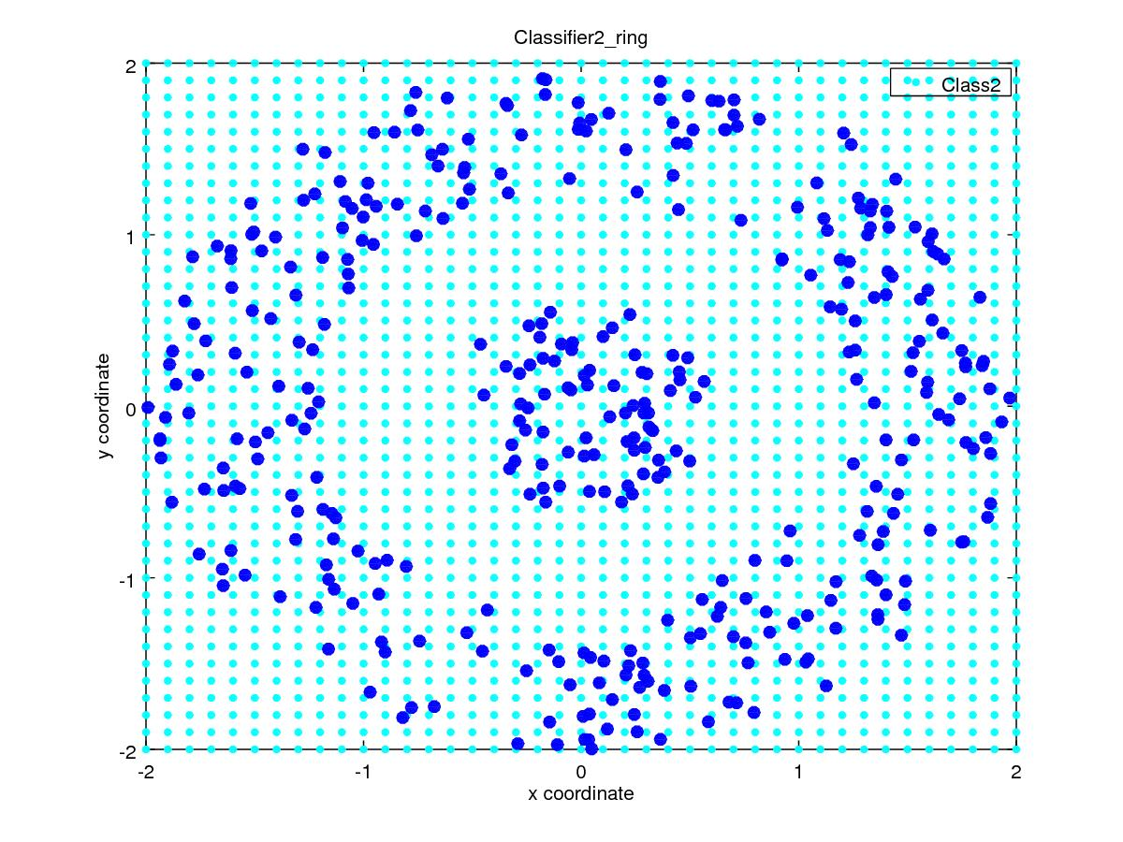
Classifiaction Accuracy
Precision for Class1
Precision for Class2
Mean Precision
Recall for Class1
Recall for Class2
Mean Recall
F-measure for Class1
F-measure for Class2
Mean F-measure
Confusion Matrix :

Classifier 3:
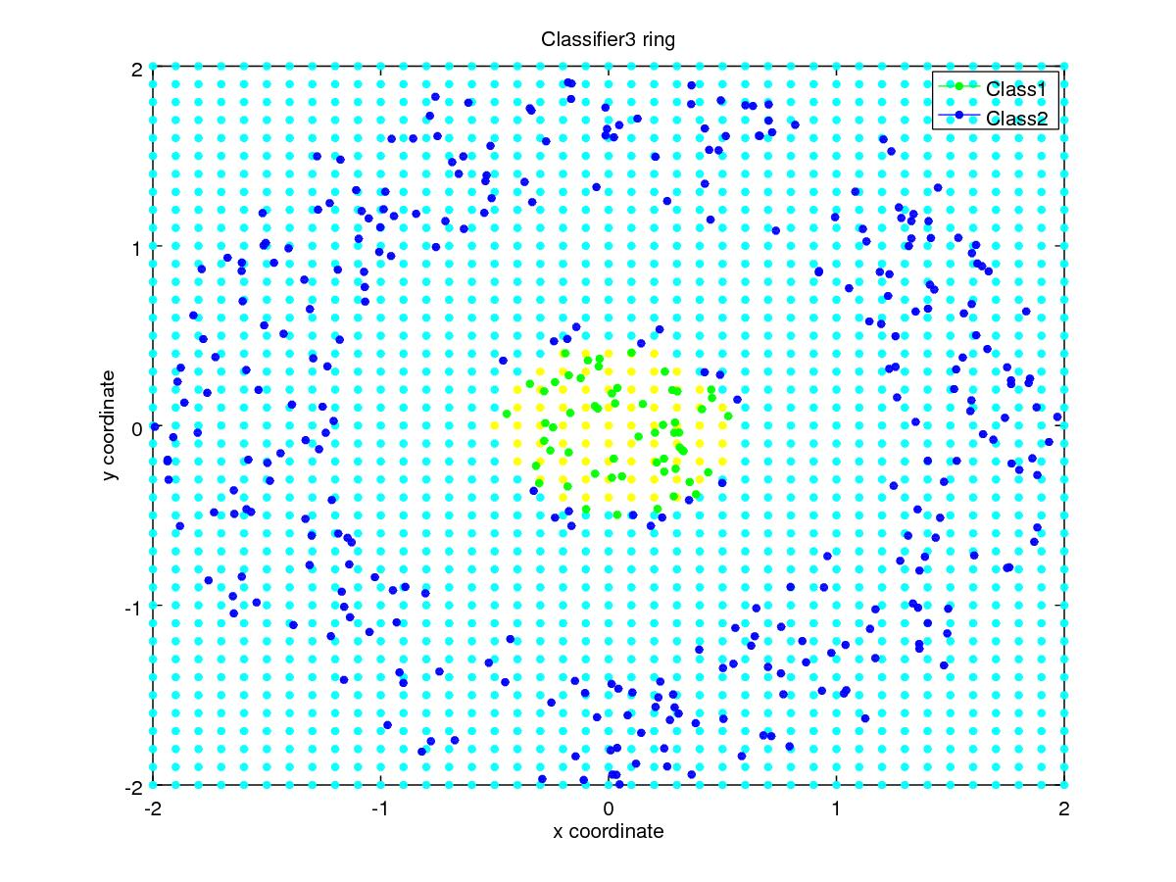

Classifiaction Accuracy
Precision for Class1
Precision for Class2
Mean Precision
Recall for Class1
Recall for Class2
Mean Recall
F-measure for Class1
F-measure for Class2
Mean F-measure

Confusion Matrix :

Dataset 1(b) : Spiral

Classifier 1:
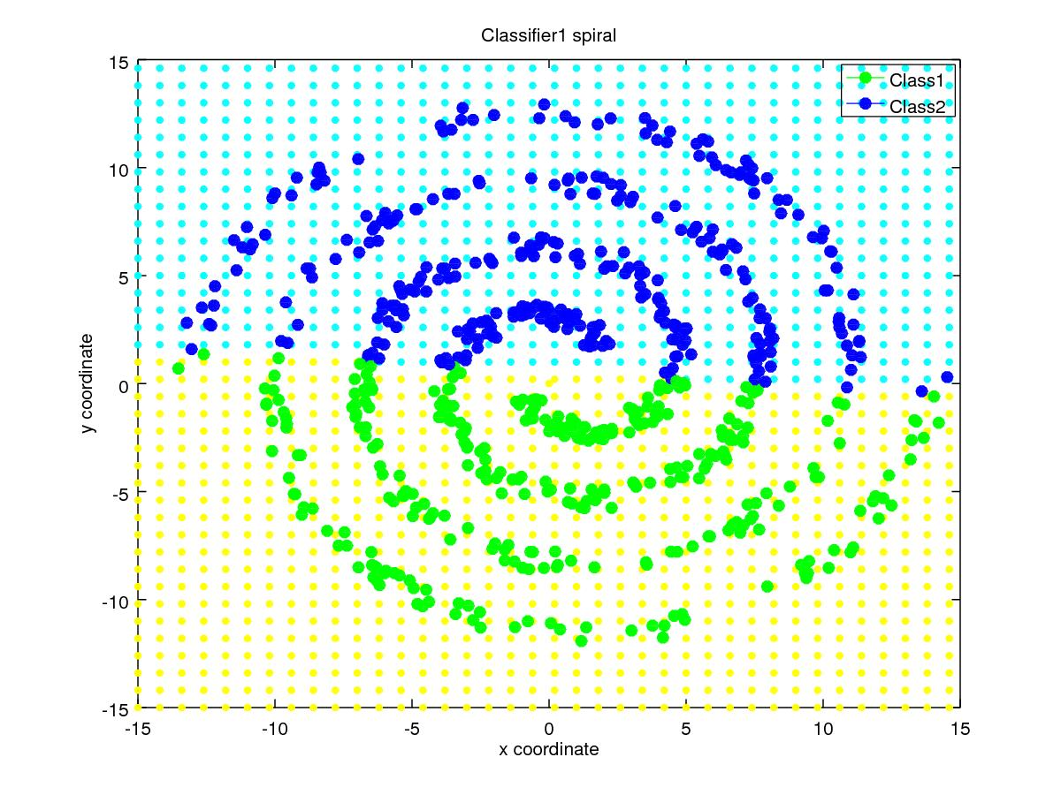

Classifiaction Accuracy (%) | 53.7 %
Precision for Class1  Precision for Class2 | 0.537  0.537
Mean Precision | 0.537
Recall for Class1  Recall for Class2 | 0.537  0.537
Mean Recall | 0.537
F-measure for Class1  F-measure for Class2 | 0.537  0.537
Mean F-measure | 0.537

Confusion Matrix :

Classifier 2:
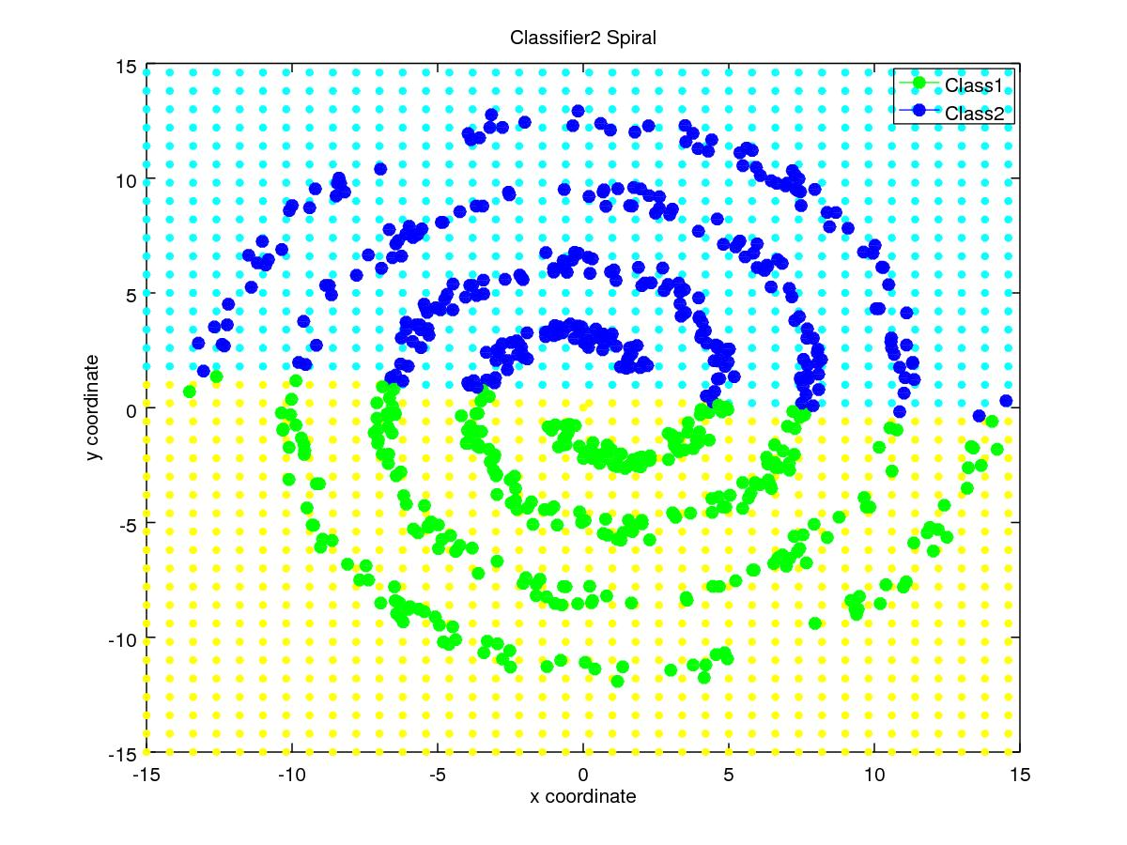
Classifiaction Accuracy | 53.7 %
Precision for Class1  Precision for Class2 | 0.537  0.537
Mean Precision | 0.537
Recall for Class1  Recall for Class2 | 0.537  0.537
Mean Recall | 0.537
F-measure for Class1  F-measure for Class2 | 0.537  0.537
Mean F-measure | 0.537
Confusion Matrix :

Classifier 3:
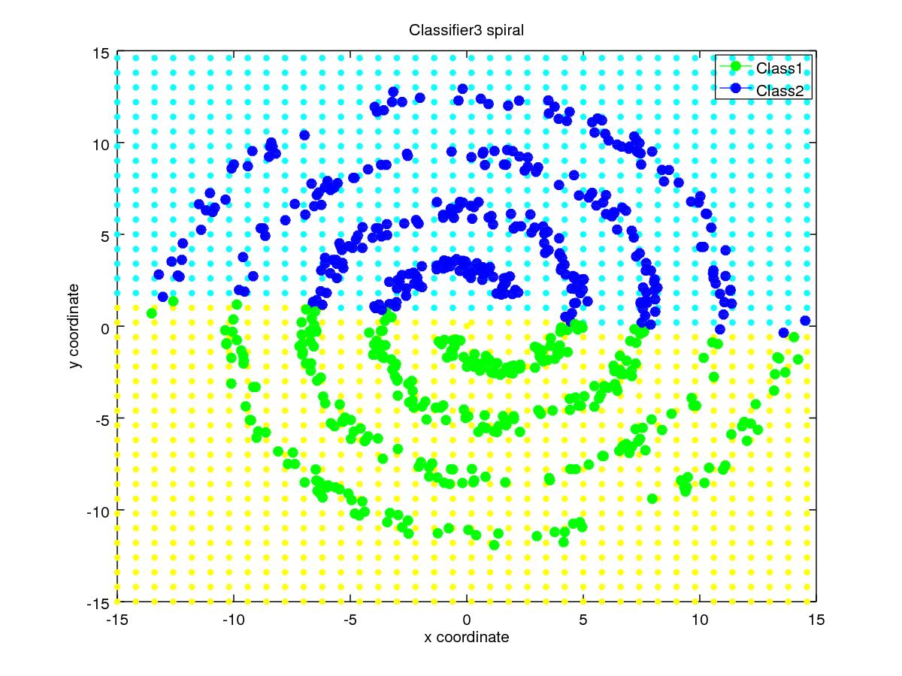
Classifiaction Accuracy | 53.7 %
Precision for Class1  Precision for Class2 | 0.537  0.537
Mean Precision | 0.537
Recall for Class1  Recall for Class2 | 0.537  0.537
Mean Recall | 0.537
F-measure for Class1  F-measure for Class2 | 0.537  0.537
Mean F-measure | 0.537

Confusion Matrix :

Dataset 1(c) : Overlapping Data Set

Classifier 1:
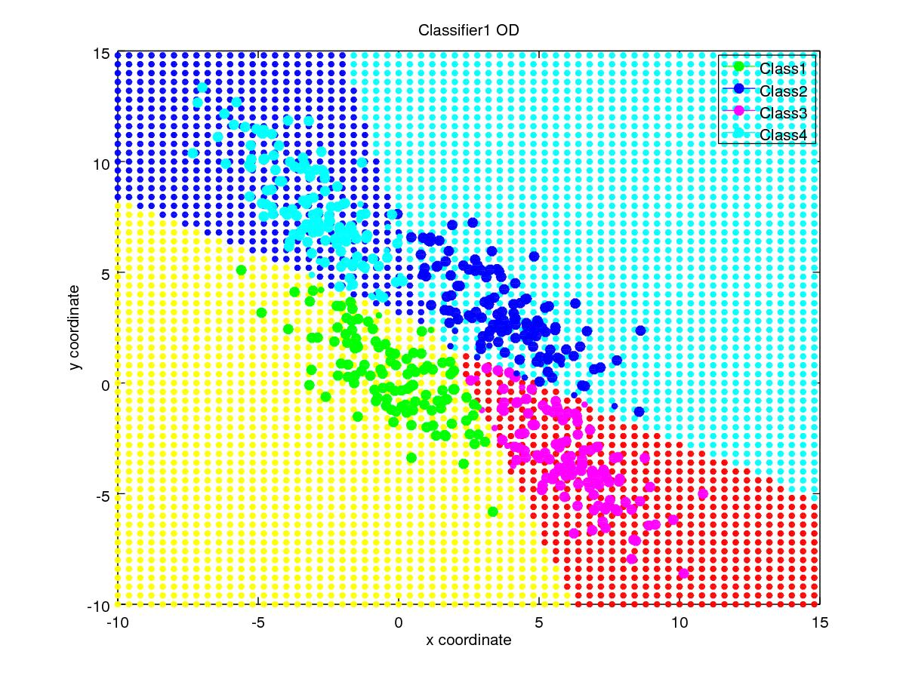
Classifiaction Accuracy (%) | 92.4 %
Precision for Class1  Precision for Class2  Precision for Class3  Precision for Class4 | 0.958  0.906  0.934  0.902
Mean Precision | 0.925
Recall for Class1  Recall for Class2  Recall for Class3  Recall for Class4 | 0.904  0.928  0.904  0.96
Mean Recall | 0.924
F-measure for Class1  F-measure for Class2  F-measure for Class3  F-measure for Class4 | 0.930  0.917  0.919  0.930
Mean F-measure | 0.924

Confusion Matrix :

Classifier 2:
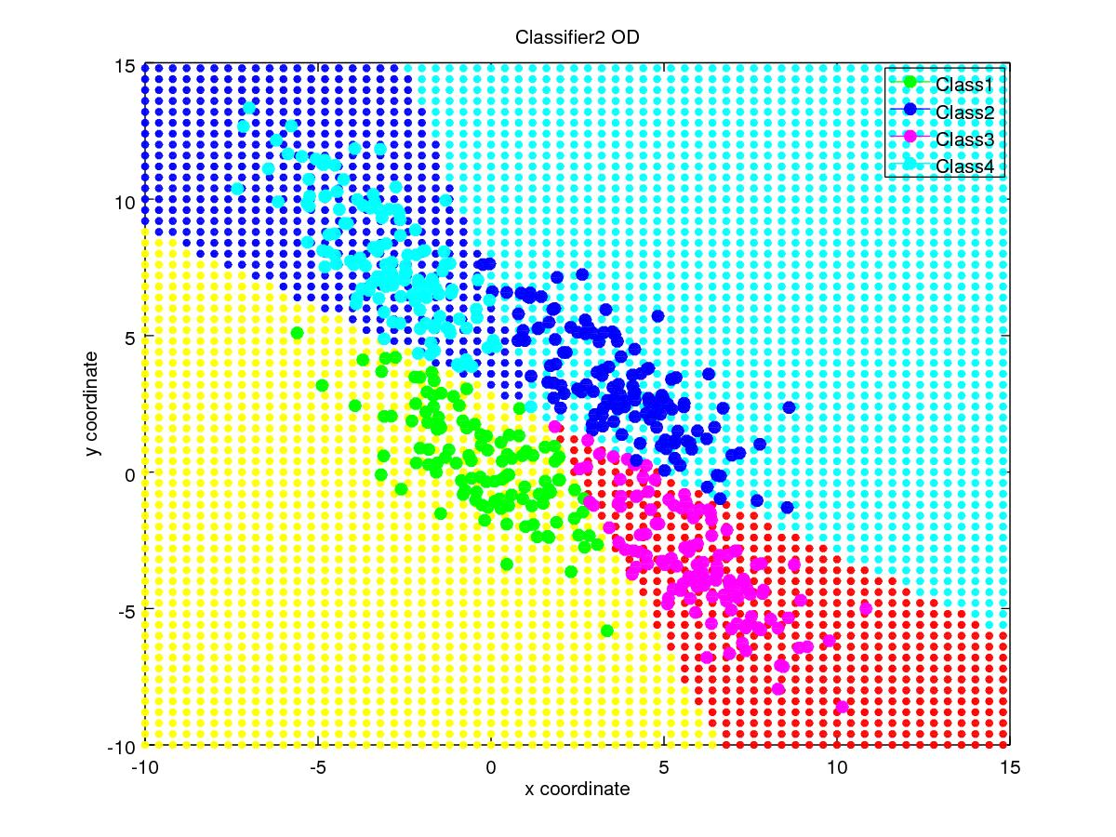
Classifiaction Accuracy (%) | 93.6 %
Precision for Class1  Precision for Class2  Precision for Class3  Precision for Class4 | 0.974  0.921  0.943  0.909
Mean Precision | 0.937
Recall for Class1  Recall for Class2  Recall for Class3  Recall for Class4 | 0.904  0.944  0.936  0.96
Mean Recall | 0.936
F-measure for Class1  F-measure for Class2  F-measure for Class3  F-measure for Class4 | 0.938  0.932  0.939  0.934
Mean F-measure | 0.936

Confusion Matrix :

Classifier 3:
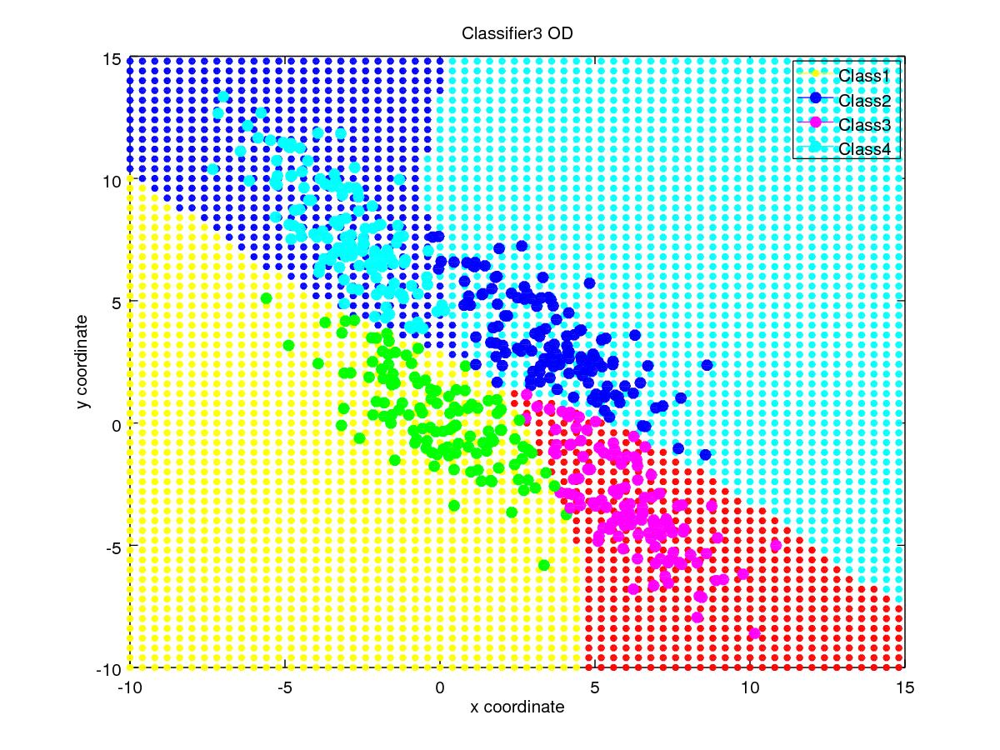
Classifiaction Accuracy (%) | 93 %
Precision for Class1  Precision for Class2  Precision for Class3  Precision for Class4 | 0.951  0.913  0.950  0.908
Mean Precision | 0.931
Recall for Class1  Recall for Class2  Recall for Class3  Recall for Class4 | 0.928  0.928  0.92  0.944
Mean Recall | 0.93
F-measure for Class1  F-measure for Class2  F-measure for Class3  F-measure for Class4 | 0.939  0.920  0.935  0.926
Mean F-measure | 0.93

Confusion Matrix :

Dataset 2 : Real Data Set

Classifier 1:
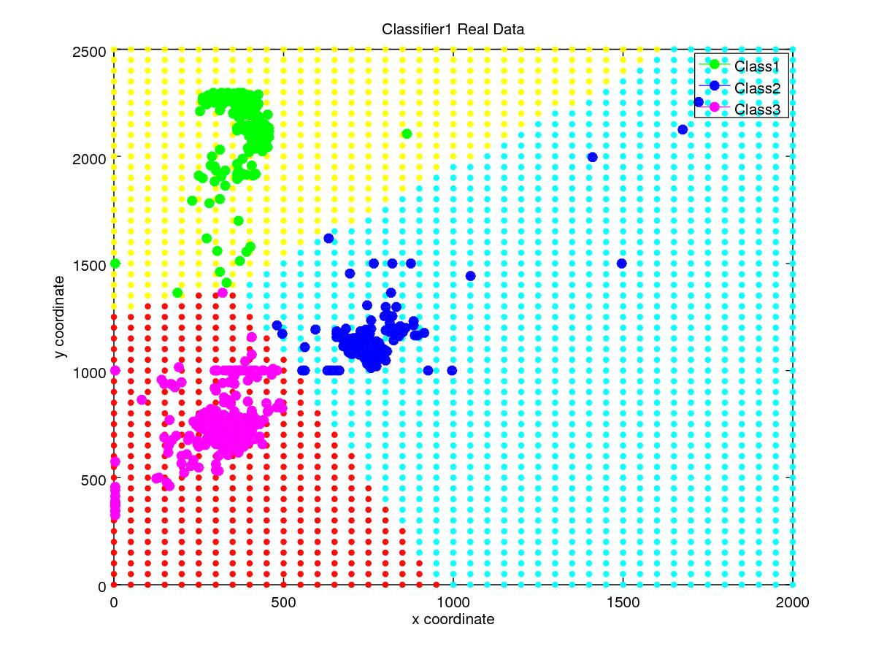
Classifiaction Accuracy (%) | 96.6 %
Precision for Class1  Precision for Class2  Precision for Class3 | 0.998  0.975  0.933
Mean Precision | 0.969
Recall for Class1  Recall for Class2  Recall for Class3 | 0.965  0.946  0.985
Mean Recall | 0.9653
F-measure for Class1  F-measure for Class2  F-measure for Class3 | 0.981  0.960  0.958
Mean F-measure | 0.966

Confusion Matrix :

Classifier 2:
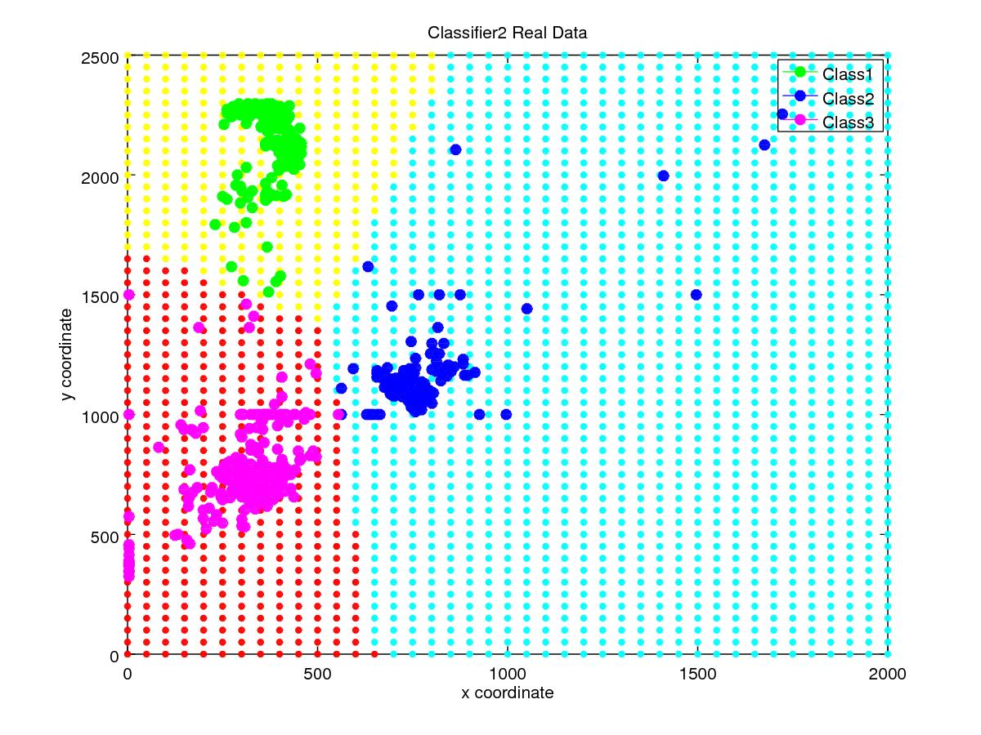
Classifiaction Accuracy (%) | 96.4 %
Precision for Class1  Precision for Class2  Precision for Class3 | 1  0.975  0.925
Mean Precision | 0.967
Recall for Class1  Recall for Class2  Recall for Class3 | 0.958  0.943  0.987
Mean Recall | 0.963
F-measure for Class1  F-measure for Class2  F-measure for Class3 | 0.978  0.959  0.955
Mean F-measure | 0.964

Confusion Matrix :

Classifier 3:
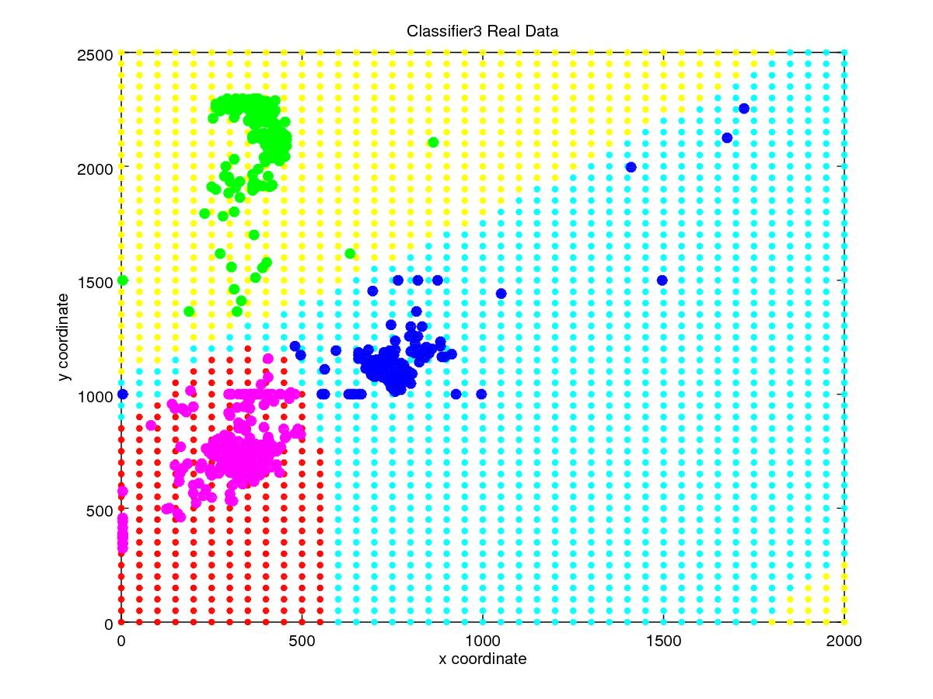
Classifiaction Accuracy (%) | 96.7 %
Precision for Class1  Precision for Class2  Precision for Class3 | 0.998  0.973  0.934
Mean Precision | 0.968
Recall for Class1  Recall for Class2  Recall for Class3 | 0.969  0.946  0.982
Mean Recall | 0.967
F-measure for Class1  F-measure for Class2  F-measure for Class3 | 0.983  0.959  0.957
Mean F-measure | 0.966

Confusion Matrix :

