PATTERN RECOGNITION ASSIGNMENT-2
REPORT
Bayes Classifier with Gaussian Mixture Model

9th October 2016

GROUP -3

NEHA MUTHIYAN SIDDHANT KUMAR
B14113 B14133
muthiyan_neha@students.iitmandi.ac.in siddhant_kumar@students.iitmandi.ac.in

in the guidance of
Dr. A.D Dileep
(Asst. Professor)
School of Computing and Electrical Engineering
Indian Institute of Technology, Mandi

Introduction

Gausian Mixture Model:

A Gaussian Mixture Model (GMM) is a parametric probability density function represented as a weighted sum of Gaussian component densities. GMM parameters are estimated from training data using the iterative Expectation-Maximization (EM) algorithm.
Unlike Bayes classification model, in GMM every class is assumed to have multiple gaussian clusters.

Let class C_{i} have K gaussian clusters then the probability of x given class C_{i} is,

p(x | C_{i}) = Σ_{k=1:K} Π_{k} p_{k}(x | µ_{ik} , Σ_{ik})

Here,
Π_{k} : mixture coefficient of k^{th} cluster
p_{k}(x | µ_{ik} , Σ_{ik}) = N(x | µ_{ik} , Σ_{ik})

K means clustering:

K-means is one of the simplest unsupervised learning algorithms that solve the well known clustering problem. The procedure follows a simple and easy way to classify a given data set through certain number of clusters (assume k clusters) fixed apriori. The choice of K is purely experimental.
The decision boundary in K means clustering depends on the distance measure used. Incase of squared eucledian distance the decision is linear whereaas for mahalanobis distance the decision boundary hyperquadratic.

TABLE OF CONTENTS

- Declaration of Authorship...........................................................................4
- Acknowledgements....................................................................................5
- Experimental Observations
3.1 Bayes Classifier
i. Linearly Separable Data.................................................................6
ii. Interlock Data................................................................................13
iii. Ring Data......................................................................................19
iv. Spiral Data.....................................................................................25
v. OverLapping Data..........................................................................31
vi. Real Data.......................................................................................40

3.2 Naive Bayes Classifier
i. Linearly Separable Data................................................................47
ii. Interlock Data.................................................................................54
iii. Ring Data.......................................................................................60
iv. Spiral Data......................................................................................66
v. OverLapping Data..........................................................................72
vi. Real Data........................................................................................81

4. Additional graphs........................................................................................
5. Conclusion..................................................................................................88
6. References................................................................................................. 89

DECLARATION OF AUTHORSHIP

We hereby certify that the report is entirely our own original work except where otherwise stated.
Our work can be found at the following Github repository -
https://github.com/saytosid/PR

Name – Neha Muthiyan (B14113)
Siddhant Kumar (B14133)

Date – 8th September 2016

Acknowledgements

Every project is successful largely due to the effort of number of people who have always given their valuable advice or lent a helping hand. We sincerely appreciate the inspiration, support and guidance of all those people who have been instrumental in the completion of this assignment.
We are also grateful to our advisor Dr. A.D Dileep for his provision of expertise and
technical support. His superior knowledge and experience played a great role in the completion of this assignment.

EXPERIMENTAL OBSERVATIONS

Ring dataset
For K = 1 , K = 2 , K = 3
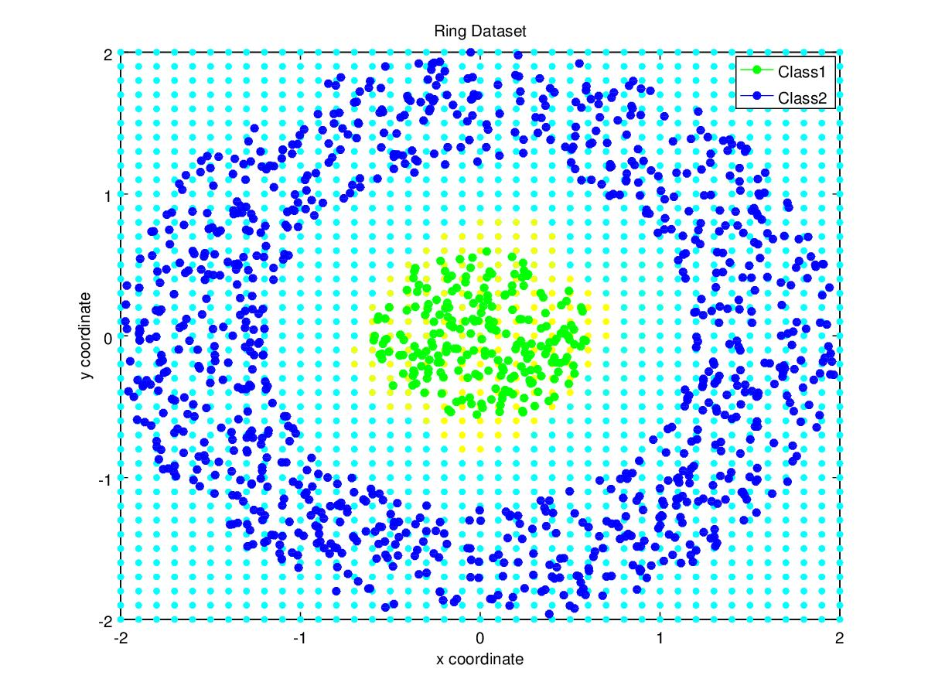
Classifiaction Accuracy (%) | 100%
Precision for Class1  Precision for Class2 | 1  1
Mean Precision | 1
Recall for Class1  Recall for Class2 | 1  1
Mean Recall | 1
F-measure for Class1  F-measure for Class2 | 1  1
Mean F-measure | 1

Confusion Matrix :
C =

Observations
- For K = 1 / 2 / 3 the classification accuracy is 100%, decision surface being a circle
- In previous assignment only Classifier 3 – different covariances for different classes could obtain 100% accuracy.

Spiral dataset
For K = 7
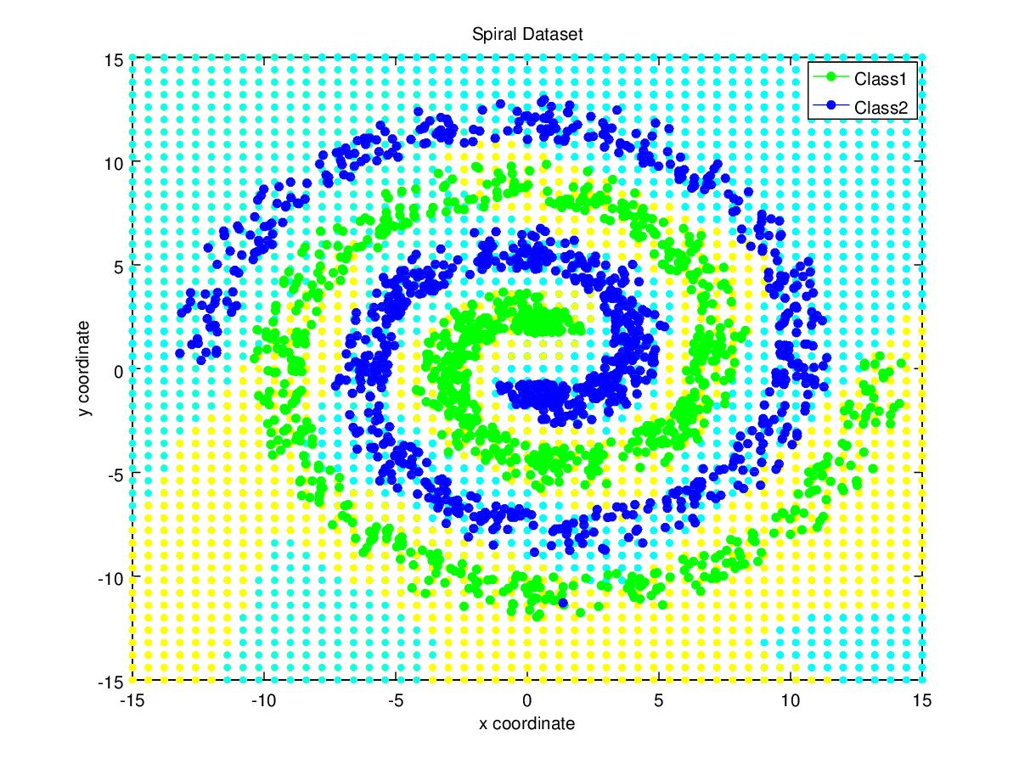
Classifiaction Accuracy (%) | 94.01%
Precision for Class1  Precision for Class2 | 0.9763  0.9111
Mean Precision | 0.9423
Recall for Class1  Recall for Class2 | 0.9049  0.9754
Mean Recall | 0.9401
F-measure for Class1  F-measure for Class2 | 0.9380  0.9422
Mean F-measure | 0.9401

Confusion Matrix :
C =

Graph of accuracy vs K

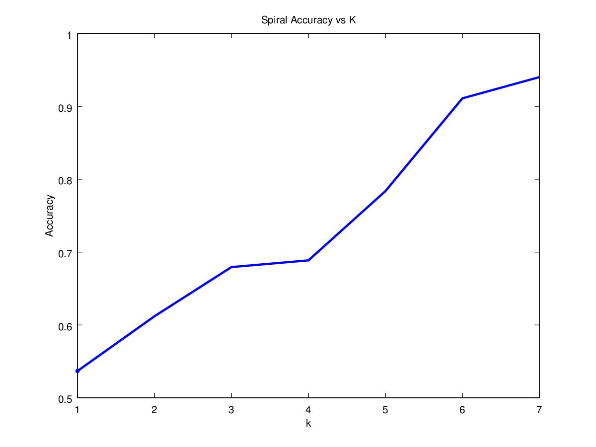

Observations
- From the above graph we observe, the accuracy value increases with K and the maximum accuracy obtained is 94.01%.
- The accuracy obtained in this case is far better than that obtained in Bayes Classifier(53.7%).
- Spiral Dataset requires a very complex decision boundary for classification. In GMM we assume every class as a cluster of gaussians which leads to a non linear complex decision boundary. This explains the vast difference in the accuracies obtained in Bayes classifier and GMM.

Interlock
For K = 2 / 3
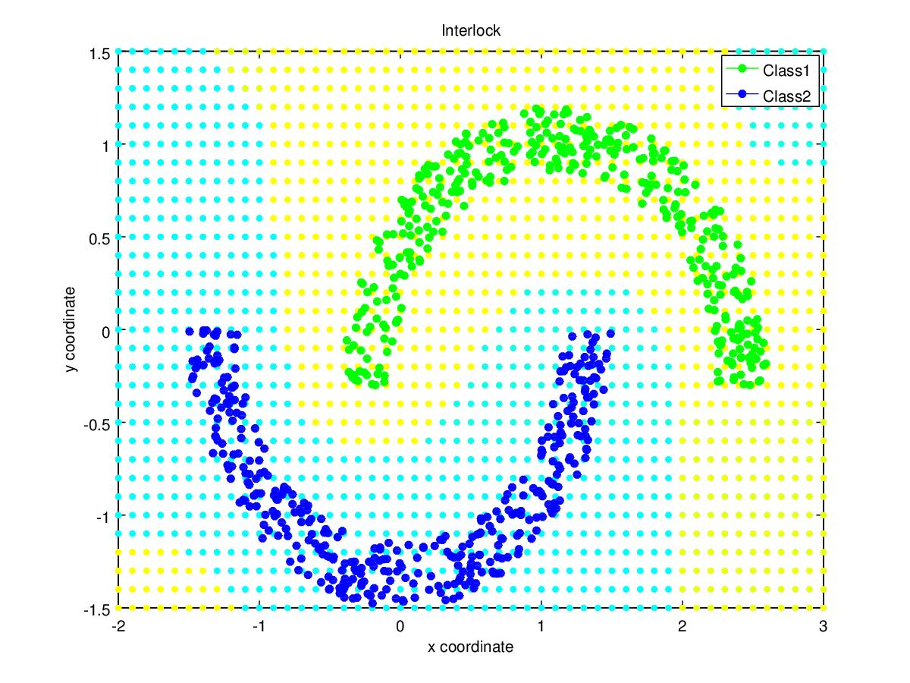
Classifiaction Accuracy (%) | 100%
Precision for Class1  Precision for Class2 | 1  1
Mean Precision | 1
Recall for Class1  Recall for Class2 | 1  1
Mean Recall | 1
F-measure for Class1  F-measure for Class2 | 1  1
Mean F-measure | 1

Confusion Matrix :
C =

Observations:
- Unlike Bayes classifier, Interlock dataset is correctly classified by GMM.

OverLapping Dataset
For k = 2

Classifiaction Accuracy (%) | 93.6%
Precision for Class1  Precision for Class2  Precision for Class3  Precision for Class4 | 0.9663  0.9280  0.9512  0.9375
Mean Precision | 0.9457
Recall for Class1  Recall for Class2  Recall for Class3  Recall for Class4 | 0.9200  0.9280  0.9360  0.9600
Mean Recall | 0.9360
F-measure for Class1  F-measure for Class2  F-measure for Class3  F-measure for Class4 | 0.9426  0.9280  0.9435  0.9486
Mean F-measure | 0.9406

Confusion Matrix :
C =

Graph of accuracy vs K
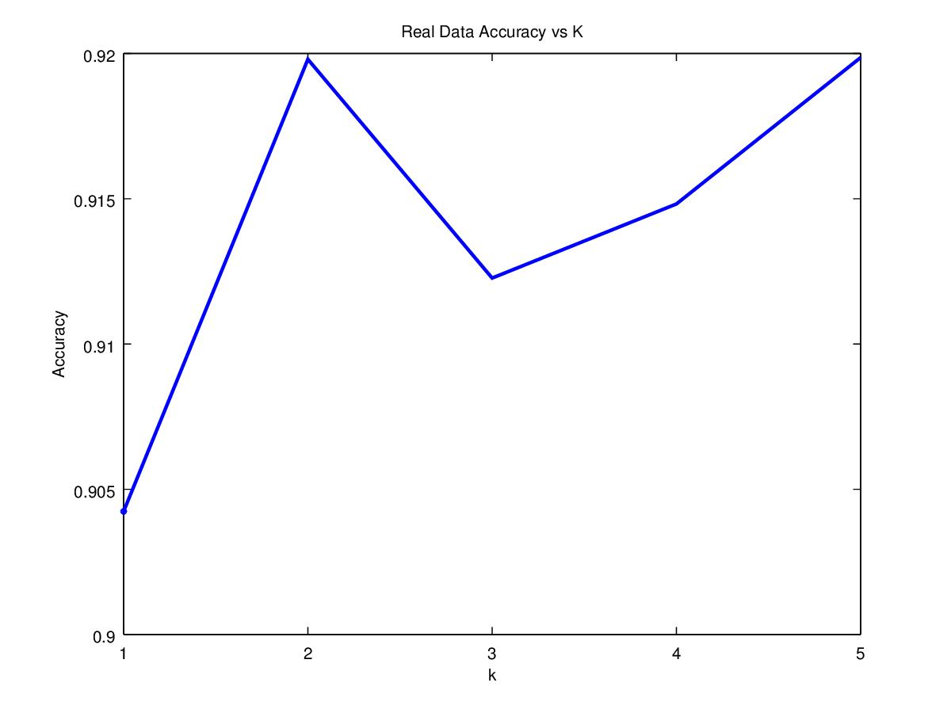

Observations:
- The classification accuracy increases till a particular K and decreases thereafter.
- The accuracy obtained for this dataset is less than that obtained in Bayes classifier.
Real Data set:
for k = 3

Classifiaction Accuracy (%) | 96.71%
Precision for Class1  Precision for Class2  Precision for Class3 | 0.9928  0.9715  0.9411
Mean Precision | 0.9685
Recall for Class1  Recall for Class2  Recall for Class3 | 0.9738  0.9482  0.9774
Mean Recall | 0.9665
F-measure for Class1  F-measure for Class2  F-measure for Class3 | 0.9832  0.9597  0.9589
Mean F-measure | 0.9673

Additional Graphs

Simulation of K means clustering for Ring Class1 data with K = 3

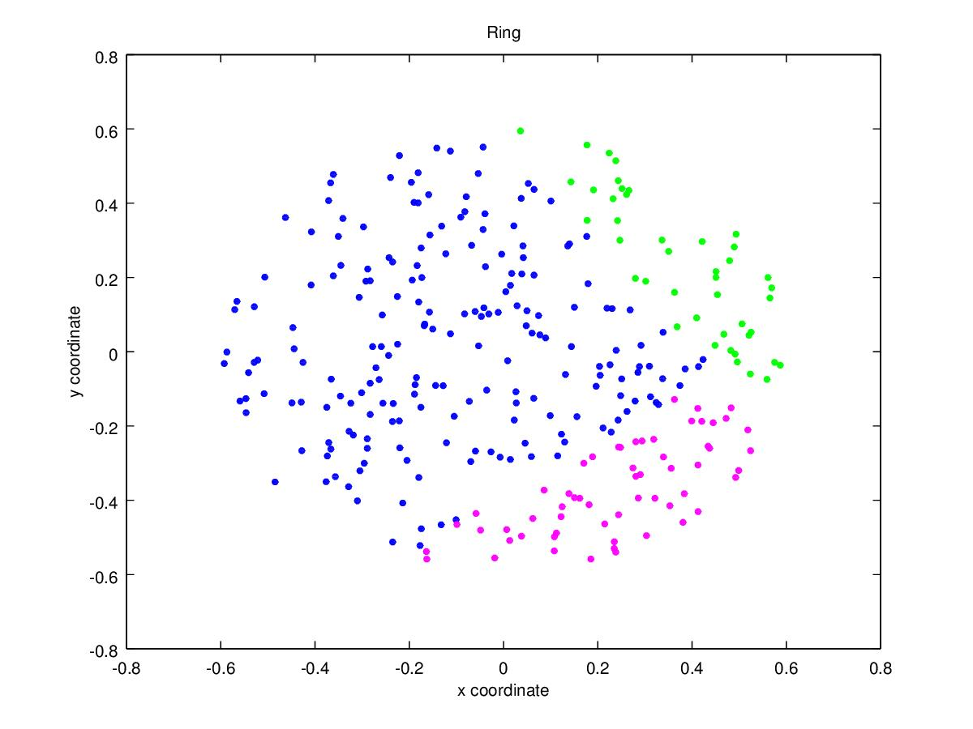
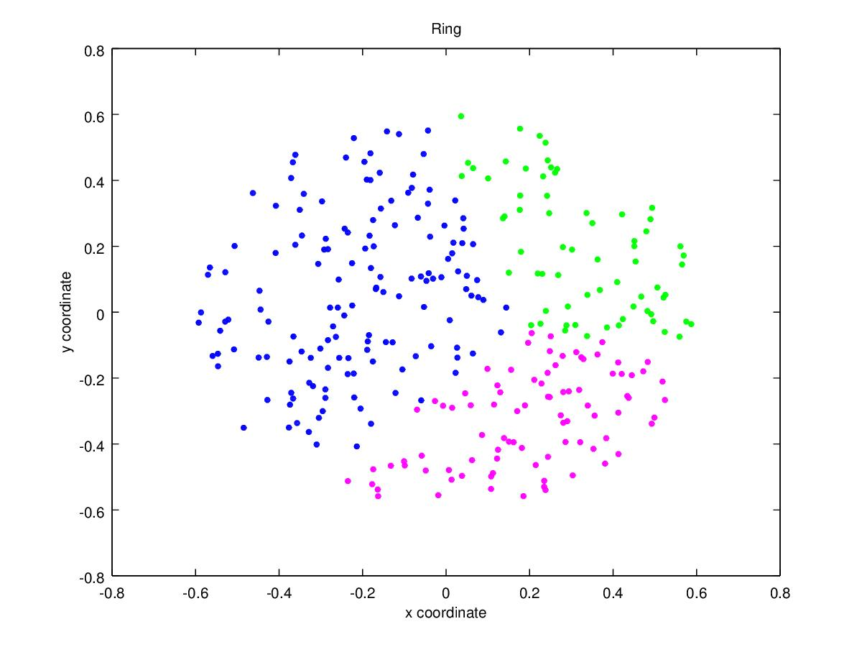
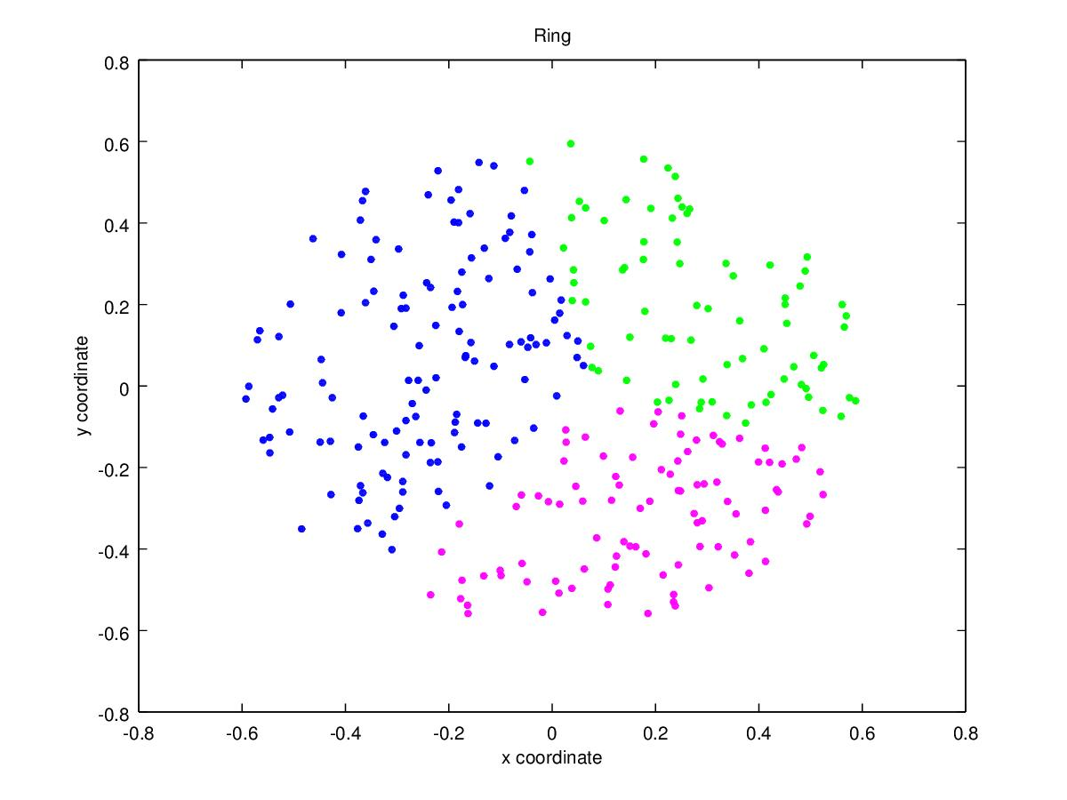
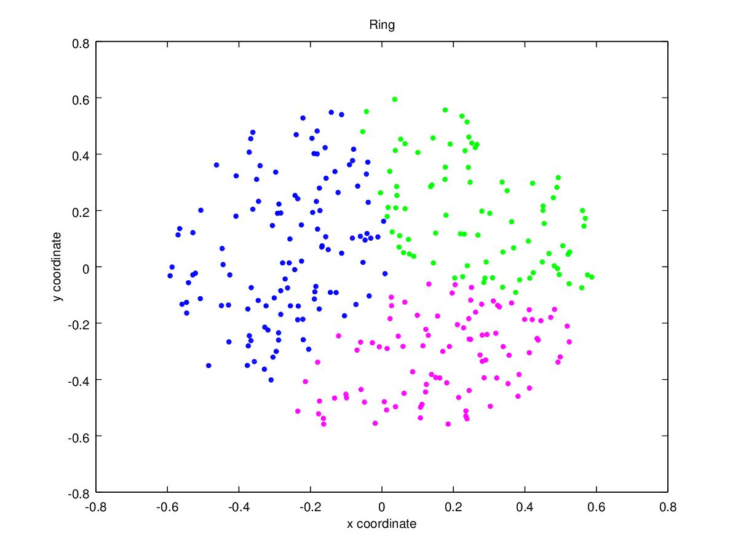
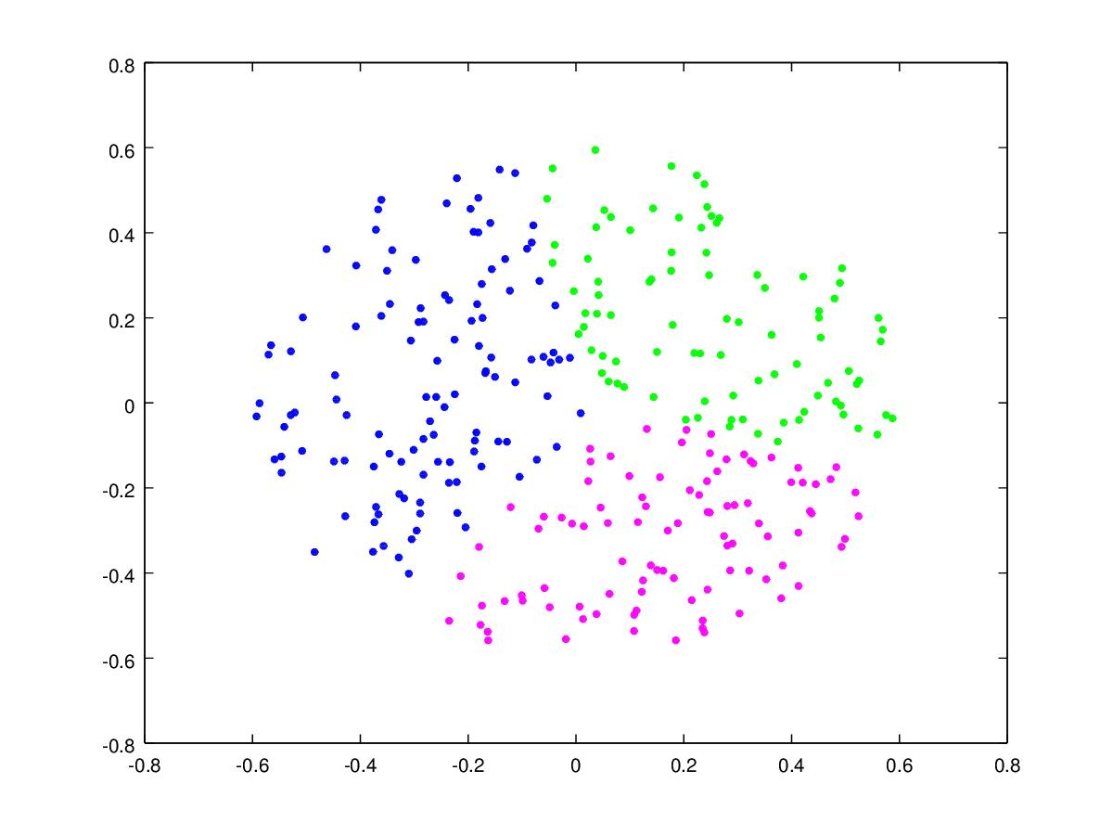

Observations :
- As the number of iterations increase, cluster assignment of the data points changes.
- The boundary between 2 clusters is linear in K means classification.

Graph of log likelihood vs number of iterations
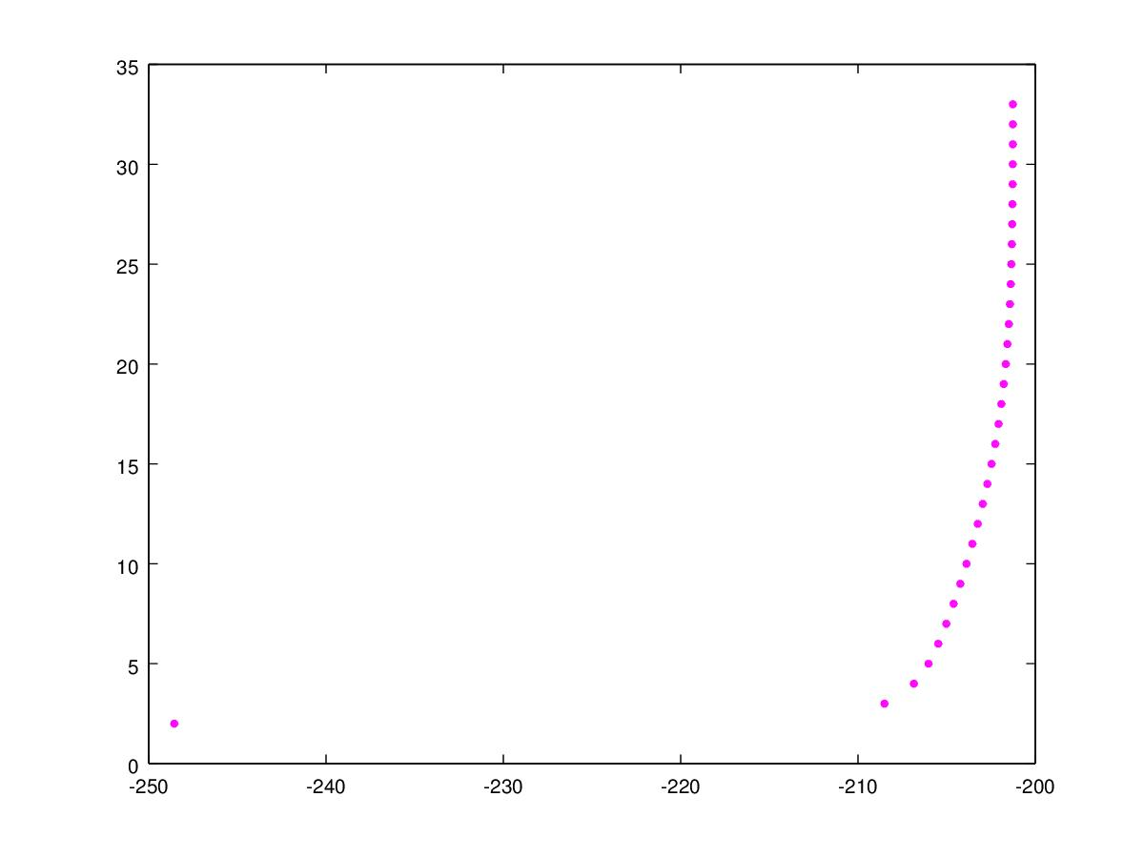

X axis – log likelihood
Y axis – number of iterations
Dataset - Interlock

References

- Pattern Classification, Duda, Hart, Stork

