NEAR-REAL TIME AI/ML BASED DNS THREAT DETECTION AND CONTEXTUAL THREAT INTELLIGENCE
Project Id: R-25-26J-066

Final Project Thesis

Gunasekara S G P I R
Student ID: IT22169662
Supervisor: Mr. Kavinga Yapa Abeywardena

B.Sc. (Hons) Degree in Information Technology Specializing in Cyber Security

Department of Information System Engineering

Sri Lanka Institute of Information Technology
Sri Lanka

April 2026

Declaration

Abstract

Acknowledgement

Table of Contents

Declaration i
Abstract ii
Acknowledgement iii
Table of Contents iv
List of Figures vi
List of Tables vi
List of Abbreviations vi
1. Introduction vii
1.1 Background and Context vii
1.2 DGA-Based Domains and DNS-Based C2 Communication vii
1.3 Literature Review viii
1.4 Research Gap ix
1.5 Research Problem x
1.6 Research Objectives xi
1.6.1 Main Objective xi
1.6.2 Specific Objectives xi
2. Methodology xii
2.1 High-Level System Overview xii
2.2 DGA-Based Domain and C2 Communication Detection Component Overview xiii
2.3 Data Collection and Dataset Preparation xiv
2.4 Feature Engineering and Data Representation xv
2.4.1 Character N-gram Extraction xvi
2.4.2 TF-IDF Representation xvi
2.5 DGA Detection Model Development xvii
2.5.1 Model Selection and Pipeline Architecture xvii
2.5.2 Probability Scoring and Thresholding xvii
2.5.3 Evaluation Metrics and Validation Approach xvii
2.6 Behavioural Rule Engine for C2 Communication Detection xviii
2.6.1 Candidate Filtering Mechanism xviii
2.6.2 Sliding-Window Detection Rules xix
2.6.3 Decision Fusion and Never-Downgrade Principle xix
2.7 Event Aggregation and Host-Level Analysis xx
2.7.1 Temporal Windowing and Filtering xx
2.7.2 Security Event Construction xx
2.7.3 Risk Scoring and Event Typing xx
2.8 Threat Intelligence Enrichment and Infrastructure Analysis xxi
2.8.1 Threat Intelligence Enrichment xxi
2.8.2 Bipartite C2 Infrastructure Graph xxi
2.8.3 Infrastructure Scoring and IP-to-IP Projection xxii
2.9 System Workflow and Implementation Design xxiii
2.9.1 Data Capture Layer (Endpoint) xxiii
2.9.2 Server-Side Analysis Workflow xxiv
3.0 Experimental Results and Evaluation xxv
4.0 Discussion - Challenges Faced, Limitations xxvi
5.0 Conclusion and Future Work xxviii
5.1. Comparison with Existing Approaches xxviii
REFERENCES xxix
APPENDICES xxx

List of Figures

List of Tables

List of Abbreviations

1. Introduction

1.1 Background and Context
The Domain Name System (DNS) is a core component of modern network communication, responsible for translating human-readable domain names into Internet Protocol (IP) addresses. Because DNS is required for almost all Internet-based services, it generates a large volume of continuous traffic from both user actions and background system processes.
Although DNS is essential, it was not originally designed with strong built-in security protections. In many enterprise environments, DNS traffic is still treated as trusted and allowed to pass with limited inspection. This creates a major blind spot in network security, where malicious activity can be hidden inside traffic that appears normal. Prior project material also highlights that attackers increasingly exploit DNS for tunneling, malware communication, infrastructure abuse, and other covert operations.
As DNS-based threats have evolved, traditional static defenses have become less effective. Signature-based and blacklist-based approaches often fail to detect newly generated domains, short-lived malicious infrastructure, and low-frequency behaviour that blends with legitimate traffic. This has increased the need for machine learning–based approaches that can analyse lexical, behavioural, and temporal characteristics directly from live DNS activity.
This research focuses on one such threat area: DGA-based domain detection and DNS-based command-and-control (C2) communication analysis. The work is part of the broader Real-Time Dns Threat Detection project, which follows a modular architecture with separate components for DNS tunneling, DGA/C2 detection, DNS abuse detection, and threat intelligence enrichment.

1.2 DGA-Based Domains and DNS-Based C2 Communication
Domain Generation Algorithms (DGAs) are used by malware to generate large numbers of pseudo-random domain names that can act as rendezvous points for attacker-controlled infrastructure. Instead of depending on one fixed domain, malware can continuously generate new domains, making static blocklists ineffective. This allows attackers to maintain resilient communication channels even when some domains are detected or taken down. The project overview describes this as a major weakness of traditional blacklist-based defenses.
DNS-based C2 communication adds another layer of difficulty. Malware communication over DNS is often designed to look similar to normal DNS activity. Queries may be low-frequency, spread over time, or hidden among legitimate requests. In some cases, malware also exhibits behavioural patterns such as repeated query bursts, high NXDOMAIN rates, or periodic beaconing, which are difficult to identify using lexical analysis alone. This is why the proposed system combines domain-level machine learning with host-level behavioural analysis.
In this research, the DGA and C2 component operates as a multi-layered detection pipeline. Its main analytical stages are:
- Domain preprocessing and lexical scoring
- Behavioural rule evaluation
- Decision fusion
- Event aggregation
- C2 infrastructure graph analysis
At the domain level, queried domains are represented using TF-IDF character n-grams and classified using Logistic Regression. The model outputs a probability score, p_dga, indicating how likely a queried domain is to be DGA-generated. At the behavioural level, sliding-window rules are used to identify host activity patterns associated with command-and-control communication. These outputs are then fused to generate operational verdicts and higher-level security events.
Failure to detect DGA-based domains and DNS-based C2 communication can allow malware to maintain persistent connectivity, evade basic reputation controls, and continue operating inside a network for extended periods. In practice, this can lead to:
- prolonged attacker persistence
- delayed incident detection and stealthy infrastructure coordination
- difficulty tracing related malicious domains and IPs
This makes early DNS-level detection valuable, especially in environments where DNS traffic is high-volume and continuously trusted. The project materials also emphasize that current solutions often lack real-time detection, alert reduction, and sufficient contextual support for investigation.

1.3 Literature Review
Recent research on DNS security has given strong attention to DGA-based domain detection and DNS-based command-and-control communication, since both are widely used by malware to maintain resilient communication channels. Domain Generation Algorithms allow malware to generate large numbers of pseudo-random domains, making blacklist-based defenses ineffective. As a result, many studies have explored machine learning–based methods for distinguishing algorithmically generated domains from legitimate domains. Common approaches include lexical analysis, character-level n-gram modelling, statistical feature extraction, and deep learning methods such as CNNs, RNNs, and BiLSTMs. Existing work shows that character-level analysis is especially useful because DGA domains often contain structural patterns that differ from benign domains.
Among the models used in prior work, Logistic Regression, XGBoost, and neural architectures have all shown effectiveness depending on the dataset and feature representation. However, the literature also shows that some DGA families, especially wordlist-based DGAs, are harder to detect because they resemble legitimate domains more closely. This means that although lexical machine learning methods are effective, they still require careful threshold selection and operational tuning.
Another important area is DNS-based C2 communication detection, where the focus extends beyond suspicious domains and considers host-level DNS behaviour over time. Prior studies show that malware C2 activity may appear through repeated query bursts, high NXDOMAIN rates, abnormal unique-domain activity, and periodic beaconing behaviour. These patterns are important because a domain may not always appear strongly suspicious on its own, but may become much more meaningful when analysed together with repeated failed lookups or regular timing behaviour.
Recent literature also supports hybrid detection approaches that combine machine learning with behavioural or rule-based analysis. This is particularly relevant for DGA and C2 detection, because machine learning can score suspicious domains while behavioural logic can reveal communication patterns associated with malware activity. Some studies also incorporate contextual enrichment such as infrastructure reputation, although this is generally used as a supporting layer rather than a primary detection mechanism.
Overall, the literature shows that DGA detection is mainly addressed through lexical domain analysis, while DNS-based C2 detection benefits from behavioural and temporal monitoring. It also suggests that combining machine learning with behavioural logic provides stronger practical value than relying on a single method alone. However, limitations still remain in integrating domain-level DGA detection with host-level C2 behavioural analysis in a near-real-time and operationally practical manner. These limitations motivate the research gap addressed in this study.

1.4 Research Gap
Although prior research has shown strong progress in DGA detection and DNS-based C2 communication analysis, several important gaps still remain. Many existing studies address only one part of the problem, either domain-level lexical detection or host-level behavioural detection, without combining both into a unified and operationally practical approach. In addition, a large portion of prior work is still evaluated in offline or controlled environments, which limits real-world applicability in live DNS monitoring scenarios.
Table 1: Research gaps identified in existing DGA and DNS-based C2 detection studies
Identified Gap | Limitation in Existing Work | Relevance to This Study
Isolated detection focus | Many studies focus only on DGA classification or only on C2 behaviour | This study combines domain-level DGA detection with host-level C2 behavioural analysis
Limited real-time applicability | A large portion of prior work is evaluated in offline or controlled environments | This study is designed for near-real-time DNS monitoring
Weak behavioural correlation | Suspicious domains are often not correlated with query bursts, NXDOMAIN concentration, or beaconing behaviour | This study includes rule-based behavioural correlation
Limited operational context | Many approaches provide classification only, with little support for investigation | This study includes event aggregation, enrichment, and infrastructure analysis

1.5 Research Problem
Malware increasingly uses DGAs and DNS-based C2 communication to maintain resilient and covert communication channels. A DGA allows malware to generate many pseudo-random domains, most of which fail to resolve, while one or a few active domains successfully connect the infected host to attacker-controlled infrastructure. This weakens static blacklist-based detection, since malicious domains can change continuously and blend with normal DNS activity.
In addition, DNS-based C2 communication is difficult to identify because suspicious activity is not always obvious from domain structure alone. Existing approaches often face the following problems:
- suspicious domains are detected without enough behavioural context
- suspicious behaviour is observed without strong domain-level evidence
- many methods are evaluated mainly in offline or controlled settings
As a result, practical detection in live enterprise DNS environments remains challenging, especially where traffic is high-volume, noisy, and continuously changing. Prior work also shows that behavioural indicators such as repeated lookups, NXDOMAIN concentration, abnormal unique-domain activity, and periodic beaconing are important, but are often analysed separately from DGA detection.
Therefore, the research problem addressed in this study is:
“ How can DGA-based malicious domains and DNS-based command-and-control communication be effectively detected in a near-real-time and operationally practical manner by combining domain-level machine learning analysis with host-level behavioural correlation? ”
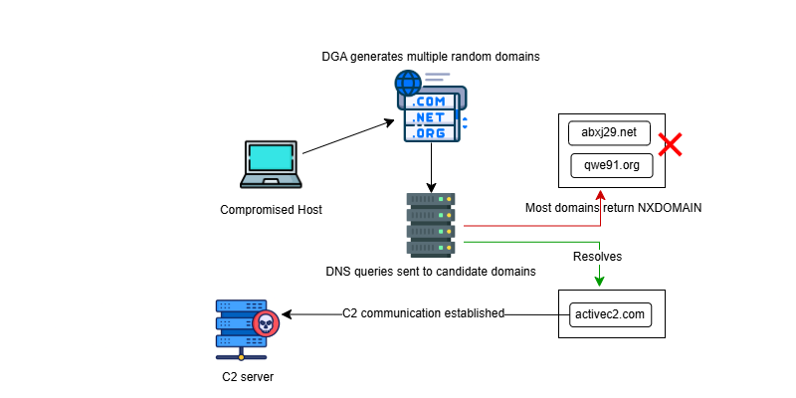
Figure 1: DGA and C2 communication flow

1.6 Research Objectives

1.6.1 Main Objective
To design and develop a near-real-time detection approach for identifying DGA-based malicious domains and DNS-based command-and-control communication using domain-level machine learning analysis and host-level behavioural correlation.

1.6.2 Specific Objectives
- To analyse lexical characteristics of queried domains for identifying algorithmically generated domains.
- To develop a machine learning–based DGA detection model using character-level domain representation.
- To identify suspicious DNS behavioural patterns associated with malware C2 communication, such as query bursts, NXDOMAIN concentration, abnormal unique-domain activity, and beaconing behaviour.
- To combine domain-level DGA scoring with host-level behavioural analysis to improve detection reliability.
- To aggregate query-level detections into higher-level host-based security events for reducing alert noise and improving interpretability.
- To enrich suspicious detections with contextual intelligence such as resolved IP reputation and infrastructure relationships.
- To evaluate the effectiveness of the proposed approach under near-real-time DNS monitoring conditions.

2. Methodology

2.1 High-Level System Overview
The proposed system is designed as a modular and pipeline-based approach for detecting DGA-based malicious domains and DNS-based command-and-control communication from live DNS traffic. It combines machine learning–based domain analysis with host-level behavioural correlation, allowing suspicious domains and suspicious DNS activity to be analysed together.
At a high level, the system begins with DNS traffic capture, where query and response information is collected and stored as raw logs. These records are then processed by a machine learning scoring stage, where queried domains are analysed using a TF-IDF and Logistic Regression model to produce a probability score indicating how likely a domain is to be DGA-generated.
After machine learning scoring, the system applies a behavioural rule engine over sliding time windows to identify suspicious host activity such as repeated query bursts, NXDOMAIN concentration, abnormal unique-domain activity, and periodic beaconing. The outputs of the machine learning stage and behavioural stage are then combined in a decision layer to produce an operational verdict. To reduce alert noise and improve interpretability, low-level detections are further grouped into event-level records based on host and time window.
Finally, the system performs contextual enrichment and infrastructure analysis. Resolved IPs associated with suspicious domains are checked against external sources such as VirusTotal and AbuseIPDB, while domain–IP relationships are used to support graph-based analysis of possible C2 infrastructure. In this way, the system supports both detection and investigation.
The major stages of the proposed system are:
- DNS traffic capture and preprocessing
- machine learning–based DGA scoring
- behavioural rule-based C2 analysis
- decision fusion and event aggregation
- threat intelligence enrichment and infrastructure analysis
Overall, the system is designed to support near-real-time detection, operational practicality, and improved analytical context for suspicious DGA-driven DNS activity.

Figure 2: Overall System Diagram

2.2 DGA-Based Domain and C2 Communication Detection Component Overview
The proposed component is designed to detect algorithmically generated domains and correlate them with DNS-based command-and-control communication behaviour in live DNS traffic. Instead of treating these as separate problems, it combines domain-level machine learning analysis with host-level behavioural detection, allowing suspicious domains to be interpreted together with suspicious communication patterns.
At a high level, the component operates as a multi-stage pipeline. DNS queries are first captured and normalised, then scored by a machine learning model that estimates the probability that a queried domain is DGA-generated. These scored records are then passed to a behavioural rule engine, which evaluates host activity over sliding time windows to identify patterns such as repeated query bursts, NXDOMAIN concentration, abnormal unique-domain activity, and periodic beaconing. The outputs are combined in a decision layer and later transformed into higher-level security events through aggregation. Suspicious events are further enriched with IP reputation and infrastructure context to support analysis.
The main functions of this component are:
- detect suspicious domains using lexical machine learning analysis
- identify behavioural DNS patterns linked to malware C2 activity
- combine domain-level and host-level evidence in a unified decision process
- reduce alert noise through event aggregation
- support investigation through enrichment and infrastructure analysis
A key design choice is the decoupled architecture, where DNS capture is separated from scoring, rule evaluation, aggregation, and enrichment. This improves scalability and makes the component more suitable for near-real-time monitoring in live environments.

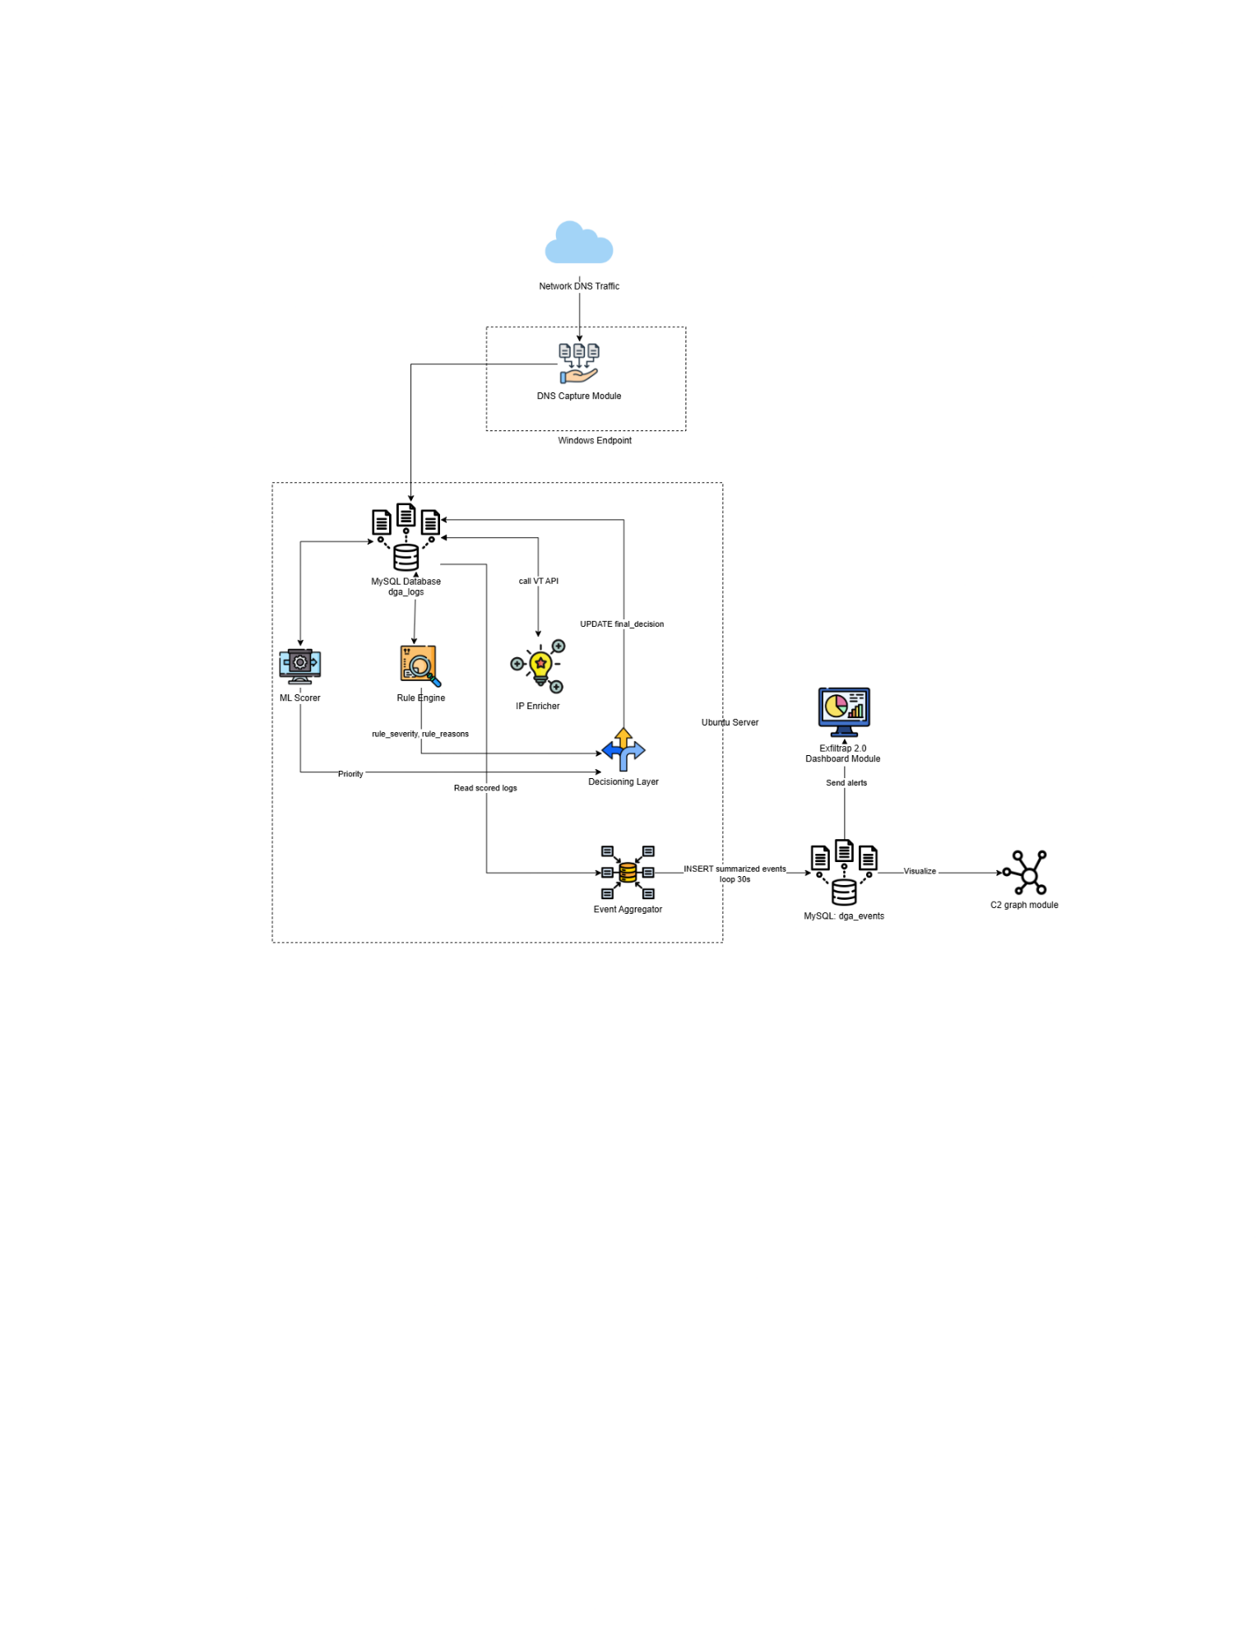
Figure 3: DGA-Based DNS and C2 Communication Detection System Architecture

2.3 Data Collection and Dataset Preparation
The data collection process supports both domain-level DGA detection and host-level C2 behavioural analysis. Since the component combines supervised machine learning with live DNS monitoring, it uses a publicly available labelled domain dataset together with captured DNS activity.
For DGA detection, the primary dataset is harpomaxx/dga-detection from HuggingFace. It contains both benign and DGA-generated domains collected from multiple public sources. The benign portion mainly comes from the Alexa Top 1 Million, together with 3,161 suspicious-but-legitimate domains from Bambenek Consulting. The malicious portion contains 1,915,335 DGA domains collected from Andrey Abakumov’s DGA repository and John Bambenek’s OSINT feeds, covering 51 malware families.
- The model development split is 70% training, 20% testing, and 10% validation.
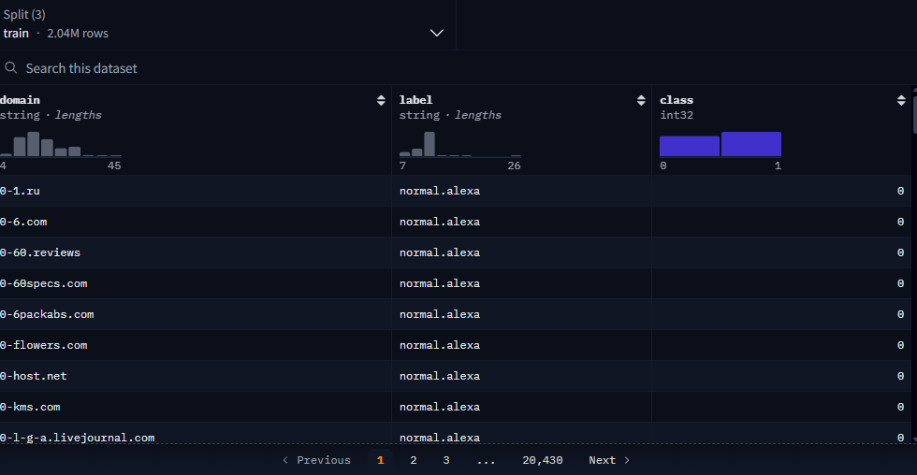
Figure 4: Sample of the DGA dataset
For behavioural C2 analysis, data comes from live DNS traffic capture rather than a separate labelled benchmark dataset. Query and response records are used to analyse host-level patterns such as query bursts, NXDOMAIN concentration, abnormal unique-domain activity, and periodic beaconing. This allows the behavioural stage to remain aligned with its intended live monitoring role.
Table 2: Dataset sources and preparation
Component | Source / Data Type | Purpose
Benign domains | Alexa Top 1 Million | Legitimate class for DGA model training
Suspicious-but-legitimate domains | Bambenek Consulting | Hard benign samples
DGA domains | Andrey Abakumov repository + John Bambenek OSINT feeds | Malicious class for supervised training
Live DNS traffic | Captured DNS queries and responses | Behavioural C2 analysis
Data split | 70% train, 20% test, 10% validation | Model development and evaluation

2.4 Feature Engineering and Data Representation
Machine learning models require numerical input. Therefore, raw domain strings must be transformed into a fixed-size numerical representation before classification. In the proposed system, this is achieved using character-level n-grams weighted by Term Frequency–Inverse Document Frequency (TF-IDF). This approach allows the model to learn discriminative lexical patterns directly from domain strings, without relying only on manually crafted features such as length, digit ratio, or vowel-to-consonant ratios.

2.4.1 Character N-gram Extraction
DGA-generated domains often contain unusual character patterns that differ from normal human-readable domains. Since many DGAs produce pseudo-random strings, word-level analysis is less effective. To capture the character sequence and internal structure of a domain, each domain is decomposed into overlapping character subsequences known as n-grams.
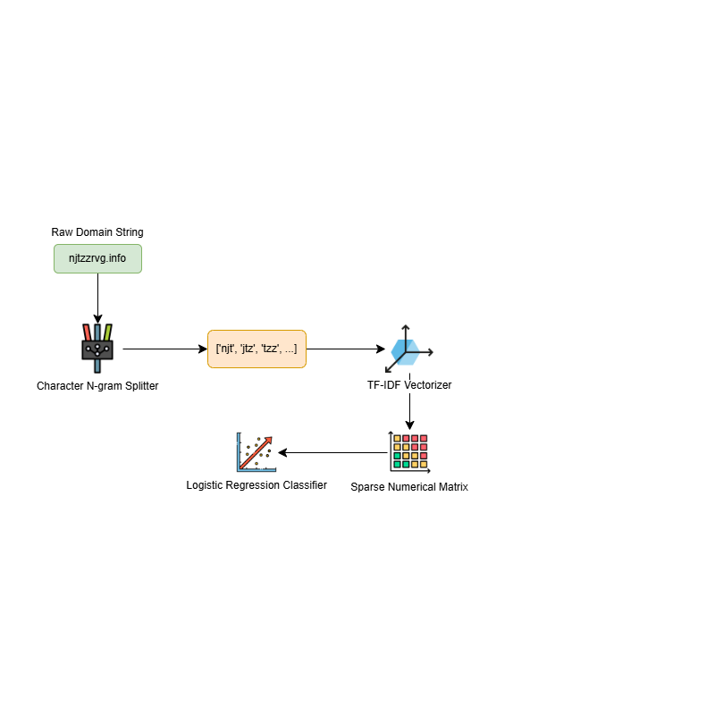
Figure 5: Feature Extraction Pipeline
By analysing these character transitions, the model can learn statistical differences between legitimate domains and DGA-generated output. Below table presents a simple example of 3-gram extraction.
Domain Type | Raw Domain | Extracted 3-grams
Normal | google | [goo, oog, ogl, gle]
DGA | njtzz | [njt, jtz, tzz]

2.4.2 TF-IDF Representation
After n-gram extraction, the character sequences are converted into numerical vectors using TF-IDF vectorisation. This gives lower weight to common n-grams and higher weight to rarer, more discriminative ones.
The TF-IDF weighting of a term $t$ in a domain $d$ is given by:
$$TFIDF(t,d)=TF(t,d)×log⁡\left(\frac{N}{DF(t)}\right)$$
where $TF(t,d)$is the frequency of the n-gram in the domain, $DF(t)$is the number of domains containing that n-gram, and $N$is the total number of domains in the corpus.

2.5 DGA Detection Model Development

2.5.1 Model Selection and Pipeline Architecture
The DGA detection stage was implemented as a supervised binary classifier that labels queried domains as benign or DGA-generated. The final model selected for this component is Logistic Regression trained on TF-IDF character n-gram features. This model was chosen because it performs well on sparse high-dimensional data and remains efficient for near-real-time DNS monitoring.
The model pipeline is straightforward:
- TF-IDF vectorisation of character n-grams
- Logistic Regression classification
This design keeps the domain-level detection stage lightweight while still providing strong lexical discrimination.

2.5.2 Probability Scoring and Thresholding
For each queried domain, the classifier produces a probability score, denoted as p_dga, representing the likelihood that the domain is algorithmically generated. The model uses a linear decision function,
$$z=w^{T}x+b$$
followed by the sigmoid transformation,
$$p_{dga}=\frac{1}{1+e^{-z}}$$
- where $x$is the TF-IDF feature vector, $w$ is the learned weight vector, and $b$ is the bias term, while the score is converted into a probability using the sigmoid function.
The probability score is retained for later stages of the pipeline. The main thresholds used are shown in following table:
Threshold | Purpose
pdga​≥0.50 | General DGA classification
pdga​≥0.70 | High-confidence ML alert
pdga​≥0.40 | Candidate threshold for behavioural rule analysis

2.5.3 Evaluation Metrics and Validation Approach
Model performance was evaluated using accuracy, precision, recall, F1-score, ROC-AUC, and confusion matrix analysis. These metrics were used to assess both classification quality and operational suitability for DNS monitoring.

The final Logistic Regression model achieved a test accuracy of 84.46% and a test AUC of 0.8865, showing that the TF-IDF and Logistic Regression combination provides an effective and practical domain-level detection approach.
Table 3: Performance comparison
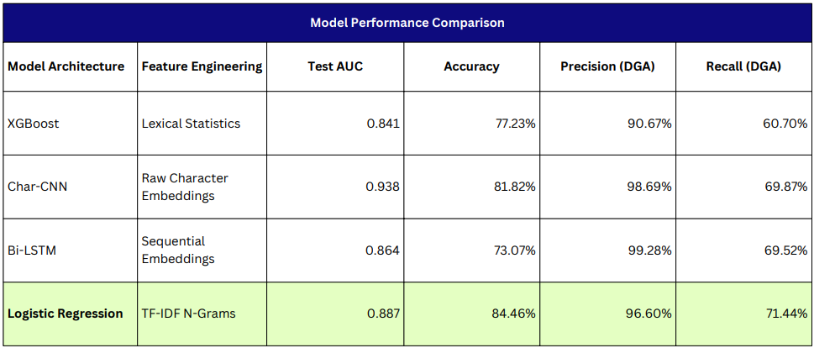

2.6 Behavioural Rule Engine for C2 Communication Detection
While the machine learning classifier identifies suspicious lexical patterns in queried domains, malware communication can also appear through behaviour over time. To strengthen detection, the proposed system uses a second analytical layer: the Behavioural Rule Engine. In this design, domains scored in the first layer are seeded into the second layer for behavioural evaluation. This allows the system to carry forward suspicious domain evidence from the machine learning stage and examine whether those domains are also associated with host-level DNS activity consistent with command-and-control communication.
- The rule engine therefore acts as a stateful sliding-window analyser that operates on machine learning–scored DNS activity rather than raw DNS traffic alone. Instead of focusing on domain syntax, it evaluates temporal patterns such as repeated queries, failed resolutions, rapid cycling through candidate domains, and periodic beaconing.

[Add Diagram: Rule Engine Data Flow]

2.6.1 Candidate Filtering Mechanism
To reduce false positives from benign background DNS traffic, the rule engine uses a candidate filtering mechanism. Rules that evaluate distinct suspicious domains, failed resolutions, or long-term beaconing only consider DNS queries that have already reached a baseline machine learning score of $p_{dga}≥0.40$. This helps prevent normal traffic such as CDN lookups, software updates, or heavy browsing activity from inflating behavioural counts.

2.6.2 Sliding-Window Detection Rules
The engine evaluates four main rules, each bound to a specific time window and threshold. These rules are designed to capture known malware communication tactics.
Table 4: Behavioural detection rules
Rule | Tactic Detected | Evaluation Window | Threshold | Severity
R1: Query Burst | High-frequency queries to the same host/domain pair | 15 seconds | ≥ 15 queries | SUSPICIOUS
R2: Unique Candidate Domains | Rapid cycling through multiple suspicious domains | 30 seconds | ≥ 15 unique domains | SUSPICIOUS
R3: NXDOMAIN Rate | Repeated failed resolutions during DGA probing | 10 seconds | ≥ 10 failures | CRITICAL
R4: Beaconing Consistency | Periodic automated check-ins to the same candidate domain | 1 hour | ≥ 4 queries | CRITICAL

- The evaluation windows and threshold values are configurable and can be adjusted according to operational requirements, traffic characteristics, and environment-specific DNS behaviour.

2.6.3 Decision Fusion and Never-Downgrade Principle
The behavioural rule engine works together with the machine learning scoring stage through a decision layer. Since both stages may produce different levels of suspicion, the system follows a strict never-downgrade principle. Behavioural analysis may increase the severity of a detection, but it does not weaken an already strong machine learning verdict.
The final alert level is determined using the following logic:
- If rule severity = CRITICAL → ALERT
- If $p_{dga}≥0.70$→ ALERT
- If rule severity = SUSPICIOUS → WARN
- Otherwise → OK

2.7 Event Aggregation and Host-Level Analysis
Real-time DNS monitoring generates a large volume of raw query records. If every suspicious query were treated as an independent alert, the system would produce excessive noise and reduce its operational usefulness.
- To address this, the proposed system includes an event aggregation layer that consolidates low-level DNS detections into higher-level host-centric security events. This allows related suspicious queries to be analysed together and reduces alert fatigue.
[Insert Diagram: Event Aggregation Pipeline]

2.7.1 Temporal Windowing and Filtering
The aggregation process operates on a time-window basis, grouping DNS records by two dimensions:
- source host IP
- 60-second time window
This design allows suspicious activity from the same host to be analysed as a single behavioural unit rather than as isolated records. To ensure that only actionable activity is retained, the aggregator filters out windows containing only benign traffic. A host-level event is generated only when the window contains at least one record marked as WARN or ALERT by the ML scorer or the behavioural rule engine.

2.7.2 Security Event Construction
When a suspicious window is identified, the corresponding DNS records are merged into a single event that summarises the host’s activity during that time period. Each event contains the following key attributes:
- total_queries and unique_domains to describe the overall activity volume
- max_p_dga to capture the highest model confidence observed in the window
- top_domains to highlight the most suspicious queried domains
- resolved_ips to collect IPs associated with those suspicious domains
This aggregation provides immediate context for analysts and supports downstream enrichment and investigation.

2.7.3 Risk Scoring and Event Typing
To support prioritisation, each aggregated event is assigned a deterministic risk score in the range 0–100. The score is computed by combining the strongest machine learning signal with penalties for selected behavioural rule triggers:

$$\text{Risk Score}=(max⁡p_{dga}×100)+\text{Burst Penalty}+\text{Unique Domain Penalty}$$
where:
- Burst Penalty = +10 if the Query Burst rule is triggered
- Unique Domain Penalty = +10 if the Unique Candidate Domains rule is triggered
The final score is capped at 100.
Based on the dominant contributing factor, the event is also assigned an event type, such as:
- ML_DGA, BURST, UNIQUE_DOMAINS, ANOMALOUS_ACTIVITY
Overall, the aggregation stage converts raw query-level detections into concise and more meaningful host-level events, making the outputs easier to prioritise, investigate, and visualise within operational dashboards and monitoring platforms.

2.8 Threat Intelligence Enrichment and Infrastructure Analysis

2.8.1 Threat Intelligence Enrichment
Because the DNS pipeline correlates queries with responses, the system captures the IP addresses to which suspicious domains resolve. These resolved IPs are then queried against external platforms, specifically VirusTotal API v3 and AbuseIPDB API v2, to obtain contextual information such as detection ratios, abuse confidence scores, and related metadata.
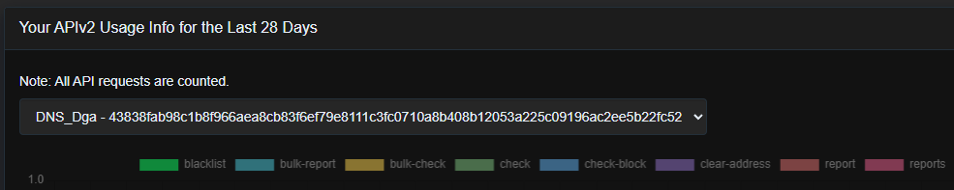
Figure 6: AbuseIPDB API usage interface

2.8.2 Bipartite C2 Infrastructure Graph
To analyse attacker infrastructure, the system constructs a bipartite C2 infrastructure:
- domain nodes - represent queried domain names
- IP nodes - represent the IP addresses to which those domains resolve
- edges - represent DNS resolution relationships between domains and IPs
If many suspicious domains resolve to the same IP, the graph can reveal a hub-and-spoke pattern that may indicate shared command-and-control infrastructure. Edge thickness can also be used to reflect the number of observed DNS lookups.

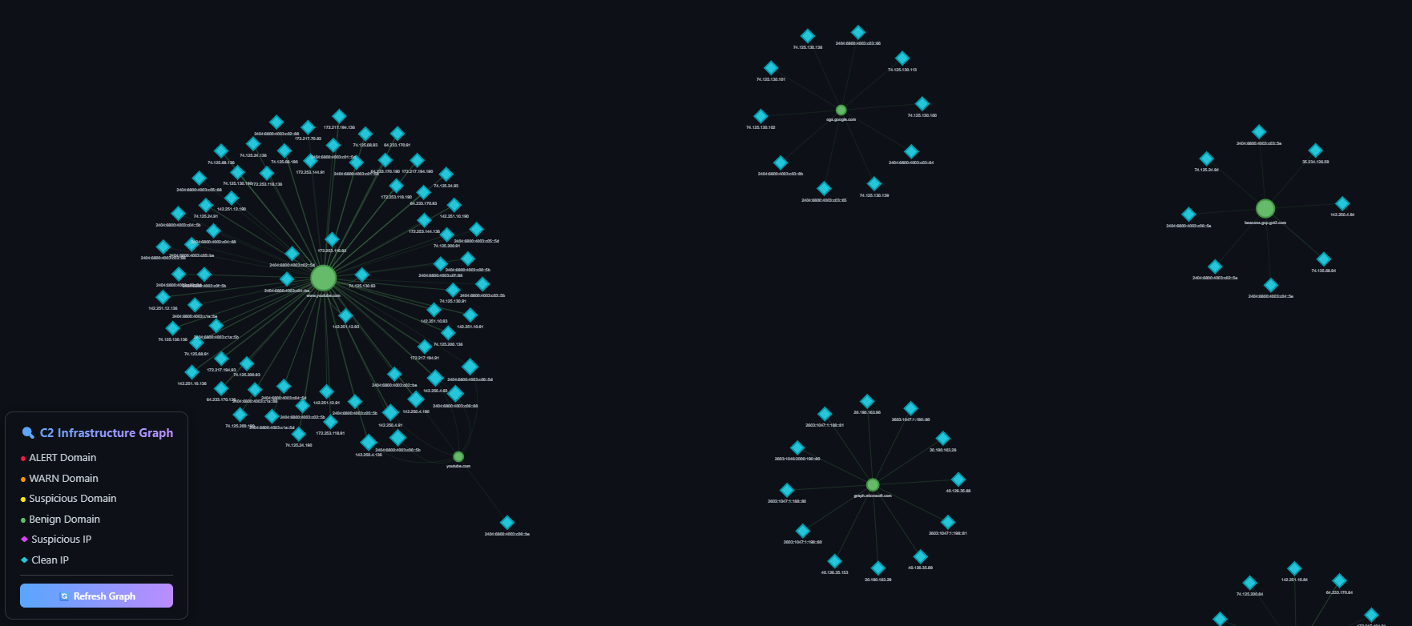
Figure 7: C2 infrastructure graph
The domain nodes are visually prioritised according to their internal risk level, while IP nodes represent the physical infrastructure behind those domains.

2.8.3 Infrastructure Scoring and IP-to-IP Projection
Not every IP resolving suspicious domains is necessarily malicious. Some may belong to shared hosting providers, CDNs, or sinkholes. To prioritise more relevant infrastructure, the system computes an Infrastructure Score for each IP node:
$$\text{Infra Score}=\text{Suspicious Domains Hosted}×\text{Host Spread}$$
where:
- Suspicious Domains Hosted: the number of domains pointing to the IP with a high machine learning probability score $\left(p_{dga} ≥ 0.70\right)$
- Host Spread: the number of unique internal endpoints querying domains that resolve to that IP (e.g., 3 internal hosts querying domains mapped to the same IP)
The system also supports IP-to-IP projection, where links are inferred between IPs that share common domains. This helps reveal possible related or failover infrastructure used by the same attacker. Following shows some suspicious domains (yellow color).
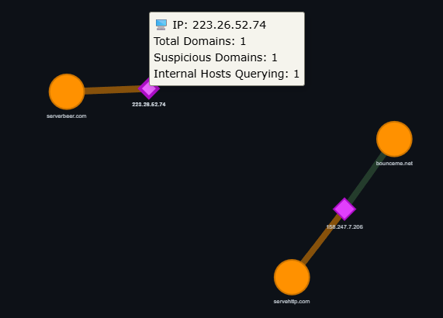
Figure 8: suspicious infrastructure
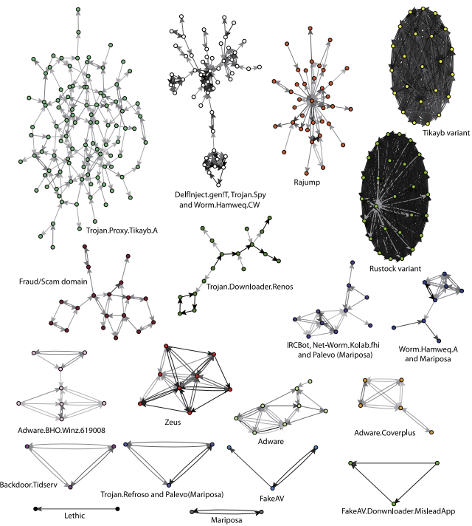
Figure 9: Samples of malicious domain name cluster

2.9 System Workflow and Implementation Design
To support scalability and near-real-time analysis, the proposed system uses a decoupled asynchronous pipeline architecture. The implementation separates the data capture layer from the analysis layer, allowing each stage to operate independently through a shared MySQL database. This makes the workflow easier to scale and ensures that delays in one stage do not interrupt DNS traffic collection.
The workflow begins at the endpoint, where DNS traffic is captured and written to the central database as raw records. Server-side daemons then poll the database in sequence to perform machine learning scoring, behavioural evaluation, event aggregation, enrichment, and graph generation.
[Diagram Here: Full Implementation Design]

2.9.1 Data Capture Layer (Endpoint)
The data capture stage is kept lightweight. An endpoint agent, implemented in sniffer.py, uses the Python Scapy library to monitor UDP port 53 and capture DNS queries and responses. The sniffer correlates requests with responses using transaction IDs, allowing the system to record both queried domains and their resolved IPs, or identify NXDOMAIN failures.
To reduce unnecessary traffic and storage, the sniffer filters reverse lookups, local suffixes, and selected CDN-related traffic before writing records to the database. These logs are stored with an initial status such as level = PENDING and $p_{dga}=0.0$. No machine learning or rule evaluation is performed at the endpoint.

2.9.2 Server-Side Analysis Workflow
After the logs are written to the database, the server-side components process them independently at configured time intervals.
Table 5: Server-side processing components
Script | Main Role | Output
ml_scorer.py | Computes (p_{dga}) and assigns initial severity | Updates dga_logs
rule_engine_runner.py | Applies behavioural rules and adjusts severity | Updates dga_logs
aggregate_events.py | Groups logs into host-based 60-second events | Writes dga_events
enricher.py | Queries VirusTotal and AbuseIPDB | Writes enrichment data
graph.py | Builds the bipartite C2 graph | Produces HTML and JSONL outputs

3.0 Experimental Results and Evaluation

4.0 Discussion - Challenges Faced, Limitations

5.0 Conclusion and Future Work

5.1. Comparison with Existing Approaches

REFERENCES

APPENDICES

