NEAR-REAL TIME AI/ML BASED DNS THREAT DETECTION AND CONTEXTUAL THREAT INTELLIGENCE
Project Id: R-25-26J-066

Final Project Thesis

Peiris S M
Student ID: IT22883902
Supervisor: Mr. Kavinga Yapa Abeywardena

B.Sc. (Hons) Degree in Information Technology Specializing in Cyber Security

Department of Information System Engineering

Sri Lanka Institute of Information Technology
Sri Lanka

April 2026

Declaration

Abstract

Acknowledgement

Table of Contents

Declaration i
Abstract ii
Acknowledgement iii
Table of Contents iv
List of tables vi
List of Figures vii
List of abbreviations viii
List of appendices ix
1. Introduction x
1.1 Background x
1.2 Literature Review xi
1.3 Research Gap xiii
1.4 Research Problem xiv
1.5 Research Objectives xiv
1.5.1 Main Objective xiv
1.4.2 Specific Objectives xv
2. Methodology xvi
2.1 System Architecture Overview xvi
2.2 DNS Abuse and Infrastructure Component Overview xvii
2.3 Data Collection and Data Preprocessing xix
2.4 Feature Engineering xx
2.4.1 Numerically Stable Statistical Computation xxi
2.4.2 DNS Header Parsing xxii
2.4.4 DoH Server Allowlist xxiii
2.4.5 Key Feature Computation Formulas xxiii
2.6 Model Design - XGBoost Classifier xxv
2.7 Real-Time Inference Pipeline xxviii
2.8 Deployment Architecture xxx
2.9 Commercialization Aspects xxxi
3. RESULTS AND DISCUSSION xxxiii
3.1 Evaluation of Methodology xxxiii
3.2 Offline Model Validation xxxiii
3.3 Live Operational Evaluation xxxiv
3.4 Comparison with Existing Approaches xxxvi
3.6 Discussion xxxvi
4: CONCLUSION xl
4.1 Summary of Work xl
4.2 Key Outcomes xl
6. References xlii
7. Appendice xliii

List of tables

List of Figures

List of abbreviations

List of appendices

1. Introduction

1.1 Background
The Domain Name System (DNS) translates human-readable domain names into numerical IP addresses. Since it was first defined in RFC 1035 (Mockapetris, 1987), DNS has become an essential part of the modern internet. Almost all online activities - from web browsing and email to cloud services - rely on DNS. Because it is so heavily used, DNS is a highly attractive target for various cyberattacks.
DNS abuse and infrastructure attacks include many malicious activities that exploit the DNS protocol. Volumetric flooding attacks try to overwhelm DNS servers with massive numbers of fake queries, causing the servers to crash or stop responding to real users. Amplification and reflection attacks take advantage of the fact that a small DNS query can result in a much larger response. In these attacks, hackers send small queries using a spoofed IP address, causing large responses to hit the victim's network. DNS spoofing involves injecting fake DNS responses to redirect users to harmful websites. Furthermore, attackers can use hidden DNS channels to steal data or control malware while avoiding basic security systems.
The massive scale of these attacks was proven by Sommese et al. (2022). They observed global DNS traffic over 17 months and found that approximately 5% of all DNS servers faced at least one Denial of Service (DoS) attack. During severe attacks, network delays increased by up to 100 times. These findings highlight the urgent need for better ways to detect and stop DNS abuse.
Recently, encrypted DNS protocols have made detection even more difficult. DNS-over-HTTPS (DoH), defined in RFC 8484, hides DNS queries inside regular secure web traffic (HTTPS) on port 443. DNS-over-TLS (DoT), defined in RFC 7858, encrypts DNS traffic on port 853. While these protocols greatly improve user privacy, they also create major blind spots for security teams. Attackers can misuse these encrypted channels to hide malicious DNS traffic from traditional security tools that only inspect unencrypted data.

Attack Type | Mechanism | Target Port(s) | Key Indicators | Detection Challenge
DNS Flooding | High-volume query generation to exhaust resolver capacity | 53 | Queries per second, flow packet rates | Distinguishing from legitimate traffic bursts
Amplification / Reflection | Spoofed queries to open resolvers; large responses directed at victim | 53 | Amplification factor, ANY/TXT query ratios, response inconsistency | Detecting at the endpoint before authoritative server saturation
DNS Spoofing | Injection of forged responses to redirect resolution | 53 | Response time variance, query-response inconsistency | Requires bidirectional flow analysis
DoH Covert Channel | Abuse encapsulated within encrypted HTTPS sessions | 443 | SNI entropy, payload size variance, known DoH server misuse | Encrypted payload prevents traditional DPI
DoT Abuse | Abuse carried over encrypted TLS connections | 853 | TLS record size patterns, flow duration anomalies | Similar to DoH; limited payload visibility

1.2 Literature Review
Sommese et al. (2022) conducted a major study on how Distributed Denial of Service (DDoS) attacks impact global DNS servers. They used passive backscatter analysis from the UCSD Network Telescope combined with active DNS probing through the OpenINTEL platform. Over a 17-month period, researchers recorded more than 4 million DDoS attacks. They found that approximately 5% of the entire DNS system experienced at least one attack. During major attacks, Round-Trip Time (RTT) increased by up to 100 times. In extreme cases, delays reached 348 times the normal baseline, making targeted websites completely inaccessible to normal users. The study also highlighted Randomly and Uniformly Spoofed Denial of Service (RSDoS) attacks, in which hackers randomize their IP addresses to complicate attribution.
This study is critical to the current research for two reasons. First, it proves that DNS attacks are a massive, real-world problem requiring automated security solutions. Second, it highlights a major limitation: Sommese et al. only analyzed attacks after they occurred. The proposed system in this research solves this by deploying a real-time detection agent at the network endpoint, catching abusive traffic before it saturates authoritative infrastructure.
Suvra et al. (2025) tested traditional machine learning algorithms to classify general DDoS attacks. They compared six algorithms - including Random Forest, Decision Tree, and Support Vector Machine - on the CIC-DDoS2019 dataset. Using Principal Component Analysis (PCA) to reduce features from 87 to 24, Random Forest achieved the best overall accuracy of 98.80%, with 99.00% precision and 98.00% recall for DNS-specific attacks. While these numbers are strong, the approach has major limitations when applied to real-world DNS security. The features used are domain-agnostic and lack DNS-specific telemetry. Testing was done entirely on offline, pre-recorded data with no live traffic evaluation. Encrypted DNS protocols were completely ignored, and no False Positive Rate was reported against realistic mixed human traffic. The proposed system in this research addresses all four limitations through 39 DNS-specific features, live traffic evaluation, encrypted protocol coverage, and explicit FPR measurement.
Erskine (2025) created a Deep Learning-based Multilayer Intrusion Detection and Prevention System Model (DLMIDPSM) specifically to protect IoT devices from DDoS attacks. The model was trained and evaluated on the CICIoT2023 dataset from over 106 physical IoT devices. While the study reported an overall accuracy of over 85% and 99% precision against Mirai botnets, a critical weakness was a recall drop to 62% for Mirai detection, meaning 38% of actual Mirai attacks were missed. Overall precision was 81%, recall 83%, and F1-score 80%. A critical limitation is the fundamental difference between IoT traffic - which is predictable and repetitive - and enterprise endpoint traffic, which is chaotic, bursty, and heterogeneous. The proposed system was specifically designed for this more challenging enterprise environment, achieving 94.05% accuracy on live endpoint traffic including authentic human browsing activity.
El Attar et al. (2024) developed a machine learning system targeting DNS flooding attacks, using both wrapper-based and filter-based feature selection to identify discriminative features. The system was evaluated on a synthetic SDN dataset and approximately 100,000 real DNS packets. On synthetic data, XGBoost achieved a perfect F1-score of 1.00. However, on real DNS traffic, Decision Tree performance dropped significantly to 0.74, demonstrating a persistent generalization challenge in network security research. The most critical limitation is the exclusive focus on unencrypted DNS flooding on port 53. The detection scheme cannot detect attacks encapsulated within DoH (port 443) or DoT (port 853) protocols. As major browser vendors including Google Chrome and Mozilla Firefox have enabled DoH by default, this represents an increasingly severe blind spot.
Alharby (2025) focused on building highly efficient machine learning models for low-power IoT devices, using the CICIoT2023 dataset. Through aggressive undersampling and feature selection (Chi-Square, PCA, and Random Forest Regressor), the best configuration achieved 99.99% accuracy with a 99.53% reduction in prediction time. However, these results require careful contextualization: the 99.99% accuracy was achieved on an artificially balanced dataset, and the study acknowledged notable confusion between DDoS and DoS subcategories despite the aggregate metric. Two distinctions are critical. First, Alharby prioritizes raw computational speed on IoT hardware, whereas the proposed system prioritizes low false positive rates for enterprise SOC integration. Second, the CICIoT2023 dataset does not include encrypted DNS traffic or mixed human browsing patterns, which are central to the proposed system.

1.3 Research Gap

A detailed review of the existing research reveals several major gaps in current methods for detecting DNS abuse.

First, most studies rely heavily on static, pre-recorded datasets, which limits how well their models work in the real world. For example, Suvra et al. (2021) tested traditional machine learning algorithms on standard datasets for DDoS detection, achieving 98.80% accuracy with Random Forest. However, this testing was done entirely offline using generic network features rather than specific DNS data. Similarly, Alharby (2025) achieved a near-perfect 99.99% accuracy on the CICIoT2023 dataset. While impressive, this result was obtained in a highly controlled Internet of Things (IoT) environment using altered data. The authors also admitted that their model sometimes confused different types of attacks despite the high overall score.

Second, models that do focus specifically on DNS are usually limited to unencrypted traffic (port 53). El Attar et al. (2023) built a machine learning system to detect DNS flooding. They achieved a perfect score on artificial data, but the model's performance dropped sharply when tested on real network traffic. Most importantly, their system only works on standard, unencrypted DNS flooding and cannot detect attacks hidden inside encrypted DoH or DoT traffic.

Third, existing research completely ignores the False Positive Rate (FPR) when dealing with live, mixed network traffic that includes real human browsing. In a real-world Security Operations Centre (SOC), a high number of false alarms causes "alert fatigue." This frustrates security analysts and wastes time and money. None of the reviewed studies tested their models against genuine human web traffic mixed with attacks to see how many false alarms would be generated.

Fourth, studies focusing on IoT networks do not apply well to regular enterprise computers. For instance, Erskine (2023) built an intrusion detection system for IoT networks that achieved 85% overall accuracy and 99% precision against Mirai botnets. However, the system missed 38% of certain attacks (a recall drops to 62%). IoT devices have very predictable traffic patterns, making them easier to monitor. In contrast, regular enterprise computers generate chaotic, highly varied web traffic, requiring a much more adaptable detection system.

Together, these gaps highlight the urgent need for a new detection system. The ideal system must operate in real time on the actual computer (endpoint), inspect both encrypted and unencrypted DNS traffic, use features specific to DNS behavior, and prove that it can keep false alarms low enough to be useful in a real SOC environment.

1.4 Research Problem

How can a lightweight, machine learning agent be designed and implemented to detect multi-vector DNS abuse and infrastructure attacks across both encrypted (DoH/DoT) and unencrypted DNS traffic channels in near real time, while maintaining a false positive rate that is operationally viable for Security Operations Centre integration?
This problem involves several challenges: extracting features from highly mixed traffic in real time, creating a machine learning model that catches as many attacks as possible without causing too many false alarms, and designing the software to run efficiently without slowing down the user's computer.

1.5 Research Objectives

1.5.1 Main Objective
To design and develop a near-real-time, endpoint-based machine learning system for detecting DNS abuse and infrastructure attacks that effectively analyses both unencrypted and encrypted (DoH/DoT) DNS traffic, ensuring high detection recall and low false positive rates suitable for operational Security Operations Centre (SOC) environments.

1.4.2 Specific Objectives
- To build a Deep Packet Inspection (DPI) tool that extracts 39 specific features from network traffic on ports 53, 443, and 853 without relying on payload decryption.
- To train and optimize an XGBoost machine learning classifier using F-beta optimization with beta set to 3.0 to prioritize catching attacks (recall) over minimizing false alarms (precision).
- To package the detection agent as a standalone Windows executable that quietly runs in the background and continuously routes telemetry to a central SOC database.
- To evaluate the fully deployed system on live, unpredictable network traffic mixing genuine human web browsing with simultaneous automated attacks.

2. Methodology
This chapter presents the complete methodology adopted for the design, development, and evaluation of the DNS abuse and infrastructure attack detection system. The chapter is organized to progressively detail the system architecture, data acquisition mechanism, feature engineering pipeline, dataset composition, model design and training, real-time inference pipeline, and deployment architecture.

2.1 System Architecture Overview
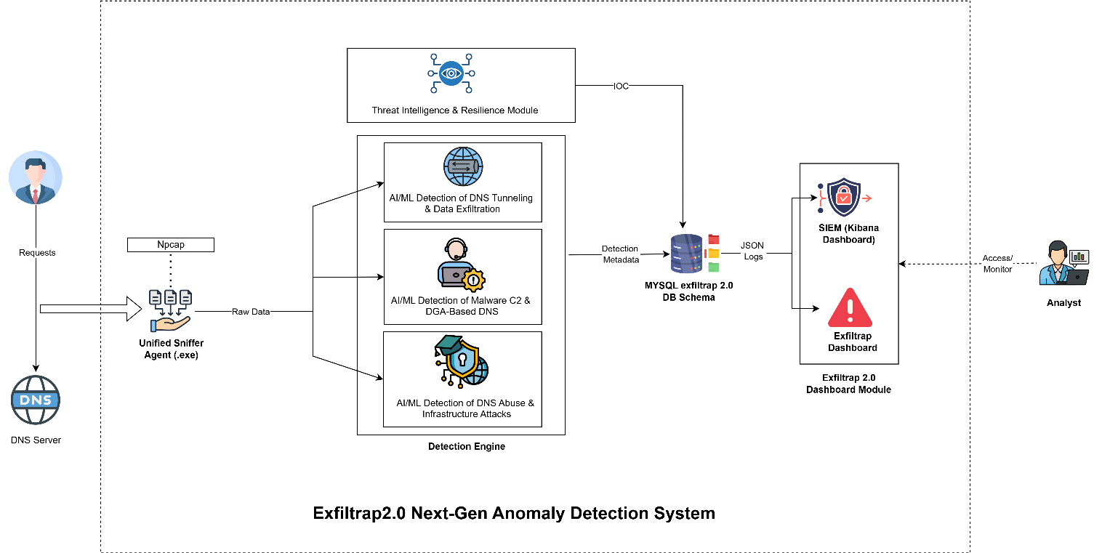
The proposed system follows a two-tier architecture comprising an endpoint capture agent and a server-side analytics engine. This separation of concerns ensures that the computationally lightweight capture process runs persistently on monitored endpoints without degrading host performance, while the more resource-intensive machine learning inference executes on a dedicated analytics server.
The endpoint tier is implemented as a Unified Sniffer Agent that orchestrates three concurrent sub-agents, each targeting a distinct DNS threat category. The sub-agent relevant to this component is the AbuseSniffer, which implements the Deep Packet Inspection engine for DNS abuse and infrastructure attack feature extraction. The other two sub-agents (TunnelSniffer for DNS tunneling detection and DGASniffer for Domain Generation Algorithm detection) operate in parallel as independent research components within the broader ExfilTrap system.

To keep the software lightweight and prevent it from slowing down the computer, a capture filter ` (udp port 53 or tcp port 53) or tcp port 443 or tcp port 853` is used. This guarantees that the agent only captures traffic related to DNS. Furthermore, the system uses a background process (an async SQL queue) to save data to the database. This separates the database writing process from the traffic capture process, ensuring that slow database connections do not cause the system to miss incoming network packets.

2.2 DNS Abuse and Infrastructure Component Overview
The AbuseSniffer engine implements stateful, bidirectional flow tracking to aggregate individual packets into coherent network flows before extracting features. This flow-based approach is essential because DNS abuse patterns manifest at the flow level (e.g., sustained high query rates, asymmetric response volumes) rather than at the individual packet level.

2.2.1 Flow Identification and Tracking
Each network flow is identified by a 5-tuple key comprising source IP address, destination IP address, source port, destination port, and transport protocol (TCP or UDP). The DnsAbuseFlowManager class maintains a dictionary of active flows, mapping each 5-tuple to a DnsAbuseFlowTracker instance that accumulates packet-level statistics for that flow.
Bidirectional flow matching is implemented by checking both the forward key (src → dst) and the reverse key (dst → src) when a new packet arrives. If a matching flow exists in either direction, the packet is added to the existing flow with the appropriate directionality flag. If no matching flow exists, a new DnsAbuseFlowTracker is instantiated.

2.2.2 Flow lifecycle Management
Flows transition through three lifecycle states:
- Active: The flow is accumulating packets. Each incoming packet updates the flow's statistical accumulators, timing records, and protocol-specific counters.

- Exported on Connection Termination: For TCP flows, the detection of a FIN flag (connection close) or RST flag (connection reset) triggers immediate flow export, provided the flow contains at least two packets. This minimum packet guard prevents the export of incomplete single-packet probes that produce degenerate feature vectors.

- Exported on Timeout: For UDP flows and long-lived TCP flows, a configurable timeout of 120,000 milliseconds (2 minutes) triggers export when no new packets have been observed. Timeout checks are performed every 5,000 packets or every 30 seconds, whichever occurs first, balancing detection latency against computational overhead.

2.2.3 Export and Database Routing
Upon flow export, the DnsAbuseFlowTracker generates a feature dictionary containing all 39 extracted features. The export callback routes the flow to the appropriate database table based on port classification:
- Flows involving port 53 (either source or destination) are routed to `dns_abuse_plain`
- Flows involving port 443 or 853 are routed to `dns_abuse_doh`
Each exported record includes a timestamp, source and destination addressing information, all 39 features, and a `final_decision` field initialized to NULL, which is subsequently populated by the server-side ML classifier.
A fault-tolerant export mechanism implements exponential backoff retry logic with three attempts (delays of 1 second and 2 seconds) before falling back to a local CSV log file (`dns_abuse_fallback.log`) to prevent data loss during database connectivity interruptions.

2.3 Data Collection and Data Preprocessing
The data collection and dataset preparation process is engineered to ensure the availability of high-quality, representative, and well-structured data for training and evaluating the DNS abuse and infrastructure attack detection models. Given the complexity of modern network environments and the necessity to capture both benign human activity and malicious volumetric behaviors, data is aggregated from multiple sources. This includes widely recognized public datasets, live captured baseline traffic, and synthetically generated attack scenarios. The overall preparation pipeline consists of several key stages, summarized below.
Stage | Description
Data Collection | Data is aggregated from multiple sources, including publicly available academic datasets (CICIoT2023 and CIC-DDoS2019), live captured baseline human traffic, and synthetically generated malicious botnet traffic. Both unencrypted DNS (port 53) and encrypted DNS (DoH/DoT on ports 443 and 853) flows are captured to ensure comprehensive coverage of real-world enterprise scenarios.
Data Labelling | A rigorous binary labeling methodology is applied. Public benchmark datasets retain their original malicious or benign labels, actively generated botnet traffic is explicitly labeled as attacks, and live captured endpoint traffic generated by human users is treated as benign under controlled conditions. This ensures a clear separation between normal operational behavior and active threats.
Data Cleaning | Duplicate, incomplete, and irrelevant flow records are removed to enhance dataset integrity. Furthermore, mathematical anomalies such as division-by-zero errors (infinity values) generated during rate calculations and missing values (NaN) are algorithmically replaced with 0.0 to ensure numerical stability during model training.
Class Balancing | To prevent model bias toward majority classes, the aggregated dataset is strictly balanced. The final unified dataset comprises ~1 million network flows, balanced perfectly at a 50/50 ratio between benign and malicious traffic, ensuring the model remains highly sensitive to threats without defaulting to benign classifications.
Feature Preparation | The raw packet captures are transformed into structured numerical feature sets compatible with machine learning models. A specialized Deep Packet Inspection engine extracts a customized schema of 39 specific features spanning seven orthogonal categories.

This structured data preparation approach ensures consistency across disparate data sources and precisely aligns the dataset with the operational requirements of the machine learning classifier. By combining highly diverse traffic sources with systematic preprocessing and domain-specific feature engineering, the dataset provides a robust mathematical foundation for training models capable of detecting DNS abuse, volumetric flooding, and infrastructure attacks across both plaintext and encrypted environments.

2.4 Feature Engineering
The feature engineering pipeline represents the core technical contribution of this component. A total of 39 features extracted from each network flow, organized into seven orthogonal categories designed to capture distinct dimensions of DNS abuse behavior. Table 3.1 presents the complete feature inventory with descriptions.
DNS Critical features:
dns_amplification_factor | Ratio of total response bytes to total query bytes. A sentinel value of 999.0 is assigned when responses exist without any queries, indicating potential reflection attacks.
query_response_ratio | Ratio of query packet count to response packet count. Deviations from 1.0 indicate asymmetric communication patterns.
dns_any_query_ratio | Proportion of DNS queries using the ANY query type (QTYPE 255), commonly exploited in amplification attacks.
dns_txt_query_ratio | Proportion of DNS queries using the TXT query type (QTYPE 16), associated with data exfiltration and tunneling.
dns_response_inconsistency | Absolute difference between query and response packet counts, indicating potential spoofing or reflection.
dns_queries_per_second | Rate of DNS query packets per second of flow duration, capturing volumetric flooding intensity.
port_53_traffic_ratio | Proportion of total flow bytes is attributable to DNS (port 53) traffic, distinguishing DNS-heavy flows from mixed traffic.
Flow Rate Features:
flow_bytes_per_sec | Total bytes transferred per second across the flow.
flow_packets_per_sec | Total packets per second across the flow.
fwd_packets_per_sec | Forward-direction packets per second.
bwd_packets_per_sec | Backward-direction packets per second.
Flow Statistics Features:
flow_duration | Total flow duration in milliseconds.
total_fwd_packets | Count of forward-direction packets.
total_bwd_packets | Count of backward-direction packets.
total_fwd_bytes | Total bytes in forward direction.
total_bwd_bytes | Total bytes in backward direction.
DNS Aggregate Features:
dns_total_queries | Total DNS query packets observed in the flow.
dns_total_responses | Total DNS response packets observed in the flow.
dns_response_size | Total bytes in DNS response packets.
Time based features:
flow_iat_mean | Mean inter-arrival time between consecutive packets (Welford algorithm).
flow_iat_std | Standard deviation of inter-arrival times.
flow_iat_min | Minimum inter-arrival time observed.
flow_iat_max | Maximum inter-arrival time observed.
fwd_iat_mean | Mean inter-arrival time in forward direction.
bwd_iat_mean | Mean inter-arrival time in backward direction.
Packet Size features:
fwd_packet_length_mean | Mean packet size in forward direction.
bwd_packet_length_mean | Mean packet size in backward direction.
packet_size_std | Standard deviation of overall packet sizes.
flow_length_min | Minimum packet size in the flow.
flow_length_max | Maximum packet size in the flow.
average_packet_size | Mean packet size across all packets.
response_time_variance | Variance of DNS response times (query-to-response delay).
large_packet_ratio | Proportion of packets exceed 600 bytes.
medium_packet_ratio | Proportion of packets between 400 and 600 bytes.
small_packet_ratio | Proportion of packets below 400 bytes.
Encrypted DNS Features:
sni_entropy | Shannon entropy of the Server Name Indication hostname extracted from TLS ClientHello, measuring randomness.
is_known_doh_server | Binary indicator (0/1) for whether the destination matches a known legitimate DoH resolver from a curated allowlist of 70+ IPs and hostnames.
encrypted_payload_size_variance | Variance of TLS Application Data record sizes, capturing payload size distribution anomalies.

2.4.1 Numerically Stable Statistical Computation
All running statistical features (mean, variance, standard deviation) are computed using Welford's online algorithm (Welford, 1962), implemented in the BasicStats class. Welford's algorithm computes variance in a single pass through the data without requiring storage of all observed values, using the recurrence relation:
For each new value x: count += 1, delta = x – mean, mean += delta / count, delta2 = x – mean,
M2 += delta * delta2, Variance = M2 / (count - 1)

$$σ^{2}=\frac{M_{2,n}}{n-1}$$
This approach is numerically stable for long-running flows that may accumulate thousands of packets, avoiding the catastrophic cancellation errors that arise from the naive two-pass variance formula when dealing with large values and small differences.

2.4.2 DNS Header Parsing
For flows traversing port 53, the DPI engine performs direct byte-level parsing of the DNS header without relying on external DNS parsing libraries. The 12-byte DNS header is decoded to extract:
- Transaction ID (bytes 0-1): Used for query-response pairing and response time measurement
- QR flag (bit 7 of byte 2): Distinguishes queries (QR=0) from responses (QR=1)
- QDCOUNT (bytes 4-5): Number of questions in the DNS message
- ANCOUNT (bytes 6-7): Number of answer records
Query type (QTYPE) extraction traverses the variable-length QNAME field using label-length prefix parsing, handling both standard labels and compressed labels (identified by the 0xC0 prefix). The extracted QTYPE values are used to compute ANY query ratio (QTYPE 255) and TXT query ratio (QTYPE 16), both of which are strong indicators of amplification and tunneling abuse respectively.

2.4.3 TLS Handshake Analysis
For flows traversing ports 443 and 853, the DPI engine extracts metadata from the TLS handshake without performing payload decryption. This decryption-free approach is a key architectural differentiator from approaches that require man-in-the-middle TLS interception.

The TLS processing logic identifies two record types:
Handshake records (content type 0x16): When a ClientHello message is detected (handshake type 0x01), the engine traverses the TLS extensions to locate the Server Name Indication (SNI) extension (extension type 0x00). The SNI hostname is extracted, and its Shannon entropy is computed using the following formula:
H(s) = - ∑ p(c) × log₂ (p(c)) for each unique character c in string s
Where p(c) = frequency(c) / length(s)
Shannon entropy measures the randomness of the hostname string. Legitimate domain names such as `dns.google` exhibit low entropy (approximately 2.5-3.5 bits) due to predictable character distributions, while algorithmically generated hostnames used in covert channels exhibit higher entropy (typically 4.0+ bits) due to pseudo-random character selection.
The TLS record length is extracted from bytes 3–4 of the record header and accumulated in the tls_payload_stats accumulator, enabling computation of encrypted payload size variance without accessing the encrypted payload content.

2.4.4 DoH Server Allowlist

The DoHServerDatabase class maintains a curated allowlist of 25 known legitimate DoH resolver hostnames and 49 known DoH resolver IP addresses (including IPv4 and IPv6), covering major providers including Google DNS (8.8.8.8, 8.8.4.4), Cloudflare (1.1.1.1, 1.0.0.1), Quad9 (9.9.9.9), OpenDNS, AdGuard, Mullvad, and others. The `is_known_doh_server` binary feature enables the classifier to distinguish between flows directed to legitimate DoH resolvers (which may carry benign encrypted DNS queries) and flows directed to unknown or suspicious servers (which may indicate covert abuse channels).

2.4.5 Key Feature Computation Formulas
The following formulas define the computation of the most critical features used by the classifier:

- Query-Response Ratio:
$$QR=\frac{\text{dns}\text{_}\text{query}\text{_}\text{packet}\text{_}\text{count}}{\text{dns}\text{_}\text{response}\text{_}\text{packet}\text{_}\text{count}}$$

- DNS Queries Per Second:
$$QPS=\frac{\text{dns}\text{_}\text{query}\text{_}\text{packet}\text{_}\text{count}}{\text{flow}\text{_}\text{duration}\text{_}\text{seconds}}$$
- Port 53 Traffic Ratio:
$$P53R=\frac{\text{total}\text{_}\text{query}\text{_}\text{bytes}+\text{total}\text{_}\text{response}\text{_}\text{bytes}}{\text{total}\text{_}\text{flow}\text{_}\text{bytes}}$$

- Packet Size Ratios:
large_packet_ratio = packets_above_600_bytes / total_packets
medium_packet_ratio = packets_400_to_600_bytes / total_packets
small_packet_ratio = packets_below_400_bytes / total_packets

- Response Time Variance:
$$σ^{2}=\frac{1}{n}\sum{t_{i}^{2}}-{\left(\frac{1}{n}\sum{t_{i}}\right)}^{2}$$
$$t_{i}=\text{response}\text{_}\text{timestamp}-\text{query}\text{_}\text{timestamp}$$

2.5 Dataset Composition
The training dataset was constructed from three complementary sources to ensure comprehensive coverage of both attack and benign traffic patterns. Table 3.2 presents the dataset composition.

Source | Traffic Type | Contribution
CICIoT2023 | IoT DDoS, DoS, Mirai, spoofing, reconnaissance | Attack pattern diversity from 106+ simulated IoT devices
CIC-DDoS2019 | Multi-vector DDoS (DNS, LDAP, MSSQL, NTP, SNMP, UDP) | DNS-specific DDoS subcategories with flow-level labels
Custom Generated Traffic | DNS-generated attacks + legitimate human browsing | Realistic operational traffic mixing concurrent attack and benign flows

The raw dataset comprised approximately 1,000,000 flows aggregated from these three sources. To address class imbalance and prevent the classifier from developing a bias toward the majority class, the dataset was balanced to a 50/50 distribution of attack and benign flows. The final training dataset contained 165,608 flows with equal representation of both classes.
The custom-generated traffic component is particularly significant for this research. Unlike the CICIoT2023 and CIC-DDoS2019 datasets, which capture traffic in controlled laboratory environments, the custom traffic was generated by concurrently executing multi-threaded botnet attack generators alongside authentic human browsing sessions (including streaming services, web search, social media, and general browsing). This concurrent generation ensures that the training data captures the realistic interleaving of attack and benign flows that characterizes actual enterprise endpoint traffic.

2.5.1 Feature Preprocessing
The feature preprocessing pipeline applies the following transformations to prepare the raw extracted features for model training:
Stage | Operation | Purpose
1 | Protocol label encoding | Converts categorical protocol labels (TRADITIONAL, DOH, DOT, TCP, UDP, UNKNOWN) to integer values via scikit-learn LabelEncoder
2 | Log transformation (log1p) | Applies np.log1p(x) to six skewed flow-rate features to compress their dynamic range and reduce the influence of extreme outliers
3 | Infinity replacement | Replaces ±inf values (arising from division by zero in rate calculations) with 0.0
4 | NaN imputation | Fills remaining NaN values with 0.0
5 | Float64 casting | Casts all features to numpy float64 for consistent numerical precision during XGBoost inference

The log transformation in Stage 2 is applied specifically to features with highly right-skewed distributions, where a small number of attack flows exhibit extremely high byte rates or packet rates that would otherwise dominate the feature space. The `log1p` function (log (1 + x)) is used rather than standard log to handle zero values gracefully.

2.6 Model Design - XGBoost Classifier
The classification model selected for this component is XGBoost (Extreme Gradient Boosting), an ensemble learning algorithm based on gradient boosted decision trees (Chen and Guestrin, 2016). XGBoost was selected over alternative algorithms for three reasons: its demonstrated superiority in tabular data classification tasks, its native support for regularization parameters that prevent overfitting on noisy network traffic data, and its computationally efficient histogram-based tree construction method that enables rapid inference suitable for real-time deployment.
2.6.1 Hyperparameter Configuration
Parameter | Value | Rationale
objective | binary:logistic | Binary classification (attack vs. benign) with logistic probability output
eval_metric | logloss, auc | Dual evaluation metrics during training for convergence monitoring
scale_pos_weight | 1.0 | Dataset is pre-balanced to 50/50; no class weight correction required
n_estimators | 1,000 | Number of boosting rounds; sufficient for convergence on training samples
learning_rate | 0.03 | Conservative learning rate to prevent overfitting; smaller steps improve generalization
max_depth | 6 | Maximum tree depth; reduced from 7 to mitigate overfitting on the cleaner unified dataset
min_child_weight | 3 | Minimum sum of instance weight in a leaf node; prevents splits on sparse partitions
gamma | 0.05 | Minimum loss reduction required for a further partition; regularization against trivial splits
subsample | 0.8 | Row subsampling ratio per tree; introduces stochasticity to reduce variance
colsample_bytree | 0.7 | Feature subsampling ratio per tree; prevents over-reliance on dominant features
colsample_bylevel | 0.7 | Feature subsampling ratio per tree level; additional diversity in split selection
reg_alpha | 0.05 | L1 regularization on leaf weights; promotes sparsity in the model
reg_lambda | 1.0 | L2 regularization on leaf weights; penalizes large weights to improve generalization
tree_method | hist | Histogram-based tree construction; significantly faster than exact method with minimal accuracy loss
random_state | 42 | Fixed random seed for reproducibility
The `scale_pos_weight` parameter is set to 1.0 because the training dataset was pre-balanced to a 50/50 class distribution during the data preparation phase. This eliminates the need for algorithmic class weight adjustment, which can introduce training instability when applied alongside aggressive threshold tuning.

2.6.2 F-beta Threshold Tuning
A critical design decision in this system is the rejection of the default classification threshold of 0.50 in favor of a threshold optimized for the F-beta score with beta equal to 3.0. When beta equals 3.0, recall is weighted nine times (3^2 = 9) more heavily than precision in the harmonic mean calculation. This reflects the operational reality of DNS abuse detection: a missed attack (false negative) can result in infrastructure compromise, service disruption, or data exfiltration, whereas a false alarm (false positive) results only in a brief investigation by a SOC analyst. The asymmetry in consequence severity justifies the mathematical prioritization of recall.
The threshold tuning procedure systematically evaluated 90 threshold candidates in the range [0.05, 0.95] with a step size of 0.01. For each candidate threshold, the F-beta (3.0) score was computed on the held-out test set. The threshold producing the maximum F-beta score was selected as the operational classification boundary.
The optimal threshold was determined to be 0.19, compared to the default threshold of 0.50. This lower threshold means the model classifies a flow as an attack when the predicted probability exceeds 19%, making the system aggressively paranoid in its attack detection. The consequence is a deliberate trade-off: the model achieves significantly higher attack recall at the cost of a moderately elevated false positive rate, which is acceptable for SOC integration where false alarms are routinely handled but missed attacks are not.

2.7 Real-Time Inference Pipeline
The server-side inference engine is implemented as a continuously running daemon process that polls the MySQL database for unclassified flows and applies the trained XGBoost model to generate predictions.
2.7.1 Polling Architecture
The inference engine operates on a 1-second polling interval, querying each of the two abuse tables (`dns_abuse_plain` and `dns_abuse_doh`) for rows where `traffic_type = 'DNS_ABUSE'` and `final_decision IS NULL`. This isolation principle ensures that the detector only processes flows generated by the AbuseSniffer component and does not interfere with records from other system components.
Each polling cycle fetches up to 25,000 unprocessed rows per table, constructs a pandas DataFrame, applies the identical preprocessing pipeline used during training (protocol encoding, log transformation, infinity replacement, NaN imputation, float64 casting), and generates predictions using the model's `predict_proba` method. Flows with predicted probabilities exceeding the 0.19 threshold are classified as ATTACK; all others are classified as BENIGN.
The classification result is written back to the source table by updating the `final_decision` column for each processed row. Additionally, rows classified as ATTACK are copied to the `dns_abuse_security_alerts` table, which serves as the primary data source for the Kibana SOC dashboard, enabling security analysts to monitor detected threats without querying the high-volume primary tables.
2.7.2 Rolling Verdict Window
To provide time-smoothed, actionable intelligence rather than per-flow noise, the inference engine implements a rolling verdict window mechanism. Every 120 seconds (configurable via `VERDICT_WINDOW_SEC`), the engine aggregates the classification results from the preceding window and emits a summary verdict. The verdict logic applies a configurable attack percentage threshold (default: 20%). If the proportion of flows classified as attacks within the window exceeds this threshold, the verdict is "ATTACK DETECTED"; otherwise, it is "CLEAN TRAFFIC". The verdict record, including total flows, attack count, benign count, attack percentage, and per-table breakdowns (plain vs. DoH), persisted to the `dns_abuse_verdicts` table for historical analysis and dashboard visualization.

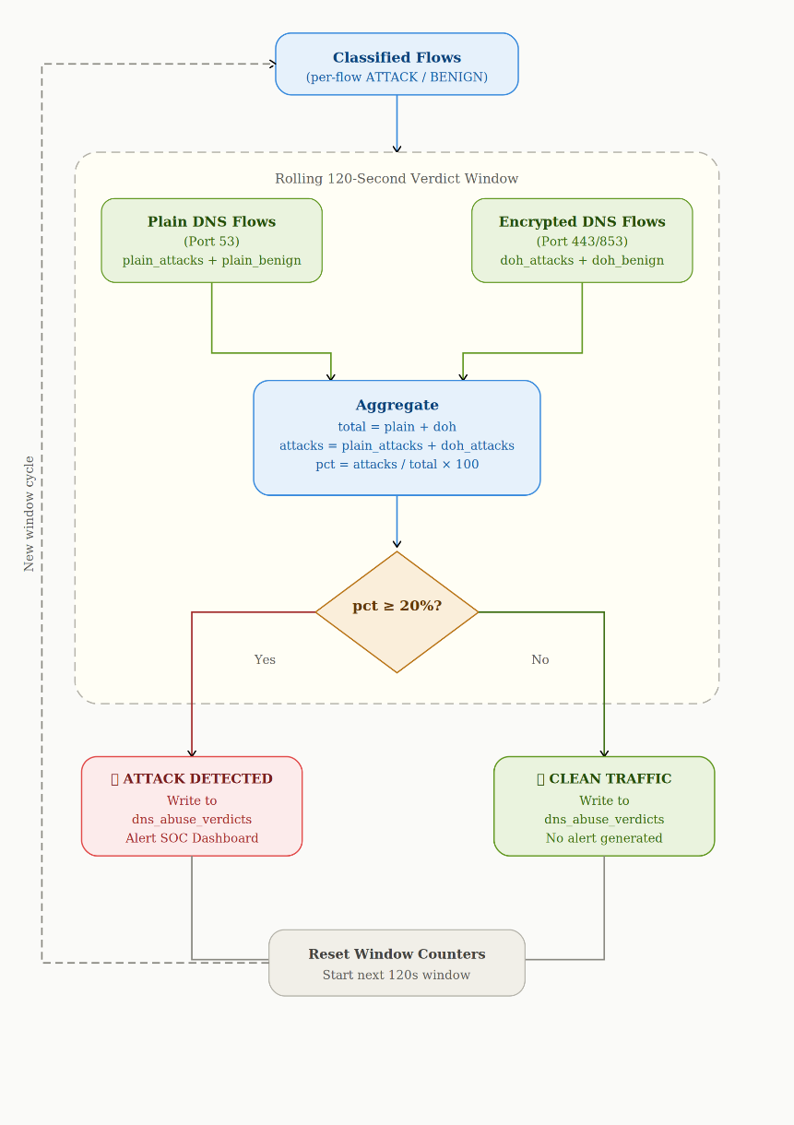

2.7.3 Fault Tolerance
The inference engine incorporates several fault tolerance mechanisms to ensure continuous operation:
- Database Auto-Reconnect: Before each polling cycle, the engine executes `conn.ping(reconnect=True, attempts=3, delay=5) ` to verify database connectivity and automatically re-establish the connection if it has been dropped due to network interruptions or database restarts.
- Singleton Enforcement: A PID file lock mechanism ensures that only one instance of the inference engine runs at any time. If a new instance is started while a previous instance is running, the new instance automatically terminates the old process before acquiring the lock.
- Composite Indexes: On startup, the engine creates composite MySQL indexes on ` (traffic_type, final_decision) ` for both abuse tables, ensuring that the polling query efficiently locates unprocessed rows without requiring full table scans as the tables grow.

2.8 Deployment Architecture
The complete system is deployed across two tiers: a Windows endpoint agent and a Linux analytics server.
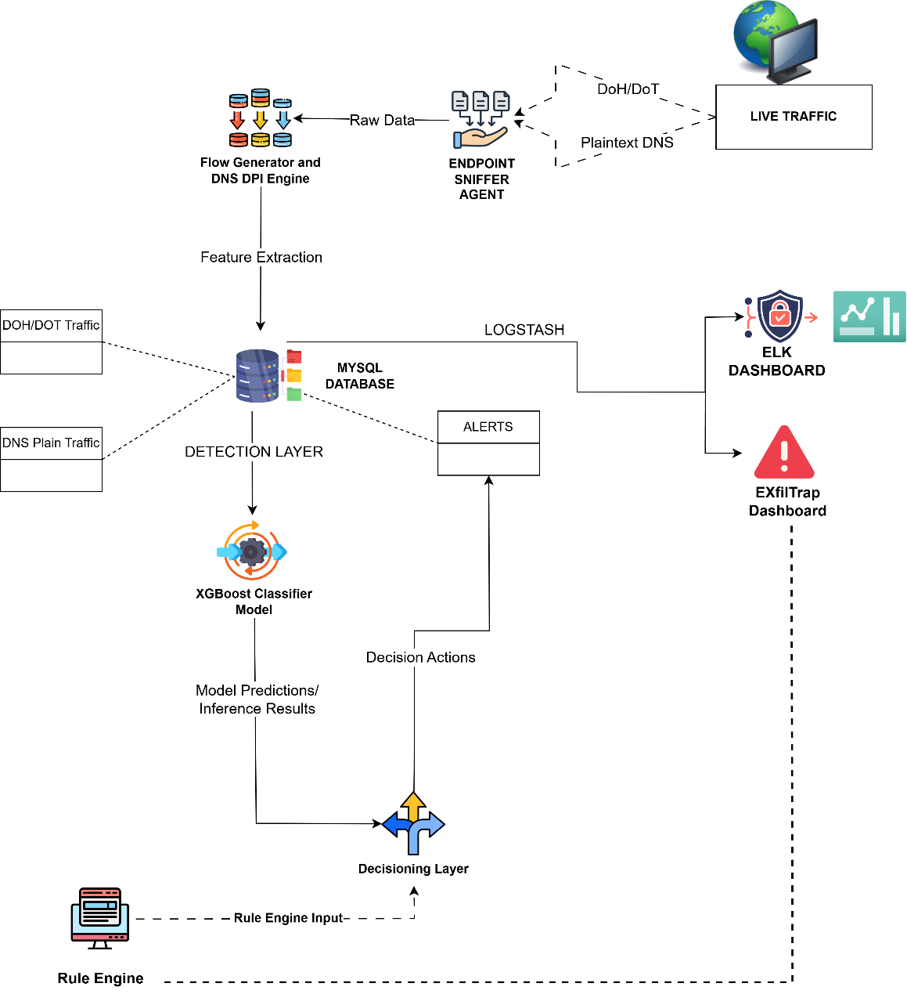

2.8.1 Endpoint Agent - Windows Executable
The executable supports two deployment modes:
Mode | Command | Use Case
Console mode | ExfiltrapSnifferAgent.exe --iface "..." --db-host ... | Testing, debugging, manual execution
Windows Service install | ExfiltrapSnifferAgent.exe install | Persistent background agent with auto-start
When installed as a Windows Service (service name: `Exfiltrap2.0-sniffer`), enabling silent auto-start without user interaction. The process priority is set to:
`BELOW_NORMAL_PRIORITY_CLASS` via the Windows API to minimize CPU impact on the monitored host.

2.8.2 Analytics Server - Linux Deployment
The server-side analytics engine (`realtime_detector.py`) runs as a persistent daemon on a Linux server that hosts the MySQL database instance. The server also hosts the Kibana and Elasticsearch stack, which consumes the `dns_abuse_security_alerts` and `dns_abuse_verdicts` tables to render real-time SOC dashboards.
The separation of the endpoint agent (Windows) from the analytics engine (Linux) provides several architectural advantages:
- Scalability: Multiple endpoint agents can report to a single analytics server, enabling centralized monitoring across an enterprise fleet.

- Model Updates: The XGBoost model can be updated on the server without requiring redeployment of the endpoint agent, as the model is loaded and applied server-side.

- Minimal Endpoint Footprint: The endpoint agent performs only feature extraction and database writes, with no ML inference overhead, ensuring negligible impact on host performance.

2.8.3 Database Schema
Table | Purpose | Key Columns
dns_abuse_plain | Port 53 flows with 39 features | abuse_plain_id, timestamp, src_ip, dst_ip, all 39 features, final_decision
dns_abuse_doh | Port 443/853 flows with 39 features | abuse_doh_id, timestamp, client_ip, server_ip, all 39 features, final_decision
dns_abuse_security_alerts | Flows classified as ATTACK (for SOC dashboard) | Mirrors abuse table schema with auto-increment alert_id
dns_abuse_verdicts | Rolling 120-second verdict summaries | verdict_id, window_start, window_end, total_flows, total_attacks, verdict
agent_hosts | Registered endpoint agent metadata | hostname, mac_address, os_version, local_ip, interface
The MySQL database `exfiltrap2.0` contains the above tables relevant to this component.

2.9 Commercialization Aspects
The deployment architecture is designed with commercial viability in mind. The single-file Windows executable eliminates complex installation procedures, making it suitable for enterprise-wide deployment through standard software distribution mechanisms such as Microsoft SCCM or Group Policy. The JSON-based configuration enables centralized management of database endpoints and network interface selection across multiple monitored hosts. The industry-standard Kibana dashboard integration ensures compatibility with existing SOC infrastructure, reducing the adoption barrier for security teams already using the Elastic Stack.

3. RESULTS AND DISCUSSION

3.1 Evaluation of Methodology
The evaluation was designed to assess the system's performance under conditions that progressively approximate real-world deployment. The offline validation (Section 4.2) establishes a performance ceiling using data drawn from the same distribution as the training set. The live operational evaluation (Section 4.3) measures performance on traffic captured from a realistic endpoint environment where no control is exercised over traffic composition or timing. This two-phase approach enables quantification of the performance degradation that occurs when transitioning from controlled to operational conditions.
The evaluation metrics used throughout this chapter are defined as follows:
Metric | Formula | Interpretation
Accuracy | (TP + TN) / (TP + TN + FP + FN) | Overall proportion of correct classifications
Precision | TP / (TP + FP) | Proportion of predicted attacks that are actual attacks
Recall (TPR) | TP / (TP + FN) | Proportion of actual attacks that are correctly detected
F1-Score | 2 × (Precision × Recall) / (Precision + Recall) | Harmonic mean of precision and recall
False Positive Rate | FP / (FP + TN) | Proportion of benign flows incorrectly classified as attacks
ROC-AUC | Area under ROC curve | Aggregate measure of discrimination ability across all thresholds
Where TP = True Positive (correctly detected attack), TN = True Negative (correctly identified benign), FP = False Positive (benign misclassified as attack), FN = False Negative (attack missed).

3.2 Offline Model Validation
The offline validation was conducted on the held-out test partition of the balanced ~1 million -flow training dataset. The metrics were computed at the tuned threshold of 0.19 and stored within the serialized model bundle at training time.
The ROC-AUC of 0.9995 indicates near-perfect discriminative ability, meaning that a randomly selected attack flow receives a higher predicted probability than a randomly selected benign flow in 99.95% of cases. The attack recall of 99.73% demonstrates that the F-beta (3.0) threshold tuning successfully maximized detection coverage, with only 0.27% of attack flows evading classification.
The benign recall of 97.69% and corresponding FPR of 2.31% represent the cost of the aggressive threshold. Approximately 2.31% of benign flows are incorrectly flagged as attacks at this operating point. This trade-off was deemed acceptable during the design phase, as the rolling verdict window (Section 3.6.2) aggregates per-flow predictions into time-smoothed verdicts, effectively dampening the impact of individual false positives on SOC alert generation.

Metric | Value
Attack Recall (TPR) | 99.73%
Benign Recall (TNR) | 97.69%
False Positive Rate | 2.31%
ROC-AUC | 0.9995
Threshold | 0.19

3.3 Live Operational Evaluation
The live operational evaluation was conducted on traffic captured from a realistic endpoint environment. The test dataset consisted of traffic generated by concurrently running multi-threaded botnet attack generators alongside authentic human browsing sessions, including video streaming, web search, social media, and general browsing activity. The traffic was captured using the deployed AbuseSniffer engine and processed through the complete inference pipeline.

Traffic Category | Flow Count
Attack flows | 36,657
Benign flows | 10,924
Total | 47,581

Metric | Value
Overall Accuracy | 94.05%
Attack Precision | 98.72%
Attack Recall (Sensitivity) | 93.48%
F1-Score | 96.03%
False Positive Rate | 4.06%
ROC-AUC | 0.9786
The live operational accuracy of 94.05% represents a 4.66 percentage point decrease from the offline validation metrics. This degradation is expected and attributable to the distribution shift between the curated training data and the noisy, heterogeneous patterns present in live endpoint traffic. The magnitude of this shift is consistent with observations in the literature; El Attar et al. (2023) documented a substantially larger degradation from synthetic to real DNS traffic.
The attack precision of 98.72% indicates that when the system flags a flow as an attack, it is correct in 98.72% cases. This high precision ensures that SOC analysts investigating system alerts will encounter a very low rate of false leads, preserving analyst trust and operational efficiency.
The false positive rate of 4.06% means that approximately 4 out of every 100 benign flows are incorrectly classified as attacks. In the context of the rolling verdict window, which aggregates flows over 120-second windows with a 20% attack threshold, this per-flow FPR is well below the threshold required to trigger a false verdict, providing an additional layer of noise suppression.

3.4 Comparison with Existing Approaches

Criterion | Sommese et al. (2020) | Suvra et al. (2021) | Erskine (2023) | El Attar et al. (2023) | Alharby (2025) | Proposed System
Accuracy | N/A (measurement) | 98.80% | 85.00% | N/A (F1-centric) | 99.99% | 94.05%
Precision | N/A | 99.00% | 81.00% | N/A | 99.99% | 98.72%
Recall | N/A | 98.00% | 83.00% / 62.00% (Mirai) | N/A | 99.99% | 93.48%
F1-Score | N/A | 98.00% | 80.00% | 1.00 (synth) / 0.74 (real) | 99.99% | 96.03%
FPR Evaluated | No | No | No | No | No | Yes -4.06%
Encrypted DNS | No | No | No | No | No | Yes (DoH + DoT)
Live Traffic Eval | Retrospective only | No | No | Partial | No | Yes
Real-Time Agent | No | No | Near RT | Near RT | No | Yes
SOC Integration | No | No | No | No | No | Yes (Kibana)
Endpoint Deployed | No | No | No | No | No | Yes (Windows EXE)

Below comparison demonstrates that while the proposed system's raw accuracy (94.05%) is numerically lower than Suvra et al.'s 98.80% or Alharby's 99.99%, this difference is explained by the fundamental distinction in evaluation conditions. The proposed system is the only approach evaluated on live, unstructured endpoint traffic; all other studies report metrics from static benchmark datasets where the test distribution closely matches the training distribution.
The proposed system is also the only approach that reports an explicit FPR, supports encrypted DNS protocols, deploys as a persistent endpoint agent, and integrates with SOC infrastructure. These capabilities represent the primary contribution of this research and address all five gaps identified in the literature review (Section 2.6).

3.6 Discussion
3.6.1 Offline-to-Live Performance Degradation
The observed accuracy drops from approximately 98% (offline) to 94.05% (live) reflects the distribution shift inherent in transitioning from curated training data to authentic operational traffic. This degradation is consistent with the broader pattern observed in the literature, where El Attar et al. (2023) documented F1-score drops from 1.00 to 0.74 between synthetic and real DNS traffic. The proposed system's degradation of approximately 4 percentage points is substantially smaller, suggesting that the combination of DNS-specific features, custom-generated training traffic, and robust regularization produces a model with superior generalization capability.

3.6.2 The FPR as a SOC Metric
The explicit measurement and reporting of FPR represents a methodological contribution of this research. In SOC environments, FPR directly determines analyst workload and system trust. The global FPR of 4.06% means that a SOC analyst reviewing 100 flow-level alerts will encounter approximately 4 false positives. When further filtered through the rolling verdict window (which requires 20% of flows in a 120-second window to be attacks before generating an alert), the effective alert-level false positive rate is substantially lower than the per-flow FPR.

3.6.3 Feature Engineering vs. Model Complexity
The system's strong performance with a relatively simple model architecture (gradient boosted decision trees) compared to the deep learning approach of Erskine (2023), which achieved lower accuracy (85%) with greater model complexity, validating the principle that domain-specific feature engineering is more impactful than model complexity for network security classification tasks. The 39 DNS-specific features capture the essential signal, enabling the model to make accurate predictions without requiring the representational capacity of deep neural networks.

3.6.4 Strengths of the Proposed Approach
The proposed DNS abuse detection approach demonstrates several key strengths that distinguish it from existing solutions.
The use of a comprehensive 39-feature DPI pipeline covering seven orthogonal categories enables the system to capture multiple dimensions of DNS abuse behavior simultaneously. This multi-dimensional feature space allows the classifier to identify diverse attack patterns, from volumetric flooding to encrypted covert channels, within a single unified model.
The decryption-free TLS metadata extraction represents a fundamental architectural advantage. By operating exclusively on TLS handshake data and encrypted record sizes, the system avoids the privacy, legal, and computational implications of man-in-the-middle decryption while still achieving effective detection of abuse within encrypted channels.
The two-tier deployment architecture ensures minimal impact on monitored endpoints while providing centralized analytics and SOC integration. The separation of feature extraction (endpoint) from ML inference (server) enables model updates without endpoint redeployment and supports multi-endpoint fleet monitoring through a single analytics server.
The F-beta (3.0) threshold tuning methodology provides a principled, reproducible approach to calibrating the precision-recall trade-off for security-critical deployment, rather than relying on the arbitrary default threshold of 0.50.
3.6.5 Limitations
Despite the system's strong overall performance, several limitations must be acknowledged.
The elevated FPR of encrypted DoH/DoT traffic indicates that the current feature set provides insufficient discriminative power for encrypted flow classification. While the rolling verdict window mitigates this at the alert level, per-flow classification accuracy for encrypted traffic remains a significant area for improvement.
The traditional DNS recall of 71.10% suggests that certain port 53 attack patterns produce feature profiles that are difficult to distinguish from legitimate high-volume DNS activity. This is particularly relevant for enterprise environments with DNS-intensive applications (e.g., Active Directory, service mesh configurations).
The evaluation was conducted on a single endpoint deployment. Multi-endpoint evaluation across diverse network environments would strengthen the generalizability claims.
3.6.6 Challenges Faced
Several challenges were encountered during the design and implementation of the system.
Maintaining feature alignment between the training pipeline and the live inference pipeline required meticulous attention. Any mismatch in feature ordering, preprocessing logic, or encoding between training and inference would silently degrade model performance without producing explicit errors.
Handling the high variability in DNS traffic patterns, including burst traffic from legitimate services, overnight background updates, and CDN resolution storms, required robust feature engineering that captures temporal and distributional characteristics rather than simple threshold-based rules.
Managing database throughput during high-volume attack simulations, where thousands of flows per second are exported simultaneously, necessitated the async SQL queue architecture and exponential backoff retry mechanism to prevent data loss.

3.6.7 Future Improvements
Several enhancements could further improve the system's performance and capabilities.
The integration of TLS certificate fingerprinting using JA3 and JA3S hash computation would provide additional discriminative features for encrypted traffic, potentially reducing the DoH/DoT FPR by distinguishing different client and server software profiles.
Implementing adaptive model retraining with data drift detection would enable the system to automatically detect changes in traffic patterns over time and trigger periodic model updates to maintain accuracy against evolving attack techniques.
Introducing environment-specific fine-tuning, where the base model is adapted to the specific traffic patterns of each deployment site, could significantly improve detection accuracy by accounting for organization-specific DNS usage patterns.
Federated model updates across multiple endpoint agents could enable collaborative learning without centralizing raw traffic data, improving model robustness while preserving endpoint privacy.

4: CONCLUSION

4.1 Summary of Work
This research focused on the design, development, and evaluation of a real-time, endpoint-deployed machine learning system for the detection of DNS abuse and infrastructure attacks. The proposed approach addresses a critical gap in the existing literature, where detection systems are predominantly evaluated on static benchmark datasets, limited to unencrypted DNS traffic on port 53, and lack explicit False Positive Rate assessment against live human traffic.
The system comprises two primary components: an endpoint-deployed Deep Packet Inspection (DPI) engine that captures live network traffic and extracts 39 specialized features from DNS-relevant flows across ports 53, 443, and 853, and a server-side analytics engine that applies an XGBoost gradient boosted decision tree classifier to generate real-time attack/benign classifications with rolling verdict aggregation for SOC integration.
The feature engineering pipeline spans seven orthogonal categories, including DNS-critical metrics (amplification factor, query-response ratio, ANY/TXT query ratios), flow statistics, timing characteristics, packet size distributions, and encrypted traffic indicators (SNI entropy, DoH server identification, encrypted payload size variance). A key architectural differentiator is the decryption-free extraction of TLS handshake metadata, enabling detection of abuse within encrypted DoH and DoT channels without the privacy, legal, and computational implications of payload decryption.
The XGBoost classifier was trained on a balanced dataset of ~1 million flows derived from CICIoT2023, CIC-DDoS2019, and custom-generated traffic. The classification threshold was optimized using F-beta tuning with beta equal to 3.0, which mathematically prioritizes attack recall nine times over precision, reflecting the operational reality that missed attacks carry significantly higher cost than false alarms in security operations.
The system was packaged as a self-contained Windows executable for endpoint deployment and integrated with a MySQL database and Kibana dashboard infrastructure for centralized SOC monitoring.

4.2 Key Outcomes
The key outcomes of this research can be summarized as follows:
A comprehensive 39-feature DPI pipeline was successfully designed and implemented, covering seven orthogonal feature categories that capture distinct dimensions of DNS abuse behavior across both encrypted and unencrypted protocols.
An XGBoost classifier was trained and optimized, achieving offline validation metrics of 99.73% attack recall, 97.69% benign recall, and an ROC-AUC of 0.9995 on the balanced test partition.
The system was evaluated on live, unstructured endpoint traffic and demonstrated an operational accuracy of 94.05%, attack precision of 98.72%, and a false positive rate of 4.06%, validating its suitability for SOC integration.
A protocol-specific analysis revealed near-perfect attack recall of 99.94% on encrypted DoH/DoT traffic, alongside an honest acknowledgement of the elevated 46.27% FPR on encrypted flows due to the inherent challenge of distinguishing attack patterns from benign activity within TLS-encrypted channels.
The F-beta (3.0) threshold tuning methodology was successfully applied, reducing the classification threshold from the default 0.50 to 0.19, which substantially improved attack detection coverage while maintaining an operationally acceptable false positive rate.
The endpoint agent was deployed as a persistent Windows Service with below-normal process priority, demonstrating practical viability for enterprise deployment without degrading host performance.
The rolling verdict window mechanism was implemented, providing time-smoothed, actionable SOC alerts rather than per-flow noise, with configurable aggregation windows and attack percentage thresholds.

6. References

7. Appendice

