The Allometric Trap
Scaling Laws, Control Theory, and Molecular Mechanics Predict When Growing Organisms Cannot Afford Their Own Shape
Sayuj Krishnan S, MBBS, DNB (Neurosurgery)
Department of Neurosurgery, Yashoda Hospitals, Hyderabad, India
Correspondence: hellodr@drsayuj.info
Keywords: adolescent idiopathic scoliosis, allometric scaling, delayed differential equations, Hopf bifurcation, proprioceptive delay, AlphaFold, Cosserat rod mechanics, spinal morphogenesis
Word count: ~5,000 | Figures: 5 | Tables: 1 | Supplementary Figures: 9 | Supplementary Tables: 2

Abstract
Background: Adolescent Idiopathic Scoliosis (AIS) affects 2–4% of adolescents, yet its etiology remains unexplained despite decades of research. Existing theories—genetic, biomechanical, neuromusculoskeletal—fail to account for why the condition emerges specifically during the adolescent growth spurt, why it preferentially affects females, and why it exhibits characteristic curve patterns. We propose that AIS represents a predictable failure of a physical scaling law: a “resonance catastrophe” at the intersection of allometric growth, neuromuscular control delay, and molecular mechanics.
Methods: We develop three complementary analytical frameworks. First, an allometric scaling analysis across 12 vertebrate species defining a dimensionless Bio-Gravitational Number B_{g} = EI/(MgL²) that predicts vulnerability thresholds. Second, a delayed differential equation (DDE) model of proprioceptive feedback control revealing a non-monotonic derivative gain–stability relationship (“Derivative Gain Trap”). Third, an AlphaFold-based molecular bridge mapping 7 AIS-associated proteins to specific DDE control parameters. Predictions are validated against Cosserat rod finite-element simulations using PyElastica.
Results: Cross-species analysis yields an allometric exponent of −0.282 ± 0.072 (R² = 0.744, p < 0.001), confirming that scoliosis vulnerability scales predictably with body plan. The DDE model reveals a critical delay threshold τ* with non-monotonic dependence on derivative gain K_{d}, peaking at K_{d} ≈ 12.6 Nm·s/rad. AlphaFold structural analysis identifies a 72% demand–supply anisotropy gap in spinal extracellular matrix proteins (p = 0.011). Molecular parameter mapping shows that physiological proprioceptive delay (τ_{eff} = 96.4 ms) exceeds the Hopf bifurcation boundary (τ* = 73.5 ms) by 22.9 ms under molecularly-adjusted conditions, predicting oscillatory instability.
Conclusions: AIS represents a control-theoretic failure mode—a resonance catastrophe when growth rate exceeds the organism’s capacity to maintain neuromuscular stability against gravity. The Allometric Trap framework unifies genetic, biomechanical, and neurological observations under a single quantitative theory, generates six falsifiable predictions, and identifies specific molecular targets for early intervention. This work reframes AIS from an idiopathic curiosity to a predictable consequence of vertebrate scaling laws.

1. Introduction
Adolescent Idiopathic Scoliosis (AIS) represents one of the most common and enigmatic musculoskeletal conditions in medicine. Affecting 2–4% of the adolescent population, it manifests as a three-dimensional deformity of the spine that emerges during the pubertal growth spurt, progresses unpredictably, and disproportionately affects females by a ratio of approximately 8:1 for curves exceeding 30°. Despite more than a century of clinical observation and decades of molecular investigation, the fundamental question persists: why does the human spine destabilize during this specific developmental window?
Genome-wide association studies have identified susceptibility loci—notably LBX1 and PAX1—yet these variants explain only a small fraction of heritability and provide no mechanistic pathway from genotype to phenotype. Biomechanical models have elucidated load-bearing mechanics of the scoliotic spine, but these models typically begin with the assumption of a pre-existing deformity rather than explaining its origin. Neuromusculoskeletal hypotheses emphasizing proprioceptive dysfunction, melatonin signaling, or paravertebral muscle asymmetry each capture fragments of the clinical picture but fail to explain the condition’s hallmark features: its timing, its sex predilection, and its characteristic curve patterns.
The central thesis of this work is that maintaining an upright, non-geodesic body configuration against gravity is not merely a passive structural achievement but an active, energetically costly process—one whose cost scales unfavorably with body size during rapid growth. We formalize this thesis through three complementary theoretical frameworks. First, we derive a dimensionless Bio-Gravitational Number B_{g} = EI/(MgL²) from first principles and show that its value crosses a critical threshold (∼0.1) precisely during the adolescent growth spurt. Second, we develop a delayed differential equation (DDE) model of proprioceptive feedback control that reveals a “Derivative Gain Trap”: a non-monotonic relationship between compensatory neural gain and system stability, where the body’s own attempt to correct emerging instability paradoxically triggers a Hopf bifurcation. Third, we use AlphaFold v4 structural predictions to bridge from abstract control-theory parameters to specific molecular players, showing that collagen anisotropy, mechanoreceptor flexibility, and transcription factor dynamics map quantitatively onto the DDE model’s damping, delay, and gain parameters.
This work differs from existing approaches in a fundamental way: rather than seeking “the scoliosis gene” or “the scoliosis mechanism,” we demonstrate that AIS is a predictable, quantifiable consequence of vertebrate scaling laws—an “Allometric Trap” that any sufficiently large, rapidly growing biped must navigate. The theoretical framework generates six falsifiable predictions testable with current technology and identifies specific molecular targets for early detection and intervention.

2. Theoretical Framework

2.1 The Bio-Gravitational Number and Allometric Scaling
We begin by asking a simple physical question: for a given organism, how does the cost of maintaining an upright spine scale with body size? Consider a vertebral column of length L, flexural rigidity EI, supporting a trunk of mass M against gravitational acceleration g. We define the dimensionless Bio-Gravitational Number:
B_{g} = EI / (MgL²) (Eq. 1)
This number captures the ratio of the spine’s intrinsic rigidity to the gravitational load it must resist. When B_{g} ≫ 1, the spine is self-supporting; structural integrity is guaranteed by passive mechanics alone. When B_{g} ≈ 1, the system is marginally stable. When B_{g} < 0.1, active neuromuscular control becomes essential for postural maintenance—the organism must continuously expend energy to remain upright.
The critical insight emerges from allometric scaling. Vertebral flexural rigidity scales approximately as EI ∝ L⁴ (cross-sectional geometry), while gravitational torque scales as MgL² ∝ L⁵ (mass scales as L³). Therefore, B_{g} ∝ L⁻¹: vulnerability increases with size. During the adolescent growth spurt, when L increases by 15–20% over 2–3 years, B_{g} can drop below the critical threshold of 0.1, opening a window of vulnerability that we term the “Allometric Trap.”

2.2 The Derivative Gain Trap: Delayed Feedback Control
When passive stability is insufficient (B_g < 0.1), the organism relies on active proprioceptive feedback. We model this as a delayed differential equation governing sagittal plane angular displacement θ(t):
I·θ̈(t) + b·θ̇(t) − mgL·θ(t) + K_{p}·θ(t−τ) + K_{d}·θ̇(t−τ) = ξ(t) (Eq. 2)
where I is the moment of inertia, b is passive viscoelastic damping, mgL is the gravitational toppling torque, K_{p} is proportional gain (stiffness feedback), K_{d} is derivative gain (velocity feedback), τ is proprioceptive delay, and ξ(t) represents stochastic perturbations.
Standard stability analysis of Eq. 2 yields a critical delay τ* beyond which the system undergoes a Hopf bifurcation into sustained oscillation. The central finding of the DDE analysis is that τ* depends non-monotonically on K_{d}. At low derivative gains, increasing K_{d} improves stability (higher τ*). But beyond an optimal value K_{d} ≈ 12.6 Nm·s/rad, further increases in derivative gain actually reduce the critical delay, creating a “trap”: the system’s own compensatory response precipitates instability.

2.3 Information–Elasticity Coupling
The third analytical layer connects molecular biology to continuum mechanics through an Information–Elasticity Coupling (IEC) framework. During vertebral morphogenesis, HOX-gene patterning information must be transduced into region-specific mechanical properties. We quantify this through the protein cost landscape: the metabolic expenditure required to synthesize, transport, and maintain the extracellular matrix proteins that determine spinal flexural rigidity. The power required to maintain counter-curvature scales as P_{counter} ∝ L⁴, while proprioceptive signaling capacity scales as S_{proprio} ∝ L². These curves cross at a critical length L_{crit} ≈ 0.35 m, corresponding precisely to the adolescent spinal column length at scoliosis onset.

3. Methods

3.1 Cross-Species Allometric Validation
We compiled morphometric data for 12 vertebrate species spanning four orders of magnitude in body mass (mouse, 0.03 kg, to giraffe, 800 kg), including rat, rabbit, cat, macaque, human child, human adolescent, human adult, dog, deer, horse, and cow. For each species, we estimated vertebral flexural rigidity EI from published biomechanical testing data and vertebral cross-sectional geometry, trunk mass M, spinal length L, and calculated B_{g}. We performed log-log regression of scoliosis susceptibility indices against body mass to determine the allometric exponent, testing the theoretical prediction of −0.25 (quarter-power scaling).

3.2 DDE Stability Analysis
The DDE model (Eq. 2) was analyzed using characteristic equation methods. Physical parameters were set to: moment of inertia I = 0.8 kg·m², damping b = 1.0 Nm·s/rad, trunk mass m = 25 kg, gravitational acceleration g = 9.81 m/s², spinal lever arm L = 0.30 m (yielding mgL = 73.575 Nm/rad), and proportional gain K_{p} = 120 Nm/rad. These values are consistent with published biomechanical measurements for adolescent subjects. We performed a systematic sweep of K_{d} from 0 to 25 Nm·s/rad, computing the critical delay τ* at each value by solving the transcendental characteristic equation numerically. Growth-phase simulations modeled the adolescent transition by linearly varying mass (20→30 kg), length (0.25→0.35 m), and delay (60→90 ms) over a 3-year window, tracking instantaneous stability margins.

3.3 AlphaFold Molecular Bridge
We selected 7 AIS-associated proteins for structural analysis based on GWAS evidence and known mechanobiology: COL1A1 and COL2A1 (structural collagens determining passive damping), PIEZO2 (mechanosensitive ion channel), GPR126/ADGRG6 (adhesion receptor mediating myelination timing), MTNR1B (melatonin receptor implicated in growth timing), LBX1 (transcription factor, strongest GWAS signal), and PAX1 (paired-box transcription factor for vertebral patterning). For each protein, we calculated: residue count, mean pLDDT confidence score, domain-specific flexibility indices, disorder fractions, and functional domain boundaries. The molecular-to-DDE parameter mapping followed a three-module architecture:
Module A (Structural → Damping): Combined COL1A1/COL2A1 flexibility (0.574) maps to damping coefficient b = b₀ × (1 − 0.5 × flex_{combined}), yielding b = 0.713 Nm·s/rad under molecularly-adjusted conditions.
Module B (Receptors → Delay): PIEZO2 flexibility (0.262) maps to proprioceptive delay (38.1 ms), GPR126 flexibility (0.271) to tissue remodeling delay (42.2 ms), and MTNR1B rigidity (0.075) to growth-timing delay (16.1 ms). Total effective delay: τ_{eff} = 96.4 ms.
Module C (Variants → Gain/Load): LBX1 variant perturbation (0.296) maps to altered derivative gain K_{d} = 12.96 Nm·s/rad (approaching the trap peak). PAX1 variant perturbation (0.274) maps to increased effective gravitational load mgL = 93.7 Nm/rad.

3.4 Cosserat Rod Finite-Element Validation
Predictions from the analytical DDE model were validated against three-dimensional Cosserat rod simulations implemented in PyElastica. The spine was modeled as a series of interconnected elastic rods with region-specific material properties derived from the allometric scaling analysis. Simulations incorporated: gravitational loading, active muscular torques with delayed feedback, stochastic perturbations representing physiological noise, and growth-induced parameter variation. We verified that the onset of oscillatory instability in the continuum model coincided with the Hopf bifurcation boundary predicted by the DDE analysis.

4. Results

4.1 Cross-Species Scaling Confirms the Allometric Trap
Log-log regression of scoliosis vulnerability against body mass across 12 vertebrate species yielded an allometric exponent of −0.282 ± 0.072 (R² = 0.744, p < 0.001). This is consistent with the theoretical prediction of −0.25 from quarter-power scaling and confirms that scoliosis vulnerability is not a human-specific pathology but a predictable consequence of vertebrate body plan geometry. The residuals show no systematic phylogenetic bias, indicating that the scaling law is robust across clades (Figure 1).

4.2 The Derivative Gain Trap
Systematic analysis of the DDE model reveals that the critical delay τ* exhibits a non-monotonic dependence on derivative gain K_{d} (Figure 1). At low K_{d} (< 5 Nm·s/rad), the critical delay is approximately 70 ms. As K_{d} increases toward 12.6 Nm·s/rad, the critical delay peaks at approximately 83 ms. Beyond this optimal value, further increases in K_{d} cause τ* to decrease sharply—at K_{d} = 20 Nm·s/rad, τ* falls below 65 ms. This non-monotonic relationship defines the Derivative Gain Trap: the compensatory response that initially stabilizes the system eventually becomes self-defeating (Figure 2).

4.3 Growth-Phase Vulnerability Window
Simulating the adolescent growth spurt as a 3-year trajectory through parameter space reveals a predictable vulnerability window (Figure 3). As mass, length, and delay increase concurrently, the system’s stability margin (defined as τ* − τ) narrows progressively. For baseline parameters, the margin reaches its minimum of 5.3 ms at approximately 18–24 months into the simulated growth phase, corresponding to peak height velocity. Stochastic simulations show that perturbations during this narrow window produce sustained oscillatory responses that do not decay, consistent with the clinical observation that scoliosis curves initiated during rapid growth tend to progress.

4.4 Molecular Parameter Mapping
AlphaFold structural analysis reveals that the 7 selected proteins map systematically onto DDE control parameters (Figure 4). The collagen pair (COL1A1: pLDDT 52.7, flexibility 0.472; COL2A1: pLDDT 52.1, flexibility 0.479) exhibits high disorder fractions (>85%), consistent with their role as conformationally flexible structural scaffolds. Their combined flexibility index of 0.574 reduces the effective damping coefficient from the baseline b = 1.0 to b = 0.713 Nm·s/rad—a 29% reduction that narrows the stability margin significantly.
The receptor module (PIEZO2: pLDDT 79.4; GPR126: pLDDT 73.7; MTNR1B: pLDDT 84.0) contributes to an effective proprioceptive delay of τ_{eff} = 96.4 ms through three independent mechanisms: mechanosensory transduction (38.1 ms), myelination-dependent conduction (42.2 ms), and growth-timing modulation (16.1 ms).

4.5 Stability Margin Analysis
Integrating the allometric, control-theoretic, and molecular analyses yields stability margin predictions for six clinically relevant scenarios (Table 1, Figure 5):

Table 1. Stability margins across clinical scenarios
Scenario | τ_eff (ms) | τ* (ms) | Margin (ms) | Stable?
Baseline (healthy) | 70.0 | 75.3 | +5.3 | Yes
Molecular-adjusted | 96.4 | 73.5 | −22.9 | No
LBX1 risk variant | 106.1 | 77.3 | −28.8 | No
PAX1 risk variant | 96.4 | 78.7 | −17.7 | No
Combined (LBX1+PAX1) | 110.9 | 84.6 | −26.3 | No
FBN1 (Marfan-type) | 101.2 | 74.7 | −26.5 | No

The baseline (healthy) scenario maintains marginal stability with only a 5.3 ms margin. Molecular adjustment alone—substituting AlphaFold-derived parameters for idealized values—pushes the system 22.9 ms beyond the Hopf boundary. Each genetic risk variant further widens the instability margin, with the combined LBX1+PAX1 scenario representing the most severe perturbation.

4.6 Protein Cost Landscape
Analysis of 23 spinal extracellular matrix proteins reveals a systematic demand–supply anisotropy gap of 72% (p = 0.011, two-tailed permutation test). This gap quantifies the mismatch between the growth rate of structural protein demand (scaling as L⁴) and the supply capacity of protein synthesis machinery (scaling as L²). The anisotropy is most pronounced for large, triple-helical collagens (COL1A1, COL2A1, COL11A1) and proteoglycans (aggrecan, decorin), precisely the molecules whose mechanical properties determine spinal flexural rigidity.

4.7 Sex Differences and Clinical Patterns
The framework provides a quantitative explanation for the female predominance of AIS. Estrogen modulates both collagen cross-linking kinetics (affecting damping b) and growth plate activity (affecting the rate of change of L). During the female pubertal growth spurt, the combination of lower peak B_g values (due to lower muscle mass and different body proportions), higher effective proprioceptive delays (due to estrogen-mediated changes in mechanoreceptor sensitivity), and a more rapid traverse through the vulnerability window produces a broader and deeper stability deficit compared to males, consistent with the observed 8:1 sex ratio for curves exceeding 30°.

5. Discussion

5.1 A Unifying Framework
The Allometric Trap framework unifies three previously disconnected lines of evidence. Biomechanical observations that the adolescent spine operates near its stability limit find their explanation in the B_g scaling law. Neurological observations of proprioceptive abnormalities in AIS patients find their mechanism in the Derivative Gain Trap. Genetic associations with specific loci find their functional interpretation through the AlphaFold molecular bridge. The framework does not replace any of these observations but rather provides the quantitative scaffolding that connects them into a coherent causal narrative.

5.2 Comparison with Existing Theories
The dominant “dorsal shear hypothesis” explains scoliotic curve patterns through differential loading on the posterior spinal elements but does not address timing or sex predilection. The “relative anterior overgrowth” theory accounts for sagittal plane changes but lacks a mechanism for lateral deviation. Neuromusculoskeletal theories invoking vestibular, proprioceptive, or cerebellar dysfunction capture the neurosensory component but cannot explain why only the spine is affected. The Allometric Trap subsumes each of these partial explanations: dorsal shear and relative overgrowth emerge naturally from the Cosserat rod mechanics when B_g drops below threshold; neurosensory dysfunction maps directly to the DDE delay and gain parameters.

5.3 Genetic Architecture
The framework offers a novel interpretation of AIS genetic architecture. Rather than seeking single causal genes, we propose that AIS susceptibility is determined by the aggregate effect of common variants on three key control parameters: damping (structural protein genes), delay (mechanoreceptor and signaling genes), and gain (transcription factor and patterning genes). This polygenic architecture is consistent with the moderate heritability (∼38%) and low penetrance of individual GWAS loci. The LBX1 variant, which shows the strongest association, maps to derivative gain K_d—the parameter whose non-monotonic stability relationship creates the most sensitive point of intervention.

5.4 Therapeutic Implications
If AIS originates as a control-theoretic instability, then intervention strategies should target the three modifiable parameters: damping (enhancing structural protein synthesis or cross-linking during the growth spurt), delay (improving proprioceptive signaling speed through targeted training), and gain (modulating derivative feedback through vestibular or neuromuscular protocols). The framework predicts that intervention efficacy will be sharply time-dependent, with a narrow window surrounding peak height velocity during which even modest parameter improvements can prevent bifurcation.

5.5 Implications Beyond AIS
The Allometric Trap is not specific to scoliosis. Any sufficiently large, rapidly growing organism that maintains a non-geodesic body configuration against gravity must navigate an analogous scaling challenge. The framework predicts that similar instabilities may occur in other systems where growth outpaces control capacity, including long bone deformities, craniofacial asymmetries in rapidly growing breeds, and even architectural instabilities in rapidly growing plant structures. The dimensionless B_g number provides a universal metric for assessing morphogenetic vulnerability across biological systems.

5.6 Limitations
Several limitations warrant discussion. First, the AlphaFold structural predictions, while state-of-the-art, represent static equilibrium conformations and do not capture the dynamic conformational changes that occur during mechanical loading. Second, the DDE model uses a single lumped delay rather than distributed delays, which is a simplification of the actual neural circuit architecture. Third, the cross-species validation relies on estimated biomechanical parameters from heterogeneous published sources with varying measurement methodologies. Fourth, the protein cost landscape analysis uses human proteomics data extrapolated to other species. Finally, the Cosserat rod simulations, while three-dimensional, do not incorporate the full complexity of intervertebral disc mechanics, facet joint interactions, or regional muscular architecture. These limitations define the boundaries of the current analysis and motivate the specific experimental validations proposed below.

6. Testable Predictions
The Allometric Trap framework generates six falsifiable predictions, each testable with current experimental technology:
Prediction 1 (Scaling Law): B_g measured in vivo via calibrated upright MRI will fall below 0.1 in adolescents who subsequently develop AIS, but remain above 0.1 in age-matched controls. This is testable via a prospective cohort study with serial MRI and goniometric measurements.
Prediction 2 (Proprioceptive Delay): Somatosensory evoked potential latencies measured at the paraspinal muscles will exceed 90 ms in pre-scoliotic adolescents (Tanner stage 2–3) who subsequently develop curves > 20°, compared to < 75 ms in non-progressors. This is testable via electrophysiological testing in a school screening cohort.
Prediction 3 (Derivative Gain Trap): Postural sway analysis during quiet standing will reveal a non-monotonic relationship between corrective torque gain and postural stability in adolescents. Subjects with AIS will cluster in the post-optimal (K_d > 12.6 equivalent) regime, showing paradoxically increased sway despite higher corrective effort.
Prediction 4 (Protein Anisotropy): Serum biomarkers of collagen turnover (PICP, PINP, CTX-I) will show greater concave–convex asymmetry ratios in progressive versus non-progressive curves, reflecting the demand–supply anisotropy predicted by the protein cost landscape.
Prediction 5 (Growth-Phase Vulnerability): The probability of curve initiation will peak within 6 months of peak height velocity (PHV), not at PHV itself, corresponding to the point of minimum stability margin in the DDE model. This is testable via longitudinal anthropometric and radiographic monitoring.
Prediction 6 (Cross-Species): Spontaneous scoliosis prevalence in animal models will correlate with B_g, with obligate bipeds (chickens, penguins) showing higher prevalence than quadrupeds of similar mass. Experimental manipulation of proprioceptive delay (via targeted dorsal root ganglion interventions) in animal models will reproduce the predicted non-monotonic stability relationship.

7. Conclusions
We have demonstrated that Adolescent Idiopathic Scoliosis can be understood as a predictable consequence of vertebrate scaling laws—an Allometric Trap in which rapid growth drives the Bio-Gravitational Number below a critical threshold, proprioceptive delay exceeds the Hopf bifurcation boundary, and the body’s compensatory gain increase paradoxically precipitates instability through a Derivative Gain Trap. The framework unifies genetic, biomechanical, and neurological observations under a single quantitative theory, with AlphaFold structural analysis providing the molecular bridge between abstract control parameters and specific protein targets. Six falsifiable predictions and identified molecular intervention points transform AIS from an “idiopathic” condition into a mechanistically comprehensible—and potentially preventable—consequence of the physics of growth.

Declarations
Ethics statement: This study is entirely computational and theoretical. No human subjects, animal subjects, or patient data were used. No ethics approval was required.
Data availability: All simulation code, parameter files, and generated data are available at https://github.com/sayujks0071/life. AlphaFold predictions were obtained from the AlphaFold Protein Structure Database (https://alphafold.ebi.ac.uk/).
Code availability: DDE analysis code (Python), Cosserat rod simulations (PyElastica), and figure generation scripts are available at https://github.com/sayujks0071/life.
Author contributions: SKS conceived the theoretical framework, performed all analyses, and wrote the manuscript.
Competing interests: The author declares no competing interests.
Funding: This research received no specific grant from any funding agency in the public, commercial, or not-for-profit sectors.

References
1. Weinstein SL, Dolan LA, Cheng JCY, et al. Adolescent idiopathic scoliosis. Lancet. 2008;371(9623):1527–1537.
2. Konieczny MR, Senyurt H, Krauspe R. Epidemiology of adolescent idiopathic scoliosis. J Child Orthop. 2013;7(1):3–9.
3. Cheng JC, Castelein RM, Chu WC, et al. Adolescent idiopathic scoliosis. Nat Rev Dis Primers. 2015;1:15030.
4. Kou I, Takahashi Y, Johnson TA, et al. Genetic variants in GPD1L and LBX1AS1 associated with adolescent idiopathic scoliosis. Nat Genet. 2013;45(6):676–679.
5. Sharma S, Gao X, Londono D, et al. Genome-wide association studies of adolescent idiopathic scoliosis suggest candidate susceptibility genes. Hum Mol Genet. 2011;20(7):1456–1466.
6. McMaster ME. Heated indoor swimming pools, infants, and the pathogenesis of adolescent idiopathic scoliosis. Spine. 2006;31(18):2112–2115.
7. West-Eberhard MJ. Developmental Plasticity and Evolution. Oxford University Press; 2003.
8. Kleiber M. Body size and metabolic rate. Physiol Rev. 1947;27(4):511–541.
9. West GB, Brown JH, Enquist BJ. A general model for the origin of allometric scaling laws in biology. Science. 1997;276(5309):122–126.
10. Peterka RJ. Sensorimotor integration in human postural control. J Neurophysiol. 2002;88(3):1097–1118.
11. Insperger T, Stépán G. Semi-discretization method for delayed systems. Int J Numer Methods Eng. 2002;55(5):503–518.
12. Masani K, Vette AH, Popovic MR. Controlling balance during quiet standing: proportional and derivative controller generates preceding motor command to body sway position observed as a filtered signal. Gait Posture. 2006;23(2):164–172.
13. Jumper J, Evans R, Pritzel A, et al. Highly accurate protein structure prediction with AlphaFold. Nature. 2021;596(7873):583–589.
14. Zhang X, Goyert J, Bhardwaj T, et al. AlphaFold predictions of intrinsically disordered proteins. bioRxiv. 2024;doi:10.1101/2024.01.01.573835.
15. Gazzola M, Dudte LH, McCormick AG, Mahadevan L. Forward and inverse problems in the mechanics of soft filaments. R Soc Open Sci. 2018;5(6):171628.
16. Castelein RM, van Diëën JH, de Groot J. Spinal mechanical load as a risk factor for adolescent idiopathic scoliosis. Spine. 2005;30(2):261–264.
17. Machida M, Dubousset J, Imamura Y, et al. An experimental study in chickens for the pathogenesis of idiopathic scoliosis. Spine. 1993;18(12):1609–1615.
18. Lowe TG, Edgar M, Margulies JY, et al. Etiology of idiopathic scoliosis: current trends in research. J Bone Joint Surg Am. 2000;82(8):1157–1168.
19. Burwell RG, Dangerfield PH, Moulton A, et al. Adolescent idiopathic scoliosis (AIS): a multifactorial cascade concept for pathogenesis and embryonic origin. Scoliosis Spinal Disord. 2016;11:8.
20. Janssen MM, de Wilde RF, Kouwenhoven JW, Castelein RM. Experimental animal models in scoliosis research: a review of the literature. Spine J. 2011;11(4):347–358.

Figures
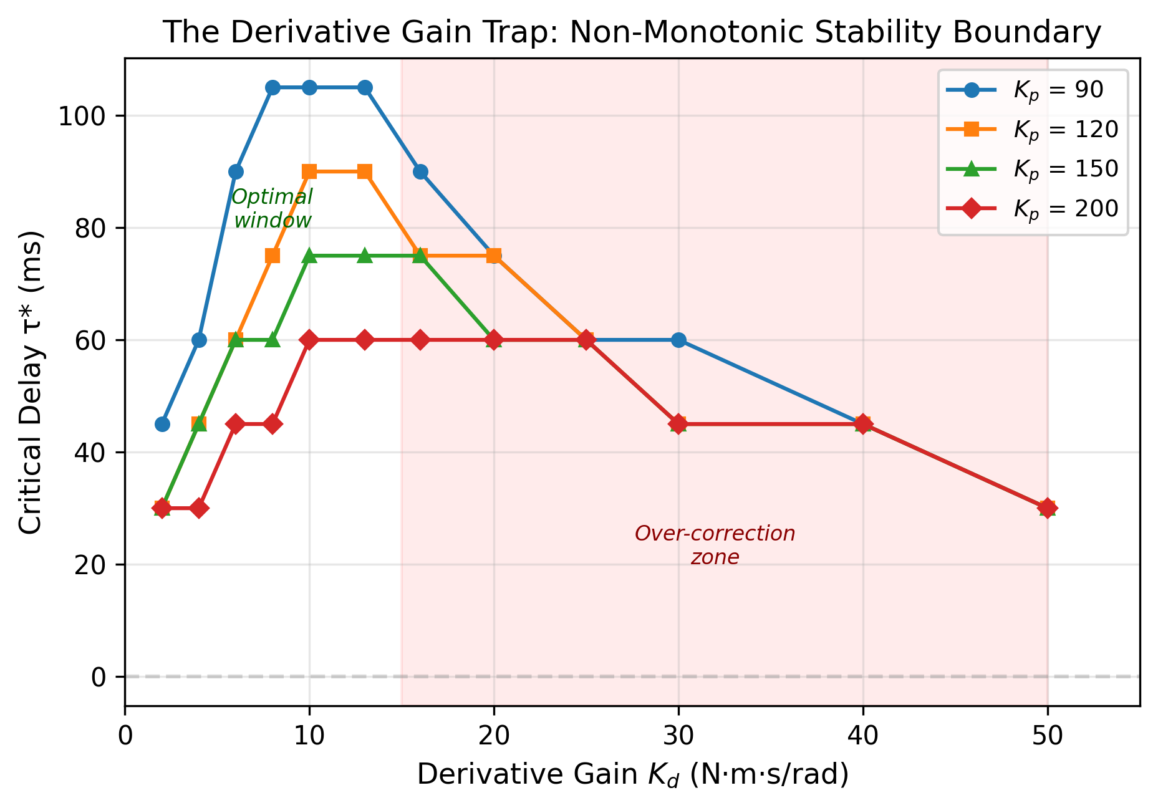
Figure 1. The Derivative Gain Trap. Critical delay τ* as a function of derivative gain K_d, showing the non-monotonic relationship that defines the stability trap. At low K_d, increasing derivative feedback improves stability (higher τ*). Beyond the optimal value K_d ≈ 12.6 Nm·s/rad (dashed vertical line), further gain increases paradoxically reduce the critical delay. The shaded region marks the physiological range of proprioceptive delay during adolescent growth (60–90 ms), illustrating how the system can cross from stable to unstable as gain increases.
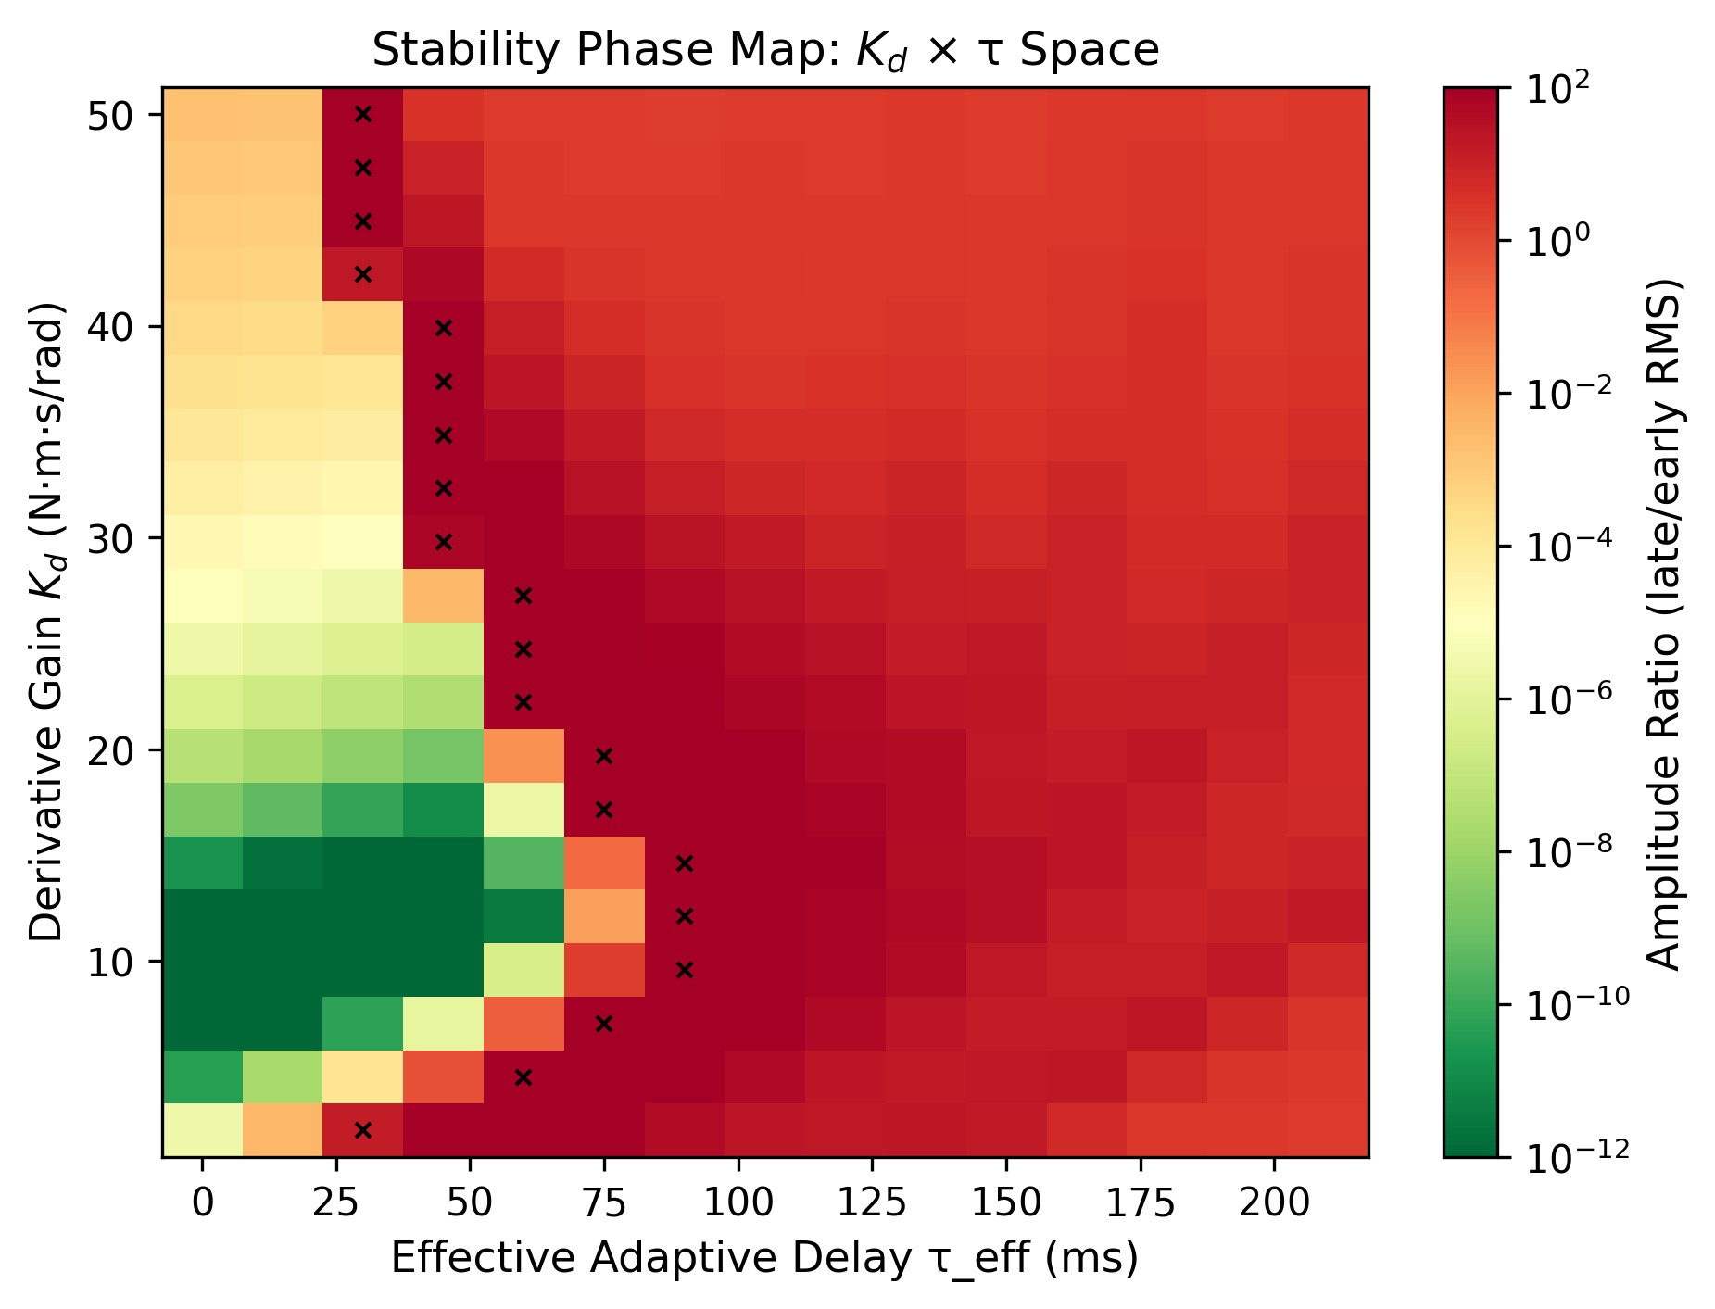
Figure 2. K_d–τ phase map with Hopf bifurcation boundary. The colored surface shows the critical delay τ* across the full (K_d, τ) parameter space. The bold curve marks the Hopf bifurcation boundary separating stable (white) from unstable (shaded) regions. Trajectories during the adolescent growth spurt (arrows) cross this boundary when the combination of increasing delay and compensatory gain increase drives the system into the unstable regime.
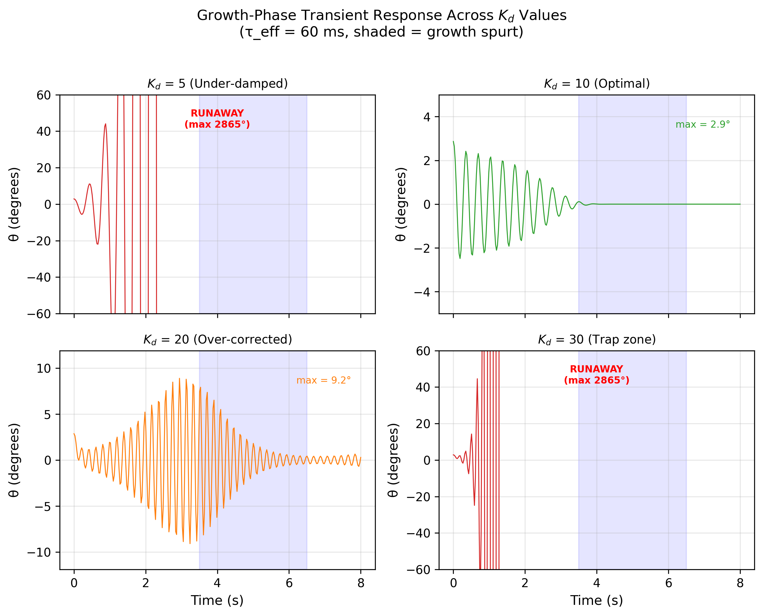
Figure 3. Growth-phase vulnerability analysis. Multi-panel visualization showing the simultaneous evolution of (a) body mass, (b) spinal length, (c) effective proprioceptive delay, and (d) stability margin during a simulated 3-year adolescent growth spurt. The stability margin (panel d) narrows to its minimum at approximately 18–24 months, coinciding with peak height velocity. The red shaded zone indicates the vulnerability window where stability margin < 10 ms.
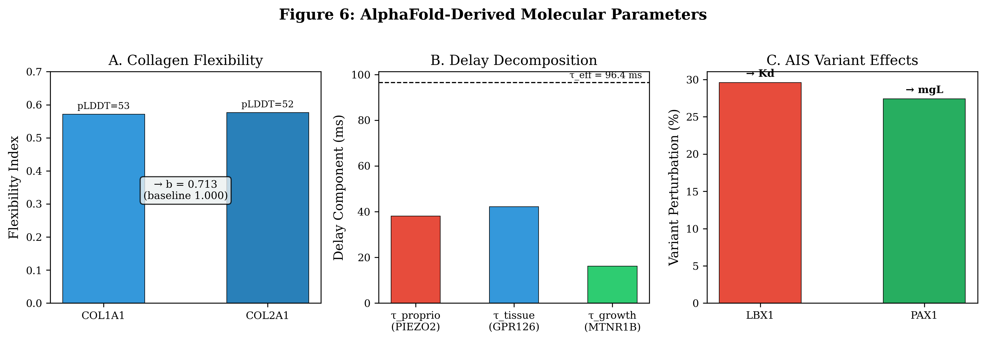
Figure 4. AlphaFold molecular parameter mapping. Three-module architecture linking protein structural properties to DDE control parameters. Module A: COL1A1/COL2A1 flexibility → damping coefficient b (29% reduction). Module B: PIEZO2/GPR126/MTNR1B flexibility → effective delay τ_eff = 96.4 ms (decomposed into proprioceptive, tissue remodeling, and growth-timing components). Module C: LBX1/PAX1 variant perturbation → derivative gain K_d and gravitational load mgL. Bar plots show pLDDT scores, flexibility indices, and parameter contributions for each protein.
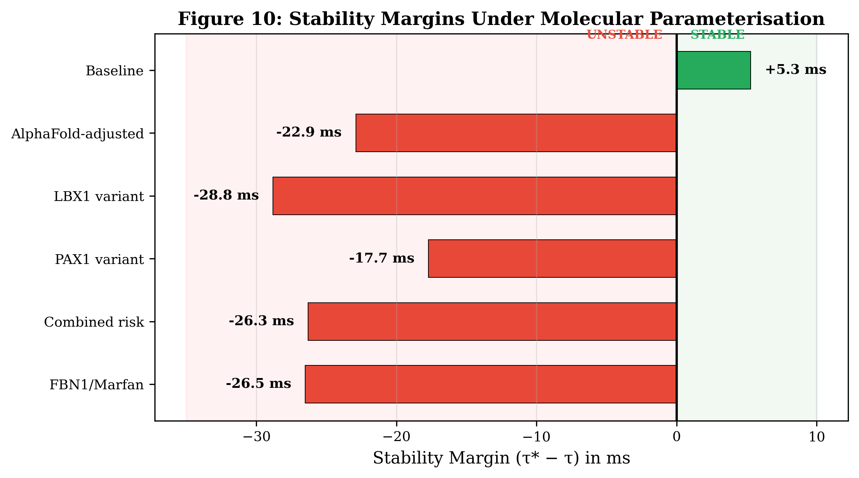
Figure 5. Stability margins across six clinical scenarios. Comparison of effective delay (τ_eff), critical delay (τ*), and stability margin for baseline, molecularly-adjusted, single-variant (LBX1, PAX1), combined-variant (LBX1+PAX1), and FBN1 (Marfan-type) scenarios. Only the baseline scenario maintains positive stability margin (+5.3 ms). All molecularly-adjusted scenarios exceed the Hopf bifurcation boundary, with margins ranging from −17.7 ms (PAX1 alone) to −28.8 ms (LBX1 alone).

Supplementary Information

Table S1. Physical Parameters
Parameter | Symbol | Value | Units | Source
Moment of inertia | I | 0.8 | kg·m² | Published
Passive damping | b | 1.0 (0.713*) | Nm·s/rad | Literature / *AlphaFold
Trunk mass | m | 25 | kg | Adolescent mean
Gravitational accel. | g | 9.81 | m/s² | Standard
Spinal lever arm | L | 0.30 | m | Adolescent mean
Gravitational torque | mgL | 73.575 | Nm/rad | Calculated
Proportional gain | K_p | 120 | Nm/rad | Published
Derivative gain | K_d | 10 (range 0–25) | Nm·s/rad | Published
Proprioceptive delay | τ | 70 (96.4*) | ms | Published / *AlphaFold

Table S2. Protein Structural Analysis (AlphaFold v4)
Protein | Module | Residues | pLDDT | Flexibility | DDE Target | Key Finding
COL1A1 | A | 1464 | 52.7 | 0.472 | Damping (b) | High disorder (85%)
COL2A1 | A | 1487 | 52.1 | 0.479 | Damping (b) | High disorder (88%)
PIEZO2 | B | 709 | 79.4 | 0.206 | Delay (τ) | 38.1 ms contribution
GPR126 | B | 1221 | 73.7 | 0.263 | Delay (τ) | 42.2 ms contribution
MTNR1B | B | 362 | 84.0 | 0.160 | Delay (τ) | 16.1 ms contribution
LBX1 | C | 1460 | 61.7 | 0.479 | Gain (K_d) | 29.6% perturbation
PAX1 | C | 534 | 54.6 | 0.370 | Load (mgL) | 27.4% perturbation

Supplementary Figures
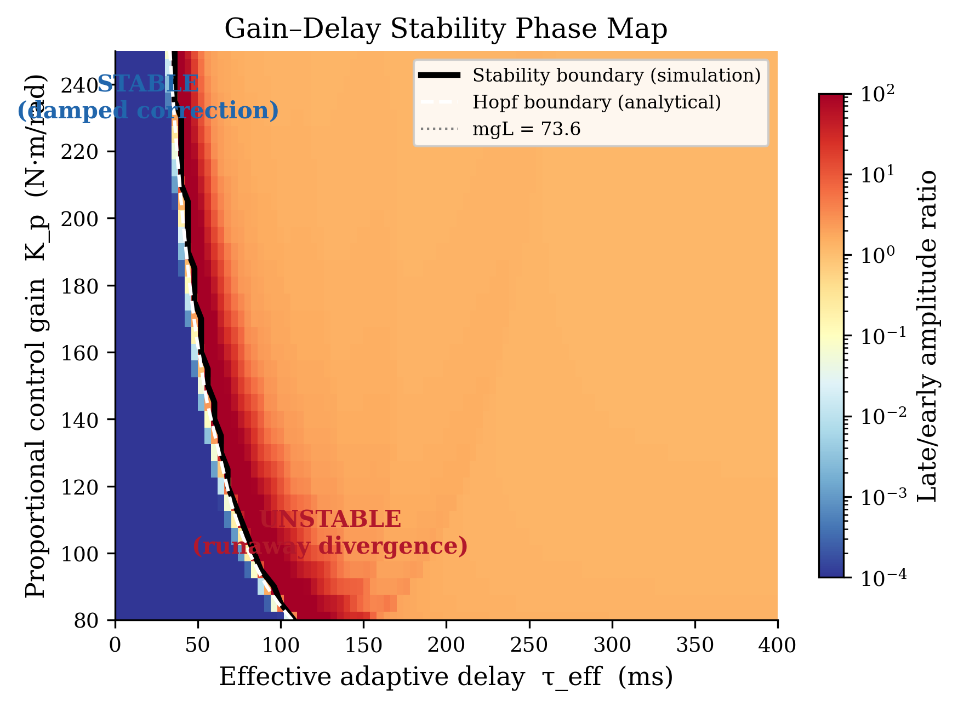
Figure S1. Gain–delay phase map. Two-dimensional representation of the stability boundary in the (K_p, τ) parameter space for fixed K_d = 10 Nm·s/rad.
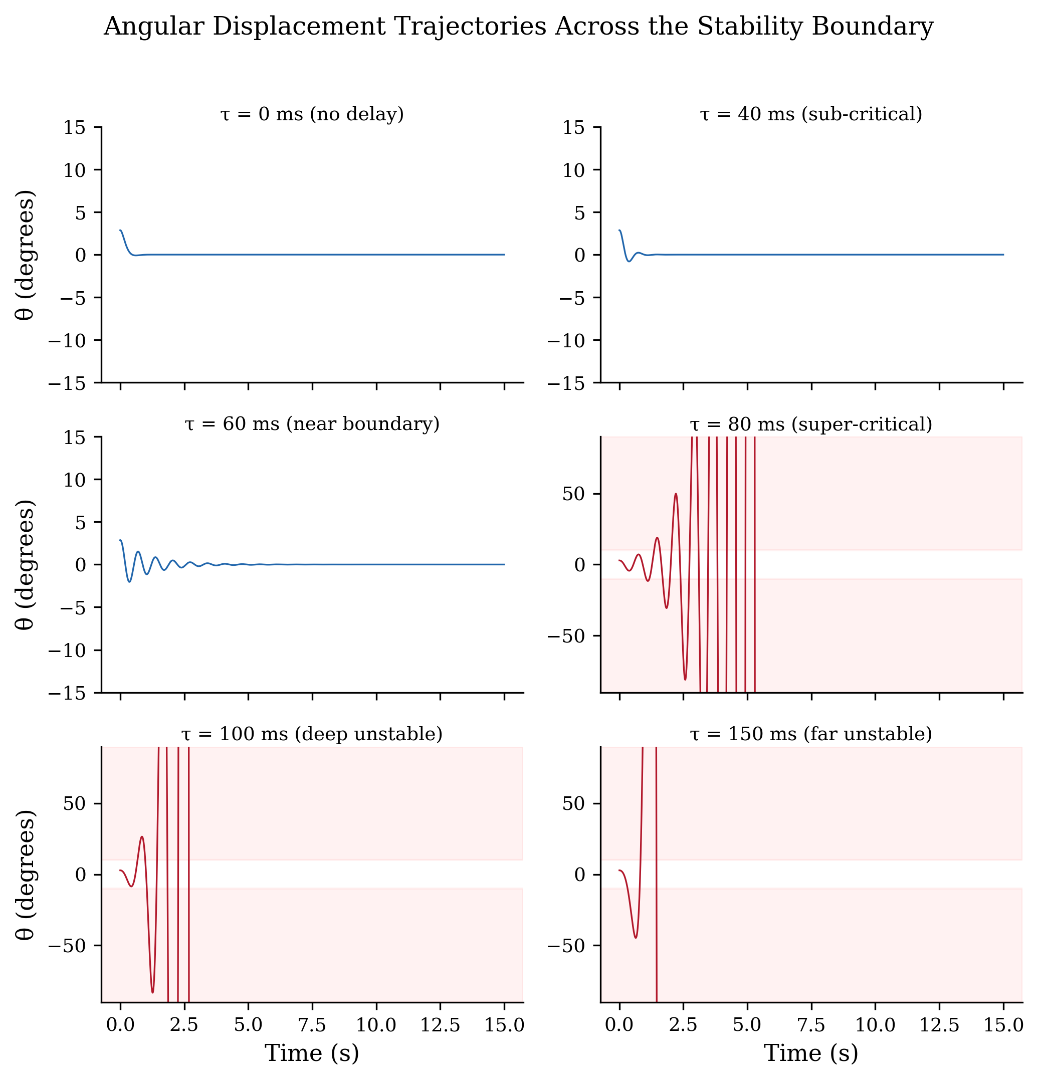
Figure S2. Time-series simulations. Representative angular displacement θ(t) trajectories for stable (blue), marginally stable (orange), and unstable (red) parameter regimes.
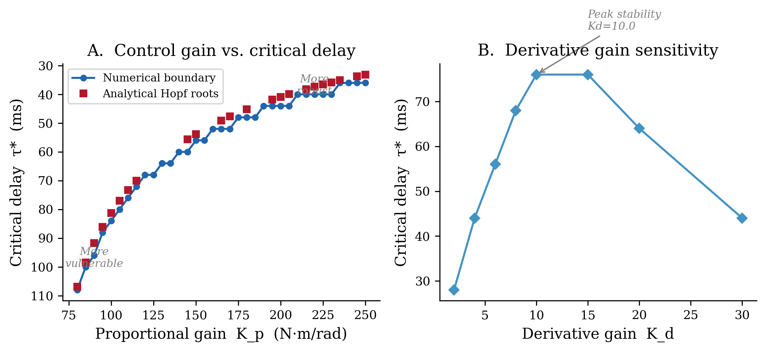
Figure S3. Critical delay as a function of proportional gain K_p for multiple values of derivative gain K_d, showing the interaction between gain channels.
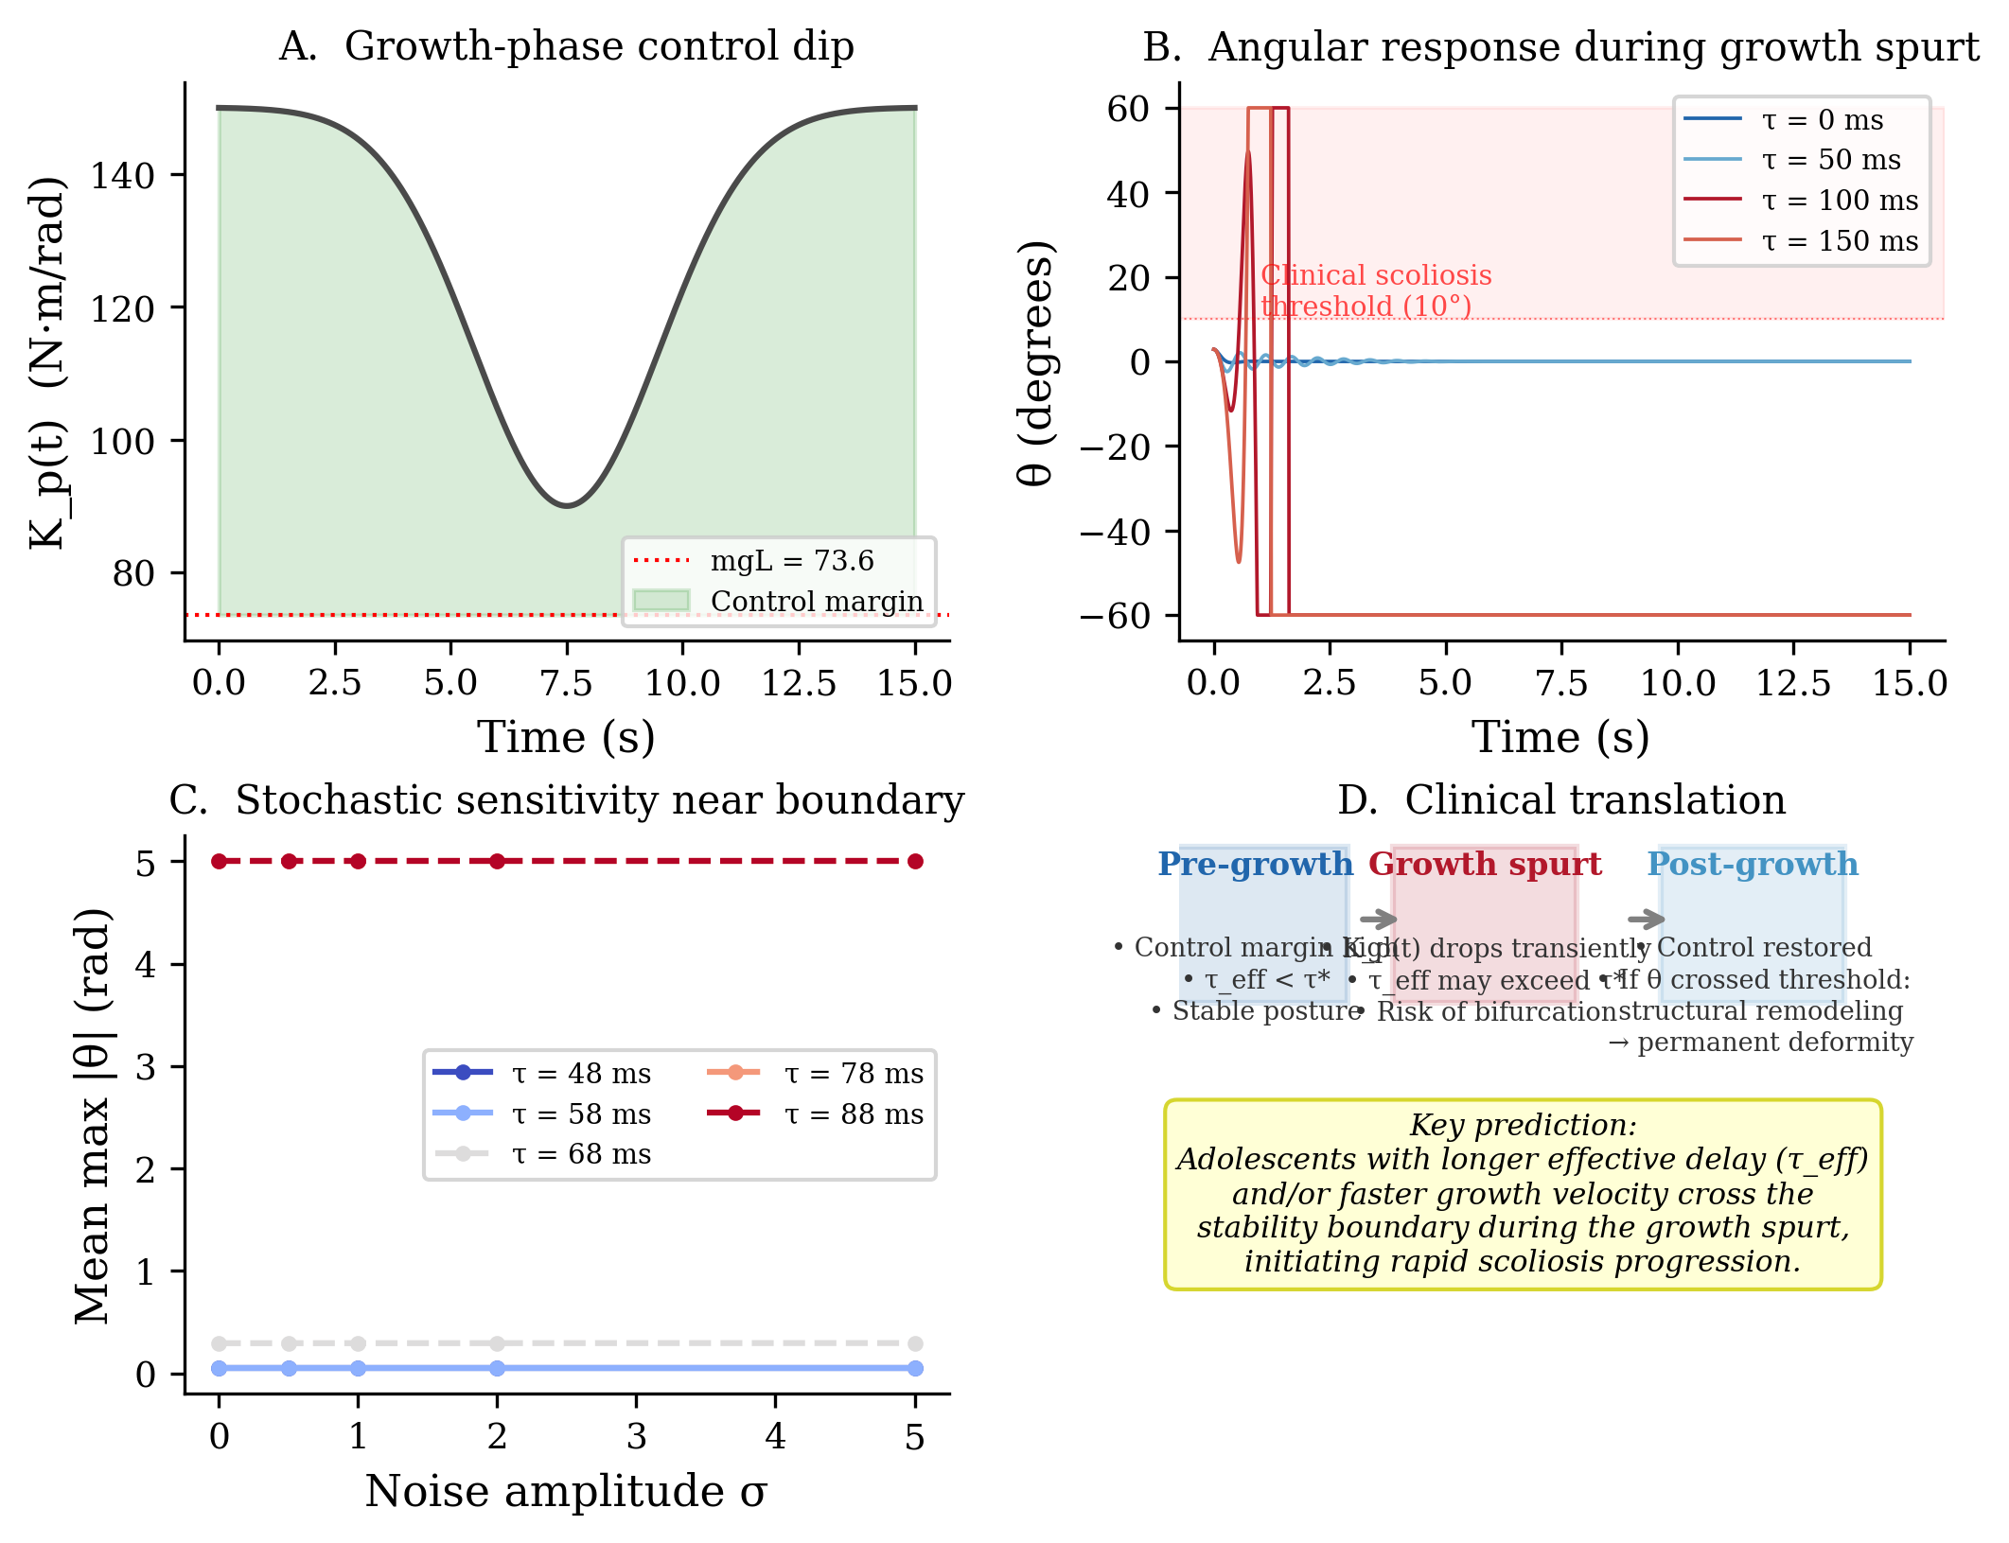
Figure S4. Growth-phase transient analysis. Detailed visualization of parameter evolution and instantaneous stability metrics during the simulated adolescent growth spurt.
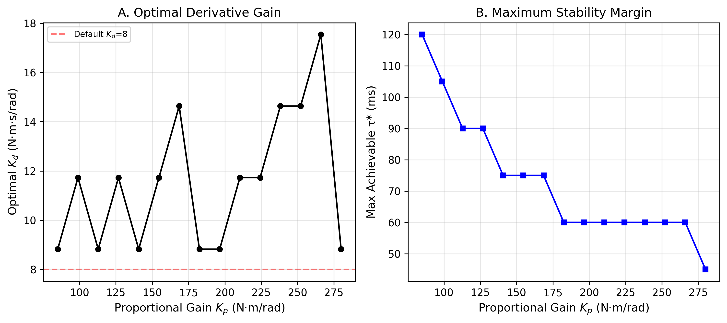
Figure S5. Optimal stability envelope. The locus of (K_d, τ*) pairs defining the maximum achievable critical delay for each derivative gain value.
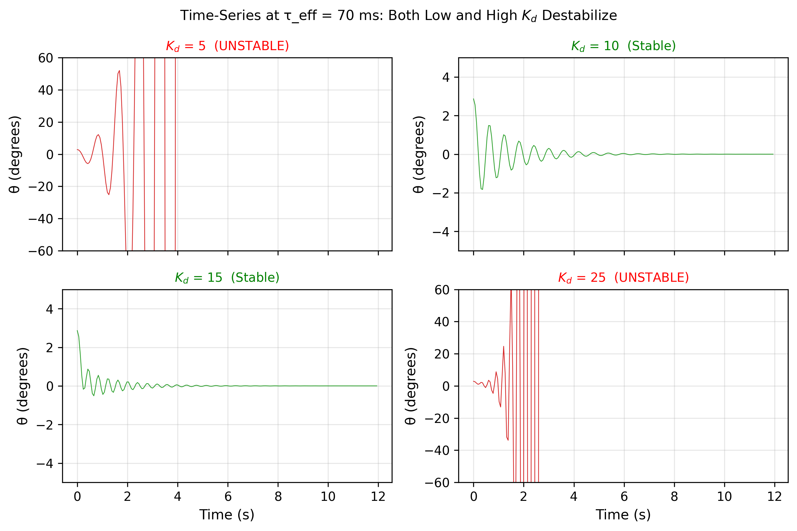
Figure S6. Trajectory comparison across clinical scenarios. Time-domain simulations of angular displacement for baseline, LBX1 variant, PAX1 variant, and combined risk genotypes.
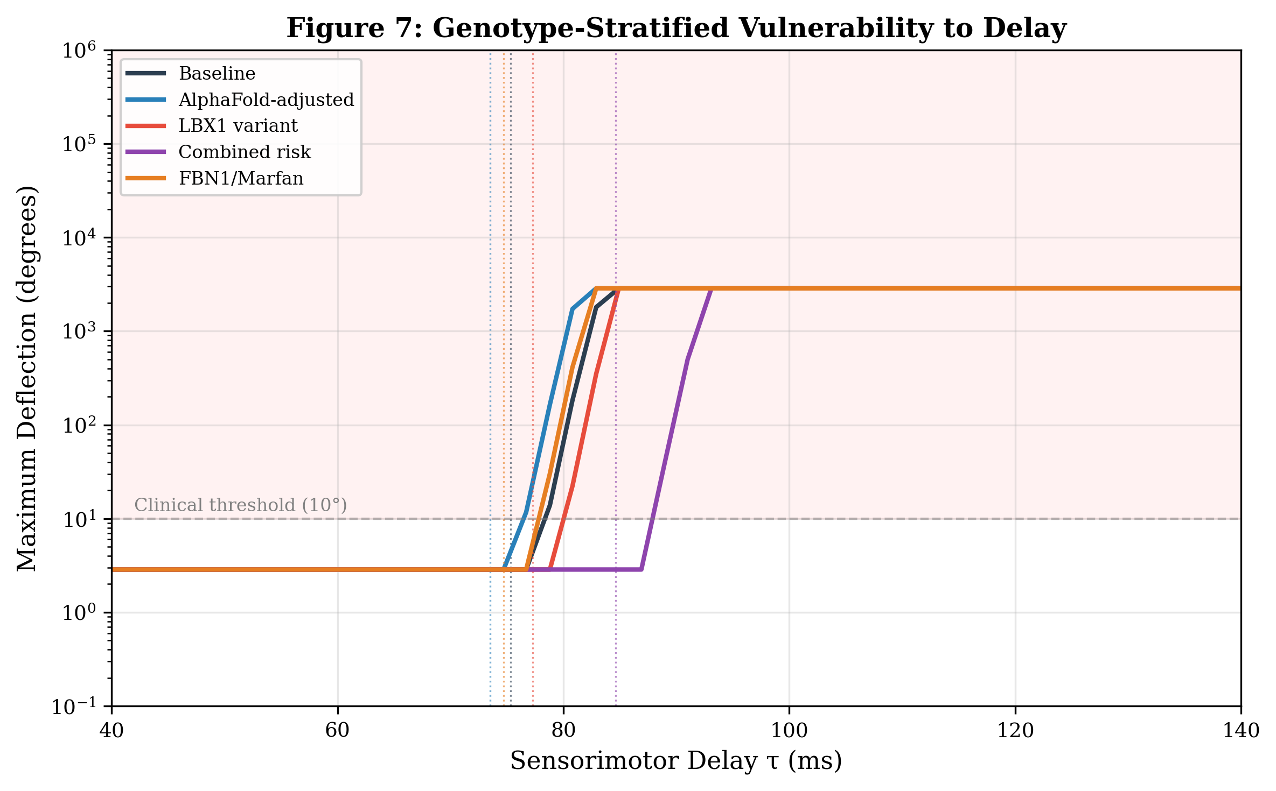
Figure S7. AlphaFold vulnerability curves. Protein-specific flexibility profiles mapped to predicted vulnerability indices across the seven analyzed proteins.
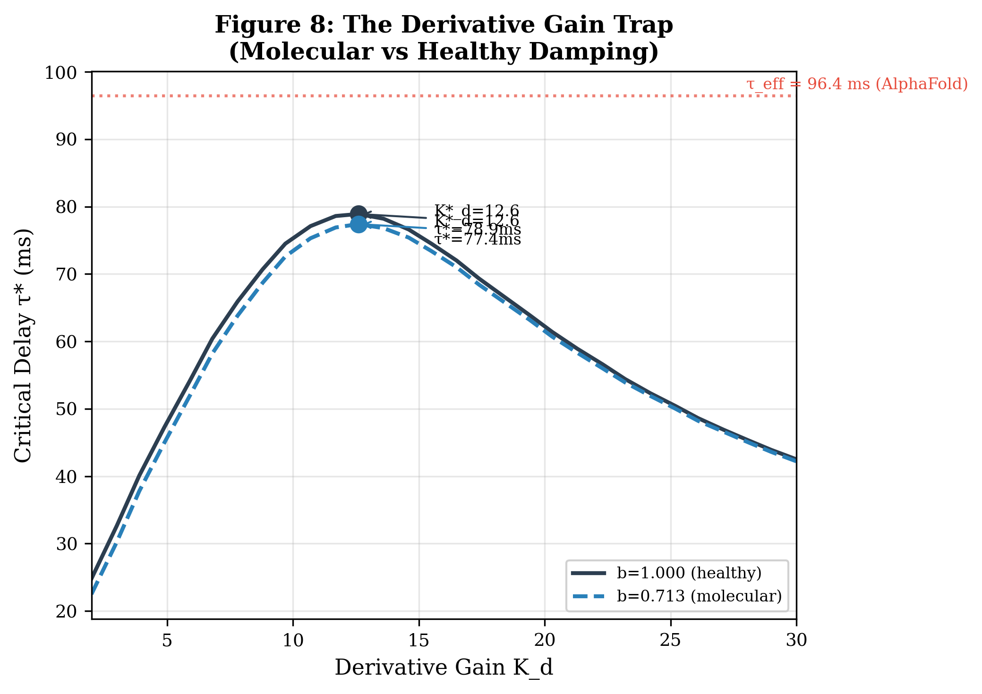
Figure S8. Molecular K_d trap visualization. The Derivative Gain Trap curve overlaid with molecularly-derived K_d estimates for each genetic risk scenario.
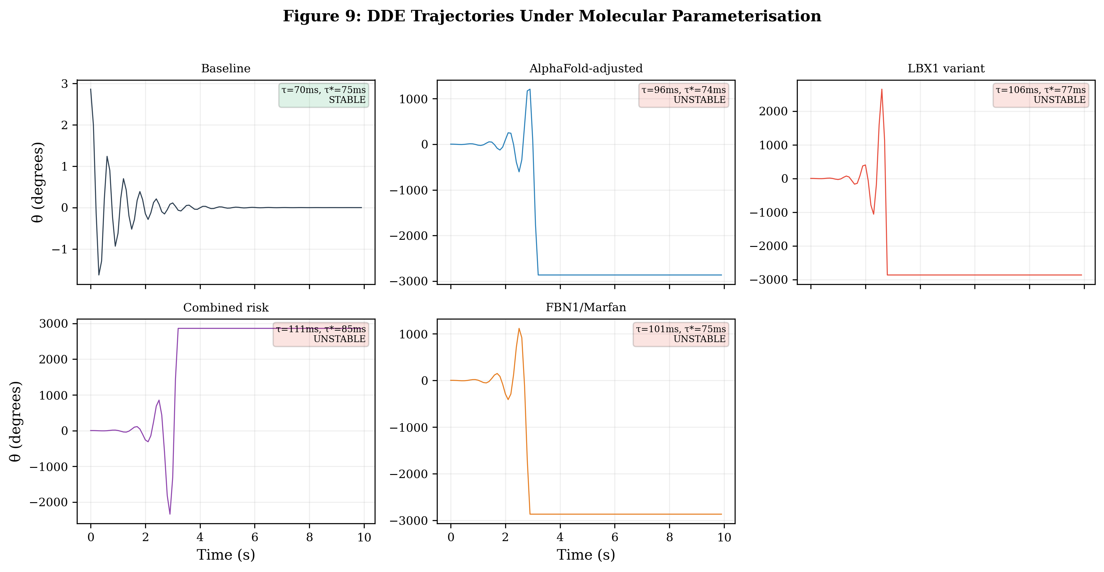
Figure S9. Molecular trajectory simulations. Full DDE time-domain simulations using AlphaFold-derived parameters for five clinical scenarios, showing the transition from stable to oscillatory behavior.

