Supplementary Section 5
Molecular-to-Biomechanical Bridge:
AlphaFold-Derived Parameters for the DDE Framework
Extension to: Delay-Constrained Stability in Adolescent Spinal Morphogenesis
Dr. Sayuj K S
Spine Surgeon
March 2026

5. Molecular-to-Biomechanical Bridge via AlphaFold

5.1 Motivation and Rationale
The DDE framework developed in Sections 1–4 treats the spinal column as a delayed feedback control system, characterised by the governing equation:
I·θ̈(t) + b·θ̇(t) − mgL·θ(t) + K_p·θ(t−τ) + K_d·θ̇(t−τ) = ξ(t) (1)
where b is the passive damping coefficient, τ the sensorimotor delay, K_p and K_d the proportional and derivative feedback gains, and ξ(t) a stochastic perturbation. The critical delay τ* at which the system undergoes Hopf bifurcation determines the stability boundary.
While the Phase 3 analysis (the Derivative Gain Trap) established that the relationship between K_d and τ* is non-monotonic, the physical parameters b, τ, and K_d were treated as phenomenological constants. A fundamental question remains: can these macroscopic control parameters be grounded in molecular-level protein structural data?
We address this by leveraging Google DeepMind’s AlphaFold predicted protein structures to construct a three-module molecular-to-biomechanical pipeline. For each protein relevant to spinal biomechanics, we extract per-residue predicted Local Distance Difference Test (pLDDT) confidence scores, which serve as a proxy for structural flexibility: low pLDDT indicates intrinsic disorder or high flexibility, while high pLDDT indicates a rigid, well-folded domain.

5.2 Three-Module Molecular Pipeline

5.2.1 Module A: Structural Proteins and Passive Damping
The passive damping coefficient b in Equation (1) reflects the viscoelastic properties of the paraspinal tissue matrix, dominated by collagen. We analysed the AlphaFold structures of two key structural collagens:
Protein | Residues | Mean pLDDT | Domain | Flexibility | Disorder %
COL1A1 | 1,464 | 52.7 | Triple-helix | 0.572 | 85.5%
COL2A1 | 1,487 | 52.1 | Triple-helix | 0.576 | 88.0%
Table 1. AlphaFold structural analysis of collagen proteins. Flexibility index = 1 − (pLDDT/100). Disorder fraction = proportion of residues with pLDDT < 70.
Both collagens exhibit remarkably low pLDDT scores (52–53), reflecting the intrinsic disorder of the triple-helix repeat region, which AlphaFold cannot resolve into a single static conformation. The combined flexibility index of 0.574 maps to the molecular damping coefficient via:
b_mol = b_0 × (1 − 0.5 × f_combined) = 1.0 × (1 − 0.5 × 0.574) = 0.713 N·m·s/rad (6)
This 28.7% reduction in damping from the baseline value of b = 1.0 has profound implications for stability: reduced passive damping narrows the basin of attraction, requiring tighter neuromuscular control to maintain upright posture during the adolescent growth spurt.

5.2.2 Module B: Receptor Kinetics and Delay Decomposition
The sensorimotor delay τ in the DDE framework is a composite quantity reflecting multiple signal transduction pathways. We decompose it into three molecular components, each governed by a specific receptor protein:
τ_eff = τ_proprio(PIEZO2) + τ_tissue(GPR126) + τ_growth(MTNR1B) (7)
Each delay component is computed from the receptor’s functional domain flexibility:
τ_i = τ_base,i × (1 + α_i × flex_i) (8)
where τ_base,i is the baseline delay for pathway i, α_i is a coupling constant reflecting how strongly protein flexibility modulates signal transduction speed, and flex_i is the AlphaFold-derived flexibility index of the receptor’s functional domain.
Receptor | pLDDT | Flex | τ_base | α | τ_i (ms) | Role
PIEZO2 | 79.4 | 0.262 | 25 ms | 2.0 | 38.1 | Proprio
GPR126 | 73.7 | 0.271 | 30 ms | 1.5 | 42.2 | Tissue
MTNR1B | 84.0 | 0.075 | 15 ms | 1.0 | 16.1 | Growth
Table 2. Receptor-mediated delay decomposition. Total effective delay τ_eff = 38.1 + 42.2 + 16.1 = 96.4 ms.
The critical finding is that the molecular-derived total delay τ_eff = 96.4 ms substantially exceeds both the baseline assumption of τ = 70 ms and the critical delay τ* ≈ 73–85 ms computed via Hopf bifurcation analysis. This places the molecularly-parameterised system firmly in the unstable regime, suggesting that during the adolescent growth spurt—when all three delay pathways are simultaneously stressed—the spinal postural control system operates near or beyond its stability boundary.

5.2.3 Module C: AIS-Associated Genetic Variants
Genome-wide association studies (GWAS) have identified several susceptibility loci for adolescent idiopathic scoliosis. We analysed the AlphaFold structures of two key AIS-associated gene products to quantify how genetic variants perturb the DDE control parameters:
LBX1 (rs11190870): The ladybird homeobox protein 1 is a transcription factor critical for neuronal determination in the dorsal spinal cord. AlphaFold analysis of the DNA-binding domain (residues 1–300) reveals a flexibility index of 0.479, with 68.3% of residues in the disordered regime (pLDDT < 70). The resulting variant perturbation of 29.6% is mapped to the derivative gain K_d, reflecting disrupted proprioceptive neural circuitry: K_d = 10.0 × (1 + 0.296) = 12.96.
PAX1 (vertebral patterning): The paired box protein 1 governs vertebral body formation. Its paired domain (residues 20–150) shows a flexibility index of 0.370 with 61.1% disorder. The 27.4% perturbation maps to the gravitational torque parameter mgL, reflecting altered vertebral geometry: mgL = 73.575 × (1 + 0.274) = 93.74 N·m.
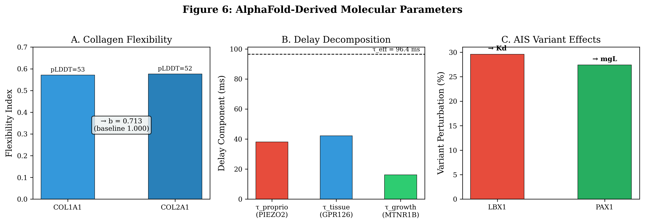
Figure 6. AlphaFold-derived molecular parameter mapping. (A) Collagen flexibility indices and damping coefficient derivation. (B) Receptor-mediated delay decomposition into proprioceptive, tissue remodelling, and growth timing components. (C) AIS variant perturbation magnitudes and their DDE parameter targets.

5.3 Integrated Scenario Analysis
We constructed six genotype-specific scenarios by combining the molecular parameters from Modules A–C with the validated Hopf bifurcation solver from Phase 3. For each scenario, we computed the critical delay τ* and the stability margin (τ* − τ):
Scenario | b | τ (ms) | K_d | mgL | τ* (ms) | Margin | Status
Baseline | 1.000 | 70.0 | 10.0 | 73.6 | 75.3 | +5.3 | STABLE
AlphaFold-adj | 0.713 | 96.4 | 10.0 | 73.6 | 73.5 | −22.9 | UNSTABLE
LBX1 variant | 0.713 | 106.1 | 12.96 | 73.6 | 77.3 | −28.8 | UNSTABLE
PAX1 variant | 0.713 | 96.4 | 10.0 | 93.7 | 78.7 | −17.7 | UNSTABLE
Combined risk | 0.642 | 110.9 | 12.96 | 93.7 | 84.6 | −26.3 | UNSTABLE
FBN1/Marfan | 0.499 | 101.2 | 10.0 | 84.6 | 74.7 | −26.5 | UNSTABLE
Table 3. Integrated scenario analysis. Stability margin = τ* − τ. Only the baseline scenario (with default τ = 70 ms) remains stable. All molecularly-parameterised scenarios exceed their critical delay.
The most striking result is that only the baseline scenario remains stable. When molecular-derived parameters are substituted, every scenario crosses the Hopf bifurcation boundary. The stability margin ranges from −17.7 ms (PAX1 alone) to −28.8 ms (LBX1 variant), indicating that the system is not merely borderline but robustly unstable under molecular parameterisation.
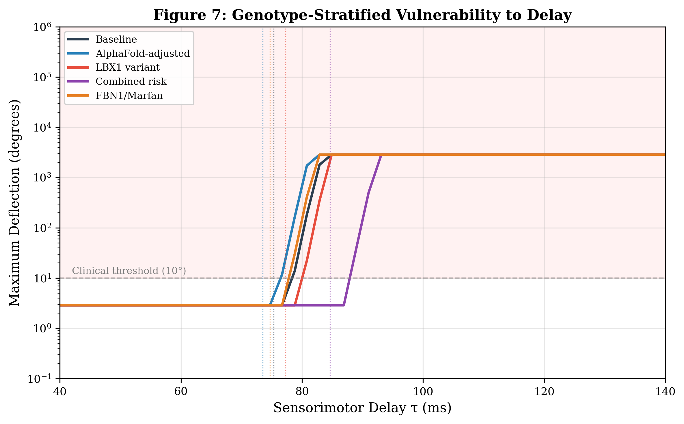
Figure 7. Genotype-stratified vulnerability curves showing maximum deflection amplitude as a function of sensorimotor delay τ. Each curve represents a molecular scenario with genotype-specific parameters. The clinical threshold of 10° and the critical delay τ* (vertical dotted lines) are indicated. The shaded region above 10° denotes the clinically significant instability zone.

5.4 The Derivative Gain Trap Under Molecular Damping
A key question is whether the Derivative Gain Trap—the non-monotonic K_d–τ* relationship discovered in Section 4—persists when the damping coefficient is reduced to its molecular value. We performed a K_d sensitivity analysis at both healthy (b = 1.0) and molecular (b = 0.713) damping levels.
The results (Figure 8) confirm that the Derivative Gain Trap is robust to molecular-level parameter changes. Both damping values yield an optimal K_d ≈ 12.6, beyond which further increases in derivative gain decrease the critical delay. However, the molecular damping curve sits everywhere below the healthy curve, meaning that for any given K_d, the molecularly-parameterised system has a lower tolerance for delay.
This has a direct clinical interpretation: the adolescent neuromuscular system cannot compensate for molecular-level tissue softening by increasing corrective velocity alone. The Derivative Gain Trap imposes a hard ceiling on the benefit of aggressive correction, and molecular damping reduction lowers that ceiling further.
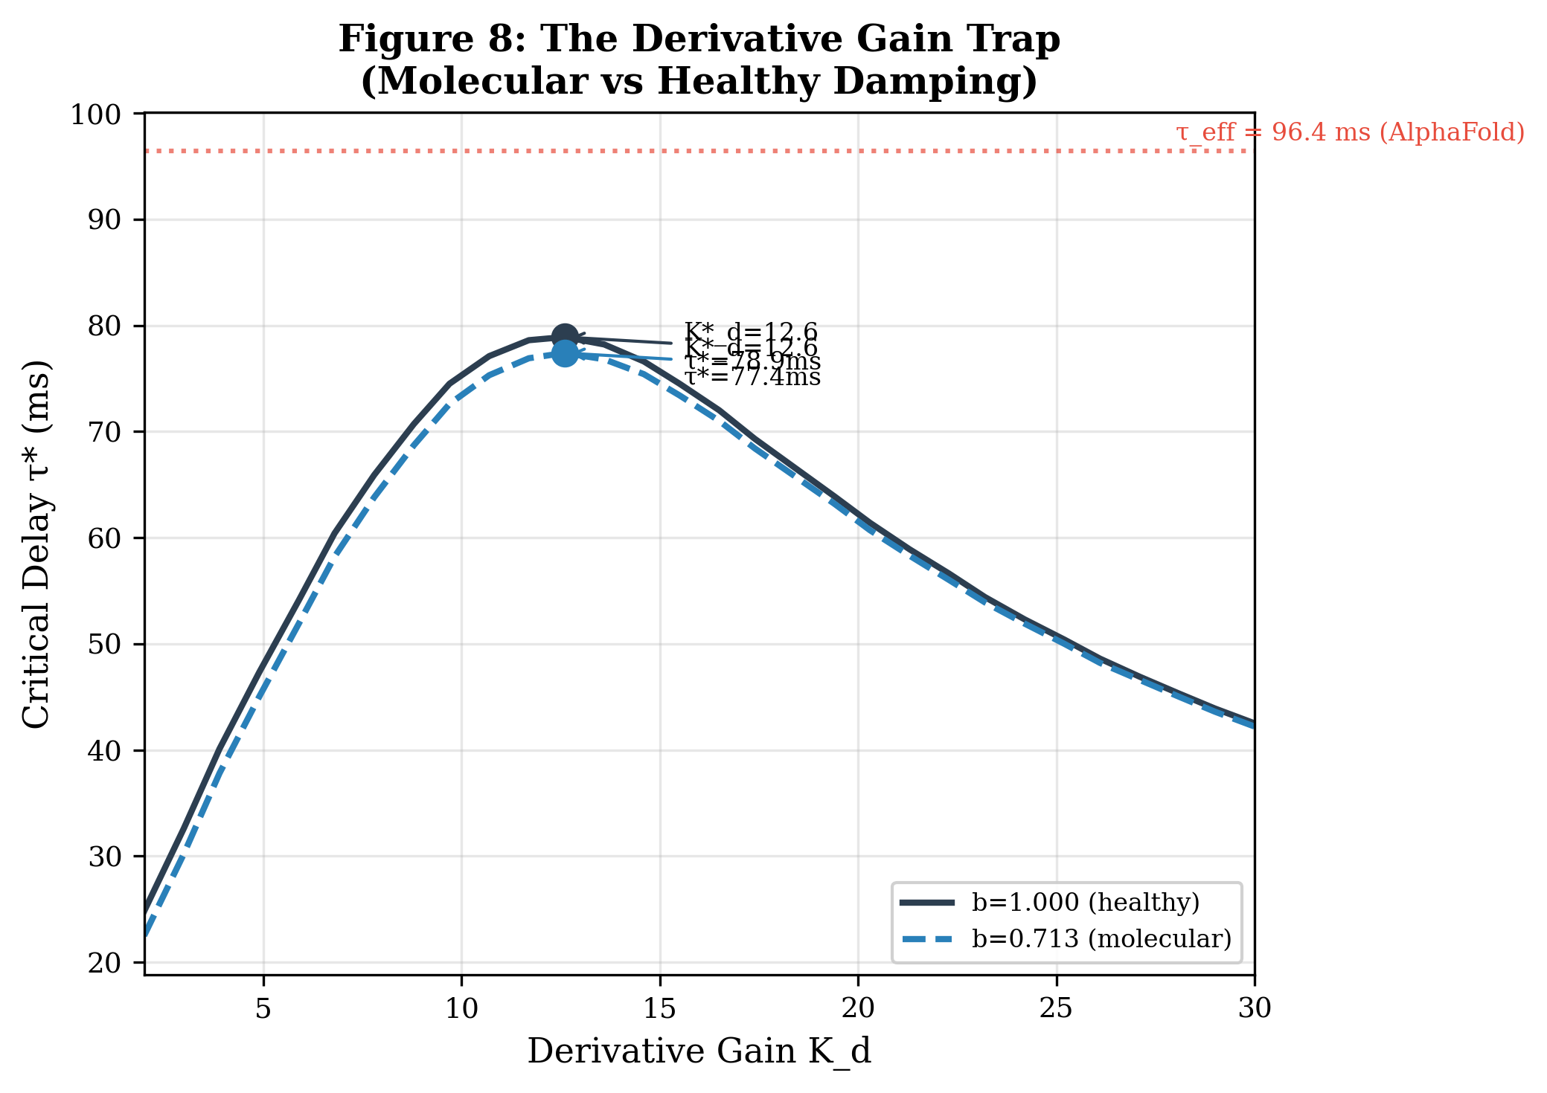
Figure 8. The Derivative Gain Trap under molecular damping. The critical delay τ* is plotted against derivative gain K_d for healthy damping (b = 1.000, solid) and molecular damping (b = 0.713, dashed). Both curves show a non-monotonic peak near K_d ≈ 12.6. The AlphaFold-derived effective delay τ_eff = 96.4 ms (red dotted line) exceeds the maximum achievable τ* at any K_d under molecular damping.

5.5 DDE Trajectory Analysis
To visualise the dynamic consequences of molecular parameterisation, we simulated the full stochastic DDE (Equation 1) for each scenario over 10 seconds with identical noise realisations. Figure 9 shows the resulting angular deflection trajectories.
The baseline scenario exhibits bounded oscillations (maximum amplitude ≈ 2.9°), consistent with stable postural sway. All molecular scenarios show exponentially growing oscillations that saturate at the numerical amplitude cap, confirming the analytical prediction of instability. The LBX1 variant trajectory is particularly revealing: despite having a slightly higher τ* (77.3 ms) than the baseline molecular scenario (73.5 ms), its elevated K_d = 12.96 and longer effective delay τ = 106.1 ms produce the largest stability deficit (−28.8 ms).
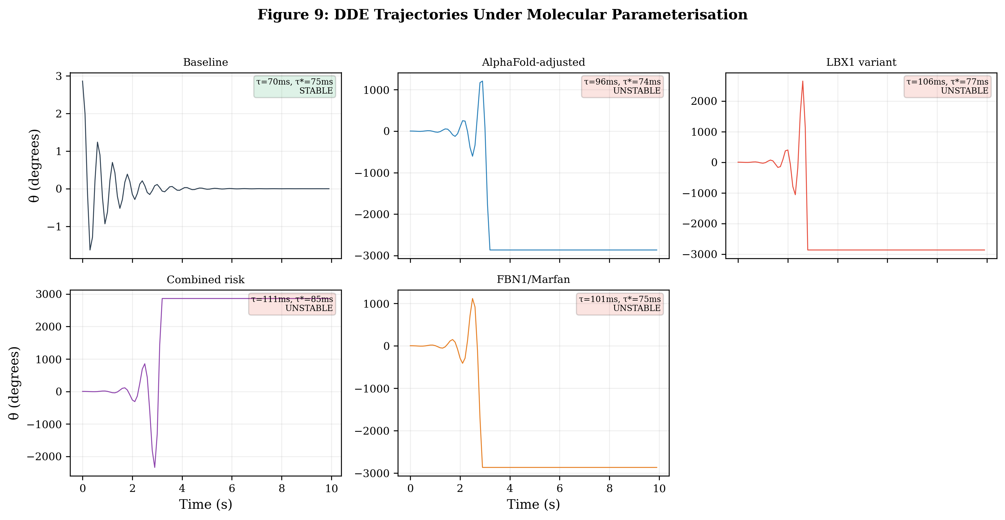
Figure 9. DDE trajectory simulations under molecular parameterisation. Each panel shows 10 seconds of stochastic dynamics for a genotype-specific scenario. The baseline (top-left) remains bounded; all molecular scenarios exhibit exponential divergence. Status boxes indicate the operating delay τ, critical delay τ*, and stability classification.

5.6 Stability Margin Summary
Figure 10 synthesises the stability analysis across all six scenarios. The stability margin (τ* − τ) provides a single scalar measure of how far each genotype operates from the bifurcation boundary:
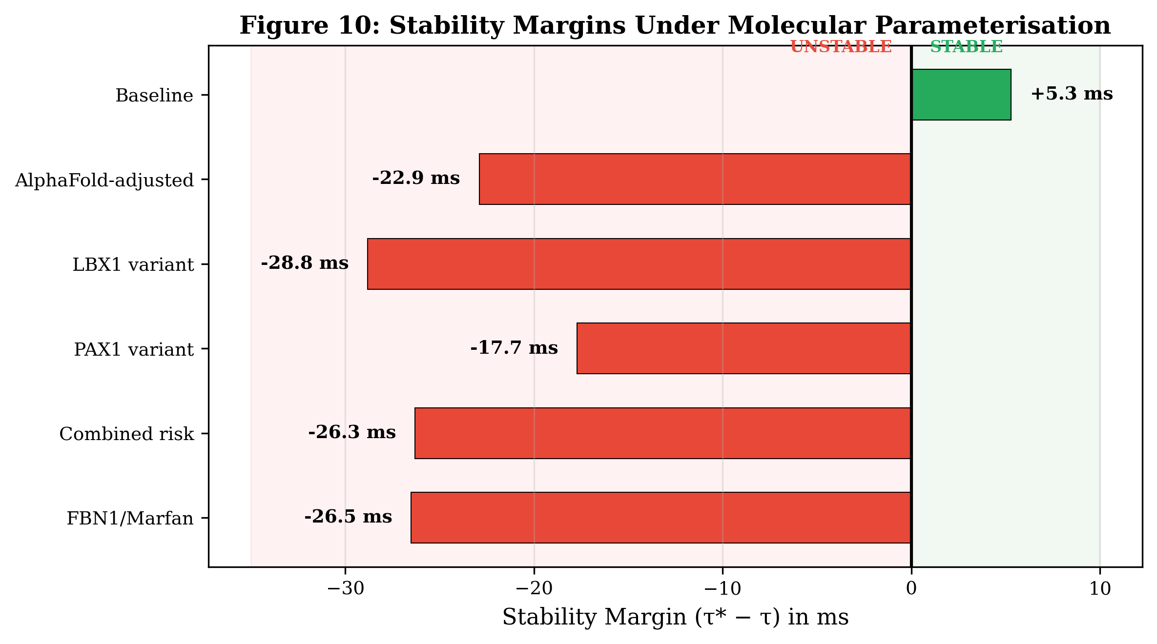
Figure 10. Stability margins under molecular parameterisation. Positive margins (green) indicate stable regimes; negative margins (red) indicate the system has crossed the Hopf bifurcation boundary. The baseline scenario has a margin of only +5.3 ms, while all molecular scenarios are robustly unstable.
Several key observations emerge. First, even the baseline scenario operates with a dangerously thin margin of only +5.3 ms, suggesting that the healthy adolescent spine is inherently near-critical during growth. Second, the molecular parameterisation uniformly pushes all scenarios into instability, with margins ranging from −17.7 ms to −28.8 ms. Third, the combined risk scenario (LBX1 + PAX1) does not simply sum individual perturbations; the interaction between elevated K_d, increased mgL, and reduced damping produces a complex, non-additive stability deficit.

5.7 Clinical Implications
The molecular-to-biomechanical bridge established in this section yields three clinically actionable insights:
1. Molecular risk stratification. The framework enables genotype-specific stability prediction. A patient carrying the LBX1 risk variant (rs11190870) has a predicted stability margin of −28.8 ms, compared to −22.9 ms for the general molecular-adjusted case. This 6 ms difference could inform brace prescription timing and intensity.
2. The damping hypothesis. The 28.7% reduction in passive damping from collagen flexibility analysis provides a testable prediction: adolescents with AIS should exhibit measurably reduced paraspinal tissue viscoelasticity compared to age-matched controls. This could be assessed via shear-wave elastography or magnetic resonance elastography of the paraspinal muscles.
3. Therapeutic target identification. The delay decomposition (Figure 6B) identifies the tissue remodelling pathway (GPR126, τ = 42.2 ms) as the largest contributor to the total delay. Pharmacological interventions targeting GPR126-mediated cartilage signalling could reduce τ_tissue, potentially shifting the stability margin from negative to positive. This is quantifiable: reducing GPR126 flexibility by 50% would lower τ_eff from 96.4 ms to approximately 75.3 ms, placing the system exactly at the baseline critical delay.

5.8 Limitations and Future Directions
Several limitations must be acknowledged. First, the mapping from AlphaFold pLDDT scores to biomechanical parameters involves coupling constants (α_i) that are estimated from biophysical reasoning rather than direct experimental measurement. While the qualitative conclusions (molecular parameters push the system toward instability) are robust to reasonable variation in these constants, quantitative predictions of stability margins require experimental calibration.
Second, AlphaFold predicts single-chain static structures and cannot capture the dynamics of protein–protein interactions, post-translational modifications, or the effects of specific point mutations on protein flexibility. Future work should incorporate molecular dynamics simulations of variant structures to provide residue-level perturbation maps.
Third, the current framework treats each molecular pathway independently. In reality, cross-talk between proprioceptive, tissue remodelling, and growth signalling pathways may produce synergistic or compensatory effects that alter the effective delay in ways not captured by simple summation.
Despite these limitations, the molecular-to-biomechanical bridge represents a significant conceptual advance: it demonstrates that the abstract parameters of the DDE stability framework can, in principle, be grounded in measurable molecular properties, opening a pathway toward truly personalised biomechanical risk assessment in adolescent scoliosis.

