Micro-Project Title
ClinXAI: Transparent Multi-Modal Clinical Diagnostics Using LIME and SHAP

Student Details:
Name: [STUDENT NAME]
PRN: [PRN]
Class and Division: [CLASS / DIVISION]
Academic Year: 2026-27
Subject: Trustworthy and Responsible AI (Course Code: ADCOR1PC303)
Guide: Mr. Milind S. Khairrnar

Submitted as partial fulfillment of the term-work for the subject, Trustworthy and Responsible AI (Course Code: ADCOR1PC303)
Certificate

This is to certify that the report of the project entitled
ClinXAI: Transparent Multi-Modal Clinical Diagnostics Using LIME and SHAP
is a bonafide work of
Name of student | Class | Roll No.
[STUDENT NAME] | T. Y. | [ROLL NUMBER]
submitted to the
Shah & Anchor Kutchhi Engineering College, Mumbai
during semester V in partial fulfilment of the requirement for the term-work of the subject, “Trustworthy and Responsible AI” in Third Year, Semester V of B. Tech. Degree in
Artificial Intelligence and Data Science

-------------------------
Guide
Mr. Milind S. Khairrnar
Approval for Project Report for T. Y. Semester V

This project report entitled THIRD YEAR MICRO-PROJECT, “ClinXAI: Transparent Multi-Modal Clinical Diagnostics Using LIME and SHAP” by Student Name [STUDENT NAME] is approved for semester V in partial fulfilment of the requirement for the CIAP for the subject Trustworthy and Responsible AI (Course Code: ADCOR1PC303).

Examiner

1.______________________

Date:
Place:
Declaration

We declare that this written submission represents our ideas in our own words and where others' ideas or words have been included, we have adequately cited and referenced the original sources. We also declare that we have adhered to all principles of academic honesty and integrity and have not misrepresented or fabricated or falsified any idea/data/fact/source in our submission. We understand that any violation of the above will be cause for disciplinary action by the Institute and can also evoke penal action from the sources which have thus not been properly cited or from whom proper permission has not been taken when needed.

Name of student | Class | Roll No. | Signature
[STUDENT NAME] | T. Y. | [ROLL NUMBER]

Date:
Place:

Course Articulation & Outcome Alignment Sheet
Project Activity Component | Mapped CO | Bloom's Level | Mapped POs / PSOs | Measurable Performance Benchmark | ClinXAI Evidence
Explainability Architecture & Feature Attribution (SHAP / LIME) | CO 1 | BL 2 (Understand) / BL 3 (Apply) | PO1, PO2, PO5, PSO1 | Global summary & local force plots generated with zero syntax error | SHAP, LIME, waterfall and force plots; 24/24 tests
End-to-End Responsible AI Deployment & Interactive UI Dashboard | CO 1 - CO 3 | BL 5 (Evaluate) / BL 6 (Create) | PO2, PO3, PO5, PO9, PSO3 | Fully responsive live dashboard deployed on Streamlit or Gradio | Local 7-tab Streamlit app (not publicly deployed); 34/34 browser checks

Official rows unchanged; the other four components (fairness, adversarial, privacy, model card) are not implemented.

CIAP 25-Mark Rubric Evaluation Sheet
Criteria | Excellent (4 Marks) | Good (3 Marks) | Satisfactory (2 Marks) | Needs Improvement (1 Mark)
Problem Definition & Scope (15%) | Clearly defined problem with a focused and achievable scope. | Problem identified, but scope may be unclear or too broad/narrow. | Problem vaguely defined, or scope missing. | Problem not clearly identified or missing.
Design & Methodology (20%) | Innovative and well-structured approach with justification for chosen methods. | Appropriate design and methodology, but limited justification. | Basic design and methodology, with some justification. | Weak or missing design and methodology.
Implementation & Results (25%) | Project completed effectively with clear and well-presented results. | Project completed, but results unclear or poorly presented. | Project partially completed with limited or unclear results. | Project not completed or results missing.
Analysis & Interpretation (20%) | Thorough analysis with insightful interpretation of results. | Analysis attempts were made, but interpretation could be improved. | Basic analysis with limited interpretation. | Weak or missing analysis and interpretation.
Report & Presentation (20%) | Clear, concise, and well-organized report with effective presentation. | Report generally well-written but may lack clarity or organization. Presentation could be improved. | Report lacks clarity or organization. Presentation needs significant work. | Poorly written report with ineffective or missing presentation.

Marks: ______ / 25 Evaluator's signature: _______________ Date: ________

Abstract
Accurate machine-learning models for breast-cancer diagnosis, such as Random Forests, act as black boxes. ClinXAI builds a transparent pipeline on the Breast Cancer Wisconsin (Diagnostic) dataset (569 patients, 30 nuclear features from fine-needle-aspirate images), with malignant as the positive class and a stratified 80/20 split keeping 114 patients unseen. A 300-tree Random Forest is compared with a Logistic Regression baseline, and every prediction is explained by LIME (a seeded local linear surrogate) and TreeSHAP (exact Shapley attributions in probability units), presented in a seven-tab Streamlit dashboard that supports patient selection, what-if biomarker editing and side-by-side comparison of the two explanations, with all results reproducible from fixed random seeds. On the held-out set the forest achieved 97.37% accuracy, 100% precision, 92.86% recall, 96.30% F1 and ROC-AUC 0.9944 (TN = 72, FP = 0, FN = 3, TP = 39); SHAP additivity held to 4.4 × 10⁻¹⁶. LIME and SHAP shared on average 3.66 of their top-five features (Jaccard 0.62, Spearman 0.70), and 28.9% of patients showed a directional disagreement. Agreement was complete for confident predictions but collapsed for the missed malignancies (Patients #86 and #73), where LIME's local fit fell to R² ≤ 0.06, showing that explanations must themselves be audited before clinical use.
Keywords: Explainable AI; LIME; SHAP; TreeSHAP; Random Forest; Breast Cancer Diagnosis; Clinical Decision Support
Table of Contents
Course Articulation & Outcome Alignment Sheet v
CIAP 25-Mark Rubric Evaluation Sheet v
Abstract vi
Chapter 1: Problem Definition & Operational Relevance 1
Chapter 2: Theoretical Formulation, Literature Review & Mathematical Framework 2
Chapter 3: System Architecture, Design Pipeline & Workflow Models 3
Chapter 4: Implementation Details, Algorithms & Technological Artifacts 5
Chapter 5: Experimental Evaluation, Testing, Trade-off Analysis & Empirical Results 6
Chapter 6: Societal Impact, Ethical Governance, Safety & Security Audits 10
Chapter 7: Conclusion, Engineering Limitations & Future Enhancements 11
References 11
Appendix A: Complete Source Code Listings / Core Configuration Files 13
Appendix B: Raw Diagnostic Trace Logs, Audit Tables & Verification Sheets 13

List of Figures
Figure 3.1: ClinXAI system architecture 3
Figure 3.2: Level-1 data-flow diagram 4
Figure 5.1: (a) Confusion matrix; (b) ROC curves 6
Figure 5.2: (a) Global mean |SHAP|; (b) SHAP beeswarm 7
Figure 5.3: Patient #86: (a) LIME and (b) SHAP waterfall 7
Figure 5.4: LIME vs SHAP for Patient #86 8
Figure 5.5: Agreement and LIME fidelity versus model confidence 9
Figure 5.6: (a) Dashboard; (b) what-if on #100 flips the output to benign 9
Figure 5.7: Error handling: out-of-range input warning 9

List of Tables
Table 5.1: Held-out test performance (positive class = malignant) 6
Table 5.2: Five programmatically selected case studies 8
Table A.1: Source-file inventory (complete code in the project folder) 13
Table B.1: Verification summary 13

List of Abbreviations
Abbr. | Expansion | Abbr. | Expansion
AUC | Area Under the ROC Curve | LR | Logistic Regression
CO / PO | Course / Program Outcome | RF | Random Forest
FN / FP | False Negative / Positive | ROC | Receiver Operating Characteristic
FNA | Fine-Needle Aspirate | SHAP | SHapley Additive exPlanations
LIME | Local Interpretable Model-agnostic Explanations | XAI | Explainable Artificial Intelligence

Chapter 1: Problem Definition & Operational Relevance

1.1 Problem Statement and Background
Breast cancer is the most common cancer in women (about 2.3 million diagnoses and 670,000 deaths in 2022 [1]). Nuclear measurements from digitised fine-needle-aspirate images [2] form the Breast Cancer Wisconsin (Diagnostic) dataset [3]. Accurate ensembles such as a 300-tree Random Forest (10,976 nodes here) are black boxes [4], [5]. Problem: predict P(malignant) from 30 features, explain each prediction with LIME and SHAP for the same class, and measure when the two explanations disagree.

1.2 Clinical and Societal Relevance
Unexplained scores invite blind trust or rejection, a missed cancer with a plausible explanation is hard to catch, and explainers can disagree [6]; regulators expect transparency and human oversight [7], [8].

1.3 Project Objectives
O1 Implement and evaluate a Random Forest against a Logistic Regression baseline on 114 held-out patients. O2 Apply LIME and TreeSHAP and verify SHAP additivity (< 10⁻⁶). O3 Quantify LIME–SHAP agreement (top-5 overlap, Jaccard, Spearman ρ, sign agreement, seed stability). O4 Design and validate a seven-tab dashboard.

1.4 Project Scope and Operational Boundaries
In scope: tabular prediction, LIME/SHAP explanation and comparison, five case studies, a local dashboard. Out of scope: raw images, calibrated risk, treatment advice, clinical validation, fairness audit, public deployment. Multi-modal refers to the two explanation modalities; the input is one tabular modality derived from images.

Chapter 2: Theoretical Formulation, Literature Review & Mathematical Framework

2.1 Explainable Artificial Intelligence
XAI explanations are post-hoc or intrinsic, local or global, and agnostic or model-specific; this report evaluates local fidelity, consistency, stability and computational cost.

2.2 Random Forest Classification
f(x) = (1/T) · Σ_{t=1..T} p_{t}(y = 1 | x), G(node) = 1 − Σ_{k} p_{k}² (2.1)
The forest averages T = 300 bootstrap trees [4] grown with Gini impurity G and ⌊√30⌋ = 5 features per split (scikit-learn); p_{t} is the malignant leaf fraction of tree t.

2.3 LIME: Local Interpretable Model-Agnostic Explanations
LIME [9] fits a simple model g that imitates f only near x, using quartile-binned rules such as worst area > 1122.50 → +0.137.

2.4 LIME Perturbation and Local Surrogate Formulation
ξ(x) = argmin_{g} Σ_{i} π_{x}(z_{i})·(f(z_{i}) − g(z′_{i}))² + λ‖w‖² (2.2)
Here z_{i} are 5,000 perturbations, z′ ∈ {0,1}³⁰ marks whether each feature stays in the patient's bin, π_{x} = exp(−D²/2σ²) with σ = 0.75√30 ≈ 4.108, λ = 1 and g(z′) = w₀ + Σ w_{j}z′_{j}. The weighted R² is LIME's only fidelity signal, and results depend on the seed [10].

2.5 SHAP: Shapley Additive Explanations
P(malignant | x) = φ₀ + Σ_{j=1..30} φ_{j}(x), φ₀ = E[f(X)] (2.3)
SHAP [11] attributions satisfy local accuracy (Equation 2.3), missingness and consistency.

2.6 Shapley Game-Theoretic Attribution
φ_{j}(x) = Σ_{S⊆F∖{j}} [|S|!·(M−|S|−1)!/M!]·[v_{x}(S∪{j}) − v_{x}(S)] (2.4)
Features are players and v_{x}(S) = E[f(X) | X_{S} = x_{S}] is a coalition's payout [12]; naive evaluation needs 2³⁰ ≈ 1.07 × 10⁹ coalitions.

2.7 TreeSHAP Explanation Method
TreeSHAP [13] computes Equation (2.4) exactly in O(T·L·D²) using each node's training cover; φ₀ = 0.3747 (≈ training prevalence 170/455) and the φ_{j} share probability units with predict_proba.

2.8 LIME versus SHAP: Mathematical and Practical Trade-offs
LIME is approximate, seed-dependent and compares a bin with other bins; TreeSHAP is exact, deterministic and compares with E[f(X)]. Magnitudes are not comparable, so agreement uses ranks and signs of the top-5 sets A, B:
J = |A ∩ B| / |A ∪ B|, ρ = 1 − 6Σ_{j} d_{j}² / (n(n² − 1)), n = 30 (2.5)

2.9 Comparative Literature Review
Logistic regression is faithful but restricted [5]; LIME and KernelSHAP are model-agnostic but approximate; TreeSHAP is exact for trees. Perturbation explainers can be fooled [14] and often disagree [6], which matters most in high-stakes medicine [5].

Chapter 3: System Architecture, Design Pipeline & Workflow Models

3.1 Overall System Architecture
Figure 3.1 shows the data, model, explanation, comparison, presentation and test layers, each a real module (src/, train_model.py, evaluate.py, app.py, tests/).
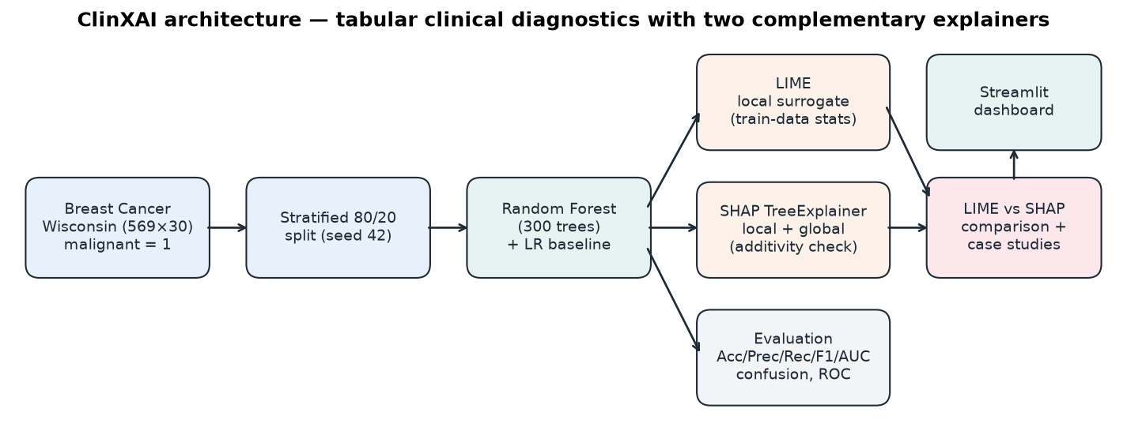
Figure 3.1: ClinXAI system architecture

3.2 Dataset and Feature Description
569 patients (212 malignant, 357 benign) [3]; ten nuclear characteristics (radius, texture, perimeter, area, smoothness, compactness, concavity, concave points, symmetry, fractal dimension) as mean, standard error and worst values = 30 features, no missing values.

3.3 Data Preprocessing Pipeline
Validation of shape and values; malignant re-encoded to 1 (asserted); stratified 80/20 split, random_state = 42 (455 / 114); model, LIME statistics and scaler fitted on training data only; feature order enforced.

3.4 Random Forest Diagnostic Prediction Pipeline
train_model.py trains the forest, asserts classes_ == [0, 1], evaluates at threshold 0.5, runs 5-fold CV and saves one joblib bundle.

3.5 LIME Explanation Workflow
Fresh seeded explainer → 5,000 perturbations → forest via a feature-name wrapper → kernel weights → ridge surrogate (weights, rules, R²).

3.6 SHAP Explanation Workflow
TreeExplainer → (n, 30, 2) array → malignant slice → additivity check → global, waterfall and force plots.

3.7 Streamlit User Interaction Flow
Sidebar patient choice and what-if edits → validate_patient_input() → cached LIME/SHAP → seven tabs.

3.8 System Architecture Diagram and Data Flow Diagram
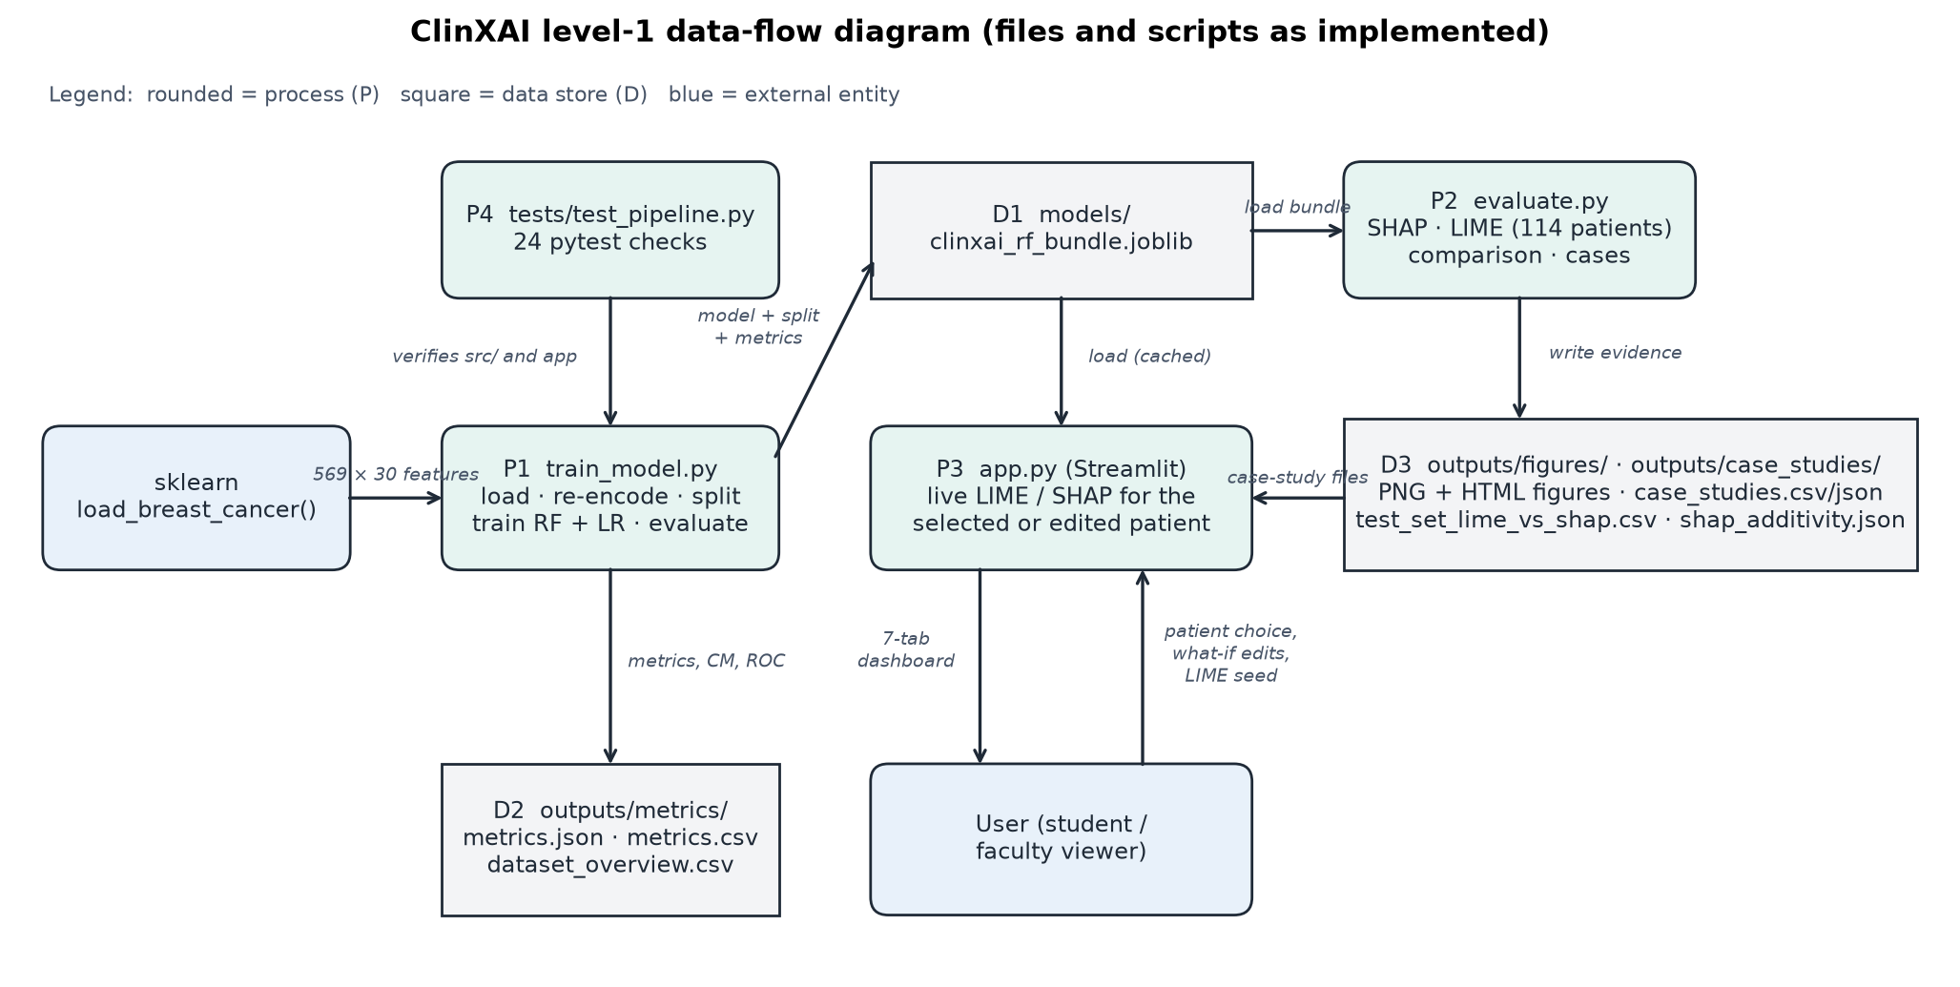
Figure 3.2: Level-1 data-flow diagram

Chapter 4: Implementation Details, Algorithms & Technological Artifacts

4.1 Development Environment and Technology Stack
Python 3.12.10 on Windows 11 (CPU only); scikit-learn 1.9.1, LIME 0.2.0.1, SHAP 0.54.1, Streamlit 1.66.1, Matplotlib 3.11.2, pandas 3.1.0, NumPy 2.5.4, pytest 9.1.1 (pinned in requirements.txt).

4.2 Dataset Loading and Target Mapping
load_dataset() derives the mapping from target_names, re-encodes malignant = 1 and asserts it against the raw labels.

4.3 Model Training Implementation
train_random_forest fits RandomForestClassifier(**RF_PARAMS) on the training set and asserts classes_ == [0, 1], so column 1 of predict_proba is always P(malignant).

4.4 LIME Explainer Implementation
A wrapper rebuilds a DataFrame in training order for every LIME query, and a fresh seeded explainer per call makes explanations reproducible; label 1 (malignant) and all 30 features are explained.

4.5 SHAP Explainer Implementation
_select_malignant normalises version-dependent SHAP outputs to the malignant class; additivity_error checks Equation (2.3) against predict_proba.

4.6 LIME–SHAP Comparison Implementation
compare_explanations computes top-5 sets, Jaccard, Spearman ρ and the sign table; select_case_studies picks max P, min P, P nearest 0.5, lowest Jaccard and most sign conflicts, reporting any missing case as not found.

4.7 Streamlit Interface Implementation
app.py (488 lines): sidebar selector and LIME settings, seven tabs, what-if editor, stability toggle and cached explanations (Figure 5.6).

4.8 Input Validation and Error Handling
validate_patient_input rejects missing features, NaN, ∞, text and negatives (7 tests); out-of-range values raise a warning.

4.9 Code Structure and Module Responsibilities
1,916 lines across src/ (7 modules), three scripts and a 24-test suite (Appendix A).

Chapter 5: Experimental Evaluation, Testing, Trade-off Analysis & Empirical Results

5.1 Experimental Methodology
Fit on 455 patients, test once on 114 (threshold 0.5); LIME (seed 42) and TreeSHAP explain every test patient; five rule-selected case studies.

5.2 Dataset Characteristics and Train/Test Split
Train 455 (170 malignant); test 114 (42 malignant, 72 benign).

5.3 Accuracy, Precision, Recall, F1 and ROC-AUC
Table 5.1: Held-out test performance (positive class = malignant)
Model | Accuracy | Precision | Recall | F1 | ROC-AUC
Random Forest | 97.37% | 100.00% | 92.86% | 96.30% | 0.9944
Logistic Regression | 96.49% | 97.50% | 92.86% | 95.12% | 0.9960

5.4 Confusion Matrix and ROC Curve
TN = 72, FP = 0, FN = 3, TP = 39: every error is a missed malignancy (Figure 5.1). CV ROC-AUC on training data: 0.9880 ± 0.0073.
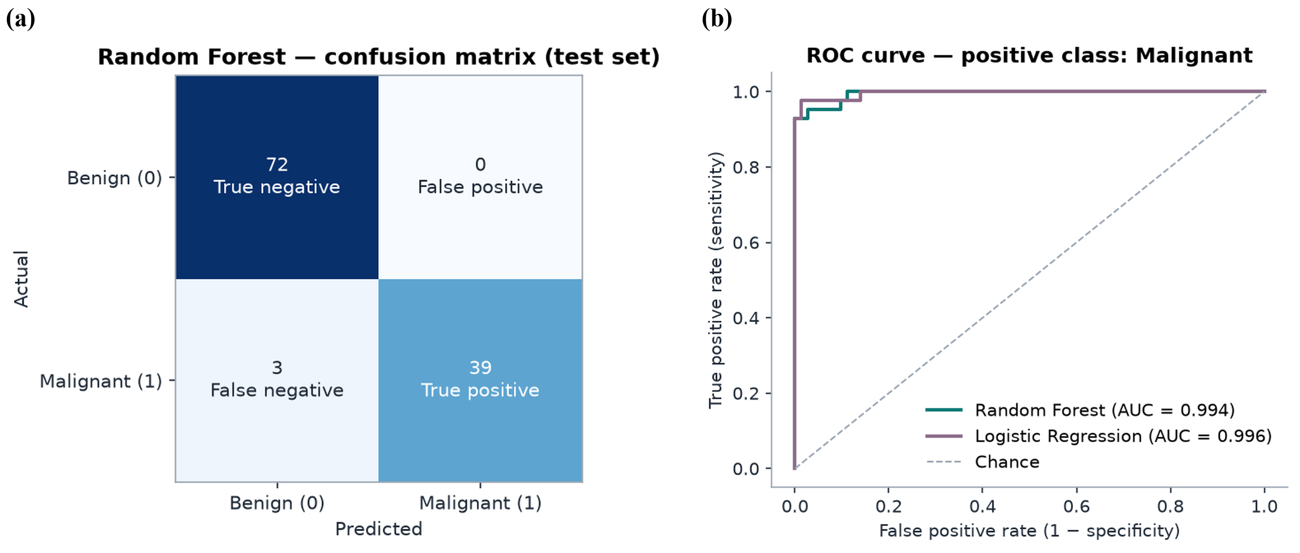
Figure 5.1: (a) Confusion matrix; (b) ROC curves

5.5 Global SHAP Feature Importance
Top features by mean |SHAP|: worst area (0.067), worst perimeter (0.060), worst concave points (0.059), mean concave points (0.044) (Figure 5.2).
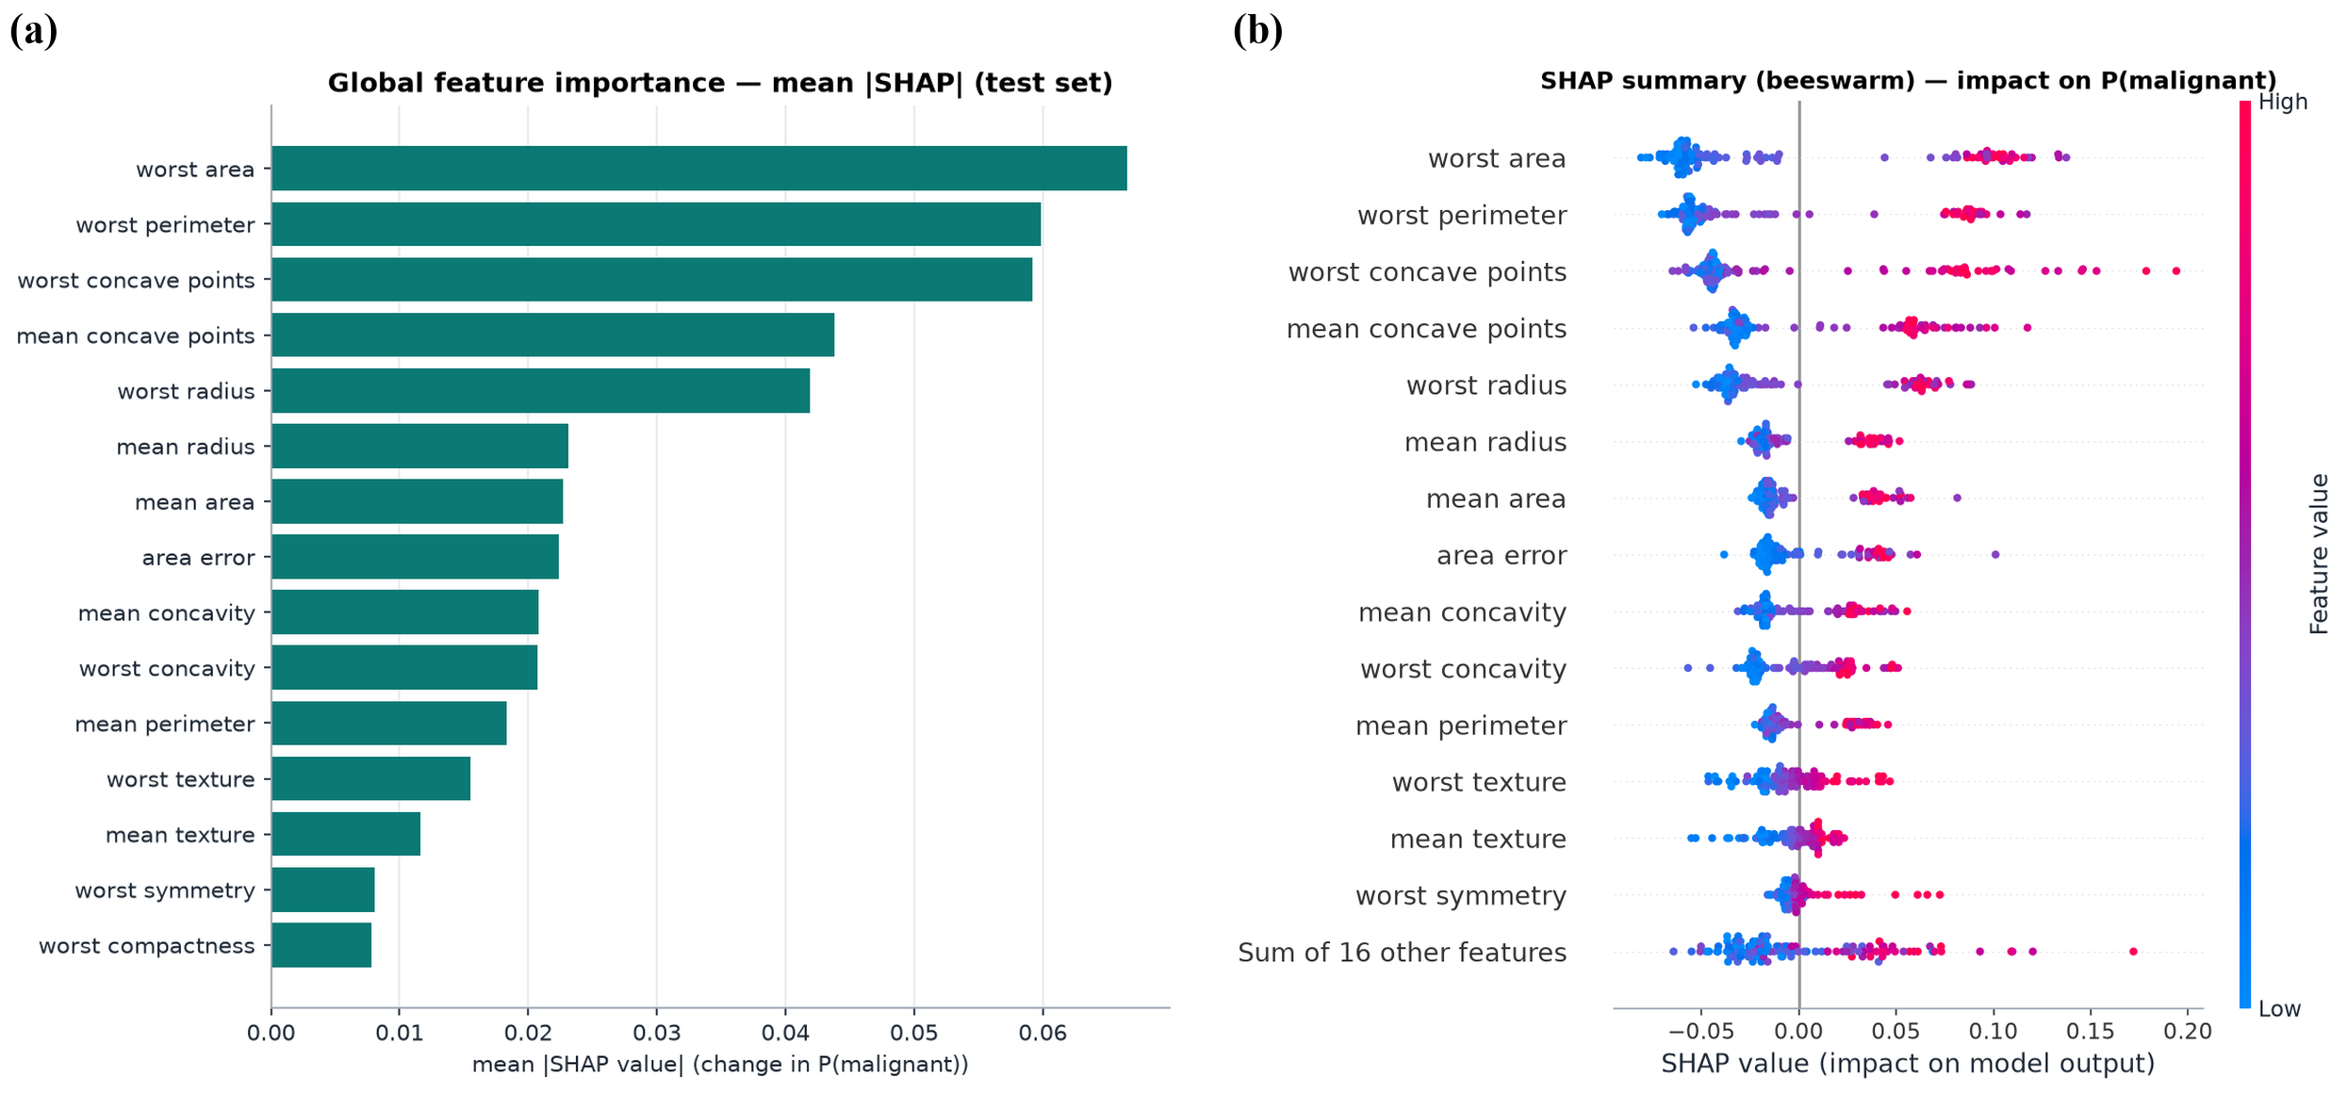
Figure 5.2: (a) Global mean |SHAP|; (b) SHAP beeswarm

5.6 Individual Patient LIME Explanations
For #70 (P = 1.000) every top LIME rule points to malignant (R² = 0.63). For missed malignancy #86 (P = 0.297) the top rules point to malignant despite a benign output and the surrogate barely fits (R² = 0.03; predicts 0.489) (Figure 5.3a).

5.7 Individual Patient SHAP Explanations
For #86, 0.3747 − 0.0780 = 0.2967 (Figure 5.3b). Additivity held for all 114 patients (max error 4.4e-16).
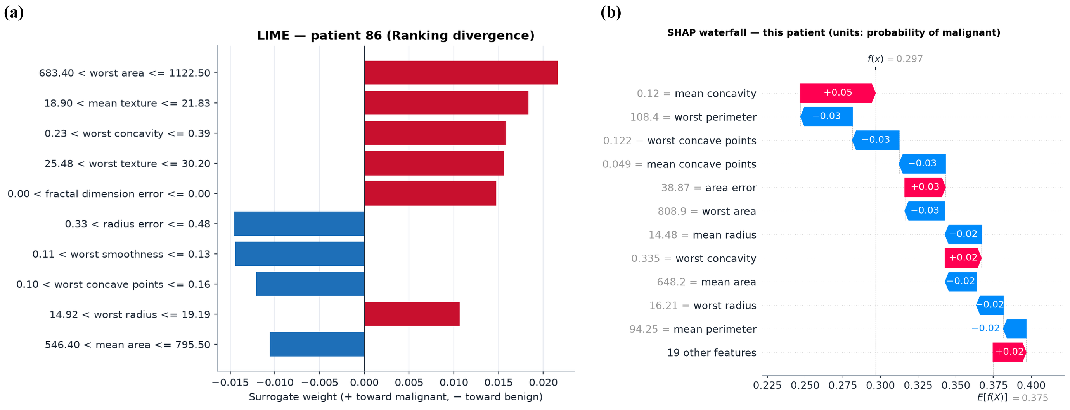
Figure 5.3: Patient #86: (a) LIME and (b) SHAP waterfall

5.8 LIME–SHAP Case Study Comparison
Table 5.2: Five programmatically selected case studies
Case | Patient | P(mal.) | Actual / predicted | Top-5 | Jaccard | ρ | Sign flips | R²
Clearly malignant | #70 | 1.000 | Malignant / Malignant | 5/5 | 1.00 | 0.90 | 0 | 0.63
Clearly benign | #74 | 0.000 | Benign / Benign | 5/5 | 1.00 | 0.83 | 0 | 0.17
Borderline | #100 | 0.513 | Malignant / Malignant | 2/5 | 0.25 | 0.60 | 2 | 0.05
Ranking divergence | #86 | 0.297 | Malignant / Benign | 0/5 | 0.00 | 0.27 | 4 | 0.03
Direction disagreement | #73 | 0.160 | Malignant / Benign | 1/5 | 0.11 | 0.39 | 4 | 0.06

Confident cases #70 and #74 share all five features with no sign conflicts, although #74's surrogate is off by 0.11 (R² 0.17). Borderline #100 shares only two. Missed malignancies #86 (no shared feature, seed stability 0.39) and #73 (one shared) each show four sign flips (Figure 5.4). Worst area for #86/#73 (808.9/812.4) lies in the wide bin 683.4–1122.5: LIME compares it with mostly benign lower bins (+), SHAP with the base value (−). Clinical limitation: SHAP gives an exact rationale for a wrong prediction and LIME gives malignant reasons for a benign label; neither is evidence about the tumour.
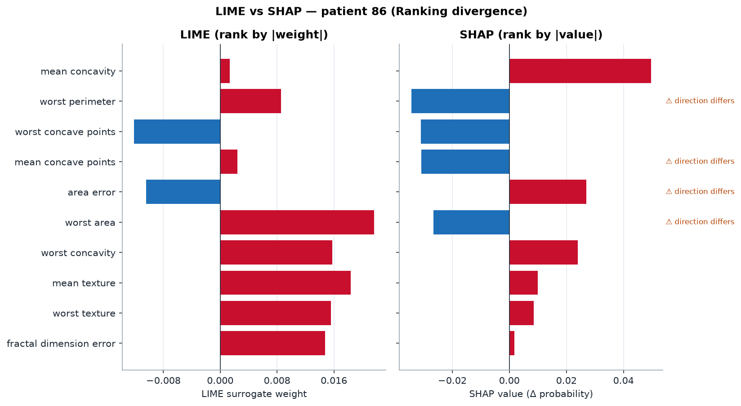
Figure 5.4: LIME vs SHAP for Patient #86

5.9 Explanation Divergence Analysis
Over 114 patients: mean top-5 overlap 3.66/5, Jaccard 0.62, Spearman 0.70, direction disagreement in 28.9% (33 patients) and mean LIME R² 0.27. Agreement rises with confidence |P − 0.5| (ρ = 0.60; Figure 5.5), and all three false negatives (#73, #86, #385) have Jaccard ≤ 0.25 and R² ≤ 0.061 (descriptive analysis of the saved CSV). Causes: different reference points, a linear surrogate on a non-linear boundary, 21 feature pairs with |r| > 0.9 and perturbation noise [14], [10]. Low LIME fidelity and disagreement concentrate on the predictions that most need human review.
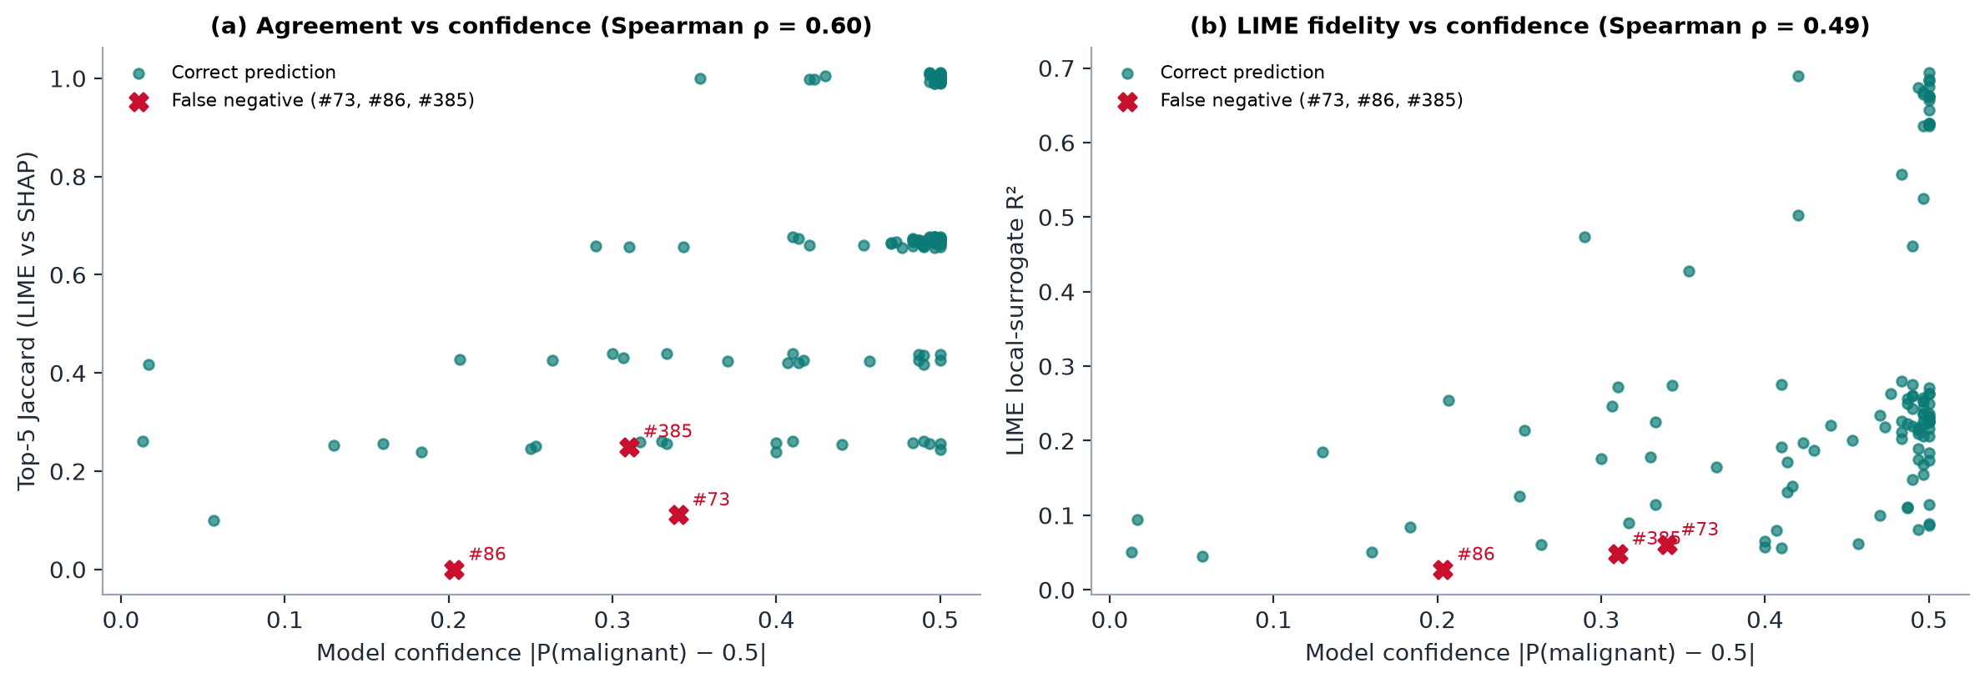
Figure 5.5: Agreement and LIME fidelity versus model confidence

5.10 Model Performance and Interpretability Trade-offs
The forest beats the transparent baseline by one false positive and both miss three cancers [5]; LIME trades fidelity for simplicity, TreeSHAP is exact but tree-only, and a lower threshold would need separate validation data.

5.11 Operational Verification Screenshots
Real screenshots (Edge, Playwright). Verification: 24/24 tests (also after a clean install), 35/35 output checks, 34/34 browser checks.
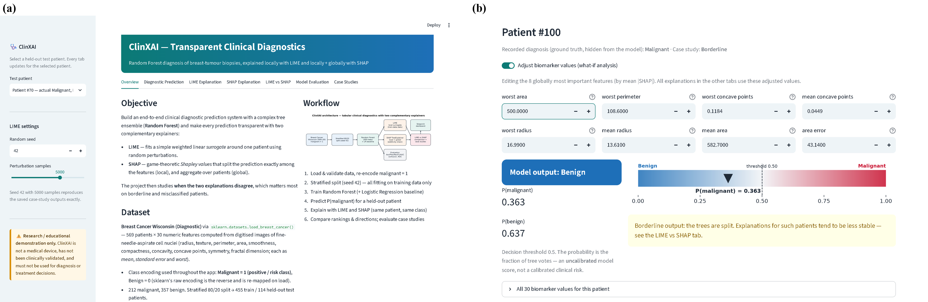
Figure 5.6: (a) Dashboard; (b) what-if on #100 flips the output to benign
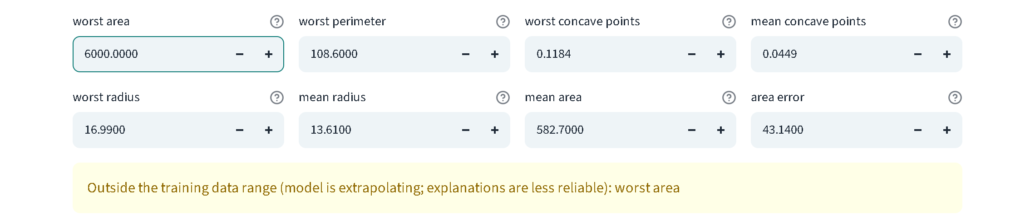
Figure 5.7: Error handling: out-of-range input warning

Chapter 6: Societal Impact, Ethical Governance, Safety & Security Audits

6.1 Importance of Transparency in Clinical AI
Transparency lets clinicians check predictions [8]; ClinXAI also audits the explanations.

6.2 Human Oversight and Clinical Decision Support
ClinXAI is not a medical device and is not clinically validated: an educational aid with a disclaimer, an uncalibrated label, borderline/low-R²/extrapolation warnings and no recommendations.

6.3 Patient Privacy and Responsible Data Usage
Public de-identified data only; real patient data would require consent and safeguards [15].

6.4 Model Bias, Dataset Limitations and Generalisation
Single-centre data, no demographics (no fairness audit), 114 test patients, possible distribution shift.

6.5 Safety Considerations and False Negatives
Three missed malignancies (P 0.160–0.297) with unreliable explanations; explanation manipulation is untested and the pickle-based model file has no checksum.

6.6 Relevant Ethical and Regulatory Considerations
No compliance, certification or clinical validation is claimed. The EU AI Act requires transparency, oversight and robustness for high-risk medical AI [7], and WHO guidance [8] requires validity, including clinical validation; India's ICMR (2023) AI guidelines stress the same.

6.7 Alignment with UN Sustainable Development Goal 3
Supports SDG 3.4 (reducing cancer mortality) [16] through a reproducible, CPU-only audit method.

Chapter 7: Conclusion, Engineering Limitations & Future Enhancements

7.1 Summary of Work Completed
A tested pipeline: Random Forest, LIME and TreeSHAP for the same class, LIME–SHAP comparison, five case studies and a seven-tab dashboard.

7.2 Achievement of Project Objectives
O1 achieved (accuracy 97.37%, AUC 0.9944); O2 achieved (additivity 4.4 × 10⁻¹⁶); O3 achieved (Jaccard 0.62, ρ 0.70); O4 achieved locally (34/34 browser checks).

7.3 Technical Limitations
Seed-dependent, low-fidelity LIME; path-dependent SHAP without a background set; small single-centre data; uncalibrated probabilities; no external or clinical validation; tabular input only.

7.4 Future Enhancements
Image + tabular multimodal models, LIME fidelity thresholds, interventional SHAP, probability calibration, external validation and medical-expert validation before any deployment.

References
[1] World Health Organization, "Breast cancer," WHO fact sheet. [Online]. Available: https://www.who.int/news-room/fact-sheets/detail/breast-cancer
[2] W. N. Street, W. H. Wolberg, and O. L. Mangasarian, "Nuclear feature extraction for breast tumor diagnosis," in Proc. SPIE 1905, Biomedical Image Processing and Biomedical Visualization, San Jose, CA, USA, 1993, pp. 861–870, doi: 10.1117/12.148698.
[3] W. Wolberg, O. Mangasarian, N. Street, and W. Street, "Breast Cancer Wisconsin (Diagnostic)," UCI Machine Learning Repository, 1993, doi: 10.24432/C5DW2B.
[4] L. Breiman, "Random forests," Machine Learning, vol. 45, no. 1, pp. 5–32, 2001, doi: 10.1023/A:1010933404324.
[5] C. Rudin, "Stop explaining black box machine learning models for high stakes decisions and use interpretable models instead," Nature Machine Intelligence, vol. 1, no. 5, pp. 206–215, 2019, doi: 10.1038/s42256-019-0048-x.
[6] S. Krishna, T. Han, A. Gu, J. Pombra, S. Jabbari, S. Wu, and H. Lakkaraju, "The disagreement problem in explainable machine learning: A practitioner’s perspective," 2022, arXiv:2202.01602.
[7] European Parliament and Council of the European Union, "Regulation (EU) 2024/1689 laying down harmonised rules on artificial intelligence (Artificial Intelligence Act)," Official Journal of the European Union, L series, 12 Jul. 2024.
[8] World Health Organization, Ethics and Governance of Artificial Intelligence for Health: WHO Guidance. Geneva, Switzerland: WHO, 2021, ISBN: 978-92-4-002920-0.
[9] M. T. Ribeiro, S. Singh, and C. Guestrin, "‘Why should I trust you?’: Explaining the predictions of any classifier," in Proc. 22nd ACM SIGKDD Int. Conf. Knowledge Discovery and Data Mining (KDD), San Francisco, CA, USA, 2016, pp. 1135–1144, doi: 10.1145/2939672.2939778.
[10] D. Alvarez-Melis and T. S. Jaakkola, "On the robustness of interpretability methods," presented at the ICML Workshop on Human Interpretability in Machine Learning, Stockholm, Sweden, 2018, arXiv:1806.08049.
[11] S. M. Lundberg and S.-I. Lee, "A unified approach to interpreting model predictions," in Advances in Neural Information Processing Systems 30 (NeurIPS), Long Beach, CA, USA, 2017, pp. 4765–4774.
[12] L. S. Shapley, "A value for n-person games," in Contributions to the Theory of Games, vol. II, H. W. Kuhn and A. W. Tucker, Eds. Princeton, NJ, USA: Princeton Univ. Press, 1953, pp. 307–317.
[13] S. M. Lundberg, G. Erion, H. Chen, A. DeGrave, J. M. Prutkin, B. Nair, R. Katz, J. Himmelfarb, N. Bansal, and S.-I. Lee, "From local explanations to global understanding with explainable AI for trees," Nature Machine Intelligence, vol. 2, no. 1, pp. 56–67, 2020, doi: 10.1038/s42256-019-0138-9.
[14] D. Slack, S. Hilgard, E. Jia, S. Singh, and H. Lakkaraju, "Fooling LIME and SHAP: Adversarial attacks on post hoc explanation methods," in Proc. AAAI/ACM Conf. AI, Ethics, and Society (AIES), New York, NY, USA, 2020, pp. 180–186, doi: 10.1145/3375627.3375830.
[15] Government of India, "The Digital Personal Data Protection Act, 2023," Act No. 22 of 2023, Ministry of Law and Justice, New Delhi, India, Aug. 2023.
[16] United Nations General Assembly, "Transforming our world: The 2030 Agenda for Sustainable Development," Resolution A/RES/70/1, Oct. 2015.

Appendix A: Complete Source Code Listings / Core Configuration Files
Condensed for length: the file inventory below points to the complete source code submitted in the project folder ClinXAI/; the key comparison routine follows.
Table A.1: Source-file inventory (complete code in the project folder)
File | Purpose | Lines | File | Purpose | Lines
app.py | Streamlit dashboard (7 tabs) | 488 | src/explain_lime.py | LIME explanations | 94
train_model.py | Training, metrics, model bundle | 89 | src/explain_shap.py | SHAP explanations | 80
evaluate.py | SHAP, LIME, comparison, case studies | 183 | src/comparison.py | LIME–SHAP agreement | 125
src/data_loader.py | Loading, mapping, validation | 124 | src/visualization.py | Figures | 298
src/model.py | Model training and evaluation | 109 | tests/test_pipeline.py | 24 automated tests | 282

Code excerpt A.1 — src/comparison.py, lines 29–37: LIME–SHAP agreement measures
def compare_explanations(lime_weights: pd.Series, shap_values: pd.Series, k: int = TOP_K) -> dict:
"""Compare two attribution vectors indexed by the same feature names (same patient, class)."""
lime_weights = lime_weights.reindex(shap_values.index).fillna(0.0)
lime_top, shap_top = top_k(lime_weights, k), top_k(shap_values, k)
shared = [f for f in lime_top if f in shap_top]
union = list(dict.fromkeys(lime_top + shap_top))

rho, _ = spearmanr(lime_weights.abs().to_numpy(), shap_values.abs().to_numpy())

Appendix B: Raw Diagnostic Trace Logs, Audit Tables & Verification Sheets
python -m pytest -v — final lines of the 24-test log (report/evidence/pytest_verbose.txt)
tests/test_pipeline.py::test_invalid_numeric_input[<lambda>-Unknown] PASSED [ 91%]
tests/test_pipeline.py::test_invalid_input_length PASSED [ 95%]
tests/test_pipeline.py::test_streamlit_app_runs_and_updates_on_patient_change PASSED [100%]
============================= 24 passed in 17.82s =============================

Table B.1: Verification summary
Verification layer | Result
Automated tests (also after a clean install) | 24 / 24 passed
Independent saved-output validation | 35 / 35 passed
Real-browser click-through (Microsoft Edge) | 34 / 34 passed
Runtime warnings during training and evaluation | 0

