Mahavir Education Trust's
Shah & Anchor Kutchhi Engineering College
Autonomous Institute Affiliated to University of Mumbai

MICROPROJECT REPORT ON

Artificial Intelligence

Course Name: Artificial Intelligence (ADCR1503)
Microproject Title: Automatic Essay Scoring

Submitted by (Group of 2):
1. Name: ______________________ Roll No: __________
2. Name: ______________________ Roll No: __________
Class: ______________________

Submitted to:
Department of Artificial Intelligence and Data Science
Shah and Anchor Kutchhi Engineering College, Chembur - 400088
Academic Year: 2025-26

ABSTRACT
Manual grading of essays is time-consuming, expensive, and prone to inconsistency between different human raters. This microproject applies deep learning to the problem of Automatic Essay Scoring (AES), where a model learns to predict a numeric score for a student essay based on its content, coherence, and language quality. The study covers the AES domain problem, dataset collection and preprocessing, the selection and design of a suitable deep learning architecture, and a full training and evaluation pipeline benchmarked against a handcrafted-feature baseline. A Bidirectional LSTM with mean-over-time pooling and GloVe word embeddings is trained on the ASAP dataset. A single BiLSTM trained across all eight essay prompts achieves a mean per-set Quadratic Weighted Kappa (QWK) of 0.686, matching an ensemble of eight prompt-specific linear baselines (0.672) and greatly exceeding a single global baseline (0.361). The project also considers deployment challenges, ethical concerns such as scoring bias, and real-world applications in education and standardized testing.
1. INTRODUCTION
Automatic Essay Scoring (AES) is the task of using a computational model to assign a score to a student essay in place of, or alongside, a human rater. Traditional grading is slow, costly to scale, and often inconsistent, since two human graders can score the same essay differently. Deep Learning is well suited to this problem because it can learn rich representations of language directly from text, capturing aspects such as vocabulary usage, sentence structure, coherence, and argument organization, without relying entirely on hand-crafted features. The motivation behind this project is to design a deep learning pipeline that reads an essay and predicts a score that closely matches the score a human rater would give, and to understand the practical constraints involved: essays vary widely in length, topic, and writing style; training data is limited and expensive to obtain; and scores must remain fair and explainable rather than being an opaque black box.
Objectives:
- To analyze the Automatic Essay Scoring domain problem and identify its key constraints and objectives.
- To collect and preprocess a suitable essay-scoring dataset for model training.
- To select and design a deep learning architecture capable of learning scoring patterns from essay text.
- To plan a training, validation, and evaluation strategy, and compare the proposed model against a baseline approach.
Scope:
This project focuses on the Natural Language Processing (NLP) domain, specifically text-based regression/scoring. The insights gained are applicable to ed-tech platforms, standardized testing (e.g., TOEFL, GRE-style essay sections), classroom assessment tools, and any system that needs to rate the quality of written text at scale.
2. METHODOLOGY
The methodology adopted in this project includes data collection, preprocessing, model selection, training, and evaluation. The workflow involves the following steps:
1. Dataset Description: The Automated Student Assessment Prize (ASAP) essay dataset (available on Kaggle) is used. It contains 12,976 student essays across 8 essay sets, each hand-scored by human raters, with scores on different scales per set (e.g., Set 3 uses 0-3 while Set 8 uses 0-60).
2. Data Preprocessing: Text cleaning (lowercasing, collapsing the ASAP anonymisation tags such as @PERSON1 to placeholder words, removing special characters), tokenization, padding/truncation to a fixed sequence length, converting words to 50-dimensional GloVe embeddings, and normalizing each essay's domain1_score to a common 0-1 range using the OFFICIAL per-set ASAP score range (not the observed min/max). Data is split into training, validation, and test sets, stratified by essay set and score bin.
3. Model Architecture: A Bidirectional LSTM (BiLSTM) network with a GloVe-initialised embedding layer, a BiLSTM layer that returns an output at every timestep, mean-over-time pooling that averages those outputs across the essay, dropout, and a dense regression head with a sigmoid output that predicts the normalised score.
4. Training Process: Adam optimizer, Mean Squared Error (MSE) loss (scoring is framed as regression), batch size of 32, and up to 30 epochs with early stopping on validation loss and restoration of the best-epoch weights.
5. Evaluation: RMSE, MAE, and Quadratic Weighted Kappa (QWK) - the standard AES metric that measures agreement with human raters. QWK is computed on scores rescaled back to the original integer range. The model is compared against a baseline linear regression built on handcrafted features (word count, sentence count, average word length, unique-word ratio, spelling-error count), and QWK is reported PER SET as well as overall.
6. Deployment and Ethical Considerations: Key challenges include ensuring the model generalizes to unseen essay topics, avoiding bias toward superficial features (e.g., essay length) rather than genuine writing quality, keeping predictions explainable, and providing a human-in-the-loop review process for borderline or low-confidence scores.
2.1 Individual Contribution to Design Methodology
Student 1 (Name: ____________, Roll No: ______): Proposed and prepared the ASAP dataset and implemented the data pipeline (Stage A data exploration and Stage B preprocessing): loading the TSV with the correct ISO-8859-1 encoding, text cleaning including collapsing the ASAP anonymisation tags, tokenisation fitted on the training split only, and padding/truncation. Made and justified the key decision to normalise scores per essay set using the official ASAP ranges rather than the observed min/max. Designed and implemented the BiLSTM model (Stage D) and ran the architecture-tuning study — introducing mean-over-time pooling and moving from a frozen to a trainable GloVe embedding — which raised the set-1 QWK from 0.30 to 0.70.
Student 2 (Name: ____________, Roll No: ______): Defined the evaluation methodology and implemented the metrics module — RMSE, MAE, and Quadratic Weighted Kappa computed on denormalised integer scores. Built the handcrafted-feature linear-regression baseline (Stage C) and designed the fair comparison: single global baseline versus eight per-prompt baselines, and per-set versus pooled QWK. Identified that pooled QWK across differently-scaled prompts is misleading and introduced score-bin stratification for representative splits. Produced the Stage E result figures and researched the deployment and ethical considerations for AES.
2.2 Design Methodology Quality (Group Consensus)
After discussing individual proposals, the group agreed on the BiLSTM-based architecture with the ASAP dataset, MSE loss with QWK/RMSE/MAE as evaluation metrics, and a handcrafted-feature linear-regression baseline for comparison. This methodology was chosen because it balances implementation feasibility within the project timeline with strong alignment to established AES research practice, and both members' proposals were integrated into the final design (dataset, preprocessing and architecture from Student 1; evaluation, baseline and ethics from Student 2).

3. IMPLEMENTATION AND RESULTS
The project was implemented in Python using TensorFlow/Keras, scikit-learn, pandas and NLTK, following the methodology in Section 2. The code is organised into five stages (A-E): data exploration, preprocessing, baseline model, BiLSTM model, and evaluation. A fixed random seed (42) is set across Python, NumPy and TensorFlow so every result is reproducible.
3.1 Dataset Exploration
The ASAP dataset contains 12,976 essays across 8 prompts, with no missing target scores. The number of essays is fairly balanced across sets (Set 8 is smallest at 723). Crucially, the score scales differ dramatically between prompts, which is why per-set normalisation is required before a single model can learn from all prompts together.
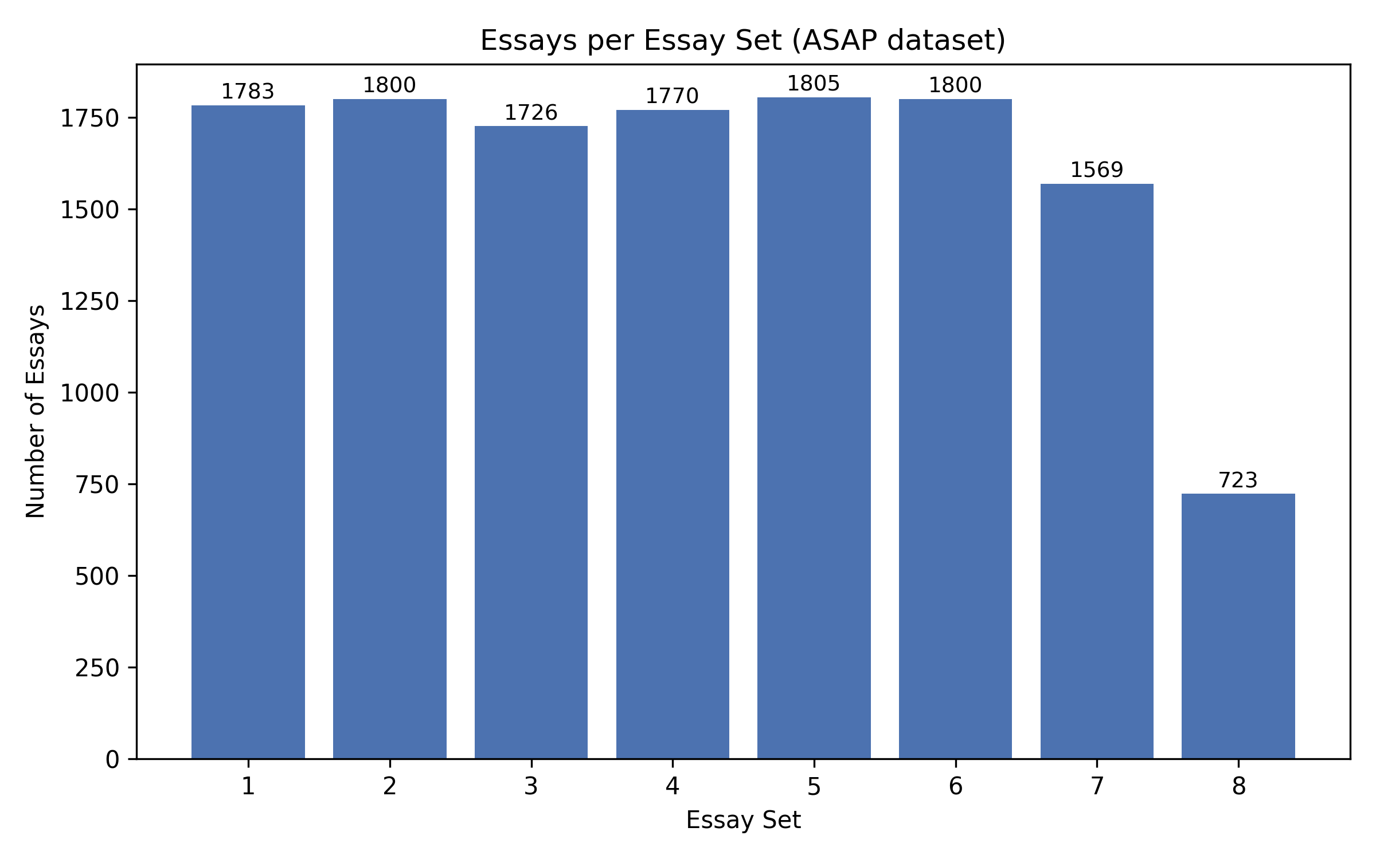
Figure 1: Number of essays per essay set.
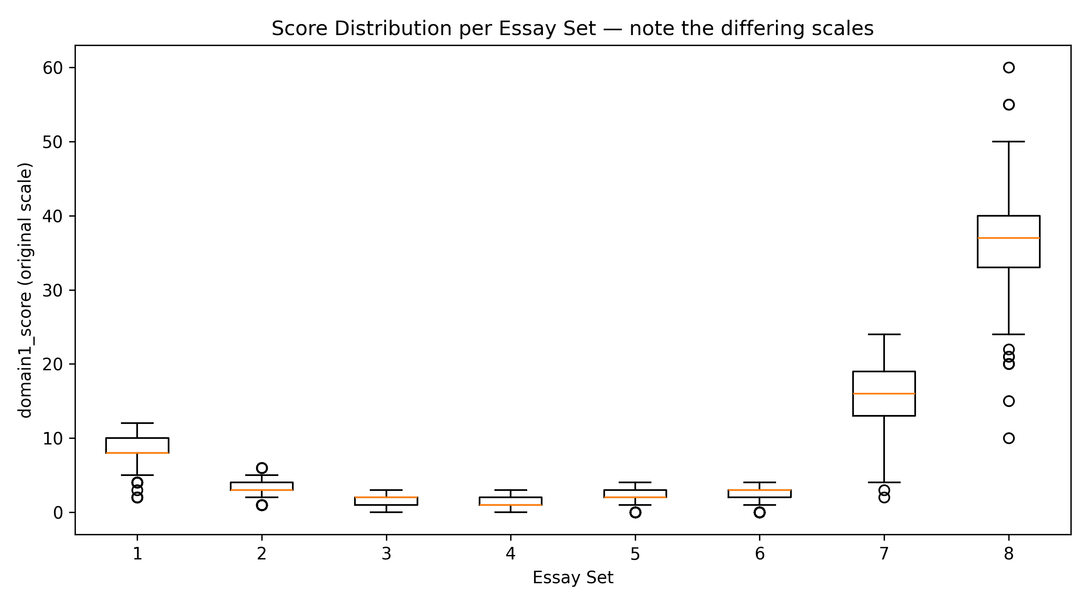
Figure 2: Score distribution per set — note the very different scales (1-6 up to 0-60), motivating per-set normalisation.
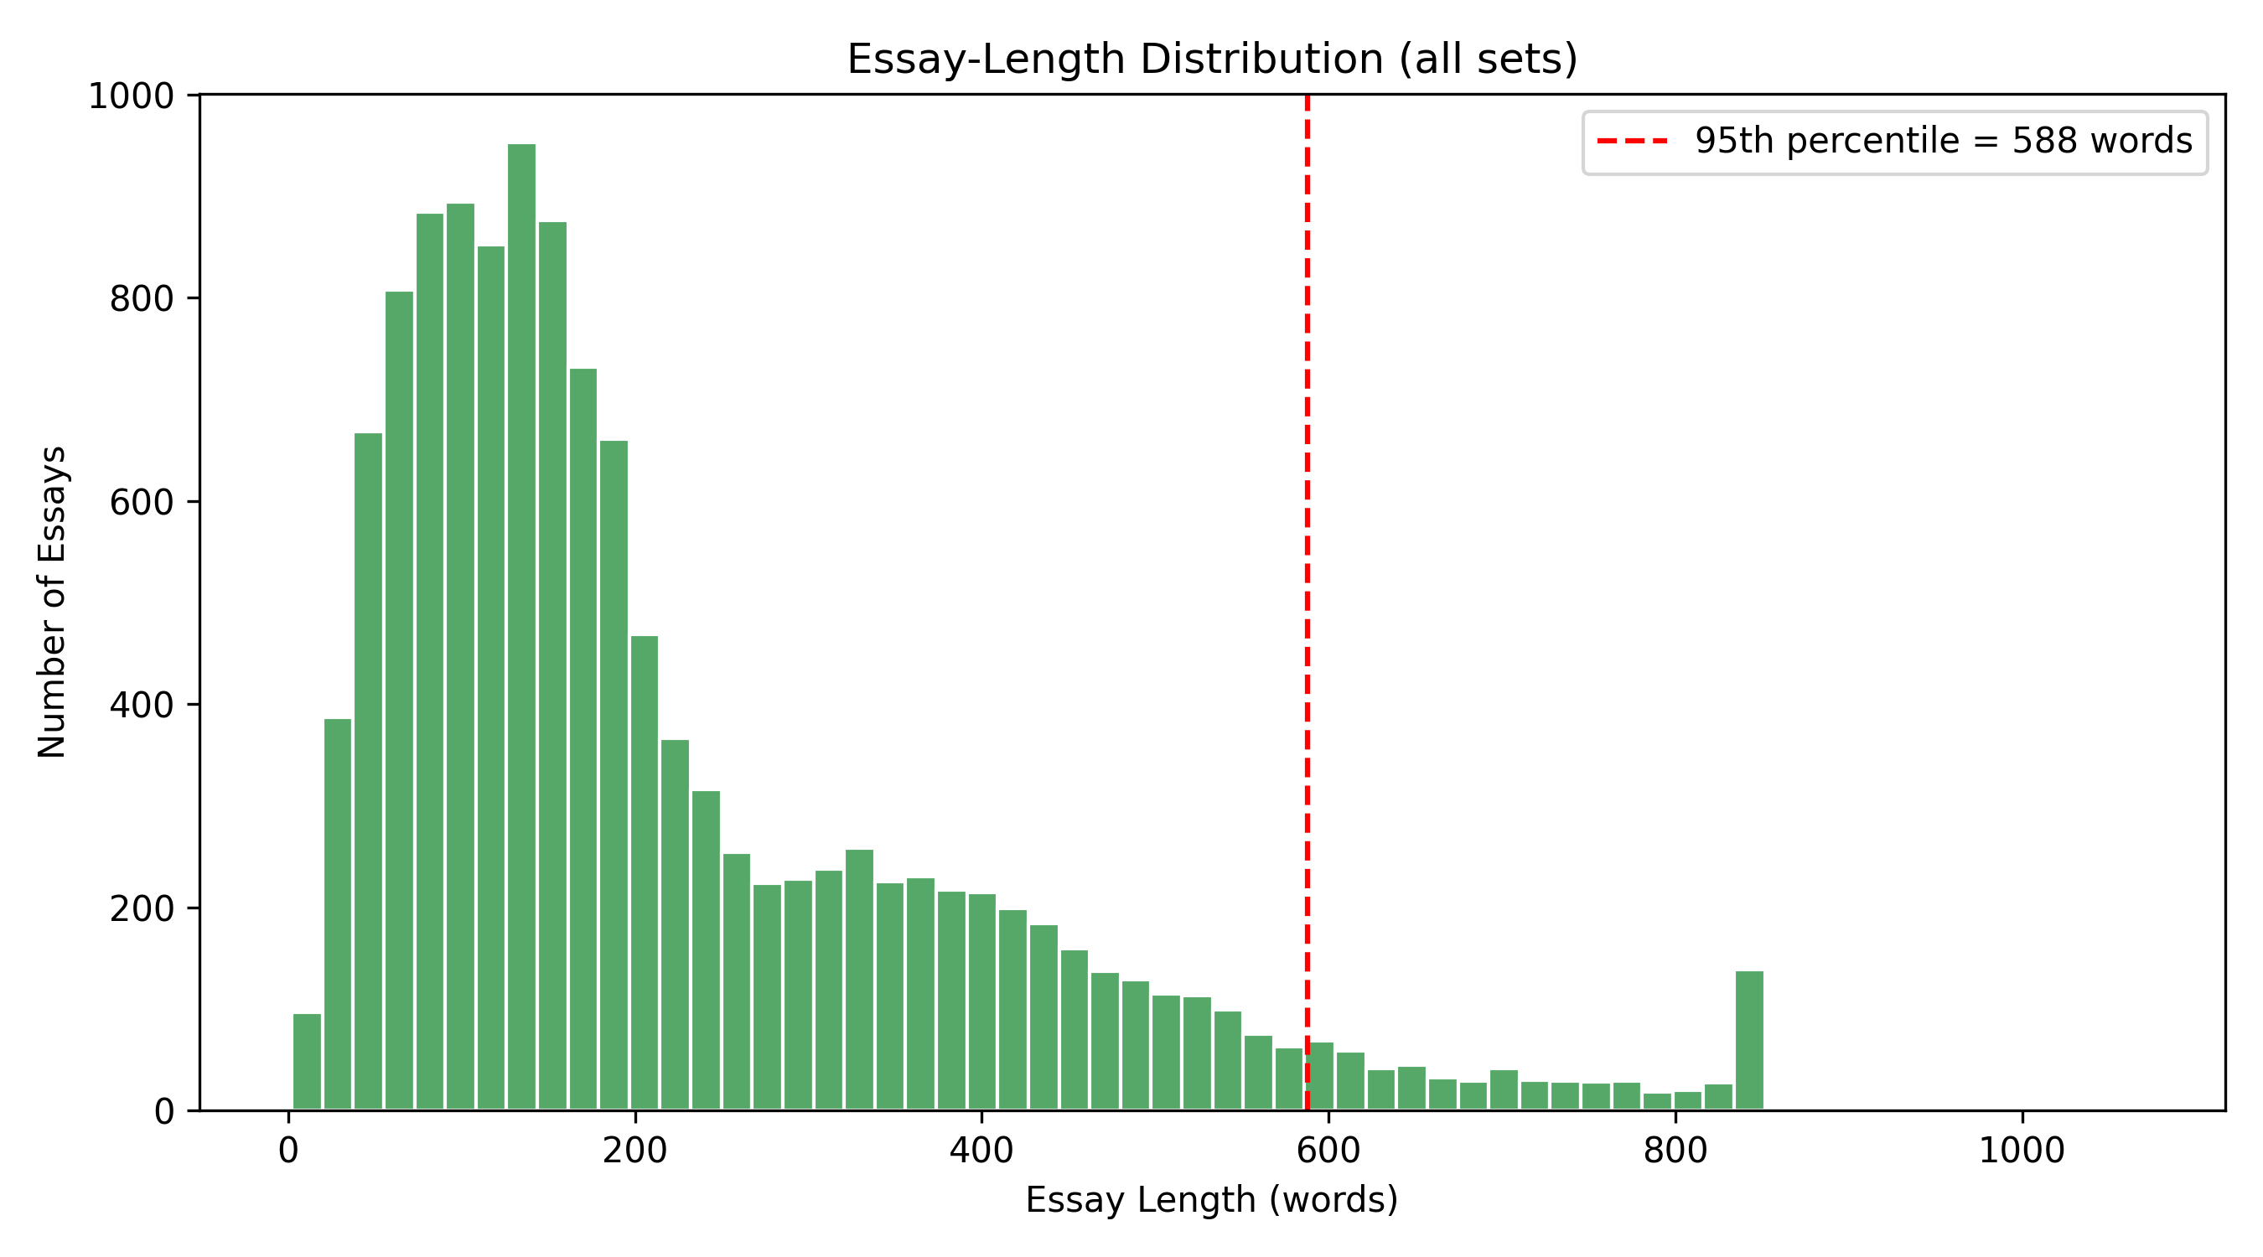
Figure 3: Essay-length distribution across all sets, used to choose the padding/truncation length.
3.2 Models and Training
The baseline is a linear regression on five handcrafted features (word count, sentence count, average word length, unique-word ratio, spelling-error count); its learned weights are dominated by word count, i.e. it essentially rewards longer essays. The deep model is a BiLSTM: a GloVe-50d embedding (77.4% of the vocabulary matched a pretrained vector), a bidirectional LSTM, mean-over-time pooling, dropout, and a dense sigmoid output. It was trained with Adam and MSE loss, batch size 32, and early stopping with best-weight restoration.
An architecture-tuning study on essay set 1 showed how each design choice contributed, which is itself an instructive result:
Design configuration (essay set 1) | QWK
Frozen embedding + final LSTM state only | 0.30
+ mean-over-time pooling | 0.47
+ trainable embedding, reduced dropout | 0.70

3.3 Results
The headline metric is the MEAN PER-SET QWK. A single BiLSTM trained on all eight prompts matches an ensemble of eight separately-tuned per-prompt baselines, and is far better than a single global feature-based model:
Model | Mean per-set QWK
BiLSTM — one model, all 8 sets | 0.686
Baseline — 8 separate per-prompt models | 0.672
Baseline — one global model, all 8 sets | 0.361

The per-set breakdown (Table 4, Figure 4) shows a genuinely even split: the BiLSTM wins on four prompts and the strongest baseline wins on four. The baseline edges the longest, most length-driven prompt (Set 1), while the BiLSTM wins where content matters more (Sets 4, 6, 7).
Set | Baseline QWK | BiLSTM QWK | BiLSTM RMSE | BiLSTM MAE | Winner
1 | 0.790 | 0.723 | 0.970 | 0.762 | Baseline
2 | 0.580 | 0.611 | 0.566 | 0.464 | BiLSTM
3 | 0.677 | 0.633 | 0.583 | 0.448 | Baseline
4 | 0.689 | 0.771 | 0.540 | 0.450 | BiLSTM
5 | 0.814 | 0.766 | 0.525 | 0.418 | Baseline
6 | 0.620 | 0.774 | 0.526 | 0.435 | BiLSTM
7 | 0.654 | 0.719 | 2.968 | 2.324 | BiLSTM
8 | 0.554 | 0.493 | 4.904 | 3.786 | Baseline
Mean | 0.672 | 0.686 | — | — | —

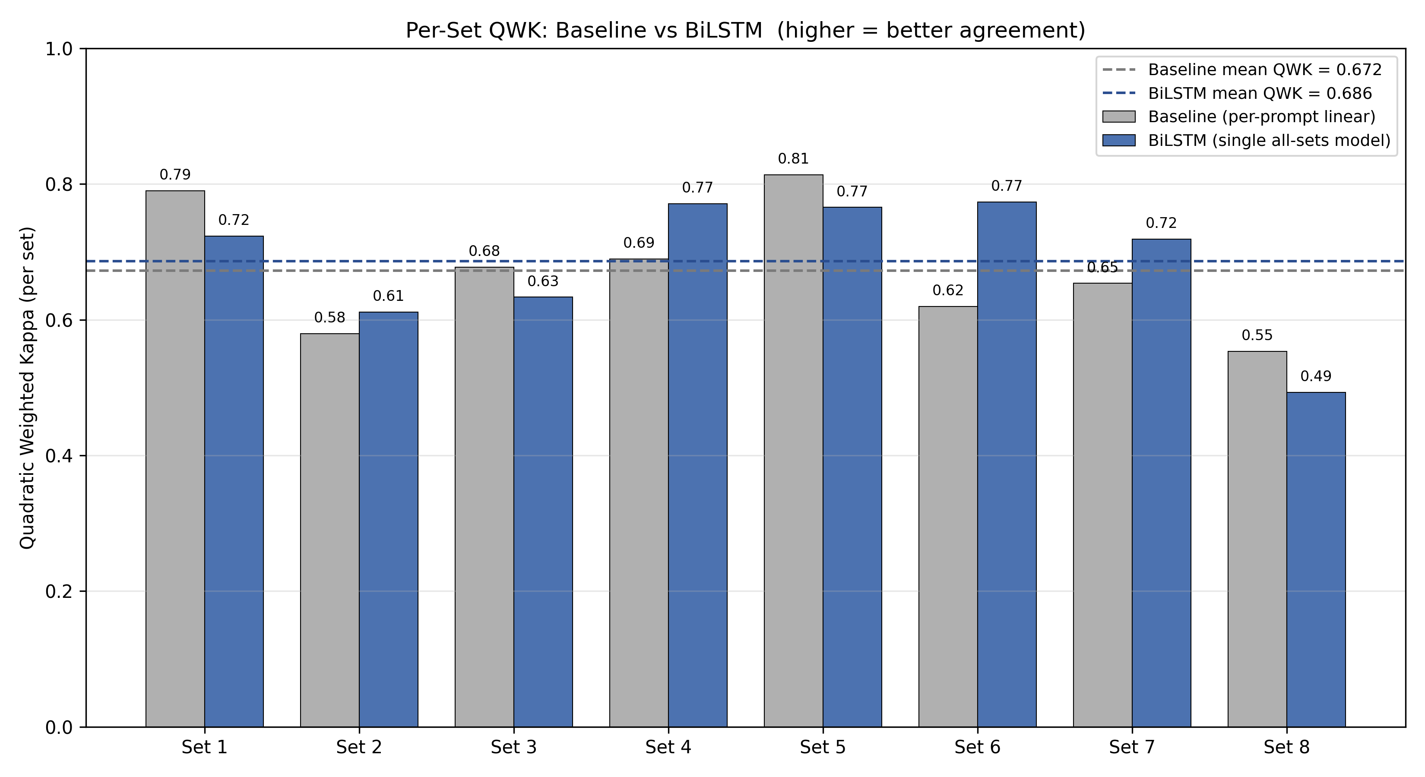
Figure 4: Per-set QWK, baseline vs BiLSTM, with each model's mean.
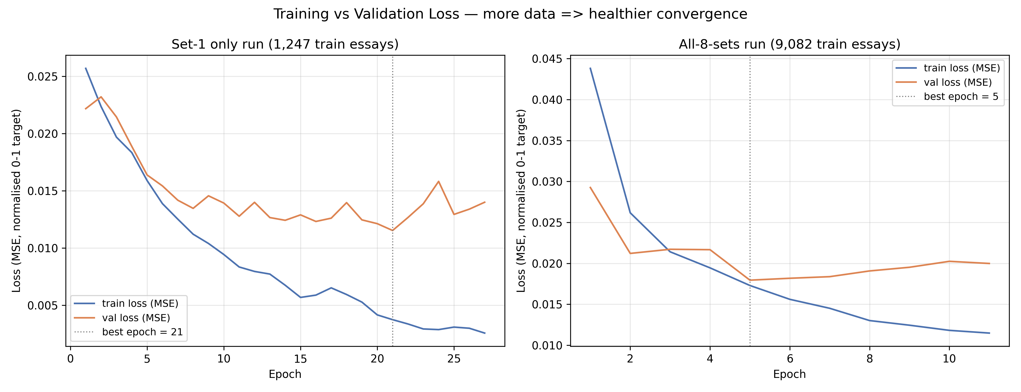
Figure 5: Training vs validation loss. The set-1 run overfits (wide train/val gap); the all-sets run converges more healthily with 7x more data.
A note on metrics: pooling all eight prompts into a single QWK gives an inflated value of 0.98, which is misleading. Because the prompts use very different score ranges, essay pairs from different sets trivially 'agree' on being far apart, so the pooled metric partly rewards the model for sorting which set an essay belongs to rather than scoring within a set. Figure 6 makes this visible as eight separated clusters. Mean per-set QWK is therefore the correct metric and is used throughout.
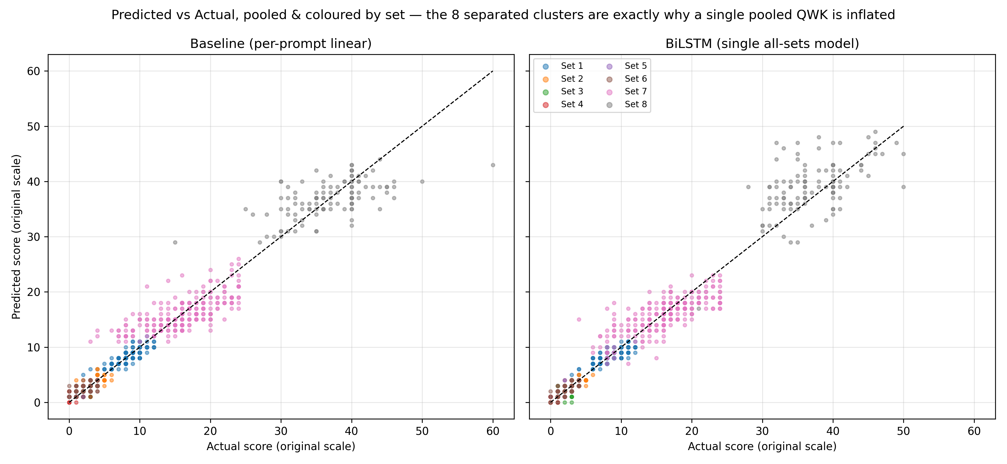
Figure 6: Predicted vs actual, pooled and coloured by set. The eight separated clusters are exactly why a single pooled QWK is inflated.
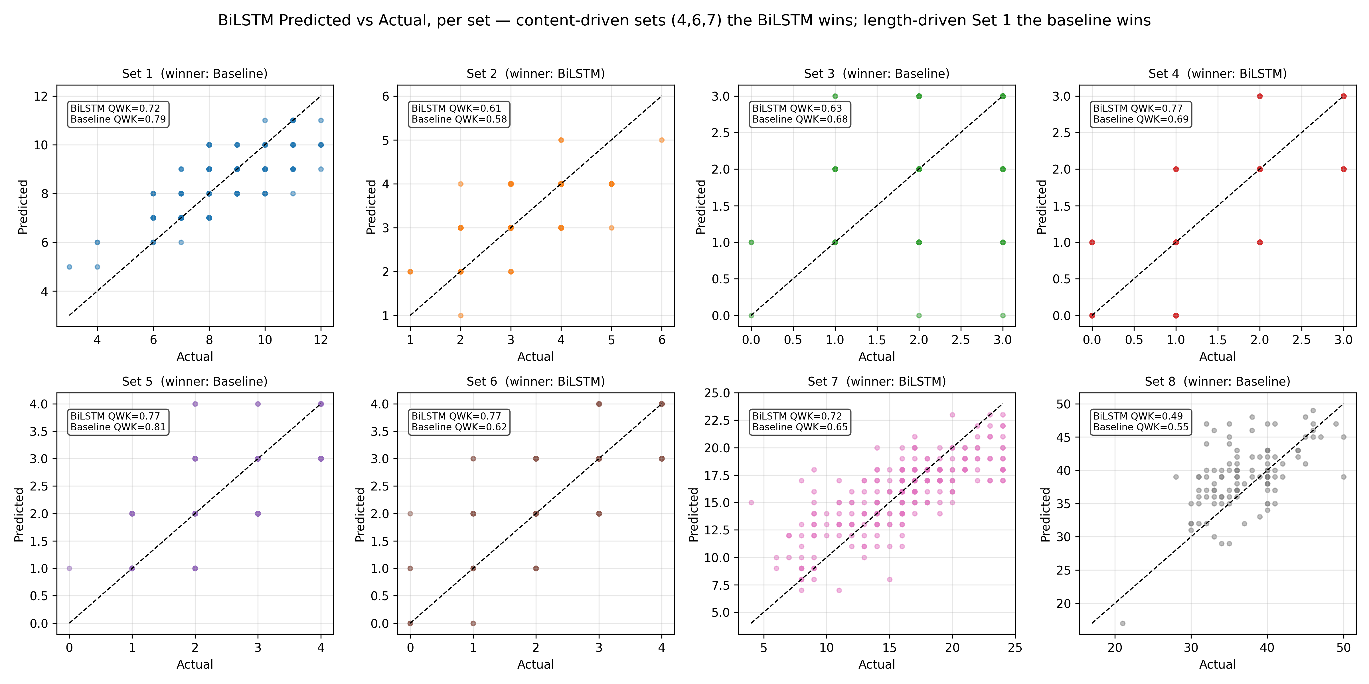
Figure 7: BiLSTM predicted vs actual, per set, with QWK annotated.
4. CONCLUSION AND FUTURE SCOPE
This microproject set out to determine not only whether a deep learning model can score essays, but whether it is genuinely suitable for the task compared with a simple baseline. The answer is a qualified yes. A single BiLSTM that reads only the essay text achieves a mean per-set QWK of 0.686 — matching an ensemble of eight separately-tuned per-prompt baselines (0.672) and far exceeding a single global feature model (0.361). The practical significance is a deployment argument: one neural model can serve all eight prompts to the same standard that the baseline reaches only by maintaining eight separate specialised models. In a real ed-tech system, one model to maintain, monitor and re-train is substantially cheaper and safer than eight.
The per-set comparison is deliberately honest rather than a single headline number. The four-to-four split between the models shows that surface features such as length remain a strong signal for some prompt types — notably Set 1, the longest and most structured prompt, where the baseline wins — while the BiLSTM's ability to read content pays off on prompts where quality is less correlated with length. The weakest result, Set 8 (QWK 0.49), is named as a genuine limitation: it is the smallest training set with the widest score scale (0-60) and the fewest test essays, making it both the hardest to learn and the noisiest to measure.
Future work. The model can be improved with larger and transfer-learning architectures such as a fine-tuned BERT regressor; with per-set output heads or ordinal-regression losses better suited to wide score scales; with a hierarchical encoder to avoid truncating very long essays (as in Set 8); and with data augmentation or additional graded essays for the smaller prompts. More robust evaluation via cross-validation would also reduce the measurement noise seen on the smaller sets.
REFERENCES
1. Ian Goodfellow, Yoshua Bengio, and Aaron Courville, Deep Learning, MIT Press, 2016.
2. Francois Chollet, Deep Learning with Python, Manning Publications, 2018.
3. Aurelien Geron, Hands-On Machine Learning with Scikit-Learn, Keras & TensorFlow, O'Reilly Media, 2022.
4. TensorFlow Documentation: https://www.tensorflow.org/
5. scikit-learn Documentation: https://scikit-learn.org/
6. Hewlett Foundation, Automated Student Assessment Prize (ASAP) - Essay Scoring Dataset (including the official per-set score ranges), Kaggle, 2012. https://www.kaggle.com/c/asap-aes
7. Jeffrey Pennington, Richard Socher, and Christopher D. Manning, GloVe: Global Vectors for Word Representation. 2024 Wikipedia + Gigaword 50-dimensional release. Stanford NLP. https://nlp.stanford.edu/projects/glove/
8. Taghipour, K. and Ng, H.T., A Neural Approach to Automated Essay Scoring, Proceedings of EMNLP, 2016.

