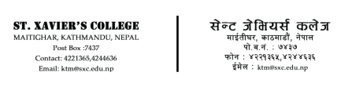


DEPARTMENT OF COMPUTER SCIENCE
IT 277: Cloud Computing

SUBMITTED BY:
Sayujya Satyal
021BIM054
TU Roll: 13417/21
8th Semester - Section B
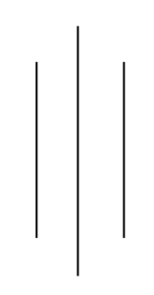

SUBMITTED TO:
Mr. Anish Shrestha
Department of Computer Science
St. Xavier’s College
Maitighar, Kathmandu

