mcx-hero
eyebrow | Spring Collection - 2026 - Tax-Free
heading-line-1 | OUTFITTED
heading-line-2 | FOR THE
heading-line-3 | mission & beyond
description | Serving Marines and their families since 1897. Premium brands, exclusive savings, and tax-free shopping - exclusively for those who serve.
image | 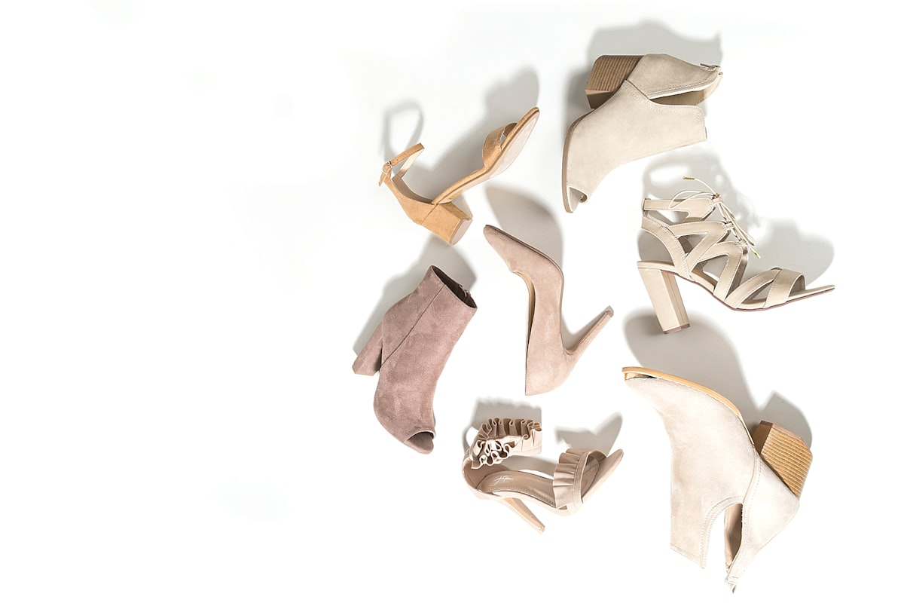  Marine Corps collection hero
primary-cta | Shop Now
secondary-cta | View Deals
status-badge-1 | SYS: MCX-2026
status-badge-2 | STATUS: ACTIVE
status-badge-3 | PATRON: AUTHORIZED
stat-1-value | 20%+
stat-1-label | Average Savings
stat-2-value | 33M+
stat-2-label | Yearly Transactions
stat-3-value | Tax Free
stat-3-label | Exclusive Benefit
stat-4-value | 127+
stat-4-label | Store Locations

