CO-2 ASSESSMENT TOOL -DEBUGGING
COUSE CODE: CSA0307 NAME:S. AHMAD ALISHA
COUSE NAME : DATA STRUCTURES REG NO: 192525415
DATE : 31/07/26
QUESTION 1 INCLUDE MISSING LINES
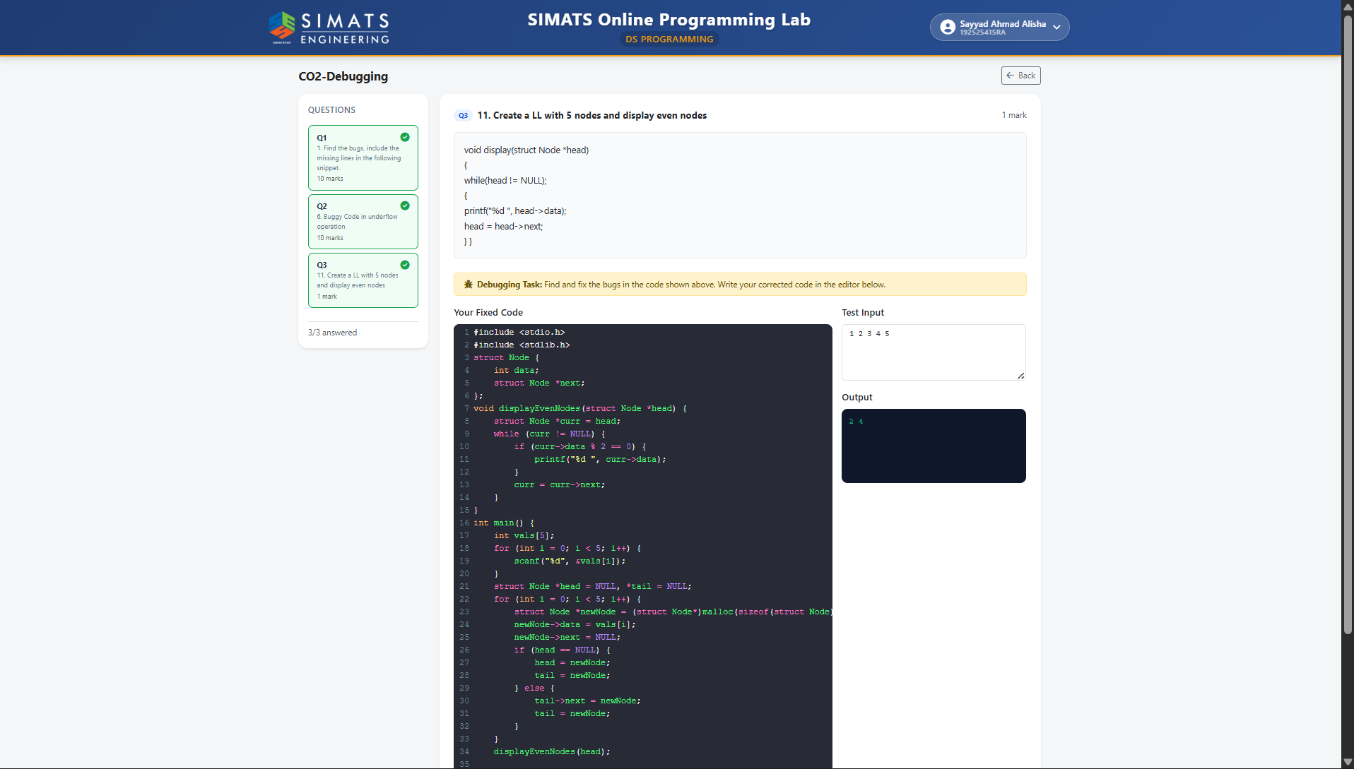
QUESTION 2 UNDER FLOW OPERATIONS
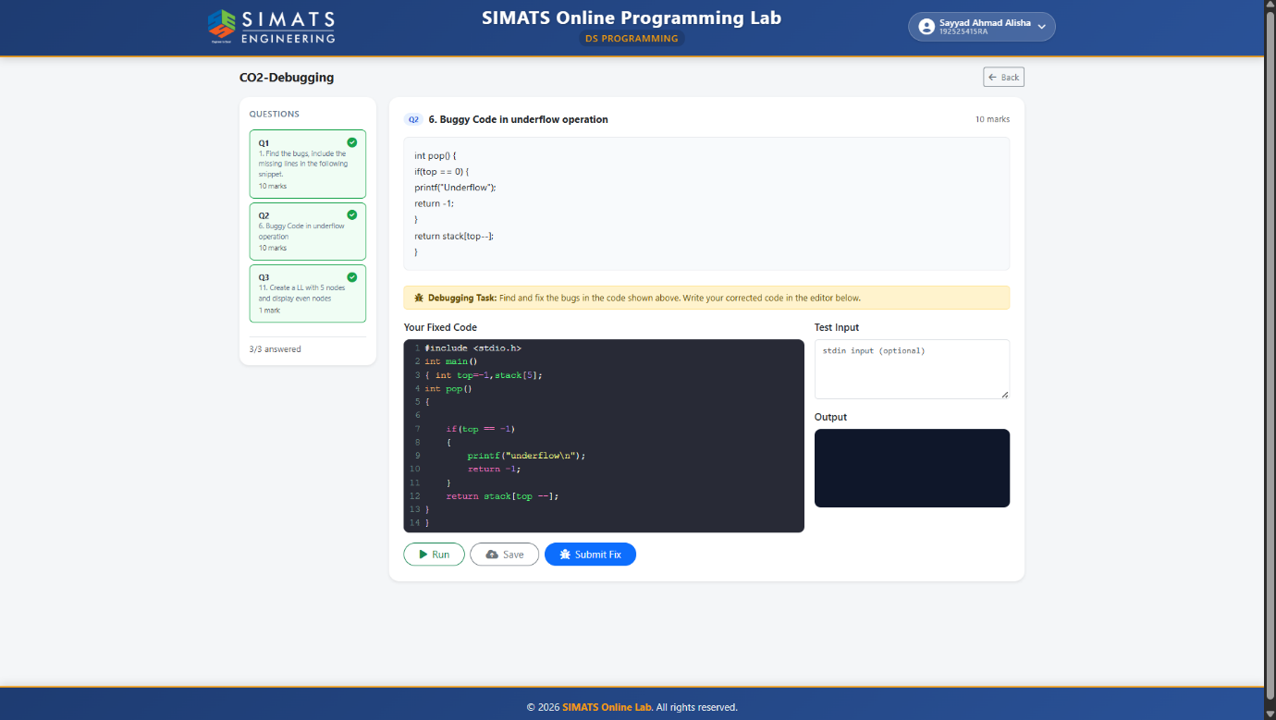
QUESTION 3 DISPLAY EVEN NODESd
