ITHENA Technical Evaluation Assignment

PROJECT 3: Snowflake- Cost & Query Performance

QUESTION 16:

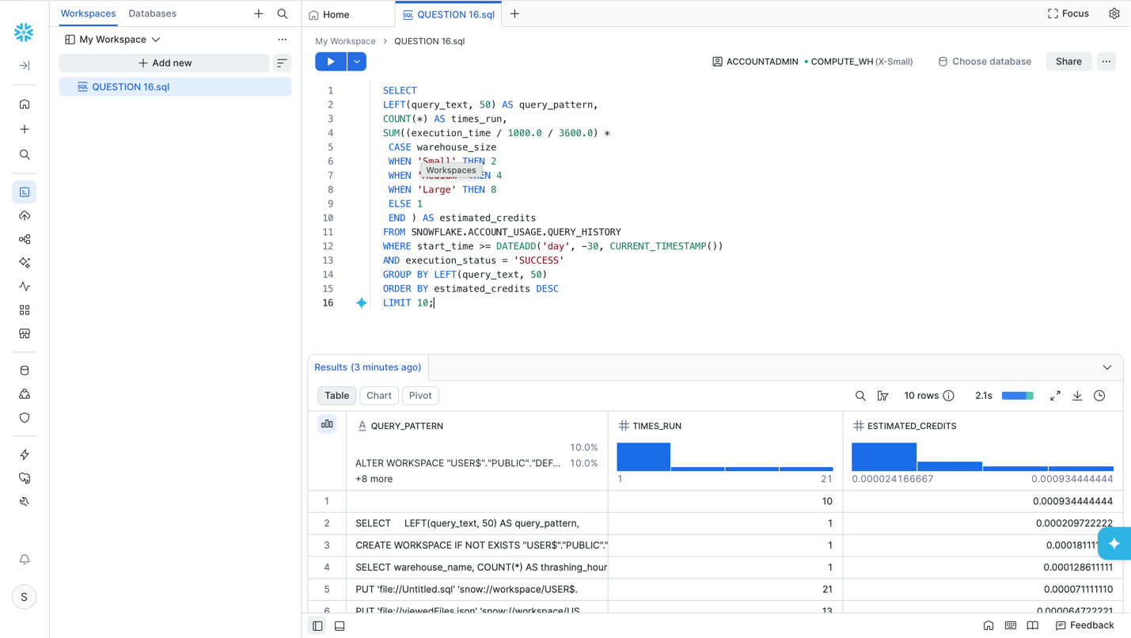

RESULTS:

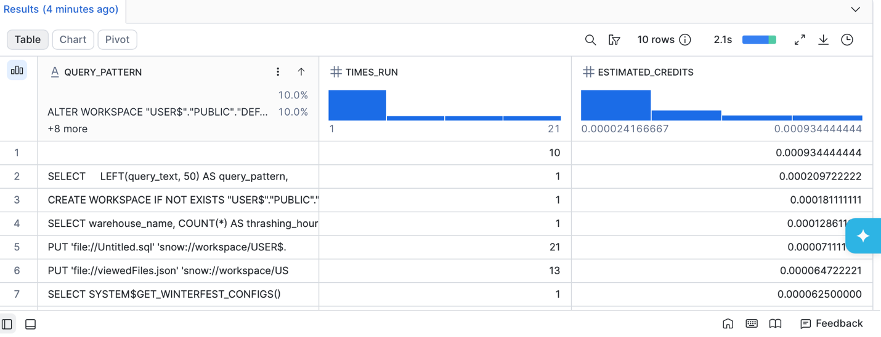
QUESTION 17:

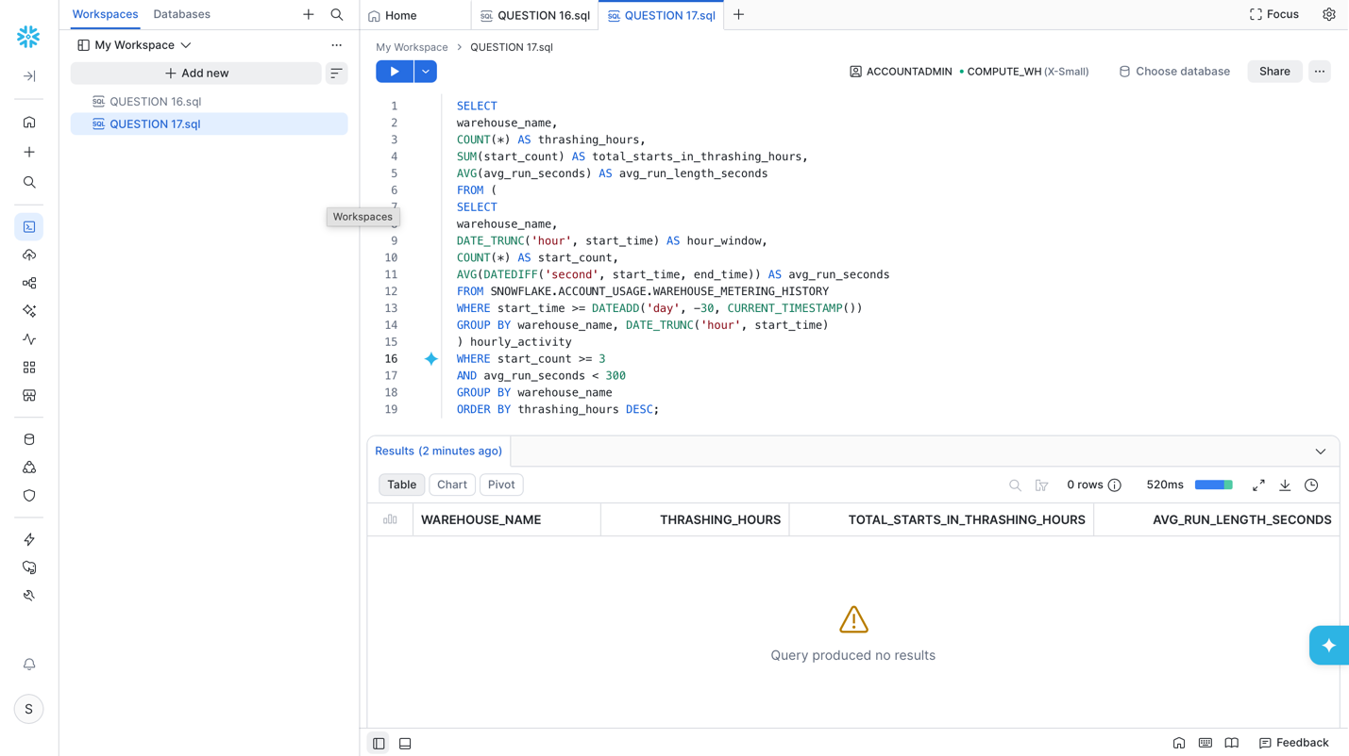

RESULTS:

