- Query for Pull data-for-bi:

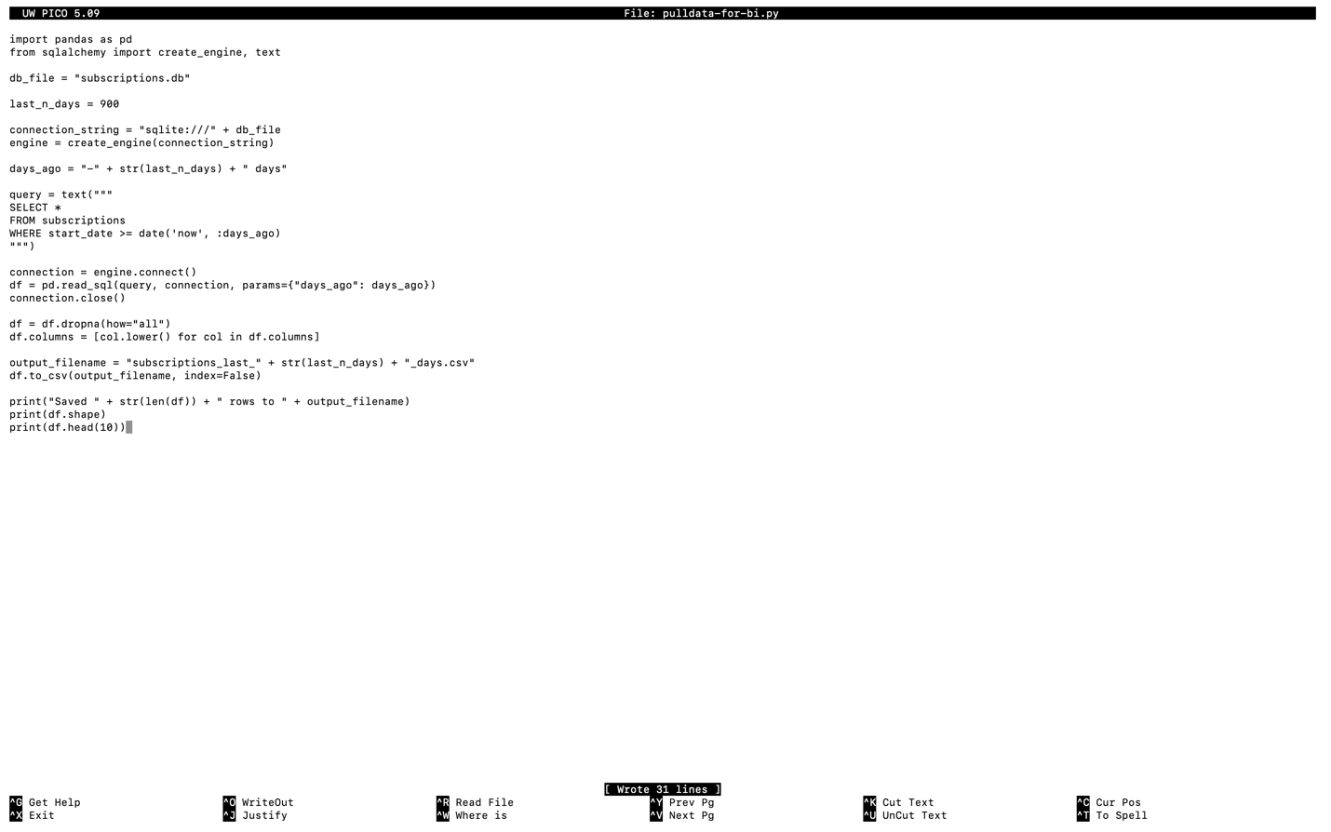

- Results:

