Software Requirement Specifications
Travel and Tour Booking Platform



Submitted by
Muhammad Sohaib (S23BINFT1M01139)

Submitted to
Dr. Mustafa Hameed

Department of Information Technology
Faculty of Computing
The Islamia University of Bahawalpur

Meeting Details
Sr No | Details | Date | Supervisor Signature
Summary
This document presents the Software Requirements Specification for a Travel and Tour Booking Platform. The system is designed to simplify how travelers discover, compare, and reserve travel packages entirely online. It covers the background and motivation behind the project, the types of users who will interact with the system, all functional and non-functional requirements, use cases with activity and sequence diagrams, class diagrams, and an entity relationship diagram. The platform provides registered users with access to a catalog of tour packages complete with destination details, pricing, schedules, and the ability to make and manage bookings. An admin control panel gives travel managers the ability to manage listings, update package information, and oversee all booking activity. Notification features keep users informed at every stage of their booking.

Table of Contents
1. Introduction 5
1.1. Purpose 5
1.2. Scope 6
1.3. Product Perspective 6
1.4. User Characteristics 6
1.5. Similar apps and systems/Literature Review 7
1.6. Proposed Technologies 8
2. Requirements 9
2.1. Function Requirements 9
2.1.1. User Registration 9
2.1.2. User Login 10
2.1.3. Browse Tour Package Catalog 10
2.1.4. Search and Filter Packages 10
2.2. Non-Functional Requirements 11
3. Use Cases and Flow of Processes 12
3.1. User Registration 12
3.2. Make a Booking 13
3.3. Search and Filter Packages 15
3.4. Admin Manages Tour Packages 16
4. References 18

- Introduction
Travel and tourism is one of the most active industries in the world, yet the process of planning and booking a trip remains frustratingly fragmented for many people. A traveler who wants to take a tour typically has to visit multiple websites, compare packages manually, call agencies to check availability, and then deal with a separate process for payment and confirmation. This scattered experience leads to confusion, missed opportunities, and distrust in online booking.
At the same time, travel agencies and tour operators who manage dozens of packages struggle to keep their listings updated, track bookings across multiple channels, and communicate timely updates to their customers. A single disorganized spreadsheet or outdated website can result in double bookings, unhappy customers, and lost revenue.
This project addresses both sides of this problem by building a Travel and Tour Booking Platform that brings the entire experience onto one organized, intuitive web application. Travelers can browse a curated catalog of packages, filter by destination or budget, view complete trip details, and reserve their spot in just a few clicks. The admin panel gives tour operators a clean dashboard to manage everything from package listings to booking statuses and customer notifications. The platform is built on a layered architecture to ensure it remains maintainable, scalable, and reliable as the number of users and packages grows.

  - Purpose
The purpose of this project is to design and develop a fully functional web-based travel and tour booking platform. The system will give travelers a convenient way to explore available tour packages and make reservations without needing to contact an agency directly. It will give administrators a centralized control panel to manage all tour listings, monitor bookings in real time, and communicate updates to customers through built-in notifications. The platform aims to reduce the time and effort required on both sides of a travel booking transaction while maintaining accuracy and transparency throughout the process.

  - Scope
The system will include user registration and login, a browsable and searchable catalog of tour packages, detailed package pages with destination information, pricing, available dates, and itineraries, a booking and reservation module, a user dashboard for managing existing bookings, a notification system for booking confirmations and status changes, and an admin panel for full content and booking management.
The following are outside the scope of this project:
- The system will not process live payment transactions through a payment gateway in this version.
- It will not include a real-time chat or customer support module.
- Flight or hotel bookings independent of tour packages are not covered.
- Third-party travel API integrations such as Amadeus or Skyscanner are not within scope.
- Mobile application development is also excluded from this release.

  - Product Perspective
This system is a standalone web application. It does not plug into any existing travel agency management software but is designed to replace or complement one. The architecture follows a three-layer model. The frontend is built with HTML, CSS, and JavaScript and provides a responsive interface accessible from any modern browser on desktop or mobile. The middle layer is built with Django, which handles routing, business logic, form processing, and the API that connects the frontend to the backend. MySQL is used as the relational database to store all user accounts, package data, booking records, and notification logs in a well-structured and queryable format. This layered separation allows each part of the system to be developed, tested, and updated independently without disrupting the others.

  - User Characteristics
There are two categories of users who interact with this system.
- The first type is the Traveler, also referred to as the User. A traveler is any individual who visits the platform with the intention of exploring or booking a tour. Travelers are expected to have basic internet literacy such as the ability to create an account, navigate a website, use a search bar, and fill in a booking form. No technical knowledge is required. Travelers will use the system occasionally, typically when planning a specific trip.
- The second type is the Administrator. The administrator is a staff member of the travel company or platform operator who manages the content and operations of the system. Administrators are expected to have moderate computer proficiency. They will regularly add and update tour packages, review incoming bookings, update booking statuses, and manage customer notifications. Administrators access a separate dashboard that is not visible to regular users.

  - Similar apps and systems/Literature Review
Several travel booking platforms currently exist in the market. Each one has strengths but also notable limitations that justify the need for this project.
- Booking.com is one of the most widely used travel platforms globally. It supports hotel, flight, and package bookings with a large inventory. However, it is a generic marketplace rather than a specialized tour management system. Tour operators listed on Booking.com have limited control over how their packages are presented, and the platform charges significant commission fees.
- Viator is a platform specifically for tours and experiences. It offers a large catalog of guided tours around the world and allows travelers to book with verified operators. Its limitation is that it operates as a third-party marketplace, meaning individual tour operators cannot maintain their own brand identity. The backend tools available to operators are also fairly basic compared to what a dedicated platform can offer.
- TourRadar focuses on multi-day tours and adventure travel. It provides detailed itineraries and customer reviews. However, it is targeted at large tour operators and international packages, making it unsuitable for smaller local agencies or student-led projects that need a self-hosted and customizable solution.
- MakeMyTrip is a popular travel booking platform in South Asia. It covers flights, hotels, and holiday packages. It is a full commercial product with a complex architecture that is far beyond what a small or mid-sized agency needs. It also does not offer a white-label or self-hosted option.
- The proposed system fills the gap left by all of these platforms by offering a fully customizable, self-hosted solution that gives the agency complete ownership of their package catalog, brand, and customer data, without dependency on a third-party marketplace or recurring commission fees.
- BookKaro
- Sastatickets
- Bookme
  - Proposed Technologies
The following technologies will be used to develop the platform.
- For the frontend, HTML5, CSS3, and JavaScript will be used to build all user-facing and admin-facing pages. The interface will be responsive to work on different screen sizes.
- For the middle layer, Django will serve as the web framework. Django handles URL routing, form validation, session management, and the REST API layer that connects the browser to the database. Django's template engine will also be used for server-side page rendering.
- For the database, MySQL will be used to store all structured data including user accounts, tour packages, bookings, notifications, and admin records.
- For version control, Git and GitHub will be used throughout development.
For deployment, the application will be hosted on a cloud server or a platform such as PythonAnywhere or Railway that supports Django applications.

- Requirements
The platform is organized around two main experiences. The traveler experience begins with account creation and login. Once logged in, the traveler can browse the full catalog of available tour packages, use the search and filter tools to narrow down options by destination, price range, or travel dates, and click through to a detailed package page. From the package page the traveler can initiate a booking by selecting a travel date and number of travelers. After submitting a booking the traveler receives a confirmation notification and can track the status of their booking from their personal dashboard. Travelers can also cancel or modify bookings within the rules set by the admin.
The administrator experience begins with logging into the Admin Control Panel. From there the admin can add new tour packages with full details including destinations, pricing, schedules, images, and itineraries. Existing packages can be edited or removed. The admin views all bookings submitted by travelers, can update booking statuses such as confirmed, pending, or cancelled, and can send notifications to customers regarding any changes. The admin also has access to an overview dashboard showing total active packages, pending bookings, and recent activity.

  - Function Requirements
    - User Registration
- Name: FR001
- Purpose: This requirement allows a new traveler to create an account on the platform so they can browse packages and make bookings.
- User(s): Traveler
- Input:
- Full Name: The traveler's complete name
- Email Address: A valid and unique email address
- Password: Must be at least 8 characters and include at least one number and one special character
- Phone Number: A working contact number with 11 digits
- Display Picture: An optional profile photograph
- Output: A new user account is created and the traveler is automatically logged in and redirected to the home page.

User Login
- Name: FR002
- Purpose: This requirement allows a registered traveler to authenticate into their account and access the full features of the platform.
- User(s): Traveler
- Input:
- Email Address: The email used during registration
- Password: The password set during registration
- Output: On successful authentication the traveler is redirected to the home catalog page. On failure a clear error message is displayed and access is denied.
    - Browse Tour Package Catalog
- Name: FR003
- Purpose: This requirement allows logged-in travelers to view all available tour packages in an organized and browsable format.
- User(s): Traveler
- Input:
- No direct input required. The system automatically loads all currently active packages.
- Output: A grid or list display of all available tour packages showing the package name, destination, a thumbnail image, starting price, and duration. Each package links to a full detail page.
    - Search and Filter Packages
- Name: FR004
- Purpose: This requirement allows travelers to narrow down the package catalog based on specific preferences so they can find the most relevant options quickly.
- User(s): Traveler
- Input:
- Search Keyword: A destination name or package name
- Price Range: A minimum and maximum price filter
- Travel Date: A preferred travel month or specific date range
- Duration: Number of days for the trip
- Output: A filtered list of packages matching the traveler's criteria. If no packages match, a helpful message is shown suggesting they broaden their search.
  - Non-Functional Requirements
- Security: All user passwords must be stored using secure cryptographic hashing. The admin panel must be accessible only to authenticated administrators. All form inputs must be validated and sanitized to prevent SQL injection and cross-site scripting attacks. Sessions must expire after a reasonable period of inactivity.
- Performance: The tour catalog page must load within three seconds under normal network conditions. Search and filter results must return within two seconds. Booking submission must be acknowledged within two seconds with a confirmation or error response.
- Usability: The traveler interface must be intuitive for users with basic internet skills. Navigation must be consistent across all pages. Error messages must be written in plain language and must tell the user exactly what went wrong and what they should do to fix it. The admin panel must be organized with clear section labels and logical workflows.
- Scalability: The system must be able to accommodate a growing number of tour packages, user accounts, and bookings without requiring architectural changes. The Django app structure must use separate modules for packages, bookings, users, and notifications to support clean scaling.
- Availability: The platform must target a minimum uptime of 99 percent. Scheduled maintenance should be avoided during peak booking periods such as weekends and public holidays.
- Maintainability: The codebase must follow Django best practices with separate apps for each major feature. Models, views, and templates must be cleanly separated. All non-obvious logic must be commented so future developers can understand and extend the system.
- Responsiveness: The frontend must display correctly and remain fully functional on screen widths ranging from mobile phones to large desktop monitors.

- Use Cases and Flow of Processes
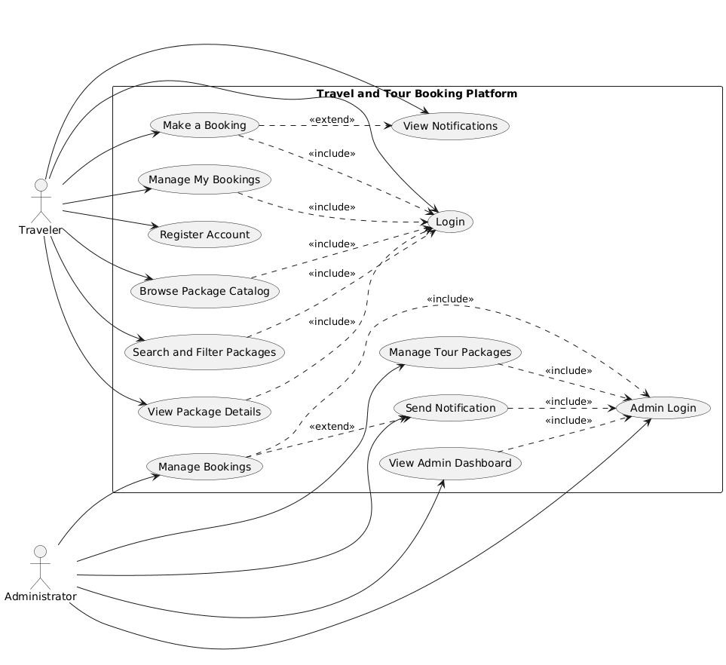
System Level Use Case Diagram
  - User Registration
ID | UC001
Name | User Registration
Description | This use case describes the process by which a new traveler creates an account on the platform
Requirement(s) | FR001
Actor(s) | Traveler
Precondition | The individual must not already have an account registered with the same email address
Postcondition | A new traveler account is created and the user is logged in and redirected to the catalog page
Basic Flow | Basic Flow  1. Traveler opens the registration page.  2. Traveler fills in full name, email, password, phone number, and optionally uploads a profile picture.  3. Traveler submits the form.  4. System validates all inputs.  5. System creates the account and logs the traveler in.  6. Traveler is redirected to the home catalog.
Diagrams
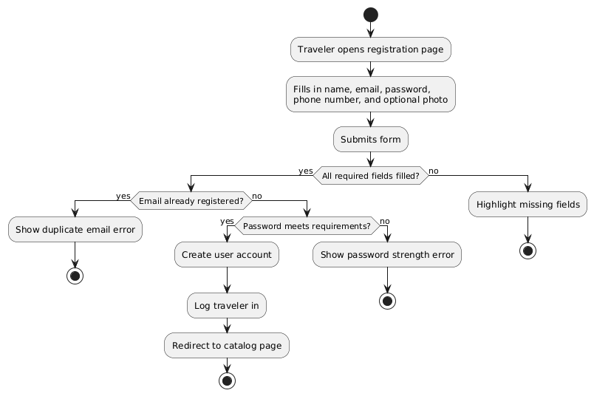
  - Make a Booking
ID | UC002
Name | Make a Booking
Description | This use case describes the process by which a logged in traveler selects a tour package and submits a reservation
Requirement(s) | FR002
Actor(s) | Traveler
Precondition | The traveler must be logged in and the selected package must have available spots on the chosen date
Postcondition | A booking record is created with pending status and the traveler receives a confirmation notification
Basic Flow | Basic Flow  1. Traveler views a package detail page.  2. Traveler clicks Book Now.  3. Traveler selects a travel date, enters the number of travelers, and adds any special requests.  4. Traveler reviews the booking summary and confirms.  5. System creates the booking record.  6. System sends a confirmation notification to the traveler. 7  . Traveler is redirected to their booking dashboard.
Diagrams
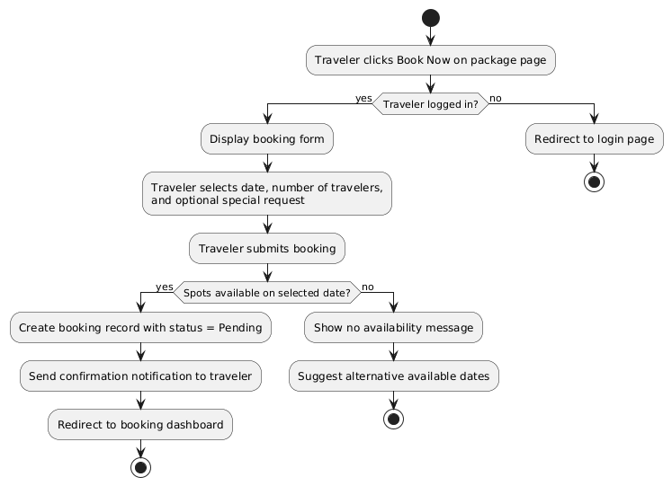
  - Search and Filter Packages
ID | UC003
Name | Search and Filter Packages
Description | This use case describes how a traveler uses the search and filter tools to find tour packages matching their preferences
Requirement(s) | FR004
Actor(s) | Traveler
Precondition | The traveler must be on the catalog page
Postcondition | A filtered list of packages matching the traveler's criteria is displayed
Basic Flow | Basic Flow  1. Traveler enters a keyword in the search bar or applies one or more filters.  2. System processes the query against the package database.  3. Matching packages are returned and displayed.  4. Traveler can click any result to view full details.
Diagrams
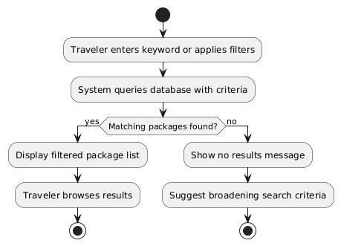
  - Admin Manages Tour Packages
ID | UC004
Name | Admin Manages Tour Packages
Description | The administrator adds new tour packages or edits and removes existing ones through the Admin Control Panel
Requirement(s) | FR004
Actor(s) | Traveler
Precondition | The administrator must be logged in to the admin panel
Postcondition | The catalog is updated immediately and reflects all changes made by the admin
Basic Flow | Basic Flow  1. Admin navigates to the Package Management section.  2. Admin chooses to add a new package or select an existing one.  3. For adding: Admin fills in all package details and uploads images. System validates and saves the package.  4. For editing: Admin modifies the desired fields and saves changes.  5. For removing: Admin confirms deletion. System removes the package from the catalog.
Diagrams
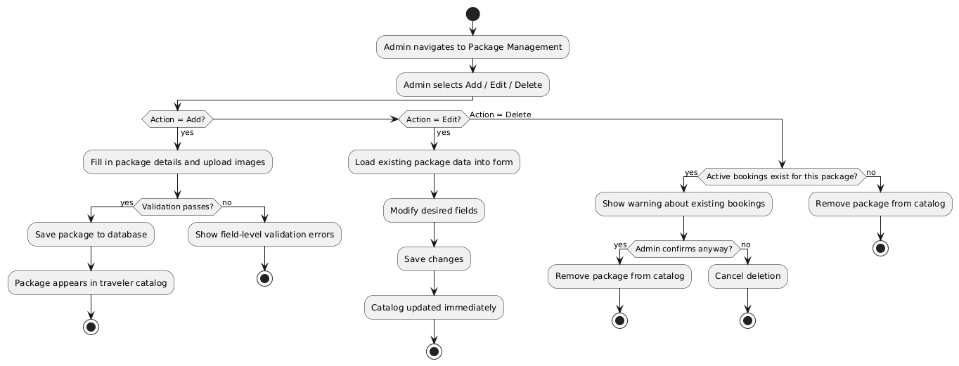
- References
[1] I. Sommerville, Software Engineering, 10th ed. Pearson, 2015.
[2] Booking.com B.V. (2024). Booking.com Travel Platform. [Online]. Available: https://www.booking.com
[3] Viator Inc. (2024). Viator Tours and Experiences. [Online]. Available: https://www.viator.com
[4] TourRadar GmbH. (2024). TourRadar Multi-Day Tour Booking. [Online]. Available: https://www.tourradar.com
[5] MakeMyTrip Ltd. (2024). MakeMyTrip Travel Portal. [Online]. Available: https://www.makemytrip.com
[6] Django Software Foundation. (2024). Django Documentation. [Online]. Available: https://docs.djangoproject.com
[7] MySQL AB. (2024). MySQL 8.0 Reference Manual. [Online]. Available: https://dev.mysql.com/doc
[8] IEEE. (1998). IEEE Recommended Practice for Software Requirements Specifications, IEEE Std 830-1998.

