Software Design Document
Travel and Tour Booking Platform



Submitted by
Muhammad Sohaib (S23BINFT1M01139)

Submitted to
Dr. Mustafa Hameed

Department of Information Technology
Faculty of Computing
The Islamia University of Bahawalpur

Summery
The Travel and Tour Booking Platform is a web-based application that centralizes the complete travel booking experience onto a single system. The motivation behind this project is that travelers currently face a fragmented process: they must visit multiple websites, compare packages manually, call agencies to confirm availability, and then manage payment and confirmation through separate channels. On the operator side, travel agencies struggle to keep listings updated, track bookings across channels, and communicate updates to customers in a timely manner.
The system addresses both problems. Travelers can browse a curated catalog of tour packages, search and filter by destination, price, or date, view full package details including itineraries and schedules, and submit a reservation in a few steps. Administrators get a dedicated control panel to manage all package listings, update booking statuses, and send notifications to customers.
The architecture follows a three-layer MVC design. The frontend is built in HTML5, CSS3, and JavaScript and is fully responsive. The middle layer is Django, handling routing, business logic, form processing, and the API bridge between frontend and database. MySQL stores all structured data including users, packages, bookings, and notifications. Each layer is independently testable and deployable.

Table of Content

- Application Architecture

1.1 Architectural Pattern
The system follows the Model-View-Controller pattern implemented through Django's app structure. The View layer is the HTML/CSS/JS frontend rendered in the browser. The Controller layer is Django's views.py files within each app module. The Model layer is Django's ORM-mapped classes that map directly to MySQL tables.

1.2 Django App Modules
The project is divided into four feature apps and one admin panel app:
- Users: handles registration, login, logout, session management, and user profile
- Packages: handles the tour catalog, individual package detail, and all admin-side CRUD for packages
- Bookings: handles booking creation, booking dashboard for travelers, status updates, and cancellations
- Notifications: handles creation and delivery of booking confirmation messages and status-change alerts
- admin_panel: provides the admin dashboard with aggregate statistics, links to package and booking management

1.3 Controllers and Their Functions
users/views.py
- register_user(request) accepts POST with full name, email, password, phone, and optional profile picture; validates all fields including password strength (min 8 chars, 1 number, 1 special character), checks email uniqueness, hashes password using bcrypt, creates User record, auto-logs in the traveler, and redirects to catalog page
- login_user(request) accepts POST with email and password; authenticates against stored hash; on success creates session and redirects to catalog; on failure returns error message without revealing which field is wrong
- logout_user(request) destroys the active session and redirects to login page
- user_dashboard(request) requires authenticated session; queries all Booking records belonging to the logged-in user; retrieves associated notifications; renders dashboard with booking list and status indicators
packages/views.py
- list_packages(request) queries all TourPackage records where is_active=True; returns name, destination, thumbnail image, price, and duration for each; renders catalog grid
- package_detail(request, package_id) retrieves single TourPackage by ID; returns full detail including itinerary, schedule, all images, pricing, and available dates; renders detail page with booking form
- search_filter(request) accepts GET parameters: keyword (searches name and destination), min_price, max_price, travel_date, duration; builds dynamic queryset filter; returns filtered package list; returns helpful message if result set is empty
- admin_add_package(request) admin-only; accepts POST with all package fields plus image upload; validates required fields; saves TourPackage record; redirects to package list
- admin_edit_package(request, package_id) admin-only; loads existing TourPackage into form; accepts POST with updated fields; saves changes; redirects to package list
- admin_delete_package(request, package_id) admin-only; accepts confirmation; sets is_active=False or hard-deletes depending on business rule; redirects to package list
bookings/views.py
- create_booking(request) requires authenticated traveler; accepts POST with package_id, travel_date, num_travelers, special_request; validates package is active and has available spots on chosen date; creates Booking record with status pending; triggers notification creation; redirects to user dashboard
- booking_detail(request, booking_id) requires authenticated traveler; returns full booking detail including package info, date, number of travelers, status, and any notifications
- cancel_booking(request, booking_id requires authenticated traveler; validates booking belongs to requesting user; changes status to cancelled; triggers cancellation notification; redirects to dashboard
- admin_update_status(request, booking_id) admin-only; accepts POST with new status value (pending, confirmed, cancelled); updates Booking record; triggers notification to traveler; redirects to booking management list
notifications/views.py
- create_notification(booking_id, message) internal utility called by bookings module; creates Notification record linked to booking_id; sets is_read=False
- mark_read(request, notification_id) requires authenticated traveler; sets is_read=True on the Notification record
admin_panel/views.py
- admin_dashboard(request) admin-only; queries count of active packages, count of pending bookings, count of confirmed bookings; queries last 10 booking records for recent activity feed; renders dashboard overview

1.4 External APIs and Libraries
No third-party travel APIs (Amadeus, Skyscanner) are integrated in this version. The system uses Django's built-in authentication framework for session management. Django's ORM is used for all database interactions. Git and GitHub are used for version control throughout development. Deployment targets PythonAnywhere or Railway, both of which natively support Django WSGI applications.

1.5 Coding Conventions
All Python and Django code follows PEP8. Variable and function names use snake_case. Class names use PascalCase. Django app names are singular nouns: user, package, booking, notification. Templates follow the naming pattern appname/action.html for example packages/detail.html or bookings/dashboard.html. All non-obvious logic is commented inline. Feature development uses Git feature branches, one branch per module, merged to main via pull request.

1.6 Class Diagram
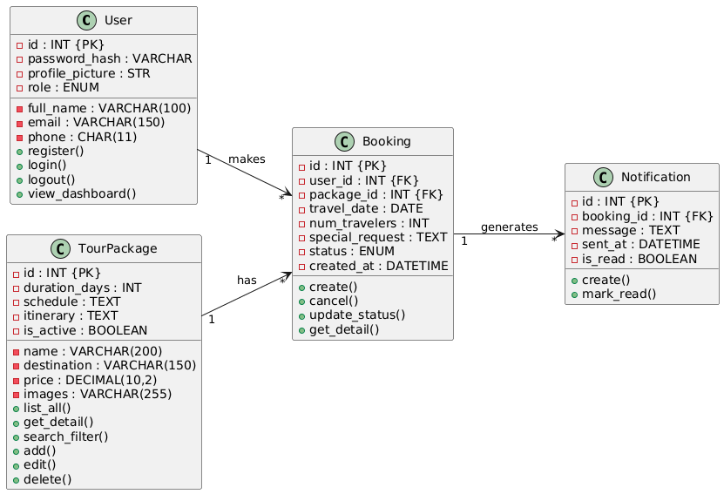
Class Diagram

1.7 Sequence Diagram User Registration
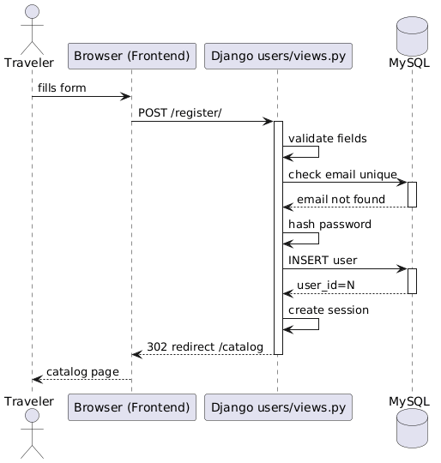

1.8 Sequence Diagram Make A Booking
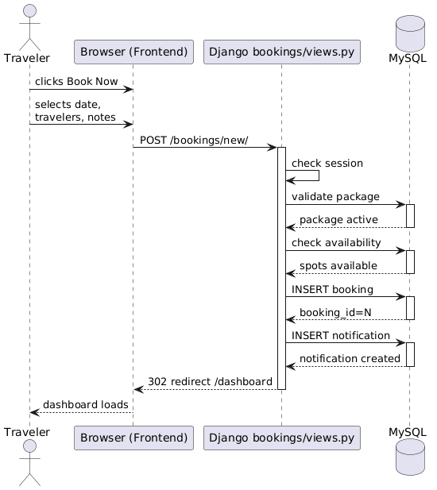

1.9 Sequence Diagram Search And Filter Packages
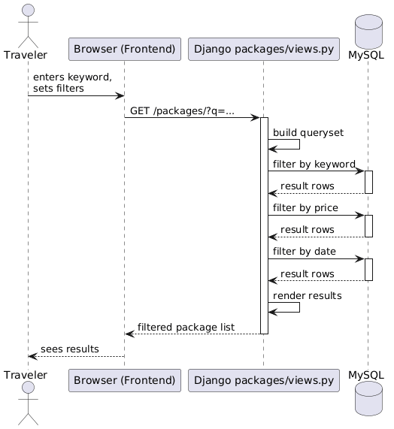

1.10 Sequence Diagram Admin Manages Packages
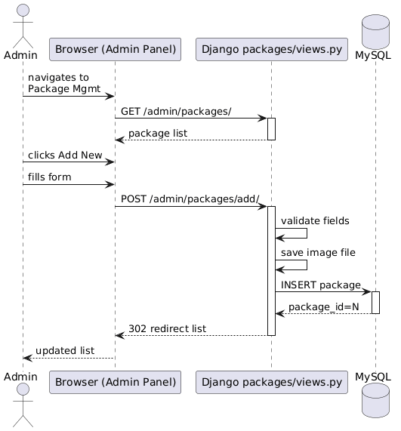

1.11 System-Level Use Case Diagram
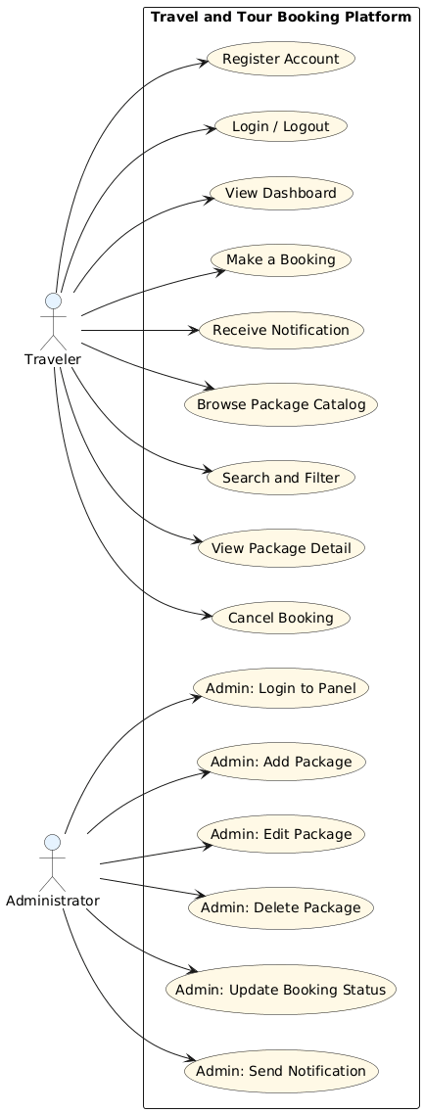

- Data Model Schema

2.1 Entity: User
Stores all registered traveler accounts and admin accounts. The role field distinguishes between the two types. Passwords are never stored in plain text; bcrypt hashing is applied before insertion.
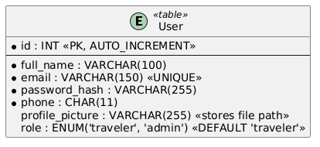

2.2 Entity: TourPackage
Stores all tour packages managed by the administrator. The is_active flag allows soft deletion so that bookings referencing the package are not orphaned. The schedule field stores structured dates in text or JSON format. The itinerary field stores the day-by-day plan in text.
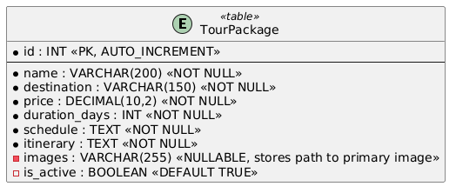

2.3 Entity: Booking
Stores every reservation submitted by a traveler. The status enum drives the notification logic. When a booking is created its status is pending. The admin changes it to confirmed or cancelled. Each status change triggers a new Notification record.
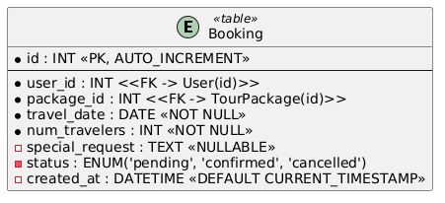

2.4 Entity: Notification
Stores all messages generated by the system for a traveler. Notifications are created automatically on booking submission, status change, and cancellation. The is_read flag drives the unread count badge on the user dashboard.
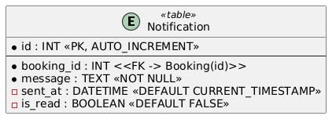

2.5 ER Diagram
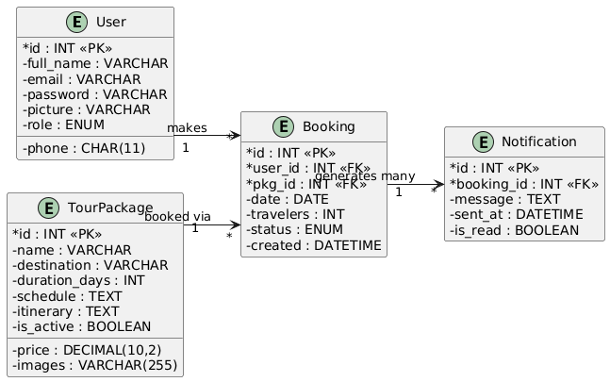

- User Interface

3.1 Design Philosophy
Color scheme uses clean travel-inspired tones: blue and white as the primary palette with an amber or orange accent on all call-to-action buttons. This gives the interface an airy, trustworthy feel appropriate for a booking platform. The font is a clean sans-serif such as Inter or Roboto for maximum legibility at all sizes. The design niche is minimal and content-forward, letting package photography do the visual work. The layout is fully responsive, viewports to 1440px desktop monitors. The package catalog switches from a single-column card list on mobile to a three-column grid on desktop.

3.2 Screen: Registration Page
Purpose: Allows a new traveler to create an account.
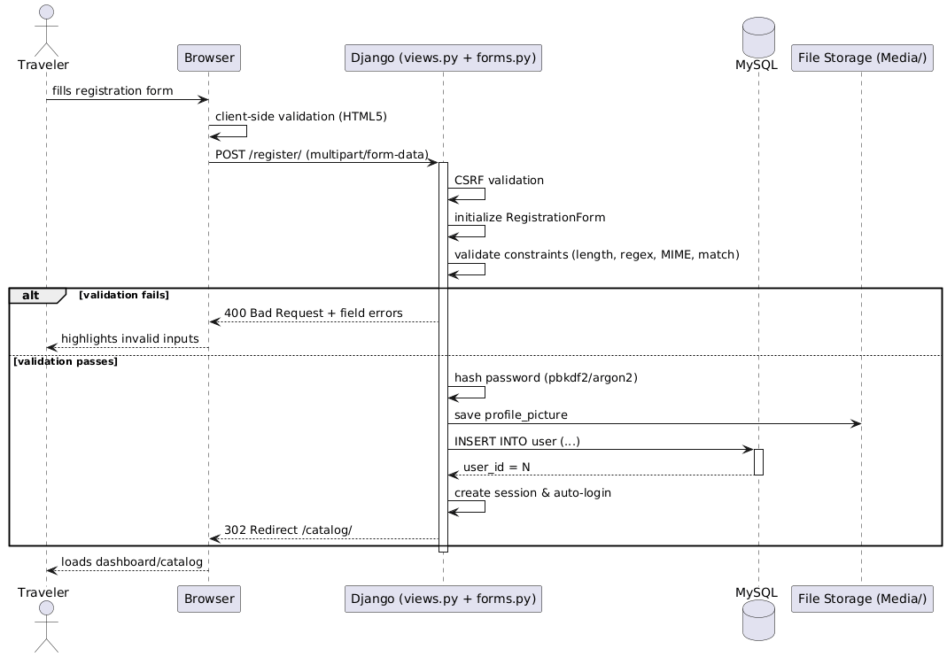
Output: On success, account is created, session is started, user is redirected to catalog. On failure, inline error messages appear beside the offending field.

3.3 Screen: Login Page
Purpose: Allows a registered traveler to authenticate.
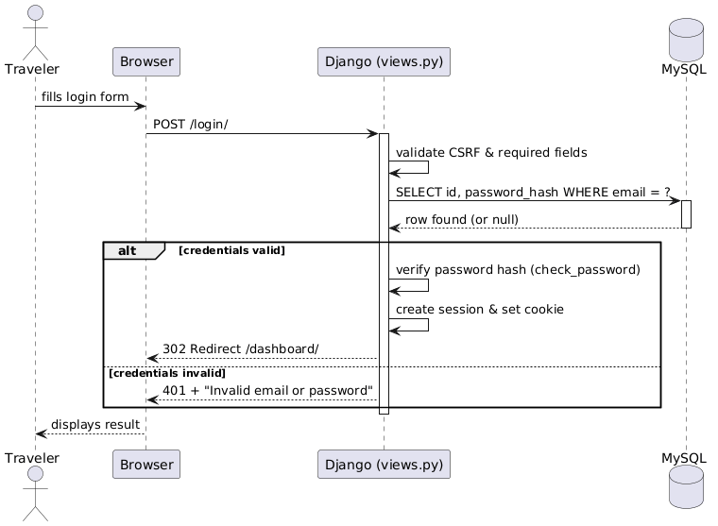
Output: On success, session created, redirect to catalog. On failure, generic error message displayed without specifying which field is wrong, to prevent enumeration attacks.

3.4 Screen: Package Catalog Page (Home)
Purpose: Displays all active tour packages in a browsable, filterable grid.
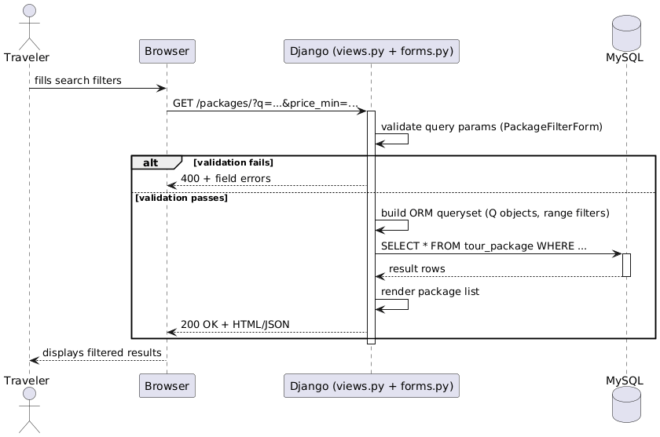
Data shown per package card: package name, destination label, thumbnail image, starting price, duration in days, Book Now link to detail page.
Output on empty results: Message reading "No packages match your search. Try broadening your filters."

3.5 Screen: Package Detail Page
Purpose: Shows full information about one tour package and presents the booking form.
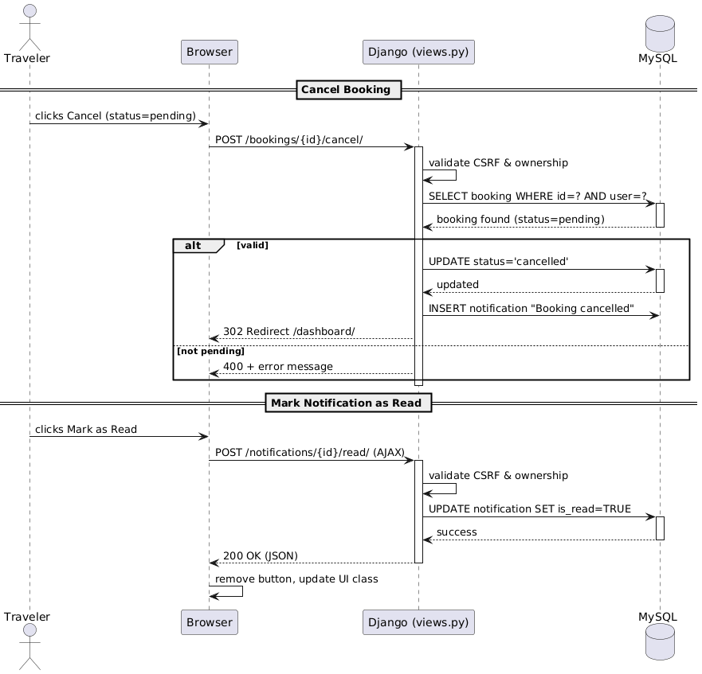
Data shown: package name, destination, full itinerary (day-by-day), schedule of available dates, price per person, all package images, duration.

3.6 Screen: User Dashboard
Purpose: Shows a traveler's booking history and notification inbox.
