Introduction
PIR
PIR sensors allow you to sense motion, almost always used to detect whether a human has moved in or out of the sensors range. They are small, inexpensive, low-power, easy to use and don't wear out. For that reason they are commonly found in appliances and gadgets used in homes or businesses. They are often referred to as PIR, "Passive Infrared", "Pyroelectric", or "IR motion" sensors.

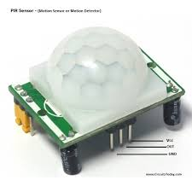
Fig(1.1):PIR Sensor(HC-SR501)

Arduino
Arduino is an open source computer hardware and software company, project, and user community that designs and manufactures single-board microcontrollers and microcontroller kits for building digital devices and interactive objects that can sense and control objects in the physical world. The project's products are distributed as open-source hardware and software, which are licensed under the GNU Lesser General Public License (LGPL) or the GNU General Public License (GPL), permitting the manufacture of Arduino boards and software distribution by anyone. Arduino boards are available commercially in preassembled form, or as do-it-yourself(DIY) kits.
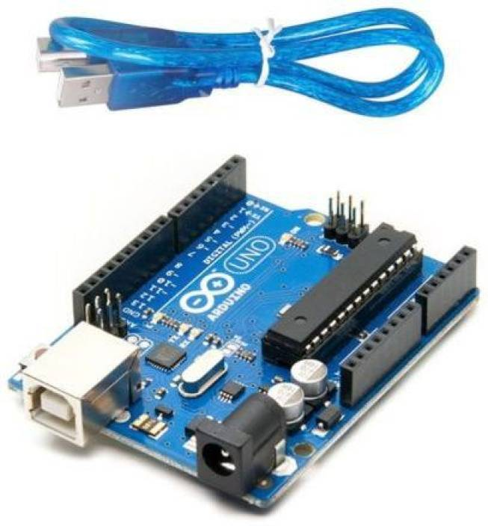
Fig(1.2):Arduino

Objectives
- Detect Human
- Detect Vehicle
Required Equipment (with approximate price)
- Arduino Price 850 TK
- PIR Sensor (HC-SR501) Price 120 TK
- LED
- Resistor
Implementation
Connect the PIR device to the Arduino and implement the Arduino code for detecting Vehicles and human.
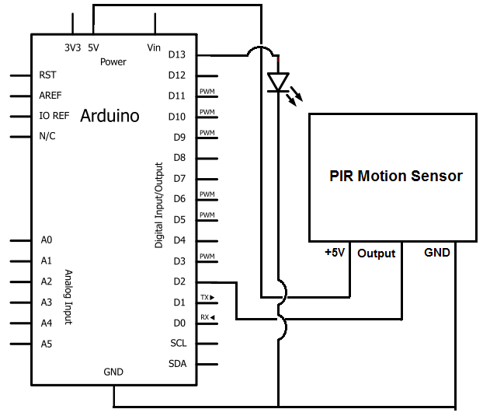
Fig(1.3):Diagram of transport checker.

Conclusion
Something front of the sensor will detect the vehicles or human.
Approval Signatures
[Sylhet International university] Project Client |  | [Sylhet International university] Project Sponsor |  | [Abdul Awal Ansary]  Project Manager

