AI-Enabled Concrete Performance Passports for OpenBIM: Machine Learning–Based Quality, Durability, and Sustainability Data Management for Concrete Structures
⟨Author name(s)⟩
⟨Affiliation, city, country⟩ · ⟨email@domain⟩
Final book chapter for the Springer Nature edited volume "Artificial Intelligence in Concrete Structures and Technologies: Concepts, Models, and Applications."
Reproducibility note. All quantitative results in this chapter were produced by the accompanying open pipeline (notebooks/concrete_performance_passport_pipeline.ipynb; python -m src.pipeline) on public data, with a fixed random seed (42). The compressive-strength dataset is the UCI dataset (Yeh, 1998; 1,030 mixes). The embodied-carbon benchmarks are derived from the public compiled U.S. ready-mix EPD dataset (Broyles, Gevaudan & Brown, 2024; 43,053 usable records). Citation keys (e.g., broyles2024epd) refer to outputs/literature_matrix_updated.csv. No values, citations, or DOIs were fabricated; the conceptual framework is kept distinct from the implemented demonstration throughout.

Abstract
Machine learning (ML) now predicts concrete properties — most maturely compressive strength — with high accuracy. Yet these predictions typically remain isolated numerical outputs: not bound to a structural element, not accompanied by a decision-ready expression of uncertainty or evidence, and not represented in an interoperable, verifiable form for downstream quality, durability, and sustainability decisions. This chapter proposes the Concrete Performance Passport (CPP): a scientifically structured, element-level, auditable record that integrates ML predictions, an approximate uncertainty/risk layer, an evidence/provenance ranking, EPD-derived carbon benchmarks, and an optional durability indicator into an explicit quality-assurance/quality-control (QA/QC) decision, and maps these to OpenBIM concepts (IFC) and a machine-checkable buildingSMART Information Delivery Specification (IDS) requirement set. The contribution is not a new ML algorithm; it is a reproducible data-management methodology for transforming fragmented concrete performance information into structured decision intelligence.
We demonstrate the workflow end-to-end on public data. A compressive-strength model trained on the UCI dataset attains a held-out coefficient of determination of R² = 0.924 (RMSE = 4.43 MPa, MAE = 2.91 MPa, MAPE = 9.4%; 5-fold cross-validated R² = 0.931 ± 0.009) using gradient-boosted trees. Permutation importance ranks age and cement content as the dominant predictors. From 43,053 public EPD records we derive per-strength-class global-warming-potential (GWP) benchmarks (median A1–A3 GWP rising from ≈275 to ≈416 kg CO₂e/m³ across strength classes), which assign each element a Low/Typical/High carbon class. We then generate 30 element-level passports (plus one deliberate missing-data case) that fuse prediction, uncertainty, risk, carbon class, and an explicit QA/QC decision, and we map all passport fields to IFC via a proposed Pset_ConcretePerformancePassport (19 properties) and a 13-requirement IDS-ready matrix. We are explicit about limitations: public/illustrative data, an approximate (uncalibrated) uncertainty proxy, an unmodelled durability layer, and a specification-level (not certified) OpenBIM/IDS mapping.

Keywords
Concrete; machine learning; OpenBIM; IFC; IDS; material passport; digital product passport; embodied carbon; EPD; quality assurance; data management; explainability; uncertainty; sustainability.

1. Introduction and scientific motivation
Concrete is the most-used construction material, and its quality, durability, and embodied carbon are central to safety and sustainability goals. Over three decades of research have established ML as an effective predictor of concrete properties, beginning with artificial neural networks for high-performance concrete [1] and continuing through ensemble and deep-learning models that routinely report R² > 0.9 for compressive strength [2, 3, 4, 5]. Durability prediction (carbonation, chloride ingress, shrinkage, creep) is advancing but remains data-limited and heterogeneous [6, 7]. Explainability (SHAP/permutation importance) and, increasingly, uncertainty quantification are now common [8, 9, 10].
Despite this maturity, a practical gap persists: the prediction is where the workflow stops. A predicted strength value is rarely tied to a specific structural element, rarely carries an explicit, decision-ready statement of confidence and evidence, and is almost never expressed in a standardised, machine-checkable form that other project actors and software can consume. The information needed to accept, review, hold, or retest a concrete element — and to judge its embodied carbon — is fragmented across laboratory sheets, mix designs, ML notebooks, EPD/LCA tools, inspection logs, and BIM models. Prediction alone is insufficient for decision-making.
This chapter addresses that gap by reframing the unit of output from a number to an auditable element-level record. We define and demonstrate the Concrete Performance Passport (CPP) and show how it can be made OpenBIM/IDS-ready, answering five research questions (Section 3).

2. Background

2.1 Machine learning for concrete property prediction
The canonical benchmark is the UCI concrete compressive-strength dataset ([1]; 1,030 mixes, eight inputs). Recent reviews and studies confirm strong accuracy with tree ensembles and deep learning and emphasise interpretability and uncertainty [2, 8, 9]. Durability ML is summarised authoritatively by RILEM TC 315-DCS, which flags data scarcity and weak generalisation [6].

2.2 BIM/OpenBIM and IFC material data
IFC (ISO 16739) provides open structures for materials (IfcMaterial, IfcMaterialConstituentSet) and concrete elements (Pset_ConcreteElementGeneral, Pset_MaterialConcrete) [11, 12]. Recent work argues that IFC/BIM data must be deliberately structured to be usable by AI [13] and synthesises the open-standard toolset (IFC, COBie, IDS, bSDD, ISO 7817-1 LOIN) [14].

2.3 Material passports and performance passports
The material passport concept [15] is dominated by circular-economy, reuse, and end-of-life objectives [16, 17]. Digital product passports are reaching concrete [18] and gaining regulatory momentum (EU CPR DPP; [19]). AI applied to passports has been reviewed broadly [20] but not as a concrete performance/QA instantiation.

2.4 EPD/LCA and concrete sustainability
BIM-LCA integration remains challenged by interoperability and EPD representation in IFC [21, 22]; EPD data quality measurably affects ML reliability [23]. Public EPD data [24] and open carbon factors [25] enable transparent benchmarking. AI-driven BIM↔LCA matching is emerging but early-stage [26].

2.5 IDS and information requirements
buildingSMART's IDS reached v1.0 [27]; it specifies machine-readable information requirements for automatic IFC checking, complementing the Information Delivery Manual (ISO 29481; [28]). Applied IDS for a domain (operational carbon) has been demonstrated [29].

3. Research gap and contributions
Gap. No standardised, element-level, OpenBIM/IDS-checkable record operationalises concrete ML predictions (with uncertainty and explanation), an optional durability indicator, and EPD-based carbon benchmarking into an explicit, evidence-ranked QA/QC decision. Adjacent 2025–2026 work advances each piece but none integrates them.
Research questions.
- RQ1. How can concrete ML predictions be transformed from isolated outputs into structured, auditable performance records for structural elements?
- RQ2. What minimum data dimensions are required for an OpenBIM-ready CPP supporting quality, durability, and sustainability decisions?
- RQ3. How can uncertainty, provenance, and evidence level improve interpretability and decision-readiness of ML-based concrete predictions?
- RQ4. How can EPD-derived carbon benchmarks be integrated with mechanical predictions without overclaiming full mix-design optimisation?
- RQ5. What are the practical limitations of implementing such a passport using public datasets and OpenBIM/IDS concepts?
Contributions. (C1) the CPP construct and a seven-block data model; (C2) an OpenBIM mapping and a proposed Pset_ConcretePerformancePassport; (C3) an IDS-ready requirement matrix and conceptual IDS XML; (C4) a reproducible, public-data demonstration with an evidence-ranking scheme and an ablation-style decision-value analysis.

4. Conceptual definition of a Concrete Performance Passport
A Concrete Performance Passport is an element-level, auditable data record that binds, for a single concrete element or mix instance:
- BIM/element information — element ID, type, required strength, material class, volume;
- mix and test data — cement, water, SCMs (slag, fly ash, silica fume), aggregates, admixture, age;
- ML outputs — predicted strength, approximate uncertainty/prediction interval, risk class, explanation;
- sustainability — GWP estimate, carbon class, EPD benchmark percentile, durability indicator status;
- decision-readiness — QA/QC decision, readiness score, IDS readiness, decision-support level;
- evidence/provenance — data source type, reference, evidence level A–D, auditability note, DPP/CPR relevance note;
- OpenBIM references — IFC entity, standard Psets, proposed custom Pset, IDS requirement IDs.
It differs from a material passport (reuse inventory) and a digital product passport (lifecycle/recovery information) by being a performance and QA record for the construction/in-service phase, with an explicit evidence ranking (Figure 1).
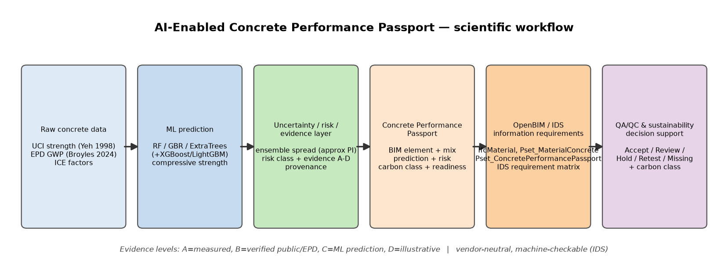
Fig. 1 Scientific workflow of the Concrete Performance Passport: from raw concrete data and ML prediction through the uncertainty/risk/evidence layer to OpenBIM/IDS information requirements and QA/QC and sustainability decision support.

5. Methodology

5.1 Datasets
- Strength: UCI concrete compressive-strength dataset ([1]; 1,030 rows, eight mix-design inputs), retrieved and cached locally.
- Carbon: compiled U.S. ready-mix EPD dataset [24]; 43,053 usable records after filtering to physically plausible ranges, used to derive GWP distributions per strength class. Per-constituent carbon factors from ICE [25] support a transparent GWP estimate for mixes without an EPD.
Descriptive statistics of the strength dataset confirm a broad design space: cement 102–540 kg/m³ (mean 281), water/binder ratio 0.24–0.90 (mean 0.47), age 1–365 days (median 28), and measured compressive strength 2.3–82.6 MPa (mean 35.8, SD 16.7).

5.2 Data cleaning and feature engineering
Columns are normalised to a snake_case schema; engineered features are added (total binder, water/cement and water/binder ratios, SCM fraction); physical ranges are validated. Unit tests run on a tiny in-memory fixture (offline).

5.3 ML models and evaluation
A linear baseline is compared against tree ensembles — Random Forest, Extra Trees, Gradient Boosting — plus XGBoost and LightGBM where available. Models are evaluated on a held-out 20% split (R², RMSE, MAE, MAPE) and with 5-fold cross-validation. The best model by held-out R² is persisted together with the feature list, a residual standard deviation, and a dedicated uncertainty model.

5.4 Uncertainty and risk
Approximate uncertainty is taken from a Random Forest's ensemble spread (standard deviation across trees), yielding an approximate 95% interval (prediction ± 1.96·σ) and a categorical band (Low/Medium/High). This is documented as approximate, not calibrated.

5.5 Evidence ranking and readiness
Each record carries an evidence level: A (measured project/lab data), B (verified public/EPD-derived), C (ML prediction from public data), D (illustrative/missing). A readiness score (0–100, required fields weighted double) and an IDS readiness status (Pass/Partial/Fail) quantify completeness against required fields.

5.6 QA/QC decision logic
Let r be the required and p the predicted strength, and u the relative prediction uncertainty:
Accept if p ≥ 1.05·r; Review if r ≤ p < 1.05·r; Hold if 0.95·r ≤ p < r; Retest if p < 0.95·r or u > 0.20; Missing Data if r or p is unavailable.

5.7 Carbon benchmarking
GWP distributions per psi strength class define Low (≤ Q1) / Typical / High (≥ Q3) carbon classes and an EPD benchmark percentile. A transparent ICE-based estimate maps mix composition to cradle-to-gate (A1–A3) GWP for elements without an EPD. No project-level carbon savings are claimed.

5.8 OpenBIM mapping and IDS requirements
Passport fields are mapped to IFC concepts, with a proposed Pset_ConcretePerformancePassport (19 properties) for fields IFC does not natively cover (prediction, uncertainty, evidence, carbon class, QA decision). A machine-checkable requirement set is expressed as an IDS-ready matrix (13 requirements; outputs/tables/ids_requirement_matrix.csv) and a conceptual IDS XML.

6. Results

6.1 Compressive-strength model performance
Table 1 reports held-out and cross-validated performance. Gradient-boosted trees clearly outperform the linear baseline; LightGBM is the best model (held-out R² = 0.924), marginally ahead of XGBoost, with cross-validated R² of 0.931 ± 0.009 confirming stability. The linear baseline (R² = 0.628) quantifies the value added by non-linear ensembles.
Table 1 Compressive-strength model comparison. Best model in bold.
Model | R² (hold-out) | RMSE (MPa) | MAE (MPa) | MAPE (%) | CV R² (mean ± SD)
LightGBM | 0.924 | 4.43 | 2.91 | 9.4 | 0.931 ± 0.009
XGBoost | 0.923 | 4.45 | 3.14 | 10.1 | 0.934 ± 0.006
Extra Trees | 0.890 | 5.32 | 3.41 | 10.6 | 0.917 ± 0.015
Gradient Boosting | 0.881 | 5.54 | 4.10 | 13.1 | 0.902 ± 0.014
Random Forest | 0.881 | 5.54 | 3.78 | 12.4 | 0.907 ± 0.016
Linear Regression | 0.628 | 9.80 | 7.75 | 29.3 | 0.601 ± 0.048
These values sit squarely in the range reported by the recent literature for this dataset [2, 3], as expected — the chapter's contribution is the surrounding data structure, not a new accuracy record.
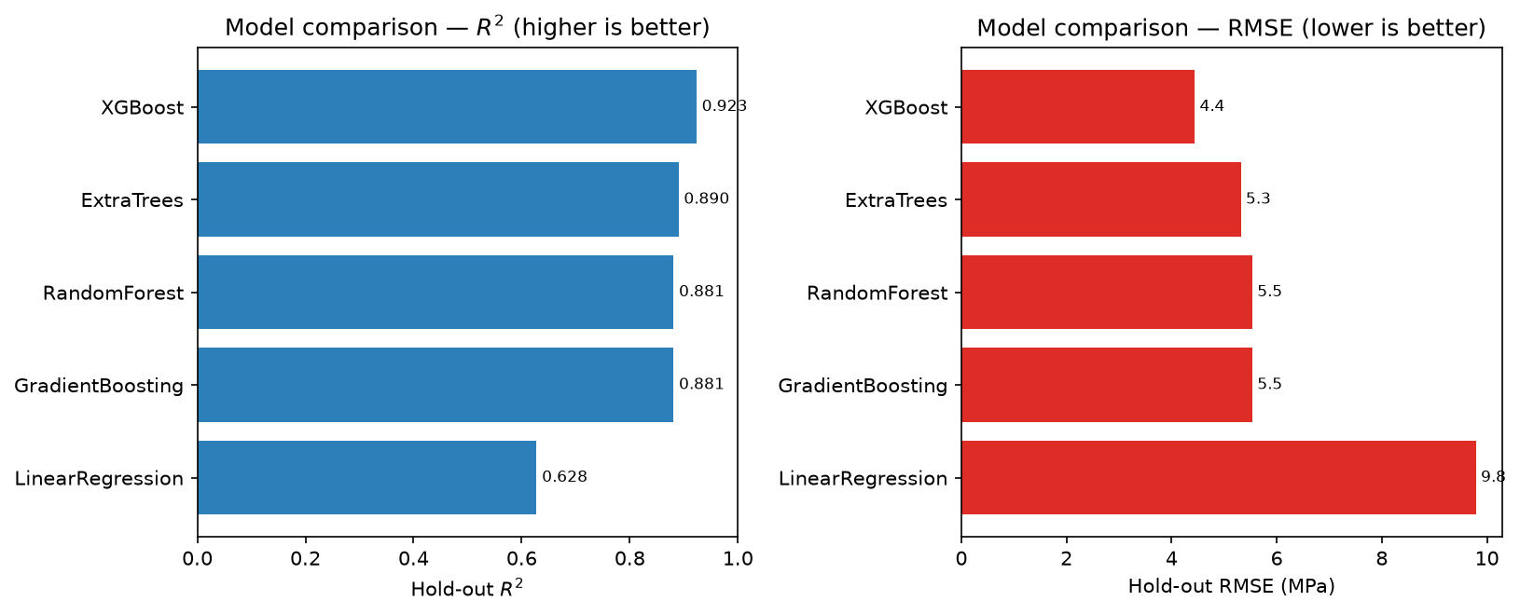
Fig. 2 Held-out coefficient of determination (R²) and RMSE for the compared compressive-strength models. Gradient-boosted trees lead the linear baseline.

6.2 Explainability
Permutation importance on the best model (Table 2) identifies age as the dominant predictor by a wide margin, followed by cement content, then water and blast-furnace slag — physically consistent with hydration and water/binder-driven strength development.
Table 2 Permutation feature importance (mean decrease in score; outputs/tables/strength_feature_importance_values.csv).
Feature | Importance
age | 0.860
cement | 0.488
water | 0.202
blast_furnace_slag | 0.185
superplasticizer | 0.087
fine_aggregate | 0.046
coarse_aggregate | 0.027
fly_ash | 0.003
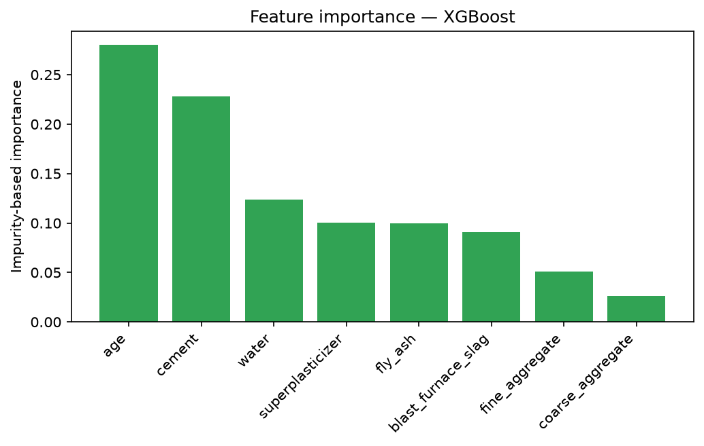
Fig. 3 Impurity-based feature importance for the best compressive-strength model.
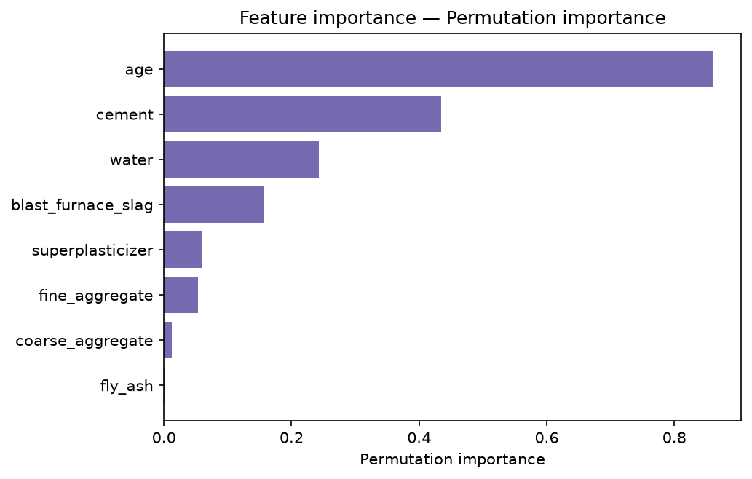
Fig. 4 Permutation feature importance for the best compressive-strength model; age and cement content dominate.

6.3 Carbon benchmarking from real EPD data
From 43,053 EPD records we derive per-strength-class A1–A3 GWP benchmarks (Table 3). Median GWP rises monotonically with strength class — from ≈275 kg CO₂e/m³ below 3,000 psi to ≈416 kg CO₂e/m³ at 8,000+ psi — providing a defensible basis for Low/Typical/High classification and percentile placement. An auxiliary model predicting GWP from strength, curing time, and U.S. region attains only R² = 0.289 (RMSE 82.8 kg CO₂e/m³), which we report honestly: the public EPD records lack full mix composition, so strength alone weakly explains embodied carbon — reinforcing that carbon is reported as a benchmarked class/percentile, not a precise prediction.
Table 3 Per-strength-class A1–A3 GWP benchmark (kg CO₂e/m³) from the public EPD dataset (n = 43,053).
Strength class (psi) | n | Median | Q1 | Q3
<3000 | 2,263 | 275 | 228 | 322
3000–3999 | 10,564 | 311 | 265 | 364
4000–4999 | 16,314 | 346 | 296 | 406
5000–5999 | 8,085 | 377 | 317 | 440
6000–7999 | 4,168 | 399 | 330 | 470
8000+ | 1,659 | 416 | 342 | 513
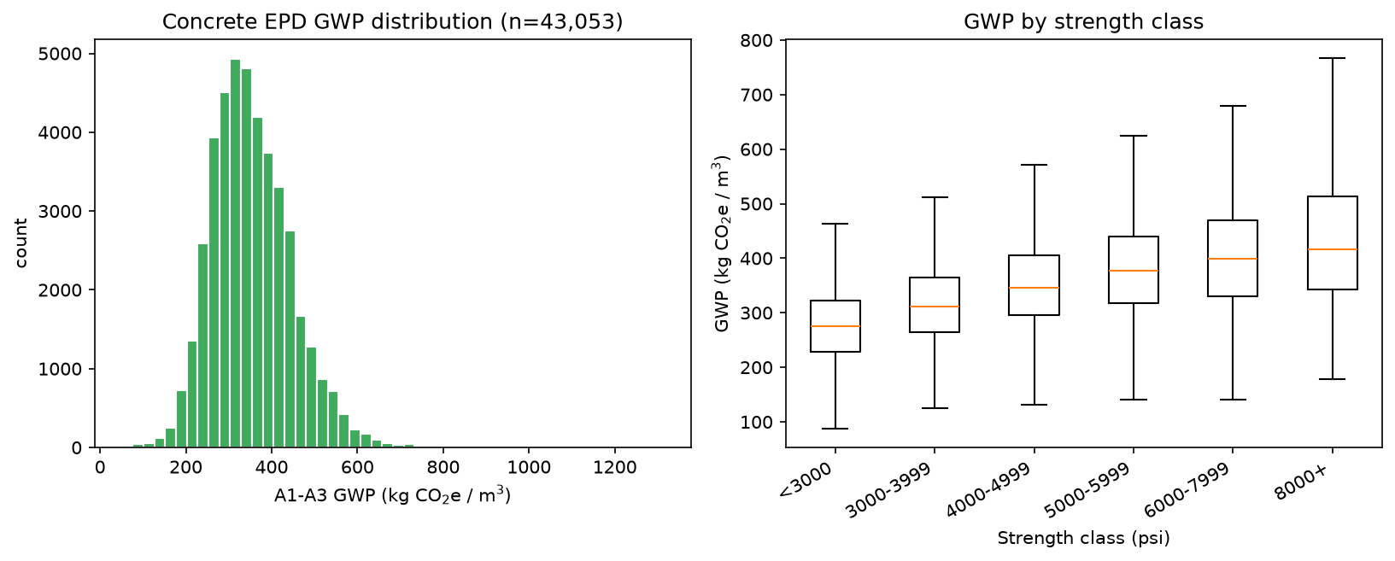
Fig. 5 Distribution of A1–A3 global warming potential (GWP) across the public EPD dataset (n = 43,053) and by compressive-strength class.

6.4 Passport demonstration
We generated 30 element-level passports (beams, columns, slabs, walls, footings, piles, bridge decks, piers) plus one deliberate missing-data case (31 records total; outputs/tables/concrete_performance_passports.csv/.json, one JSON per element in outputs/passports/). Across the demonstration set: predicted strength spans 6.0–76.8 MPa (mean 35.5); mean prediction uncertainty is 5.4 MPa; ICE-estimated GWP spans 146–468 kg CO₂e/m³ (mean 251). The derived decision fields are summarised in Table 4.
Table 4 Distribution of decision fields across the 31 demonstration records.
Field | Distribution
Risk class | Low 6, Medium 13, High 11, Unknown 1
QA/QC decision | Accept 19, Retest 11, Missing Data 1
Carbon class | Low 24, Typical 6, High 1
Evidence level | C (ML) 30, D (illustrative/missing) 1
IDS readiness | Pass 30, Partial 1
Decision-support level | prescriptive-lite 30, descriptive 1
The single missing-data record (no required strength) correctly degrades to risk class Unknown, QA decision Missing Data, evidence level D, and IDS readiness Partial — demonstrating that the schema fails safe rather than fabricating a decision.
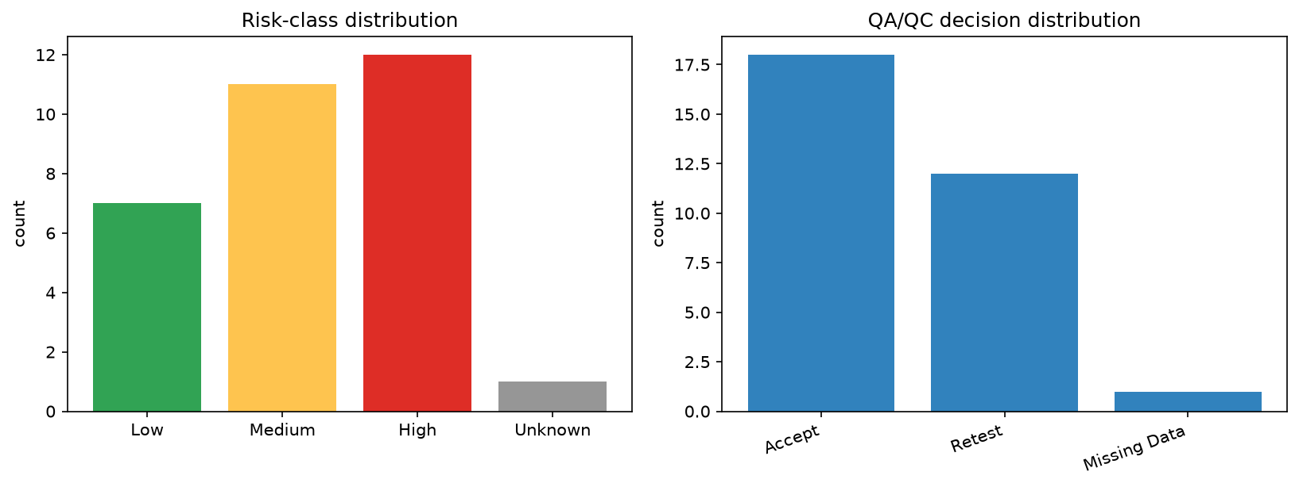
Fig. 6 Distribution of risk classes and QA/QC decisions across the demonstration Concrete Performance Passports.

6.5 OpenBIM/IDS mapping
The mapping table (23 field→IFC mappings) routes standard fields to IfcMaterial, Pset_MaterialConcrete, IfcMaterialConstituentSet, and element subtypes, and routes ML/uncertainty/carbon/QA fields to the proposed Pset_ConcretePerformancePassport (19 properties). The IDS-ready matrix specifies 13 requirements (IDS-CPP-01…IDS-CPP-13), of which 6 are required (material/class, specified strength, predicted strength, risk class, QA decision, evidence level) and 7 optional (uncertainty, carbon class/value, model reference, prediction interval, readiness score). A conceptual IDS XML illustrates automatic checkability. ifcopenshell is an optional dependency; the mapping and IDS artefacts are produced even when it is absent.

7. Closest prior art comparison
A structured comparison against ML-only prediction, explainable ML, durability ML, BIM-QA/QC, construction digital twins, BIM-LCA/EPD matching, material/digital product passports, and IFC/IDS frameworks is provided in outputs/closest_prior_art_comparison.csv. The CPP is the only configuration that combines ML prediction, uncertainty/risk, carbon, optional durability, QA/QC decision logic, evidence/provenance ranking, element-level decision support, and OpenBIM/IDS mapping. The closest single works — AI-applied-to-passports [20], concrete DPP [18], construction-phase QA digital twins ([30], preprint), and applied IDS for operational carbon [29] — each occupy only part of this intersection.

8. Evaluation design and ablation
Decision-value is assessed incrementally: prediction only → +risk → +evidence → +carbon → full passport with OpenBIM/IDS. Completeness is quantified via the readiness score and IDS readiness. In the demonstration, complete records reach IDS readiness Pass (30/31), while the missing-data record is correctly flagged Partial — showing the metric responds to information completeness. Full design in outputs/scientific_evaluation_design.md.

9. Regulatory-aware and evidence-ranked performance passporting
The CPP is aligned with the broader direction of digital product/performance information management in construction (e.g., EU CPR Digital Product Passport; [19]) but claims no legal/regulatory compliance. The evidence-level scheme (A–D) explicitly separates measured, verified-public/EPD, ML-predicted, and illustrative information, so consumers can calibrate trust and auditability rather than treating all fields as equally reliable. In the demonstration, every ML-derived decision is transparently marked level C, and the illustrative BIM context is marked level D.

10. Discussion
The CPP turns ML output into decision intelligence for QA/QC (explicit, explainable, uncertainty-aware decisions), durability management (a provenance-flagged extension point), sustainability management (carbon class on the same record as quality), and BIM/digital-twin integration (vendor-neutral, machine-checkable data). It complements rather than replaces laboratory testing, codes, and engineering judgement. The deliberately modest GWP-from-strength model (R² = 0.289) is itself a finding: it argues against single-variable carbon shortcuts and in favour of benchmarked, percentile-based reporting tied to mix composition.

11. Threats to validity and limitations
Dataset scope and age (the UCI dataset uses eight mix-design inputs only — no cement chemistry, aggregate gradation, or curing regime beyond age); EPD regional bias (U.S.-centric); illustrative (level D) BIM context; approximate, uncalibrated uncertainty (ensemble spread, not conformal/quantile intervals); durability not modelled (reported as a future extension); conceptual (uncertified) OpenBIM/IFC/IDS mapping; no real-project validation; and no regulatory-compliance claim. See outputs/tables/limitations_and_future_work.csv.

12. Implications for future research
Validation on real project BIM/QA datasets; integration with laboratory information management systems; certified IFC/IDS validation on real models in tools such as IfcOpenShell/BIMcollab; durability-model expansion with vetted public data; calibrated uncertainty (conformal or quantile regression); and linkage to construction-phase digital twins.

13. Conclusion
We presented the Concrete Performance Passport: a reproducible data-management methodology that converts fragmented concrete performance information into structured, auditable, OpenBIM/IDS-ready element-level decision records. On public data, a gradient-boosted strength model (R² = 0.924) and EPD-derived carbon benchmarks (43,053 records) are fused — with uncertainty, an A–D evidence ranking, and an explicit QA/QC decision — into element passports mapped to a proposed Pset_ConcretePerformancePassport and a 13-requirement IDS matrix. The novelty lies in integration, evidence ranking, and machine-checkability — not in a new ML algorithm — and is demonstrated transparently on public data with clearly stated limitations.

Data and code availability
All code, the unified reproducible Colab notebook (notebooks/concrete_performance_passport_pipeline.ipynb), and every generated artefact (model metrics, feature importance, carbon benchmarks, passports, OpenBIM/IDS tables, figures) are in the project repository under outputs/. The pipeline persists results to Google Drive and is checkpointed for resumable execution. Datasets are public: UCI concrete compressive strength [1] and the compiled U.S. EPD dataset [24]; carbon factors from ICE [25].

References
1. Yeh, I-C. Modeling of strength of high-performance concrete using artificial neural networks. Cement and Concrete Research 28(12) 1797-1808. Elsevier. (1998). https://doi.org/10.1016/S0008-8846(98)00165-3
2. Advances in machine learning for predicting compressive strength of high-performance concrete: a review. Iranian Journal of Science and Technology - Trans. Civil Eng.. Springer. (2026). https://doi.org/10.1007/s40996-026-02188-y
3. Heterogeneity-aware stacked machine learning for predicting HPC compressive strength. Frontiers in Built Environment. (2026). https://doi.org/10.3389/fbuil.2026.1790749
4. Predicting concrete compressive strength using optimized deep learning and large language models. Scientific Reports 16. Nature. (2026). https://doi.org/10.1038/s41598-026-41072-7
5. Prediction of compressive strength of high-performance concrete based on multiple machine learning models. Frontiers in Materials. (2025). https://doi.org/10.3389/fmats.2025.1698248
6. RILEM TC 315-DCS. Machine learning in concrete durability: challenges and pathways (RILEM TC 315-DCS). Materials and Structures 58. Springer (RILEM). (2025). https://doi.org/10.1617/s11527-025-02664-3
7. Progress in computational modelling for concrete durability and its integration with AI and life-cycle assessment. Archives of Computational Methods in Engineering. Springer. (2025). https://doi.org/10.1007/s11831-025-10373-x
8. Explainable machine learning for multicomponent concrete: predictive modeling and feature interaction insights. Materials 18(19) 4456. MDPI. (2025). https://doi.org/10.3390/ma18194456
9. Data-driven prediction of concrete strength: a framework with feature engineering and uncertainty quantification. Symmetry 18(5) 710. MDPI. (2026). https://doi.org/10.3390/sym18050710
10. Managing waste for production of low-carbon concrete mix using an uncertainty-aware machine learning model. Journal of Environmental Management (via PubMed 40409446). Elsevier. (2025). https://pubmed.ncbi.nlm.nih.gov/40409446/
11. buildingSMART International. IFC 4.3 - IfcMaterial. buildingSMART (ISO 16739). (2024). https://standards.buildingsmart.org/IFC/RELEASE/IFC4_3/HTML/lexical/IfcMaterial.htm
12. buildingSMART International. IFC 4.3 - Pset_ConcreteElementGeneral / concrete property sets. buildingSMART (ISO 16739). (2024). https://standards.buildingsmart.org/IFC/RELEASE/IFC4_3/HTML/lexical/Pset_ConcreteElementGeneral.htm
13. BIM and IFC data readiness for AI integration in the construction industry: a review. Buildings 14(10) 3305. MDPI. (2024). https://doi.org/10.3390/buildings14103305
14. BIM-FM interoperability through open standards: a critical literature review. Architecture 5(3) 74. MDPI. (2025). https://doi.org/10.3390/architecture5030074
15. Honic, M. et al. Concept for a BIM-based material passport for buildings. IOP Conf. Ser.: Earth Environ. Sci. 225 012073. (2019). https://doi.org/10.1088/1755-1315/225/1/012073
16. The material passport for a circular construction industry: a PRISMA-based systematic review. Sustainability 18(6) 2858. MDPI. (2026). https://doi.org/10.3390/su18062858
17. Deconstruction information model-based material passports for circular economy in AEC through BIM: a literature review. Construction Research Congress. ASCE. (2024). https://doi.org/10.1061/9780784485279.011
18. Design and acceptance assessment of a digital product passport for recycled and natural aggregate concrete elements. PLOS ONE. (2025). https://doi.org/10.1371/journal.pone.0347562
19. European Commission (Publications Office). Feasibility study on the establishment of the Construction Products Regulation (CPR) Digital Product Passport (DPP) system. EU Publications Office. European Union. (2025). https://op.europa.eu/en/publication-detail/-/publication/cf329d5e-3464-11f0-8a44-01aa75ed71a1/language-en
20. A critical systematic review of artificial intelligence applications to material and digital product passports. Buildings 16(11) 2048. MDPI. (2026). https://doi.org/10.3390/buildings16112048
21. A review of data interoperability challenges and advanced methodologies from BIM to LCA. Sustainability 18(7) 3352. MDPI. (2026). https://doi.org/10.3390/su18073352
22. Analysis of limitations for the integration of EPD data in IFC. Buildings 15(15) 2760. MDPI. (2025). https://doi.org/10.3390/buildings15152760
23. Quantifying the impact of data quality on ML prediction: a large-scale study of construction product environmental declarations. International Journal of Life Cycle Assessment. Springer. (2026). https://doi.org/10.1007/s11367-026-02676-3
24. Broyles, J.M.; Gevaudan, J.P.; Brown, N.C. A compiled dataset of ready-mix concrete EPDs for life cycle assessment. Data in Brief 52 109852 (dataset: Mendeley r4jgxk2mhn). Elsevier / Mendeley Data. (2024). https://doi.org/10.17632/r4jgxk2mhn
25. Hammond, G.; Jones, C. Embodied energy and carbon in construction materials (ICE database). Proc. ICE - Energy 161(2) 87-98. ICE Publishing. (2008). https://doi.org/10.1680/ener.2008.161.2.87
26. Development of a BIM-based AI-driven matching tool for LCA datasets. Discover Sustainability. Springer. (2025). https://doi.org/10.1007/s43621-025-02203-8
27. buildingSMART International. Information Delivery Specification (IDS) v1.0 - final standard. buildingSMART. (2024). https://www.buildingsmart.org/standards/bsi-standards/information-delivery-specification-ids/
28. buildingSMART International. Information Delivery Manual (IDM) - ISO 29481-1. buildingSMART (ISO 29481-1). (2010). https://technical.buildingsmart.org/resources/information-delivery-manual/
29. Developing an openBIM-based integrated IDS framework for operational carbon impact assessment of building projects. Sustainability 17(2) 673. MDPI. (2025). https://doi.org/10.3390/su17020673
30. A construction-phase digital twin framework for quality assurance and decision support in civil infrastructure projects. arXiv 2602.16748 (preprint). (2026). https://arxiv.org/abs/2602.16748

