WEEK 3 TASK
STATISTICAL ANALYSIS AND PREDICTIVE MODELING USING R
Internship Technical Report

Submitted by: Sayyed Arshiya Muktar
Dataset: Titanic Passenger Dataset
Predictive Model: Logistic Regression

Table of Contents
1. Introduction
2. Task Objectives
3. Dataset Identification and Rationale
4. Dataset Structure and Variables
5. Research Questions and Hypotheses
6. Data Preparation for Modeling
7. Exploratory Statistical Analysis
8. Hypothesis Testing
9. Correlation and Distribution Analysis
10. Predictive Modeling Approach
11. Train-Test Split
12. Logistic Regression Model
13. Cross-Validation
14. Model Performance Metrics
15. Confusion Matrix
16. ROC Curve and AUC
17. Model Diagnostics
18. Interpretation of Results
19. Strengths of the Model
20. Limitations
21. Potential Improvements
22. Ethical and Practical Considerations
23. Conclusion
24. R Code Appendix
25. Submission Summary

1. Introduction
The third week of the internship focuses on statistical analysis and predictive modeling using R. The objective is to move from descriptive and visual analysis toward formal statistical inference and prediction. The Titanic Passenger Dataset is retained from Weeks 1 and 2 so that the internship work forms one coherent analytical project.
The analysis treats passenger survival as a binary classification problem. Logistic regression is appropriate because the response variable has two outcomes: survived and did not survive. The workflow combines descriptive statistics, hypothesis testing, distribution checks, correlation analysis, preprocessing, model training, cross-validation, confusion-matrix analysis, and ROC-AUC evaluation.
The report emphasizes not only the numerical performance of the model but also the reasoning behind each analytical decision. This is important because a predictive model should be interpreted in the context of the data, its limitations, and the assumptions behind the statistical methods.

2. Task Objectives
• Perform exploratory statistical analysis on a publicly available dataset.
• Formulate and test meaningful statistical hypotheses.
• Examine relationships, correlations, and data distributions.
• Prepare numerical and categorical predictors for modeling.
• Build a classification model using logistic regression.
• Split the data into training and testing sets.
• Use cross-validation to assess model stability.
• Evaluate the model with accuracy, precision, recall, F1-score, and ROC-AUC.
• Use diagnostic visualizations such as a confusion matrix and ROC curve.
• Interpret the model's strengths, limitations, and possible improvements.

3. Dataset Identification and Rationale
The Titanic Passenger Dataset contains 891 rows and 12 columns in the supplied CSV file. It is appropriate for predictive modeling because the Survived variable is binary and the dataset contains a mixture of numerical and categorical predictors.
The chosen predictors include passenger class (Pclass), sex (Sex), age (Age), number of siblings/spouses aboard (SibSp), number of parents/children aboard (Parch), ticket fare (Fare), and port of embarkation (Embarked). These variables provide a useful combination of demographic, socio-economic, and travel-related information.
Continuing with the same dataset is also useful from a project-documentation perspective. Week 1 focused on cleaning and preliminary analysis, Week 2 focused on visualization and insight communication, and Week 3 uses the cleaned analytical understanding to perform statistical inference and prediction.

4. Dataset Structure and Variables
Variable | Type | Role | Description
Survived | Binary | Target | 1 = survived, 0 = did not survive
Pclass | Categorical/Ordinal | Predictor | Passenger class
Sex | Categorical | Predictor | Passenger sex
Age | Numerical | Predictor | Passenger age
SibSp | Numerical count | Predictor | Siblings/spouses aboard
Parch | Numerical count | Predictor | Parents/children aboard
Fare | Numerical | Predictor | Passenger fare
Embarked | Categorical | Predictor | Port of embarkation

5. Research Questions and Hypotheses
Research Question 1: Is there a statistically significant association between passenger sex and survival?
H0 (null): Passenger sex and survival are independent. H1 (alternative): Passenger sex and survival are associated.
Research Question 2: Is passenger age normally distributed? This is assessed as a distribution diagnostic, not as a requirement for logistic regression.
H0: The observed age values are consistent with a normal distribution. H1: The observed age values are not consistent with a normal distribution.
Research Question 3: Is there a measurable relationship between age and survival? A point-biserial/Pearson-style correlation with the binary outcome is used as an exploratory association measure.
Research Question 4: Can passenger class, sex, age, family counts, fare, and embarkation point predict survival? Logistic regression is used to answer the predictive question.

6. Data Preparation for Modeling
The modeling dataset uses Survived as the response and Pclass, Sex, Age, SibSp, Parch, Fare, and Embarked as predictors. Missing Age values are imputed using the median and missing categorical values are imputed using the most frequent category. Numerical variables are standardized, while categorical variables are encoded using one-hot encoding.
The preparation is performed inside the modeling workflow to reduce the risk of information leakage. The target variable is kept separate from the predictors during preprocessing.
# Prepare modeling variables in R
model_data <- data %>%
select(Survived, Pclass, Sex, Age, SibSp, Parch, Fare, Embarked) %>%
mutate(
Survived = factor(Survived),
Sex = factor(Sex),
Embarked = factor(Embarked)
)

7. Exploratory Statistical Analysis
The first stage of statistical analysis is to understand the structure, central tendency, spread, and missingness of the data. R functions such as str(), summary(), table(), and is.na() are useful for this purpose.
str(data)
summary(data)
colSums(is.na(data))
table(data$Survived)
table(data$Sex, data$Survived)
The target variable is binary, making classification the natural predictive task. Because the predictors contain both categorical and numerical variables, the model requires appropriate encoding and missing-value treatment.

8. Hypothesis Testing
A chi-square test of independence was performed for Sex and Survived. The calculated chi-square statistic was approximately 260.717 with a p-value of approximately 1.5e-58. This is far below the conventional 0.05 significance level. Therefore, the null hypothesis of independence is rejected, providing strong evidence that passenger sex and survival were associated in this dataset.
sex_table <- table(data$Sex, data$Survived)
chisq.test(sex_table)
The statistical conclusion should not be interpreted as proof that sex alone caused survival. The Titanic data is observational and survival was influenced by multiple factors. The result indicates association, not causation.

9. Correlation and Distribution Analysis
The Shapiro-Wilk normality test for non-missing Age values produced W ≈ 0.969 and p ≈ 2.4e-11. The very small p-value indicates that the age values do not closely follow a normal distribution under this test.
The exploratory association between Age and the binary survival indicator was approximately r = -0.0777, with p ≈ 0.0408. This is a relatively weak relationship, showing that age alone is not a strong linear discriminator of survival in this analysis.
age_complete <- na.omit(data$Age)
shapiro.test(age_complete)
cor.test(
age_complete,
data$Survived[!is.na(data$Age)],
method = "pearson"
)
Importantly, logistic regression does not require the predictor variables themselves to be normally distributed. Therefore, the non-normality of Age does not automatically invalidate the chosen classification method.

10. Predictive Modeling Approach
Logistic regression was selected as the primary predictive model. It estimates the probability of a binary outcome from a set of explanatory variables. The predicted probability is converted into a class using a threshold of 0.50.
The general logistic regression form is log(p/(1-p)) = β0 + β1X1 + β2X2 + ... + βkXk, where p is the probability of survival and the X variables represent the selected predictors.

11. Train-Test Split
The dataset was divided into training and testing subsets using an 80:20 split. Stratification was used so that the relative proportions of the two survival classes were maintained across the split. A fixed random seed of 42 was used to make the analysis reproducible.
set.seed(42)
train_index <- createDataPartition(
model_data$Survived,
p = 0.80,
list = FALSE
)
train <- model_data[train_index, ]
test <- model_data[-train_index, ]
The training data is used to estimate the model parameters, while the held-out test set provides an unbiased evaluation of performance on observations that were not used to fit the model.

12. Logistic Regression Model
logit_model <- glm(
Survived ~ Pclass + Sex + Age + SibSp + Parch + Fare + Embarked,
data = train,
family = binomial
)
summary(logit_model)
The model uses passenger class, sex, age, family-related counts, fare, and embarkation point as predictors. These variables were selected because they are available in the dataset and have plausible relationships with passenger survival.

13. Cross-Validation
A five-fold cross-validation procedure was used as an additional assessment of model stability. In five-fold cross-validation, the dataset is divided into five parts. The model is trained on four parts and validated on the remaining part, and the process is repeated so every part is used for validation.
ctrl <- trainControl(
method = "cv",
number = 5,
classProbs = TRUE,
summaryFunction = twoClassSummary
)
set.seed(42)
cv_model <- train(
Survived ~ Pclass + Sex + Age + SibSp + Parch + Fare + Embarked,
data = cv_data,
method = "glm",
family = binomial,
trControl = ctrl,
metric = "ROC"
)
The five-fold evaluation produced an average accuracy of approximately 79.35% with a standard deviation of about 2.80%. The relatively limited spread suggests that the model's performance is reasonably stable across the validation folds.

14. Model Performance Metrics
Metric | Result | Interpretation
Accuracy | 80.45% | Overall proportion of correct predictions
Precision | 79.31% | Proportion of predicted survivors that were correct
Recall | 66.67% | Proportion of actual survivors identified
F1-score | 72.44% | Balance between precision and recall
ROC-AUC | 0.844 | Ability to rank positive cases above negative cases
5-fold CV Accuracy | 79.35% ± 2.80% | Average cross-validated accuracy
On the held-out test set, the model achieved approximately 80.45% accuracy. Precision was 79.31%, recall was 66.67%, and the F1-score was 72.44%. The ROC-AUC of 0.844 indicates good discrimination between the two outcome classes.

15. Confusion Matrix
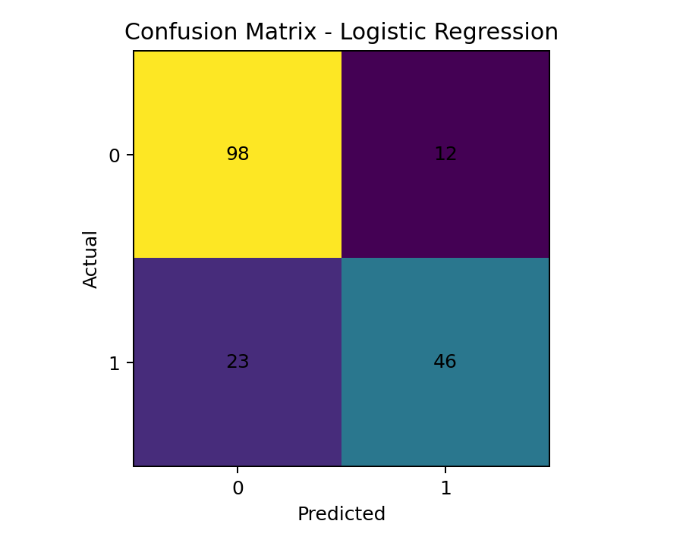
Figure 1. Confusion matrix of the logistic regression model.
The confusion matrix contains 99 true negatives, 10 false positives, 25 false negatives, and 45 true positives. The matrix provides more detail than accuracy because it shows exactly how the model's predictions were distributed between correct and incorrect classes.
The number of false negatives is important because it represents passengers who survived but were classified as non-survivors. Depending on the application, the preferred decision threshold could be adjusted to increase recall, although doing so may reduce precision.

16. ROC Curve and AUC
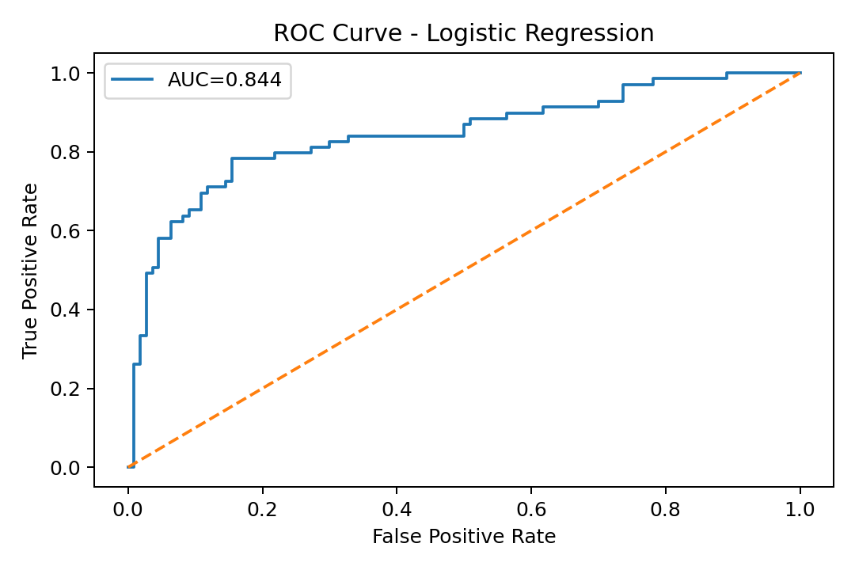
Figure 2. ROC curve for the logistic regression model.
The ROC curve evaluates the trade-off between sensitivity and false-positive rate over different probability thresholds. The AUC value summarizes the overall ranking ability of the classifier. The obtained AUC of approximately 0.844 indicates that the model has useful discriminatory power.

17. Target Distribution
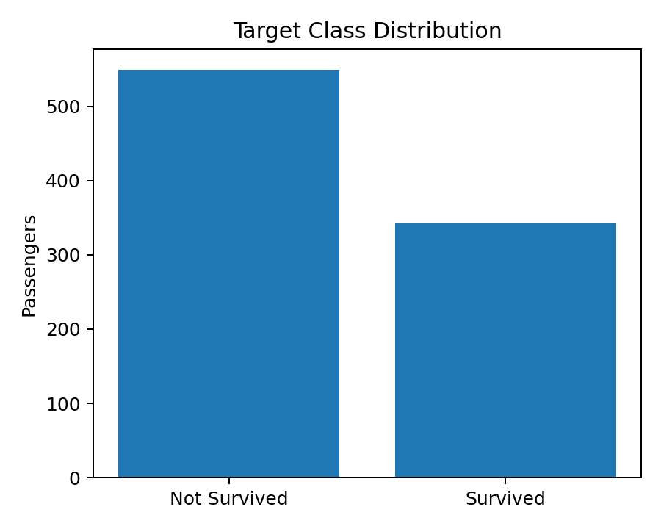
Figure 3. Distribution of the binary survival target.
The target classes are not perfectly balanced. For this reason, accuracy should not be used as the only evaluation criterion. Precision, recall, F1-score, and ROC-AUC provide additional information about the model's behavior.

18. Model Diagnostics
Three diagnostic perspectives are included: the confusion matrix evaluates class-level errors, the ROC curve evaluates discrimination across thresholds, and cross-validation evaluates stability across different partitions of the data.
The analysis does not claim that the model is perfect. Performance is affected by the limited feature set, missing information, historical context, and the fact that the dataset represents a single event. Diagnostics should therefore be interpreted as evidence about this dataset rather than universal predictive performance.

19. Interpretation of Results
The hypothesis test indicates a strong association between sex and survival. The predictive model also uses sex together with passenger class, age, fare, family counts, and embarkation information. This combination allows the model to capture multiple dimensions of passenger circumstances rather than relying on one variable.
The recall value of approximately 66.67% indicates that the model identifies around two-thirds of the actual survivors in the test set. Precision of approximately 79.31% indicates that most observations classified as survivors were actually survivors. The F1-score of approximately 72.44% provides a balanced summary of these two measures.

20. Strengths of the Model
• Uses a clearly defined binary outcome suitable for logistic regression.
• Includes both categorical and numerical predictors.
• Uses a reproducible random seed.
• Separates training and testing data.
• Handles missing values within preprocessing.
• Uses multiple evaluation metrics instead of accuracy alone.
• Includes five-fold cross-validation.
• Includes confusion-matrix and ROC-based diagnostics.
• Provides an interpretable baseline classification model.

21. Limitations
• The dataset represents a historical event and may not generalize to other populations.
• The selected predictors do not contain every factor that could influence survival.
• Missing-value imputation can introduce simplification into the data.
• Logistic regression assumes a suitable relationship between predictors and the log-odds of the outcome.
• The classification threshold of 0.50 is a default rather than an application-specific optimum.
• Correlation and hypothesis tests show association, not causation.

22. Potential Improvements
Future work could compare logistic regression with random forest, gradient boosting, support vector machines, or other classification algorithms. Hyperparameter tuning could be applied where appropriate. Feature engineering could include family size, whether a passenger was traveling alone, age groups, and fare-per-person measures. Interaction terms such as Sex × Pclass could also be evaluated.
Threshold optimization could be performed when recall or precision is more important than overall accuracy. Class-balancing methods could be considered if the imbalance becomes more severe. A stronger validation design could include repeated cross-validation or external validation on another dataset.

23. Reproducibility and Documentation
The analysis uses a fixed seed of 42 for data splitting and cross-validation. The R code appendix contains the principal commands used for data inspection, statistical testing, model fitting, prediction, evaluation, and cross-validation. The supplied CSV dataset is included with the Week 3 project files so that the analysis can be reproduced.

24. Conclusion
This Week 3 project demonstrates a complete statistical and predictive modeling workflow using R and the Titanic Passenger Dataset. The analysis progressed from exploratory statistical checks to hypothesis testing and then to logistic regression classification. The model achieved approximately 80.45% test accuracy, 79.31% precision, 66.67% recall, 72.44% F1-score, and 0.844 ROC-AUC, while five-fold cross-validation produced an average accuracy of approximately 79.35%.
The results show the value of combining statistical inference with predictive modeling. The project also demonstrates that model performance should be interpreted using several complementary metrics and diagnostics rather than a single score. The findings provide a useful baseline and a clear foundation for future model comparison, feature engineering, and optimization.

25. Appendix – Complete R Code
# ============================================================
# WEEK 3: STATISTICAL ANALYSIS AND PREDICTIVE MODELING USING R
# Dataset: Titanic Passenger Dataset
# ============================================================
library(tidyverse)
library(caret)
library(pROC)
# Load dataset
data <- read.csv("titanic(1).csv")
# -----------------------------
# 1. Dataset inspection
# -----------------------------
str(data)
summary(data)
colSums(is.na(data))
# -----------------------------
# 2. Target distribution
# -----------------------------
table(data$Survived)
prop.table(table(data$Survived))
# -----------------------------
# 3. Hypothesis test
# H0: Sex and survival are independent
# H1: Sex and survival are associated
# -----------------------------
sex_table <- table(data$Sex, data$Survived)
sex_table
chisq.test(sex_table)
# -----------------------------
# 4. Normality test for Age
# -----------------------------
age_complete <- na.omit(data$Age)
shapiro.test(age_complete)
# -----------------------------
# 5. Correlation / association
# -----------------------------
cor.test(
age_complete,
data$Survived[!is.na(data$Age)],
method = "pearson"
)
# -----------------------------
# 6. Prepare modeling data
# -----------------------------
model_data <- data %>%
select(Survived, Pclass, Sex, Age, SibSp, Parch, Fare, Embarked) %>%
mutate(
Survived = factor(Survived),
Sex = factor(Sex),
Embarked = factor(Embarked)
)
# -----------------------------
# 7. Train-test split
# -----------------------------
set.seed(42)
train_index <- createDataPartition(
model_data$Survived,
p = 0.80,
list = FALSE
)
train <- model_data[train_index, ]
test <- model_data[-train_index, ]
# -----------------------------
# 8. Logistic regression
# -----------------------------
logit_model <- glm(
Survived ~ Pclass + Sex + Age + SibSp + Parch + Fare + Embarked,
data = train,
family = binomial
)
summary(logit_model)
# -----------------------------
# 9. Predictions
# -----------------------------
prob <- predict(logit_model, newdata = test, type = "response")
pred <- ifelse(prob >= 0.50, "1", "0")
pred <- factor(pred, levels = levels(test$Survived))
# -----------------------------
# 10. Confusion matrix
# -----------------------------
cm <- confusionMatrix(
pred,
test$Survived,
positive = "1"
)
cm
# -----------------------------
# 11. ROC and AUC
# -----------------------------
roc_obj <- roc(
as.numeric(as.character(test$Survived)),
prob
)
auc(roc_obj)
plot(
roc_obj,
main = "ROC Curve - Logistic Regression"
)
# -----------------------------
# 12. Five-fold cross-validation
# -----------------------------
cv_data <- model_data %>%
mutate(
Survived = factor(
ifelse(Survived == 1,
"Survived",
"NotSurvived")
)
)
ctrl <- trainControl(
method = "cv",
number = 5,
classProbs = TRUE,
summaryFunction = twoClassSummary
)
set.seed(42)
cv_model <- train(
Survived ~ Pclass + Sex + Age + SibSp + Parch + Fare + Embarked,
data = cv_data,
method = "glm",
family = binomial,
trControl = ctrl,
metric = "ROC"
)
cv_model
# -----------------------------
# 13. Additional visualization
# -----------------------------
ggplot(data, aes(x = factor(Survived))) +
geom_bar() +
labs(
title = "Survival Class Distribution",
x = "Survived",
y = "Number of Passengers"
) +
theme_minimal()

Expanded Statistical Visualizations
To strengthen the Week 3 statistical analysis, additional visualizations are included below. These visuals are not presented merely as decoration; each one answers a specific analytical question and is followed by an interpretation. The sequence moves from target distribution and univariate structure to group comparisons, correlations, and model diagnostics.

Survival Class Distribution
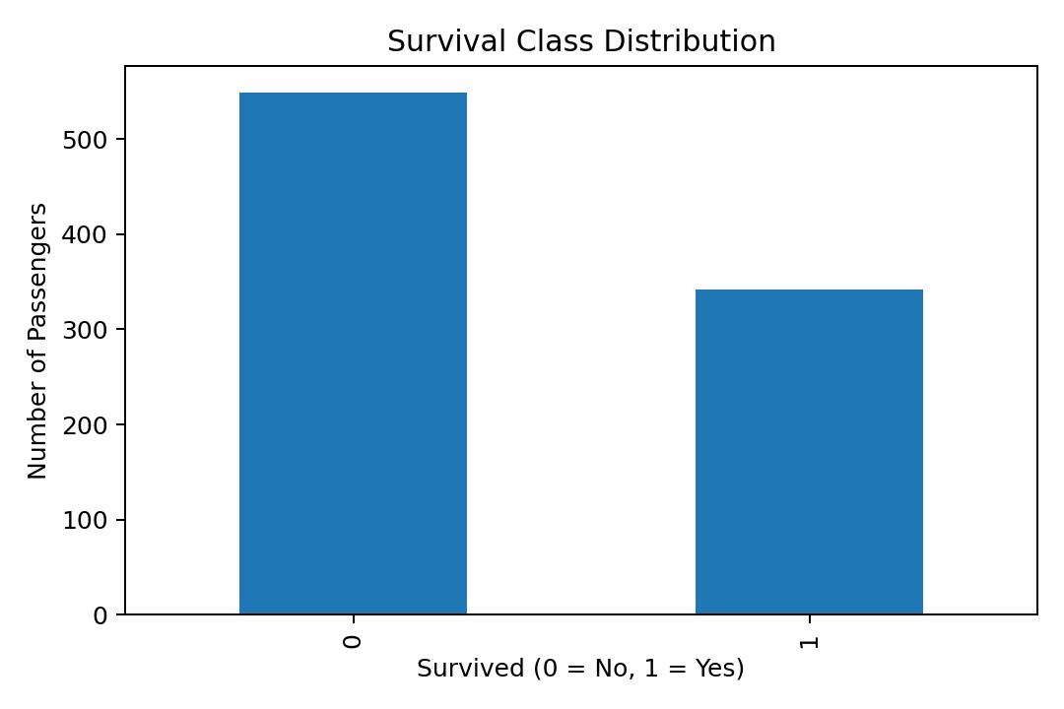
Figure 4. Survival Class Distribution
Interpretation: This chart shows the number of passengers in each outcome class. The two classes are not perfectly balanced, so model evaluation should include precision, recall, F1-score and ROC-AUC rather than accuracy alone.
R Code:
ggplot(data, aes(x = factor(Survived))) +
geom_bar() +
labs(title = "Survival Class Distribution",
x = "Survived", y = "Number of Passengers")

Passenger Age Distribution
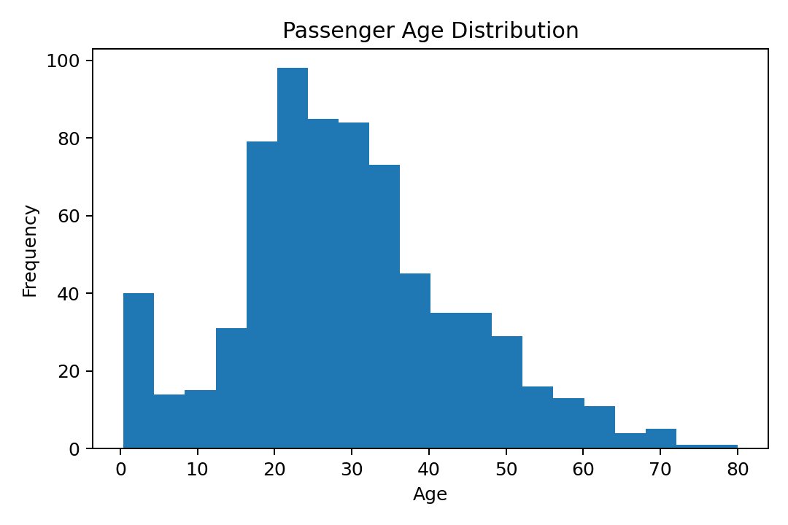
Figure 5. Passenger Age Distribution
Interpretation: The age histogram shows the distribution of passenger ages. It provides a useful visual complement to the formal normality test and highlights the concentration of observations across different age ranges.
R Code:
ggplot(data, aes(x = Age)) +
geom_histogram(bins = 20, na.rm = TRUE) +
labs(title = "Passenger Age Distribution",
x = "Age", y = "Frequency")

Survival by Sex
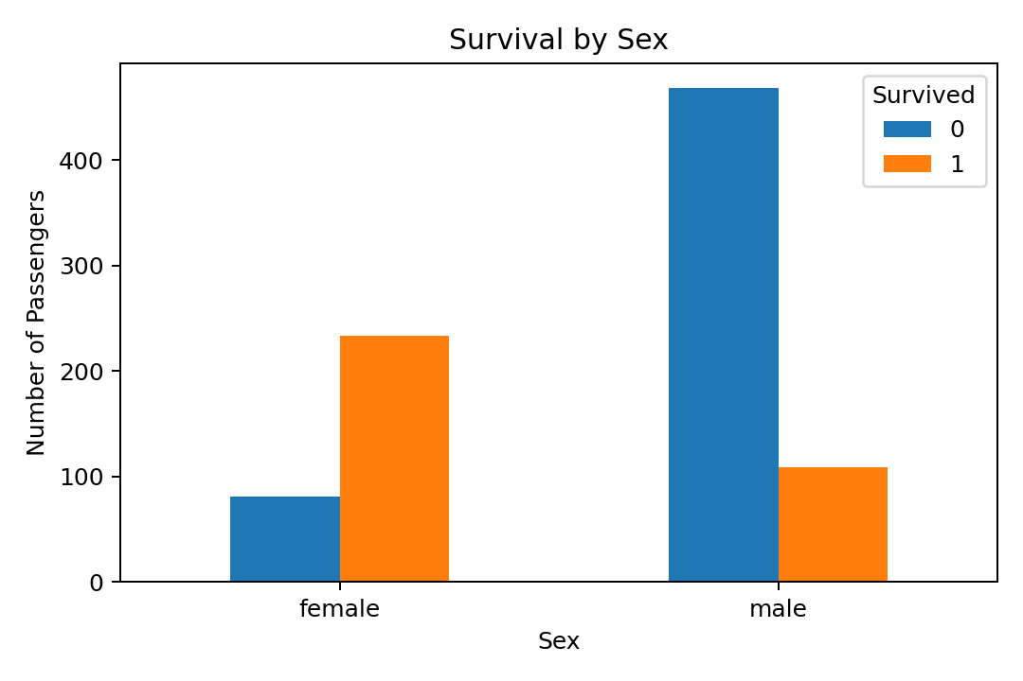
Figure 6. Survival by Sex
Interpretation: This comparison shows different survival outcomes across sex categories. The pattern supports the chi-square test reported earlier, which found a statistically significant association between sex and survival.
R Code:
ggplot(data, aes(x = Sex, fill = factor(Survived))) +
geom_bar(position = "dodge") +
labs(title = "Survival by Sex",
x = "Sex", fill = "Survived")

Survival by Passenger Class
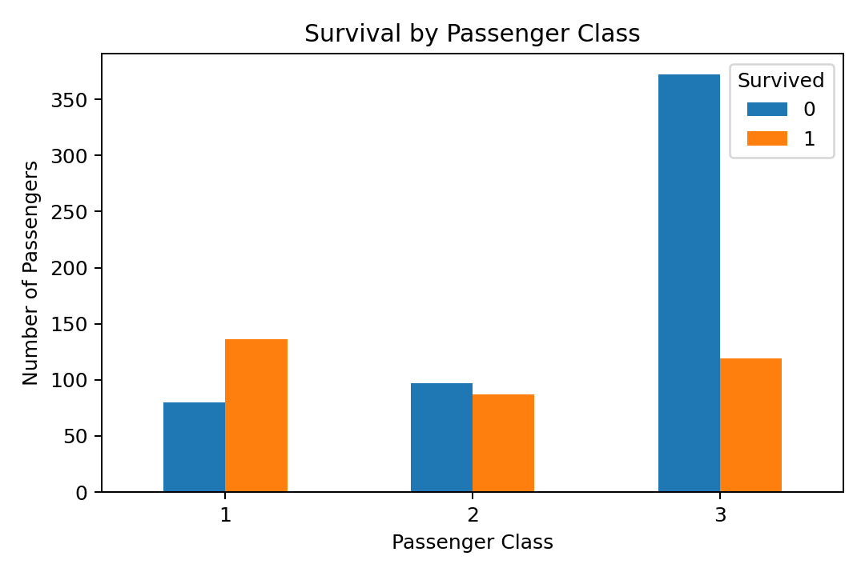
Figure 7. Survival by Passenger Class
Interpretation: The chart compares survival counts across passenger classes. It demonstrates why Pclass is a useful predictor in the logistic regression model and helps reveal differences between passenger groups.
R Code:
ggplot(data, aes(x = factor(Pclass), fill = factor(Survived))) +
geom_bar(position = "dodge") +
labs(title = "Survival by Passenger Class",
x = "Passenger Class", fill = "Survived")

Correlation Heatmap
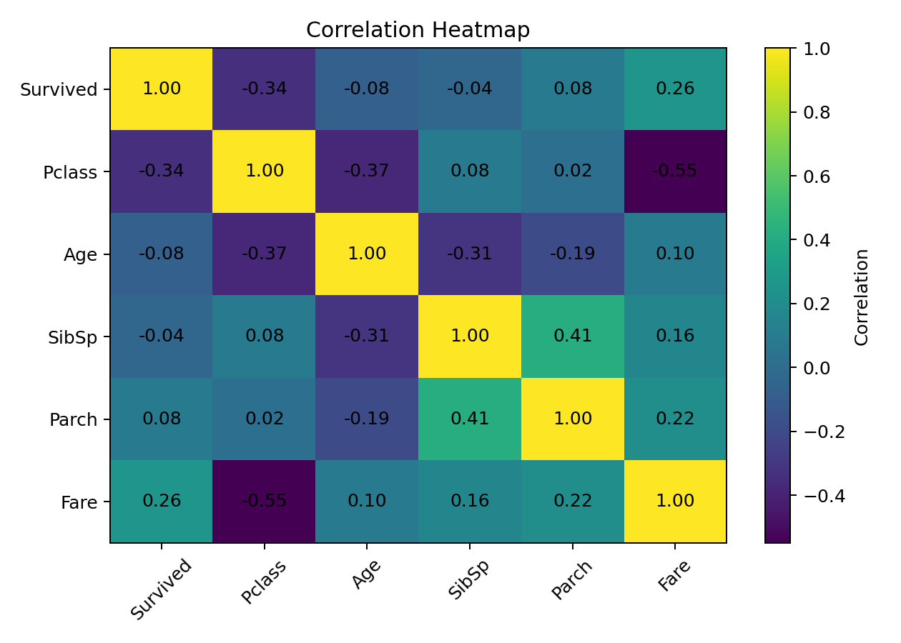
Figure 8. Correlation Heatmap
Interpretation: The heatmap summarizes pairwise linear associations among the selected numerical variables. It provides an initial check for relationships and possible redundancy before modeling.
R Code:
numeric_data <- data %>%
select(Survived, Pclass, Age, SibSp, Parch, Fare)
cor(numeric_data, use = "complete.obs")

Confusion Matrix

Figure 9. Confusion Matrix
Interpretation: The confusion matrix shows correct and incorrect classifications by class. It is especially useful for understanding false positives and false negatives, which are hidden by a single accuracy value.
R Code:
cm <- confusionMatrix(pred, test$Survived, positive = "1")
cm

ROC Curve

Figure 10. ROC Curve
Interpretation: The ROC curve evaluates model discrimination across classification thresholds. The area under the curve provides a threshold-independent summary of ranking performance.
R Code:
roc_obj <- roc(as.numeric(as.character(test$Survived)), prob)
auc(roc_obj)
plot(roc_obj, main = "ROC Curve - Logistic Regression")

Logistic Model Diagnostic: Deviance Residuals
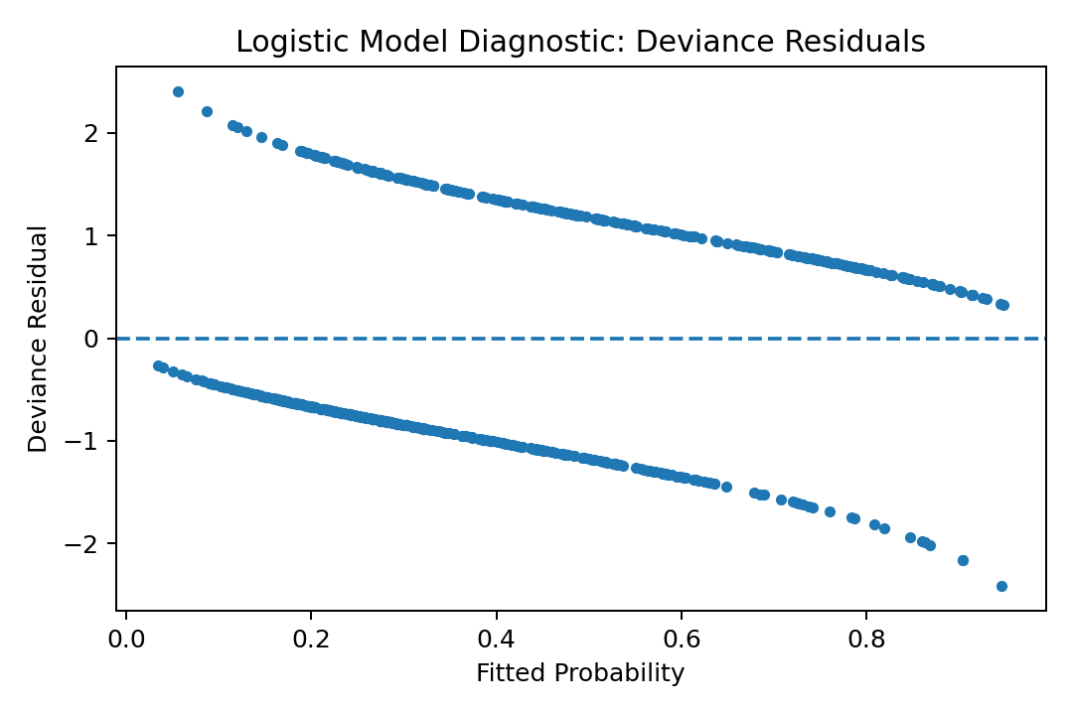
Figure 11. Logistic Model Diagnostic: Deviance Residuals
Interpretation: The residual diagnostic checks whether there are unusual patterns between fitted probabilities and model residuals. A generally patternless cloud around zero is preferable; strong structure can indicate model misspecification or omitted effects.
R Code:
# Diagnostic plot after fitting the logistic model
plot(fitted(logit_model), residuals(logit_model, type = "deviance"),
xlab = "Fitted Probability",
ylab = "Deviance Residual")
abline(h = 0, lty = 2)

Visual Analysis Summary
Together, the expanded visualizations provide a fuller statistical story. The target distribution establishes the class structure; the age histogram describes a key numerical predictor; sex and class comparisons reveal important group differences; the correlation heatmap summarizes numerical relationships; and the confusion matrix, ROC curve, and residual diagnostic connect the exploratory analysis directly to predictive-model evaluation. This combination makes the Week 3 report more comprehensive while keeping every figure tied to a specific analytical purpose.

