WEEK 2 TASK
DATA VISUALIZATION AND INSIGHT COMMUNICATION
Internship Submission Report
Role: Data Analyst Intern
Submitted by: Sayyed Arshiya Muktar
Dataset: Titanic Passenger Dataset
Tools: R, RStudio, ggplot2, tidyverse
Estimated effort: 30–35 hours

1. Executive Summary
This Week 2 project continues the Titanic data analysis from Week 1 and focuses on data visualization and insight communication using R. The objective is not only to create charts, but to select visual forms that make important patterns easy to understand for a non-technical audience. The analysis uses 891 passenger observations and focuses on survival, passenger class, gender, age and ticket fare.
The project contains eight complementary visualizations: a histogram, a 100% stacked bar chart, a survival-rate bar chart, a boxplot, a scatter plot, a line chart, a grouped bar chart and a correlation heatmap. Together, these visualizations examine distributions, comparisons, relationships, trends and potential anomalies.

2. Dataset Overview
The Titanic passenger dataset contains 891 observations. The key variables used in this visualization project are Survived (0 = deceased, 1 = survived), Pclass (1st, 2nd or 3rd class), Sex, Age, Fare, SibSp and Parch. Age was completed using the sample median of 28.0 years, consistent with the Week 1 preprocessing.
Variable | Type | Meaning
Survived | Binary | 1 = Survived; 0 = Deceased
Pclass | Categorical | Passenger class: 1, 2, 3
Sex | Categorical | Male / Female
Age | Numeric | Passenger age in years
Fare | Numeric | Ticket fare
SibSp | Numeric | Siblings/spouses aboard
Parch | Numeric | Parents/children aboard

3. Data Preparation and Visualization Strategy
The cleaned dataset is imported into R using read.csv(). The analysis checks dimensions, data types, summary statistics and missing values before visualization. The supplied R script then creates each figure and saves a 300 DPI PNG copy. This makes the analysis reproducible and suitable for both GitHub and formal internship submission.
The visualization strategy follows a simple principle: use the chart type that best answers the question. Histograms are used for distributions, bars for categorical comparisons, boxplots for outliers, scatter plots for relationships, line charts for ordered age-group patterns, and a correlation heatmap for numerical relationships.

4. Visualization 1 – Passenger Age Distribution (Histogram)
A histogram was selected because the question is about how passenger ages are distributed. The chart shows the concentration of observations across age intervals and includes a dashed median marker. The completed dataset has a median age of 28.0 years. The distribution is concentrated in young and middle-adult ages, while children and older passengers form smaller groups.
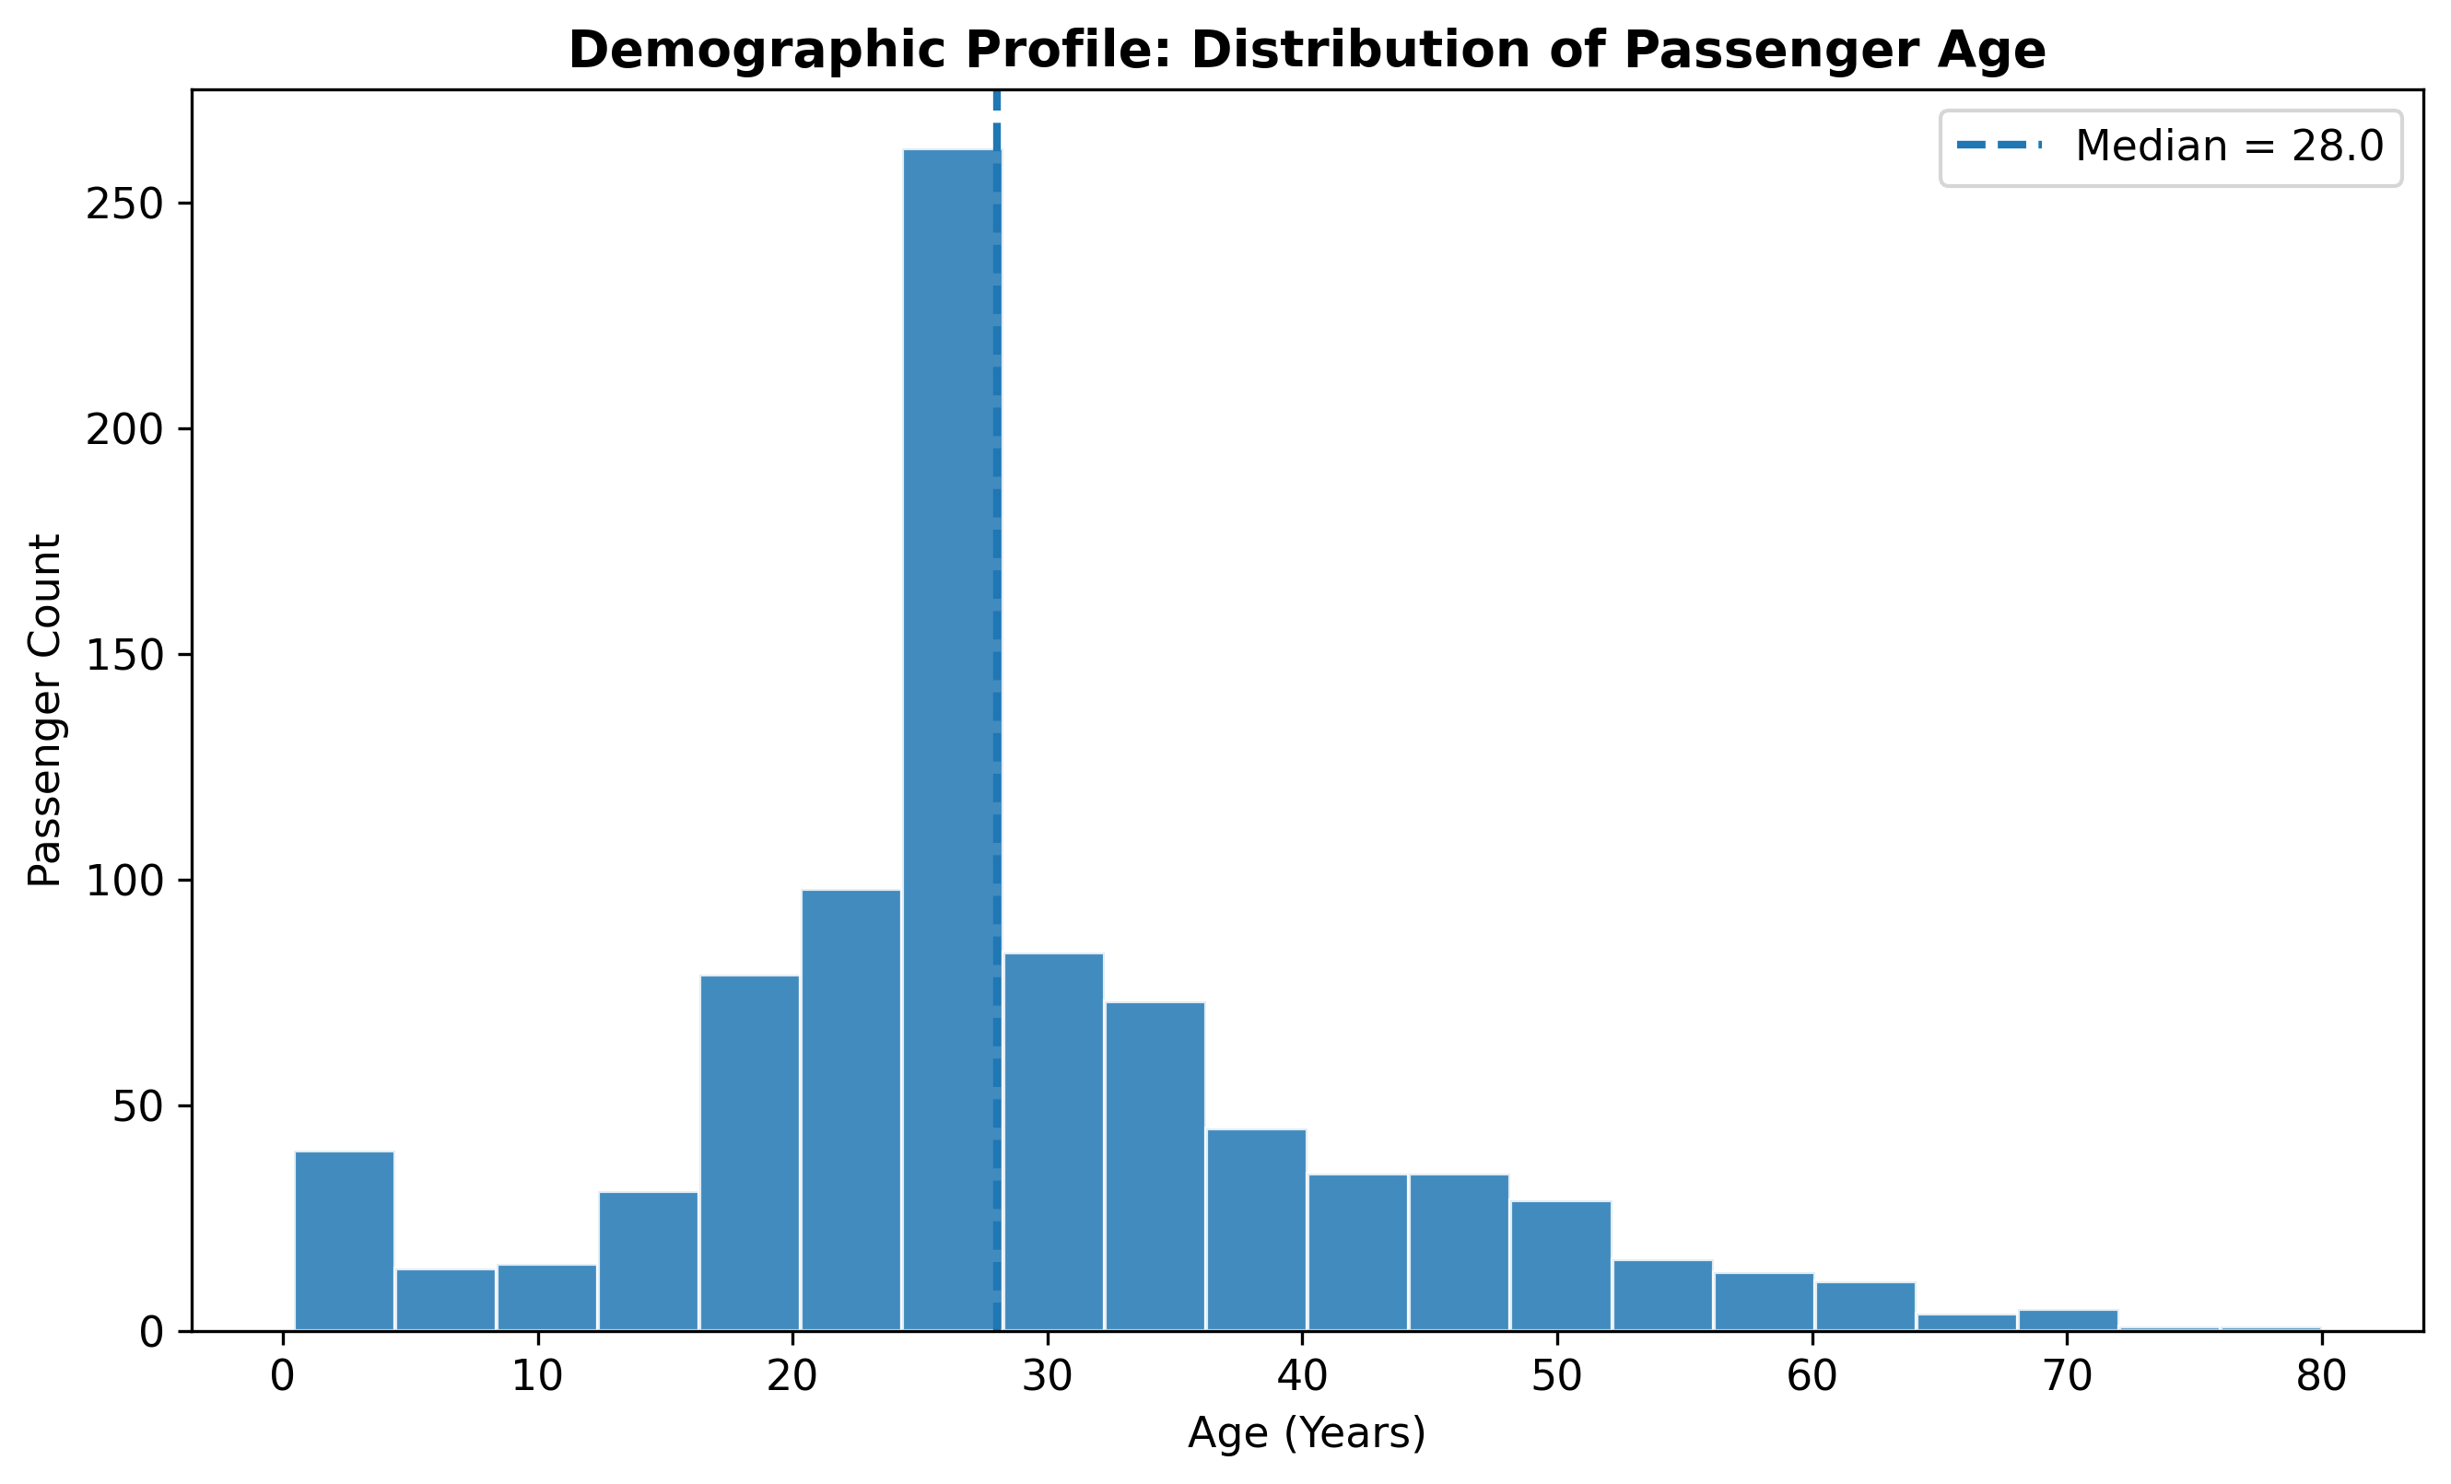
Figure: Passenger Age Distribution (Histogram)

R Code
# Age distribution
ggplot(data, aes(x = Age)) +
geom_histogram(bins = 20, fill = "#2b5c8f",
color = "white", alpha = 0.85) +
geom_vline(xintercept = median(data$Age),
linetype = "dashed", linewidth = 1) +
labs(title = "Demographic Profile: Distribution of Passenger Age",
x = "Age (Years)", y = "Passenger Count") +
theme_minimal()

Interpretation for a Non-Technical Audience
The main communication point is that the chart turns a table of numbers into an easy-to-read pattern. A reader does not need to understand R or statistical terminology to identify the dominant category, unusual values or visible relationship. The visualization should therefore be read together with its short narrative rather than as a standalone decorative graphic.

5. Visualization 2 – Survival by Gender (100% Stacked Bar Chart)
A 100% stacked bar chart is appropriate because the objective is to compare the proportion of survivors and non-survivors within each gender group. Female passengers had a survival rate of 74.20%, compared with 18.89% for male passengers. This is one of the strongest differences visible in the dataset and demonstrates why proportions are more informative than simply comparing raw passenger counts.
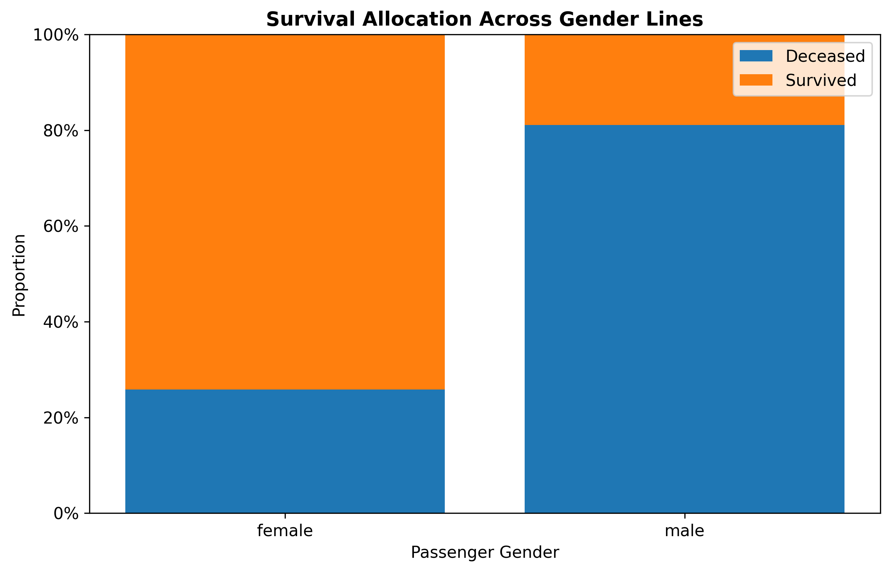
Figure: Survival by Gender (100% Stacked Bar Chart)

R Code
# Survival proportion by sex
ggplot(data, aes(x = Sex,
fill = factor(Survived,
levels = c(0,1),
labels = c("Deceased","Survived")))) +
geom_bar(position = "fill") +
scale_y_continuous(labels = scales::percent) +
labs(title = "Survival Allocation Across Gender Lines",
x = "Passenger Gender", y = "Proportion",
fill = "Outcome") +
theme_minimal()

Interpretation for a Non-Technical Audience
The main communication point is that the chart turns a table of numbers into an easy-to-read pattern. A reader does not need to understand R or statistical terminology to identify the dominant category, unusual values or visible relationship. The visualization should therefore be read together with its short narrative rather than as a standalone decorative graphic.

6. Visualization 3 – Survival by Passenger Class (Bar Chart)
A bar chart provides a direct comparison of average survival rates between the three passenger classes. The results are 62.96% for first class, 47.28% for second class and 24.24% for third class. The downward pattern indicates a strong association between passenger class and survival outcome.
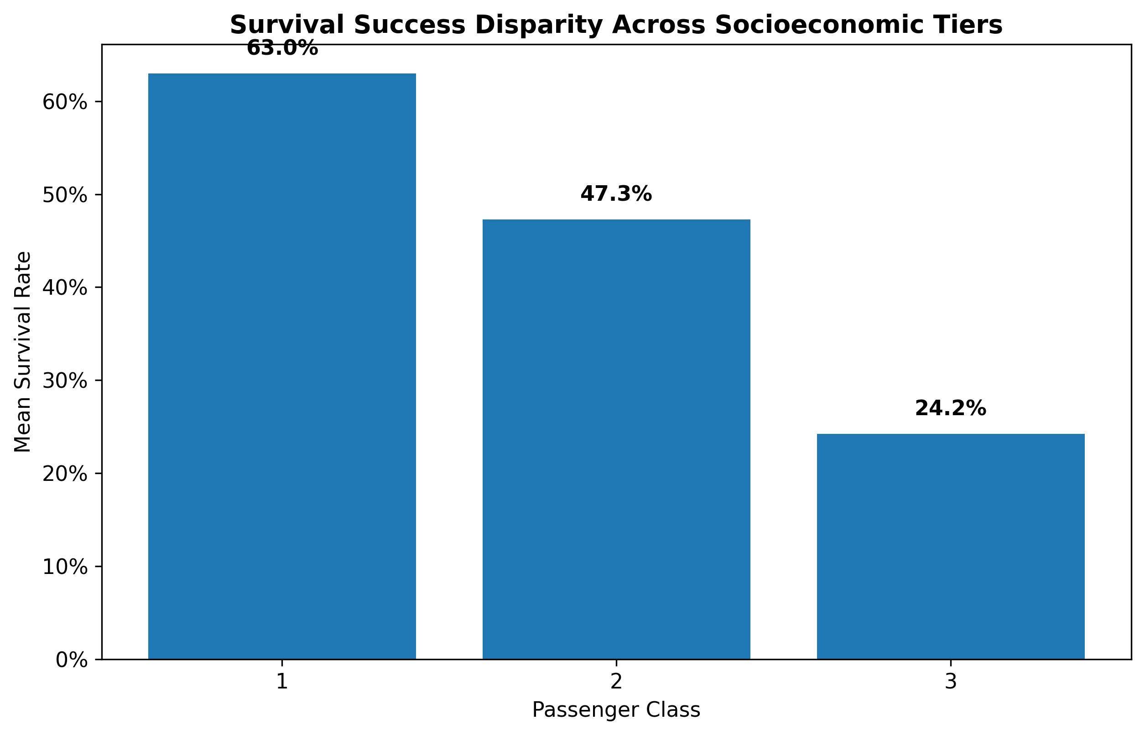
Figure: Survival by Passenger Class (Bar Chart)

R Code
# Survival rate by class
class_summary <- data %>%
group_by(Pclass) %>%
summarise(Survival_Rate = mean(Survived))
ggplot(class_summary, aes(x = factor(Pclass),
y = Survival_Rate)) +
geom_col(width = 0.6) +
scale_y_continuous(labels = scales::percent) +
labs(title = "Survival Success Disparity Across Socioeconomic Tiers",
x = "Passenger Class", y = "Survival Rate") +
theme_minimal()

Interpretation for a Non-Technical Audience
The main communication point is that the chart turns a table of numbers into an easy-to-read pattern. A reader does not need to understand R or statistical terminology to identify the dominant category, unusual values or visible relationship. The visualization should therefore be read together with its short narrative rather than as a standalone decorative graphic.

7. Visualization 4 – Ticket Fare Outliers (Boxplot)
A boxplot was chosen to show the median, interquartile range and unusually high fares in one compact figure. The median fare is approximately £14.45, while the upper-tail values extend to approximately £512.33. The high outliers are important because they represent legitimate extreme fare observations rather than errors that should automatically be deleted.
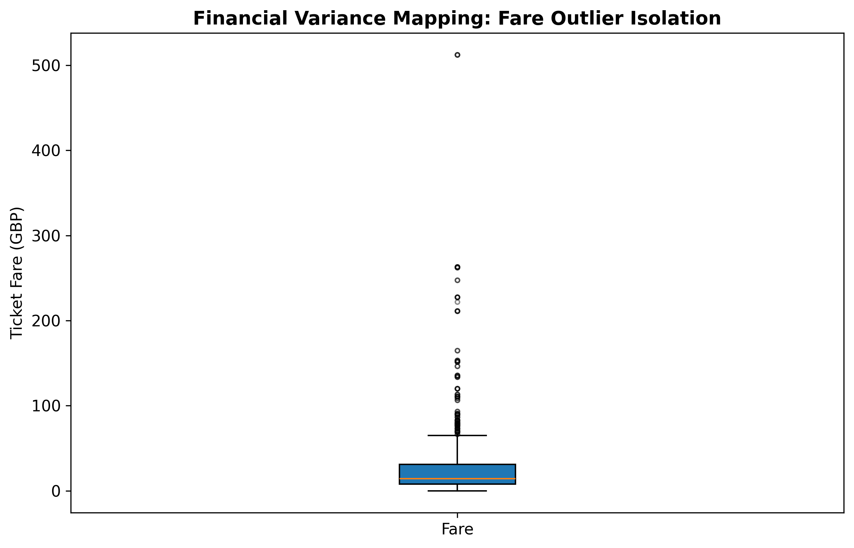
Figure: Ticket Fare Outliers (Boxplot)

R Code
# Fare outlier profile
ggplot(data, aes(y = Fare)) +
geom_boxplot(fill = "#f2f2f2",
outlier.color = "#c00000") +
labs(title = "Financial Variance Mapping: Fare Outlier Isolation",
x = NULL, y = "Ticket Fare (GBP)") +
theme_minimal()

Interpretation for a Non-Technical Audience
The main communication point is that the chart turns a table of numbers into an easy-to-read pattern. A reader does not need to understand R or statistical terminology to identify the dominant category, unusual values or visible relationship. The visualization should therefore be read together with its short narrative rather than as a standalone decorative graphic.

8. Visualization 5 – Age versus Fare (Scatter Plot)
A scatter plot is appropriate for checking whether two numerical variables move together. The points are widely distributed across the age range, with most fares concentrated in the lower fare band. There is no obvious strong upward linear pattern, suggesting that passenger age alone was not a strong direct determinant of ticket fare.
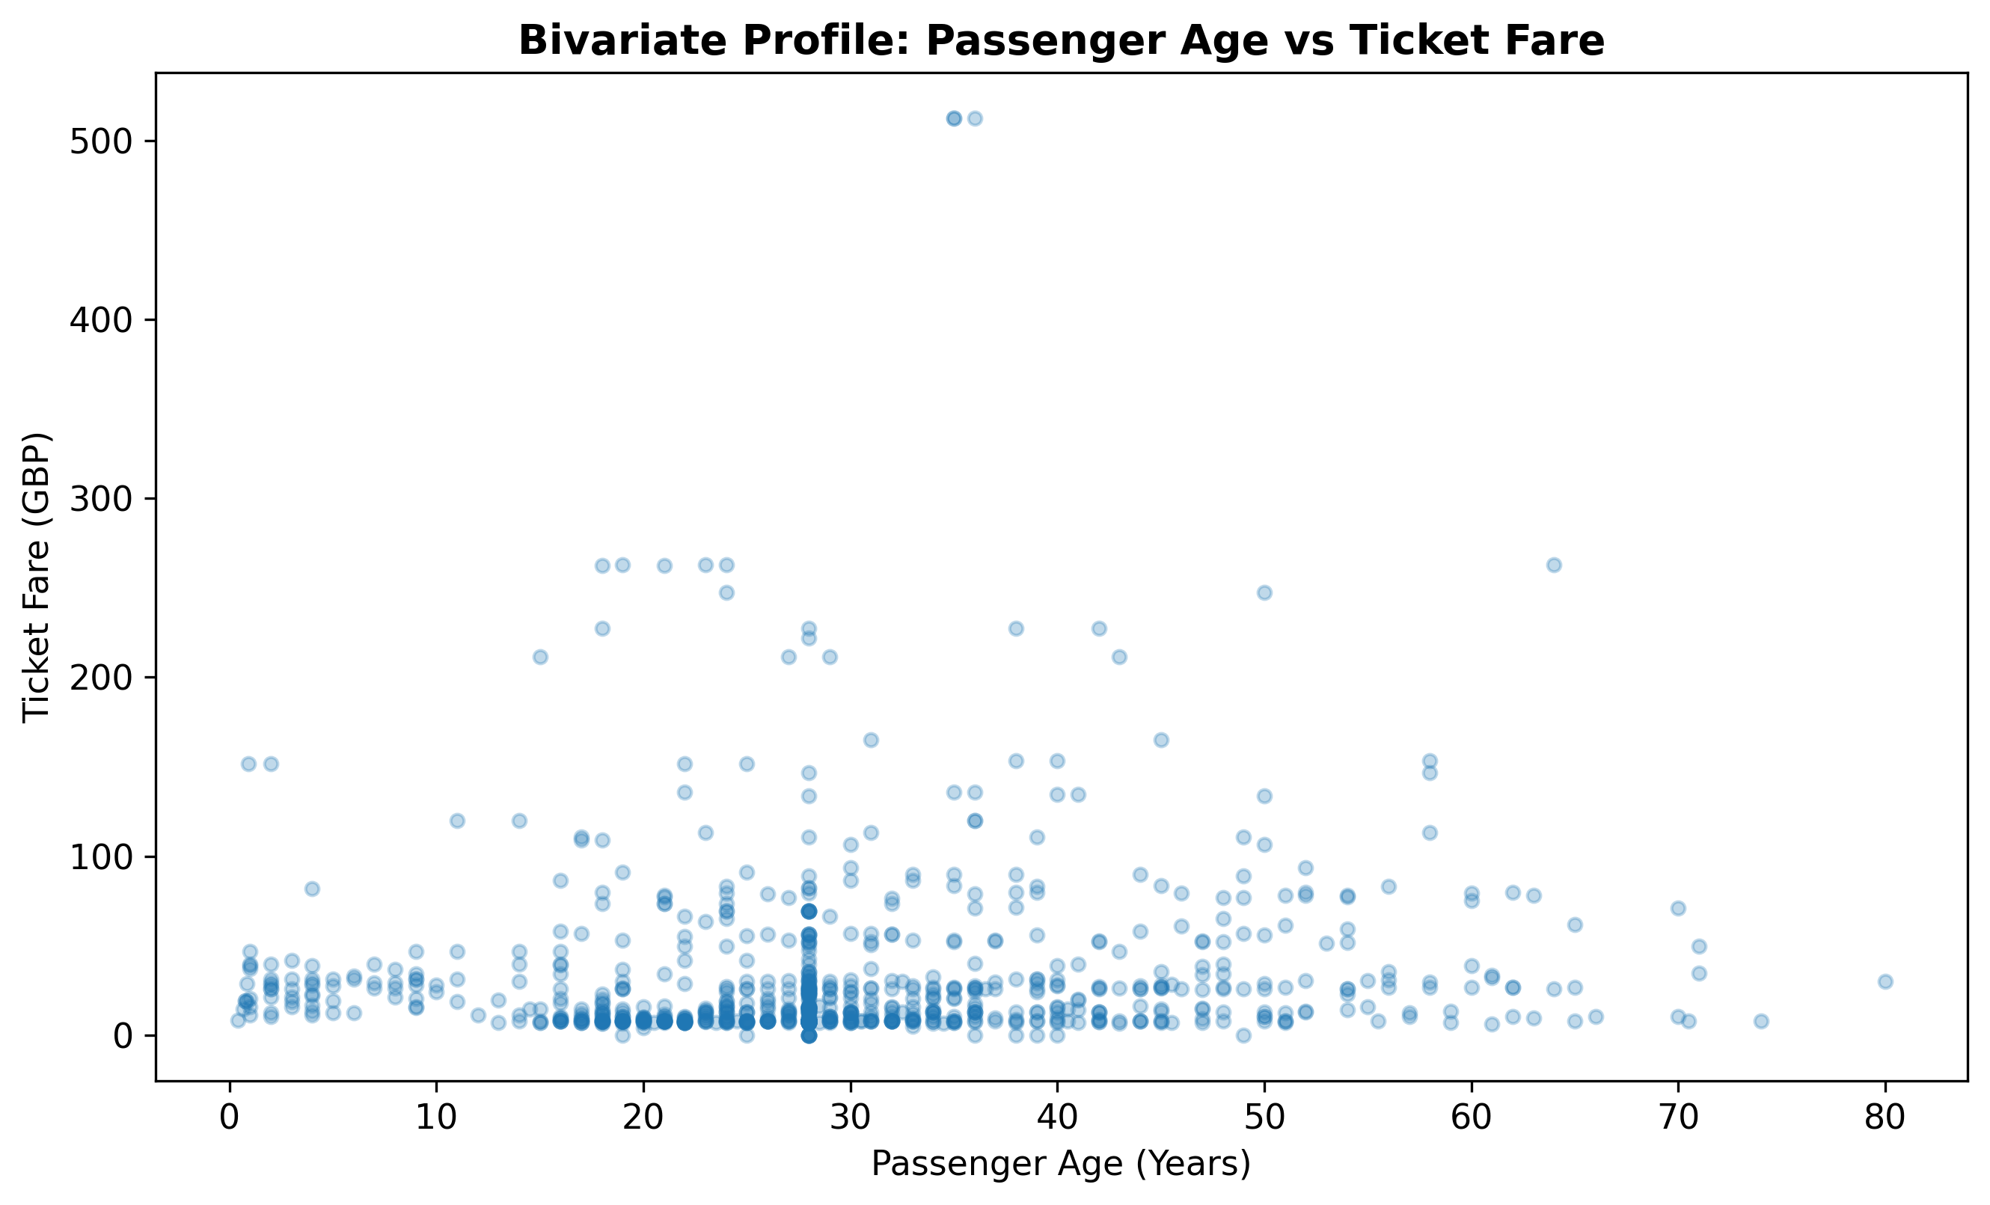
Figure: Age versus Fare (Scatter Plot)

R Code
# Age versus fare
ggplot(data, aes(x = Age, y = Fare)) +
geom_point(alpha = 0.30, size = 2) +
labs(title = "Bivariate Profile: Passenger Age vs Ticket Fare",
x = "Passenger Age (Years)", y = "Ticket Fare (GBP)") +
theme_minimal()

Interpretation for a Non-Technical Audience
The main communication point is that the chart turns a table of numbers into an easy-to-read pattern. A reader does not need to understand R or statistical terminology to identify the dominant category, unusual values or visible relationship. The visualization should therefore be read together with its short narrative rather than as a standalone decorative graphic.

9. Visualization 6 – Survival Trend by Age Group (Line Chart)
The line chart organizes passengers into ordered age groups and connects their survival rates to make changes across age ranges easy to follow. It adds an age dimension to the gender and class analysis and helps identify whether survival was broadly similar across different stages of life.
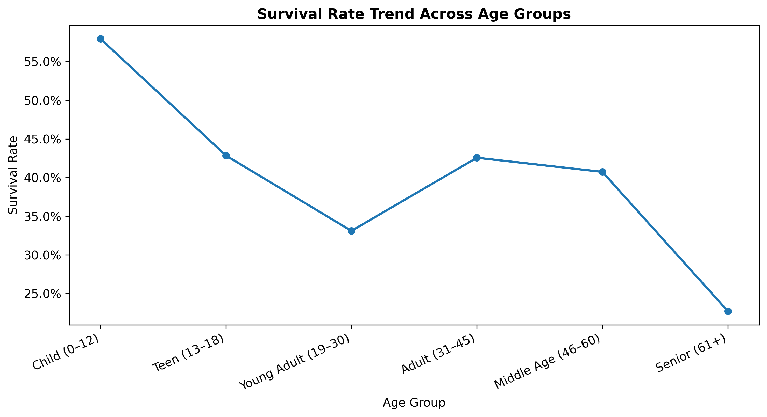
Figure: Survival Trend by Age Group (Line Chart)

R Code
# Survival trend by age group
data$AgeGroup <- cut(data$Age,
breaks = c(0, 12, 18, 30, 45, 60, Inf),
labels = c("Child (0–12)", "Teen (13–18)",
"Young Adult (19–30)", "Adult (31–45)",
"Middle Age (46–60)", "Senior (61+)"),
include.lowest = TRUE)
age_summary <- data %>%
group_by(AgeGroup) %>%
summarise(Survival_Rate = mean(Survived))
ggplot(age_summary, aes(x = AgeGroup,
y = Survival_Rate, group = 1)) +
geom_line(linewidth = 1) +
geom_point(size = 3) +
scale_y_continuous(labels = scales::percent) +
labs(title = "Survival Rate Trend Across Age Groups",
x = "Age Group", y = "Survival Rate") +
theme_minimal()

Interpretation for a Non-Technical Audience
The main communication point is that the chart turns a table of numbers into an easy-to-read pattern. A reader does not need to understand R or statistical terminology to identify the dominant category, unusual values or visible relationship. The visualization should therefore be read together with its short narrative rather than as a standalone decorative graphic.

10. Visualization 7 – Combined Effect of Class and Gender
The grouped bar chart combines two important categorical variables. It shows that gender differences remain visible within passenger classes, while class also changes the overall survival environment. This visualization is useful because looking at only gender or only class can hide interactions between the two variables.
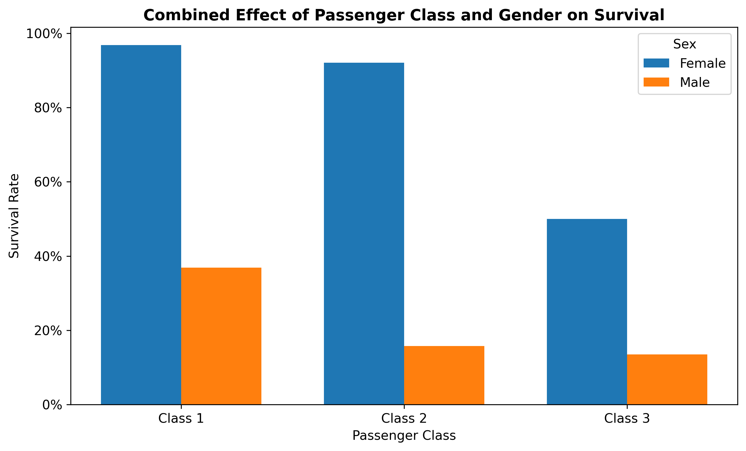
Figure: Combined Effect of Class and Gender

R Code
# Class and gender together
class_gender <- data %>%
group_by(Pclass, Sex) %>%
summarise(Survival_Rate = mean(Survived))
ggplot(class_gender,
aes(x = factor(Pclass),
y = Survival_Rate, fill = Sex)) +
geom_col(position = "dodge") +
scale_y_continuous(labels = scales::percent) +
labs(title = "Combined Effect of Passenger Class and Gender on Survival",
x = "Passenger Class", y = "Survival Rate",
fill = "Sex") +
theme_minimal()

Interpretation for a Non-Technical Audience
The main communication point is that the chart turns a table of numbers into an easy-to-read pattern. A reader does not need to understand R or statistical terminology to identify the dominant category, unusual values or visible relationship. The visualization should therefore be read together with its short narrative rather than as a standalone decorative graphic.

11. Visualization 8 – Correlation Heatmap
The heatmap provides a compact overview of relationships among numerical variables. It is useful as a screening tool because it highlights which variables deserve deeper investigation. In this dataset, passenger class and fare show an important relationship, while age and fare do not show a strong direct linear relationship.
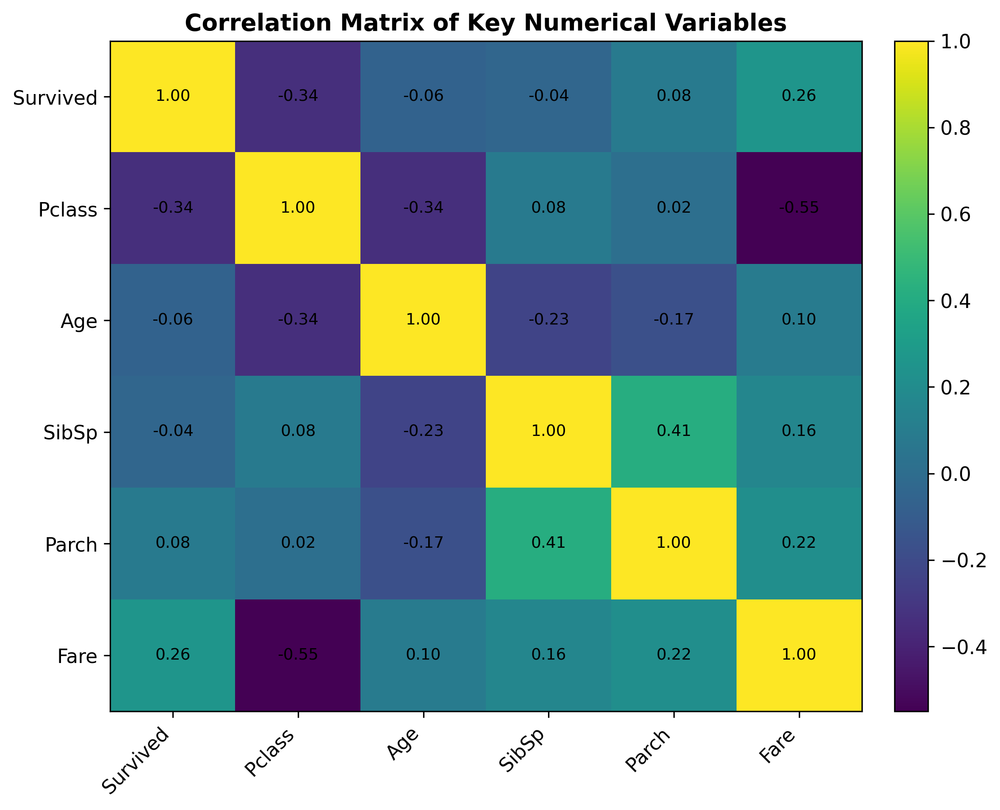
Figure: Correlation Heatmap

R Code
# Correlation heatmap
numeric_data <- data %>%
select(Survived, Pclass, Age, SibSp, Parch, Fare)
corrplot(cor(numeric_data),
method = "color",
type = "upper",
addCoef.col = "black",
tl.col = "black")

Interpretation for a Non-Technical Audience
The main communication point is that the chart turns a table of numbers into an easy-to-read pattern. A reader does not need to understand R or statistical terminology to identify the dominant category, unusual values or visible relationship. The visualization should therefore be read together with its short narrative rather than as a standalone decorative graphic.

12. Overall Key Insights
- Gender was strongly associated with survival: female passengers had a 74.20% survival rate, while male passengers had an 18.89% survival rate.
- Passenger class was strongly associated with survival: survival fell from 62.96% in first class to 24.24% in third class.
- Ticket fares were highly right-skewed. Most passengers paid relatively modest fares, while a small number paid very high amounts.
- Age and fare do not show a strong obvious linear relationship in the scatter plot, so age alone does not explain ticket price differences.
- Combining class and gender gives a more complete picture than examining either variable separately.
- The correlation heatmap is useful for identifying variables that deserve further statistical investigation, but correlation should not be interpreted as causation.

13. Technical Quality and Reproducibility
The project is designed to be reproducible. The R script contains the complete workflow from data import through visualization and image export. All charts are saved at 300 DPI, making them appropriate for a DOC/DOCX report. The GitHub repository is organized so that the code, data, figures and final report can be reviewed together.

14. Conclusion
This Week 2 analysis demonstrates how R visualization tools can convert a structured dataset into clear analytical stories. The eight visualizations cover distributions, category comparisons, outliers, numerical relationships, ordered trends and multivariable comparisons. The strongest findings concern the relationship of survival with gender and passenger class. The project also shows practical internship skills: reproducible code, appropriate chart selection, interpretation for non-technical readers, high-resolution figure export and GitHub-based project organization.

15. References and Tools
R and RStudio were used as the intended analysis environment.
Primary visualization package: ggplot2.
Additional packages: tidyverse, scales and corrplot.
Dataset: Titanic Passenger Dataset (891 observations), continued from the Week 1 internship analysis.

