WEEK 1 TASK
DATA CLEANING AND PRELIMINARY ANALYSIS WITH R
Dataset: Titanic Passenger Dataset
Tool: R Programming
Task Area: Data Cleaning, Preprocessing and Exploratory Data Analysis
Submitted by: Sayyed Arshiya Muktar

1. Introduction
This report presents the Week 1 task on Data Cleaning and Preliminary Analysis using R. The objective is to prepare a real-world dataset for reliable analysis by inspecting its structure, identifying data-quality problems, treating missing values, detecting outliers, transforming variables, encoding categorical data, and performing exploratory data analysis. The Titanic passenger dataset was selected because it contains numerical and categorical variables as well as substantial missing data, making it suitable for demonstrating practical preprocessing techniques.

2. Objectives
- Understand the structure and quality of a publicly available dataset.
- Identify and handle missing values appropriately.
- Check for duplicate observations and inconsistent data types.
- Detect potential numerical outliers using the IQR method and boxplots.
- Normalize a numerical variable using min-max normalization.
- Encode categorical variables into numerical form.
- Generate descriptive statistics and correlation measures.
- Use visualizations to identify patterns and initial insights.

3. Dataset Overview
The Titanic dataset contains passenger-level information from the RMS Titanic. It has 891 records and 12 original variables. Variables include passenger class, survival status, sex, age, family-related counts, ticket information, fare, cabin and port of embarkation. The dataset contains missing values, particularly in Age and Cabin, and therefore provides a realistic example for data cleaning.
Variable | Type | Description | Missing
PassengerId | Numerical | Unique passenger identifier | 0
Survived | Numerical/Binary | 1 = survived, 0 = did not survive | 0
Pclass | Categorical/Ordinal | Passenger class: 1, 2 or 3 | 0
Name | Categorical/Text | Passenger name | 0
Sex | Categorical | Passenger sex | 0
Age | Numerical | Passenger age | 177
SibSp | Numerical | Number of siblings/spouses aboard | 0
Parch | Numerical | Number of parents/children aboard | 0
Ticket | Categorical/Text | Ticket number | 0
Fare | Numerical | Ticket fare | 0
Cabin | Categorical/Text | Cabin information | 687
Embarked | Categorical | Port of embarkation | 2
Public dataset source: Kaggle Titanic dataset / widely distributed Titanic passenger dataset. The CSV used in this project is included with the submission files.

4. Tools and Technologies
R, RStudio, base R functions, dplyr, ggplot2 and caret. The analysis can be reproduced by placing titanic.csv and week1_analysis.R in the same folder and running the script in R/RStudio.

5. Initial Data Inspection
data <- read.csv("titanic.csv", stringsAsFactors = FALSE)
head(data)
str(data)
summary(data)
dim(data)
colSums(is.na(data))
Initial dimensions: 891 rows × 12 columns.
Initial missing-value counts:
Variable | Missing values
PassengerId | 0
Survived | 0
Pclass | 0
Name | 0
Sex | 0
Age | 177
SibSp | 0
Parch | 0
Ticket | 0
Fare | 0
Cabin | 687
Embarked | 2

6. Data Cleaning Process

6.1 Duplicate Records
Duplicate rows were checked and removed using dplyr::distinct(). No material reduction in the 891 observations was required by this dataset.

6.2 Missing Values
Age had 177 missing values. Because Age is numerical and its distribution can be influenced by extreme values, the median (28.0) was used for imputation. Embarked had 2 missing values, so the mode ('S') was used. Cabin had 687 missing values; dropping all such rows would remove a large proportion of the dataset, so a new binary feature Cabin_known was created instead.
data$Age[is.na(data$Age)] <- median(data$Age, na.rm = TRUE)
data$Embarked[is.na(data$Embarked)] <- "S"
data$Cabin_known <- ifelse(is.na(data$Cabin), 0, 1)

6.3 Outlier Detection
The Fare variable was examined using the Interquartile Range (IQR) method. Q1 = 7.91, Q3 = 31.00, IQR = 23.09. The upper threshold was 65.63. Values above this threshold were flagged as potential outliers. 116 records were flagged. These observations were not automatically deleted because high fares may represent legitimate first-class or group bookings. Therefore, they were documented rather than removed.
Q1 <- quantile(data$Fare, 0.25, na.rm = TRUE)
Q3 <- quantile(data$Fare, 0.75, na.rm = TRUE)
IQR_value <- Q3 - Q1
lower <- Q1 - 1.5 * IQR_value
upper <- Q3 + 1.5 * IQR_value
fare_outliers <- subset(data, Fare < lower | Fare > upper)
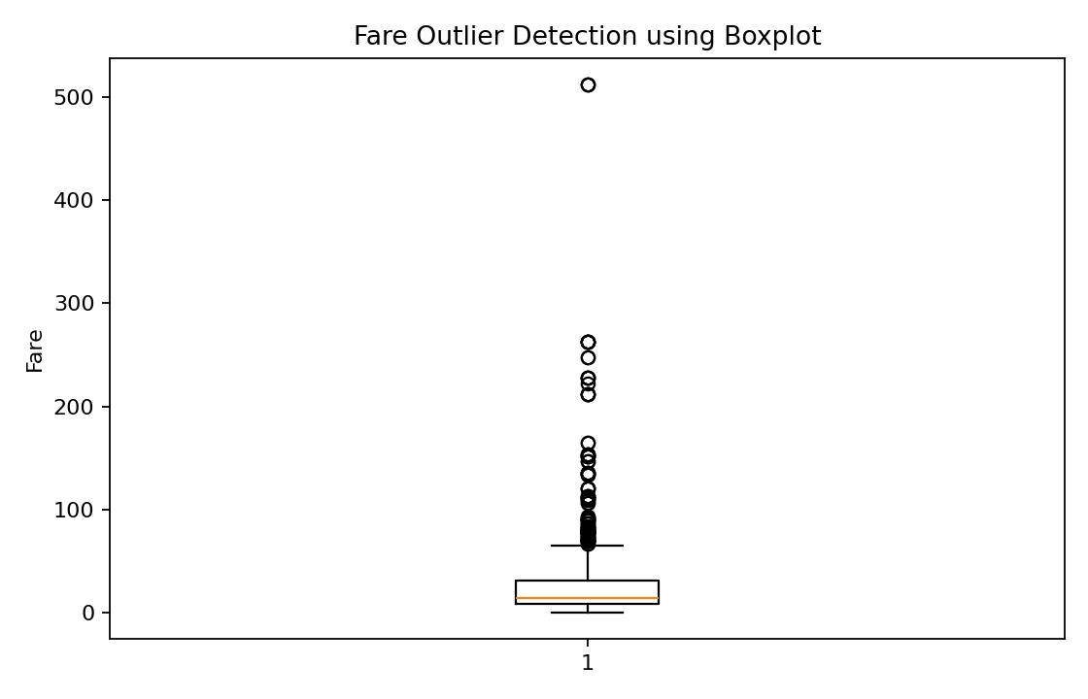
Figure 1: Boxplot used for Fare outlier detection. 116 potential outliers were identified.

6.4 Normalization
Min-max normalization was applied to Fare so that its values were transformed to a 0–1 range without changing their relative order.
data$Fare_normalized <- (data$Fare - min(data$Fare, na.rm = TRUE)) /
(max(data$Fare, na.rm = TRUE) - min(data$Fare, na.rm = TRUE))
Fare minimum = 0.00; Fare maximum = 512.33; normalized range = 0 to 1.

6.5 Categorical Encoding
Sex was encoded as female = 0 and male = 1. Embarked was encoded using the ordered levels C, Q and S. These encoded fields allow categorical information to be used in numerical analysis and future machine-learning workflows.
data$Sex_encoded <- ifelse(data$Sex == "female", 0, 1)
data$Embarked_encoded <- as.integer(factor(data$Embarked,
levels = c("C", "Q", "S"))) - 1

7. Exploratory Data Analysis

7.1 Descriptive Statistics
After cleaning, the mean passenger age was 29.36 years and the median age was 28.00 years. The mean fare was 32.20 and the median fare was 14.45.
summary(data$Age)
summary(data$Fare)
mean(data$Age)
median(data$Age)
mean(data$Fare)
median(data$Fare)
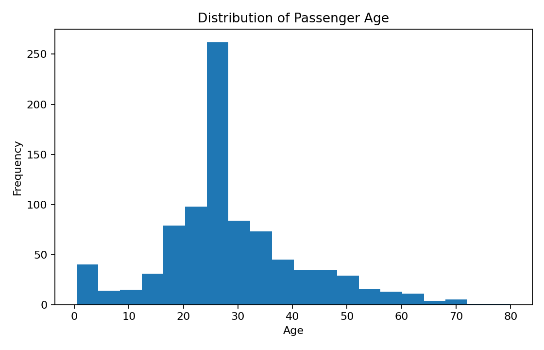
Figure 2: Age distribution after median imputation.

7.2 Survival Analysis
The overall survival rate was 38.38%. Survival differed substantially by sex: approximately 74.20% of female passengers survived compared with 18.89% of male passengers.
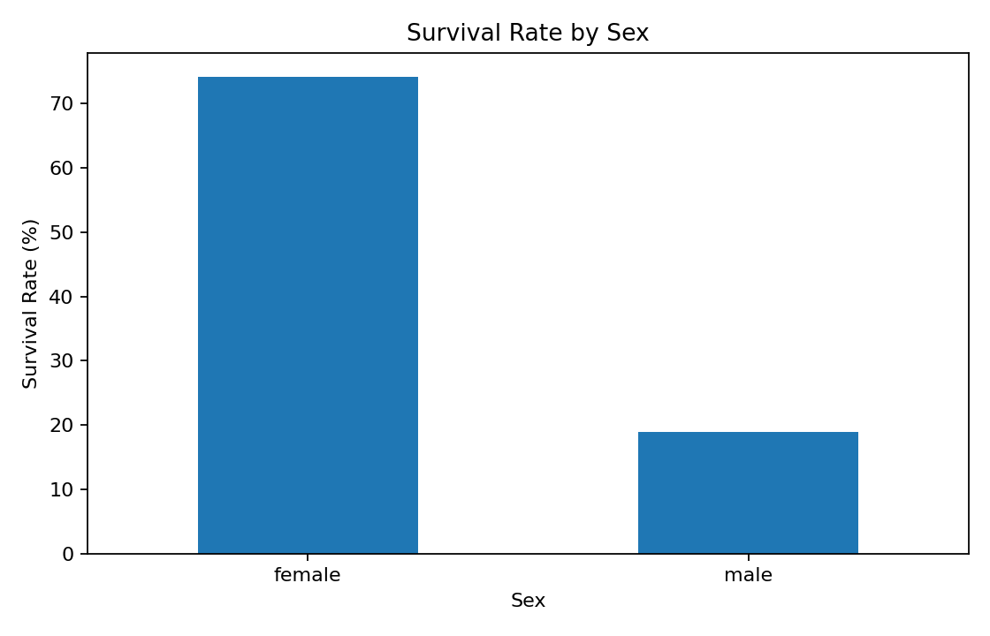
Figure 3: Survival rate by sex.
Passenger class also shows a clear difference in survival:
- Class 1: 62.96% survival
- Class 2: 47.28% survival
- Class 3: 24.24% survival
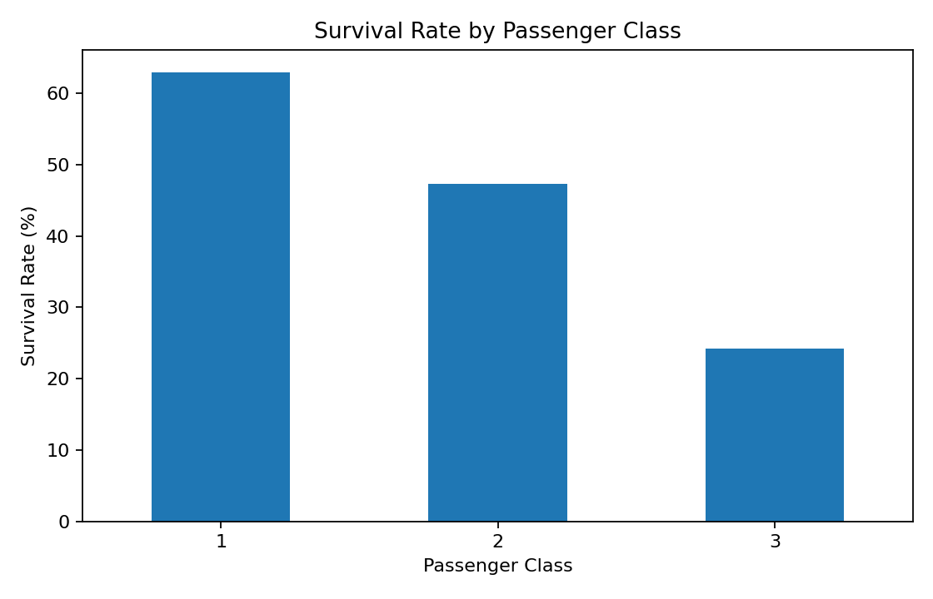
Figure 4: Survival rate by passenger class.

7.3 Correlation Analysis
cor(data[, c("Survived", "Pclass", "Age", "SibSp", "Parch", "Fare")],
use = "complete.obs")
- Survived: 1.000
- Fare: 0.257
- Parch: 0.082
- SibSp: -0.035
- Age: -0.065
- Pclass: -0.338
The strongest negative relationship with survival among the listed numerical variables is associated with Pclass, while Fare has a positive relationship with survival. Correlation indicates association, not causation.
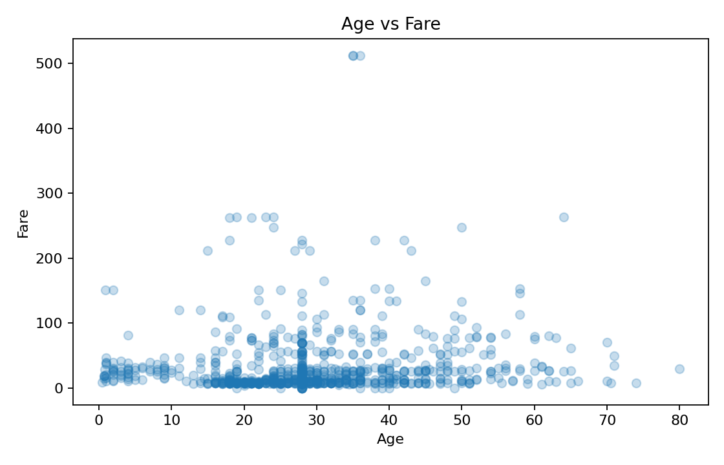
Figure 5: Scatter plot of Age versus Fare.

8. Before and After Cleaning
Quality Check | Before Cleaning | After Cleaning
Age missing | 177 | 0
Embarked missing | 2 | 0
Cabin missing | 687 | 687
Rows | 891 | 891
Normalized Fare | No | Yes
Encoded variables | No | Yes
Cabin missingness remains represented in the original Cabin column, but Cabin_known provides a complete analytical feature. This preserves information without discarding most observations.

9. Initial Insights
- Female passengers had a substantially higher survival rate (74.20%) than male passengers (18.89%).
- Passenger class was strongly associated with survival: Class 1 had 62.96% survival, compared with 24.24% in Class 3.
- Age contains substantial missingness, so median imputation was selected to preserve observations while limiting sensitivity to extreme values.
- Fare contains high-value observations flagged by the IQR method. These were retained because they can represent genuine passenger or booking characteristics.
- Normalization and encoding created additional analysis-ready variables for later statistical or machine-learning work.

10. Conclusion
The Week 1 task successfully demonstrated a complete data-cleaning and preliminary-analysis workflow in R. The Titanic dataset was inspected, missing values were treated, duplicate records were checked, potential outliers were identified, Fare was normalized, and categorical variables were encoded. Exploratory analysis using descriptive statistics, correlations and visualizations revealed meaningful patterns in survival by sex and passenger class. The resulting dataset is more consistent and suitable for subsequent analysis. Importantly, cleaning decisions were made with the goal of preserving useful information rather than removing observations unnecessarily.

11. Reproducibility and Files
The submission package contains the cleaned-analysis report, the Titanic CSV dataset, the complete R script and a README file. To reproduce the analysis, open week1_analysis.R in RStudio, keep titanic.csv in the same working directory, install the required packages if necessary, and run the script.

12. Complete R Code
# Week 1: Data Cleaning and Preliminary Analysis with R
# Dataset: Titanic Passenger Dataset
# Save titanic.csv in the same folder as this script.
library(dplyr)
library(ggplot2)
library(caret)
# 1. Load data
data <- read.csv("titanic.csv", stringsAsFactors = FALSE)
# 2. Initial inspection
head(data)
str(data)
summary(data)
dim(data)
colSums(is.na(data))
# 3. Remove duplicate rows
data <- data %>% distinct()
# 4. Handle missing values
data$Age[is.na(data$Age)] <- median(data$Age, na.rm = TRUE)
data$Embarked[is.na(data$Embarked)] <- names(sort(table(data$Embarked), decreasing = TRUE))[1]
# Cabin has many missing values. Instead of dropping most rows,
# create a useful indicator showing whether cabin information exists.
data$Cabin_known <- ifelse(is.na(data$Cabin), 0, 1)
# 5. Outlier detection using IQR
Q1 <- quantile(data$Fare, 0.25, na.rm = TRUE)
Q3 <- quantile(data$Fare, 0.75, na.rm = TRUE)
IQR_value <- Q3 - Q1
lower <- Q1 - 1.5 * IQR_value
upper <- Q3 + 1.5 * IQR_value
fare_outliers <- data %>% filter(Fare < lower | Fare > upper)
nrow(fare_outliers)
# 6. Min-max normalization
data$Fare_normalized <- (data$Fare - min(data$Fare, na.rm = TRUE)) /
(max(data$Fare, na.rm = TRUE) - min(data$Fare, na.rm = TRUE))
# 7. Encode categorical variables
data$Sex_encoded <- ifelse(data$Sex == "female", 0, 1)
data$Embarked_encoded <- as.integer(factor(data$Embarked,
levels = c("C", "Q", "S"))) - 1
# 8. Descriptive statistics
summary(data$Age)
summary(data$Fare)
mean(data$Age)
median(data$Age)
mean(data$Fare)
median(data$Fare)
# 9. Correlation
cor(data[, c("Survived", "Pclass", "Age", "SibSp", "Parch", "Fare")],
use = "complete.obs")
# 10. Visualizations
ggplot(data, aes(x = Age)) +
geom_histogram(bins = 20) +
labs(title = "Distribution of Passenger Age")
ggplot(data, aes(x = Sex, fill = factor(Survived))) +
geom_bar(position = "fill") +
labs(title = "Survival Proportion by Sex", y = "Proportion")
ggplot(data, aes(x = factor(Pclass), y = Survived)) +
stat_summary(fun = mean, geom = "bar") +
labs(title = "Survival Rate by Passenger Class",
x = "Passenger Class", y = "Survival Rate")
ggplot(data, aes(y = Fare)) +
geom_boxplot() +
labs(title = "Fare Outlier Detection")
ggplot(data, aes(x = Age, y = Fare)) +
geom_point(alpha = 0.25) +
labs(title = "Age vs Fare")

13. References
1. Titanic Passenger Dataset, publicly available Titanic dataset used for data-analysis education.
2. R Documentation – base R functions: read.csv(), summary(), str(), median(), mean(), cor().
3. Wickham et al., dplyr and ggplot2 documentation for data manipulation and visualization.

