Assignment No. 1

Problem statement: Create a drag and drop activity as shown in below image:

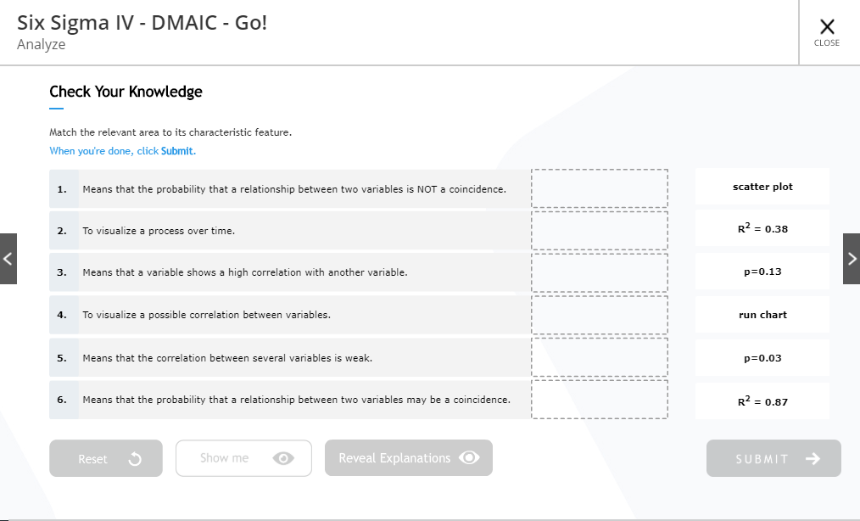

Point to remember:

1. Create the complete same UI as shown in above image but no need to include next and previous arrows as well no need to add reveal explanations button.
2. Give all the text data (instructions, questions, answers, numbers etc.) in a json file and then use that json file in your code.
3. The drag drop activity should be re draggable activity i.e., one a drag is dropped in the box it should be again re draggable.
4. Submit button should be enabled once all drags are dropped in the box and if any drag is again re dragged and placed out of the box then submit should be disabled. On clicking on submit, depending on the answers the feedback should be shown in a popup whether it correct or incorrect and it should show a tick mark icon near correct answer and cross mark icon near incorrect answer. Please refer demo for the same.
5. Reset button should be enabled once any of the drags is dragged into the box. On clicking reset button, the drags which are in the box should be sent back to its original position and should be available for dragging again.
6. Show me button should be enabled if user makes 3 incorrect attempts so after that enable show me button and disable the remaining buttons. On clicking on show me button, it should display the correct answers.
7. Images for buttons, tick mark, background image, drag image and cross mark are given in images folder.

Note: There is a demo activity available for the same which you can refer for better understanding. Please find the details below for the same:

Link: <https://webhost.mitrmedia.com/ftp/pa_project/Assignment_Demo/MF1012/MF1012/htmlVersion/index.html?lang=en&standAlone=false>

Screen no.: 6

Assignment No. 2

Problem statement: Create a MCSS (Multiple choice Single select) activity as shown in below image:

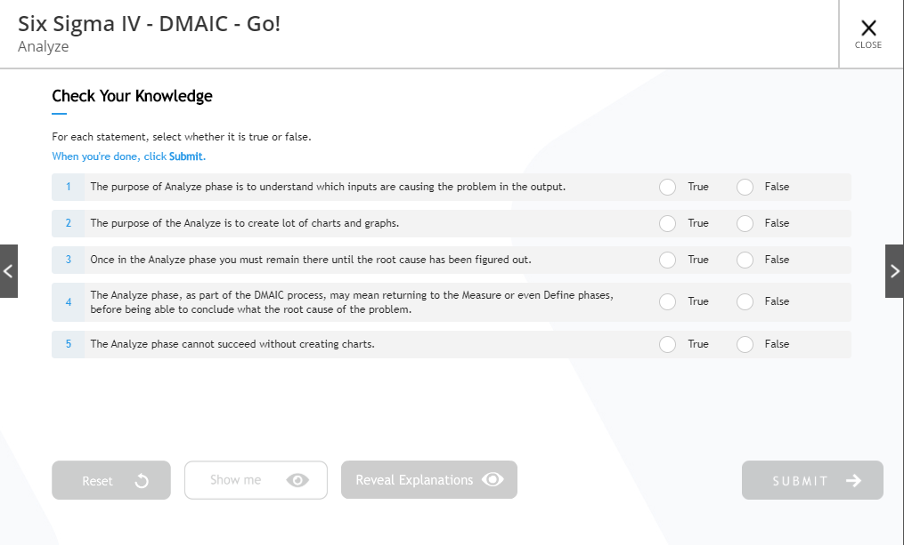

Point to remember:

1. Create the complete same UI as shown in above image but no need to include next and previous arrows as well no need to add reveal explanations button.
2. Give all the text data (instructions, questions, answers, numbers etc.) in a json file and then use that json file in your code.
3. The mcms activity is based on mcq’s where you will have to for each question out of 2 options, user is allowed to select any one and based on the entire answers the feedback will be shown.
4. Submit button should be enabled once all the questions are answered. On clicking on submit, depending on the answers the feedback should be shown in a popup whether it correct or incorrect and it should show a tick mark icon near correct answer and cross mark icon near incorrect answer. Please refer demo for the same.
5. Reset button should be enabled once any of the question is answered. On clicking reset button, all the selected radio buttons will be in default i.e., empty state and it will be again available for answering.
6. Show me button should be enabled if user makes 3 incorrect attempts so after that enable show me button and disable the remaining buttons. On clicking on show me button, it should display the correct answers.
7. Images for buttons, tick mark and cross mark are given in images folder.

Note: There is a demo activity available for the same which you can refer for better understanding. Please find the details below for the same:

Link: <https://webhost.mitrmedia.com/ftp/pa_project/Assignment_Demo/MF1012/MF1012/htmlVersion/index.html?lang=en&standAlone=false>

Screen no.: 7