Assignment 07

Mohammad Faisal Sayed

2023PCS0034

1. popen() and pclose()
   1. Scenario: You have a parent process that needs to execute a child process to perform a specific task
   2. Explanation:This program uses **popen()** to execute the **"ls -i"** command in a child process and reads the output of the child process line by line, printing it to the console.
   3. **-i** known as inode which displays the index number (inode) of each file and directory.

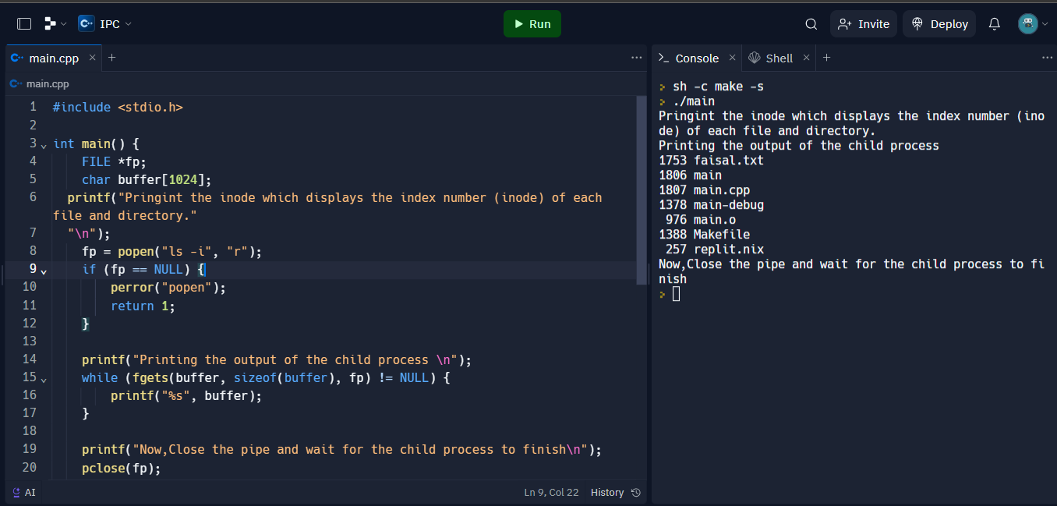

1. pipe()
   1. Scenario: You want to create a simple pipe to send a message from one process to another.
   2. Explanation:
   3. This program creates a pipe using pipe() and forks into a parent and child process. The parent process writes the message "Hello, Pipe!" to the pipe, and the child process reads from the pipe and prints the received message.

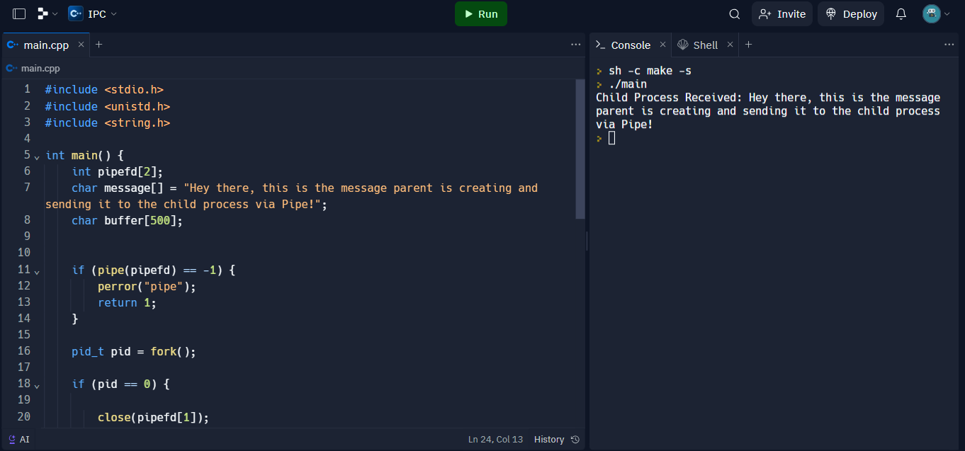

1. mkfifo()
   1. It creates a named pipe which can be used exactly like a file. So, if you know how to read/write in a file this is a convenient method for IPC
   2. Note: The FIFO pipe works in blocked mode(by default) i.e., the writing process must be present on one end while the reading process must be present on the other side at the same time else the communication will not happen. Operating the FIFO special file in non-blocking mode is also possible.

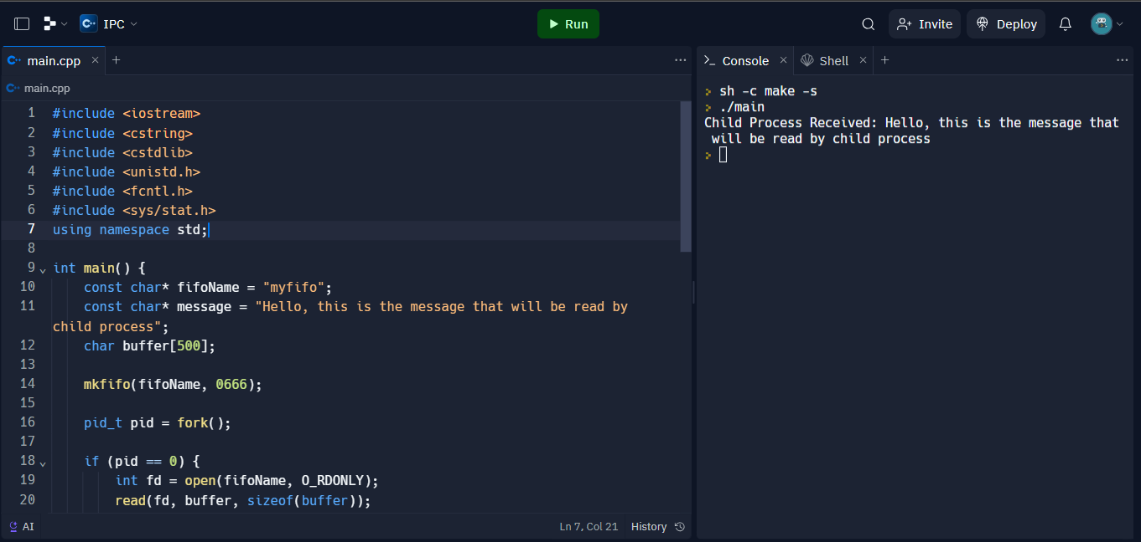

1. Shared memory

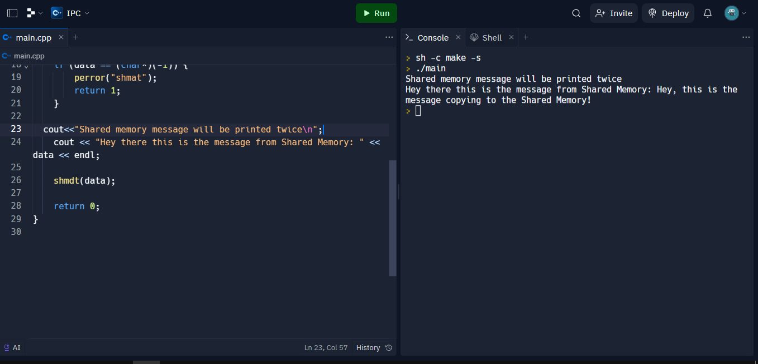

1. 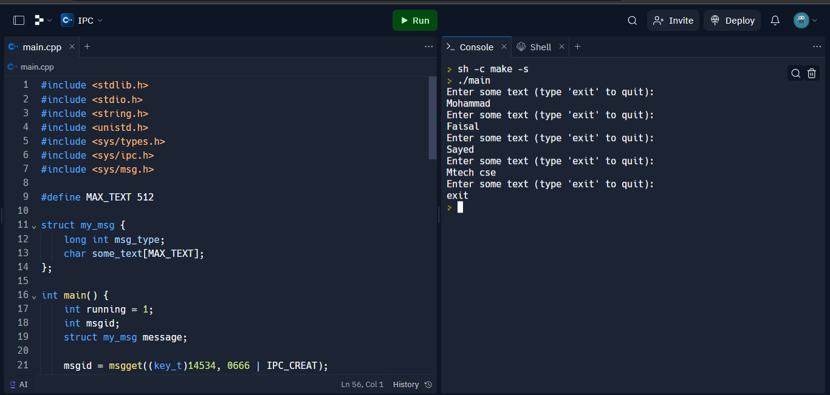Message passing