Assignment 02

Computer Systems

2023PCS0021

Akash Kumar gupta

1. Linux Commands
2. Check current working directory:

Command: **pwd**

Description: Prints the current working directory.

Output:



1. Check the contents in the current directory:

Command: **ls**

Description: Lists the contents of the current directory.

Output:



1. Create a new directory:

Command: **mkdir new_directory**

Description: Creates a new directory named "new_directory".

Output: 

1. Copy and move files/folders:

Command: **cp source_path destination_path**

Description: Copies files/folders from the source to the destination.

Output:

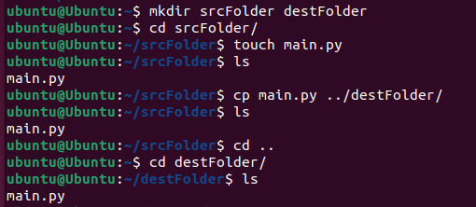

Command: **mv source_path destination_path**

Description: Moves files/folders from the source to the destination.

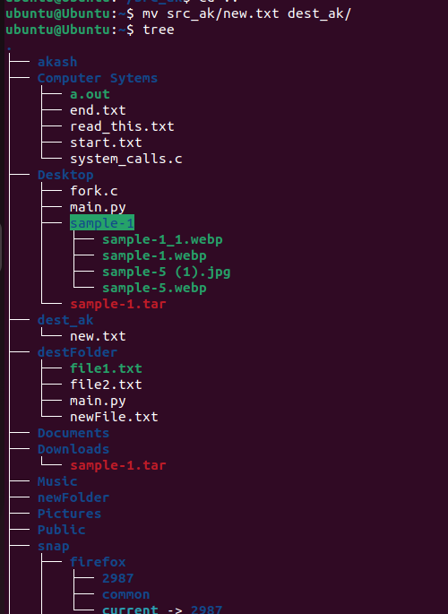Output:

Download and unzip a .tar file:

Command: **wget URL/to/your/file.tar**

Description: Downloads a .tar file from a specified URL.

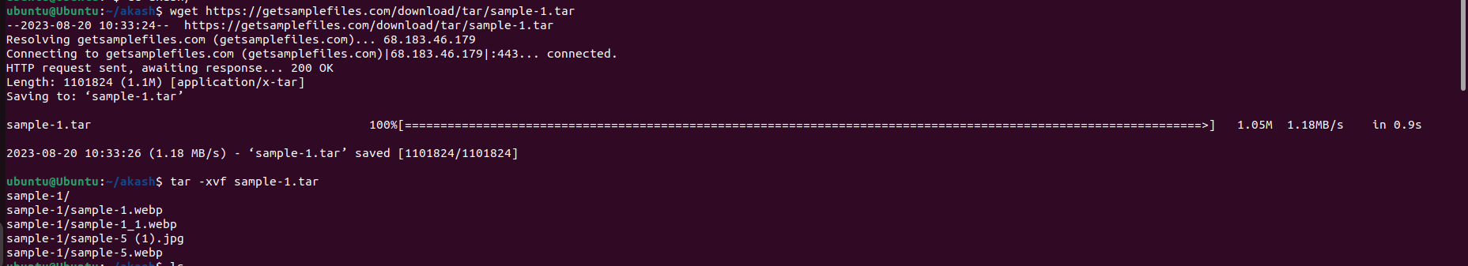

Command: **tar -xvf file.tar**

Description: Extracts the contents of the downloaded .tar file.

Output:

1. Show contents of a file:

Command: **cat file.txt**

Description: Displays the contents of "file.txt" in the terminal.

Output:

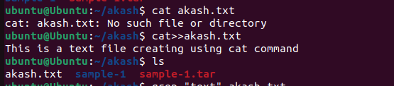

This is the content of the file.

It can have multiple lines.

1. Search for a keyword within a file:

Command: **grep "keyword" file.txt**

Description: Searches for the specified "keyword" within "file.txt" and displays matching lines.

Output:



This line contains the keyword.

Another line with the keyword.

1. Show difference between two files:

Command: **diff file1.txt file2.txt**

Description: Compares the contents of "file1.txt" and "file2.txt" and shows the differences.

Output:

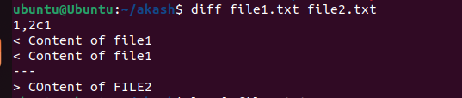

1. View and change permissions of a file:

Command: **ls -l file.txt**

Description: Displays the permissions and other information of "file.txt".

Output:

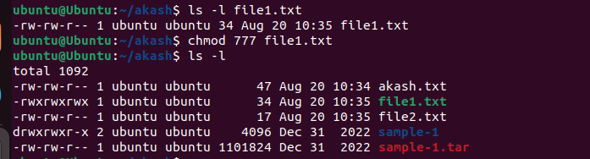

1. Command: **chmod permissions file.txt**

Description: Changes the permissions of "file.txt" (e.g., `chmod 755 file.txt`).

Output:



1. List of running processes:

Command: **ps aux**

Description: Displays a list of all running processes.

Output:

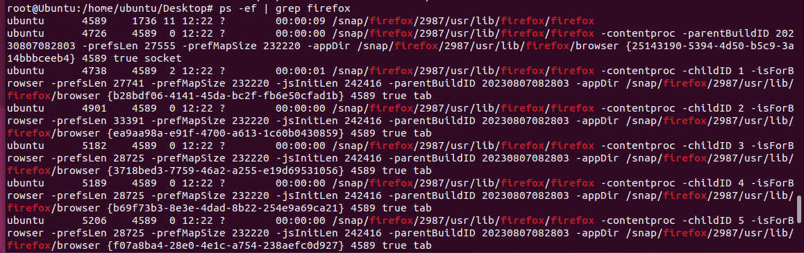

1. Kill a process:

Command: **kill PID**

Description: Terminates the process with the specified Process ID (PID).

Output:



1. Use of editors: vim, emacs, nano:

Description: You can use editors like Vim, Emacs, or Nano to edit text files directly from the terminal.

- Vim: **vim filename**

- Emacs: **emacs filename**

- Nano: **nano filename**

Output:

