Cloud computing practical examination
Total Marks: 40
Duration: 60 Minutes

Instructions
● Perform all tasks on your own cloud virtual machine.
● You may use AWS EC2, GCP Compute Engine VM, or Azure Virtual Machine. ● Attach screenshots as evidence of completion.
● Create a single PDF containing all screenshots and answers.
● Mention question numbers clearly.
● Ensure all screenshots clearly show successful execution of commands. ● Look at the end of the pdf for submission instructions
Question 1: Docker Installation & Nginx Deployment
Task
1. Install Docker on your cloud virtual machine.
2. Verify Docker installation.
3. Download the Nginx image.
4. Run the Nginx container.
5. Access the Nginx welcome page from your browser.
Required Screenshots
● Docker version output
● Docker images output
● Docker ps output showing Nginx running
● Browser showing "Welcome to nginx!"
Hint
Relevant Docker topics:
● Images
● Containers
● Port Mapping
● Container Lifecycle

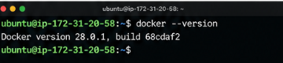

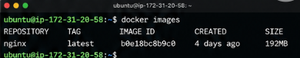
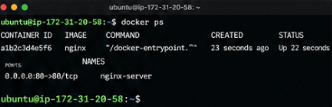
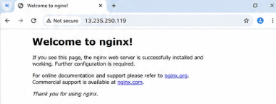
Question 2: Docker Volume Practical
Task
1. Create a Docker volume named: studentdata
2. Run an Ubuntu container using the volume.
3. Create a file: /data/info.txt
4. Write your name and roll number inside the file.
5. Display the contents of the file.
Required Screenshots
● Volume creation
● Running container
● File creation
● File contents displayed using cat

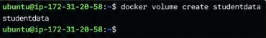
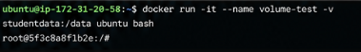
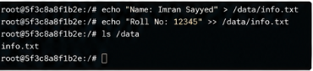

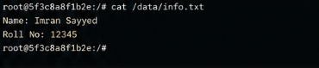
Question 3: Build Your First Docker Image

Task
Create a custom Docker image that displays the following message when executed: Cloud Computing Practical Exam Completed Successfully
Build the image and run it successfully.
Required Screenshots
● Dockerfile
● docker build output
● docker images output
● docker run output
Hint
Relevant Dockerfile keywords:
● FROM
● CMD
● COPY
Think about:
● Which base image should be used?
● How does Docker know what command to execute when the container starts? ● When would COPY be useful while building an image?
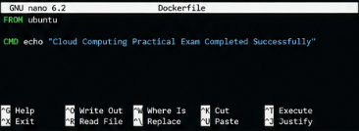
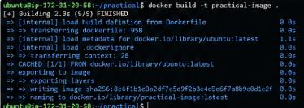
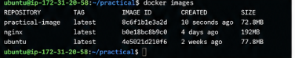
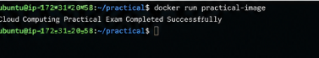

Bonus Challenge (Optional)
Explain in 2–3 lines each:
- Difference between a Docker Image and a Docker Container.
Docker Image
- A read-only template used to create containers.
- Contains application code, libraries, and dependencies.
Docker Container
- A running instance of a Docker image.
- Executes the application in an isolated environment.

2. Why are Docker Volumes used?
• Docker volumes provide persistent storage for containers.
• Data remains available even if the container is deleted or recreated.

