SentinelShield: Advanced Intrusion Detection & Web Protection System

Practical Work Documentation and Final Project Report
Project Title: SentinelShield: Advanced Intrusion Detection & Web Protection System
Technology Stack: Python, Flask, Pandas, HTML
Project Category: Cybersecurity / Web Application Security
Name: Sayyed Kashaf Zulfikar Ali
Course: Bsc Data Science Student
Internship Program: Cybersecurity Fellowship - 3 Months
Organization: Unified Mentor Pvt. Ltd.
Submission Date: 24-05-2026

1. Introduction
Web applications are among the most common targets for cyberattacks. Attackers frequently attempt to exploit vulnerabilities such as SQL Injection (SQLi), Cross-Site Scripting (XSS), Command Injection, and Directory Traversal to gain unauthorized access to systems or sensitive information.
SentinelShield is a lightweight Intrusion Detection and Web Protection System developed to simulate the behavior of a Web Application Firewall (WAF). The system inspects incoming user requests, identifies malicious patterns, logs suspicious activities, applies rate-limiting controls, and provides a dashboard for security monitoring and analysis.
The project demonstrates the workflow of modern security solutions used to detect and respond to web-based attacks.

2. Objective
The primary objectives of this project are:
- To understand web application security concepts.
- To detect common web attacks using signature-based detection.
- To monitor incoming HTTP requests.
- To implement IP-based rate limiting.
- To generate security logs for analysis.
- To create a dashboard for monitoring security events.
- To understand the workflow of detection, logging, and alert generation.

3. Tools and Technologies Used
Tool | Purpose
Python | Core programming language
Flask | Web application framework
Pandas | Log analysis and dashboard generation
HTML | Frontend interface
VS Code | Development environment
GitHub | Version control and project hosting

4. System Architecture
The SentinelShield system consists of the following components:
- User Interface
- Request Processing Engine
- Attack Detection Module
- Rate Limiting Module
- Logging System
- Dashboard Monitoring System

Architecture Workflow
User
|
v
Flask Web Application
|
+----------------------------+
| | |
v v v
Detector Rate Limiter Logger
Module Module System
|
+----------------------------+
|
v
Security Logs (CSV)
|
v
Dashboard
Insert Screenshot: Architecture Diagram

5. Project Methodology
The project was developed in multiple phases.

Phase 1: Project Setup
The project structure was created using separate modules for attack detection, logging, rate limiting, and dashboard visualization.

Phase 2: Attack Detection
A signature-based detection engine was implemented to identify:
- SQL Injection
- Cross-Site Scripting (XSS)
- Directory Traversal
- Command Injection
Regular expressions were used to compare user input against known attack signatures.

Phase 3: Security Logging
A logging system was implemented to record:
- Timestamp
- IP Address
- Attack Type
- Action Taken
Logs were stored in a CSV file for future analysis.

Phase 4: Rate Limiting
An IP-based rate limiter was implemented to detect excessive requests within a fixed time window.
The system blocks users who exceed the predefined threshold.

Phase 5: Dashboard Development
A dashboard was developed using Flask and Pandas to display:
- Total security events
- Attack logs
- Security monitoring information

6. Implementation Details

Attack Detection Module
The detector module scans user inputs and compares them against predefined attack signatures.

Examples of Detected Attacks

SQL Injection
' OR 1=1 --

Cross-Site Scripting (XSS)
<script>alert(1)</script>

Directory Traversal
../../etc/passwd

Command Injection
&& whoami
When a signature match occurs, the request is marked as malicious and blocked.

Logging Module
The logging module records all detected attacks in a CSV file.

Logged Information
- Timestamp
- Source IP Address
- Attack Category
- Action Performed
This data is later used by the dashboard for analysis.

Rate Limiting Module
The rate limiter monitors the frequency of requests from individual IP addresses.
If an IP exceeds the allowed threshold within a specified time window:
- Request is blocked.
- Event is logged.
- User is flagged as suspicious.

Dashboard Module
The dashboard provides visibility into security events.
Features include:
- Event count
- Attack records
- Log monitoring
- Security activity tracking

7. Testing and Results
The system was tested using both legitimate and malicious requests.

Test Case 1: Normal Request
Input
hello
Expected Result
Request Allowed
Actual Result
Request Allowed
Status
Passed

Test Case 2: XSS Attack
Input
<script>alert(1)</script>
Expected Result
Blocked: XSS Detected
Actual Result
Blocked: XSS Detected
Status
Passed

Test Case 3: Directory Traversal Attack
Input
../../etc/passwd
Expected Result
Blocked: Directory Traversal Detected
Actual Result
Blocked: Directory Traversal Detected
Status
Passed
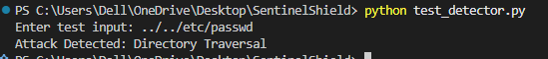

Test Case 4: Rate Limiting
Multiple requests were sent from the same IP address.
Expected Result
Blocked after threshold exceeded.
Actual Result
Blocked successfully.
Status
Passed
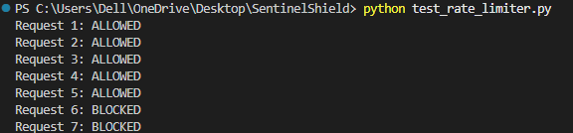

8. Security Log Analysis
The generated logs provide valuable information about attack behavior.

Observations
- Malicious requests were successfully detected.
- Attack types were correctly categorized.
- Repeated requests were identified through rate limiting.
- Security events were recorded with timestamps and IP addresses.

Benefits
- Improved visibility into attack attempts.
- Easier incident analysis.
- Better understanding of user behavior.
- 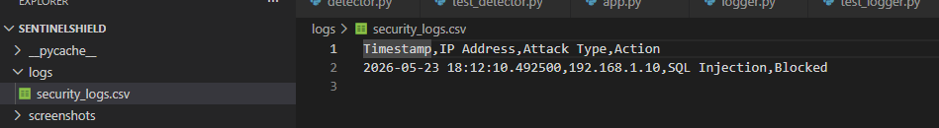

9. Results Summary
Metric | Result
Total Attack Types Implemented | 4
Logging System | Implemented
Dashboard | Implemented
Rate Limiting | Implemented
Successful Attack Detection | Yes
Web Interface | Implemented
The project successfully achieved all intended objectives.

10. Security Recommendations
The following improvements can be implemented in future versions:
- Add Machine Learning-based anomaly detection.
- Integrate real-time alert notifications.
- Implement IP blacklisting.
- Store logs in a database instead of CSV files.
- Add authentication and user management.
- Integrate with threat intelligence feeds.
- Support advanced attack signatures.

11. Challenges Faced
- Understanding attack signatures.
- Designing regular expression patterns.
- Implementing rate limiting logic.
- Managing and analyzing log data.
- Integrating multiple modules into a single application.

12. Conclusion
SentinelShield successfully demonstrates the core functionality of a lightweight Intrusion Detection and Web Protection System. The project is capable of detecting common web attacks, applying rate-limiting controls, generating security logs, and displaying security events through a dashboard.
The project provided practical experience in web application security, attack detection techniques, traffic monitoring, and incident analysis. It also strengthened understanding of how modern Web Application Firewalls operate in real-world environments.

