Smart Traffic Signal Using Reinforcement Learning
Submitted in fulfilment of the requirements of the
Mini Project in
Reinforcement Learning Subject
by
Sayyed Maaz(48)



Department of Artificial Intelligence and Data Science
Vivekanand Education Society’s Institute of Technology

2025-2026

1. Introduction
Traffic congestion is a major issue in urban areas, leading to increased travel time, fuel consumption, and pollution. Traditional traffic signal systems operate on fixed timings, which fail to adapt to dynamic traffic conditions.
This project proposes an adaptive traffic signal control system using Reinforcement Learning (RL), where the signal dynamically adjusts based on real-time traffic conditions to minimize congestion and waiting time.

2. Problem Formulation
The problem is modeled as a Markov Decision Process, where:
- The agent is the traffic signal controller
- The environment is the traffic intersection
- The goal is to learn an optimal policy to minimize congestion

3. System Design
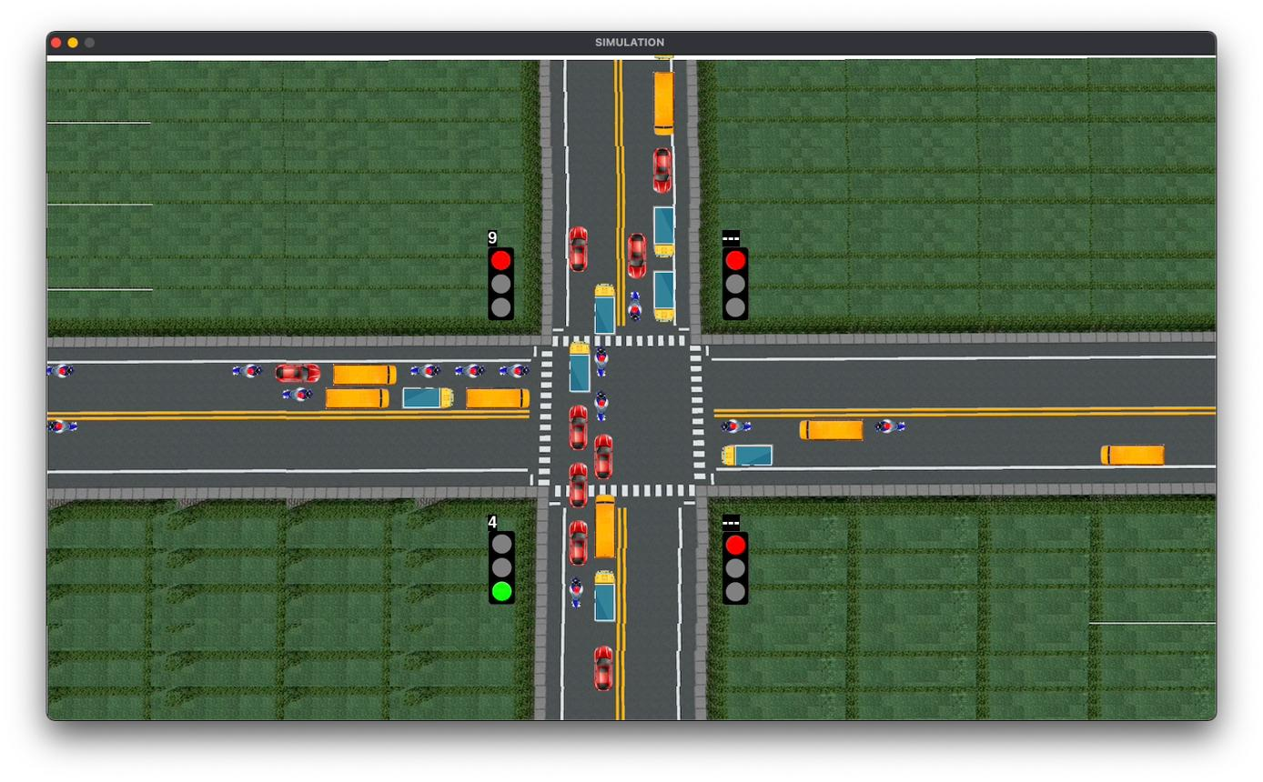

🔹 Intersection Setup
- Single 4-way intersection
- Each direction has:
  - Left-turn lane
  - Straight lane

🔹 Signal Control
- Phase-based control system
- Only one phase active at a time
- Yellow signal automatically inserted during transitions

4. State Space
The state represents traffic conditions:
S = [
Q_N_left, Q_N_straight,
Q_S_left, Q_S_straight,
Q_E_left, Q_E_straight,
Q_W_left, Q_W_straight,
current_phase
]
- Queue lengths are discretized into:
  - Low (0–5), Medium (6–10), High (>10)
- Phase ∈ {0,1,2,3}

5. Action Space
The agent selects one of the following phases:
0 → NS_Straight
1 → NS_Left
2 → EW_Straight
3 → EW_Left
Each phase activates a non-conflicting set of lanes.

6. Reward Function
The reward function is designed to minimize congestion:
Reward = - (total_queue + 0.5 × total_waiting_time)
- Penalizes long queues
- Penalizes high waiting times
- Encourages balanced traffic flow

7. Learning Algorithm

🔹 Q-Learning (Tabular)
The agent learns a Q-value function:
Q(s, a)
Update rule:
𝑄(𝑠,𝑎)←𝑄(𝑠,𝑎)+𝛼[𝑟+𝛾max⁡𝑄(𝑠′,𝑎′)−𝑄(𝑠,𝑎)]Q(s,a)←Q(s,a)+α[r+γmaxQ(s′,a′)−Q(s,a)]
Where:
- α = learning rate
- γ = discount factor

🔹 Exploration Strategy
An ε-greedy policy is used:
- With probability ε → random action (exploration)
- With probability 1−ε → best action (exploitation)

8. Training Procedure
- Each episode consists of 200 timesteps
- Total training: 3000 episodes

At each step:
- Observe state
- Select action (ε-greedy)
- Execute action
- Receive reward
- Update Q-table

9. Results and Observations
- Initial rewards were highly negative due to random actions
- After training, rewards improved significantly
- The agent learned to:
  - Prioritize congested lanes
  - Avoid long waiting times
  - Balance traffic flow across directions

Observed behavior:
- Reduced queue buildup
- More timely switching of phases
- Improved traffic efficiency

10. Challenges
- Large state space (~100K possible states)
- High variance due to stochastic traffic arrival
- Slow convergence in early stages

11. Future Work
- Implement Deep Q Network (DQN) for better generalization
- Extend to multiple intersections (multi-agent RL)
- Incorporate:
  - Real traffic data
  - Pedestrian signals
  - Emergency vehicle prioritization

12. Conclusion
This project demonstrates that Reinforcement Learning can effectively optimize traffic signal control in dynamic environments. The Q-learning agent successfully learns a policy that reduces congestion and improves traffic flow compared to static signal systems.

