AIM for Business Flows
MD.050 Application Extensions Functional Design
Lanka Sathosa Limited
LSL EBS Implementation

Author: Sayuru Jayasinghe
Creation Date: May 5, 2019
Last Updated: May 14, 2019
Document Ref: LSLEBS
Version: V1

Title, Subject, Last Updated Date, Reference Number, and Version are marked by a Word Bookmark so that they can be easily reproduced in the header and footer of documents. When you change any of these values, be careful not to accidentally delete the bookmark. You can make bookmarks visible by selecting Tools->Options…View and checking the Bookmarks option in the Show region.

Approvals:
Sayuru Jayasinghe
Shehan Perera
To add additional approval lines, press [Tab] from the last cell in the table above.
You can delete any elements of this cover page that you do not need for your document. For example, Copy Number is only required if this is a controlled document and you need to track each copy that you distribute.
 Copy Number __1__

Document Control

Change Record
1
Date | Author | Version | Change Reference
02-May-19 | Sayuru Jayasinghe | V1 | No Previous Document

Reviewers

Name | Position

Distribution

Copy No. | Name | Location
 | Library Master | Project Library
 |  | Project Manager
The copy numbers referenced above should be written into the Copy Number space on the cover of each distributed copy. If the document is not controlled, you can delete this table, the Note To Holders, and the Copy Number label from the cover page.

Note To Holders:
If you receive an electronic copy of this document and print it out, please write your name on the equivalent of the cover page, for document control purposes.
If you receive a hard copy of this document, please write your name on the front cover, for document control purposes.
Contents
Document Control ii
Topical Essay 1
Basic Business Needs 1
Major Features 1
Definitions 1
User Procedures 1
Examples 3
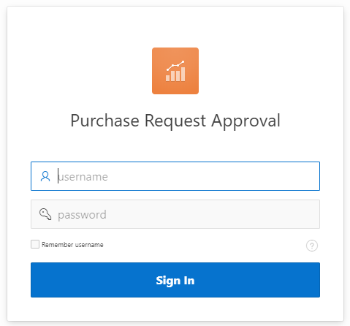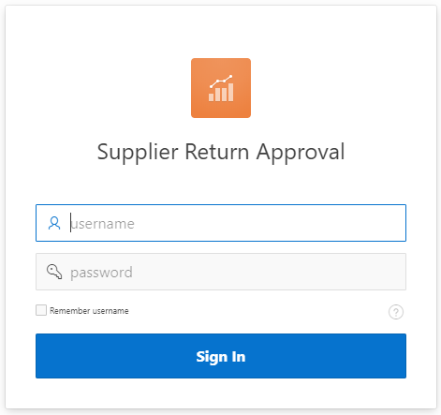 3
Business Rules 4
Assumptions 4
Century Date Compliance 4
Form and Report Descriptions 5
Purchase Order and Approval – Use to query and approve PO 5
Purchase Order and Supplier\Item Form 5
Prerequisites 7
Create Item Zone 7
Create Supplier Zone 7
Purchase Order Zone 7
Invoice Aging Report - Report Description 8
<Report Title> 8
Report Parameters 8
Report Headings 8
Column Headings 9
Void Payment Register - Report Description 10
<Report Title> 10
Report Parameters 10
Report Headings 10
Column Headings 11
Age Analysis - Report Description 12
<Report Title> 12
Report Parameters 12
Report Headings 12
Column Headings 13
VAT Schedules Report - Report Description 14
<Report Title> 14
Report Parameters 14
Report Headings 14
Column Headings 15
Customer Creditability Report - Report Description 16
<Report Title> 16
Report Parameters 16
Report Headings 16
Column Headings 17
Concurrent Program Description 18
When to Run the Program 18
Launch Parameters 18
Business Rules Implemented 18
Log Output 18
Restart Procedures 18
Concurrent Program Description 19
When to Run the Program 19
Launch Parameters 19
Business Rules Implemented 19
Log Output 19
Restart Procedures 19
Concurrent Program Description 20
When to Run the Program 20
Launch Parameters 20
Business Rules Implemented 20
Log Output 20
Restart Procedures 20
Concurrent Program Description 21
When to Run the Program 21
Launch Parameters 21
Business Rules Implemented 21
Log Output 21
Restart Procedures 21
Concurrent Program Description 22
When to Run the Program 22
Launch Parameters 22
Business Rules Implemented 22
Log Output 22
Restart Procedures 22
Concurrent Program Description 23
When to Run the Program 23
Launch Parameters 23
Business Rules Implemented 23
Log Output 23
Restart Procedures 23
Concurrent Program Description 24
When to Run the Program 24
Launch Parameters 24
Business Rules Implemented 24
Log Output 24
Restart Procedures 24
Technical Overview 25
Open and Closed Issues 26
Open Issues 26
Closed Issues 26

To update the table of contents, put the cursor anywhere in the table and press [F9]. To change the number of levels displayed, select the menu option Insert->Index and Tables, make sure the Table of Contents tab is active, and change the Number of Levels to a new value.

Topical Essay
If you use a user-friendly name for this customization as the replacement for <Subject>, the following paragraphs will default nicely.
LSL EBS Implementation allows you to enhance current procurement cycle.
LSL EBS Implementation contains:
- P2P cycle – Oracle Application purchase order approval
- P2P cycle – supplier creation
- P2P cycle – product\item creation
- P2P cycle – APEX supplier return approval
- P2P cycle – APEX purchase request approval

Basic Business Needs
LSL EBS Implementation provides you with the features you need to satisfy the following basic business needs. You will be able to address the following:
- PO Approval (integrated supplier and product available)
- Reject PO lines

Major Features

Oracle Procurement Approval for PO
Workflow approval to approve PO and approval request sent to pbsa

Reject PO\Supplier Return Lines
Reject PO lines and sent to pbsa.

Definitions

APEX
Oracle Application Express

EBS
Oracle E-Business Suit

User Procedures
Replace <Step 1> and <Step 2> with actual instructions below. Add steps to the bullet list and then add a Heading 4 below to describe the step in more detail.
In order to PO approval, you must perform the following steps:
- Login to EBS or mobile application
- Approve workflow
Each of these steps is described in more detail below.

Login to EBS or mobile application
Use super user login credentials

Approve workflow
Check the details and approve the request

In order to reject PO lines, you must perform the following steps:
- Login to APEX page
- Approve\reject lines
Each of these steps is described in more detail below.

Login to EBS or mobile application
Use created login credentials or sso.

Approve workflow
Check the details and approve\reject the request line

Examples
Include examples with actual data to help the reader understand the functionality and flow.

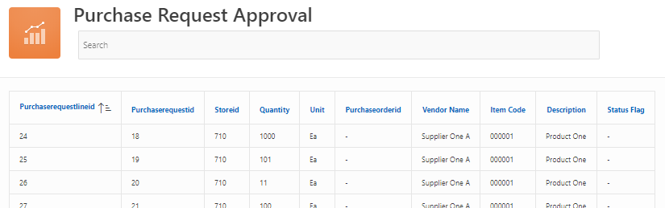

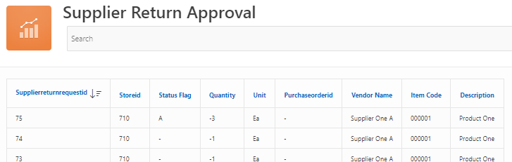

Business Rules
PO\Supplier return line level approval\rejection
Define specific business rules that the customization must provide. These rules can form the basis of a user acceptance test.

Assumptions
This design assumes that the following statements are true:
- PO\Supplier return has one or more than request lines
- PR created and approved in Oracle EBS similar to pbsa approved PR

Century Date Compliance
In the past, two character date coding was an acceptable convention due to perceived costs associated with the additional disk and memory storage requirements of full four character date encoding. As the year 2000 approached, it became evident that a full four character coding scheme was more appropriate.
In the context of AIM for Business Flows, the convention Century Date or C/Date support rather than Year2000 or Y2K support is used. Coding for any future Century Date is now considered the modern business and technical convention.
Every applications implementation team needs to consider the impact of the century date on their implementation project. As part of the implementation effort, all customizations, legacy data conversions, and custom interfaces need to be reviewed for Century Date compliance.
When designing and building application extensions, it is essential that all dates be entered, stored, and processed using the full four digit year for compliance with Century Date standards. In the case of custom interfaces, both the program code and imported legacy or third-party application data must be checked for compliance with Century Date standards.

Form and Report Descriptions
The following defines the form and report elements of LSL EBS Implementation customization:

Purchase Order and Approval – Use to query and approve PO

Purchase Order and Supplier\Item Form – P2P cycle
Create mockups of the forms using a graphic or design tool. You can use embedded objects as well as screen hardcopies.
Create Item
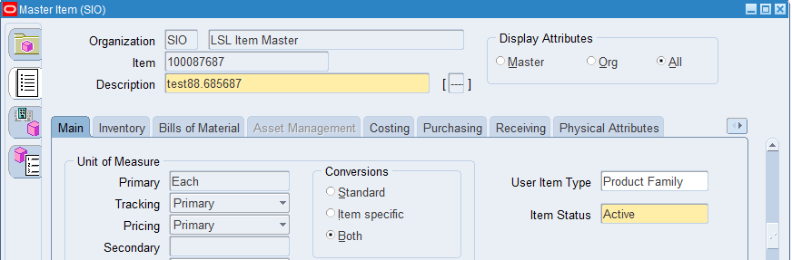
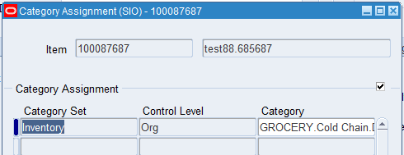

Create\Update Supplier
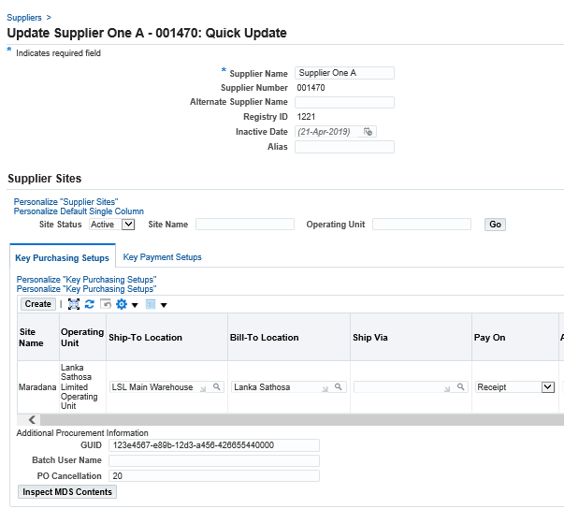
Use this form to approve\reject PO
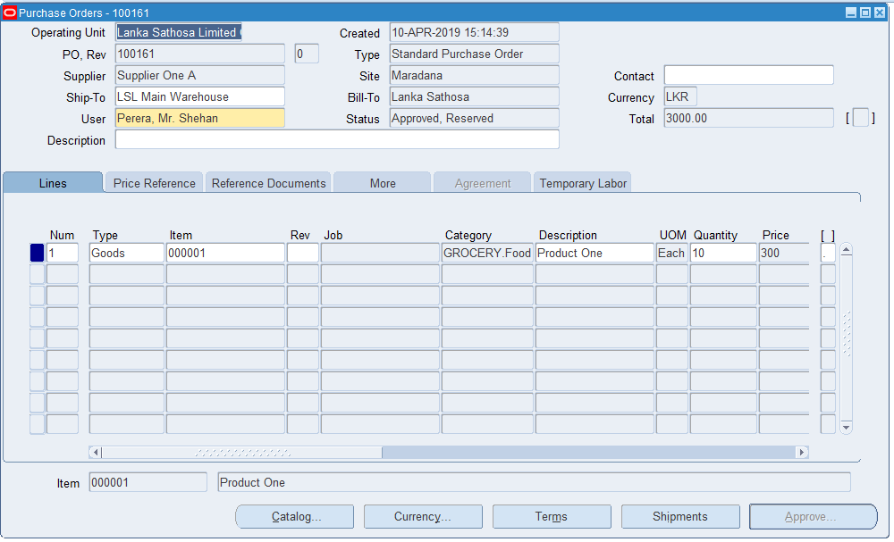
Delivery summary
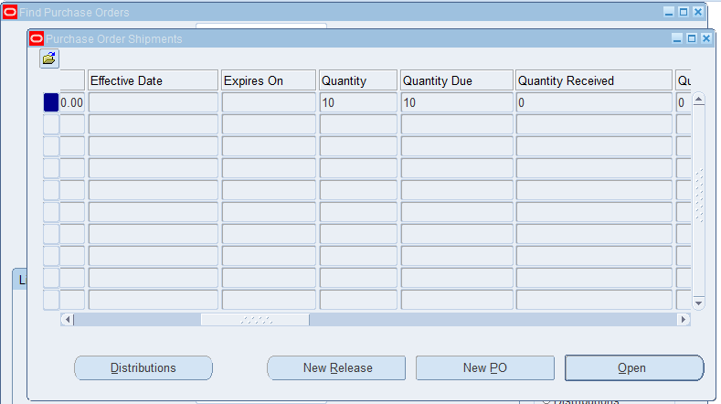
PO Cancellation
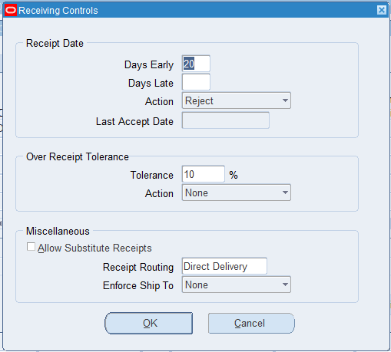

Prerequisites
Before you can use this form you must perform the following:
- Integrated PO with respect to pbsa
- Approve\Reject PO

Create Item Zone
Use this zone in Oracle to query created items in pbsa
For each field, use the center and right tabs to enter additional information about the field.
Include in the parenthesized list one or more of the following:
Optional
Required
Default
Display Only
List of Values (LOV) source

Field 1 (Display only) HELP
Item

Field 2 (Optional, LOV source) HELP
Oracle EBS Inventory Category assigned

Create Supplier Zone

Field 3 (Required, Default) EDIT ZOOM PICK HELP
Choose one of the following options:
Standard Supplier Oracle EBS displays supplier type.

Purchase Order Zone

Field 4 (Display only) HELP
PO, Rev

Field 5 (Display only) HELP
Outlet

Field 6 (Required, Default) HELP
Days Late

Use the Hanging Indent style or choose Insert List Table from the OM menu (if the first column must wrap)

Invoice Aging Report - Report Description

<Report Title>
Use the <Report Title> report to ...

Report Parameters
You run the <Report Title> report from the Standard Report Submission form. Enter the following parameters specify the desired reporting options.

Parameter 1 (Required, Default) PICK
Select one of the following values:
Option 1 Description.
Option 2 Description

Parameter 2 (Optional)
Enter...

Report Headings

<Company Long Name>
<Custom Application Name> prints the name of the organization running the report.

Date:
<Custom Application Name> prints the date and time that it ran the report. The date is in DD-Mon-YY format and the time is in 24-hour format.

<Left Title>
<Custom Application Name> prints <whatever this is used for on this report>.

<Report Title>
<Custom Application Name> prints the name of the report

<Report Sub-Title>
<Custom Application Name> prints <whatever this indicates>.

Page:
<Custom Application Name> prints the page number for each page of the report.

Column Headings

Heading 1
<Custom Application Name> prints...

Void Payment Register - Report Description

<Report Title>
Use the <Report Title> report to ...

Report Parameters
You run the <Report Title> report from the Standard Report Submission form. Enter the following parameters specify the desired reporting options.

Parameter 1 (Required, Default) PICK
Select one of the following values:
Option 1 Description.
Option 2 Description

Parameter 2 (Optional)
Enter...

Report Headings

<Company Long Name>
<Custom Application Name> prints the name of the organization running the report.

Date:
<Custom Application Name> prints the date and time that it ran the report. The date is in DD-Mon-YY format and the time is in 24-hour format.

<Left Title>
<Custom Application Name> prints <whatever this is used for on this report>.

<Report Title>
<Custom Application Name> prints the name of the report

<Report Sub-Title>
<Custom Application Name> prints <whatever this indicates>.

Page:
<Custom Application Name> prints the page number for each page of the report.

Column Headings

Heading 1
<Custom Application Name> prints...

Age Analysis - Report Description

<Report Title>
Use the <Report Title> report to ...

Report Parameters
You run the <Report Title> report from the Standard Report Submission form. Enter the following parameters specify the desired reporting options.

Parameter 1 (Required, Default) PICK
Select one of the following values:
Option 1 Description.
Option 2 Description

Parameter 2 (Optional)
Enter...

Report Headings

<Company Long Name>
<Custom Application Name> prints the name of the organization running the report.

Date:
<Custom Application Name> prints the date and time that it ran the report. The date is in DD-Mon-YY format and the time is in 24-hour format.

<Left Title>
<Custom Application Name> prints <whatever this is used for on this report>.

<Report Title>
<Custom Application Name> prints the name of the report

<Report Sub-Title>
<Custom Application Name> prints <whatever this indicates>.

Page:
<Custom Application Name> prints the page number for each page of the report.

Column Headings

Heading 1
<Custom Application Name> prints...

VAT Schedules Report - Report Description

<Report Title>
Use the <Report Title> report to ...

Report Parameters
You run the <Report Title> report from the Standard Report Submission form. Enter the following parameters specify the desired reporting options.

Parameter 1 (Required, Default) PICK
Select one of the following values:
Option 1 Description.
Option 2 Description

Parameter 2 (Optional)
Enter...

Report Headings

<Company Long Name>
<Custom Application Name> prints the name of the organization running the report.

Date:
<Custom Application Name> prints the date and time that it ran the report. The date is in DD-Mon-YY format and the time is in 24-hour format.

<Left Title>
<Custom Application Name> prints <whatever this is used for on this report>.

<Report Title>
<Custom Application Name> prints the name of the report

<Report Sub-Title>
<Custom Application Name> prints <whatever this indicates>.

Page:
<Custom Application Name> prints the page number for each page of the report.

Column Headings

Heading 1
<Custom Application Name> prints...

Customer Creditability Report - Report Description

<Report Title>
Use the <Report Title> report to ...

Report Parameters
You run the <Report Title> report from the Standard Report Submission form. Enter the following parameters specify the desired reporting options.

Parameter 1 (Required, Default) PICK
Select one of the following values:
Option 1 Description.
Option 2 Description

Parameter 2 (Optional)
Enter...

Report Headings

<Company Long Name>
<Custom Application Name> prints the name of the organization running the report.

Date:
<Custom Application Name> prints the date and time that it ran the report. The date is in DD-Mon-YY format and the time is in 24-hour format.

<Left Title>
<Custom Application Name> prints <whatever this is used for on this report>.

<Report Title>
<Custom Application Name> prints the name of the report

<Report Sub-Title>
<Custom Application Name> prints <whatever this indicates>.

Page:
<Custom Application Name> prints the page number for each page of the report.

Column Headings

Heading 1
<Custom Application Name> prints...

Include a description of each column or label on the report. Provide enough detail so that a user of the report can understand how the data is derived.

Concurrent Program Description
The Set - PBSA Oracle Integration for JE concurrent program is needed to import sales\return\stock\bank deposits.
Provide a description of the concurrent program associated with <Subject> customization and include the supplemental information below. If no concurrent program (other than reports addressed above) are included in the customization, then delete this section.

When to Run the Program
Set - PBSA Oracle Integration for JE concurrent program should be run when daily at mid night to create JE batches

Launch Parameters
Launch parameters for the Set - PBSA Oracle Integration for JE concurrent program include:
Day
Batch Type (SALE\RETURN\STOCK\BANK etc)

Business Rules Implemented
The business rule implemented by Set - PBSA Oracle Integration for JE concurrent program is used for receivables and asset JE entries

Log Output
The log output consists of successes\fails

Restart Procedures
Restart procedures for Set - PBSA Oracle Integration for JE concurrent program are as follows:
- Network failed outlet
- Missing defined Chart of Accounts

Concurrent Program Description
The Set - PBSA Oracle Integration for Purchase Request concurrent program is needed to …

Provide a description of the concurrent program associated with <Subject> customization and include the supplemental information below. If no concurrent program (other than reports addressed above) are included in the customization, then delete this section.

When to Run the Program
<Component Name> concurrent program should be run when…

Launch Parameters
Launch parameters for the <Component Name> concurrent program include:

Business Rules Implemented
The business rule implemented by <Component Name> concurrent program is…

Log Output
The log output consists of ….

Restart Procedures
Restart procedures for <Component Name> concurrent program are as follows:

Concurrent Program Description
The Set - PBSA Oracle Integration for GRNs concurrent program is needed to …
Provide a description of the concurrent program associated with <Subject> customization and include the supplemental information below. If no concurrent program (other than reports addressed above) are included in the customization, then delete this section.

When to Run the Program
<Component Name> concurrent program should be run when…

Launch Parameters
Launch parameters for the <Component Name> concurrent program include:

Business Rules Implemented
The business rule implemented by <Component Name> concurrent program is…

Log Output
The log output consists of ….

Restart Procedures
Restart procedures for <Component Name> concurrent program are as follows:

Concurrent Program Description
The Set - PBSA Supplier Return Requests concurrent program is needed to …
Provide a description of the concurrent program associated with <Subject> customization and include the supplemental information below. If no concurrent program (other than reports addressed above) are included in the customization, then delete this section.

When to Run the Program
<Component Name> concurrent program should be run when…

Launch Parameters
Launch parameters for the <Component Name> concurrent program include:

Business Rules Implemented
The business rule implemented by <Component Name> concurrent program is…

Log Output
The log output consists of ….

Restart Procedures
Restart procedures for <Component Name> concurrent program are as follows:

Concurrent Program Description
The Program - PBSA - Oracle to Head Office concurrent program is needed to …
Provide a description of the concurrent program associated with <Subject> customization and include the supplemental information below. If no concurrent program (other than reports addressed above) are included in the customization, then delete this section.

When to Run the Program
<Component Name> concurrent program should be run when…

Launch Parameters
Launch parameters for the <Component Name> concurrent program include:

Business Rules Implemented
The business rule implemented by <Component Name> concurrent program is…

Log Output
The log output consists of ….

Restart Procedures
Restart procedures for <Component Name> concurrent program are as follows:

Concurrent Program Description
The Alert - LSL notification for PO cancellation concurrent program is needed to …
LSL Customer Payment Settlement Notification
LSL Create PBSA Store Program
LSL Update Invoice Number(s) Program
Provide a description of the concurrent program associated with <Subject> customization and include the supplemental information below. If no concurrent program (other than reports addressed above) are included in the customization, then delete this section.

When to Run the Program
<Component Name> concurrent program should be run when…

Launch Parameters
Launch parameters for the <Component Name> concurrent program include:

Business Rules Implemented
The business rule implemented by <Component Name> concurrent program is…

Log Output
The log output consists of ….

Restart Procedures
Restart procedures for <Component Name> concurrent program are as follows:

Concurrent Program Description
The Alert - LSL due payment alert concurrent program is needed to …
Provide a description of the concurrent program associated with <Subject> customization and include the supplemental information below. If no concurrent program (other than reports addressed above) are included in the customization, then delete this section.

When to Run the Program
<Component Name> concurrent program should be run when…

Launch Parameters
Launch parameters for the <Component Name> concurrent program include:

Business Rules Implemented
The business rule implemented by <Component Name> concurrent program is…

Log Output
The log output consists of ….

Restart Procedures
Restart procedures for <Component Name> concurrent program are as follows:

Technical Overview
Use this section to describe the technical approach, high-level algorithms, process flows, etc. Discuss possible solutions to technical challenges. The detailed designs for forms and programs will provide the details for the general overview presented here.

Considerations
If any Oracle Manufacturing tables change in future versions of Oracle Manufacturing, components of this customization may also require changes to work correctly. Evaluating the impact of such changes on custom programming is the responsibility of the company, although additional consulting services can be contracted to assist prior to upgrading.

Open and Closed Issues
Add open issues that you identify while writing or reviewing this document to the open issues section. As you resolve issues, move them to the closed issues section and keep the issue ID the same. Include an explanation of the resolution.
When this work product is complete, any open issues should be transferred to the project- or process-level Issue Log (PJM) and managed using a project level Issue Form (PJM). In addition, the open items should remain in the open issues section of this work product, but flagged in the resolution column as being transferred.

Open Issues

ID | Issue | Resolution | Responsibility | Target Date | Impact Date
1 | Capture credit sales | New API develop from pbsa | LSL\PBSA | 02-May-19 | 13-May-19
2 | Pending POs to Management | Custom Oracle Alert | LSL\KPMG Tech | 02-May-19 | 13-May-19
3 | Supplier Return Process Confirmation | SR before\after GRN and tolerance | LSL\KPMG Tech | 14-May-19 | 14-May-19

Closed Issues

ID | Issue | Resolution | Responsibility | Target Date | Impact Date
1 | Due Payments to notification to Customer | Custom Oracle Alert | LSL\KPMG Tech | 02-May-19 | 13-May-19

