AIM
MD.070 Application Extension Technical Design
Lanka Sathosa
Otacle EBS Implementation

Author: Sayuru Jayasinghe
Creation Date: August 29, 2018
Last Updated: August 29, 2018
Document Ref: MD70_LS
Version: DRAFT 1A

Title, Subject, Last Updated Date, Reference Number, and Version are marked by a Word Bookmark so that they can be easily reproduced in the header and footer of documents. When you change any of these values, be careful not to accidentally delete the bookmark. You can make bookmarks visible by selecting Tools->Options…View and checking the Bookmarks option in the Show region.

Approvals:
Fahad Cader
Ravindu Silva
To add additional approval lines, press [Tab] from the last cell in the table above.
You can delete any elements of this cover page that you do not need for your document. For example, Copy Number is only required if this is a controlled document and you need to track each copy that you distribute.
 Copy Number __1__

Document Control

Change Record
1
Date | Author | Version | Change Reference
29-Aug-18 | Sayuru Jayasinghe | Draft 1a | No Previous Document

Reviewers

Name | Position
Fahad Cader | General Manager
Ravindu Silva | Oracle Technical Consultant

Distribution

Copy No. | Name | Location
 | Saravana Subramaniam | KPMG Technology Solutions
The copy numbers referenced above should be written into the Copy Number space on the cover of each distributed copy. If the document is not controlled, you can delete this table, the Note To Holders, and the Copy Number label from the cover page.

Note To Holders:
If you receive an electronic copy of this document and print it out, please write your name on the equivalent of the cover page, for document control purposes.
If you receive a hard copy of this document, please write your name on the front cover, for document control purposes.
Contents
Document Control
Technical Overview
Approach
Module List
<Form Title> - Form Logic
Navigation Logic
Block Relationship Diagram
Table and View Usage
Zone and Field Summary
Special Logic
<Report/Program Name> - Concurrent Program Logic
Calling Arguments
Log Output
Table and View Usage
Program Logic (pseudo code)
SQL Statements
Default Data Sources
Validation Logic
Incompatibility
Performance Considerations
Other Considerations
Integration Issues
Changes Required
Shared Components
Alert conditions
Incompatibilities
Performance Issues
Database Design
Desired Table Changes
New/Updated Seed Data
Descriptive Flexfields
Value Sets
Grants/Synonyms
Archiving
Database Diagram
Tables, Indexes, Sequences
Installation Requirements
Implementation Notes
Design Summary
Coding Summary
Testing Summary
Installation
Open and Closed Issues for this Deliverable
Open Issues
Closed Issues

To update the table of contents, put the cursor anywhere in the table and press [F9]. To change the number of levels displayed, select the menu option Insert->Index and Tables, make sure the Table of Contents tab is active, and change the Number of Levels to a new value.

Technical Overview
This document defines the technical components required to implement customization <BRM Number>, Oracle EBS Implementation – Lanka Sathosa. This Application Extension Technical Design document complements the Application Extension Functional Design document for Oracle EBS Implementation – Lanka Sathosa and you should consider the set to be the complete detailed design.

Approach
If the Functional Design included a Technical Overview section, duplicate that information here and add additional details.

Module List

Forms
<Subject> includes the following forms:
<Form Name> <Description>

Reports
<Subject> includes the following reports:
<Report Name> <Description>

Concurrent Programs
<Subject> includes the following concurrent programs:
<Program Name> <Description>

Database REST services
Oracle Implementation – Lanka Sathosa includes the following web services:
stores <Description>
products <Description>
purchase-requests <Description>
supplier-return-requests <Description>
supplier <Description>
Add other components above as required

<Form Title> - Form Logic
<Overview description of form logic>

Navigation Logic
Update the sample navigation logic below as needed to reflect the requirements of your customization.

Entry Mode
START
- User enters data into form.
- User commits transaction.
- Form calls concurrent program X with selected parameters.
- Form displays "Request xxxx has been sent to the concurrent manager".
- User presses any key to acknowledge message.
- Form clears.
- Cursor moves to field 1.
END

Block Relationship Diagram
The diagram below represents the base tables of each block or zone of the form (vertical) and tables referenced for validation or lookups (horizontal).
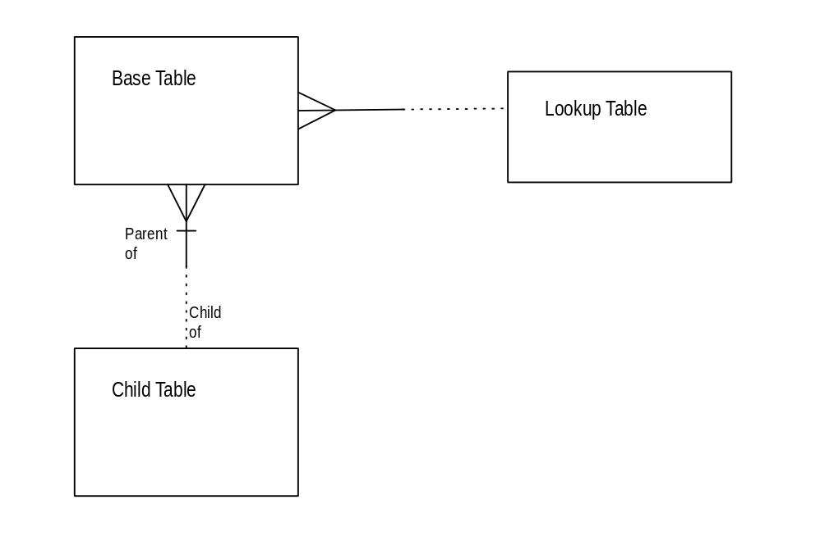
The diagram above is just an example—Double click on it to edit it as an embedded object. Select it and choose Edit->VISIO Object->Open to open it in the full Visio application.
You can also use Oracle Developer to draw your diagram and define most of the information in this section.

Table and View Usage
Table Name | Select | Insert | Update | Delete | Base Table
 | X
MTL_SYSTEM_ITEMS

Zone and Field Summary

Zone 1
Base Table:
Where/Order By:
Field/Column | Type | Rqd? | Default | Validation | QuickPick
Field 1  COLUMN_NAME | Char | Yes |  | Validated against <column>  from <table>  where <column> = <value> | Display MEANING  from <Application Short Name>_LOOKUPS where LOOKUP_TYPE = '<lookup type>

Zone 2
Base Table:
Where/Order By:
Field | Type | Rqd? | Default | Validation | QuickPick
 |  |  |  | (
Field 1  COLUMN_NAME | Char | No |  | (QuickPick validation) | Display MEANING  from <Application Short Name>_LOOKUPS where LOOKUP_TYPE = '<lookup type>

Special Logic

Zone 1
<Description of special zone-level logic (if any)>

Field Name
<Description of special field logic>

<Report/Program Name> - Concurrent Program Logic
<Overview description>

Calling Arguments
<PROGNAME> is called from the Standard Report Submission form with the following arguments:
Argument | Prompt | Value Set | Default Value
ORG_ID | Organization id | Generic | :$PROFILE$.mfg_organization_id
USER_ID | Application User ID | Generic | :$PROFILE$.user_id
DATE | Selection Date | FND_Date4_required | :$$DATE$$
Example of call from a form:
#FND CONCURRENT <Application Short Name> <PROGNAME>
":GET_ORGANIZATION.ORGANIZATION_ID"
":LAST_UPDATED_BY"
Example of call from Unix:
<PROGNAME> mfg/mfg 1 0

Log Output
.........1.........2.........3.........4.........5.........6.........7.........8
________________________________________________________________________________

________________________________________________________________________________

Table and View Usage
Table Name | Select | Insert | Update | Delete
MTL_SYSTEM_ITEMS | X

Program Logic (pseudo code)
BEGIN
Get command line parameters

Write Report Header

Select rows (see SQL statement 1)

FOR EACH row returned
Build output record(s) (see data sources)
Write row(s) to <table>
ENDFOR
END

SQL Statements

1 - Data Selection

SELECT <data>
FROM <tables>
WHERE <select criteria>
AND <join conditions>

Default Data Sources
Table | Column | Source Value
<table name> | <column name | <table>.<column>
 | <column 2> | 'Literal string'
 | <column 3> | (Description of derived value)

Validation Logic

Error Conditions:

Warning Conditions:

Incompatibility

Performance Considerations

Other Considerations

Restart Strategy

Crash Recovery

Integration Issues

Changes Required

Within Product
Custom menus

Other Products
No changes required

Shared Components
The Oracle Application product short names listed below are examples only. Update the shared component information to reflect the requirements of your customization.

INV
None

BOM
None

ENG
None

MPS/MRP
None

WIP
None

Alert conditions
None.

Incompatibilities
None.

Performance Issues
None.

Database Design
This section summarized new and changed database objects and data required to support <Subject>. However, the complete database design is documented in the Database Extensions Design document.

Desired Table Changes
None

New/Updated Seed Data
Rows added to <App Prefix>_LOOKUPS:
Lookup Type | Code | Meaning

Descriptive Flexfields
Application:
Form Name:
Base Table:
Segment Name | Prompt | Size | Value Set | Default Value

Application:
Form Name:
Base Table:
Segment Name | Prompt | Size | Value Set | Default Value

Value Sets
Value Set | Size | Type | Rqd | Validation/Values
<App Prefix>_ITEM_SELECT | 15 | Char | Yes | ALL All Items  ONE Specific Item
<App Prefix>_SPECIAL_CODE | 10 | Char | No | Code Meaning  From <App Prefix>_LOOKUPS  Where lookup_type = 'SPECIAL'

Grants/Synonyms
Owner | Object | Grantees
<App Prefix> | <App Prefix>_LOOKUPS | MFG  INV

Archiving
No need to archive.

Database Diagram
No new tables

Tables, Indexes, Sequences
No new tables

Installation Requirements
Installation scripts must be prepared to perform the following actions in an automated way:
- Create new tables\view\m-views.
- Host web services
- Execute data base migration script(s)
- Report file transfer
- Master data upload
- Add to or modify this list as appropriate. Provide additional details where necessary to facilitate the creation of the installation routines.

Implementation Notes
- Complete this section after completing the <Subject> customization. Update the design to reflect any changes made in the course of development and describe how the customization was implemented below.
This document describes exactly how <Subject> was developed and implemented at <Company Long Name>.

Design Summary

Functional Design

Functional Design Approval

Technical Design

Design Review

Final Acceptance

Coding Summary
Development was done on <description of hardware>, to work with Release <Applications Release> of Oracle Applications. All coding follows the standards defined in the Build Standards document for <Project Name>.

Program Files
The files required for this customization are as follows:
File | Description | Coded By

Testing Summary
The customizations were tested in <Company Short Name>'s test environment before being moved to production. See the Link Test scripts for more information.

Installation
All modules are installed as if part of a separate product. A UNIX directory structure is created under $APPL_TOP as shown in the following example:
$APPL_TOP
|
<Application Short Name>
|
1.0.0
___________________________|___________________________________
| | | | | | | | |
forms bin src sql log out srw install sql

The directories contain the components of the enhancement as shown below (directories not listed are empty). All future customizations will also be stored in these directories.
forms/
<Formname>
bin/
src/
sql/
srw/
install/sql/
- Update the example directory structure above as appropriate for your project. Fill in the filenames under the appropriate directories.
The forms and concurrent programs are registered in Application Object Library under the <Application Short Name> application.
A new set of menus (owned by <Application Short Name>) is created to call the new forms as follows:
Navigate
Sub-menu
Sub-menu
- Indicate the specific menu options added to access new forms.

Open and Closed Issues for this Deliverable
- Add open issues that you identify while writing or reviewing this document to the open issues section. As you resolve issues, move them to the closed issues section and keep the issue ID the same. Include an explanation of the resolution.
When this deliverable is complete, any open issues should be transferred to the project- or process-level Risk and Issue Log (PJM.CR.040) and managed using a project level Risk and Issue Form (PJM.CR.040). In addition, the open items should remain in the open issues section of this deliverable, but flagged in the resolution column as being transferred.

Open Issues

ID | Issue | Resolution | Responsibility | Target Date | Impact Date
1 | Web service hosting facility | WebLogic or Azure like application cloud | Technical Team | 3-Sep-2018 | 17-Sep-2018
2 | Implement event based web services | Use scheduled concurrent program or materializaed view | Technical Team | 3-Sep-2018 | 17-Sep-2018
3 | Handle high data volume (eg. Pulled large data volume from outlets, Queued data in case of failure) | Use database Table Queue | Technical Team | 17-Sep-2018 | 1-Oct-2018
4 | Implement a report request based relational schema | Create a custom schema in Oracle | Technical Team | 17-Sep-2018 | 1-Oct-2018
5 | acl and wallet use for SSL certificate | Use an acl for an user and a wallet to keep\keep updating token | DBA Team, Technical Team | 3-Sep-2018 | 17-Sep-2018
6 | Test case design | Agree the test scenarios with PBSA\Softwatch | Technical Team\Softwatch | 30-Aug-2018 | 3-Sep-2018

Closed Issues

ID | Issue | Resolution | Responsibility | Target Date | Impact Date
1 | Use ISG or PL\SQL REST services | Use PL\SQL REST services | Technical Team | 28-Aug-2018 | 28-Aug-2018

