DATA ANALYSIS PROJECT REPORT
COVID-19 in India
Trend Analysis, Growth Rate & 7-Day Forecast

Prepared by
Sazeda Nisha
Dataset coverage: 30 Jan 2020 – 11 Aug 2021
Tools: Python · Pandas · Prophet · Plotly

1. Introduction and Objective
COVID-19 caused an unprecedented public health crisis in India, with case counts, recoveries and deaths changing rapidly over an 18-month period. Understanding how the outbreak evolved — and being able to anticipate near-term case trends — is valuable both for retrospective analysis and for health-system planning. This project analyses the daily state-wise COVID-19 case data published for India and derives national trends, outcome rates, and a short-term forecast using time-series modelling.
The specific objectives of this project are to:
- Track the trajectory of confirmed cases, recoveries and deaths accumulated nationally across the pandemic timeline.
- Quantify patient outcomes by calculating the day-wise recovery rate and death rate.
- Identify and compare the two major waves of daily new cases seen in 2020 and 2021.
- Forecast near-term daily new cases using Facebook Prophet, a model suited to time series with strong seasonal patterns.

2. Dataset Description
The analysis uses the publicly available covid_19_india.csv dataset, which records daily, state-wise COVID-19 statistics for India. The dataset used in this project spans 560 daily observations from 30 Jan 2020 to 11 Aug 2021, with each row reporting the cumulative number of confirmed cases, cured/recovered patients and deaths for a given state or union territory on a given date.
Attribute | Description
Date | Date of the observation
State/UnionTerritory | Indian state or union territory
Cured | Cumulative number of recovered patients
Deaths | Cumulative number of deaths
Confirmed | Cumulative number of confirmed cases
Table 1: Key fields used from the raw dataset

3. Methodology

3.1 Data Cleaning
Several state names in the raw data contained inconsistencies and annotation artefacts introduced by the original source, such as “Telengana”, “Bihar” and “Nagaland”. These were standardised to their correct names (e.g. Telangana, Bihar). Rows corresponding to unassigned or reassigned cases, which do not belong to a specific state, were removed to keep the state-level aggregation accurate.

3.2 Aggregation to National Level
The cleaned state-level records were grouped by date and summed to construct a single national daily time series covering total confirmed cases, cures and deaths. This national series forms the basis for all subsequent analysis.

3.3 Derived Metrics
From the national cumulative series, the following daily metrics were derived:
- New Confirmed, New Deaths, New Cured — the day-over-day change in each cumulative column, clipped at zero to remove reporting corrections that would otherwise appear as negative values.
- Active Cases — calculated as Confirmed minus Cured minus Deaths.
- Recovery Rate (%) — Cured divided by Confirmed, expressed as a percentage.
- Death Rate (%) — Deaths divided by Confirmed, expressed as a percentage.

3.4 Forecasting Model
Short-term forecasting was performed using Prophet, an additive time-series model developed by Meta that is well suited to data with strong weekly seasonality — a pattern visible in COVID-19 reporting due to lower case counts typically reported on weekends. The model was configured with weekly seasonality enabled and daily/yearly seasonality disabled, and was trained on a rolling window of the most recent 90 days of daily new confirmed cases rather than the full historical series. This windowing keeps the forecast responsive to the current trend rather than being influenced by case levels from much earlier in the pandemic. The fitted model was then used to project daily new cases 7 days beyond the last available date in the dataset.

4. Results and Analysis

4.1 National Snapshot
The table below summarises the cumulative national totals as of the final date in the dataset, 11 Aug 2021.
3,20,36,511  Total Confirmed | 3,12,20,981  Total Recovered | 4,29,179  Total Deaths | 3,86,351  Active Cases
Table 2: National totals as of 11 Aug 2021
By the end of the observed period, the national recovery rate stood at 97.45% and the death rate at 1.34%, indicating that the overwhelming majority of confirmed cases resulted in recovery.

4.2 Cumulative Case Trend
The chart below shows how confirmed cases, recoveries and deaths accumulated over the full observation period. The curve is relatively shallow through most of 2020, then rises sharply from March 2021 onward as the second wave took hold, before flattening again by mid-2021.
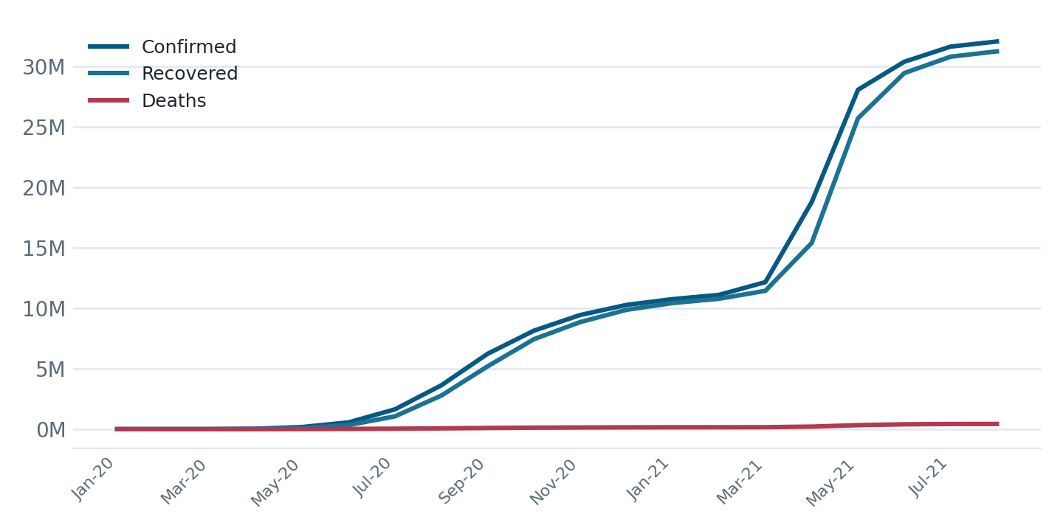
Figure 1: Cumulative confirmed cases, recoveries and deaths, monthly

4.3 Daily New Cases and Wave Analysis
Plotting new cases on a daily (weekly-sampled) basis reveals two distinct waves. The first wave peaked at 97,894 new cases on 17 Sep 2020, driven largely by outbreaks in major urban centres. The second wave was substantially larger and faster-moving, peaking at 4,14,188 new cases on 07 May 2021 — more than four times the first wave's peak — and placed significant strain on healthcare infrastructure nationally.
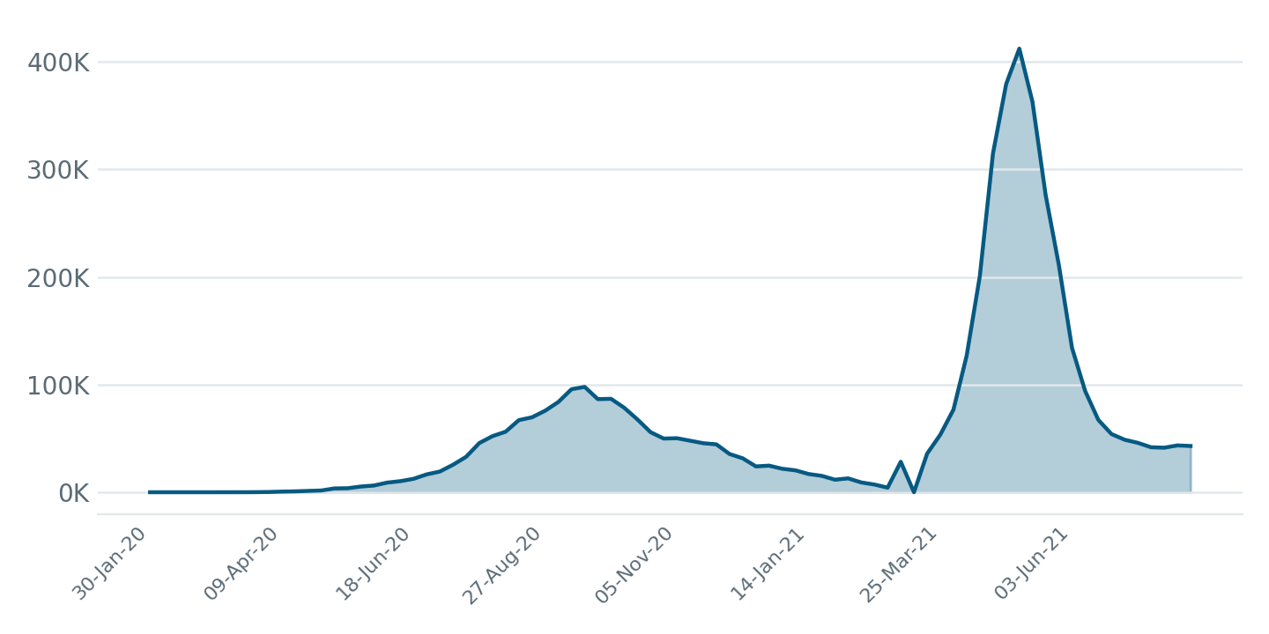
Figure 2: Daily new confirmed cases, showing the two pandemic waves

4.4 Recovery Rate vs Death Rate
Tracking the recovery rate and death rate as percentages of cumulative confirmed cases shows how patient outcomes evolved. The recovery rate climbed steadily through 2020 as treatment protocols and testing capacity matured, dipped briefly during the rapid case growth of the second wave in April 2021 (as new confirmations temporarily outpaced recoveries), and then recovered to a high, stable level. The death rate, in contrast, was highest in the very early months of the pandemic when testing was limited and fell steadily thereafter, remaining low and stable through to the end of the observed period.
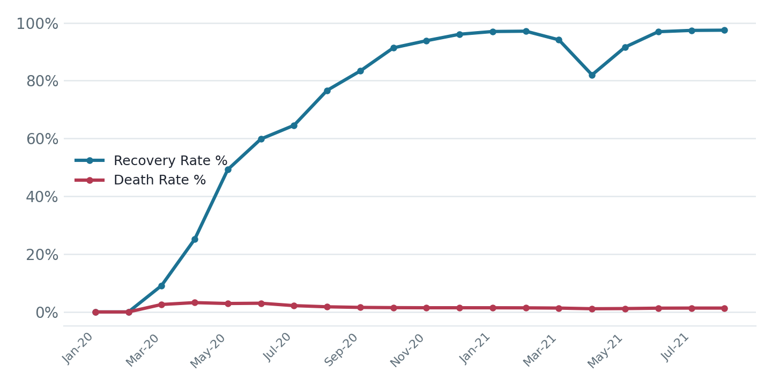
Figure 3: Recovery rate and death rate as a percentage of confirmed cases, monthly

5. Forecasting Results
Using the Prophet model described in Section 3.4, daily new confirmed cases were forecast for the 7 days following 11 Aug 2021, the last date available in the dataset. The forecast, along with its surrounding actual values, is shown below.
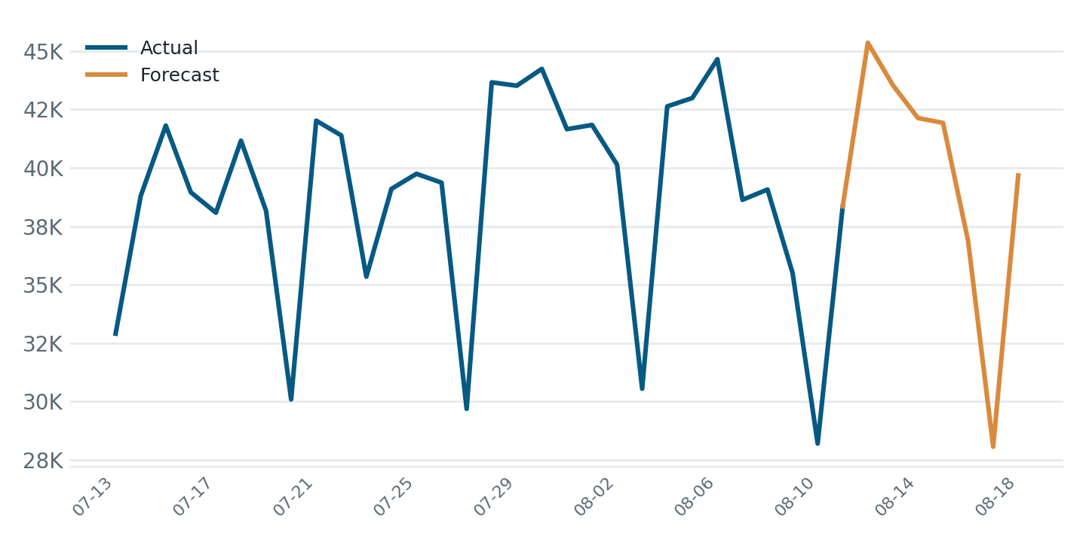
Figure 4: Actual daily new cases (last 30 days) and 7-day Prophet forecast
Date | Projected New Cases
12 Aug 2021 | 45,345
13 Aug 2021 | 43,533
14 Aug 2021 | 42,126
15 Aug 2021 | 41,919
16 Aug 2021 | 36,872
17 Aug 2021 | 28,069
18 Aug 2021 | 39,670
Table 3: 7-day forecast of daily new confirmed cases
The forecast projects a broadly stable-to-slightly-declining trend in daily new cases over the week ahead, consistent with the levelling-off pattern visible in the most recent actual data. As with any short-horizon time-series forecast, accuracy depends on the recent trend continuing without a new disruptive event (e.g. a new variant or major policy change).

6. Key Insights
- Two very different waves: the second wave (07 May 2021) peaked at over 4x the daily case count of the first, indicating faster transmission and far greater pressure on healthcare capacity.
- Recovery kept pace overall: the national recovery rate reached 97.45% by the end of the observed period, reflecting steady improvement in patient outcomes as the healthcare response matured.
- Death rate declined and stabilised: the death rate fell from an early peak of 3.46% to 1.34% by 11 Aug 2021, reflecting improved treatment protocols and wider testing coverage over time.
- Short-term forecasting is viable: a lightweight Prophet model trained on a rolling 90-day window produced a plausible 7-day outlook without requiring the full historical series, making it practical for ongoing near-term resource planning.

7. Tools and Technologies Used
Tool / Library | Purpose
Python 3 | Core programming language for the analysis pipeline
Pandas | Data cleaning, aggregation and metric calculation
Plotly | Interactive charting of trends and forecasts
Prophet | Time-series forecasting of daily new cases
VS Code | Development environment (Windows)

8. Appendix A: Python Source Code
The complete Python script used to load, clean, analyse and forecast the dataset (covid.py) is reproduced below for reference and reproducibility.
"""
COVID-19 India: Trend Analysis, Rate Calculation, and 7-Day Forecast
Dataset: covid_19_india.csv
"""

import pandas as pd
import plotly.graph_objects as go
from prophet import Prophet
import logging

# Hide Prophet warnings
logging.getLogger("cmdstanpy").setLevel(logging.WARNING)
logging.getLogger("prophet").setLevel(logging.WARNING)

# ============================================================
# STEP 1: Load and Clean Data
# ============================================================

df = pd.read_csv(r"C:\Users\sazed\Downloads\covid_19\covid_19_india.csv")

df["Date"] = pd.to_datetime(df["Date"])

state_fixes = {
"Telengana": "Telangana",
"Bihar****": "Bihar",
"Madhya Pradesh***": "Madhya Pradesh",
"Himanchal Pradesh": "Himachal Pradesh",
"Karanataka": "Karnataka",
"Maharashtra***": "Maharashtra",
"Nagaland#": "Nagaland",
}

df["State/UnionTerritory"] = df["State/UnionTerritory"].replace(state_fixes)

df = df[
~df["State/UnionTerritory"].isin(
["Unassigned", "Cases being reassigned to states"]
)
]

df = df[
["Date", "State/UnionTerritory", "Cured", "Deaths", "Confirmed"]
]

df.columns = [
"Date",
"State",
"Cured",
"Deaths",
"Confirmed",
]

# ============================================================
# STEP 2: National Daily Statistics
# ============================================================

national = (
df.groupby("Date")[["Cured", "Deaths", "Confirmed"]]
.sum()
.reset_index()
)

national = national.sort_values("Date")

national["New_Confirmed"] = (
national["Confirmed"].diff().fillna(0).clip(lower=0)
)

national["New_Deaths"] = (
national["Deaths"].diff().fillna(0).clip(lower=0)
)

national["New_Cured"] = (
national["Cured"].diff().fillna(0).clip(lower=0)
)

national["Active"] = (
national["Confirmed"]
- national["Cured"]
- national["Deaths"]
)

national["Recovery_Rate_%"] = (
national["Cured"] / national["Confirmed"] * 100
).round(2)

national["Death_Rate_%"] = (
national["Deaths"] / national["Confirmed"] * 100
).round(2)

# ============================================================
# STEP 3: Charts
# ============================================================

# Chart 1
fig1 = go.Figure()

fig1.add_trace(
go.Scatter(
x=national["Date"],
y=national["Confirmed"],
name="Confirmed",
)
)

fig1.add_trace(
go.Scatter(
x=national["Date"],
y=national["Cured"],
name="Recovered",
)
)

fig1.add_trace(
go.Scatter(
x=national["Date"],
y=national["Deaths"],
name="Deaths",
)
)

fig1.update_layout(
title="India: Cumulative COVID-19 Cases",
xaxis_title="Date",
yaxis_title="Cases",
)

fig1.write_html("chart1_cumulative.html")

# ------------------------------------------------------------

fig2 = go.Figure()

fig2.add_trace(
go.Scatter(
x=national["Date"],
y=national["New_Confirmed"],
name="Daily New Cases",
)
)

fig2.update_layout(
title="India: Daily New Confirmed Cases",
xaxis_title="Date",
yaxis_title="New Cases",
)

fig2.write_html("chart2_daily_new.html")

# ------------------------------------------------------------

fig3 = go.Figure()

fig3.add_trace(
go.Scatter(
x=national["Date"],
y=national["Recovery_Rate_%"],
name="Recovery Rate %",
)
)

fig3.add_trace(
go.Scatter(
x=national["Date"],
y=national["Death_Rate_%"],
name="Death Rate %",
)
)

fig3.update_layout(
title="Recovery Rate vs Death Rate",
xaxis_title="Date",
yaxis_title="Percentage",
)

fig3.write_html("chart3_rates.html")

# ------------------------------------------------------------

latest_date = df["Date"].max()

latest = (
df[df["Date"] == latest_date]
.sort_values("Confirmed", ascending=False)
.head(10)
)

fig4 = go.Figure()

fig4.add_trace(
go.Bar(
x=latest["State"],
y=latest["Confirmed"],
)
)

fig4.update_layout(
title=f"Top 10 States by Confirmed Cases ({latest_date.date()})",
xaxis_title="State",
yaxis_title="Confirmed Cases",
)

fig4.write_html("chart4_top_states.html")

# ============================================================
# STEP 4: Prophet Forecast
# ============================================================

prophet_df = national[
["Date", "New_Confirmed"]
].rename(
columns={
"Date": "ds",
"New_Confirmed": "y",
}
)

prophet_df["y"] = prophet_df["y"].clip(lower=0)

recent = prophet_df.tail(90).reset_index(drop=True)

model = Prophet(
daily_seasonality=False,
weekly_seasonality=True,
yearly_seasonality=False,
changepoint_prior_scale=0.1,
)

model.fit(recent)

future = model.make_future_dataframe(periods=7)

forecast = model.predict(future)

forecast["yhat"] = forecast["yhat"].clip(lower=0)
forecast["yhat_lower"] = forecast["yhat_lower"].clip(lower=0)

last_actual = recent["ds"].max()

historical = forecast[forecast["ds"] <= last_actual]
future_forecast = forecast[forecast["ds"] > last_actual]

print("\n7-Day Forecast\n")

print(
future_forecast[
[
"ds",
"yhat",
"yhat_lower",
"yhat_upper",
]
]
)

# ============================================================
# STEP 5: Forecast Chart
# ============================================================

fig5 = go.Figure()

fig5.add_trace(
go.Scatter(
x=recent["ds"],
y=recent["y"],
mode="lines+markers",
name="Actual",
)
)

fig5.add_trace(
go.Scatter(
x=historical["ds"],
y=historical["yhat"],
name="Model Fit",
)
)

fig5.add_trace(
go.Scatter(
x=future_forecast["ds"],
y=future_forecast["yhat"],
name="Forecast",
)
)

fig5.add_trace(
go.Scatter(
x=list(future_forecast["ds"])
+ list(future_forecast["ds"][::-1]),
y=list(future_forecast["yhat_upper"])
+ list(future_forecast["yhat_lower"][::-1]),
fill="toself",
fillcolor="rgba(255,0,0,0.15)",
line=dict(color="rgba(255,255,255,0)"),
name="Confidence Interval",
)
)

fig5.update_layout(
title="India Daily New Cases with 7-Day Forecast",
xaxis_title="Date",
yaxis_title="New Confirmed Cases",
)

fig5.write_html("chart5_forecast.html")

# ============================================================
# STEP 6: Export CSV
# ============================================================

national.to_csv("national_daily.csv", index=False)

print("\nAnalysis completed successfully!")
print("Generated files:")
print("✓ chart1_cumulative.html")
print("✓ chart2_daily_new.html")
print("✓ chart3_rates.html")
print("✓ chart4_top_states.html")
print("✓ chart5_forecast.html")
print("✓ national_daily.csv")

9. Conclusion and Future Scope
This project demonstrates an end-to-end workflow for analysing a real-world epidemiological time series: cleaning inconsistent raw data, aggregating it to a meaningful level of granularity, deriving outcome metrics that go beyond raw counts, and applying a time-series model to generate a short-term forecast. The analysis confirms that India experienced two epidemiologically distinct waves, that patient outcomes improved substantially as the pandemic response matured, and that a simple, rolling-window Prophet model can produce a reasonable near-term forecast without needing to model the entire pandemic history.
Future extensions of this work could include state-level forecasting to identify localised risk before it becomes visible at the national level, incorporation of vaccination-rate data as an external regressor in the Prophet model, and comparison against alternative forecasting approaches such as ARIMA or LSTM-based models to benchmark accuracy.

