Team 9

Instructor Matt Sopha

Section [86173](https://webapp4.asu.edu/myasu/?action=clearschedcache&nextUrl=https%3A%2F%2Fcatalog.apps.asu.edu%2Fcatalog%2Fclasses%2Fclasslist%3Fkeywords%3D86173%26searchType%3Dall%26term%3D2237%23detailsOpen%3D86173)

| Team member's name | Team member's Slack handle | Team member's @asu.edu email address |
| --- | --- | --- |
| Suprya Azhakath  Igli Balliu  Zinah Othman  Elena Reed  Nathan Tekeste  Tzu Huey Weng | Sazhakat  Iballiu  Zothman  Epreed  Ntekeste  Tweng8 | [sazhakat@asu.edu](mailto:sazhakat@asu.edu)  [iballiu@asu.edu](mailto:iballiu@asu.edu)  [zothman@asu.edu](mailto:Zothman@asu.edu)  [epreed@asu.edu](mailto:epreed@asu.edu)  [ntekeste@asu.edu](mailto:ntekeste@asu.edu)  [tweng8@asu.edu](mailto:tweng8@asu.edu) |

**Summary Bar Graph**

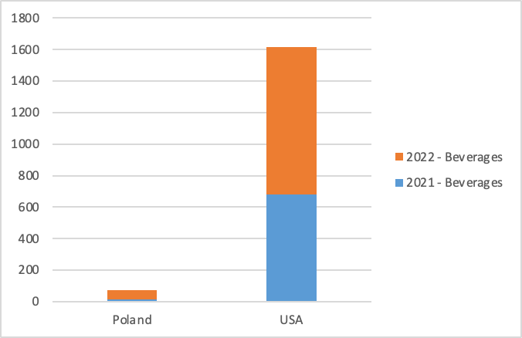

By analyzing all the data, we can show the gross quantity sales by country and the years 2021 to 2022. The illustrations show that the USA has the highest sales in terms of beverages. As seen in the chart, there was a drastic increase from 2021 to 2022. In comparison, we see that the quantity sales in Poland were drastically low. This illustration can guide and help us focus on regions with quantity sales.

[Northwind Trader Global Sales Data. T5.xlsx](https://arizonastateu-my.sharepoint.com/:x:/r/personal/zothman_sundevils_asu_edu/Documents/Northwind%20Trader%20Global%20Sales%20Data.%20T5.xlsx?d=wdc39a4b9769f40de9b84f454633337b9&csf=1&web=1&e=ckJMG8)

**Trends in Order Sales in Different Countries**

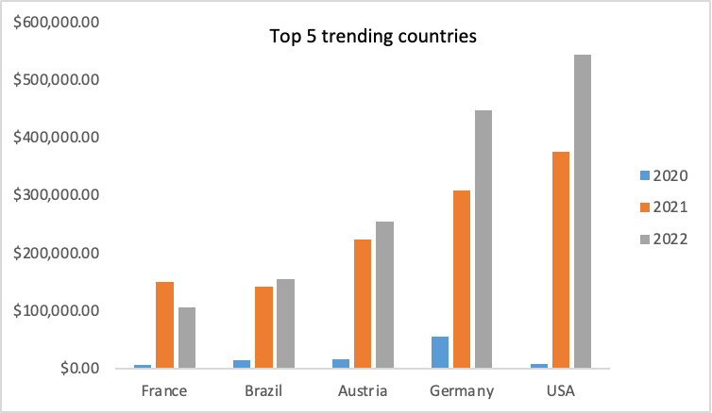

We chose this specific data set to determine which country has the largest sales. This visualization will give the company a basis to determine countries with high sales. The

trend from each country is illustrated by the year starting from 2020 to 2022. This allows us to determine the difference among each country and we see that the USA is leading in sales and see a drastic increase from 2020 to 2022. A data set that would be crucial in this data set would be total profits from each country which would include taxes on products.

**Product categories that are trending in the USA.**

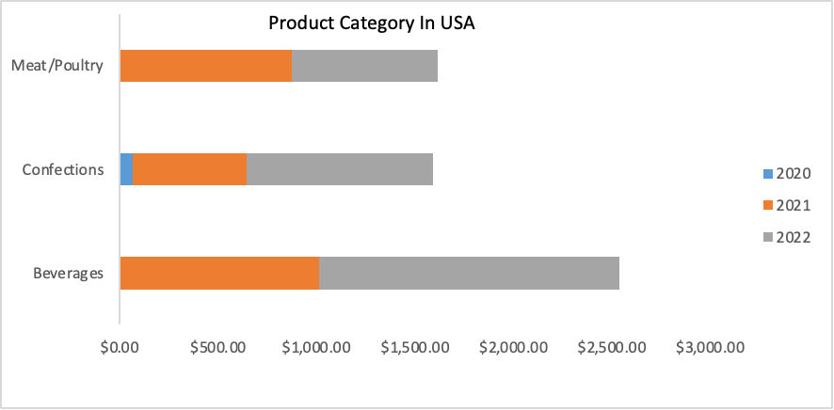

Based on the top-selling country which is the USA we are able to determine what category of products brings in the most sales. The visualization shows order unit sales

in meat, confections, and beverages for the year 2020 to 2022. The graph shows that the sale of beverages consists of the highest and has trended up in comparison to the different years. One data set that is missing in this which could be beneficial would be the age group for the sales. Knowing the age group we can target certain groups specifically.

**The most selling Product name in all countries by product order unit price.**

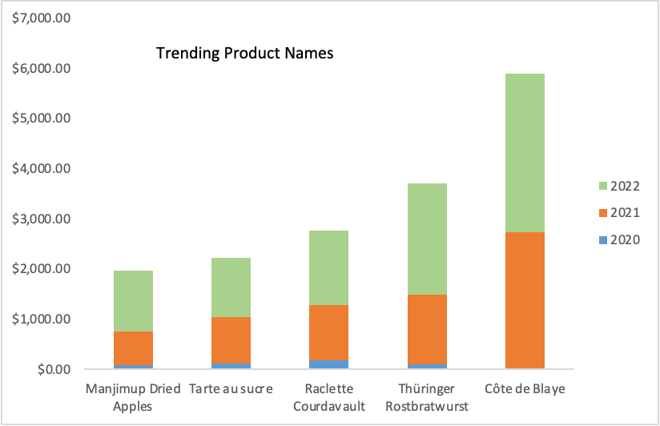

The data set illustrates the specific product name with the highest sales in all countries. The chart illustrates that in 2020 none of these products had any sales. In 2022 the product Cote de Blaye is the highest-grossing product whereas in 2020 there were no sales. This trend in products will help us determine what to focus on in sales**.**

**Top customers selling the most quantity in all countries**

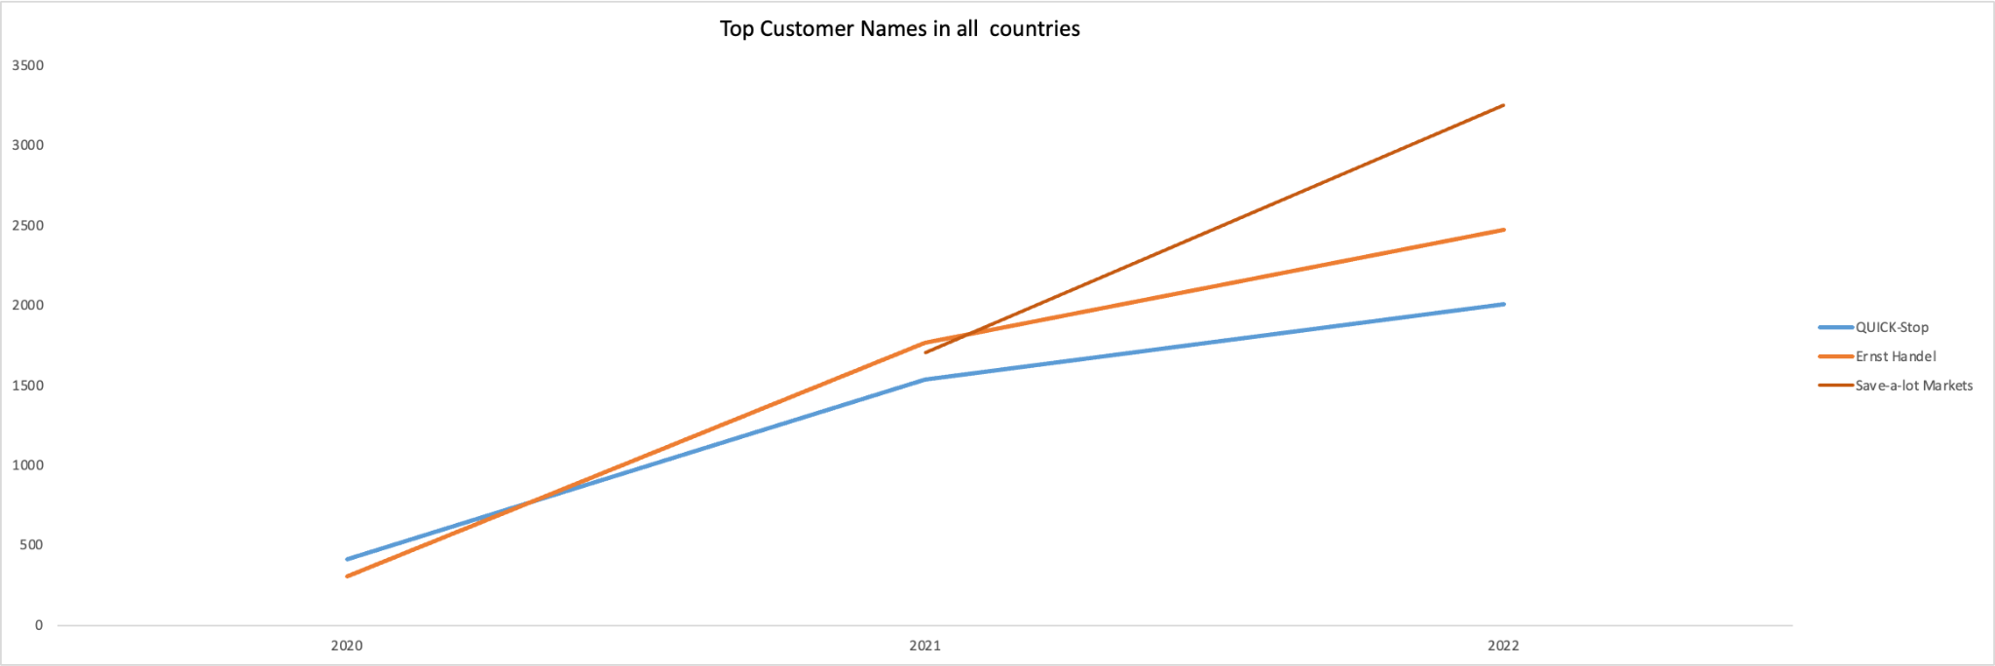

The graph analysis shows the customers that are grossing the largest in sales over the period of time. The illustration compares the sales of three different chains from 2020 to 2022. We can see that Save-a-lot which became a customer in 2021 saw a drastic increase in sales compared to the others and is growing exponentially. Quick Stop and Ernest Handel have seen a steady increase in sales by quantity from 2020 to 2022.

**The worst-performing countries by the order price total**.

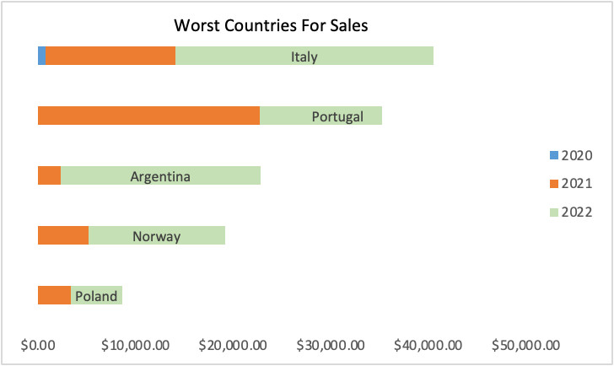

This dataset helps analyze which countries are the worst in sales organized by years 2020, 2021, and 2022. This visualization displays data showing the amount of money brought in for the countries Poland, Norway, Argentina, Portugal, and Italy. We know that these five countries have brought in the least amount of revenue for Northwind Trader. The data is displayed by year, allowing us to see the change in amount per year from 2020 to 2022 for each of the five countries but specifically highlighting the year 2022. I think that it would be beneficial to link the Product Order Quantity and Product Type to analyze which countries are ordering which products and how much of each they need. From this data, the company can narrow in on which countries are spending the least amount of money. If they linked the two categories mentioned above, they could hopefully alter their products or marketing to increase purchases from these countries. This should result in a higher demand for their products and therefore the countries should begin purchasing larger quantities of their products.

Through each summary, we are able to further understand data trends based on our analysis. We are able to summarize, as well as break down data sets into detail. For instance, in our first analysis, we can view the gross quantity sold of beverages broken down by year and country. In a further analysis, we can view sales revenue sorted by country as well as year, as shown in our second visualization. We analyzed popular products and product categories as well. This allows us to easily view which countries purchased the top-selling products as well as their product categories and respective years sold. We further investigated and discovered which specific chains sold the highest quantity of goods which allows for insight into details. In our final visualization, we can see the lowest 5 countries for sales and how much they sold each year. Our 6 visualizations allow easier analysis of Northwind Traders data. They allow for effective decision-making based on the leading countries, products, and chains, as well as the countries that have the lowest sales margins.

| Team 9 | Proposal Due By **9/29/2023** | |
| --- | --- | --- |
| **Project Overview:**  Northwind Trader's Request for Proposal (RFP) focuses on achieving a dual objective: increasing sales revenue while reducing operational costs. The first objective is Cost reduction to ensure an efficient operation system. Reducing cost involves an analysis of workflow, resource allocation, and mitigating risk in the best way possible. Identify areas for potential reduction and implementation of optimized strategies. The second objective is enhancing Northwind Traders' resources, as developing lasting customer relationships is equally important. Involving innovative sales and marketing strategies outlines a clear roadmap to a long-term sustainable and growing business. The aim is to enhance the company's financial performance and maintain a competitive position within the market. Innovative ideas and partnerships are instrumental to NorthWind Traders' success. | | |
| **Project Goals:**   * Enhance the financial performance of Northwind Trader by implementing a comprehensive set of strategies geared towards boosting company revenue. These strategies are designed to not only drive revenue growth but also solidify Northwind Trader's competitive position within the market. * One pivotal aspect of this initiative involves elevating the overall brand awareness and market share of Northwind Trader. By doing so, the company aims to not only attract new customers but also retain its existing client base. This will be achieved through targeted marketing campaigns, customer engagement programs, and innovative branding efforts that resonate with the target audience. * Northwind Trader is committed to reducing operational costs and production expenses. This cost-saving endeavor involves streamlining internal processes, optimizing resource allocation, and adopting more efficient production techniques. By identifying areas where costs can be trimmed without compromising product quality or customer satisfaction, the company ensures a more sustainable and profitable future. | | |
| **Scope of Work:**   * Perform a thorough investigation to fully understand our organization's specific requirements and goals * Collect data on the sales revenue in the past year into Excel workbooks. * Analyze the advantages and disadvantages of the products and create an improvement plan. * Collect the costs used for production, human resources, and other costs. * Analyze customer feedback to determine strategies for producing products that meet market needs. * Create a chart and summary of customers' habits, supply chain issues, and market trends. * Continue to innovate in production and supply chain to increase competitiveness. * Provide a presentation for Northwind Trader to optimize its operations. | | |
| **Current Roadblocks and Barriers to Success**   * The constraints associated with the data attributes, including their scope and range, need to be considered. * The audit expenditure should be in accordance with the budget that has been provided, ensuring that it does not exceed the allocated financial limits. * Balancing the trade-off between time constraints and maintaining high-quality work within a specified timeframe. | | |
| **Evaluation Metrics and Criteria**     * A history of work in related fields along with three positive references for work provided within the last quarter. (Contact information to be provided by the bidder) * Accuracy and presentability of data collected. Applicants should be able to present data in a clear and understandable method, statistical models should be present and include information regarding necessary fields. These fields shall include; The time and date that each order was created, the price per order including unit price and total price, customer information including country of order, the city/state and the category of products ordered per customer. * Any data used for analysis must come between 11/11/2019-12/31/2022 * Data should be presented in a total of eight graphs, Microsoft Excel and Tableau should be the primary software used to create and present these graphs.   + Any graph created in Tableau should indicate data that is useful for making predictive decisions.   + Graphs created in Excel should be useful for making descriptive and prescriptive decisions.   + Graphs and charts are expected to be presented in a formal business style avoiding the use of bright colors and unnecessary graphics, along with being generally readable and easily understood the data should be presented in a way that’s aesthetically pleasing. * Proportional cost for the services rendered, market conditions will be used in order to determine a “reasonable price” however no bid can go above the listed budget of $2,000,000 * The project must begin at the latest by 11/01/2023 and must finish no later than 11/08/2023 * The final proposal should be submitted directly to Northwind Traders INC, as soon as complete, either through the use of email or other instant information services through protected and confidential channels. More information to follow. | | |
| **Submission Requirements**     * Keep track of market trends to maintain a competitive position by widening the scope of data, and involve a team of data analysts to track revenue, operational costs, sale locations, etc. to keep steady improvement. * Use of a concise schedule, and uphold company objectives with high-quality work within time constraints. * Excel workbook on all sales revenue within the past year. * Presentations to Northwind to optimize operations for every quarter to more easily track data and supply chain trends. * Presentations to Northwind as soon as complete. * Graphs on tableau multiple times a quarter to maximize success of predictive decisions * Review of every product and its advantages and disadvantages for business success and optimization * Eight graphs for presentation primarily excel and tableau * Project timeline stays between 11/01/2023 and 11/08/2023 | | |
| Contact: page 6 | | Budget:$2,000,000 |

Company References:

1. General Mills
2. Internal Contact:(209)972-0827
3. External Contact: (209)547-8060

i. Website: <https://www.generalmills.com/>

ii. Contact Info: (209)547-8060

1. Mars, Inc.
2. Internal Contact: (703)243-2343
3. External Contact: (703)251-3950

i. Website: <https://www.mars.com/>

ii. Contact Info: (703)243-2343

1. RR Donnelley
2. Internal Contact:(866)782-9758
3. External Contact: (800)782-4892

i. Website: <https://www.rrd.com/>

ii. Contact Info: (800)782-4892

Video Presentation Link:

<https://youtu.be/-P-BiNUru6I>