# Tester

List of testing:

|  |  |
| --- | --- |
| NO | Test Name |
| 1. | Unit Test |
| 2. | Integration Test |
| 3. | Functional Test |
| 4. | Usability Test |
| 5. | Security Test |
| 6. | Browser compatibilitynTest |

**Test Plan:** From the Beginning of the system, a test plan has been made where the name of testing (which area are going to test), Criteria of testing and outcome are all described .The test plan is very essential part of the system. In the test plan, all the testing field are going to be identified by following criteria.

|  |  |  |  |
| --- | --- | --- | --- |
| Test no | Name | Criteria | Outcome |
| 1. | Unit-Test | Add event  Comments | All the result of these test will be accurate. |
| 2. | Integration-Test | Sending Email  View weather | All step of the function will  Work accurately. |
| 3. | Functional-Test | Add Event, | All the step of the function will be work sequentially and get expected results. |
| 4. | Usability-Test | Search option  Page Details  Navigation Bar | All the items of the function will be pace accurately. |
| 5. | Security-Test | User Authentication,  Bruit Force Attack  SQL injection | All the result of the security testing will be accurate. |
| 6. | Browser –Compatibility-Test | Google Chrome,  Mozilla,  Explore |  |

# Test design:

Unit Test:

|  |  |  |  |  |  |
| --- | --- | --- | --- | --- | --- |
| No | Test Title | Pre-condition | Test Steps | Expected Results | Actual results |
| 1 | Updating event time | Change event time. | Update new time | The result was expected | Expected |

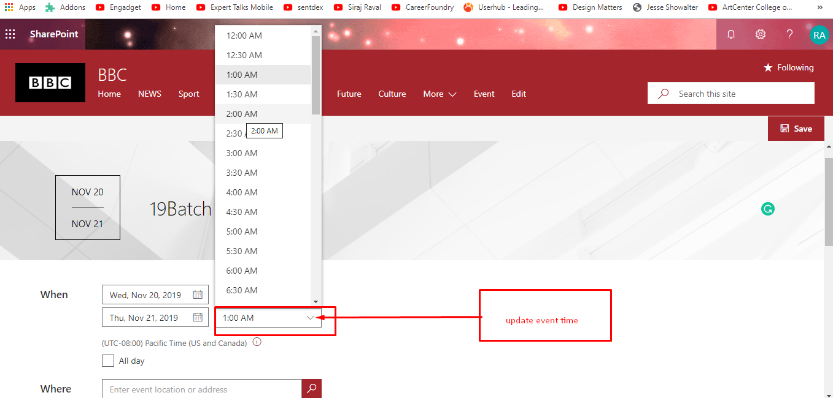

Figure 5: changing event time.

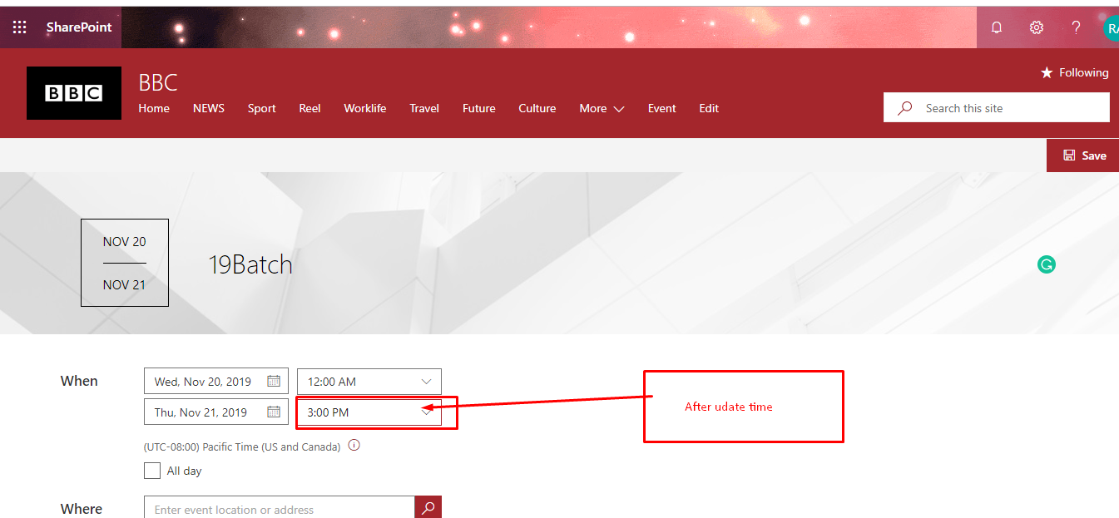

Figure 6: Update Event time.

Integration Test:

|  |  |  |  |  |  |
| --- | --- | --- | --- | --- | --- |
| No | Test Title | Pre-condition | Test Steps | Expected Results | Actual results |
| 2. | Replying of Comment. | Commenting | reply | The expected result has been found | Expected  Result |

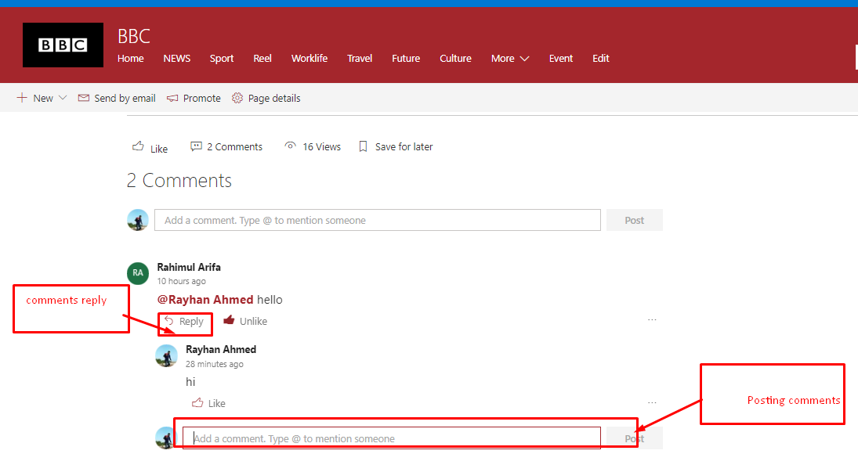

Figure 7: replying on comment.

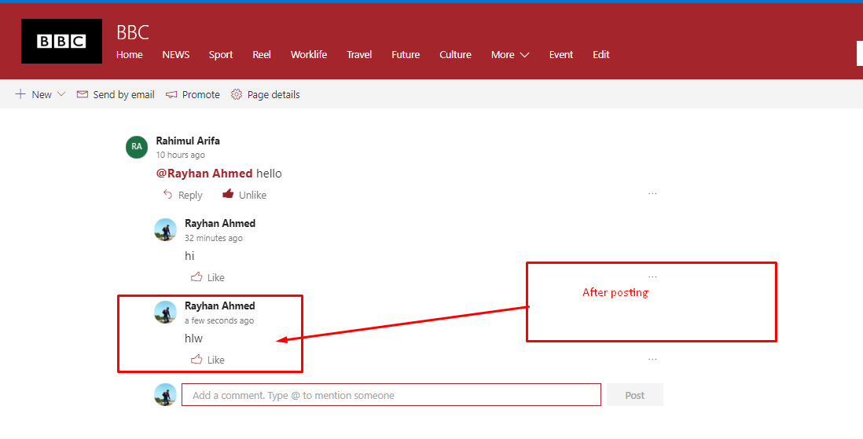

Figure 8: Reply on the comment.

**Functional test:**

|  |  |  |  |  |  |
| --- | --- | --- | --- | --- | --- |
| No | Test Title | Pre-condition | Test Steps | Expected Results | Actual results |
| 3. | Creating Event. | Process of creating event. | Create event | The results was same. | Expected  Result |

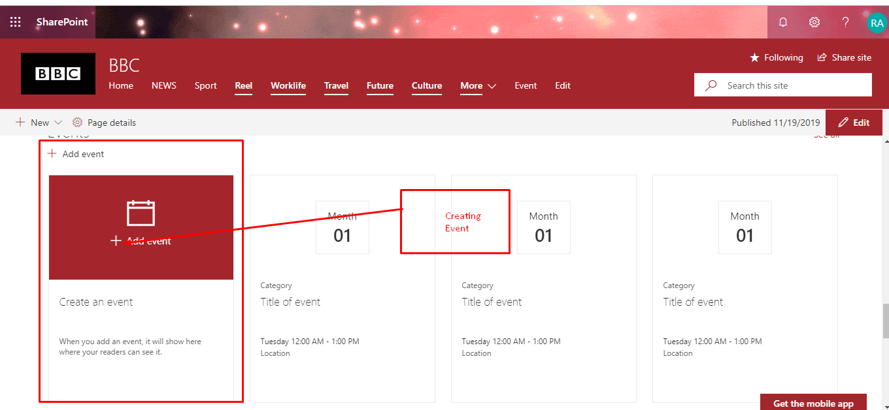

Figure 9: Creating event.



Figure 10: Process of creating table.

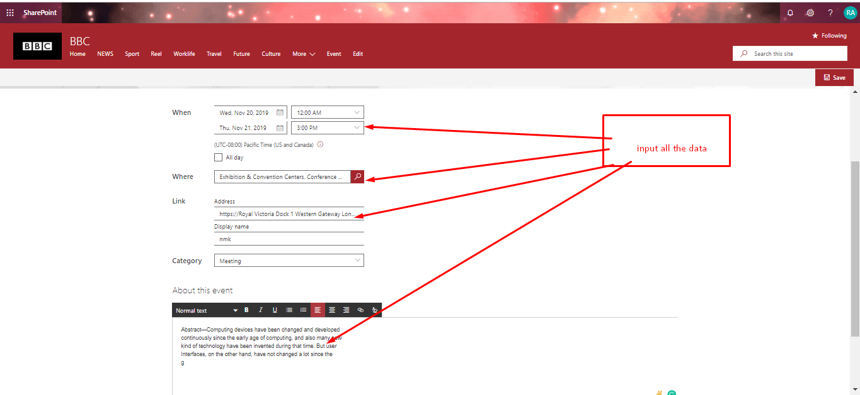

**Figure 11: process of creating table.**

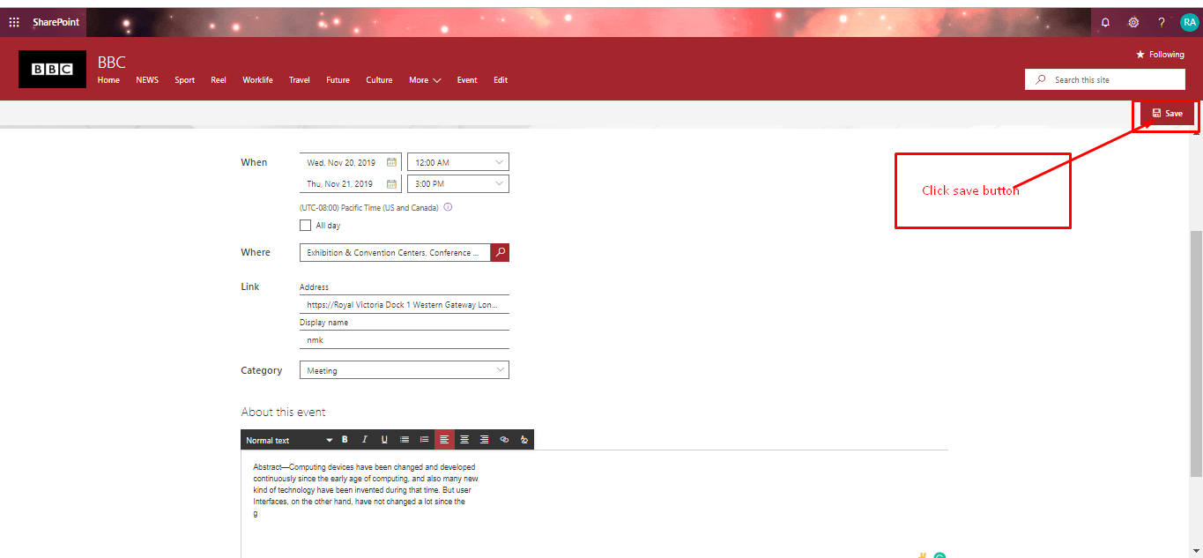

Figure 12: After fill-up form click on button.

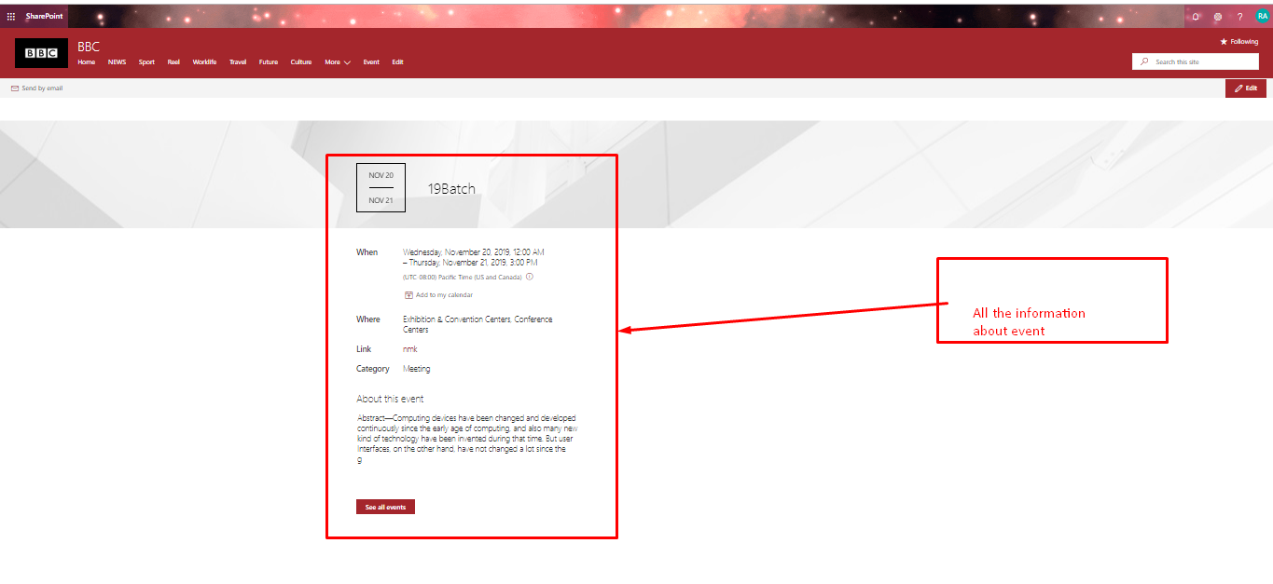

Figure 13: After create event Information.

Usability test:

|  |  |  |  |  |  |
| --- | --- | --- | --- | --- | --- |
| No | Test Title | Pre-condition | Test Steps | Expected Results | Actual results |
| 4. | User friendly Navigation bar and search bar | User friendly navigate bar | Size ,color are friendly to user. | The results was same. | Expected  Result |

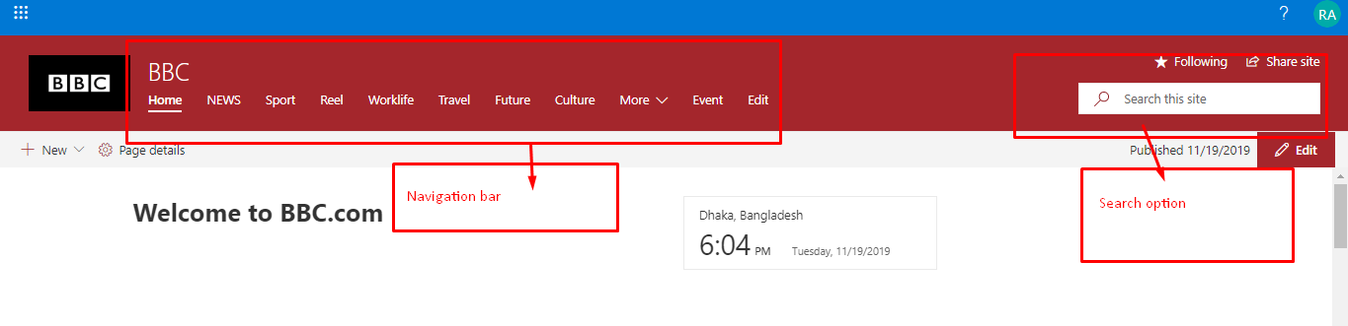

Figure 14: User-friendly navigation bar.

Security test:

|  |  |  |  |  |  |
| --- | --- | --- | --- | --- | --- |
| No | Test Title | Pre-condition | Test Steps | Expected Results | Actual results |
| 5. | Authentication process | Sign-up by email | Complete task | The results was same. | Expected  Result |

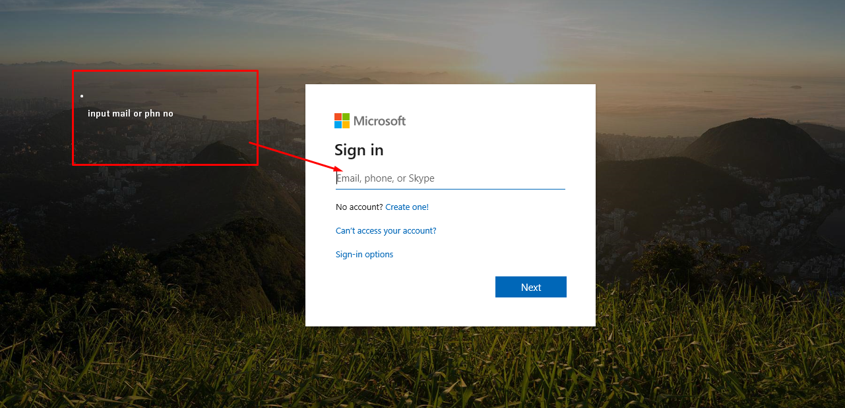

Figure 15: User authentication process.

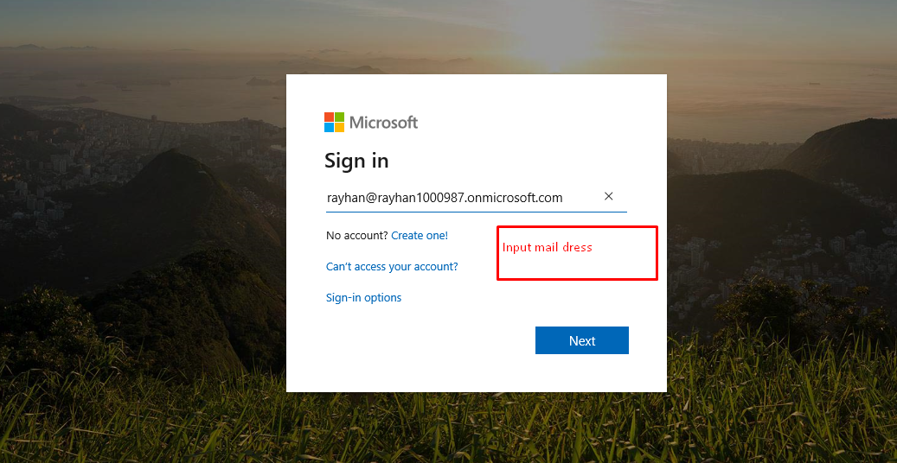

Figure 16: User Authentication process.

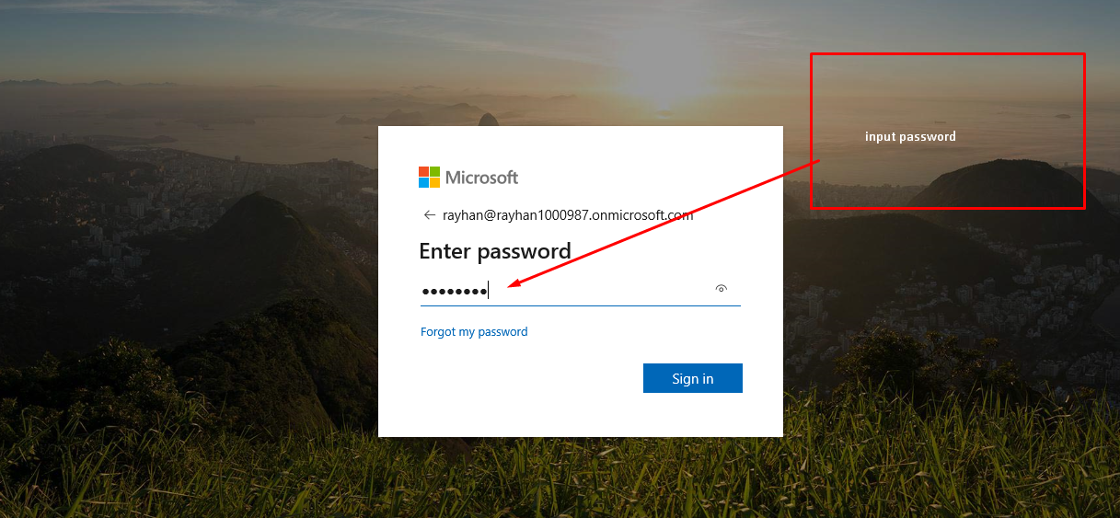

Figure 17: User authentication process.

Browser compatibility test:

|  |  |  |  |  |  |
| --- | --- | --- | --- | --- | --- |
| No | Test Title | Pre-condition | Test Steps | Expected Results | Actual results |
| 6. | Feature testing from different browser. | Availability check | The system will be run from every browser. | The results was same. | Expected  Result |

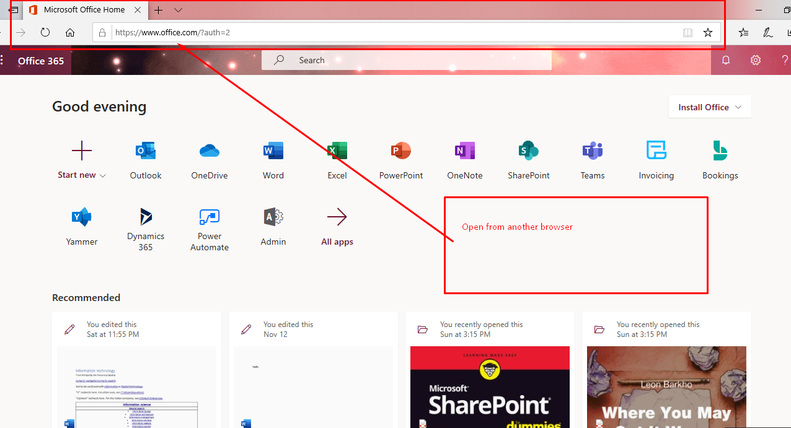

Figure 18: Browser capability test.

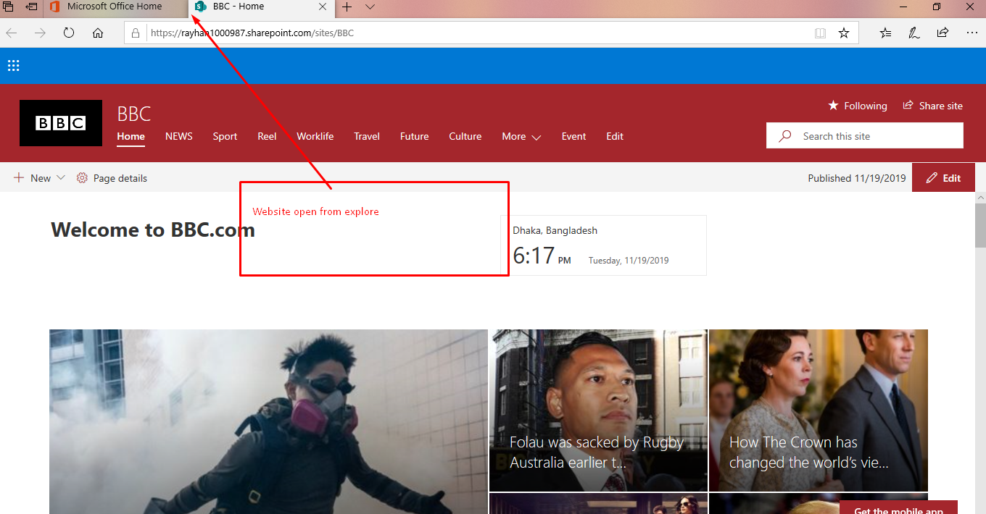

Figure 19: testing from different browser.

# Test-Log:

|  |  |  |  |  |
| --- | --- | --- | --- | --- |
| Test no | Name | Criteria | Outcome | Results |
| 1. | Unit-Test | Add event  Comments | All the result of these test will be accurate. |  |
| 2. | Integration-Test | Sending Email  View weather | All step of the function will  Work accurately. |  |
| 3. | Functional-Test | Add Event, | All the step of the function will be work sequentially and get expected results. |  |
| 4. | Usability-Test | Search option  Page Details  Navigation Bar | All the items of the function will be pace accurately. |  |
| 5. | Security-Test | User Authentication,  Bruit Force Attack  SQL injection | All the result of the security testing will be accurate. |  |
| 6. | Browser –Compatibility-Test | Google Chrome,  Mozilla,  Explore |  |  |