# HungryBites Management System

# Overview

**Introduction:**

HungryBites is a new medium of restaurant for Dhaka city who are interested to take the home service and share their experience within a community. This service is very helpful for people who want to enjoy best food without going restaurant. On the other hand the system is going to make easy for the restaurant owner to maintain account and staff section.

**Project justification:**

HungryBites restaurant provide food devices for their customers. Most of the restaurants in our country are maintain their Business through papers. But it is difficult to keep track of their business and store all the business related data. Beside this, the customer might have some personal opinion about their services and food quality. Furthermore, the customer sometime wants to enjoy food without going outside of their food which is the very big problem for the restaurant staffs. By using this system these problems will be solved.

**Project description:**

HungryBites management system will be fully web based system. To use this system the users must be completed their registration by providing some relevant information. After completing registration the users are ready to use the system. After Log in users can select their desire dishes and order them. To find users desire dishes, the dishes will be displayed through category and random. Beside this, the users can the user can post their opinion based on service, food quality etc. and the other users can comment on the post as well as edit their comment and delete their comment. On the other hand, the super admin will be able to take the staff attendance. The super admin can accept or reject the order. The admin can add new food items.Furthermore the admin will notify the registered users for launching new food items or offer.

# Aims, objectives and Scope:

**Project Aims:**

1. To help the customer to find out favorites dishes.

2. To order Food from anywhere.

3. By using this system customers can expose their opinion in a community.

4. The system will help to maintain the accounts of the organization.

5. To take attendance of the staff the owner can use it.

6. By using this system the customers will notify about new offer as well as launching new dishes.

**Project Objectives:**

1. The user must complete their registration to use the system.

2. The owner will log in as admin to confirm the order.

3. Optimizing paper work.

4. Making process as fast as possible.

5. Increasing interaction with users.

6. User can browse from mobile phone.

**System Scope and Architecture:**

The system is going to automate the HungryBites Restaurant. It will provide some facilities both for the customers and the owner through online. It will help the customers to order food from their residence as well as they can express about their opinion on restaurant. Beside this, the admin can take attendance on their staff. Admin can also confirm order and they can also take information of sales. They can also notify their customers through mail.

The system has some boundary also. It is not incorporate with the following feature such as online payment. The users also cannot recover their forget password. The users cannot book based on table.

The system is basically web based system. The system developed by programing language of HTML, CSS, BOOTSTRAP, JS, JQUERY, PHP and MYSQL. The design part will be completed by using HTML, CSS, BOOTSTRAP, JS and JQUERY. Php and mysql is used to interact between user and browser. The main cause of using php on this project is people can easily access from anywhere by any smart device where the internet browsing facility is available.

# Work breakdown structure

**Gantt chart**

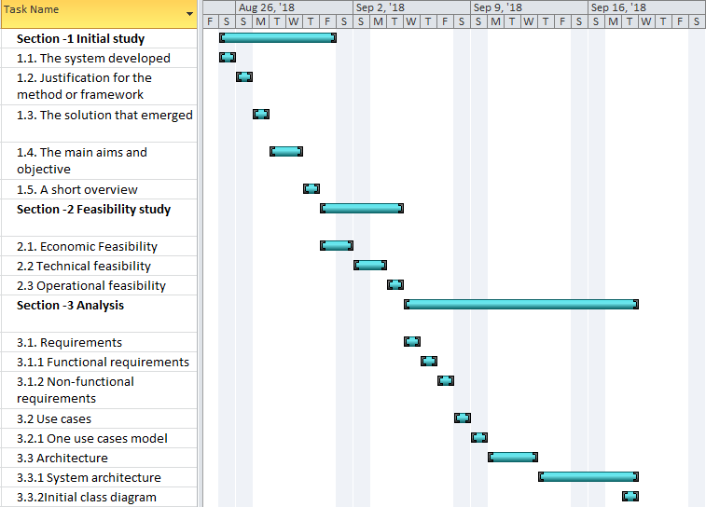

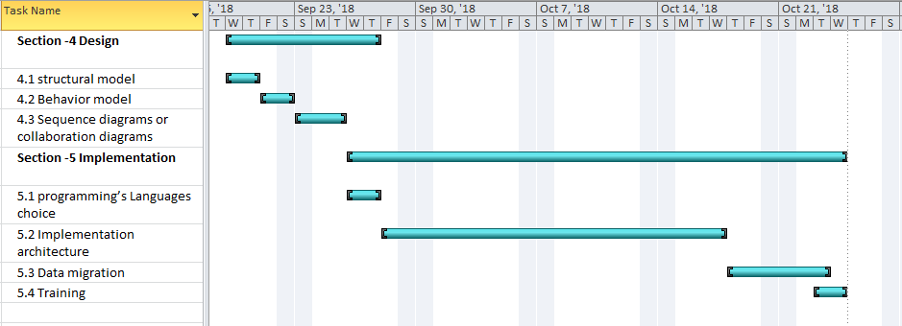

**Identification for key milestone with key**

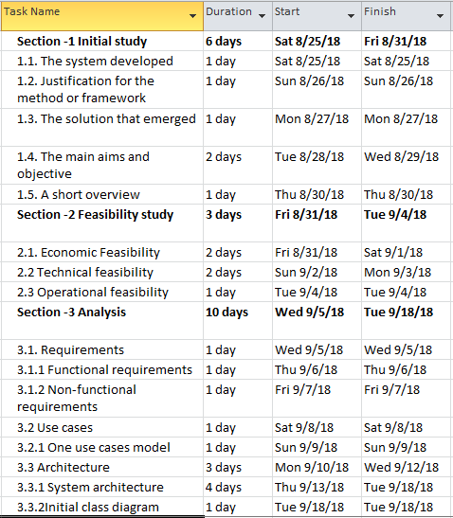

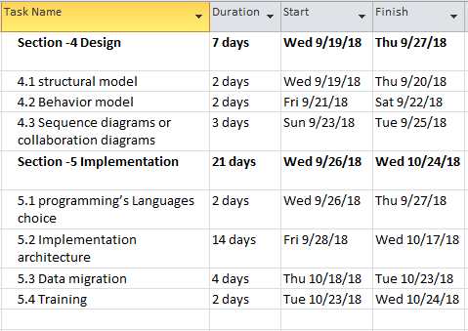

**Outline of key Activity**

**Initial study:** in initial studies focuses given to find out what type of facility customers actually want from an organization. I have visited several online restaurants and also manually. I talked with the owners and decided that it would be better to provide services through online.

**Feasibility Study:** The implementation of a restaurant management system (HngryBites) will bring up many questions such as costs, efficiency, security etc. but the main vision of the system will provide customers facilities online based. Ordering food from the home and express their opinion about services will bring out the maximum client satisfaction.

**Analysis:** In this section, it is very important to find out the requirements of the project and prioritize the requirements. Then it carries out the tasks of representing use case diagram, class diagram, initial diagram defines as my system architecture that I can represent my system graphically.

**Design:** In this section I mapped for my system and thinking about what will be actual graphical represent of my system.

**Implementation:** In this stage, I will define the programming language that I want to use for developing my system. Testing and training also included in this section. Lots of method and database table will be define here. Actually, all the real-life activity of the system will be gained from this stage.