Rentora — QA Test Report
Bangladesh Rental Marketplace · End-to-End Quality Assessment
Prepared by QA Automation (Playwright + Playwright-MCP) · 24 Jun 2026

1. Executive Summary
Rentora is a three-portal rental marketplace (public renter site, owner portal, admin portal). The application was analysed live with Playwright-MCP across all roles (guest, renter, owner, admin), and 58 test cases were designed from the observed behaviour. 39 were automated and executed this run; the remaining 19 are documented manual/E2E cases. Testing uncovered 3 distinct defects, two of which (registration crash and debug-mode disclosure) are release-blocking.
Metric | Count
Total test cases designed | 58
Automated & executed | 39
Passed | 34
Failed | 5
Blocked | 0
Not executed (manual / E2E) | 19
Distinct defects found | 3
Automated pass rate: 87% (34/39).

2. Feature Coverage

2.1 Features Tested
- Authentication — registration, login (owner/admin/renter), logout, validation, email-verification gate
- Guest browsing — home, search catalogue, property detail, type filter, city pages, 404 handling
- Search filters — price slider health, console-error health, filter controls
- Owner portal — dashboard KPIs, my listings, 10-step create wizard entry & gating, profile
- Admin portal — dashboard KPIs, review queue, users list & role filter, self-ban protection, NID verify
- Access control — guest/owner/admin route guards, no-data-leak checks
- Security — contact-PII gating, error-page information disclosure

2.2 Features Not Fully Tested (carried as manual / blocked)
- Full owner→admin→publish E2E (OWN-05, ADM-03/04) — structurally validated, not run end-to-end.
- Email-dependent flows (verification, password reset, resend) — blocked by the mailer defect.
- Authenticated renter journeys (contact owner, messaging) — blocked by BUG-001 + verification gate.
- IDOR / CSRF / banned-login security cases — designed (OWN-07, SEC-04, SEC-05), require negative tooling.
- Map view, sorting and multi-filter combinations — designed, lower priority.

2.3 Coverage by Module
Module | Designed | Automated | Passed | Failed
Authentication | 14 | 11 | 0 | 2
GuestBrowsing | 11 | 9 | 0 | 0
SearchFilters | 6 | 2 | 0 | 2
OwnerPortal | 8 | 5 | 0 | 0
AdminPortal | 9 | 6 | 0 | 0
AccessControl | 5 | 4 | 0 | 0
Security | 5 | 2 | 0 | 1

3. Bug Report
BUG-001 — User registration crashes with HTTP 500 (mailer scheme misconfiguration)
Severity | Critical | Priority | P1
Module | Authentication / Onboarding | Linked TCs | AUTH-01, AUTH-02
Preconditions:
Application running; guest on /register with valid form data.
Steps to Reproduce:
1. Open http://127.0.0.1:8000/register
2. Fill Full Name, Email, Phone (01XXXXXXXXX), Password, Confirm Password
3. Select 'Find a rental', accept Terms
4. Click 'Create account'
Expected Result:
Account is created, the user is logged in (Auth::login) and redirected to the email-verification notice.
Actual Result:
The user row IS inserted, but event(new Registered($user)) throws Symfony\Component\Mailer\Exception\UnsupportedSchemeException: "The \"tls\" scheme is not supported; supported schemes for mailer \"smtp\" are: \"smtp\", \"smtps\"." The request returns HTTP 500, Auth::login() (RegisteredUserController.php:45-47) never runs, and the user is left with a stack-trace page. Combined with BUG-002, this blocks 100% of renter self-onboarding.
Supporting Evidence:
RegisteredUserController.php:45 event(new Registered($user)); → vendor/symfony/mailer/Transport/Smtp/EsmtpTransportFactory.php:28. DB query log confirms the user INSERT succeeded before the crash.
Screenshot:
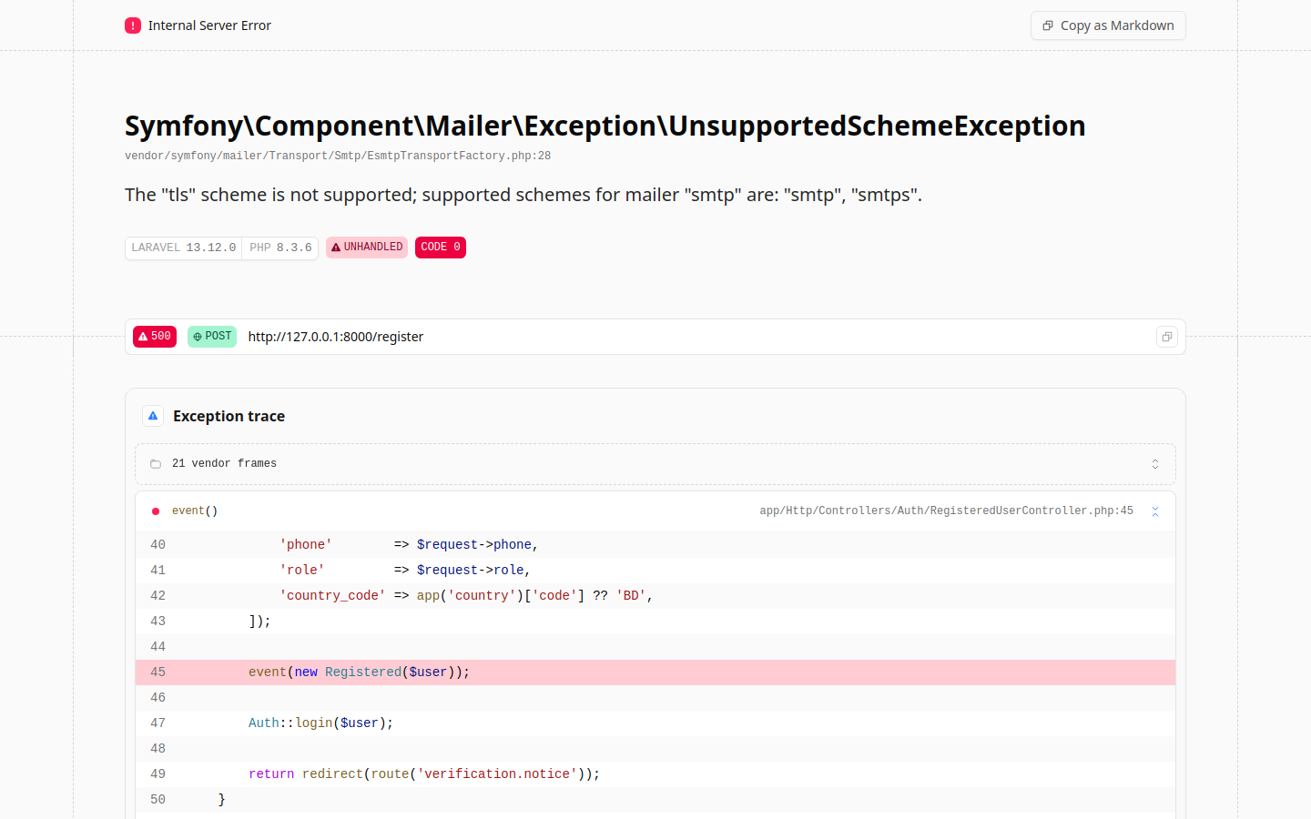
BUG-002 — Application debug mode exposes full stack traces, file paths and SQL to end users
Severity | High | Priority | P1
Module | Platform / Security Hardening | Linked TCs | SEC-02
Preconditions:
Any unhandled server error (e.g. trigger BUG-001).
Steps to Reproduce:
1. Trigger a server-side error (submit the registration form)
2. Observe the error response rendered to the browser
Expected Result:
A generic, branded error page (HTTP 500) with no internal detail.
Actual Result:
Laravel/Ignition debug page is shown with the framework version, full exception trace, source file paths (app/Http/Controllers/...), middleware names, and the executed SQL including the inserted user's email and bcrypt hash. This is sensitive information disclosure (APP_DEBUG=true in a reachable environment).
Supporting Evidence:
Rendered page includes 'LARAVEL 13.12.0', 'PHP 8.3.6', stack frames and the SQL: insert into "users" (...) values ('QA Renter Test', 'qa.renter1@rentora.test', ...).
Screenshot:

BUG-003 — Price-range filter on /search is broken — slider never renders, 20 JS console errors
Severity | High | Priority | P2
Module | Search & Discovery | Linked TCs | SRCH-01, SRCH-02
Preconditions:
Guest on http://127.0.0.1:8000/search.
Steps to Reproduce:
1. Open /search
2. Scroll to the 'Monthly Rent (৳)' filter under Filters
3. Open the browser developer console
Expected Result:
A dual-handle price slider renders with live ৳ min/max labels and filters results by rent.
Actual Result:
The slider does not render (only the heading appears). Alpine.js throws on every reactive expression: 'SyntaxError: Invalid or unexpected token', 'ReferenceError: fmt is not defined', 'lower/upper/loPct/hiPct is not defined' (20 console errors, 20 warnings). The compiled bundle (build/assets/app-*.js) is missing the helper functions/state the slider markup references, so renters cannot filter by budget — a primary rental search dimension.
Supporting Evidence:
Console: SyntaxError at app-Dumc3-yK.js:5:727; ReferenceError: fmt is not defined at [Alpine] fmt(lower); repeated for fmt(upper), loPct, hiPct, min, max.
Screenshot:
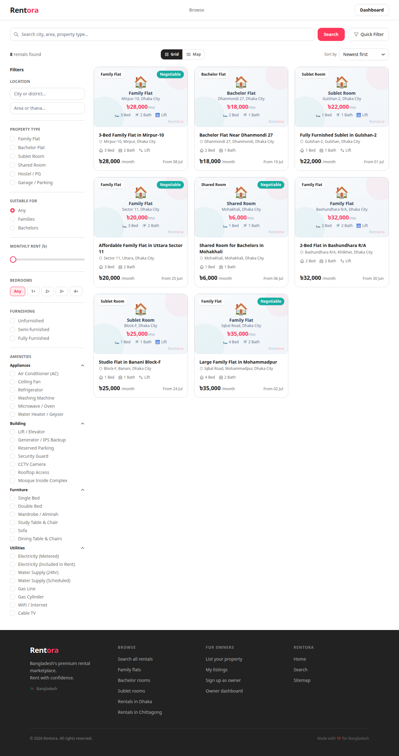

4. Improvement Recommendations

UX Improvements
- Show inline, field-level validation messages on register/login instead of relying on full-page reloads.
- Provide a visible empty-state and active-filter chips on /search so users understand why results changed.
- Surface the property 'views' counter and 'available from' date more prominently on cards.

Workflow Improvements
- Decouple email sending from the registration transaction — queue the verification email so a mail failure never blocks account creation (fixes BUG-001's blast radius).
- Allow renters limited browsing before email verification; gate only owner-contact actions behind verification.
- Add a 'save & resume' confirmation to the 10-step listing wizard (the caption promises it — verify it persists).

Validation Improvements
- Enforce and unit-test BD phone format (+8801XXXXXXXXX / 01XXXXXXXXX) on both client and server.
- Add boundary validation on the Pricing step (reject negative / non-numeric rent and deposit).
- Enforce a documented password policy and confirm it is consistent across register and reset flows.

Performance Improvements
- Eliminate the 20 console errors on /search — they indicate repeated failed Alpine effect evaluations on every render.
- Lazy-load property images and the map tile only when the Map view is activated.

Security Recommendations
- Set APP_DEBUG=false in any shared/staging/production environment and ship a custom 500 page (fixes BUG-002).
- Confirm passwords are hashed (observed bcrypt-style hash — keep it) and never logged.
- Add automated checks for IDOR on owner listing edit/delete and for CSRF on all state-changing POSTs.
- Verify banned users are rejected at login and existing sessions are invalidated.

Automation Recommendations
- Adopt this POM suite (pages = locators, actions = logic, specs = assertions) as the regression baseline; wire it into CI.
- Add data-testid attributes to key controls (price slider, wizard steps, result cards) to harden selectors.
- Seed a pre-verified renter via a factory/seeder so authenticated renter journeys can be automated despite BUG-001.
- Add visual-regression and accessibility (axe) checks to the guest browsing specs.

Maintainability Suggestions
- Keep test-case inventory in data/testcases.js as the single source for Excel + report + specs (already done).
- Pin the seeded slugs/credentials in config so specs do not hard-code environment data.
- Run the suite headless in CI with the html + json reporters archived as build artifacts.

5. Risk Assessment
High-Risk Areas
- Renter self-onboarding is completely blocked (BUG-001 + email verification gate) — no new renter can use the platform.
- Sensitive information disclosure via debug stack traces (BUG-002) if this build reaches a public environment.
Medium-Risk Areas
- Budget-based search is unusable (BUG-003), undermining the core discovery experience.
- End-to-end owner→admin→publish flow and admin approve/reject were validated structurally but not executed E2E (manual TCs OWN-05, ADM-03/04).
- Email-dependent flows (verification, password reset, resend) are untested because the mailer is broken.
Low-Risk Areas
- Map view is not configured (GOOGLE_MAPS_API_KEY) — acceptable for local but should be tracked.
- Minor selector fragility where data-testids are absent.

6. Overall QA Assessment

Application Readiness
The platform's foundations are solid: role separation and route guards are correctly enforced, the public catalogue and property pages render well, owner/admin dashboards are functional, and owner contact PII is properly gated behind authentication. However, the new-user onboarding path is broken end-to-end and the environment leaks internal detail on error.

Release Recommendation
NO-GO for production in the current state.
Blockers: BUG-001 (registration HTTP 500 — no renter can sign up) and BUG-002 (debug-mode information disclosure). BUG-003 (broken budget filter) should be fixed before any marketing of search. Re-run this automated suite after fixes; a green run plus execution of the manual E2E set (owner→admin→publish, email flows) is the recommended exit criteria.

Testing Coverage Summary
58 test cases designed across 7 modules; 39 automated (34 passed, 5 failed); 19 manual/E2E cases documented for the next cycle. All 3 defects are reproduced by automated tests and captured with screenshot evidence.

