Rentora — Bug Report
Defects from End-to-End Testing (Guest · Renter · Owner · Admin)
Playwright-MCP live analysis · Desktop 1920×1200 + Responsive (768 / 375) · 26 Jun 2026

Summary
6 defects were captured across all roles. Two are release-blockers (registration crash and debug-mode disclosure). The single broken /search price-slider component is responsible for both the missing budget filter and all 20 console errors on that page.
Severity | Count | IDs
Critical | 1 | BUG-001
High | 2 | BUG-002, BUG-003
Low | 2 | BUG-004, BUG-005
Trivial | 1 | BUG-006

Test execution — headed rerun (1920×1200)
The full automated suite was re-run in the live headed browser at 1920×1200 to match the current configuration. 160 of 163 tests passed (98%) in 8.8 minutes. The 3 failures are itemised below; two are app defects (BUG-003) and one is a test-data artefact, not an application bug.
Result | Count
Passed | 160
Failed | 3
Total | 163
Failed test | Classification | Maps to
SRCH-01 price-range slider renders and is operable | App defect | BUG-003
SRCH-02 no JavaScript console errors on /search | App defect | BUG-003
AUTH-12 unverified renter gated at /verify-email | Test-data / config (not an app bug) | Env note below
AUTH-12 note: the test signs in as the configured renter and expects the /verify-email gate, but .env contains a duplicate RENTER_EMAIL — the last value (a verified account) overrides the intended unverified renter (qa.renter1@rentora.test), so login lands on /renter/dashboard instead. Fix: remove the duplicate RENTER_EMAIL/RENTER_PASSWORD pair from .env so the unverified seed account is used. No application change required.

Defect index
ID | Title | Severity | Role
BUG-001 | User registration crashes with HTTP 500 (mailer scheme misconfiguration) | Critical | Guest → Renter
BUG-002 | Debug mode exposes full stack traces, file paths and SQL to end users | High | Any
BUG-003 | Price-range filter on /search never renders — 20 JS console errors | High | Guest / Renter
BUG-004 | Search filters silently accept invalid input instead of validating it | Low | Guest / Renter
BUG-005 | Admin Users role breakdown does not reconcile with the total | Low | Admin
BUG-006 | Header “Browse” link is inconsistent across breakpoints | Trivial | Guest

Defect Details
BUG-001 — User registration crashes with HTTP 500 (mailer scheme misconfiguration)
Severity | Critical | Priority | P1
Module | Authentication / Onboarding | Role | Guest → Renter
Preconditions:
App running; guest on /register with valid form data.
Steps to Reproduce:
1. Open http://127.0.0.1:8000/register
2. Fill Full Name, Email, Phone (01XXXXXXXXX), Password, Confirm Password
3. Select ‘Find a rental’, accept Terms
4. Click ‘Create account’
Expected Result:
Account is created, the user is logged in, and redirected to the email-verification notice.
Actual Result:
The user row IS inserted, but event(new Registered($user)) throws Symfony Mailer UnsupportedSchemeException: “The "tls" scheme is not supported; supported schemes for mailer "smtp" are: "smtp", "smtps".” The request returns HTTP 500, Auth::login() never runs, and the user is left on a stack-trace page. Combined with BUG-002 this blocks 100% of renter self-onboarding.
Supporting Evidence:
RegisteredUserController.php:45 event(new Registered($user)) → EsmtpTransportFactory. DB log confirms the user INSERT succeeded before the crash.
Screenshot:
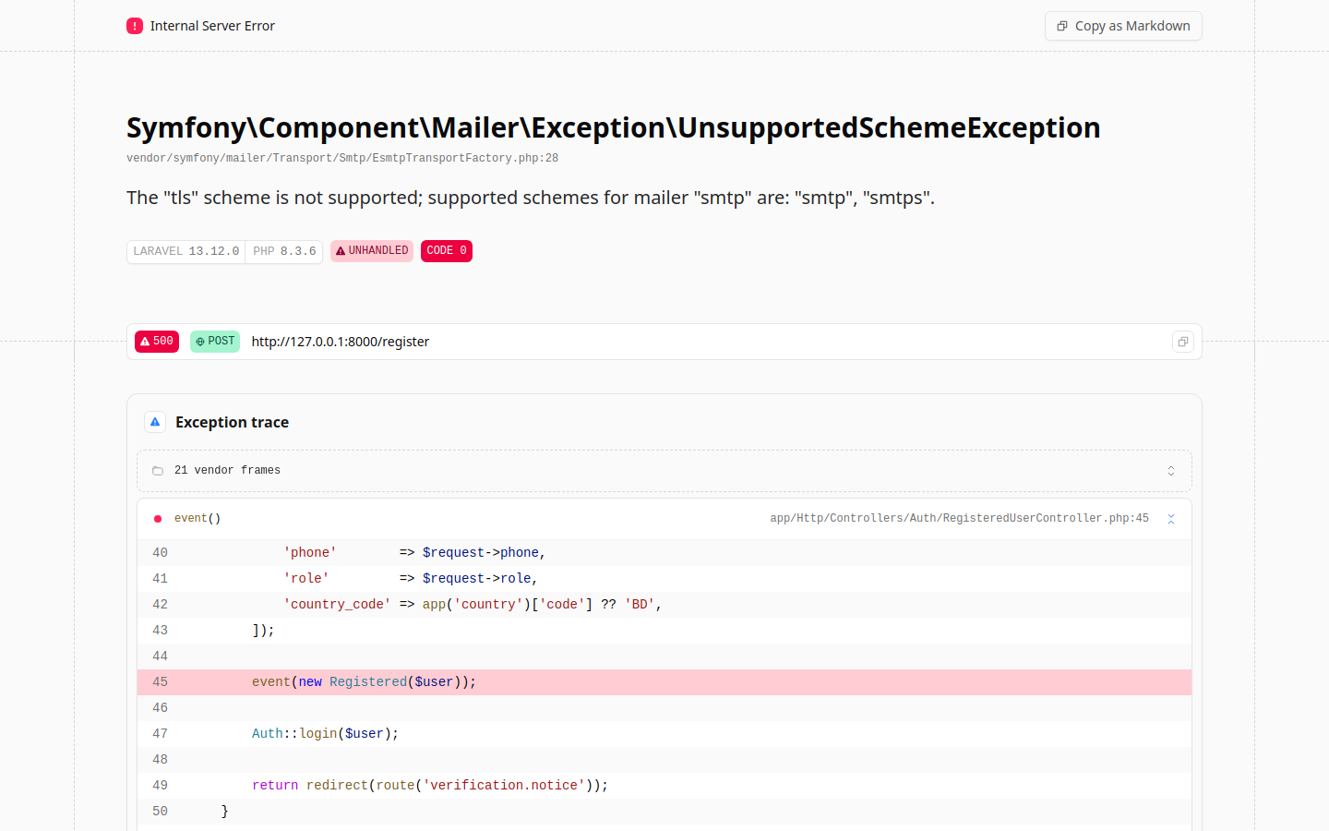
BUG-002 — Debug mode exposes full stack traces, file paths and SQL to end users
Severity | High | Priority | P1
Module | Platform / Security Hardening | Role | Any
Preconditions:
Any unhandled server error (e.g. trigger BUG-001).
Steps to Reproduce:
1. Trigger a server-side error (submit the registration form)
2. Observe the error response rendered to the browser
Expected Result:
A generic, branded HTTP 500 page with no internal detail.
Actual Result:
Laravel/Ignition debug page is shown with framework version, full exception trace, source file paths (app/Http/Controllers/...), middleware names, and the executed SQL including the inserted user’s email and bcrypt hash. Sensitive information disclosure (APP_DEBUG=true in a reachable environment).
Supporting Evidence:
Rendered page includes ‘LARAVEL 13.12.0’, ‘PHP 8.3.6’, stack frames and the insert-into-users SQL with the user email + hash.
Screenshot:

BUG-003 — Price-range filter on /search never renders — 20 JS console errors
Severity | High | Priority | P2
Module | Search & Discovery | Role | Guest / Renter
Preconditions:
Guest on http://127.0.0.1:8000/search (desktop, tablet or mobile).
Steps to Reproduce:
1. Open /search
2. Scroll to the ‘Monthly Rent (৳)’ filter in the sidebar
3. Open the browser developer console
Expected Result:
A dual-handle price slider renders with live ৳ min/max labels and filters results by rent.
Actual Result:
Only the ‘Monthly Rent (৳)’ heading renders; the slider is absent (input[type=range] count = 0). The inline Alpine.js x-data component fails to compile (SyntaxError: Invalid or unexpected token at app-Dumc3-yK.js), so every binding throws ReferenceError: fmt / lower / upper / loPct / hiPct is not defined — 20 console errors + 20 warnings on every render. ‘fmt’ is referenced by the markup but never defined in the component. Renters cannot filter by budget from the UI. Reproduced at 1920×1200, 768 and 375.
Supporting Evidence:
Console: SyntaxError at app-Dumc3-yK.js:5:727; ReferenceError: fmt is not defined (×6), loPct (×4), lower/upper/hiPct. input[type=range].length === 0.
Screenshot:
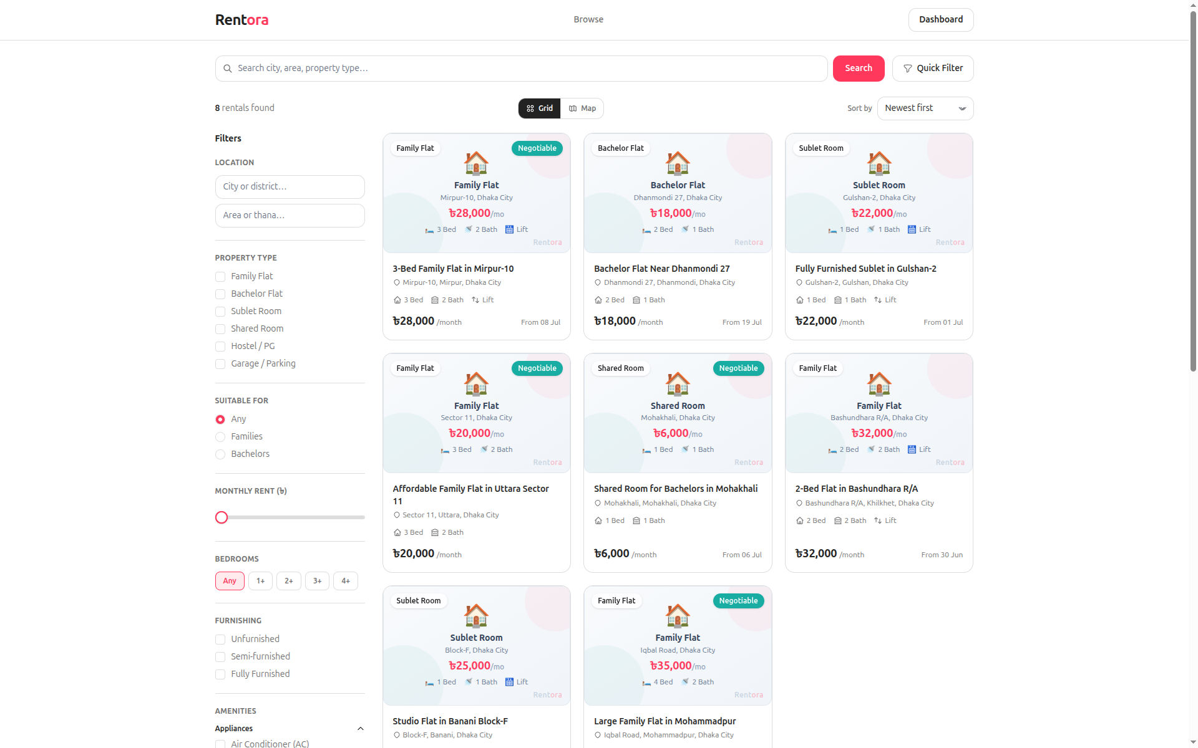
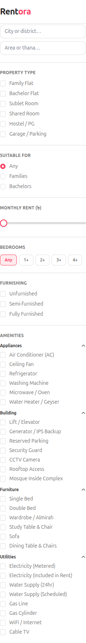
Sidebar close-up: the blank gap under “Monthly Rent (৳)” where the slider should be.
BUG-004 — Search filters silently accept invalid input instead of validating it
Severity | Low | Priority | P3
Module | Search & Discovery | Role | Guest / Renter
Preconditions:
Guest on http://127.0.0.1:8000/search.
Steps to Reproduce:
1. Open /search?min_price=-100 (negative)
2. Open /search?min_price=abc (non-numeric)
3. Open /search?max_price=0 (zero ceiling)
4. Read the ‘N rentals found’ counter for each
Expected Result:
Invalid / out-of-range filter values are rejected or normalised with visible feedback (e.g. ignored AND flagged, or HTTP 422).
Actual Result:
All three return HTTP 200 and silently drop the filter: min_price=-100 and min_price=abc each return the full catalogue (8 of 8), and max_price=0 is treated as ‘no maximum’ (8 of 8) rather than ‘rent ≤ 0’. The query string still carries the bogus value, so the result set contradicts the apparent filter with no message. Graceful (no crash) but unvalidated.
Supporting Evidence:
Probed live: min_price=-100 → 8 found; min_price=abc → 8 found; max_price=0 → 8 found. Valid boundary min_price=6001 → 7 found.
Screenshot:
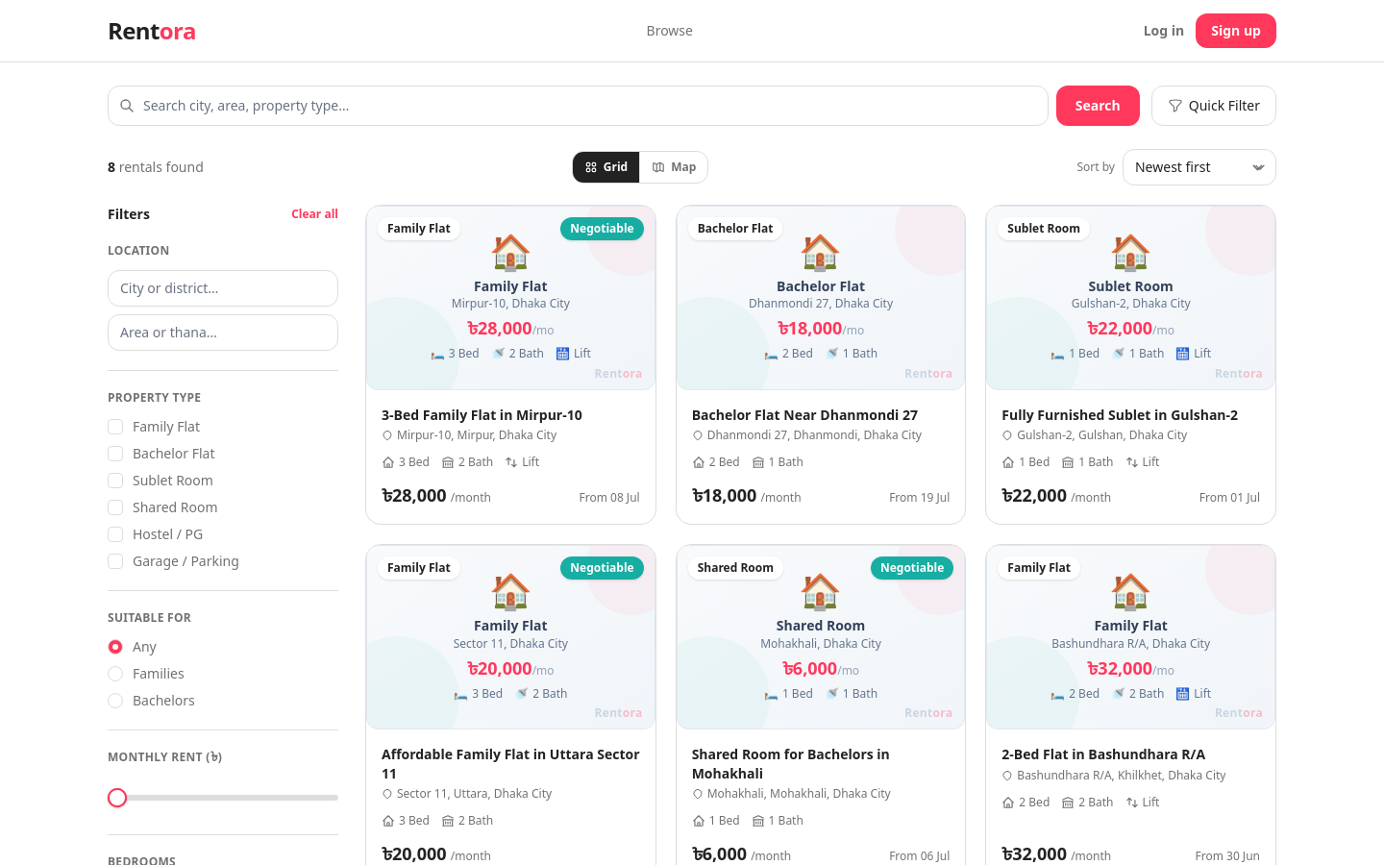
BUG-005 — Admin Users role breakdown does not reconcile with the total
Severity | Low | Priority | P4
Module | Admin / Users | Role | Admin
Preconditions:
Logged in as admin at http://localhost:8000/admin/users.
Steps to Reproduce:
1. Open Admin → Users
2. Read the count summary under the page title
Expected Result:
The role breakdown reconciles with the stated total (all roles accounted for).
Actual Result:
Header reads “55 total · 2 owners · 52 renters”, which sums to 54 — the admin account(s) are excluded from the role breakdown, so the figures don’t add up. Cosmetic but undermines trust in the dashboard numbers.
Supporting Evidence:
Live read of the Users header: 55 total, 2 owners, 52 renters (2 + 52 = 54).
Screenshot:
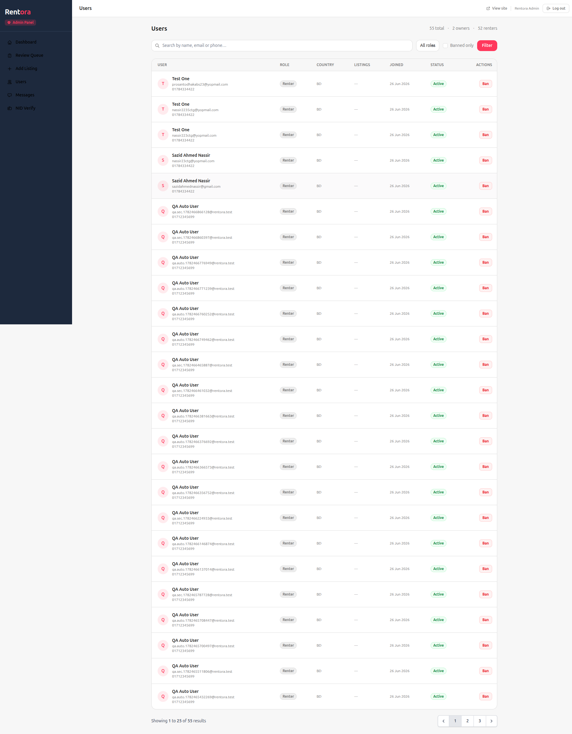
BUG-006 — Header “Browse” link is inconsistent across breakpoints
Severity | Trivial | Priority | P4
Module | Public Header / IA | Role | Guest
Preconditions:
Guest on http://127.0.0.1:8000 at desktop vs mobile widths.
Steps to Reproduce:
1. Load the home page at 1920px — note the header nav
2. Resize to 375px and open the mobile drawer — compare links
Expected Result:
Primary navigation is consistent across breakpoints.
Actual Result:
The desktop header shows a “Browse” link (→ /search), but the mobile drawer omits it entirely (only Log in / Sign up). The destination is already reachable from the hero search, city cards, “View all” links and the footer, so the link is redundant on desktop and missing on mobile. (See Recommendation R1 — remove it, or rename to “Search rentals” and add to the drawer.)
Supporting Evidence:
Desktop header nav = [Browse]; mobile drawer links = [Log in, Sign up] (no Browse). Footer already has a full Browse column.
Screenshot:
