Rentora — UI/UX Recommendations Report
End-to-End Testing across Guest, Renter, Owner & Admin roles
Playwright-MCP live analysis · Desktop 1920×1080 + Responsive (768 / 375) · 26 Jun 2026

1. Scope & Test Environment
The live application was driven end-to-end with the Playwright MCP browser across every role. The desktop pass ran at full-screen 1920×1080; a responsiveness sweep was then run at tablet (768×1024) and mobile (375×812). This report contains four targeted recommendations requested for this cycle (remove Browse from the header, fix the search sidebar filter, clear the console report, update the admin UI), plus the responsiveness findings.
Item | Detail
Renter / Owner host | http://127.0.0.1:8000
Admin host | http://localhost:8000/admin/dashboard
Roles exercised | Guest · Renter · Owner (owner1@rentora.test) · Admin (admin@rentora.com.bd)
Viewports | Desktop 1920×1080 · Tablet 768×1024 · Mobile 375×812
Seed data | 8 approved listings · 55 users · 2 owners

1.1 Recommendations at a glance
# | Recommendation | Area | Priority
R1 | Remove “Browse” from the header | Public header / IA | Low
R2 | Fix the /search sidebar “Monthly Rent” price slider | Search & Discovery | High
R3 | Clear the 20 console errors on /search | Front-end health | High
R4 | Update / polish the Admin UI | Admin portal | Medium
R5 | Responsiveness refinements (tablet / mobile) | Cross-cutting | Medium

2. R1 — Remove “Browse” from the header
Area | Priority | Effort | Status
Public header / Information Architecture | Low | Trivial (1 template edit) | Confirmed live
Finding
The global header renders a single primary navigation link, “Browse” (→ /search), next to the Rentora brand and the Log in / Sign up actions. Its destination is already reachable from several more prominent places, so the link adds navigational noise without adding a new destination.
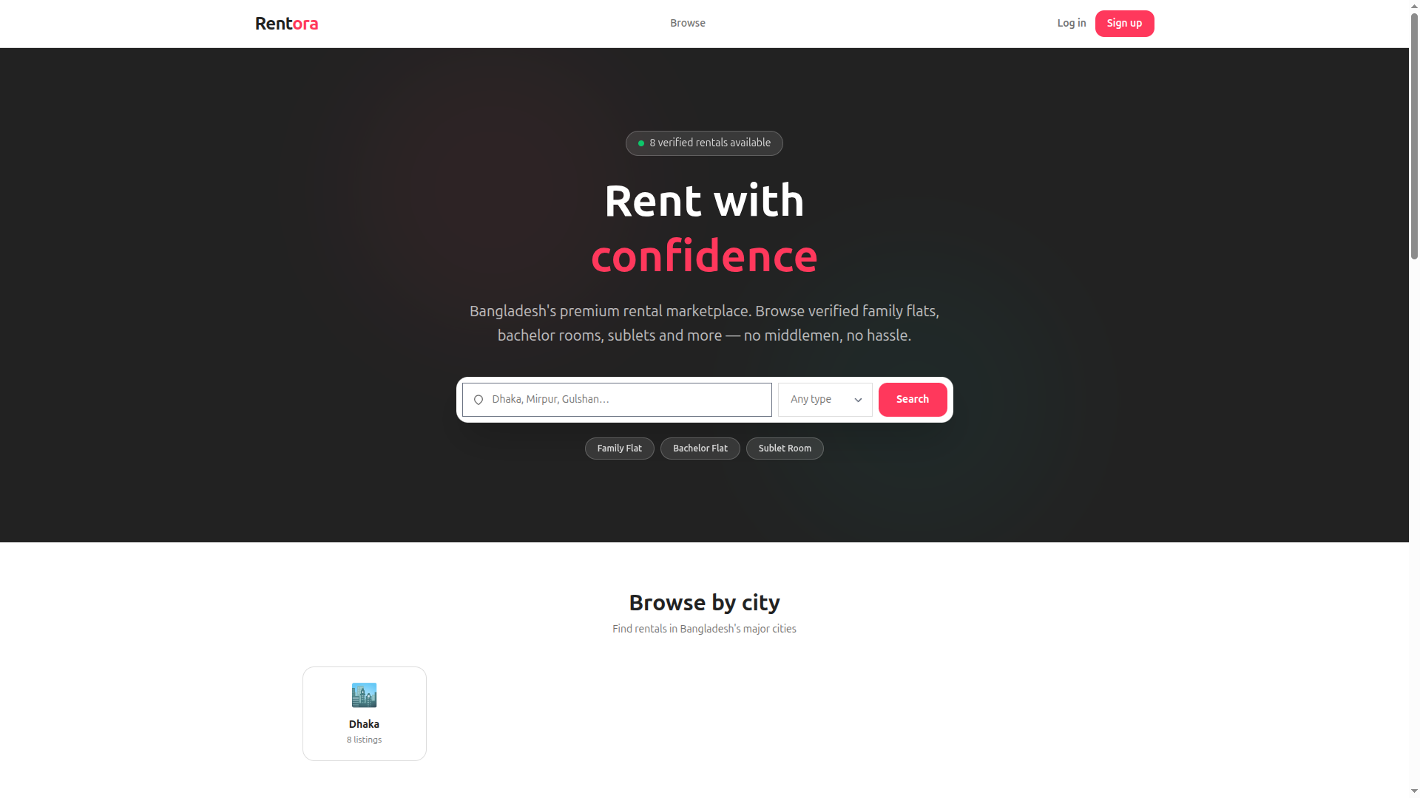
REC-01 — Desktop header at 1920×1080: “Browse” sits between the brand and the auth actions.
Why remove it
- Redundant destination — the hero search bar, the “Find a rental” CTA, the city cards, every “View all” link and the footer “Browse” column all already route to /search.
- “Browse” is a vague label; the prominent hero search communicates the same intent more clearly.
- Inconsistent across breakpoints — the mobile drawer does NOT include “Browse” (it shows only Log in / Sign up), so the link only exists on desktop. Removing it makes the header consistent everywhere.
- A cleaner top bar (brand + auth only) sharpens the primary call-to-action for guests: sign up / log in.
Recommendation
- Remove the “Browse” link from the desktop top navigation (the <nav> inside the banner).
- Keep discovery via the hero search, the “Find a rental” CTA and the footer “Browse” column.
- If a top-level discovery link is still wanted, rename it to “Search rentals” and add it to the mobile drawer too, so desktop and mobile match.

3. R2 — Fix the /search sidebar “Monthly Rent” price filter
Area | Priority | Severity | Linked bug
Search & Discovery | High | Functional defect | BUG-003
Finding
In the Filters sidebar on /search, the “Monthly Rent (৳)” section renders only its heading — the dual-handle price slider never appears. A live DOM probe returns zero range inputs (document.querySelectorAll('input[type=range]').length === 0). Reproduced at desktop, tablet and mobile. Renters therefore have no UI control to filter by budget, a primary rental search dimension.
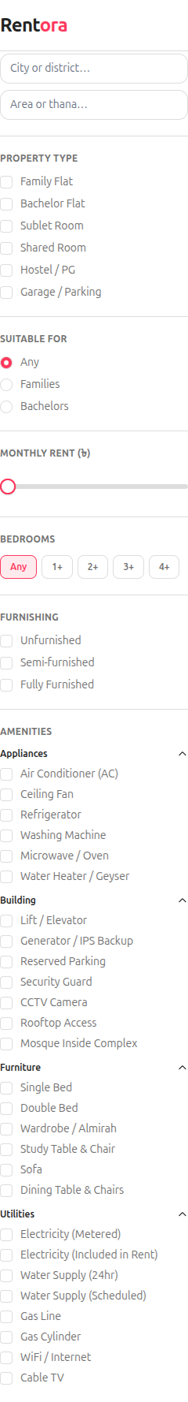
REC-02 — Filters sidebar: the gap under “Monthly Rent (৳)” is where the slider should render. Every other filter (Type, Suitable For, Bedrooms, Furnishing, Amenities) renders correctly.
Root cause
The price filter is an Alpine.js component declared inline via a multi-line x-data attribute that defines min/max/step/lower/upper plus getters loPct/hiPct and methods snap()/startDrag(). The compiled bundle (build/assets/app-Dumc3-yK.js) throws a SyntaxError while compiling that expression in a new AsyncFunction, so the component never initialises. Consequently every binding that reads its scope throws ReferenceError. Note the markup also calls fmt(...) which is not defined anywhere in the x-data object — so even after the SyntaxError is fixed, ‘fmt is not defined’ will remain.
x-data="{ min:6000, max:35000, step:1000, lower:6000, upper:35000,
get loPct(){...}, get hiPct(){...}, snap(v){...}, startDrag(h,e){...} }"
// referenced by bindings but never defined → fmt(lower), fmt(upper), fmt(min), fmt(max)
Recommendation
- Move the slider out of the inline x-data into a registered Alpine.data('priceSlider', () => ({...})) factory in a source module, then rebuild the asset — inline multi-line x-data with getters is exactly what the SyntaxError points at.
- Define the missing fmt currency helper on the component scope (or as an Alpine.magic('fmt')).
- Add a no-JS fallback: two numeric min/max inputs bound to min_price / max_price so budget filtering still works if Alpine fails to boot.
- Add data-testid on the slider handles so the regression suite can assert it renders.
Note: the server-side filter itself works (e.g. /search?min_price=6001 → 7 of 8 results). Only the on-page control is missing.

4. R3 — Console report: eliminate the 20 errors on /search
Area | Priority | Count | Scope
Front-end health | High | 20 errors + 20 warnings | /search only
Finding
Loading /search prints 20 console errors and 20 warnings on every render. All of them originate from the broken price-slider component (same root cause as R2). The home, owner and admin pages are clean (0 console errors), so the problem is isolated to /search. Because the errors fire on every Alpine effect re-evaluation — not once — they waste CPU and bury any genuine future errors in noise.
Console error breakdown (captured live):
Error | Count | Origin
SyntaxError: Invalid or unexpected token | 2 | AsyncFunction compile of price x-data
ReferenceError: fmt is not defined | 6 | fmt(lower/upper/min/max) bindings
ReferenceError: loPct is not defined | 4 | :style track / handle position
ReferenceError: lower is not defined | 2 | x-text lower label
ReferenceError: upper is not defined | 2 | x-text upper label
ReferenceError: hiPct is not defined | 2 | :style handle position
Total | 20 | All from the one slider component
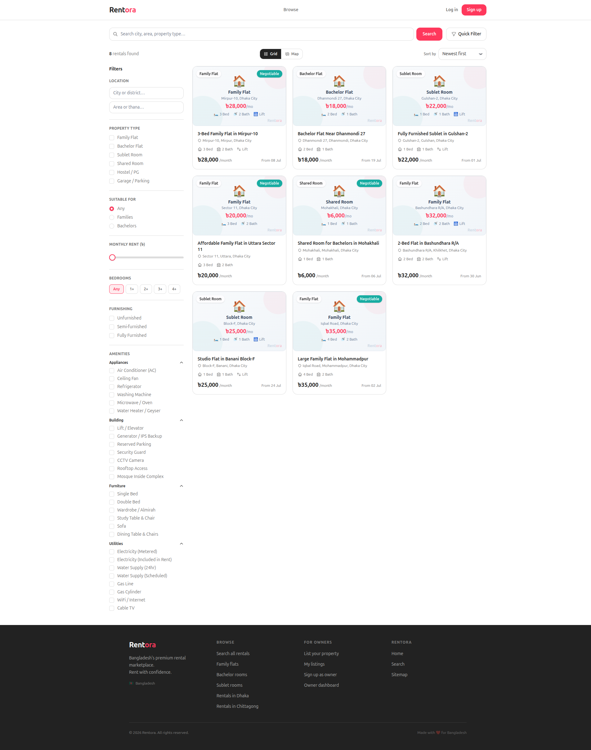
REC-02 (full page) — /search renders fine visually, but the page header reports “20 errors, 20 warnings”; the slider area is blank.
Recommendation
- Fixing R2 removes all 20 errors — they share one root cause.
- Keep the existing console-health spec as a CI regression gate: assert zero console errors on /search.
- Add a client-side error monitor (e.g. Sentry) in staging so build-time bundle breakages are caught before release.

5. R4 — Update the Admin UI
Area | Priority | Console | Responsive
Admin portal | Medium | 0 errors | Yes
Finding
The admin portal (Dashboard, Review Queue, Add Listing, Users, Messages, NID Verify) is functional, clean and responsive, with no console errors. The items below are polish / usability improvements, not blockers.
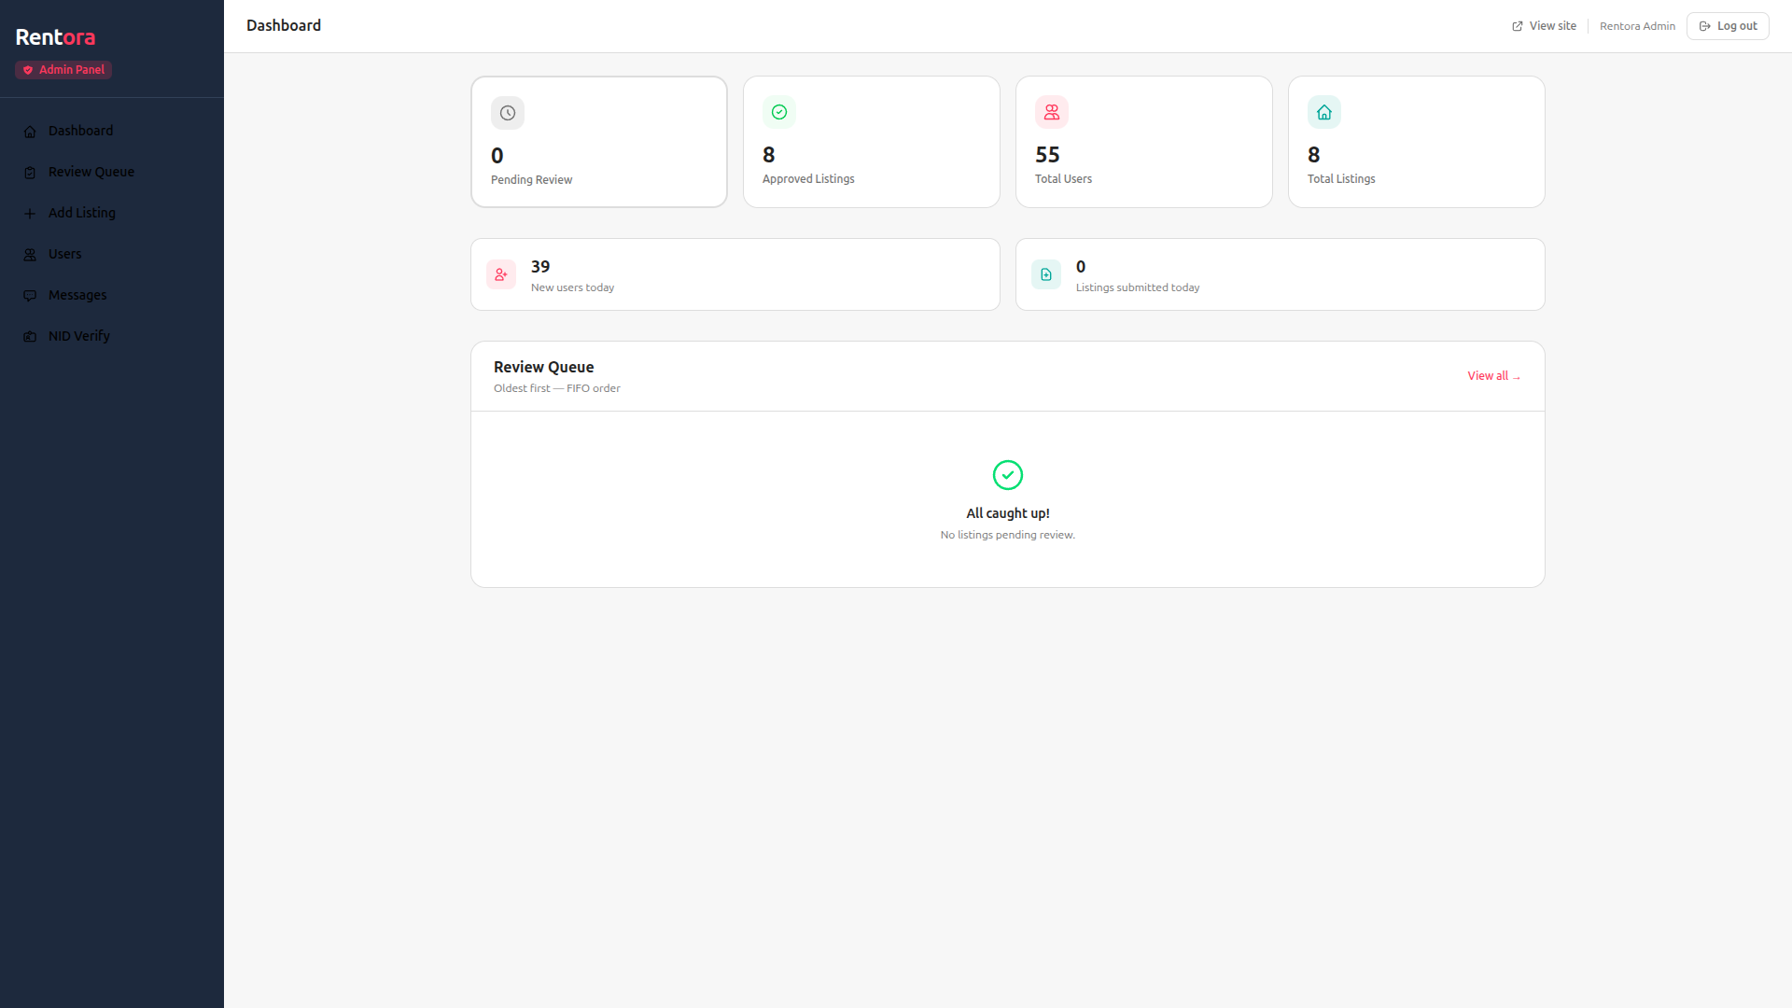
REC-04 — Admin dashboard: KPI cards + FIFO review queue. Note “39 New users today”, inflated by automated test accounts.
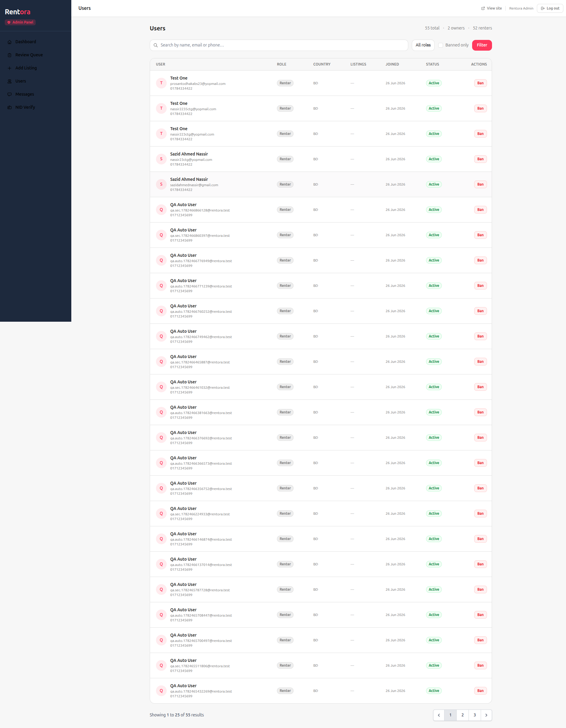
REC-04b — Users table: search, role filter, banned-only filter, pagination (55 users). Header reads “55 total · 2 owners · 52 renters” (= 54; admins omitted).
Recommended improvements
# | Issue | Recommendation
1 | User-count math: “55 total · 2 owners · 52 renters” sums to 54 — admin accounts excluded. | Show all role buckets (incl. Admins) or relabel “by role (excl. admins)” so the numbers reconcile.
2 | Test-data pollution: dozens of qa.auto.* / qa.sec.* rows and “39 new today” dominate the Users table. | Add a “hide test accounts” toggle (or tag/filter seeded accounts) so real signal isn’t buried.
3 | No user drill-down: the only row action is “Ban”; banned users have no visible “Unban”. | Add a user-detail drawer (listings, messages, NID status) and an Unban action.
4 | No bulk actions / sorting on a growing table (55+ and climbing). | Add column sort (Joined, Role) and bulk select → ban / export CSV.
5 | Inconsistent CTA labels (“Add Listing” vs “Create Sample”). | Standardise to a single primary label across dashboard and listings.
6 | Empty states: “No listings found” gives no next step. | Add a helpful empty-state CTA (e.g. “Create a listing” / change filter).
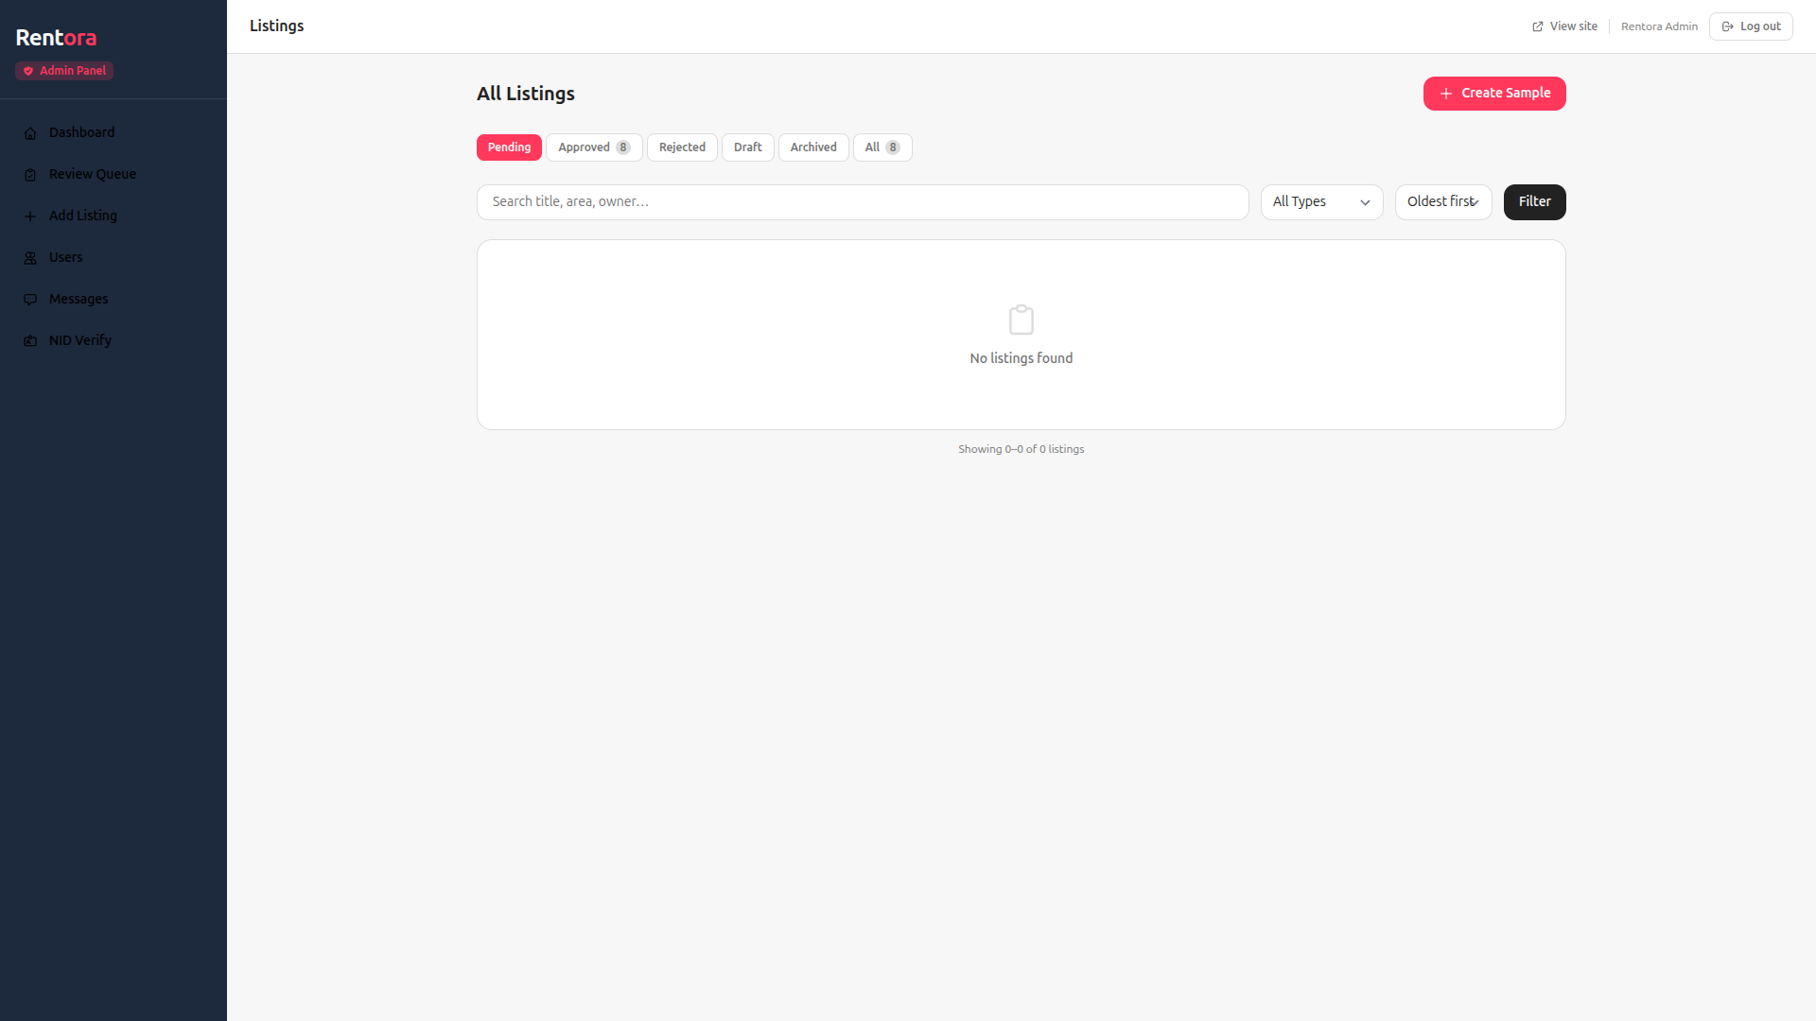
REC-04c — Review Queue with status tabs (Pending / Approved 8 / Rejected / Draft / Archived / All). Functional; benefits from the empty-state CTA above.

6. Role-wise core-feature verification
Each role’s core journeys were exercised live in the headed browser. Every authenticated surface is clean (0 console errors); only the public /search page carries the 20 slider errors (R2/R3). Guest→renter self-registration remains blocked by BUG-001 (mailer 500).
Role | Core surfaces verified | Console | Result
Guest | Home, /search catalogue, property detail, property-type quick filter, city landing page, 404 handling | 20 on /search | Pass*
Renter | /renter/dashboard (Saved · Messages · Verification · Profile), property detail with “Save listing” + “Message Owner”, owner phone PII-gated | 0 | Pass
Owner | /owner/dashboard KPIs, My Listings, 10-step Add-Listing wizard (Continue gated until valid), Profile | 0 | Pass
Admin | /admin/dashboard KPIs, Review Queue (status tabs), Users (search · role filter · ban · pagination), NID Verify, Messages | 0 | Pass
* Guest passes functionally; the /search slider defect (R2/R3) is the only blemish on the public path.
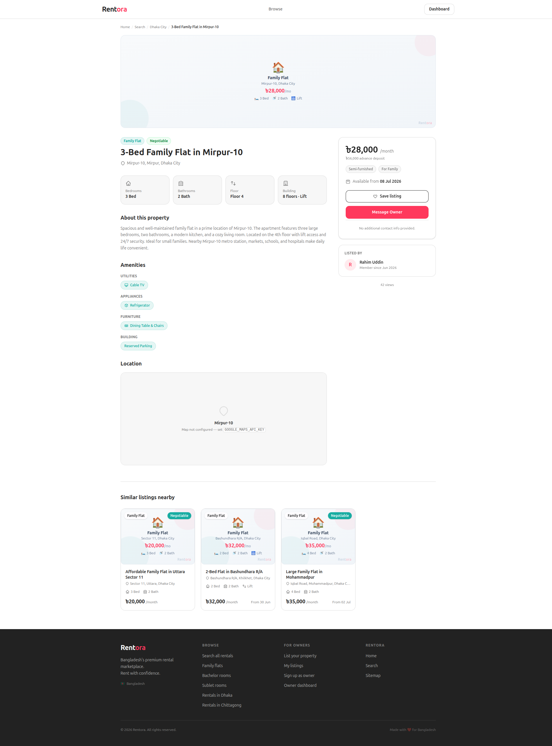
Renter — property detail: “Save listing” and “Message Owner” available; the owner’s phone is correctly hidden (PII-gated) until contact.
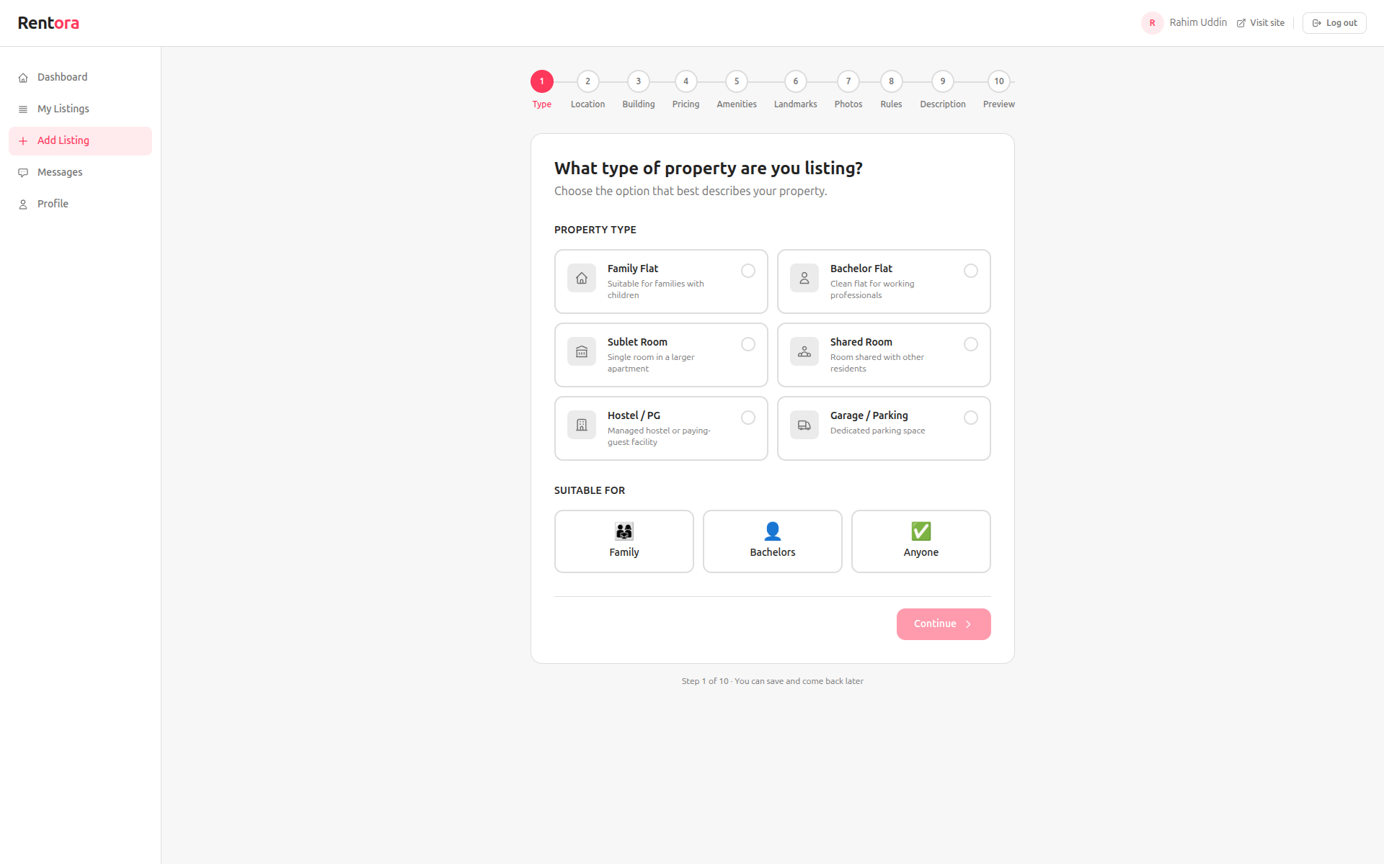
Owner — 10-step Add-Listing wizard (Type → Preview); “Continue” stays disabled until a property type + audience are chosen, and the flow promises save-and-resume.
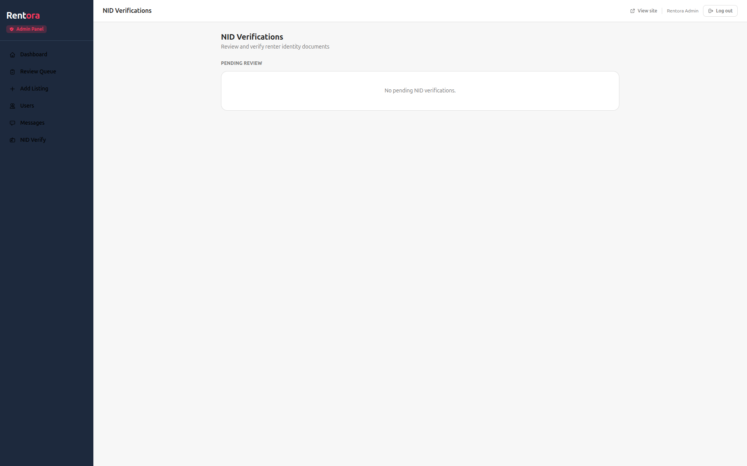
Admin — NID Verify queue; loads cleanly with 0 console errors.

7. R5 — Responsiveness findings
Each surface was re-tested at tablet (768×1024) and mobile (375×812). Overall the responsive behaviour is solid — proper breakpoints, collapsing navigation, and no horizontal overflow (admin documentScrollWidth 360 ≤ 375). Two nits and one carry-over bug are noted.
Surface | Desktop 1920 | Tablet 768 | Mobile 375 | Verdict
Home (guest) | Full header | Hamburger + drawer | Hamburger + drawer (Alpine OK, 0 errors) | Pass
Search (guest) | 2-col sidebar + grid | Sidebar → Filters drawer | Single col + Filters drawer | Pass*
Admin | Fixed sidebar | Collapses | Off-canvas drawer, no overflow | Pass
Renter dashboard | Sidebar + content | Reflows | Sidebar collapses, no overflow (scrollWidth 360) | Pass
Owner | Sidebar + content | — | Same shell as renter/admin | Desktop OK
* Search reflows correctly, but the price slider is missing at every breakpoint (R2).
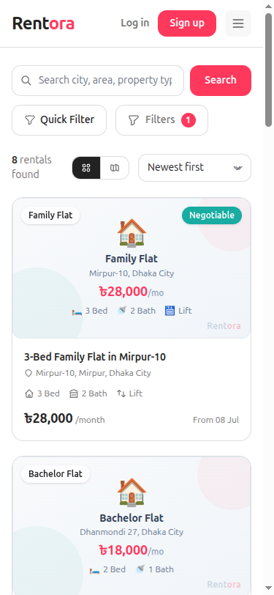
RESP-02 — Search at 375px: sidebar collapses, filters move into a Quick Filter / Filters drawer. Layout reflows cleanly.
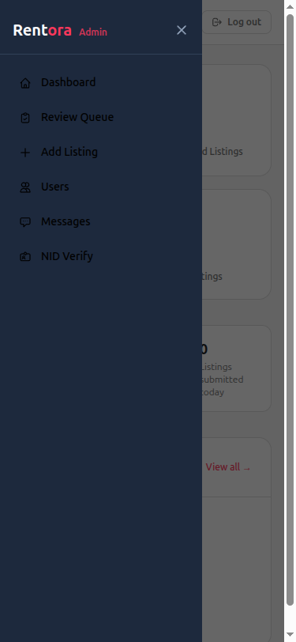
RESP-04b — Admin at 375px with the off-canvas nav drawer open; no horizontal overflow.
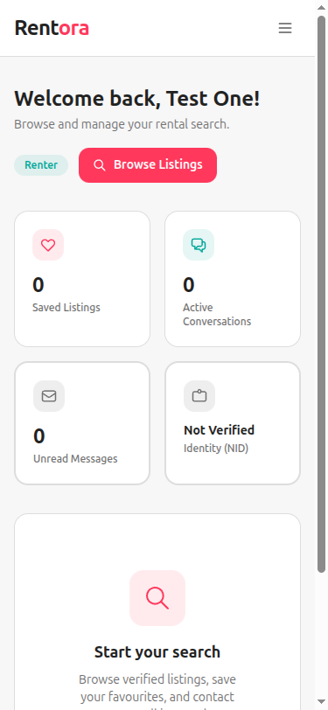
Renter dashboard at 375px: sidebar collapses, KPI cards stack, no horizontal overflow.
Responsiveness recommendations
- Add “Browse”/“Search rentals” to the mobile drawer for parity with desktop (ties to R1).
- Ensure the fixed price-slider (R2) also renders inside the mobile Filters drawer once rebuilt.
- Run the owner portal through the same 768 / 375 sweep before release (not deep-tested this cycle).

8. Summary
Two recommendations (R2 + R3) share a single root cause — the broken /search price-slider Alpine component — and fixing that one bundle issue resolves both the missing filter and all 20 console errors. R1 is a trivial header cleanup, R4 is admin-UI polish, and R5 confirms the responsive layout is healthy bar the carry-over slider bug. Defects are itemised with reproduction steps in the companion Bug Report.
Rec | Effort | Impact | Priority
R1 Remove Browse | Trivial | Cleaner IA / consistency | Low
R2 Fix price slider | Medium | Restores budget filtering | High
R3 Clear console | Medium (= R2) | Front-end health / CI gate | High
R4 Admin UI | Medium | Admin usability at scale | Medium
R5 Responsive | Low | Parity / polish | Medium

