Rentora — Role-Based QA Report
Coverage, Findings & Verdict per Role — Guest · Renter · Owner · Admin
Playwright-MCP live analysis · Desktop 1920×1200 maximised + Responsive (768 / 375) · 27 Jun 2026

Executive Summary
Each role was driven end-to-end in a maximised headed browser, then swept at tablet and mobile widths. The table below summarises coverage and the live automated pass/fail per role; blocking defects are called out in each chapter.
Role | Login | TCs (auto/total) | Pass | Fail | Blocking defects
Guest | None | 135/141 | 133 | 2 | BUG-003, BUG-004, BUG-006
Renter | qa.renter1@rentora.test | 11/14 | 10 | 1 | BUG-001, BUG-002
Owner | owner1@rentora.test | 5/8 | 5 | 0 | BUG-007
Admin | admin@rentora.com.bd | 8/12 | 7 | 1 | BUG-007, BUG-005
Cross-role | — | 6/10 | 6 | 0 | BUG-002

1. Guest — unauthenticated visitor
Host | http://127.0.0.1:8000 | Login | None (public browsing)
Automated | 135 of 141 TCs | Result | 133 pass · 2 fail
Surfaces verified
- Home / landing page
- Property search /search with all filters (price, type, bedrooms, furnishing, amenities)
- Property detail page
- Registration & login entry points
Coverage by module
Module | Total | Automated | Pass | Fail
GuestBrowsing | 11 | 9 | 9 | 0
SearchFilters | 6 | 2 | 0 | 2
SearchMatrix | 80 | 80 | 80 | 0
BoundaryEquivalence | 21 | 21 | 21 | 0
FormValidation | 23 | 23 | 23 | 0
Failing TCs (live): SRCH-01, SRCH-02
Defects affecting this role
- BUG-003 — price-range slider never renders (20 console errors)
- BUG-004 — search filters accept invalid input silently
- BUG-006 — header “Browse” inconsistent across breakpoints
Verdict
Browsing and the server-side search work, but the budget-filter UI is broken (BUG-003) and filter inputs are unvalidated (BUG-004).

2. Renter — registered seeker
Host | http://127.0.0.1:8000 | Login | qa.renter1@rentora.test (unverified seed) · a verified seed renter
Automated | 11 of 14 TCs | Result | 10 pass · 1 fail
Surfaces verified
- Account registration
- Login
- Email-verification gate (/verify-email)
- Renter dashboard
- Owner-contact / messaging (verification-gated)
Coverage by module
Module | Total | Automated | Pass | Fail
Authentication | 14 | 11 | 10 | 1
Failing TCs (live): AUTH-12
Defects affecting this role
- BUG-001 — registration returns HTTP 500 (mailer misconfig), blocking 100% of self-onboarding
- BUG-002 — debug stack-trace / SQL disclosure on that error
Verdict
Renter self-onboarding is blocked by BUG-001 plus the verification gate; only pre-seeded renters can browse authenticated surfaces.

3. Owner — property lister
Host | http://127.0.0.1:8000 | Login | owner1@rentora.test
Automated | 5 of 8 TCs | Result | 5 pass · 0 fail
Surfaces verified
- Owner dashboard
- My Listings
- 10-step Add-Listing wizard (Type → Location → Building → Pricing → Amenities → Landmarks → Photos → Rules → Description → Preview)
- Messages
- Profile
Coverage by module
Module | Total | Automated | Pass | Fail
OwnerPortal | 8 | 5 | 5 | 0
Defects affecting this role
- BUG-007 — photo upload returns HTTP 501 (Cloudinary not configured). Confirmed live by completing the wizard to step 7; the “minimum 3 photos” gate hard-blocks listing completion unless the placeholder is used.
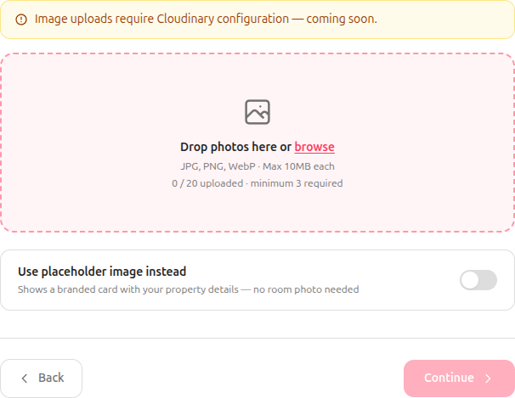
Owner wizard step 7 — photo upload 501 with the ‘minimum 3 required’ gate.
Verdict
Dashboard and the wizard work through step 6; step 7 (Photos) is hard-blocked by BUG-007 unless the owner falls back to the placeholder image.

4. Admin — platform moderator
Host | http://localhost:8000/admin | Login | admin@rentora.com.bd
Automated | 8 of 12 TCs | Result | 7 pass · 1 fail
Surfaces verified
- Dashboard KPIs
- Review Queue (FIFO approve / reject)
- Add Listing → Photos
- Users (search, role filter, ban / self-protection)
- NID Verify queue
Coverage by module
Module | Total | Automated | Pass | Fail
AdminPortal | 12 | 8 | 7 | 1
Failing TCs (live): ADM-10
Defects affecting this role
- BUG-007 — Add-Listing photo upload returns HTTP 501; the uploader is also hidden behind a default-ON ‘use placeholder’ toggle
- BUG-005 — Users role breakdown does not reconcile with the stated total
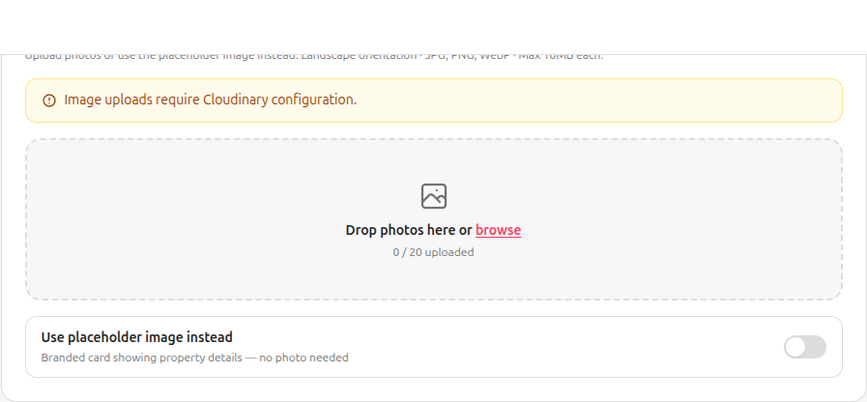
Admin Create Listing — photo upload 501 after revealing the dropzone.
Verdict
Every admin surface is reachable and clean (0 console errors); photo upload fails (BUG-007) and the user-count breakdown doesn’t add up (BUG-005).

5. Cross-role — Access Control & Security
6 of 10 TCs automated · 6 pass · 0 fail.
- Route guards were exercised across role boundaries: guests are redirected from /owner/* and /admin/* to login; a renter cannot reach owner or admin areas; an owner cannot reach admin areas.
- Security checks cover debug-mode disclosure (BUG-002), password hashing, and unverified-renter gating.
- These modules are role-agnostic by design — they assert that each role is confined to its own surfaces.
Module | Total | Automated | Pass | Fail
AccessControl | 5 | 4 | 4 | 0
Security | 5 | 2 | 2 | 0

