Repo: https://github.com/sazidludi/car-rental.git
Video: https://drive.google.com/file/d/1GmJz0IhxEBZbItxfB2WL157ROeVBCxE7/view?usp=sharing
Class Diagrams:
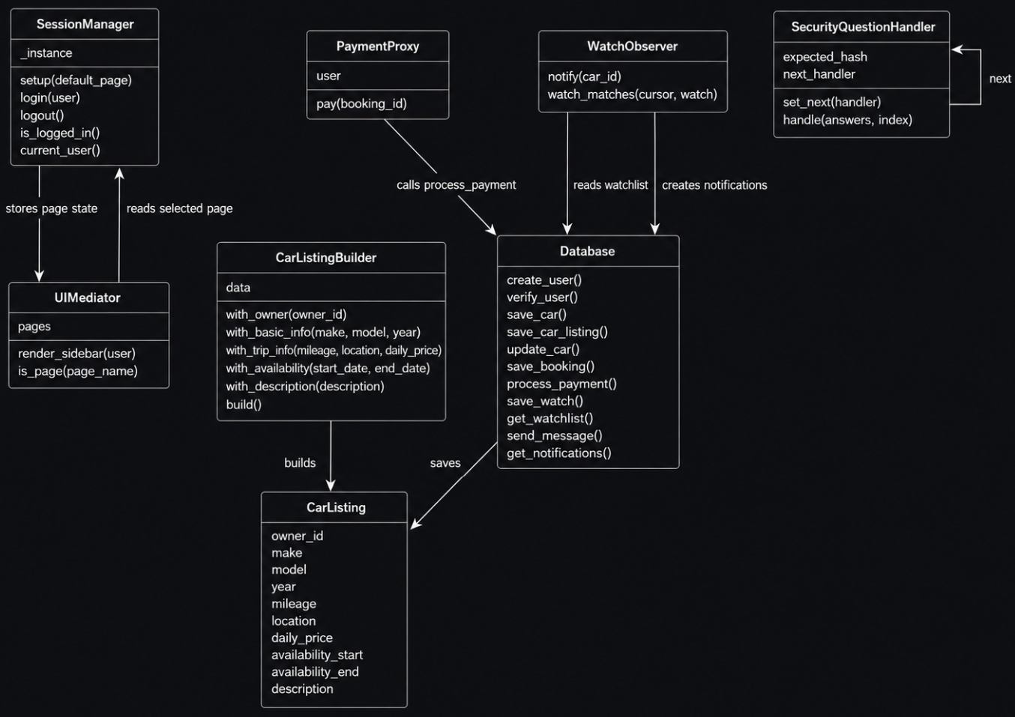
Description:
SessionManager
SessionManager handles the user’s current session. It stores login information, selected page state, selected car, selected booking, and other session values. It uses the Singleton pattern so the app always works with one shared session manager.
UIMediator
UIMediator controls navigation between pages. Instead of each page deciding how navigation works, the mediator handles the sidebar and checks which page is currently selected. This keeps page routing cleaner in app.py and supports the Mediator pattern.
CarListingBuilder
CarListingBuilder builds a car listing step by step. The owner dashboard collects make, model, year, mileage, location, price, availability, and description. The builder puts those values together into one CarListing object. This follows the Builder pattern and makes listing creation easier to read and explain.
CarListing
CarListing is the object created by CarListingBuilder. It stores the details needed for a car rental listing, including owner ID, car information, availability dates, price, and description. After the object is built, it is passed to the database save function.
PaymentProxy
PaymentProxy controls access to the simulated payment process. It checks that the current user is a renter before allowing payment to continue. If the user is valid, it calls the database payment function.
WatchObserver
WatchObserver handles watchlist notifications. When a car listing is created or updated, the observer checks watched cars to see if any renter’s desired price and dates are now matched. If a match is found, it creates an in-app notification. This follows the Observer pattern.
SecurityQuestionHandler
SecurityQuestionHandler is used for password recovery. Each handler checks one security answer. The first handler passes control to the second, and the second passes control to the third. The password can only be reset if all three answers are correct. This follows the Chain of Responsibility pattern.
Database Module
The Database box represents the functions in database.py. It is not a class in the code, but it acts as the data access layer for the app. It stores and retrieves users, cars, bookings, payments, watchlist items, messages, and notifications. Other pattern classes call database functions when they need to save or read data.
Relationship Descriptions
SessionManager works with UIMediator because session state stores the selected page, while the mediator reads and updates that page state through the sidebar.
CarListingBuilder creates a CarListing object. The database module then saves that listing into the cars table.
PaymentProxy calls the database payment function after checking that the user is allowed to pay.
WatchObserver reads the watchlist and creates notifications through the database module.
SecurityQuestionHandler links to another SecurityQuestionHandler, forming a chain of three security question checks.

Database Schema:
Python, Streamlit for UI, SQLite for database, powershell script to launch the app

Users: Stores account information for owners and renters.
Field | Description
id | Primary key
email | User login email
role | Either owner or renter
balance | User’s simulated account balance
password_hash | Hashed password using hashlib
security_question_one | First recovery question
security_answer_one_hash | Hashed first answer
security_question_two | Second recovery question
security_answer_two_hash | Hashed second answer
security_question_three | Third recovery question
security_answer_three_hash | Hashed third answer

Cars: Stores owner vehicle listings.
Field | Description
id | Primary key
owner_id | User who owns the car
make | Car make
model | Car model
year | Car year
mileage | Car mileage
location | Pickup location
daily_price | Rental price per day
availability_start | First available date
availability_end | Last available date
description | Listing description

Bookings: Stores renter reservations.
Field | Description
id | Primary key
car_id | Booked car
renter_id | User renting the car
owner_id | Owner of the car
start_date | Booking start date
end_date | Booking end date
total_price | Total rental price
is_paid | Payment status

Watchlist: Stores renter watch preferences.
Field | Description
id | Primary key
user_id | Renter watching the car
car_id | Watched car
target_price | Desired maximum price
desired_start | Desired start date
desired_end | Desired end date
is_notified | Whether notification was already sent
created_at | Watch creation time

Payments: Stores simulated payment records.
Field | Description
id | Primary key
booking_id | Related booking
renter_id | User paying
owner_id | User receiving payment
amount | Payment amount
status | Payment status
created_at | Payment time

Notifications: Stores in-app notifications.
Field | Description
id | Primary key
user_id | User receiving notification
title | Notification title
message | Notification body
booking_id | Optional related booking
is_read | Read/unread status
created_at | Notification time

Messages: Stores user-to-user messages.
Field | Description
id | Primary key
sender_id | User sending message
receiver_id | User receiving message
body | Message text
created_at | Message time

UI Screenshots
