 | 

Development and Post development for distributing OMS Rice/Flour
by Fingerprint for Ministry of Food
SD-40, Lot-3

Software requirement specification (srs)



Table of Contents

Introduction 4
Purpose 4
Scope 4
Overview 4
Functional Requirements 5
Module 1 - Dealer registration 5
Description 5
Online Registration 5
Dealer Approval 6
Dealer login 6
Dealer renewal 7
Module 2 - Dealer Management 7
Description 7
Dealer allotment 7
Dealer deposit 8
Dealership cancel request 8
Extra dealer enrollment 8
Dealer payment approval 9
DO Order create 9

Module 3 - Distribution 10
Description 10
Allotment Received 10
Beneficiary registration 10
Food Distribution 11
Restrict multi lifting in a single day 11
Module 4 - Observation 12
Description 12
sales activity monitoring 12
Physical inspection 12
System concept 13
Module 5 - OMS Operation setup 14
Description 14
Office setup 14
Office wise Dealer approval setting 14
OMS program setup 15
Office wise operation setup 15

Module 6 - User Account Management 16
Description 16
Features 16
Create User 16
Update User Information 17
Set/Re-Set User Password 17
Create User-Group 18
Update User-Group Information 18
Grant/Revoke User Permission 19
Assign/Change User Role 19
Active/In-active User 20
Grant/Revoke User-Group Permission 20
Active/In-active User Group 21
Additional Information 21
System Concept 22

External Interface Requirements 23
User Interfaces 23
Hardware Interfaces 23
Software Interfaces 23
Communication Interfaces 23
Non-Functional Requirements 23
Application Compliance Requirements 23
Web Application 23
Mobile Application Requirements 24
Sizing, Performance and Scalability Requirements 24
Interoperability and Data Exchange 25
System Audit 25
Tools and technologies to be user 25
Additional Requirements 26

- 1. Introduction

- 1.1 Purpose:
- The purpose of this document is to present a detailed description of the OMS (Open Market Sales) operation of DG (Directorate General) food . It will explain the purpose and features of the system, the interfaces of the system, what the system will do, the constraints under which it must operate and how the system will react to external stimuli. This document is intended for both the stakeholders and the developers of the system and will be proposed to the Regional Historical Society for its approval.

- 1.2 Scope:
- The scope of this system will cover the following:
- Dealer registration through online.
- Automation of OMS operation.
- Monitoring OMS activities through IP Camera.
- Distributes food grain to beneficiaries by face authentication system.
- Distributor payment authentication through Bangladesh Bank.
- SMS notification for distributor allotment and payment.
- Restrict multiple lifting of food grain in a single day by a individual beneficiaries.
- As well as restrict beneficiaries total lifting quota in a month. (Please crate a customizable module)
- Monitor and control dealer distribution from system Dashboard.
- Zone wise OMS Activity monitoring from system Dashboard.
- Analysis of beneficiary data for finding out the details of poverty status thus demand and supply can be controlled on the basis of the result. (Please Add data analysis module).
(This module will analyze yearly data of beneficiary lifting for finding out demand of an area, country demand, buying pattern, Habit, suggest more/less demanding area, poverty rate on the basis of buying pattern Etc.)
- Please consider to devise a plan for dealer rating from beneficiaries for next update.
- Please add source code/technology handover policy.
- Please consider adding comments inside source code for easy understanding. Thus, after handing over the project, we can modify as our need.
- Please add a public comments option at home page of web application. (do it at next update.)
- Please consider a instruction manual for developer along with system user. (It will come handy after completion of your project.)

- 1.3 Overview:
- The next chapter of this document gives an overview of the functionality of the service. It describes the requirements and is used to establish a context for the technical requirements specification.
- This document is written in such a way that both technical and non-technical persons can understand, and the chapters beyond is written primarily for the developers and describes in technical terms the details of the functionality of the product.

- 2.
- Functional Requirements
- 2.1 Module 1 – Dealer Registration :
- 2.1.1 Description
- This module describes the online dealer registration process. Dealer can apply for registration from DG Food web application. The dealer registration process is as bellow :
- 2.1.2 Online Registration
- This feature allows creation of New Dealer for the proposed Application. The process details is shown below:
- Process flow:
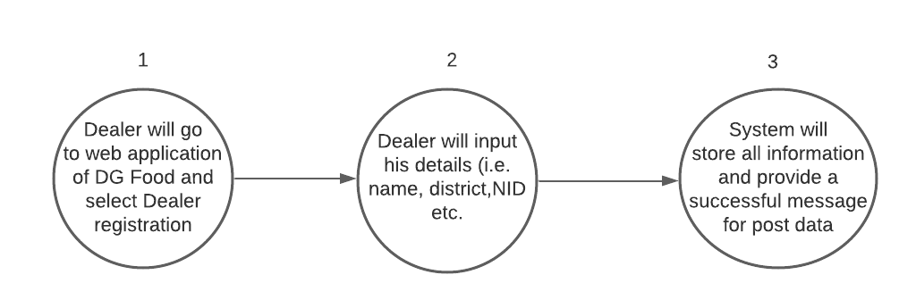

- Check list information:
Dealer Registration form is collected from field level and it will implemented as per collected documents.

- 2.1.3 Dealer Approval
- This feature allows the dealer approval process from OMS application . The process details is shown below:
- Process flow:

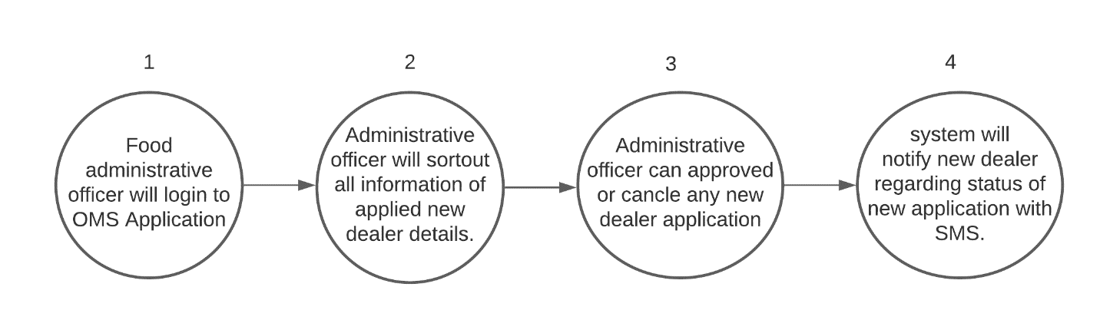

- 2.1.4 Dealer Login
- This feature allows the dealer login to OMS Mobile Application . The process details is shown below:
- Process flow:

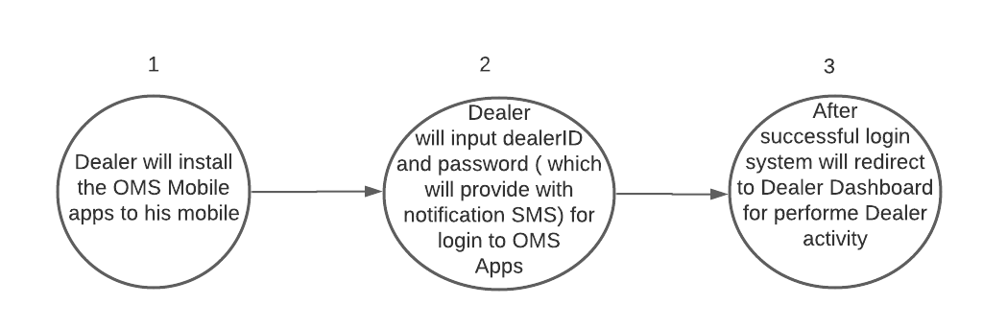

- 2.1.4 Dealer renewal
- This feature allows the dealer renewal process from OMS Mobile Application . The process details is shown below:
- Process flow:

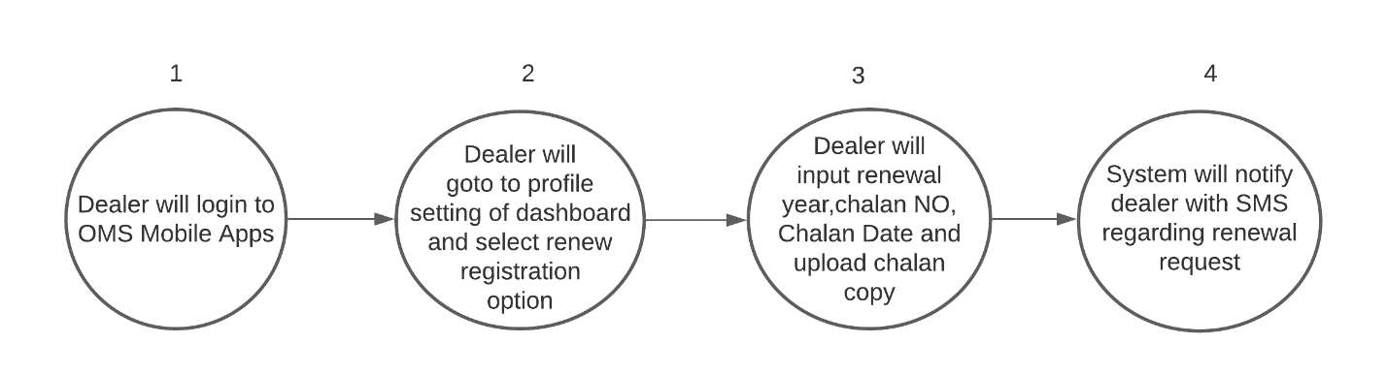
- 3.1 Module 2 – Dealer Management :
- 3.1.1 Description
- This module describes the online dealer management process. The dealer management process is as bellow :
- 3.1.2 Dealer allotment
- This feature allows to process dealer allotment from the Application. The process details is shown below:
- Process flow:
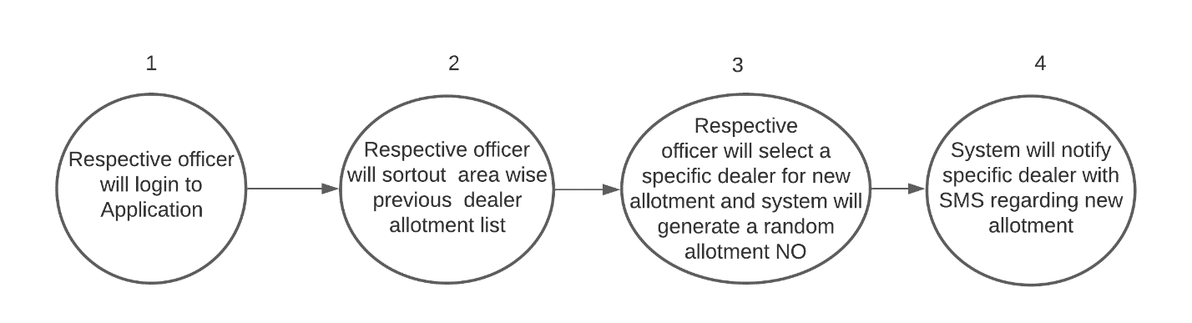

- 3.1.3 Dealer Deposit
- This feature allows to process dealer deposit from the OMS mobile apps. The process details is shown below:
- Process flow:
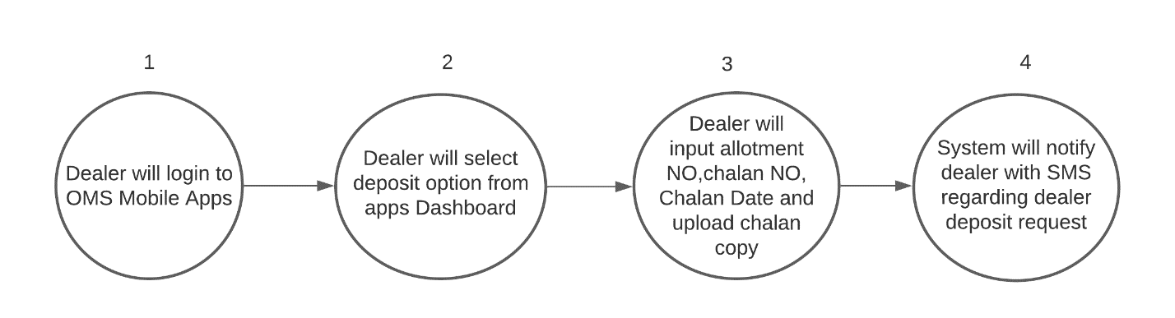

- 3.1.4 Dealership cancel/Suspension request
- This feature allows to process dealership cancel request from this application. The process details is shown below:
- Process flow:
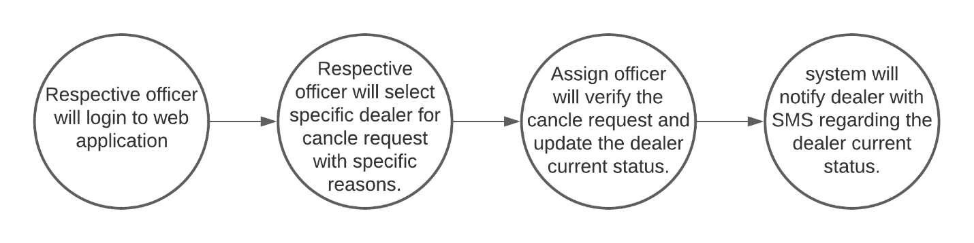
- 3.1.5 Extra Dealer Enrollment
- This feature allows to process extra dealer enrollment request from this application. The process details is shown below:
- Process flow:
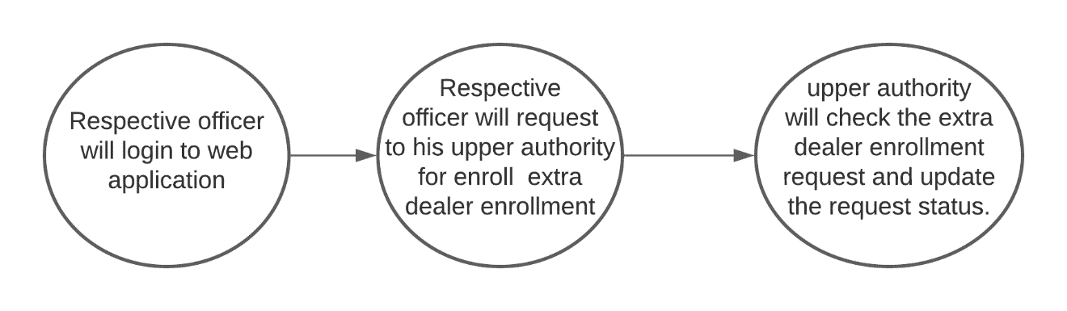
- 3.1.6 Dealer payment approval
- This feature allows to process dealer payment approval from this application. The process details is shown below:
- Process flow:
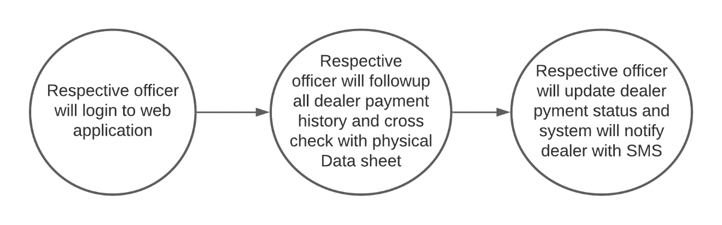

- 3.1.7 DO Order Create
- This feature allows to process dealer Delivery order from this application. The process details is shown below:
- Process flow:
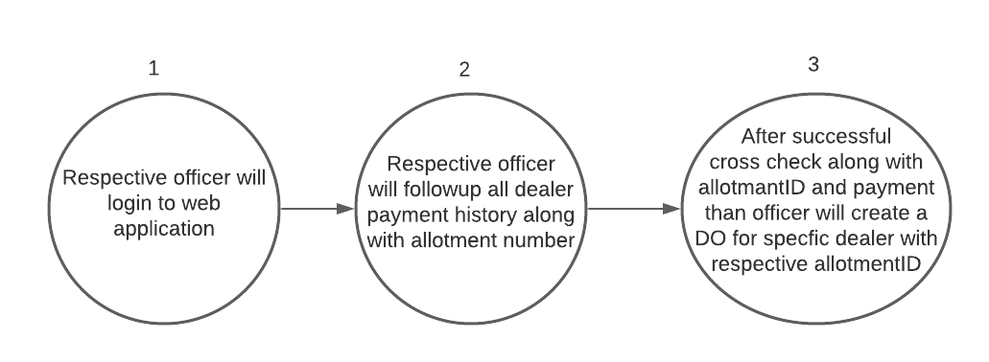

- 4.1 Module 3 – Distribution :
- 4.1.1 Description
- This module describes the OMS Distribution process in details . The OMS Distribution process is as bellow :
- 4.1.2 Allotment Received
- This feature allows to process dealer allotment received from the Mobile Apps. The process details is shown below:
- Process flow:
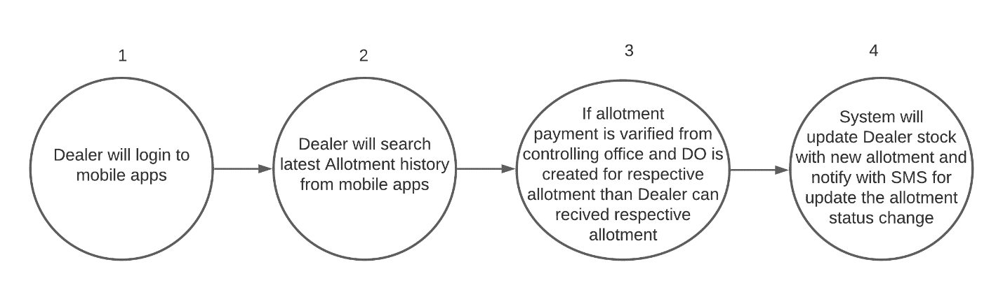

- 4.1.3 Beneficiary Registration
- This feature allows to process beneficiary registration from the Mobile Apps. The process details is shown below:
- Process flow:
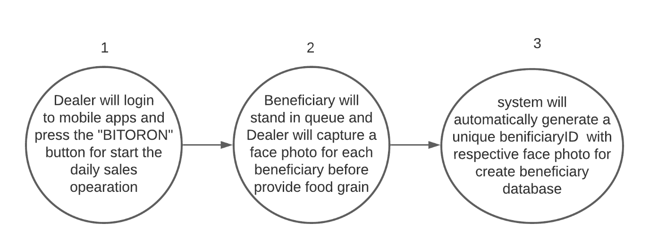

- 4.1.4 Food Distribution
- This feature allows to process food distribution to beneficiaries from the Mobile Apps. The process details is shown below:
- Process flow:
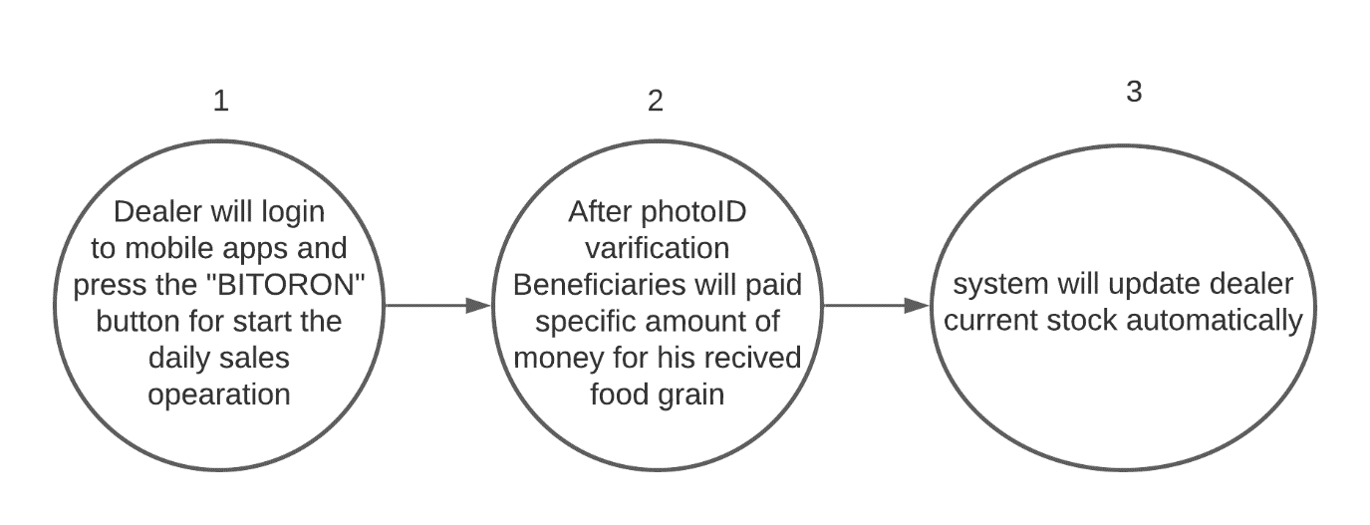
- 4.1.5 Restrict multi lifting in a single day
- This feature allows to process Restrict multi lifting for each beneficiary in a single day from the Mobile Apps. The process details is shown below:
- Process flow:
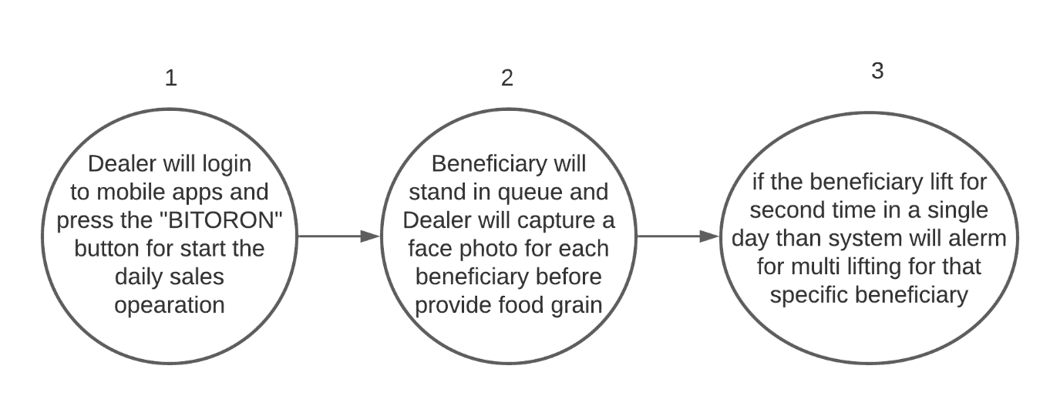

- 5.1 Module 4 – Observation :
- 5.1.1 Description
- This module describes the OMS activity observation process from this application . The OMS observation process is as bellow :
- 5.1.2 Sales activity monitoring
- This feature allows to monitoring dealer sales activity from the application . The process details is shown below:
- Process flow:
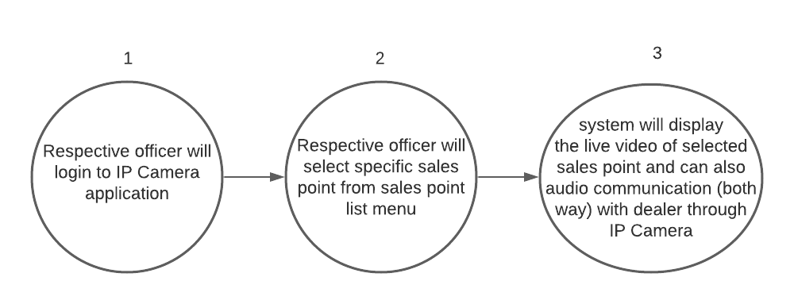

- 5.1.3 Physical inspection
- This feature allows to process physical inspection from this mobile apps . The process details is shown below:
- Process flow:
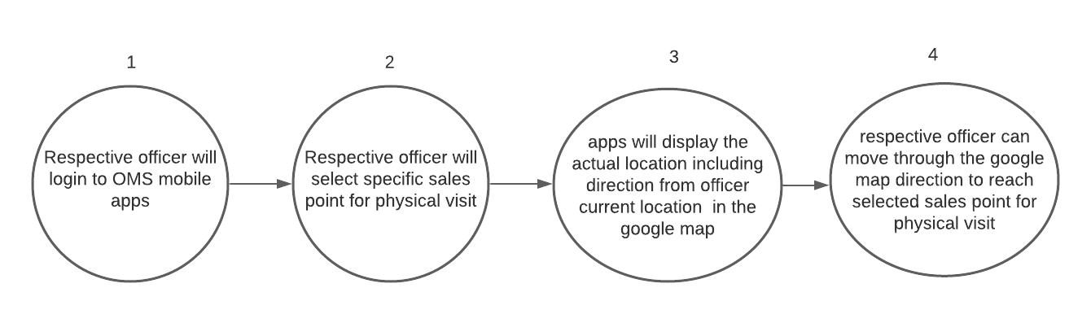

- 6 .1 System concept :
- The following diagram shows the concept of this module:
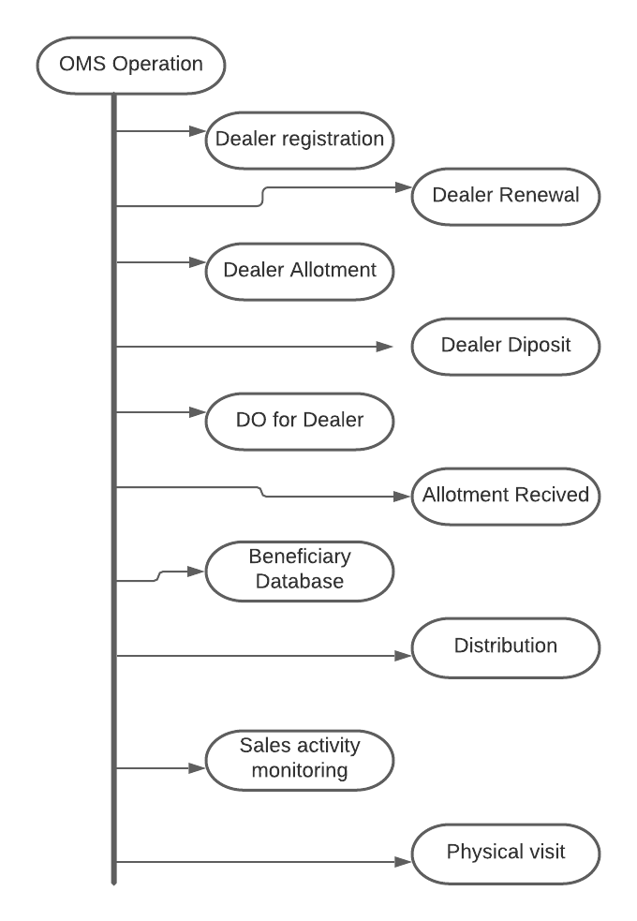

- 7.1 Module 5 – OMS Operation Setup :
- 7.1.1 Description
- This module describes the OMS operation setup process from this application . The OMS operation process is as bellow :
- 7.1.2 Office setup
- This feature allows to create new office for performed OMS operation from the application . The process details is shown below:
- Process flow:
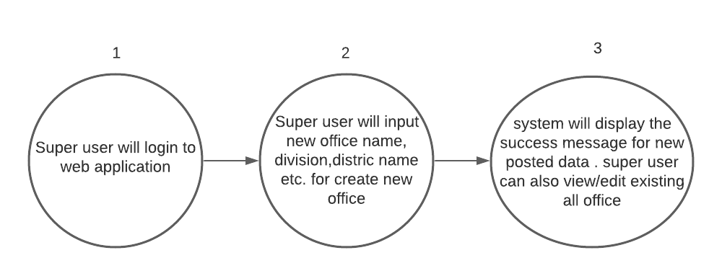

- 7.1.3 Office wise Dealer approval setup
- This feature allows to process office wise dealer approval setup from the application . The process details is shown below:
- Process flow:
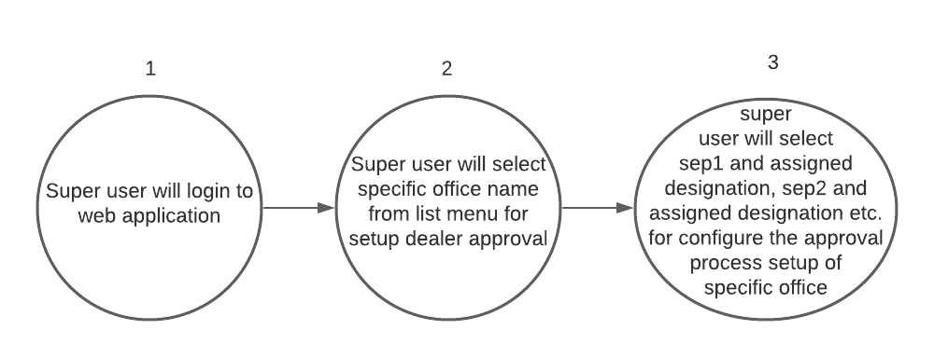

- 7.1.4 OMS Program setup
- This feature allows to process different OMS program setup from the application . The process details is shown below:
- Process flow:
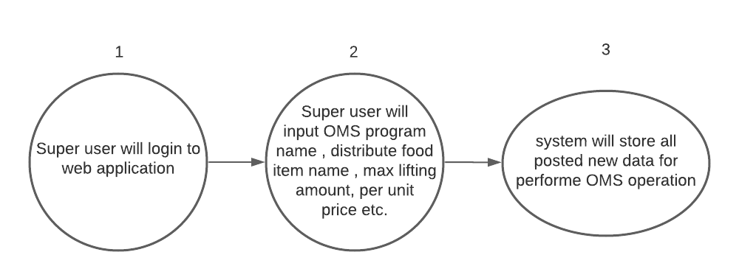
- 7.1.5 Office wise operation setup
- This feature allows to process office wise operation setup from the application . The process details is shown below:
- Process flow:
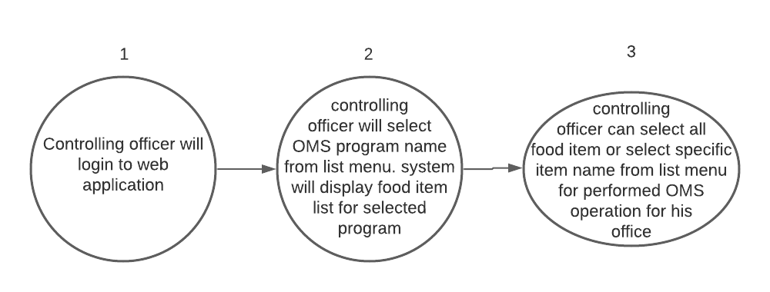

- 8.1 Module 6 – User Management :
- 8.1.1 Description
- This module describes about users of the Application. There type role and functionalities, basically there will be three types user group:
- Super User (It’s a default user group, users of this group will be able to perform any operation in this application without any restriction in web part).
- User group for Monitoring OMS Operation ( Inspector) from mobile apps and web .
- User group for Distribution food grain ( Dealer ) from mobile apps.
- 8.1.2 Features
- Details about the features of this module is defined bellow:
- 8.1.2.1 Create User
- This feature allows creation of New User for the proposed Application. The process details is shown below:
- Process flow:
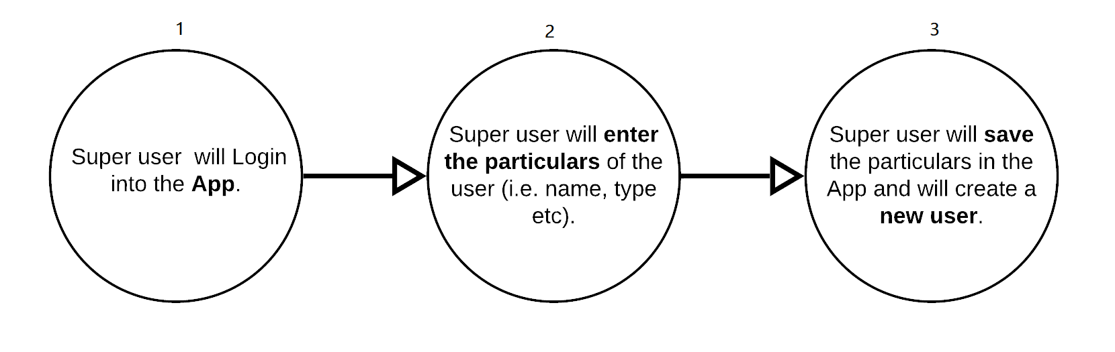
- Check list information:
Yet to receive documents from the real field; otherwise standard information collection practice will be applied in every stages of process flow where needed.

- 8.1.2.2 Update User Information
- This feature allows changing of users information of the proposed Application. The process details is shown below:
- Process flow:
- 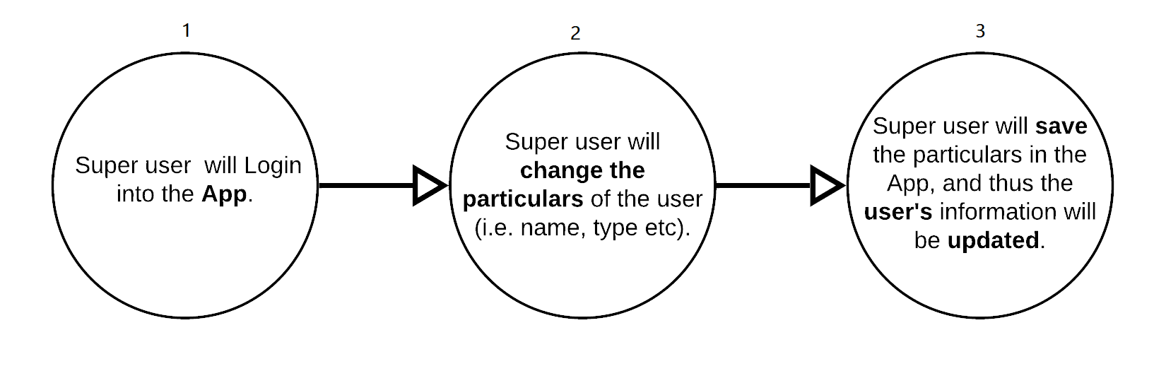 Check list information:
Yet to receive documents from the real field; otherwise standard information collection practice will be applied in every stages of process flow where needed.

- 8.1.2.3 Set/ Re-Set User Password
- This feature allows setting or re-setting Users Password of the proposed Application. The process details is shown below:
- Process flow:
- 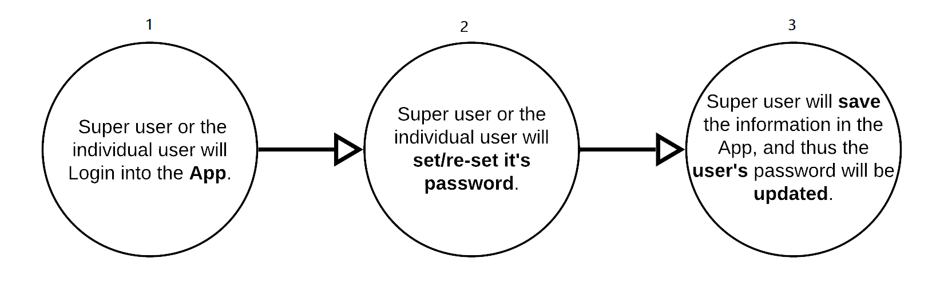 Check list information:
Yet to receive documents from the real field; otherwise standard information collection practice will be applied in every stages of process flow where needed.

- 8.1.2.4 Create User-Group
- This feature allows Creation of new User-Group of the proposed Application. The process details is shown below:
- Process flow:
- 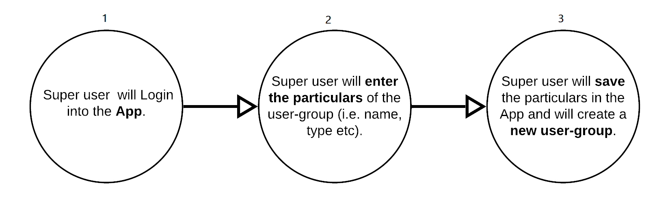 Check list information:
Yet to receive documents from the real field; otherwise standard information collection practice will be applied in every stages of process flow where needed.

- 8.1.2.5 Update User-Group Information
- This feature allows updating of User-Group information of the proposed Application. The process details is shown below:
- Process flow:
- 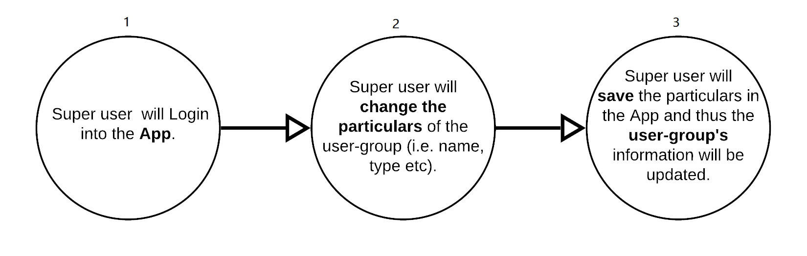 Check list information:
Yet to receive documents from the real field; otherwise standard information collection practice will be applied in every stages of process flow where needed.

- 8.1.2.6 Grant/Revoke User Permission
- This feature allows Granting or Revoking users rights of the proposed Application. The process details is shown below:
- Process flow:
- 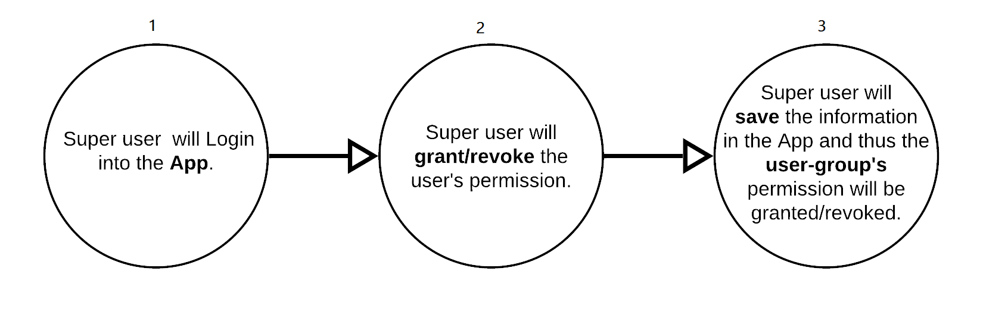 Check list information:
Yet to receive documents from the real field; otherwise standard information collection practice will be applied in every stages of process flow where needed.

- 8.1.2.7 Assign/Change User Role
- This feature allows Assigning or Changing of users role of the proposed Application. The process details is shown below:
- Process flow:
- 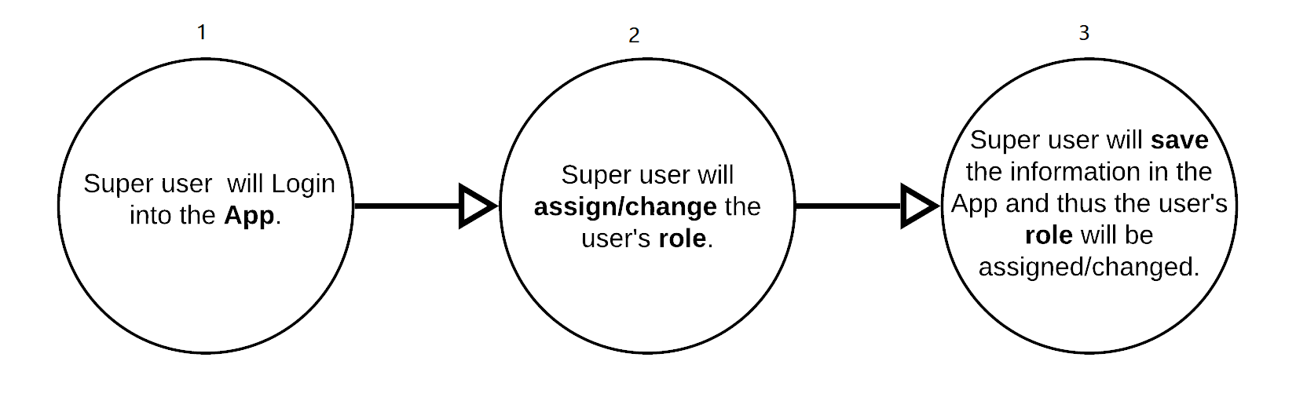 Check list information:
Yet to receive documents from the real field; otherwise standard information collection practice will be applied in every stages of process flow where needed.

- 8.1.2.8 Active/In-active User
- This feature allows to Activate or In-activate any users of the proposed Application. The process details is shown below:
- Process flow:
- 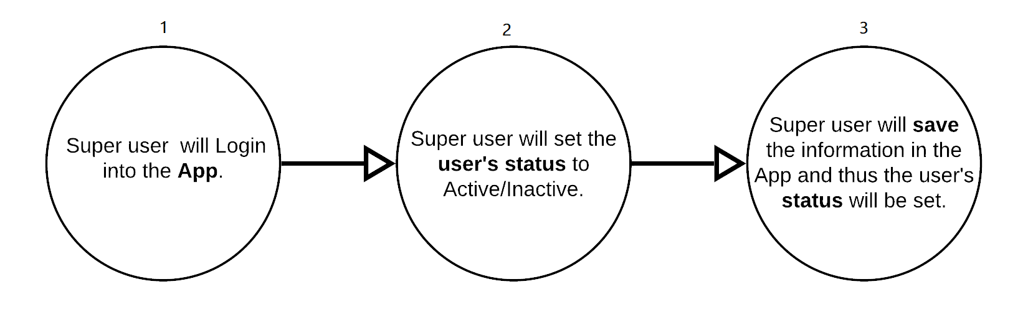 Check list information:
Yet to receive documents from the real field; otherwise standard information collection practice will be applied in every stages of process flow where needed.

- 8.1.2.9 Grant/Revoke User-Group Permission
- This feature allows to Grant or Revoke Group-Users Permission of the proposed Application. The process details is shown below:
- Process flow:
- 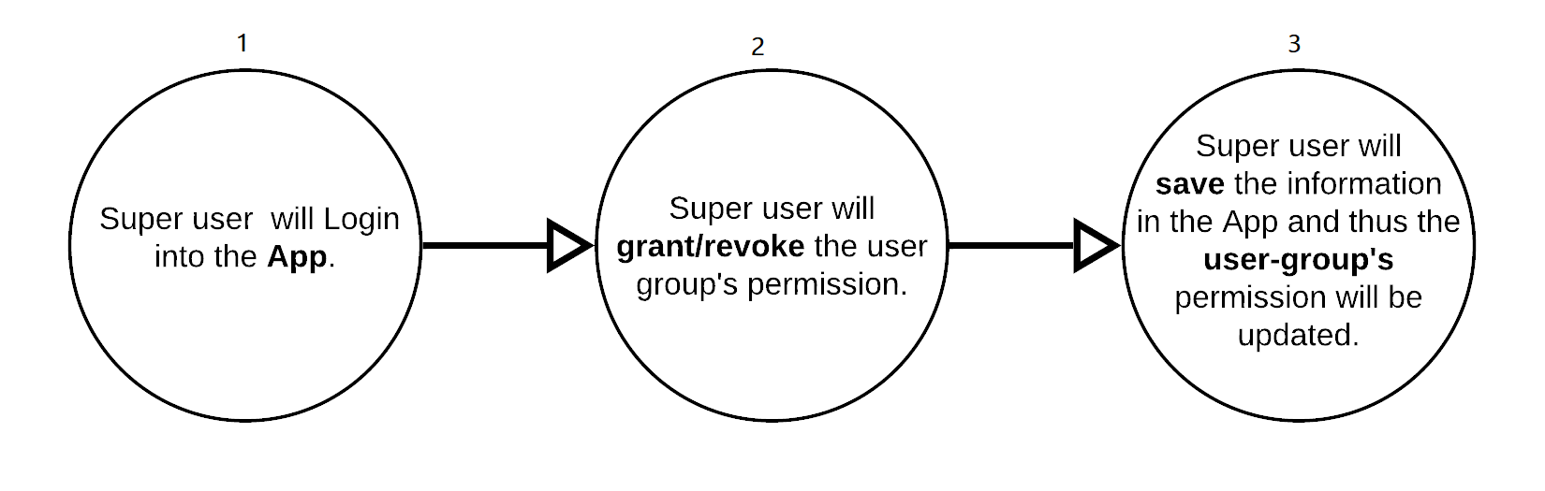 Check list information:
Yet to receive documents from the real field; otherwise standard information collection practice will be applied in every stages of process flow where needed.

- 8.1.2.10 Active/In-active User Group
- This feature allows to Activate or In-activate an Users-Group of the proposed Application. The process details is shown below:
- Process flow:
- 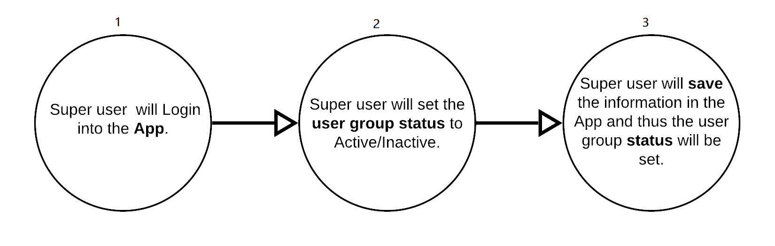 Check list information:
Yet to receive documents from the real field; otherwise standard information collection practice will be applied in every stages of process flow where needed.

- 8.1.3 Additional Information
- None

- 8.1.4 System Concept
- The following diagram shows the concept of this module:
- 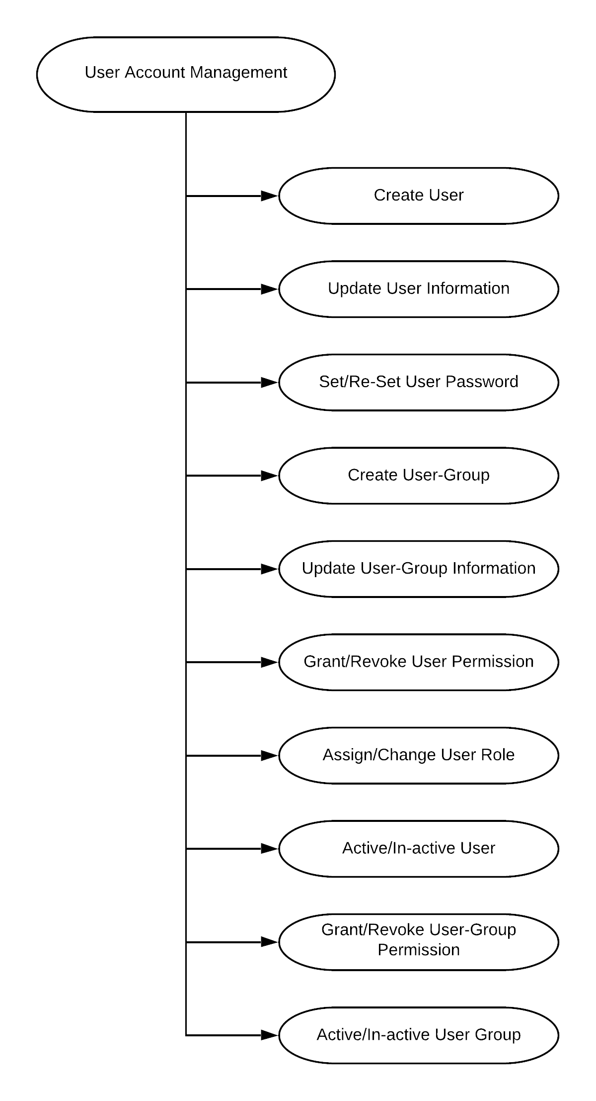

- 3. External Interface Requirements
- 3.1 User Interfaces:
- Web application shall permit complete navigation and other item selection using the keyboard alone, in addition to using mouse and keyboard combinations.
- Android application shall support hardware as well as virtual keyboard input.

- 3.2 Hardware Interfaces:
- Since the application must run over the internet, all the hardware shall require to connect internet will be hardware interface for the system. As for e.g. Modem, WAN – LAN, Ethernet Cross-Cable.
- 3.3 Software Interfaces:
- No software interfaces have been identified.
- 3.4 Communication Interfaces:
- The system shall use the HTTP protocol for communication over the internet and for the intranet communication will be through TCP/IP protocol suite.
- The system shall send notification(s) to the dealer for dealer allotment and dealer payment completion.
- The system shall send SMS message(s) to confirm new dealer registration and Other Customized SMS when necessary, with the system.
- The system shall send notification(s) to inform dealer for new allotment.

- 4. Non-Functional Requirements
- 4.1 Application Compliance Requirements
- 4.1.1 Web Application
- The application which is a web based solution, has to be hosted in a centralized Web-server
- The application should be developed following Service Oriented Architecture (SOA)
- Application should support MVC framework.
- Considering the operating/client environment at different level of this application, it should be developed in such a way so that it requires low bandwidth to run.
- The web-based application should support cross browser platforms (popular web-browsers such Mozilla Firefox, Opera, Chrome, Internet Explorer, Safari etc.)
- Should have ability to seamless integration with future module/components/applications
- Application should be lightweight and rich client-side scripting
- UI should be developed based on the analysis of UX.
- Any web interface of this application should be fully responsive

- 4.1.2 Mobile Application Requirements

- The mobile application version of the system should be developed for Android .
- Java Coding Language will be preferred.
- The mobile app should have capability of displaying system notifications
- Functionality for OMS Beneficiary registration automatically
- App should enable compact view of dealer daily sales activity.
- App should compatible with most of the Smart phone and tab available in market.
- There should be an option to auto/conditional synchronization with the central database with apps local data based on the availability of the internet connectivity.

- 4.2 Sizing, Performance and Scalability Requirements
- The system shall be capable of handling online functionalities for a database of at least 210,000 +300000(approx.) ( upazilla operation will increase database size) starts transition each day for service recipients and in terms of service provider 560 Offices and approximately System Users and Dealer users 2000+1000 (approx.). ( System user and dealer will increase when upazilla operation starts)
- The system processing shall be scalable to support the volume estimates for a period of 10 years at a 20% annual growth rate.
- The system shall be designed to handle estimated 5000 simultaneous connection (online users) when it is ultimately rolled out.
- The database architecture should be such that the system is available to user 24 x 7 x 365 days a year without any unapproved down-time.
- Page load time, login response-time, on-click‟ load time for the web application should be less than 3 seconds while this is accessed over the intranet.
- Average transaction response time, on-submit response-time, or any other database access/ search time should be less than 5 seconds when the system solution is accessed over the intranet.
- Considering the network infrastructure challenges in Bangladesh, the solution must support low bandwidth conditions for the services defined in the functional requirements.
- IN case of mobile application also, this should support very low bandwidth even in 2G network provided internet bandwidth.
- The proposed solution should be highly scalable to accommodate current and future requirements within the scope of the scope mentioned in the TOR
- Analyze the requirements whether both horizontal scaling (scale out) and vertical scaling (scale up) will be required for this e-Service application or not?
- The web application should be provided with appropriate caching mechanism to handle very high-traffic scalability.

- 4.3 Interoperability and Data Exchange
- The system should be designed for interoperability using industry standard protocols.
- System must expose data by Advanced Message Queuing Protocol and REST via TLS
- All imported data must undergo data validation to ensure full integrity.
- Data exchange within the system at different levels via the internet shall be encrypted.
- The system should have functionality to exchange data with other own systems or external institute systems.
- The system shall have functionality to export/import files based on the standard template defined through web services and/or API. Full API documentation must be provided so that third party integrators can integrate their system with this system.

- 4.4 System Audit
- This OMS system will maintain an audit trail of any changes or updates made in any information that are considered as vital and should maintain the audit log with information such as:

- Log the users who are accessing the system
- Log the parts of the application that are being accessed
- Log the fields that are being modified
- Log the results of these modifications
- Log attempted breaches of access
- Log attempted breaches of modification rights
- Timestamp.

- Ensure an audit trail is kept for all transactions and all audit transactions logged are kept on the trail file or trail database from where system can generate different audit reports as and when required.

- 4.5 Tools and technologies to be user

- The main components of the software will be web based application. It should be run in Windows/Linux/OSx operating system at user end and should be compatible to all major browsers such as – Internet Explorer, Firefox, Google Chrome, Opera etc.
- The System UI should be compatible with Tab & Smart Phone browsers.

- 5. Additional Requirements

- 5.1 Additional Information
- A third party application ( IP Camera Application) will be install in a PC in each controlling office.
- Controlling officer will monitor dealer sales activity ( live video) from IP Camera Application .
- DF food need to take license for IP Camera application . ( up to 8 camera is free license ).
- DG food need to recharge for Data pack for each SIM Router for each sales point .
- DG food need to purchase Google API for Google map to display sales point path direction in google map.

