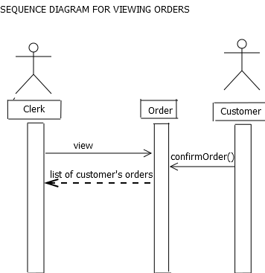
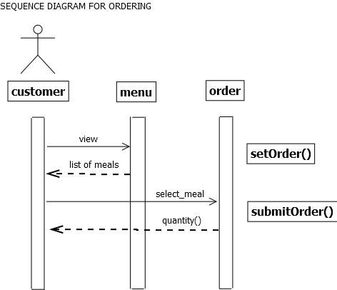

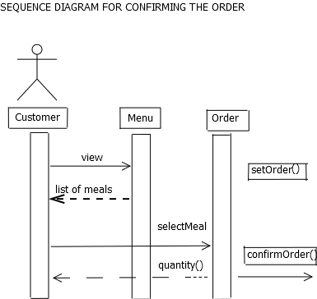

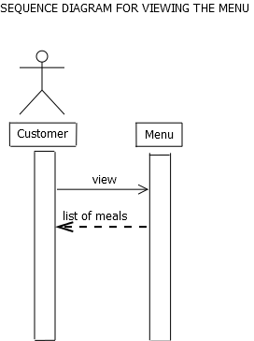

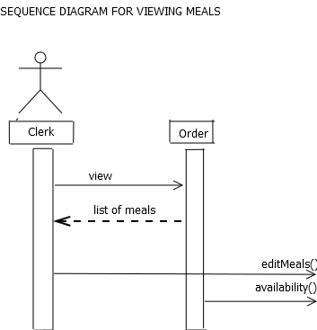

Database Schema
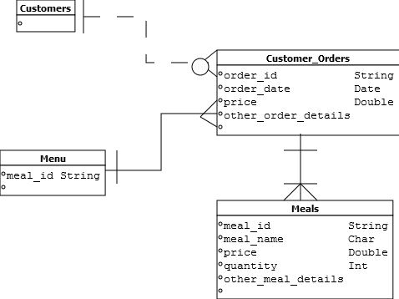

System Architecture for Coffee and Pastry House Ordering System
ADMIN
MENU
UPDATE
ORDERING TRANSACTIONS
ORDER
MODIFICATION
LAN

DATABASE
CLIENT SERVER
ORDER
MANAGEMENT MODULE

The admin inputs meal data into the database in which the data will be seen through the order management module where the client makes an order. The client can also modify his/her order. The ordering transactions of the client will be seen by the admin through LAN connection. The menu updates can only be done by the admin.

