1. The HR department wants a query to display the ename, job, hiredate, and empno for each employee, with empno appearing first. Provide an alias “STARTDATE” for the HIREDATE column.   
   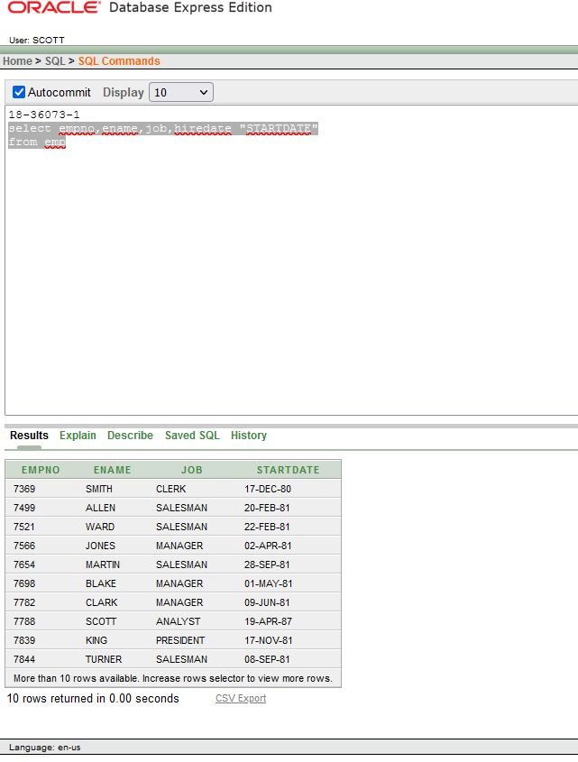
2. The HR department needs a query to display all unique sal from the EMPLOYEES table.  
   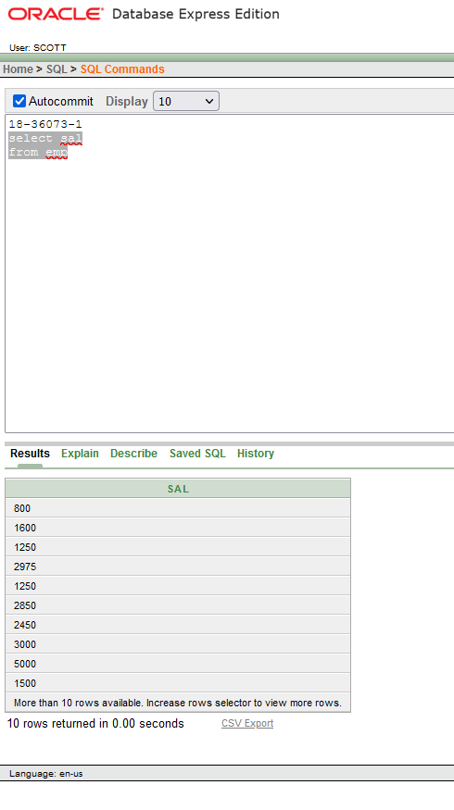
3. Show the information of all employees like

“SMITH go salary $ 800”.

1. To familiarize yourself with the data in the EMP table, create a query to display all the data from that table. Separate each column output by a comma. Name the column title THE_OUTPUT.
2. List the deptno from emp uniquely.
3. Show the information of all employees like “SMITH go salary $ 800”.
4. Check whether all the empno are indeed unique.
5. List “Annual salary” for all employee use column aliasing.
6. List the information for all employee whose job is either MANAGER or ANALYST.
7. List the department name whose department no is 20.