This is a page of a user who signed up on the 8th March but hasn’t added any steps yet.

Design notes: The Pedometer instructions need to be added. The logo is a bit iffy and may need to change

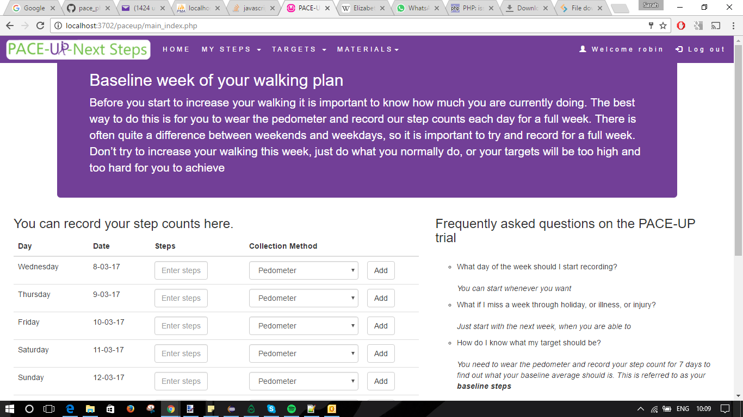

Adding steps

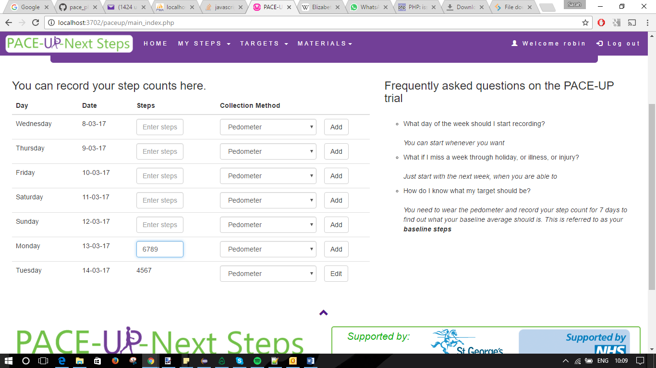

The control box is now shown as all the data has been entered

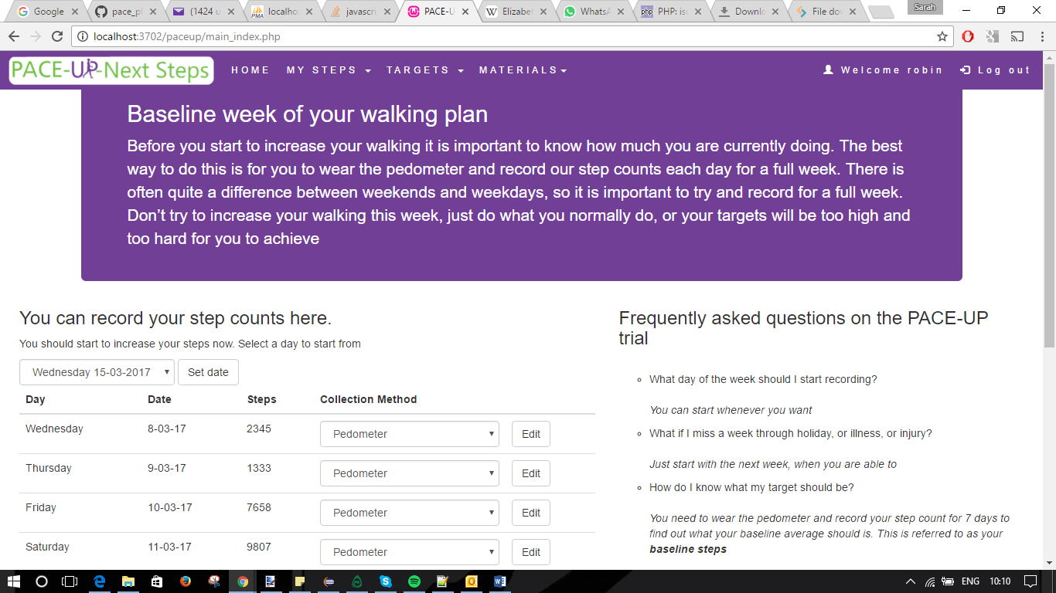

The control box shows tomorrow and up until 7 days from today (14th March)

